UDC 631.8: 629.7

THE CREATION OF VEGETATION INDICES FOR THE NEEDS OF PRECISION AGRICULTURE BY MEANS OF MATHCAD

N. A. Pasichnyk, Candidate of Agricultural Science, Associate Professor of
Agricultural chemistry and Plant Production Quality Chair

V. P. Lysenko, Doctor of Technical Science, Professor of the Automation and Robotic Systems Chair

O. O. Opryshko, Candidate of Technical Science, Associate Professor of
the Automation and Robotic Systems Chair

V. O. Miroshnyk, Candidate of Technical Science, Associate Professor of
the Automation and Robotic Systems Chair

D. S. Komarchuk, Candidate of Technical Science, Associate Professor of
the Automation and Robotic Systems Chair

The National University of Life and Environmental Sciences of Ukraine
Е-mail: N.Pasichnyk@nubip.edu.ua; ozon.kiev@gmail.com

Abstract. Most of the existing vegetation indices were developed for the satellite platforms and, at the same time, didn’t consider their use for crop management. The development of a method of creating measurement indices based on the results of the processing of remote sensing data obtained from UAVs is relevant, which is the purpose of the work. Experimental studies were carried out in 2017 in a long-term field stationary of the Department of the Agrochemical and Agricultural products of NULES of Ukraine. For monitoring, the FC200 and GoPro HERO 4 iZ IR-cameras were used for optical and infrared bandwidths. The calculation was carried out in the environment of MathCad. The method of developing the measuring vegetation indices was suggested, which is based on the regression link analysis between the intensity of the color components and the result, which these components affect. When creating vegetation indices besides linear regression, we can consider and possible impact of the interaction factor. The vegetation index was suggested for state determination of the condition of the nitrogen nutrition, adapted for differential fertilizing application with the use of ground equipment. The introduction to the regression (vegetation index) additional design parameter - the area of the horizontal projection of the plants has the prospect for increased accuracy provided improvement of the method of identification of plantations.

Keywords: remote monitoring of crops, UAV, unmanned aerial vehicles, vegetation cover, spectral shooting, MathCAD software.

Actuality. The precision farming technologies, the use of which is an indispensable condition for high profitability of crop production, require the introduction of specialized vegetation indices adapted to equipment for applying agrochemistry and, in particular, fertilizers. Unmanned aerial vehicles (hereinafter UAVs) is a platform where they place a digital photo for the acquisition of high-resolution images at a competitive cost. However, most of the available vegetation indices were developed specifically for satellite platforms and, at the same time, the possibility of their use for crop management was not considered.

Analysis of recent researches and publications. Specialized software Agisoft is presented on the market, described in Yinuo Liu et all [1, 105,026], which allows the user to introduce their own equation for the vegetation index. However, the methodology for creating indices for crop management is not given.
Processing the results of spectral sounding is possible based on the use of standard mathematical software products that provide the user with the opportunity for regression analysis. An example of such products is MatLab [2, 61-80] and MathCad [3, 244-250 (MathCad, in our opinion, is more universal and widespread among agricultural specialists).
Spectral monitoring is carried out using multispectral complexes аs MicaSense RedEdge and Parrot SEQUOIA, which are described in [4, 47-60], and created on the basis of standard Action cameras with specialized lenses such as MAPIR Survey [5, 109-117]. Cheap action cameras, adapted for extreme operating conditions, are more universal, as they can be used for other household needs.
The orientation of vegetation indices for calculating the application rates of agrochemicals has its own specifics. Given the existing range of equipment and the variety of plant varieties and hybrids, farmers require a method for creating specialized measuring vegetation indices, in particular for the rational use of fertilizers and the application of seifers to neutralize the aftereffect of herbicides. Therefore, the development of such a method for creating measurement indices from the results of processing remote sensing data obtained from UAVs is relevant, which was the purpose of our work.

Materials and research methods. Experimental studies were carried out on 05.31.2017 on the fields of the NULES of Ukraine of Ukraine “Agronomic Experimental Station” in a long-term field stationary of the Department of Agrochemistry and Quality of Plant Production (GPS coordinates: 50º4’28’’; N, 30º13’20’’ E.). For monitoring, we used the PHANTOM VISION FC200 RGB camera and GoPro HERO 4 action camera with an infrared (hereinafter IR) lens. Thanks to a specialized IR lens, an image is obtained for three channels in pseudo colors, which corresponds to various combinations of the red and infrared spectra [6, 180-216].
For the experiment with winter wheat, Colonia cultivar, which was in the “exit to the tube” vegetation stage, the following fertilizer application options were used: 1) without fertilizer (control); 2) P; 3) RK; 4) NRK (recommended rate) 5) NRK (1.5 recommended rates). The minimum amount of fertilizer on the right side of the images (near the road), the maximum - on the left side (shown in Fig. 1).

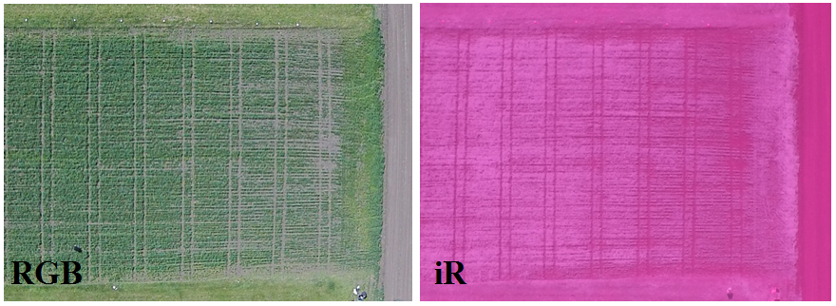
Fig. 1. Photograph of a research hospital in the optical range (RGB) and in pseudo colors using an infrared lens (IR)

The nitrogen content in the dry mass of plants was determined by the photometric method with Nessler's reagent. The determination of the intensity of the color components for the sites was carried out according to the procedure [3, 244 250]. Using a cascade filter [3, 244–250] and an approach to object image recognition [7, 105-114], we additionally determined how much of the total area of the plot falls on the horizontal projection of plants.

Research results and discussion. The results of spectral monitoring are presented in table.

The intensity of the color components of plants for optical and IR lenses (R, G, B; IR1, IR2, IR3, respectively) and the area of the horizontal projection of plants for areas
№ ділянки | Вміст азоту | Оптичний об’єктив |  |  |  | ІЧ об’єктив
№ ділянки | Вміст азоту | R | G | B | s,% | iR1 | iR2 | iR3 | s,%
0 | 2,1 | 103 | 120 | 106 | 0,774 | 195 | 75 | 158 | 0,734
1 | 2,4 | 99 | 121 | 105 | 0,831 | 199 | 80 | 166 | 0,917
2 | 2,8 | 89 | 117 | 94 | 0,832 | 204 | 87 | 175 | 0,993
3 | 3,7 | 87 | 116 | 91 | 0,872 | 207 | 90 | 179 | 1,000
4 | 3,7 | 81 | 113 | 89 | 0,898 | 207 | 90 | 179 | 0,998
5 | 4,6 | 78 | 112 | 86 | 0,92 | 212 | 96 | 186 | 1,000
6 | 3,7 | 78 | 109 | 84 | 0,935 | 207 | 91 | 180 | 1,000

The analysis of the data presented in the table allows us to conclude that for all spectral measuring channels, the intensity of the color components of plants and the values ​​of the identified horizontal plant projection area (%) show a certain dependence on the nitrogen content.
The linear nature of the dependency is desirable for analysis. The approximation of the experimental results by just such a dependence gives the determination coefficient (R 2) for the optical lens (0.6 - 0.8), and for IR - (0.9 - 0.93). Approximations of the data by a linear dependence on the identified horizontal projection area gave a determination coefficient (R 2) for optical and IR lenses, respectively, 0.77 and 0.46.
It should be noted that even with the highest value of R 2, which was recorded for channel iR1, the standard error was 11.2.
A typical solution for the differential application of agrochemistry is to control the speed of movement of ground equipment, for which the linear nature of the relationship between the speed and rate of application is optimal. Since the correlation between the nitrogen content and the intensities of the color components and the horizontal projection area calculated on this basis is manifested for the data in the table, it is advisable to consider the option of accounting for several indicators in the vegetation index. In this case, both linear regression and linear regression with the effect of the interaction of factors can be used when individual indicators are presented in the equation as a product (Fig. 2).

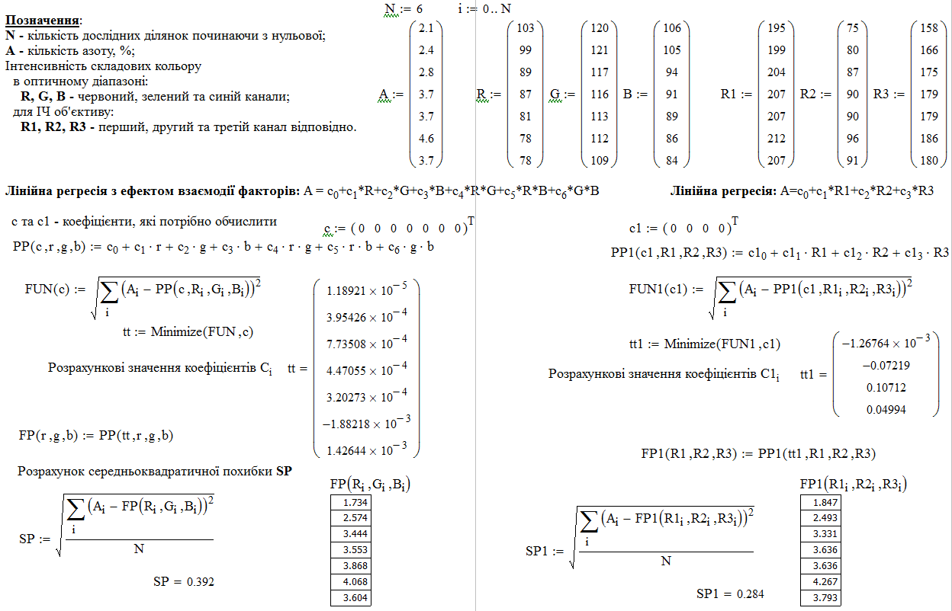
Fig. 2 Program for calculating the coefficients of the vegetation index

In the calculations, such combinations of measuring channels were considered: RGB, RsB, RGBs, and R1R2R3, R1sR3, R1R2R3s. For a multivariate linear regression model, the following results for the standard error are obtained: 0.328, 0.339, 0.328 and 0.284, 0.176, 0.179, respectively. For linear regression with the interaction effect, the mean square error was 0.342, 0.346, 0.448 and 0.235, 0.415, 0.168, respectively.
Thus, taking as a basis the value of the standard error of determining the amount of nitrogen (A) for the above wheat variety in the “exit to the tube” vegetation stage, we suggest using a vegetation index adapted for differentiated fertilizer application (not only the area of ​​the horizontal projection of plants is taken into account, but also the interaction effect factors)
A = 3.5·10 -5 ·R1 – 1.7 × 10 -5 ·R2 - 6.1·10 -5 ·R3 + 3.4·10 -3 ·R1·R2 – R1·R3·10 -3 –
–1.4·10 -3 ·R2·R3 – 9.8·10 -4 ·R1·s – 4·10 -4 ·R2·s – 8.8·10 -4 ·R3·s.
When using an IR lens, the best results were obtained by applying linear regression with the effect of the interaction of only spectral indicators.
For the optical range, the introduction of an additional parameter, namely, the horizontal projection area s, which is a derivative of the intensities of the color components, didn't lead to a decrease in the mean square error.
Taking into account the surface area of ​​the horizontal projection of plants is promising and the influence of this factor will increase with a more perfect identification of plants. This is ensured both by higher resolution of images and by using alternative formats of data storage with fixing the values ​​of each pixel, and not a certain number of them, as provided in the standard jpeg format for household cameras.

Conclusions and perspectives. A method is proposed for creating measuring vegetative indices, which is based on a regression analysis of the relationships between the intensities of the constituent flowers of the plants and the result that these components influence. For its implementation, it is recommended to use the mathematical software MathCAD.
When creating vegetation indices, in addition to linear regression, it is advisable to consider the possible influence of the interaction effect. factors.
A vegetation index is proposed for determining the state of nitrogen nutrition, adapted for differential application of fertilizers by ground equipment.
The introduction into the regression equations (vegetation index) of an additional calculated parameter — the area of ​​the horizontal projection of plants — has prospects for increasing accuracy under conditions of improving the method for identifying plantations.

References

1. Yinuo Liu, Shishi Liu, Jing Li, Xinyi Guo, Shanqin Wang, Jianwei Lu (2019) Estimating biomass of winter oilseed rape using vegetation indices and texture metrics derived from UAV multispectral images. Computers and Electronics in Agriculture, 166, 105026. https://doi.org/10.1016/j.compag.2019.105026;
2. Chao Sun, Sergio Fagherazzi, Yongxue Liu (2018) Classification mapping of salt marsh vegetation by flexible monthly NDVI time-series using Landsat imagery. Estuarine, Coastal and Shelf Science, 213, 61-80.
https://doi.org/10.1016/j.ecss.2018.08.007;
3. N.A.Pasichnyk, O.O.Opryshko, D.S.Komarchuk, V.O.Miroshnyk (2019) Experience in using mathcad to analyze data from UAVS for remote sensing of crops. Roslynnytstvo ta gruntoznavstvo, 286, 244-250;
4. Jyun-Ping Jhan, Jiann-Yeou Rau, Norbert Haala (2018) Robust and adaptive band-to-band image transform of UAS miniature multi-lens multispectral camera. ISPRS Journal of Photogrammetry and Remote Sensing, 137, 47-60,
https://doi.org/10.1016/j.isprsjprs.2017.12.009;
5. L.Hambrecht, R.P.Brown, A.K.Piel, S.A.Wich (2019) Detecting ‘poachers’ with drones: Factors influencing the probability of detection with TIR and RGB imaging in miombo woodlands, Tanzania. Biological Conservation., 233, 109-117.
https://doi.org/10.1016/j.biocon.2019.02.017;
6. V.Lysenko, S.Shvorov, O.Opryshko, N.Pasichnyk, D.Komarchuk (2018) Information support of Some automated systems of remote monitoring of planted areas state. Control Systems: Theory and Applications, 285.
7. Xiuliang Jin, Shouyang Liu, Frédéric Baret, Matthieu Hemerlé, Alexis Comar (2017) Estimates of plant density of wheat crops at emergence from very low altitude UAV imagery. Remote Sensing of Environment. 198, 105-114,
http://dx.doi.org/10.1016/j.rse.2017.06.007.

