UGC 712:23.719 (477-25)

IMPROVEMENTS LANDSCAPING

ST. CYRIL'S CHURCH NATIONAL PRESERVE

"SOPHIA" IN KIEV

А. І. KUSHNIR, Candidate of Biological Sciences

О. А. SUHANOVA, Candidate of Agricultural Sciences

А. U. UDOVENKO, Master's student *

The article highlights the complex variants, present in studies carried out on the territory of St. Sophia's church in St. Cyril's national reserve during 2012-2015: the main steps of the reserve, factors who influenced the formation of particular areas and particular plantations, definition of the current state of the area who is studied and the developed measures for his improvement.
St. Cyril's Church, landscaping, greenery, planning structure

Cyril Church - a unique monument of architecture of Ukraine (XI-XVIII c.), Has historical and spiritual value, is a monument monumental painting XII-XIX. It was built on the territory of contemporary Dorozhychi tract, which was located in the northwest part of the city. Kyiv, which later became known Dorohozhychi. The name is derived from the passage of this important trade routes in Vyshhorod, Smolensk, Chernigov, Polotsk, Novgorod [1, 5, 6, 7].
At the time of Kievan Rus were the most powerful princes of Chernigov O. hereditary who seized the solution of important trade routes - Dorozhychi. In 1146 built a large stone church on a hill, from which opens a good view of the river Pochayna. Church of St. Cyril named in honor of St. Cyril of Alexandria, one of the Slavic educators.
Cyril Church was ancestral burial O. family. In 1194 became the burial place for Kiev prince Svyatoslav - the protagonist of the story "The Tale Ihorovim" [1, 7].
In the first half XVII. Kirillov monastery was restored under the reign of Constantine Ostrog.
In 1748-1760 gg. In the territory adjacent to the interior of the church was built of stone monastery buildings erected wall and tower. Until now, only a small portion of these extensions. After XVII. general appearance of the church has changed and it has become a modern image in the Ukrainian Baroque style.
The aim - to determine the current state of the landscaping at St. Cyril's Church National Reserve "Sophia" in the city. Kyiv, its planning structure stezhkovoyi state road network, small architectural forms, decorative plants and propose measures for their improvement.
Materials and methods of research. The study was conducted by an object we pre-analysis area is determined mistobudivelnu, historical, functional, architectural and landscape planning and evaluation; state was established landscaping and space resolution of an object made poderevna inventory space. The main methods of establishing a general assessment area were full-scale inspection route, iconographic analysis, journalistic and academic sources, a significant achievement in the study served as stages of church archives.
Research results. Since 1883 in the interior of the church was carried out works on cleaning and restoration of wall murals, under the direction of Professor A. Prahova, who worked in a team of Mikhail Vrubel. It is thanks to the coordinated work was able to significantly improve the appearance of the interior of the church. [7]
In 1929 St. Cyril's Church proclaimed the State Historical and Cultural Museum-Reserve of national importance. Started archaeological research projects continue until the end of the Great Patriotic War (1941-1945.). Subsequently conduct extensive restoration work, strengthen the walls and foundation of the church.
In 1965, St. Cyril's Church declared a museum, which is part of the National Reserve "Sophia." During the museum spend big in terms of rehabilitation and restoration work.
Recently, the major work conducted on the interior of the church building had character restoration, initiated and financed enterprise "base-Solsif." When these works were found the remains of the foundations of past extensions churches and other securities in the archaeological and historical significance of things. [7]
Currently, St. Cyril's Church National Reserve "Sophia" a museum open to visitors. The main part of the complex stretches along the slope, and the interior of the church building is located directly on the hill (Fig. 1).
The complex stairs leading bahatomarshevi (Fig. 2), requiring repair. On both sides of the stairs surrounded by an array of trees and shrubs. Until recently, the slope was terraced, where growing fruit trees. Today he reinforced retaining walls, terraces not visible, an array of trees and shrubs THICKENED, species composition of vegetation is represented with lime, alder., Maples and ash. Under the canopy of tall woody plant fruit are not sufficient conditions for normal growth and fruiting, so eventually fall out.
The dominant building complex stands interior of the church, except for her with built-existing administrative structures and small architectural forms. The complex is shopping kiosk that performs a service function and read the whiteboard, working hours and conditions visit possible by information stands.

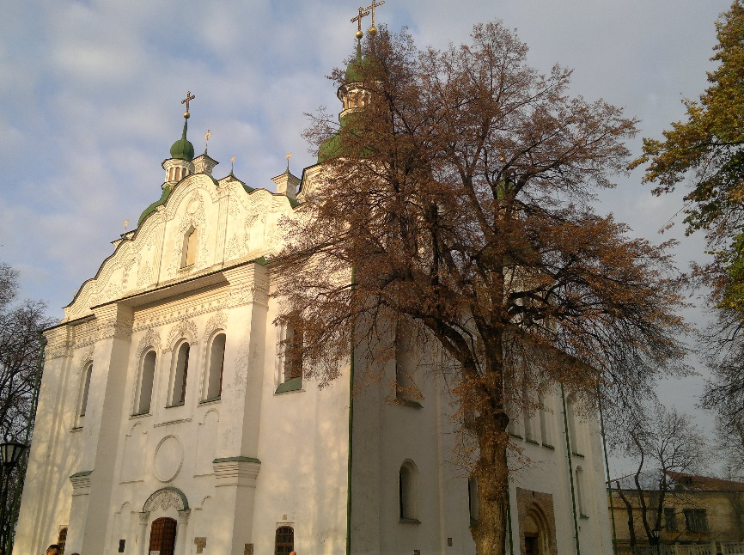 | 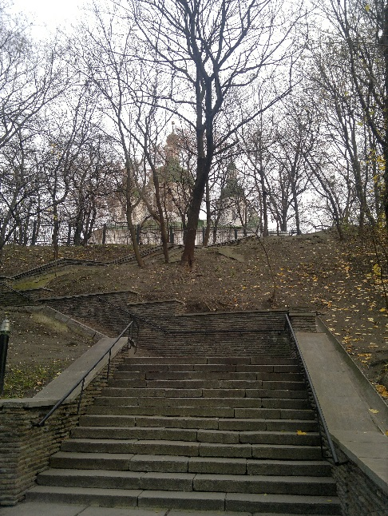
Fig. 1. The facade of St. Cyril's Church  with lime cordata foreground | Fig. 2. Stairs leading to the interior of the church  from the side of the street. Telihy

The complex has an extensive road network stezhkovu that is inserted lighting area and surrounded by a wall that needs renovation. In many places electric cables unearthed, are unaesthetic appearance and pose a threat to workers and visitors to the facility.
Sanitary zone is not clear the examined areas for rest and appropriate landscape equipment.
Flower design of the compound represented mixborders, the range of plants is not relevant to the object and its functions.
For the convenience of the work on the inventory of structural elements of the object of research area was divided into seven sections. In terms of inventory, presented in Fig. 3, these areas are marked with different colors.
During the 2013-2015 biennium. Custom Directorate of the National Reserve "Sophia of Kyiv" we were made to work with pre study area and research facility planned major steps to improve its existing condition.
As a result of inventory work established species composition of vegetation, defined by their age structure, distribution of plants held in diameter trunks and origin; The types of plantations and established their quality status (see. Table.) [8].
During the study, the research area of ​​the object we found that plantations are 39 taxa of woody plants in an amount of 106 specimens of trees and bushes of 108 copies. The predominant species are of the genus maple (Acer L.).
In the first three parts of the inventory plan that surround St. Cyril's Church and considered its estates, plantations are 19 species of plants, 11 species of which are local, and 8 - introduced, of which 11 species - trees, 8 - bushes. The basis of the plantings in these areas constitute cordata plant linden (Tilia cordata L.). Diameter shafts are plants include seven groups of eight diameters defined in the Regulations inventory of green spaces in cities and towns of Ukraine [9]. Thus, a group of diameters up to 6 cm referred 13 instances are usually shrubs; most specimens of plants classified in the group of more than 50 cm in diameter - 12, the smallest number of plants classified in the group 38,1-46,0 cm - 9 copies.
Age structure stands presented 3 age groups. Assigned to the prevailing woody plants that are aged over 50 years, the least represented - to 15 years. By type of plantations in which plants are concentrated, dominated by single (Tapeworm) landing.
Quality state of the plants installed during the inventory work is satisfactory. Some specimens of woody plants with good fortune. Typically, these young people landing on the open field.
The idea for writing slope terraces fruit plants today are not monitored, self-seeding crops and pushed yasenelystoho Branch maple, linden cordata, alder sticky and Robinia psevdoakatsiyi. Among shrubs dominated lilac ordinary [2, 3, 4].
Today, the area is complex represented a small area, which leads to lack of allocation of certain elements common to the monastery gardens - orchard or vegetable garden herbs. Available copies lime characteristic species for monastic cadiv and have a good condition, so the overall concept, dedicated to the reconstruction of the facility, they offered to keep.

Fig. 3 inventory plan of St. Cyril's Church

Overall inventory sheet woody plants
№ п/п | Name of plant | Count, pc. | Якісний стан
№ п/п | Name of plant | Count, pc. | good | satisfactory | unsatisfactory
1 | Абрикоса звичайна– Armeniaca vulgaris Lam. | 2 |  | +
2 | Барбарис звичайний - Berberis vulgaris L. | 4 |  | +
3 | Береза повисла – Betula pendula Roth. | 7 |  | +
4 | Бузина чорна – Sambucus nigra L. | 9 |  | +
5 | Бузок звичайний – Syringe vulgaris L. | 15 |  | +
6 | Верба ламка – Salix fragilis L. | 3 |  | +
7 | Вишня повстяна – Cerasus tomentosa Wall. | 3 |  | +
8 | В’яз граболистий – Ulmus carpinifolia Rupp. ex Suchkov | 2 |  | +
9 | В'яз шорсткий – Ulmus glabra Huds. | 4 |  | +
10 | Гіркокаштан звичайний – Aesculus hippocastanum L. | 5 |  | +
11 | Горіх грецький – Juglans regia L. | 2 |  | +
12 | Горіх сірий – Juglans cinerea L. | 2 |  | +
13 | Горобина звичайна – Sorbus aucuparia L. | 2 |  | +
14 | Гортензія деревоподібна – Hydrangea arborescens L. | 3 |  | +
15 | Гортензія волотиста – Hydrangea paniculata Sibe. | 2 |  | +
16 | Груша домашня – Pyrus domestica Medic. | 3 |  | +
17 | Дуб звичайний– Quercus robur L. | 2 |  | +
18 | Калина звичайна – Viburnum opulus L. | 3 |  | +
19 | Кизил звичайний – Cornus mas L. | 3 |  | +
20 | Клен гостролистий – Acer platanoides L. | 19 |  | +
21 | Клен польовий – Acer campestre L. | 4 |  | +
22 | Клен цукристий – Acer saccharinum L. | 2 |  | +
23 | Клен ясенелистий – Acer negundo L. | 7 |  | +
24 | Липа серцелиста – Tilia cordata Mill. | 5 |  | +
25 | Малина звичайна – Rubus idaeus L. | 16 |  | +
26 | Самшит вічнозелений – Buxus sempervirens L. | 5 |  | +
27 | Слива домашня – Prunus domestica L. | 2 |  | +
28 | Сумах оленерогий ‘Ланцетний’ – Rhus typhina ‘Lanciniata’ | 3 |  | +
29 | Таволга верболиста – Spiraea salicifolia L. | 10 |  | +
30 | Тополя канадська – Populus × canadensis Moench. | 2 |  | +
31 | Робінія звичайна – Robinia pseudoacacia L. | 13 |  | +
32 | Чубушник вінцевий – Philadelphus coronarius L. | 12 |  | +
33 | Шипшина зморшкувата – Rosa rugosa Thunb | 5 |  | +
34 | Шовковиця біла – Morus alba L. | 8 |  | +
35 | Яблуня домашня – Malus domestica Borkh. | 4 |  | +
36 | Ялина звичайна – Picea abies (L.) H. Karst. | 3 |  | +
37 | Ялина сиза ‘Коніка’ – Picea glauca ‘Conica’ | 2 |  | +
38 | Ялівець козацький – Juniperus sabina L. | 7 |  | +
39 | Ясен звичайний – Fraxinus excelsior L. | 3 |  | +

The results of our studies during 2012-2015. Reasoned recommendations on improvement of landscaping St. Cyril's Church National Reserve "Sophia of Kyiv", which includes a number of provisions:
1) continue the search and analysis of historical, archival, reference, scientific, normative literature on the stages of formation and development of the object of research to identify the best measures that would contribute to the aim pursued;
2) determine the optimal methods of studying and establishing comprehensive assessment of historical object, based on domestic and foreign experience in reconstruction and restoration of these facilities;
3) conducting phenological observations in plantations complex to analyze changes in the overall appearance and condition of vegetation in different seasons.
Conclusions. According conducted our search and field research complex structures and areas that belong to the interior of the church of the National Reserve "Sophia", identified a number of provisions included in the general recommendations for improving its improvement. The main works to be carried out on the subject of research in the first place are the following:
1. cleaning the slope of self-seeding and porosti maple, linden and several other species that cover the interior of the church historic building from the side of the street. Telihy limit viewing facility and damaging the main building, placed on the approaches and the territory of the complex;
2. advisable to develop project proposals for the reconstruction of decorative plantation complex using a wide range of plants and propose options for their layout, inherent to the objects of national heritage and historical cultural heritage, including plants and symbols;
3. for the reconstruction of a number of measures to improve the campus must apply modern technologies in the formation and maintenance of historic objects, materials (for fastening of slopes, atmospheric water drainage, installation of lighting) and equipment to farming operations.
Список літератури
1. Успенская Н. Д. Формирование зелёных насаждений при памятниках Древней Руси / Н. Д. Успенская, Ю. А. Клименко, С. И. Кузнецов, И. А. Давиденко– Киев: Наукова думка, 1991. – 112 с.
2. Кучерявий В. П. Озеленення населених місць: [підручник] / В. П. Кучерявий. – 2-ге вид. – Львів : Світ, 2008. – 456 с.
3. Ван дер Неер Ян. Всё о самых популярных хвойных растениях / Ян Ван дер Неер. – Москва: ОНИКС, 2008. – 208 с.
4. Теодоронский В. С. Садово-парковое строительство и хозяйство / В. С. Теодоронский. – Москва: Академия, 2012. – 288 с.
5. Odebur М.-Т. Lesjardinsde Moyen-Ages / M.-T. Odebur. – Paris : Livre, 2001. – 205 с.
6. Mosse М. Histoire des jardins, de la Renaissance a nosjours / M. Mosse, J. Teyso // – Paris : Livre, 2002. – 218 с.
7. Візит у Київ [Електронний ресурс]. – 2013. – 1 с. Режим доступу http://visitkyiv.com.ua/.
8. Інструкція з інвентаризації зелених насаджень у містах і селищах міського типу України: ГКН 03. 08. 007 – 2002: Затверджено наказом Держбуду України 24. 12. 2001 № 226. – К., 2002. – 20 с.

В статье освещены материалы комплексных исследований, проводимых на территории Кирилловской церкви Национального заповедника «София Киевская» на протяжении 2012-2015 гг. Определены основные этапы становления заповедника, факторы, влияющие на формирование территории и насаждений в частности, установлено современное состояние территории объекта и разработаны мероприятия по его улучшению.
Кирилловская церковь, благоустройство, насаждения, планировочная структура

* Supervisor - Doctor of Biological Sciences, docent Kushinir А.І.

