UGC 602.4:57.088:634.75

MICROCLONAL PROPAGATION OF STRAWBERRY (FRAGARIA ANANASSA DUCH.) ALINA SORT IN CULTURE IN VITRO

О. V. SUBIN, postgraduate *

National Agriculture University of Ukraine

The possibility of in vitro micropropagation of strawberry (Fragaria Ananassa Duch.) and the impact of growth regulators on the regenerative capacity of microrossetes was explored. The highest propagation coefficient have been found for the clones C3 and C4 of variety Alina with using nutrient medium MS supplemented with 1.0 mg/l BAP, 1.0 mg/l IBA, 0.1 mg/l gibberellic acid was 4.9 and 7.7 respectively.
Fragaria Ananassa Duch, microclonal propagation, in vitro

Strawberry - traditional fruit crops for consumers, which is cultivated in more than 60 countries with a total area of ​​254.5 thousand. Ha [6]. Strawberry is the main berries taste due to a significant, early ripening, high skoroplidnosti, its ability to assimilate nutrients lehko and predstavlyaye Mighty value as a product of dietary [3, 10]. A plastic strawberry crop. With the high level of farming can be grown in different climatic conditions, a ground closed in off-season it is possible to obtain marketable yield. [9]
The specifics of the current state of berry in Ukraine is that most of the strawberry acreage is on private land, small farms and in nurseries that are hard to control in terms of phytosanitary security. Mass planting material uncontrolled trade in species composition promotes pathogens and pests. This also leads to the fact that the spread of viral diseases becomes complex and in the future could become rampant. One solution to the problem of rehabilitation planting material of pathogens microclonal is a method of reproduction in conditions in vitro. In addition, this method can significantly accelerate the breeding and get quality, genetically uniform planting material [6].
Method microclonal strawberry breeding used since the early 60s [2, 5]. For growing strawberry isolates were used by different authors liquid and agar medium Murasihe-Skuha with various modifications. However, these various authors are not always consistent. The contradictory nature of wear and research results obtained during the study of the influence of various growth factors on morphogenesis isolates strawberry.
The aim - to study the features of morphogenesis strawberry isolated mikrorozetok depending on the composition of the culture medium.
Materials and methods. The basic material used plants of strawberry (Fragaria Ananassa Duch.) Clones of the variety Alina C3 and C4, a thing of actively growing creeping shoots, including youth outlet. Sterilization explants was performed in 0.1% solution of mercuric chloride (HgCl2). Aseptic conditions created by methods conventional in biotechnology [5].
Explants were placed on a modified nutrient medium Murasihe-Skuha (MS) [1]. In studies used options with the addition of 6 different combinations and concentrations of auxin, cytokinins and gibberellins: Option №1 - 0,5 mg / l BAP (6-Benzylaminopuryn) variant №2 - 1,0 mg / l BAP, variant №3 - 1.5 mg / l BAP option №4 - 0,5 mg / l BAP and 0.75 mg / l IMC (β-indolilmaslyana acid) version №5 - 1,0 mg / l BAP, 1.0 mg / l IMC, 0.1 mg / l hiberelova acid variant №6 - 1,0 mg / l BAP, 0.1 mg / l IMC.
Cultivation was carried out in a thermal room at a temperature of + 25-26 ° C, relative humidity 70-75%, light 2.0 - 3.0 KLK and 14-hour photoperiod [7, 8].
For induction rhizogeny used three variants of culture media: 1 variant - hormoneless nutrient medium MS, option 2 - ½ MS with the addition of activated carbon, option 3 - ½ MS with the addition of 0.5 mg / l IMC.
To adapt plants regenerants to the conditions in vivo using peaty substrate and substrate using peat, perlite and sand in the ratio 3: 1: 1. In both cases, the effectiveness of adaptation was over 90%.
Statistical analysis of experimental data was performed using analysis package MS Excel.
Results and discussion. The work was carried out in several stages. The first step is the sterilization of explants, which serves as an important prerequisite for a successful microclonal reproduction. As the sterilizing agent used 0.1% solution of mercuric chloride. Sterilization was carried out in stages: first explants were washed 20 minutes. in soapy water, stirring constantly, then sterile explants immersed for 30 seconds in 70% ethanol, followed by transfer to 10 minutes. to 0,1% HgCl2 and money in three portions of distilled water for 10 minutes. each.
In order to develop proper technique microclonal reproduction strawberry varieties Alina was investigated the influence of different growth regulators on the growth in culture of explants in vitro. We used 6 variants modified MS medium with different concentrations and compositions auxin, cytokinins and gibberellins (Table. 1).

- Reproduction ratio micro outlets strawberry using different concentrations of phytohormones in terms in vitro
№ version | Alina clone С3 |  |  |  |  |  | Alina clone С4
 | 0,5 БАП | 1,0 БАП | 1,5 БАП | 0,5 БАП 0,75 ІМК | 1,0 БАП 1,0 ІМК, 0,1 гіб | 1,0 БАП 0,1 ІМК | 0,5 БАП | 1,0 БАП | 1,5 БАП | 0,5 БАП 0,75 ІМК | 1,0 БАП 1,0 ІМК, 0,1 гіб | 1,0 БАП 0,1 ІМК
1 | 2 | 3 | 4 | 2 | 5 | 5 | 5 | 4 | 5 | 5 | 7 | 8
2 | 3 | 3 | 4 | 2 | 5 | 4 | 4 | 7 | 5 | 2 | 8 | 6
3 | 2 | 2 | 2 | 2 | 5 | 4 | 5 | 5 | 5 | 2 | 10 | 8
4 | 5 | 2 | 3 | 5 | 8 | 5 | 2 | 4 | 7 | 3 | 5 | 5
5 | 4 | 4 | 3 | 3 | 5 | 5 | 9 | 2 | 4 | 5 | 4 | 8
6 | 4 | 3 | 3 | 4 | 5 | 5 | 8 | 6 | 6 | 4 | 8 | 7
7 | 2 | 3 | 2 | 4 | 4 | 3 | 6 | 5 | 3 | 2 | 9 | 9
8 | 2 | 2 | 2 | 5 | 5 | 5 | 7 | 6 | 3 | 2 | 7 | 8
9 | 5 | 4 | 5 | 2 | 6 | 5 | 6 | 2 | 5 | 4 | 5 | 7
10 | 3 | 3 | 2 | 3 | 5 | 6 | 5 | 4 | 5 | 3 | 8 | 9
11 | 5 | 3 | 4 | 3 | 4 | 5 | 4 | 5 | 4 | 4 | 10 | 5
12 | 4 | 2 | 2 | 3 | 4 | 5 | 5 | 4 | 6 | 6 | 6 | 7
13 | 5 | 3 | 2 | 2 | 4 | 5 | 6 | 3 | 6 | 4 | 7 | 5
14 | 3 | 3 | 2 | 2 | 4 | 4 | 4 | 4 | 5 | 4 | 10 | 7
15 | 2 | 2 | 3 | 2 | 5 | 4 | 6 | 3 | 5 | 5 | 11 | 4
Σ | 3,4 | 2,8 | 2,87 | 2,9 | 4,9 | 4,7 | 5,5 | 4,3 | 4,9 | 3,7 | 7,7 | 6,9

The data of Table 1 it can be concluded that the optimal environment for reproduction microclonal strawberry clones C3 and C4 have the option №5: 1,0 mg / l BAP, 1.0 mg / l IMC, 0.1 mg / l hiberelova acid (Fig. 1).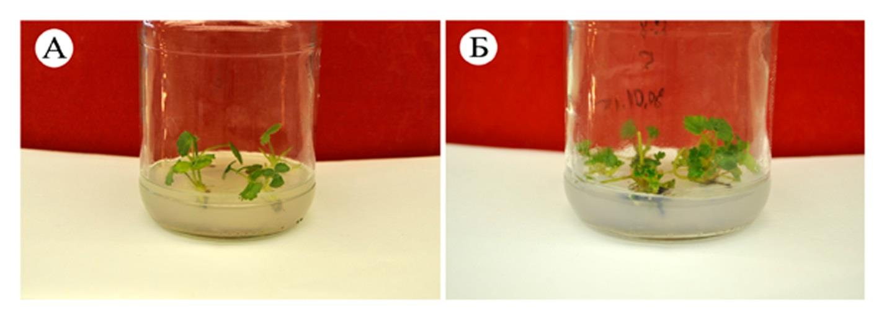
Рис. 1. The initial phase of morphogenesis shoots strawberry on medium MS + 1.0 mg / L BAP, 1.0 mg / l IMC, 0.1 mg / l hiberelova acid:
A - Alina clone C3, B - Alina clone C4.

This significant increase was observed explants and multiplication factor was: C3 - 4.9, C4 - 7.7. (Figure 2).

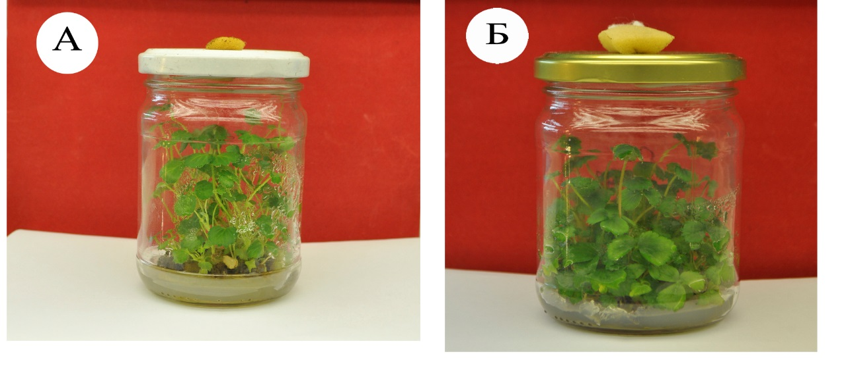
Рис. 2. This significant increase was observed explants and multiplication factor was: C3 - 4.9, C4 - 7.7. (Figure 2)..

It was found that with increasing concentrations of cytokines (B2: 1.0 mg / l BAP B3: 1.5 mg / l BAP) in explants clone C3 significantly reduced multiplication factor (2.8) in comparison with other variants environments. It should be noted that the plant propagation clone C3 happened more slowly in comparison to clone C4. For explants clone C4 minimum multiplication factor was in the version number 4 (0.5 mg / l BAP and 0.75 mg / l IMC) and made 3.7.
The third stage of our work was rooting process of plant-regenerants. By RG Butenko induction ryzonhenezu can call in several ways: the cultivation of shoots or plants regenerants in an environment with a small amount of auxin, breeding 2 times hormoneless mineral composition of the culture medium MS, wrap the bottom of the foil tubes or adding to the culture medium of activated carbon, given the inhibitory effect on root formation process of high intensity light [4]. In our studies were used to rhizogeny shoots with two or three trifoliate leaves that are cultivated in different variants of culture media (Table. 2).

- Effect of components of nutrient medium on induction rhizogeny plants regenerants strawberry.
breeding ground | Alina clone С3 |  | Alina clone С4
 | The formation of roots planted, % | The average length of roots mm | The formation of roots planted, % | The average length of roots, mm
MS | 30 | 28 ±0,2 | 42 | 34±0,2
½ MS + activated carbon | 90 | 76±0,5 | 98 | 94±0,5
½ MS + 0,5 ІМК | 70 | 45±0,2 | 85 | 52±0,2

The data (Table. 2) you can see that by using culture medium supplemented with activated charcoal, the highest percentage of root formation of regenerated plants accounted for 90% C3 clone to clone C4 - 98% of the length of roots under 76 ± 0 5 and 94 mm ± 0,5 mm. Somewhat lower results were obtained for the use of the medium ½ MS + 0,5 IMC. The percentage rhizogeny to clone C3 was 70%, for clone C4 - 85%. The lowest figures root environment characterized hormoneless MS: clone C3 - 30%, clone C4 - 42%. For cultivation on medium ½ MS with the addition of activated charcoal for 3-4 weeks formed roots and growing vegetative mass (Fig. 3). The resulting regenerated plant were suitable for further adaptation.
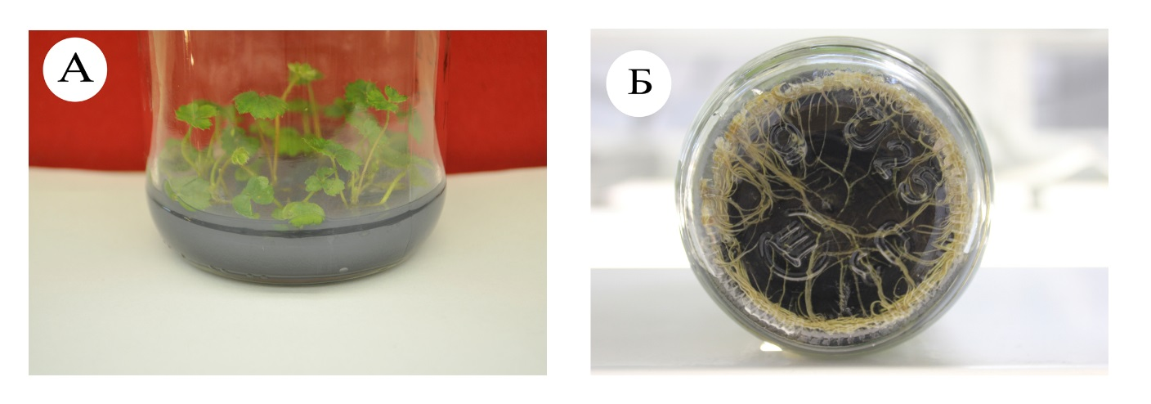
Fig. 3. root plants regenerants Alina class on medium ½ MS + activated carbon: A - Clone C3 B - Clone C4.

An important step in microclonal reproduction is the adaptation of plant-regenerants and planting them in the substrate. The substrate used was a mixture of peat and peat, perlite, sand in the ratio 3: 1: 1 (Table. 3.).

- Приживлюваність рослин регенерантів суниці садової в субстратах
Substrate | Number of plants planted, pc | Plant survival
 |  | pc. | %
Peat | 30 | 27 | 90±0,1
Peat: Perlite: Sand with 1: 1 | 30 | 28 | 93±0,3

For quality homogeneous material conducted sorting plants regenerants. Conducted shortening of the roots to 30-40 mm in order to prevent refraction roots and their subsequent decay. Landed on the substrate plants kept in a humid chamber for 10-14 days at a temperature of 25 ° C to lower humidity. During the period of adaptation carried out preventive treatment with fungicides of biological origin. After 4-5 weeks the plants formed 3-4 leaves and fibrous root system. The effectiveness of adaptation on both substrates was over 90%.
Conclusions. An optimized method and reproduction microclonal strawberry varieties Alina clones C3 and C4. As the sterilizing agent used 0.1% solution of mercuric chloride. Found that the optimal medium is MS + 1.0 mg / L BAP, 1.0 mg / l IMC, 0.1 mg / l hiberelova acid. Reproduction ratio - respectively 4.9 and 7.7 clone clone C3 and C4. The highest percentage was 90% rhizogeny - clone C3 and 94% - clone C4 to medium ½ MS + activated carbon. Adapting to conditions in vivo held in peat substrate and substrate using peat, perlite, sand in the ratio 3: 1: 1, the effectiveness of adaptation was over 90%.

Список літератури
- Murashige T. A revised medium for rapid growth and bio assays with tobacco tissue cultures / T. Murashige, F. Skoog // Physiol. Plantarum.–1962. –Vol. 15. – P. 473-497.
- Quak F. Plant cell tissue and organ culture 33 / F. Quak // Ed. J. Reinert J. R. S. Bajaj. Berlin etc.:Springer-Verlag. –1977.– P. 598-618.
- Samir C. Debnath, Strawberry culture in vitro. Applications in genetic transformation and biotechnology / Samir C. Debnath, Jaime A. Teixeira da Silva // Fruit, Vegetable and Cereal Science and Biotechnology. –2007. – P.1-12.
- Бутенко Р. Г. Биология клеток высших растений in vitro и биотехнологии на их основе. / Р. Г. Бутенко. – М.: ФБк – Пресс, 1999 – 259 с.
- Калинин Ф. Л. Методы культуры тканей в физиологии и биохимии растений / Ф. Л. Калинин, В. В. Сарнацкая, В. Е. Полищук. – К.: Наукова думка, 1980. – 488 с.
- Копылов В. И. Земляника: [Пособие] / В. И. Копылов – Симферополь: Поли ПРЕСС, 2007. – 368 с.
- Мельничук М. Д. Біотехнологія в агросфері. / М. Д. Мельничук,
О. Л. Кляченко // Навчальний посібник для студентів вищих навчальних закладів. – Київ, 2014. – 247 с.
- Мельничук М.Д Біотехнологія отримання високоякісного садивного матеріалу суниці (FRAGARIA ANANASSA DUCH.): науково-методичні рекомендації / А. А. Клюваденко, А. Ф. Ліханов, А. М. Силаєва,
М. М. Спірочкіна – Київ: 2014. – 56 с.
- Самойленко Н. А. Пути совершенствования промышленного возделывания земляники садовой в Северном Причерноморье : автореф. … дис. д-ра с.-х. наук : 06.01.07 / Самойленко Николай Александрович. –
М., 2003. – 23 с.
- Яновський Ю. П. Ягідництво: [Навч. посібник] / Ю. П. Яновський,
В. В. Воєводін, О. М. Лапа, Є. В. Чепернатий. – Київ, 2009. – 216 с.

Изучали возможность микроклонального размножения земляники садовой (Fragaria Ananassa Duch.) и влияние регуляторов роста на регенерационные способности микророзеток в условиях in vitro. Установлено, что наибольший коэффициент размножения для клонов С3 и С4 сорта Алина составил 4,9 и 7,7 соответственно при выращивании на среде MS с добавлением 1,0 мг/л БАП, 1,0 мг/л ИМК, 0,1 мг/л гибберелловой кислоты.
Fragaria Ananassa Duch, микроклональное размножение, in vitro

* Supervisor Doctor of Biological Sciences, prof., Academician of NAAS of Ukraine Dr. M. Melnychuk.

