336.741.236.2:336.711
Regulation of money the National Bank of Ukraine
I.О. Kolomiets, student, "Finance and Credit"
Supervisor: L.A. Avramchuk, assistant professor of finance and credit

The methods of regulating the money supply in Ukraine using NBU in its policy approaches to its analysis and development of necessary software for managing it.
Key words: bank, money supply, banking regulation, the rate of money supply.
Cumulative cash flow provided by certain mass of money, the value of which is important for the central bank and monetary economy
Changing the volume of money circulating in the economic system, can significantly affect real output product prices, employment and so on.
Money supply - the total amount of money balances in all its forms, which are available to economic agents at a time.
Since control of the amount of money is very important for economic stability, you must have adequate capacity to measure the money supply. In the developed market economy determine the amount of money - a daunting task. This is because in today's economy different kinds of assets simultaneously to some extent perform all the basic functions of money (medium of exchange, measure of value, a means of accumulation).
Analysis of recent research and publications. The problems of regulating the money supply are investigated leading Ukrainian scientists and economists as A. Wasylyk, A. Halchynskiy, V. Geets, V. Lagutin, V. Lissitzky, IA February, Vladimir Mishchenko, A. Frost, P. Nikiforov, A. Peresada, M. Puhovkina, M. Savluk, W. Stelmach, A. Chukhno, and other.
Whereas the development of scientific and based on the latest statistics there is a need to define the current problems regulating the money supply National Bank, and the creation of new approaches to its analysis.
The monetary system of Ukraine at the present stage of development is in its infancy and the transition to a developed money market-type structures. In the future cash flow management system meeting international standards and requirements. It is clear that the regulation of the money supply should be based on a combination of market and administrative regulations in different ratios depending on specific conditions. Therefore, the current state of monetary relations in Ukraine requires new approaches to the analysis of money and develop the necessary software for its management.
Objective: to analyze the methods of the NBU, the money supply in the country and suggest areas to improve it.
The main material. Money serve the needs of the economy, mediating the flow of goods and incomes in the areas of production, distribution, exchange and consumption of national products. Serving the needs of the economy with money needs to quantify their mass and structure in turn meet the needs of the economy. Therefore, the circulation of money in all its sectors has provided a certain amount of money - money supply. The size of this magnitude is an important characteristic of the monetary and market economy status.
Banking regulation is one of the functions of the National Bank of Ukraine is to create a system of rules governing the activities of banks, establishing the procedure for banking supervision.
According to Article 25 of the Law of Ukraine "On the National Bank of Ukraine" major economic means and methods of monetary policy is to regulate the money supply through:
- the definition and regulation of required reserves for commercial banks;
- The interest rate policy;
- the refinancing of commercial banks;
- management of foreign exchange reserves;
- issue its own debt. [2]
Until the money supply includes all cash, which are in the hands of individuals and legal entities cash balances , all deposit money. Some economists and central banks to money supply include any assets that are specific to liquidity - bonds, bills, insurance policies , because they can change money in the operation of monetary circulation.
Broad money belongs to individuals , businesses , community organizations, government agencies that administer cash money or hold deposits in various accounts of commercial banks.
The regulation of the money supply by the Central bank of issue the following methods:
1. open market operations ;
2. setting the discount interest rate;
3. changing the mandatory reserve requirements.
Implementing monetary policy, the National Bank sets targets for the regulation of the money supply based on the selection of certain monetary aggregates. Commercial banks operate within that money supply is determined by the National Bank . Today, the search for new specific mechanisms to regulate the money supply is very important in Ukraine . Thus, the NBU is a priority :
1. reducing the rate of dollarization ,
2. increasing and effective use of available reserves,
3. ensuring the stability of the national currency.
After completing these tasks NBU will provide an opportunity to serve the process of economic development.
Over the analyzed period (2002 to 2012), the money supply is growing, but since mid-2008, there has been a trend towards reduction.
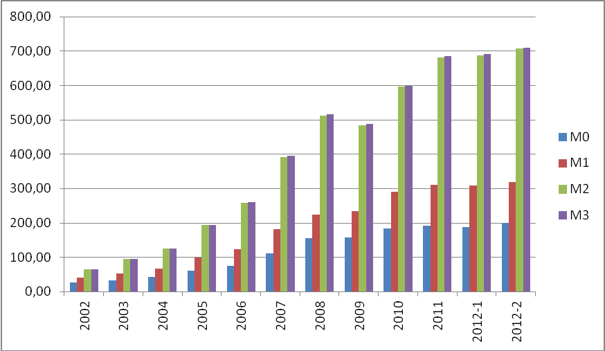
Figure 1 The current money supply in circulation in Ukraine for the period 2002-2012 [http://zavantag.com/docs/1641/index-2430066.html]
Money supply for the first quarter of 2013 increased by 3.6% - to 800.9 billion. Money supply growth was due to an increase in deposits in the national currency (5.6% or 29.3 billion. - Up to 554.1 bln.), Reflecting improved market expectations and increase confidence in the national currency of Ukraine . The currency component of the money supply during this period decreased by 0.6%, or 1.6 billion. - Up to 246.8 billion. The cash portion of money for the first quarter of 2013 increased by 1.4% - to 206.1 billion. The share of cash in the money supply during this period decreased from 26.3% to 25.7%. Analyzing the first half of 2011 and 2012, in 2013, we see that the money supply has a positive upward trend. This was mainly due to the increase of deposits in national and foreign currencies. The problem of sub-optimal structure of money supply (a large proportion of cash) is the result not only of no confidence in the banking sector as an unreliable financial intermediary and undeveloped mass of non-cash payments, and the availability and expansion of the shadow economy. And it is not surprising that the existence of this problem has led to an increase in financial transactions conducted outside the banking system and, consequently, the complexity of the taxation process, control of monetary aggregates, the slowdown in money multiplier, reducing the effectiveness of monetary policy.
Conclusions.
Money supply is one of the most important factors of financial stability, has a deep connection with all the economic and social
processes and holds a special place in the national economy.
Index of money is essential for economic stability, since a change in the quantity of money circulating in the economic turn, could materially affect the main macroeconomic indicators. Money supply in Ukraine is gradually increased, this is due to a gradual increase in production and an increase in the money supply in an economy that is growing.
To the direction of improving the regulation of the money supply include:
- The amount of money necessary to coordinate the physical volume of GDP, its cost structure and prices. It is advisable to determine the approximate size of the money supply by 2-3 years due to the forecast of GDP, prices, and evaluation assets.
- Recognizing the special importance of monetary aggregates, it is necessary to expand the composition of the money supply, including her government securities. It should also take into account the volume of the equities market and its impact on monetary aggregates.
- Based on the experience of the banking system must coordinate the functions of the National Bank and accordingly adjust its organizational structure.
References:
1. Ivasiv BS Money and Credit [Text]: a tutorial / BS Ivasiv. - Ed. 3rd, rev. and add. - Ternopol: Carte blanche, K.: Condor, 2008. - 528 p. - ISBN 966-7952-37-1
2. Ryabinina LM Role of the NBU and the laws of Ukraine in its economic Development / L.M.Ryabinina / / Business & state, 2004, № 8. - P. 29-37.
3. Savluk, MI Money and credit: a textbook / MI Savluk, A. Frost, MF Puhovkina et al., According Society. eds. MI Savluk. - 3rd ed., Revised. and add. - K.: MBK, 2002. - 598 p. - ISBN 966-574-369-4.
4. Statistical Materials of the National Bank of Ukraine - Statistical Bulletin (electronic edition) [electronic resource] - Access mode: http://www.bank.gov.ua/Statist/Electronic% 20bulletin/data/stat.pdf.
Регулювання грошової маси Національним банком України
І.О. Коломієць, студентка, напрям підготовки «фінанси і кредит»
Науковий керівник:Л.А.Аврамчук, доцент кафедри фінансів і кредиту.
Досліджено методи регулювання грошової маси в Україні, що використовує НБУ у своїй політиці, підходи до її аналізу і розробки необхідного забезпечення щодо управління нею.
Ключові слова: Банк, грошова маса, банківське регулювання, показник грошової маси.
Регулирования денежной массы Национальным банком Украины
И.А. Коломиец, студентка, специальность «финансы и кредит»
Научный руководитель:Л.А.Аврамчук, доцент кафедры финансов и кредита.
Исследованы методы регулирования денежной массы в Украине, использующий НБУ в своей политике, подходы к ее анализу и разработке необходимого обеспечения по управлению ею.
Ключевые слова: Банк, денежная масса, банковское регулирование, показатель денежной массы.

