PROSPECTS OF CREDIT UNIONS IN THE UKRAINE'S FINANCIAL SERVICES MARKET
I considered the dynamics of the development of the credit unions, found the prospects for their activities in the financial services market in Ukraine and suggested areas for further development.
Keywords: credit unions, credit cooperatives, financial services market, non-bank financial intermediation, banks, credit
Statement of the problem. Developed market economy involves the functioning of many markets, including the financial services market. One of the participants in the financial services market is a savings and credit cooperatives - credit unions, which are the youngest depository financial institutions. Credit unions have become those financial institutions that make it possible to get financial services to individuals who have little income and no higher standard of living, small entrepreneurs and agricultural producers who can't any other way to meet their financial needs. So the problem the functioning and development of credit unions is an important part of the financial mechanism and it has particular relevance in a market economy.
Analysis of recent publications. Today the study of problems of credit unions engaged in more Ukrainian scientists who analyzed the nature and regularities of credit cooperatives in the country, working with serious scientific research. Various aspects of scientific developments on the operation of credit unions dedicated work of domestic scientists as Alimen M. Bekeshkina I. Vinogradov, V. Goncharenko, Dzyubyka S. Dragomiretskaya I. Zinovchuk V. Zlupko S., A. Kuzmin , Marochko V. Morozov A. Olenchyk, Panteleymonenka A., J. Przyszlak, Yakymenko M. and others. Significant contribution to the study of problems of credit-cooperative movement in Ukraine were also made such scientists and practitioners of Ukrainian diaspora as Balyuh M. Begun, R., A. Kaczor, Morhun O. Pleshkevych O. Salenko A. and others.
However, the problems of the modern development of credit unions at the micro level have not yet found enough reflection of the economic scientific thought. At this time, are still unresolved issues of a solid foundation for the establishment and future development of credit unions in Ukraine, the problem of improving state regulation of unions, the problem of default contributions and ensure the solvency and liquidity of credit unions.
The purpose of the article is to analyze the development of credit unions and determine the prospects of their activities in Ukraine.
The main material. It is known that the main objective of credit unions is financial and social protection of its members by bringing their personal savings for mutual lending, financial support to business initiatives and providing other financial services.
Financial activities of the credit union makes it similar to other financial market participants - banks. Between these institutions there is a lot in common as well as excellent. Common is that both banks and credit unions in the market act as financial intermediaries created to meet consumer needs for financial resources. They have the ability to accumulate funds from those who currently have their surplus and those who feel they have an urgent need. The fundamental difference between these structures is the purpose of each of them: making a profit for the bank and the provision of financial services to credit unions. Abroad credit unions in its development is more close to the banks, but the main difference remains: they serve only their members.
Lending by credit unions has its advantages. First, the credit union as opposed to a bank is quite open structure, and works on a voluntary basis. Each member union has legitimate reason to monitor the activities of the association. Second, there is the opportunity to work out a positive credit history outside the bank. Third, if a credit union charter liberal, you can get a loan even without collateral. Money can be obtained within days or hours.
In Ukraine, the first savings and borrowing institution founded in 1871 in the village Sokyryntsi Priluky district, Poltava province. In the early twentieth century in Ukraine were about 3,500 credit cooperatives of various types. Credit cooperatives occupied key positions in lending mainly farmers and operate in a single sector with agricultural and consumer cooperatives.
In independent Ukraine first credit union resumed its activities in 1992 in the city of Krivoy Rog and Stry. Restoring Credit Union was the support of the Ukrainian diaspora and the governments of Canada and the United States. 90 years of the twentieth century were characterized by the establishment of a large number of credit unions, but hyperinflation 1993-1994 and " currency " crisis of 1998 led to the closure of many unions. In 2004 was held re solid and licensing of credit unions. To date, there has nominally 1.5 thousand unions , of which only 500 re gone .
As of 30.09.2013 in the State Register of financial institutions accounted for 628 credit unions. The dynamics of credit unions during the analyzed period (2007 - 9 months. 2013) is given in Table 1.
Table 1. Dynamics of credit unions in Ukraine
Indicators | 2007 | 2008 | 2009 | 2010 | 2011 | 2012 | 9 months2013 | Темпи приросту, %
The number of registered credit unions | 800 | 829 | 755 | 659 | 613 | 617 | 628 | -21,5
Number of members CU (thousands) | 2 391,6 | 2 669,4 | 2 190,3 | 1 570,3 | 1 062,4 | 1 095,9 | 978,7 | -59,1
Total assets (million UAH) | 5 261,0 | 6 064,9 | 4 218,0 | 3 432,2 | 2 386,5 | 2 656,9 | 2 807,2 | -46,6
Loans to members of CU (million UAH) | 4 512,3 | 5 572,8 | 3 909,1 | 3 349,5 | 2 237,4 | 2 531,0 | 2 621,7 | -41,9
Contributions of members to deposit accounts (million UAH) | 3 451,3 | 3 951,1 | 2 959,3 | 1 945,0 | 1 185,5 | 1 287,5 | 1 363,3 | -60,5
Capital (million UAH) | 1 552,0 | 1 714,0 | 765,8 | 1 117,3 | 942,9 | 1088,7 | 1 169,2 | -24,7
The number of credit unions since 2007 began to decline and at the end of 2011 compared to the same period in 2007 decreased by 187 units, or 23.4%. First of all, this is due to a significant deterioration of the financial situation of the credit union, lower indicators of solvency and liquidity.
The market segment of the credit institutions at credit cooperatives continued to deteriorate: key performance and further significantly reduced. The results of the credit unions over the period testified as to reduce the number of credit unions and the number of credit union members and the slowdown of economic activity and a significant decrease in the growth rate of their activities. However, unlike banks , credit unions almost never stopped lending , despite the difficult conditions of the activity.
However, since 2012 we can traced recovery of credit unions, building key performance indicators. And as of 30.09.13 the number of unions increased by 15 units. The rate of increase in the number of credit institutions due to the growth of public confidence in the sector of the financial market and the availability of obtaining loans from credit unions due to their specific advantages over bank loans.
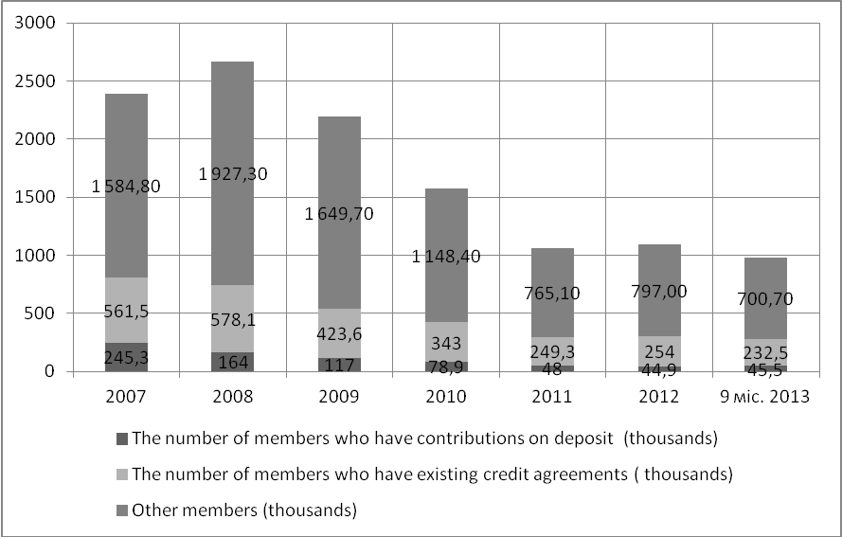
Figure 1. Changes in the number of credit union members in 2007 - 9 months 2013
Proportion of members who have deposits on changed almost doubled to 30.09.13 is 4.6% (45.5 million people ), compared with 10.2 % ( 245.3 thousand) in 2007. Proportion of members who have loans over the period remained almost unchanged and the average is 22.4 %. Ratio of members who are not contributors , in 2007 - 9 months 2013 was 71-72 %, it is not significantly changed and remains significant. However, these members have a crucial votes and direct influence on decision -making credit unions.
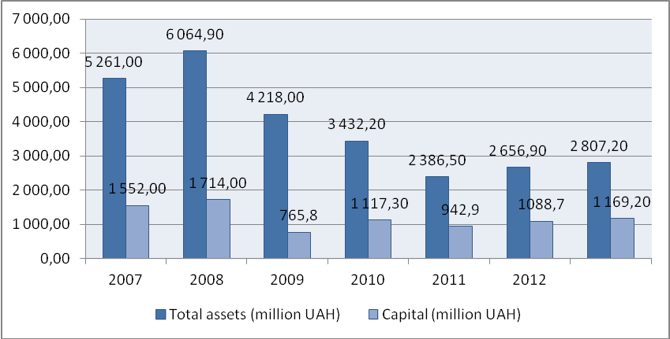
Figure 2. Dynamics of main indicators of credit unions in 2007 - 9 months 2013
The whole system of credit unions in Ukraine since 2009 showed a decrease in performance compared to previous periods , but in 2012 began a gradual increase.
The highest values ​​of observed in 2008. The total assets of credit unions in 2008 increased by 15.3% and stood at the end of year 6 064.9 mln. , 5 of which 550.2 million., or 91.5% - is productive and the remaining 85 % (514.7 mln.) - unproductive assets. The total amount of capital credit unions increased during the year by 10.4% as at 31 December 2008 amounted to 1 714 million. The largest share of its stock was equity capital (1 204.8 million).
The total assets of credit unions as of 30.09.2013 is 2 807.2 million. , which is 46.6 % less than in 2007. The total amount of capital credit unions as of 30.09.2013 is 1 169.2 million and compared to 2007 decreased by 24.7%. Total capital is formed by:
- Shares of credit union members - 60.3% (705.5 million)
- Reserve capital - 35.5% (415.0 million.)
- Additional capital - 4.4% (51.3 million).
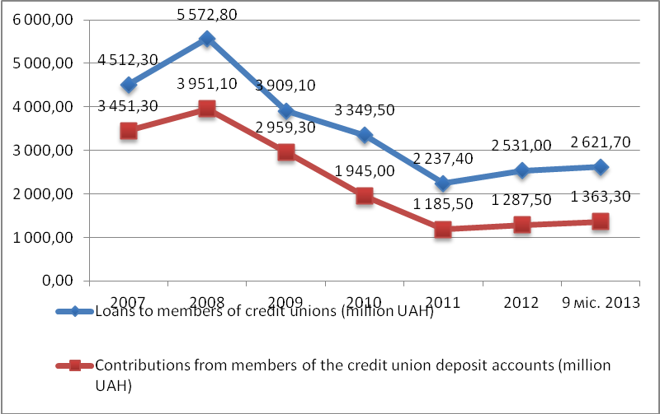
Figure 3. Dynamics of credit and to attract contributions from members of credit unions in 2007 - 9 months 2013
In general, credit unions lending its members increased every year. However, in 2009, 65% of the volume of credit operations declined compared to 2008 , and the balance of loans to members of credit unions at the end of the period - by 30%.
Panic among depositors of credit unions in the financial crisis led to a massive outflow of deposits: for the period 2008-2009, the number of contributors has decreased by 52.3% from 245.3 to 117 thousand people, while the number of borrowers fell by 24.6% from 561.5 to 423.6 thousand. , resulting in an imbalance of loan and deposit portfolios.
Involvement of contributions (deposits) to deposit accounts by credit unions continued in 2009 due to the significant excess rate of return of deposits higher interest rates) compared with banks. In 2009, the average rate was %:
on deposits on loans
in the banking sector 12.8% 17.8%
in credit unions 25% 36.4%
Brought to resources such conditions by decision of the credit union used in speculative transactions that occurred primarily on real estate and land, which was one of the main causes of the crisis in the system of credit cooperatives .
As of 30.09.2013 on deposits of credit union members accounted deposits totaling 1 363.3 million exceeding the respective period of 2012 to 6.0%. Average amount of contributions on deposit accounts is 30 thousand (as of 30.09.2012 - 28,5 thous. , as of 30.09.2011 - 24.8 thous. ).
The growth of deposits (contributions) of the credit union to deposit accounts in general and per credit union member indicates a growing public confidence in credit unions as depository institutions . Loans to members of credit unions also increased by 1.5% 39.8 million) compared to last year and is 2 621,7 million.
Activities of credit unions in financial services has shown that credit unions are actively developing dynamically increasing the field of membership, annual increase assets, capital, loan portfolio, providing loans and small business population and their future non-bank financial intermediaries.
The conclusions and recommendations for further research. Thus, the purpose of the credit unions are not for profit , and providing various financial services only to their members , who are both the owners and the customers, because the credit union manages to combine the interests of owners and customers. The credit union is both a form of mutual aid citizens and their non-governmental organization that provides a variety of collective funds used for public purposes , and the financial institution that can provide its members with almost full range of banking services. Credit unions are relevant for today, they are a good alternative to banks, since their development in financial services is necessary.
Prospects for the development of credit unions in Ukraine:
- Comprehensive market coverage in rural areas with deep penetration of financial services to all categories of people in rural areas (social lending, consumer credit, credit for the development of private farms, the implementation of local energy efficiency programs, the development of eco-tourism and support for land reform, etc.);
- Loans for small business and farmers who are not a priority for customers of banks and other types of credit institutions;
- Functional integration with local communities, other types of cooperatives, various forms of economic or social self-organization of population, trade unions, labor groups, educational institutions and others.

Areas for further development of credit cooperatives in Ukraine:
- To ensure the stability of credit unions and their compliance with the rules of civilized behavior in the market due to the reform of state regulation and supervision of credit unions and the development of compulsory participation of self-regulation;
- The establishment of national deposit guarantee system of credit union members similar to the system that exists today for depositors;
- The establishment of centralized financial resources to maintain short-term liquidity and conducting medium rehabilitation credit unions, especially in the context of systemic financial crises.
List of references:
- Брусковська К. І. Стан та особливості розвитку кредитних спілок України// Режим доступу http://archive.nbuv.gov.ua/portal/natural/nvvnu/ ekonomika/2008_7/2/Bryskovska.pdf
- Закон України «Про кредитні спілки» від 20.12.2001 № 2908-III // Режим доступу http://zakon2.rada.gov.ua/laws/show/2908-14
- Оленчик А.Я. Значення кредитних спілок у фінансовому оздоровленні української економіки в посткризовий період: Презентація доповіді президента об’єднання кредитних спілок «Програма захисту вкладів», 21 травня 2012 року // Режим доступу http://vaks.org.ua
- Офіційний сайт Державної комісії з регулювання ринків фінансових послуг України // Режим доступу www.dfp.gov.ua
- Терещенко Г.М. Перспективи розвитку кредитних спілок в Україні // Фінанси України. – 2009. - №5

