Trends of development of grain market in Ukraine
Chebotar S., Prof.
Balatska M., stud.
National University of Life and Environmental Sciences of Ukraine
Resume: A marketing research on potential grain production in the context of achieving food security in Ukraine has been conducted. The grade of current state of the grain market of Ukraine has been determined and its main development trends. The ways of the grain’s sector development in Ukraine have been offered for achieve the highest yield and profitability of agricultural enterprises.
Key words: competitiveness, profitability, food safety, agricultural business, marketing tools.
Introduction. The current stage of development of the grain market of Ukraine is characterized by increasing competition among entrepreneurs in the region, the country and internationally. In such conditions the key to success is the market orientation of agri-food products based on marketing. From this perspective, the relevance of the work is to investigate and assess the current state of the grain market of Ukraine and identifying its key trends in 2008-2012. It do not only allows for entrepreneurs be knowledgeable enough in the field of agriculture, but also rely on measures designed to improve the efficiency of production and marketing of grain.
Analysis of recent research and publications. Problem dynamics and development of the grain market of Ukraine boasts versatility of its constituent aspects and multi-character. Evidence of these are scientific publications V. Andrijchuka, P. Sabluk, A. Bilyk, V.Halushko and more. Proceedings of the researchers allowed summarize theoretical, methodological and applied principles of formation and development of the agri-food market of Ukraine. However, in today's economic development trends in the grain market of Ukraine quickly changed as necessitated this study.
The aim of the study is to analyze the current state of economic activity on the production of grain farms in Ukraine and determination of grain crops, taking into account the need to ensure food security.
The main material of the study. The economic crisis of recent years greatly excelled in almost all sectors in Ukraine than agribusiness. Ukraine has large areas of arable farmland with high fertile properties, which cover more than half of the country. Scope of Agribusiness covers three quarters of the territory of Ukraine, which is home to one-third of the population and generates nearly 60% of the consumption fund , producing 17% of GDP [3 , p. 22-24 ]. Clarification of the nature and problems of economic security has added even more weight this problem . Therefore, government regulation is one of the most important factors in the development of agribusiness in Ukraine . Despite it had declared a few years ago the transition to an innovative way of development, business activity remains low. Lack of progress in the development and implementation of new technologies prevented improve industrial competitiveness, to some extent led to profound structural crisis and the drop in agricultural production. The degree of wear of fixed assets exceeded 60 %, transport - 84 %, which is a major factor in the depressed state of the economy. [6] Agriculture is one of the most promising activities in Ukraine , with except of the high risks of agribusiness. The basis of crop industries Ukraine formed crops , crops which in 2010 occupied 57 % of the total cultivated area of the country [ 3, p. 22-24 ]. In recent years, the average volume of grain production in Ukraine reached 50 million tons, which in value is about 80 billion.
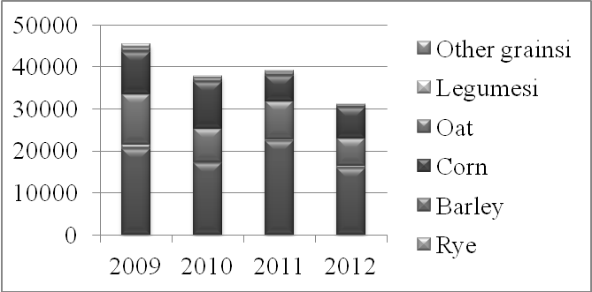
Figure . 1. The gross yield of grain crops in Ukraine in 2009-2012.
Source: Statistical Yearbook of Ukraine for 2009-2012 years data of the State Statistics Service of Ukraine [5].
The volume of grain development was a record year for Ukraine in 2011. In particular, they collected 56.7 million tonnes , which is significantly higher than in previous years. First of all, such a high rate for the production of cereals has been achieved by increasing corn production to 22.8 million tonnes, which is almost two times more than in 2010. From the above graph ( Figure 1 ) shows that wheat production reached 22.3 million tonnes , which is also higher than the average of previous years. Growing barley decreased due to the decrease in the area , due to the low yield of this crop . Each year, Ukraine's domestic market consumes about 26 million tonnes of grain: 12 million tonnes - wheat , 6 million tonnes - of barley , 6 million tonnes - corn and 2 million tonnes - of other cereals. Therefore, emerging export potential , which reaches 25 million tonnes [ 4, p. 52-54 ]. Despite a record harvest of grain in the 2011/2012 marketing years, to fully realize the export potential in that period failed because the existing export duties significantly affected the rate of shipment of the products at the beginning of the season. Agriculture, including crop production are raw materials for the industry, which in turn provide people with food . Among the areas of agriculture crops is the leader in over -breeding, and in turn has a higher rate of return that varies in the range of 10-30%. The main factors of competitiveness plant in Ukraine is fertile soils, temperate continental climate, low wages, the availability of commercial sea ports. Considering the efficiency of cultivation of certain agricultural crops, we can say that Ukraine increased production of grains and oilseeds, and holds leading positions in the list of major exporters of grain, rapeseed, sunflower oil and sunflower seeds (Fig. 2).
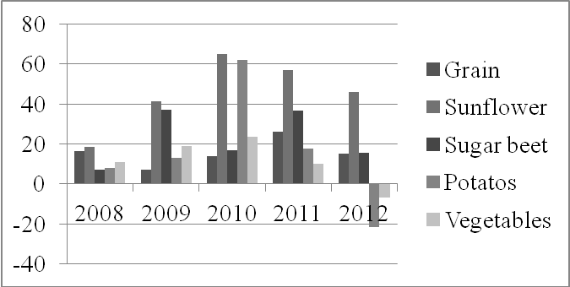
Fig.2. Profitability crop production in agricultural enterprises of Ukraine ,%
Source: Statistical Yearbook of Ukraine for 2008-2012 data of the State Statistics Service of Ukraine [5].
Analyzing the profitability of crop production, we need to note that the record levels of profitability in recent years demonstrates the sunflower. Profitability of rape are also quite high and more stable compared to it. The profitability of grain somewhat lower than oil, but the average profitability of grain is sufficient to stimulate an increase in their production. Research economists farmers agree that in Ukraine there are a significant increase in productivity in the production of grain. In particular, the yield of corn in the last seven years has increased by an average of 3.2 kg / ha ( or 7% ) [4 , p. 52-54 ]. This is primarily due to the widespread use of high performance hybrids , improving fertilizer and improved weed control . For wheat and barley productivity growth was lower - about 3 % annually. Recently, the somewhat increased the total capacity of the grain market by increasing external use , but this trend is unclear . In general, low power grain market countries indicates shortage of domestic consumption, exports and attract the necessary financial resources in order to improve productivity and increase gross fees. Relatively low population of Ukraine and the present tendency to reduce it limits the amount of domestic consumption of grain for food and depriving farmers of economic stimulus increase production. The current development of domestic agricultural markets of Ukraine depends on many factors that determine its potential capacity , based on rational norms nutrition. According to scientists, the capacity of the domestic agricultural markets in 2009 is estimated to be within 302-303 billion, and potentially limit its capacity could reach 450-460 billion [3]. The limited capacity of the domestic market due primarily to the low purchasing power of the population and high costs domestic agricultural production, which is the root cause of the existing imbalances in the structure of certain types of agri-food products , the price disproportions of considerable social problems in rural areas , etc. .. Ways of solving these problems may be more active use of marketing tools on both domestic and foreign markets. Elements of marketing activities, which are useful in the grain sector is market research, identification of strategies as grain production , marketing pricing, sales management based marketing . This market research is both a channel of communication between businesses and the agricultural environment of the market.
Conclusions and recommendations for further research. So, for the development of the grain sector of the country and ensure its competitiveness to increase the volume of grain exports that do not depend on the population . Analysis of balances of grains indicates that the amount of grain fully satisfy the needs of the domestic market of Ukraine. During the last ten years the domestic demand for grains needed about 75 % of total production, with the exception of a very lean 2003 , when domestic production was unable to meet the needs of the country in the grain . After these events Ukraine gradually embarked on an export- oriented country and of 2005 - 2006 exported almost 33% of all grain produced . Neither of significant changes in the balance of food grains during the 2008-2012 period happened , except for increasing the share of foreign consumption. In 2008 Ukraine put into foreign markets record amount of grain that allowed her to enter the world's three largest grain exporter after the United States and the European Union's global market share in excess of 10%. The greatest demand in foreign markets was Ukrainian wheat export supply of which 12.6 million tons were in second place - barley (6.3 million tons ), the third - corn (5.5 million tons). Market research in the agricultural sector is the channel of communication between businesses and the agricultural environment of the market. In this aspect of marketing research presented research activities aimed at meeting the information and analytical needs of the agricultural marketing.
REFERENCES
- Sabluk P. – Sabluk P.: The problems of profitability of agricultural production in Ukraine in the post-industrial period: Economy APC,2008. – № 4 - p.19-37
- Analysis and strategy of agricultural market [electronic resource]: according to the monthly analytical publication ODA-Ukraine, February 2012. - Access to the magazine: http://oda-ukraine.com.ua/
- Doing Agribusiness in Ukraine periodical Association Ukrainian Agribusiness Club. - 2011. - 64 p.
- Doing Agribusiness in Ukraine periodical Association Ukrainian Agribusiness Club. - 2012. - 81 p.
- Production of major crops [electronic resource]: According to the State Statistics Service UkrayinyDerzhavna Statistics Service of Ukraine 2008-2012. - Mode of access: http://www.ukrstat.gov.ua/
- Report of the First Vice Prime Minister of Ukraine - Minister of Economic Development and Trade of Ukraine Andriy Klyuyev at a meeting of the Cabinet of Ministers of February 2, 2011

