UDC 330.131.5:631.11
THE THEORETICAL ASPECTS OF BUSINESS EFFICIENCY IN AGRICULTURAL FORMATIONS
Datsenko I.M., PhD student NULES of Ukraine
Abstract. The paper describes the main types of efficiency and made generalization of their characteristics in transformation economy.
Keywords: efficiency, entrepreneurship, agricultural formation, transformation economy.

Statement of the problem. The transformation of economic relations in society, the development of a market economy requires clarification of methodological approaches in determining the economic, social and environmental performance.
Analysis of recent research and publications. Outlined aspects of the economic efficiency of enterprises are reflected in the works of local and foreign authors. In particular, this authors: V.H. Andriychuk, I.V. Bakum, V.I. Zaharchenko, M.M. Ilchuk, A.I. Makarenko, H.A. Ohanyan, A.M. Turyl, V.I. Homyakov, etc.
The purpose of the study - to summarize the theoretical aspects of the formation efficiency in enterprises at the way of transformation economy.
The main material. The concept of efficiency is an important issue in economic theory and practice. As you know, distinguish industrial, social, technical, economic and environmental efficiency. Technical efficiency determines the effectiveness of actions aimed at improving engineering and technology, social - to improve working conditions and psychological climate in the workplace, etc., cost - to improve the profitability of the whole business, industrial - to minimize costs and maximize profits, environmental - reflects compliance costs and environmental outcomes interests of the state and society.
________________________________________________________________
Supervisor:
Doctor of Economics,
Professor of business economics NULES of Ukraine Ilchuk MM
Efficiency - is an economic category that reflects the relationship between the obtained results and wasted resources to achieve them, and the measurement of efficiency resources can be represented either in a certain amount of their historical (revalued) cost (resources used), or part of their value in the form of production costs. If to take into account the results of production are not only diverse, but also can be presented in different forms: cost, natural, social, it becomes apparent need to identify categories of performance according to those aspects of the enterprise that are important to analyze and evaluate. Given the specificity of agricultural production, it is advisable to distinguish between these types of performance: industrial, technological, economic, environmental and social.
All types of efficiency are closely interrelated, interdependent and together determine the efficiency of the economic system as a whole (Fig.1.1.).

Figure. 1.1. The main components forming the overall efficiency of agricultural units (Source: own study)
The economy of the modern period is the improvement of existing socio- economic relations. In the system of these relations is always operating companies with different levels of economic development. Objective laws of market economy forced them to continually find effective forms and methods of farming.
Production efficiency - is a complex and multifaceted phenomenon. Agriculture requires organic combination and interaction of four factors - labor, plant and equipment, household labor and land. In the process of production is consumption of these resources in order to get some use value, able to satisfy the needs of the people. Therefore, any production involves consumption of resources and to obtain the certain results. But the same amount of resources spent businesses can not get the same results in magnitude. In this case, we can assume that companies are producing with varying efficiency. In general, this process can display the following scheme (Fig. 1.2).
Advanced capital
Production
Results of manufacturing

Efficiency of production

Figure. 1.2. Formation of efficiency (Source: own study)
Technological efficiency – it’s a result of the interaction of factors of production that characterizes the achieved performance of live organisms used in agriculture as a means of production. In terms of technological efficiency of crop yields is a unit of cultivated area and the main quality parameters of crop production (sugar content in sugar beet, oil - in sunflower seeds, protein - in the grain, etc.). According to the result of the gross production tax is levied certain type of product, and this result is compared with the resource - acreage crops. To account for the quality of products, we can determine the biological output of sugar, oil, protein, etc. per hectare cultivated area by multiplying the yields per hectare corresponding to the percentage of organic matter (coefficient).
The effectiveness of the company analyzed the following indicators: income, profit margins, profitability, and utilization of human resources (labor productivity), fixed assets (capital productivity, capital intensity), material resources and others.
The achieved level of technological efficiency significantly affects economic efficiency, mainly due to the existence of fixed costs, which are known producers in the short term is not impact. It is also important that the rate of technological efficiency and reflect the characteristics of agriculture -related operation in the field of the main means of production - land and living organisms as a means of production. They make it possible to carry out a comparative assessment of the impact of the dynamics in the territorial aspect of the individual businesses and regions.
Economic efficiency - it is a relationship between resources and results of production, which are cost parameters efficiency. Thus, there are three options specified value: 1) the resources and the results are expressed in financial form, 2) resources - in terms of value and results - in kind, 3) resources - in kind, and the results - in financial form. Measuring system of economic efficiency of agricultural production should be built so that it was able to fully reveal two interrelated and complementary aspects of the productive farms - rational use of their land through indicators of general effect, reduced to unit area of agricultural land, and cost of production figures which would disclose what the price obtained this effect. Considering the above to assess the effectiveness of agricultural enterprises should be widely used indicators of the efficiency of capital advanced, indicators of production costs and labor productivity, capital assets.
However, a full assessment of the efficiency of production and its in-depth analysis must also widely used traditional indicators of profitability. They accumulated impact of all factors - natural, economic, organizational and economic. However, they significantly affect the action of the environment, especially those parts of it to which farmers have any effect.
The importance of the profitability for the evaluation and analysis of economic efficiency requires them special consideration.
Social performance - a concept that reflects the improvement of social conditions of life (improving working and living conditions , increased employment, security of life and human labor, etc.). Social efficiency is, in fact, derives from economic efficiency. It is under the same other conditions will be the higher, the higher level of economic efficiency achieved.
Social performance can not always be quantified. However, a thoroughly social efficiency achieved can be measured by such indicators as defined in the dynamics, the share of profit aimed at social events, with a total weight of net profit, the value of profit per average employee company.
Environmental performance - displays various indicators of intermediate and final results of the company (in a business combination). These indicators include volume commodity, clean or sales, the value of profit, saving certain types of inputs or the total savings from reducing production costs and so on.
Environmental effectiveness associated with the use of the resource potential of the industry that does not harm the environment and produces environmentally friendly products. Equally important is to ensure the environmental effectiveness of economic reproduction of soil fertility, increased content in the humus. All types of efficiency should be considered not in isolation but in close connection and interdependence.
However, in a market economy, where the foreground is the economic social and environmental performance must be paid no less attention. Thus, effective from an economic standpoint entity can is ineffective in social or environmental point of view.
Today for cost recovery and profit for the continuation or expansion not only of price regulation that would provide these results. As in the highly competitive even a slight excess of the price of the products the company over the price of a similar product quality competition may lead to loss of customers and market share. Therefore, it is important to note that producing, the company should predict that net income it will receive from the sale of products and then balance the costs of the, so they do not exceed the income.
In Ukraine, the priority of the overall performance is considered productive efficiency. To determine the complex index of efficiency of management of enterprise (E_{yv}) recommended the formula payback.
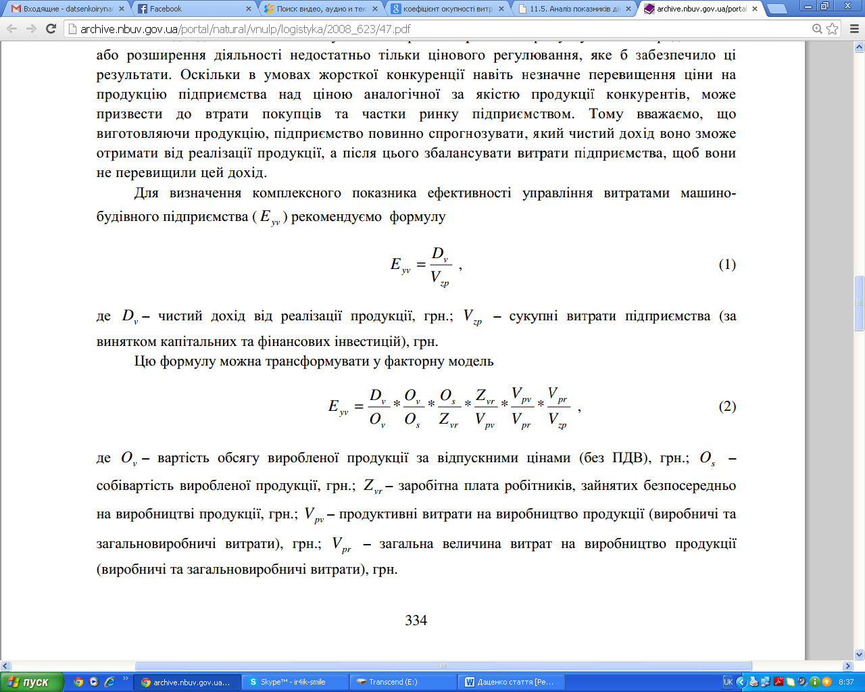(1)
where D_{v}- net income from sales, hr.; V_{zp} - total costs of the company (excluding capital and financial investments), USD.
This formula can be transformed into a factor model:
(2)
where O_{v}- value of output at ex-factory prices (excluding VAT ), € .; O_{s} - the cost of production , hr .; Z_{vr} - wages of workers employed directly in manufacturing, hr .; V_{pv} - productive costs of production ( production and total production costs ), hr .; V_{pr} - the total value of production costs (production and overhead costs ), hr.
Conclusions and recommendations for further research. Thus, the effectiveness on any enterprise is not only important for the study, but deserves primary attention of managers of companies and their leaders, because this issue requires multi- system approach to monitoring key performance indicators to achieve competitive advantage in a transforming economy.
The main ways of improving the efficiency can be: both internal (to ensure effective recruitment, motivation, training, improving the forms and methods of work, etc.) and external (to improve the state of economic and social policy, ensuring sufficient development of industrial and economic infrastructure, etc.) However, only using the whole system factors together, we can achieve the high growth of the economy and efficiency of the enterprise.

References
1. "Methodological approaches to assessing the effectiveness of the company" Golubev T.S., Colossus I.V. / / Actual problems of economy. - 2006. - № 5 (59).
2. "Improving the methodology for assessing the efficiency of public sector enterprises" Kantsurov A.A., Belousov A.S. / / Finance of Ukraine. - 2006. - № 9.
3. "The criteria of economic efficiency of enterprises in crisis management" Makarenko A.I. / / Actual problems of economy. - 2006. - № 7.
4. "Further study essence of economic efficiency and the classification of its species" Turilo A.M., Turilo A.A. / / Current Economic Issues. - 2004. - № 3 (33).

«Теоретичні аспекти формування ефективності підприємницької діяльності аграрних формувань»
Даценко І.М.
Анотація.В статті розглянуті основні види ефективності та зроблені узагальнення їх особливостей в трансформаційній економіці.
Ключові слова: ефективність, підприємницька діяльність, аграрні формування, трансформаційна економіка.

«Теоретические аспекты формирования эффективности предпринимательской деятельности аграрных формирований»
Даценко И.М.
Аннотация. В статье рассмотрены основные виды эффективности и сделаны обобщения их особенностей в условиях трансформационной экономики.
Ключевые слова: эффективность, предпринимательская деятельность, аграрные формирования, трансформационная экономика.

