Brazilian experience of financing under future crops
Dibrova A. D., Dr. of Economic Sciences, Prof., Director of the Educational and Scientific Institute of Business of the National University of Life and Environmental Sciences of Ukraine.
Kolisnyk V.P., Postgraduate, Leading expert of Agrarian Markets Development Institute (AMDI, Ukraine)
Abstract
The article highlights the Brazil’s experience as to the functioning of financial instrument in the form of notes-agreements of CPR (Сedula de Produto Rural) that itself represent the promise to supply agricultural produce in future in exchange to receive the inputs (financial or tradable) already today for the conduction of agricultural activity.
KEY WORDS: CPR (Сedula de Produto Rural), financial instrument, agricultural producers, future harvest
Introduction
In the last years the agricultural enterprises, especially medium and small size, practically have no access to loans of commercial banks, even upon a condition of the existence of state program as to partial compensation of banking interest rates. Besides that the new norms of VAT management for agricultural enterprises, in the accordance with the Tax Code of Ukraine, also do not favor the acceleration of conclusion of agreements between input suppliers and agricultural enterprises due to the fact that VAT is accrued only during their first transaction and suppliers are forced to reduce the price on agricultural production, or lose their incomes on the amount of VAT. As a rule, the companies that supply mineral fertilizers, plant protection means and other inputs are not involved in sales of agricultural produce that they are obliged to receive in exchange for inputs delivered, and then, they have to conclude forward agreements with companies that are involved in export or sales at the domestic market, but today it became impossible due to insufficient VAT management.
With the overview of these problematic issues the agricultural producers should have alternative options of crediting, namely, one of such options may be the crediting under the collateral of future harvest that successfully functions in Brazil.
The study highlights the Brazil’s experience as to the functioning of financial instrument in the form of notes-agreements of CPR (Сedula de Produto Rural) that itself represent the promise to supply agricultural produce in future in exchange to receive the inputs (financial or tradable) already today for the conduction of agricultural activity.
methodology
The authors was using a combination of different research tools, such as desk research, statistical and legal analysis based on different data sources.
MATERIALS
Agrarian sector of Brazil produces more than 33% of GDP. Agrarian sector traditionally is taking a leading place in the economy of this country and it concentrates more than 40% of the able-bodied population, which is more than in industry.
Naturally, a lot is explained by the climate but not all of it. One may suggest, as an example, many countries, where there are same favorable climate and the fertile lands but they are not efficient in the use of its resources. Many Brazilian successes are the result of attraction of investments, and also a duly financing of agrarian sector (by strict rules).
Indisputable advantage of the country on the background of the increasing of the world’s demand on food products is an availability of 90 mn of hectares of uncultivated lands suitable for agriculture.
Brazil in the 80-s and 90-s of the last century had gone through a few financial crises. The specific weight of the agriculture in gross production has been decreasing to the mid 90-s. State financing of agriculture was about 80% from the needs, meanwhile, through a constant increase of the cost of material and technical resources, relevantly the costs for production were increasing as well, so the allocations from the state budget were increasing eventually as well. At the same time, regardless a constant increase of financing of farmers from the state’s budget, the harvest was not becoming bigger. Annual needs of agriculture of Brazil in financial terms are about 149 bn of USD, 40% out of them is provided by the National System of Crediting of Agrarian Sector (SNCR).
In the period from 1986 to 1996 (as it is called in Brazil the period of «crisis»), the volumes of bank financing were considerably decreased. The production of agrarian produce was directly dependent upon the market, and a sharp fluctuation of production of agrarian products is observed yearly wise.
The lack of financial loan resources (the absence of banking institutions in rural area, high rates, and the absence of alternative sources of financing also) negatively impacted on agrarian activity. Then, the agrarian enterprises together with the Government of Brazil reached the agreement about introduction of the new financial instrument initiated by the Bank of Brazil. The essence of the idea was to create a loan that would be capable to substitute the contract with the terms that were used by the trading companies in order to purchase the goods in advance.
Starting from 1996 Brazil faced the «market» phase, when the new instruments (CPR) of financing of agrarian farmers were introduced, and also some special loan programs for the agricultural sector were implemented. A considerable increase of production of agrarian products was observed on the background of rational crediting by the commercial banks with the attraction of the new loan instruments.
Before the introduction of CPR, the financing of agrarian sector was limited by the loans provided by the banks and credit institutions or by direct financing by agro - industrial companies, traders by the way of advance payments for inputs, seeds, pesticides, etc. provided in exchange to farmer’s liabilities to supply the produce to the creditor.
After adoption of the relevant law draft in 1994, a financing mechanism was created that was an attempt of the power to find some alternative sources to support the agricultural production with the inputs. CPR as one of the mechanisms of crediting was introduced and was successfully implemented by joint efforts of the Government of Brazil, the Bank of Brazil and with the immediate participation of the main agrarian enterprises.
It should be noted that in the period at the end of 1994 (when CPRs were implemented) and to 1996 the result was not as the expected one, because of the fact that the campaign on implementation of the new mechanism of lending was not very active, and because other programs of support from the state to agrarian sector were not implemented.
Starting from 1994 Brazil had a successful financial instrument in the form of CPR contracts (Сedula de Produto Rural) that represent itself the promise to supply agricultural produce in future in exchange for the resources (financial or commodities) already today for the performance of agricultural activity.
Chart 1. Options of possible financial provision of agricultural producers of Brazil, the year of 2010
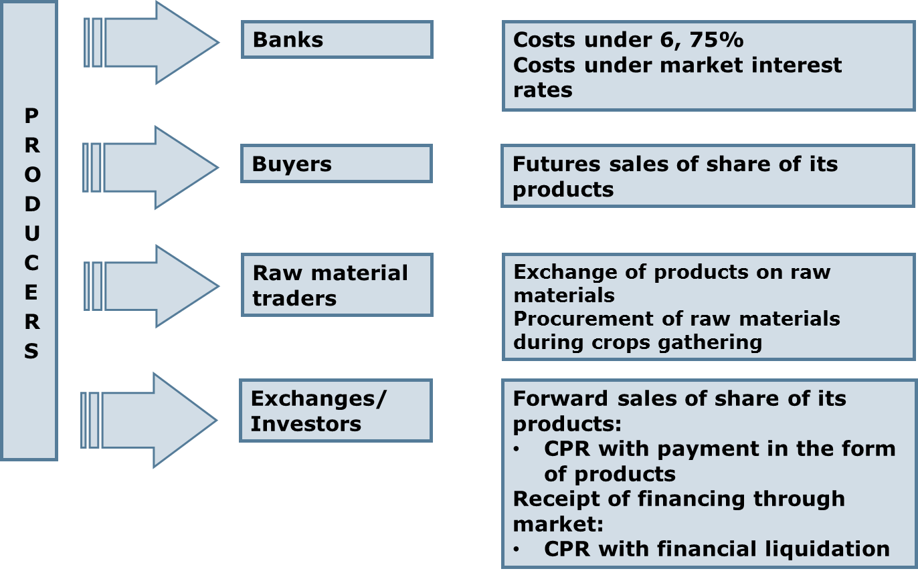
Source: Banco do Brasil and Agribusiness, 2011
At the Chart 1, it is shown that today the agricultural enterprises of Brazil have the opportunity to obtain bank loans both at the market interest rates (13%) and also at the discounted interest rates – 6.75%. Also the part of agricultural produce is sold by forward contracts (delivery of produce in the term defined by the agreement by the price at the moment of conclusion of the agreement); part of them is sold in exchange for the supplied inputs. A large list of produce that is considered in our study is sold by agricultural producers with the application of CPR contracts.
CPR contracts may also contain a pledge that is provided to a creditor.
In Brazil there are two types of CPR contracts: tradable (commodity) and financial. It means that the owner of CPR can obtain its funds in the form of commodity or money dependently the type of CPR owned.
Tradable CPRs were introduced at the legislative level in Brazil in 1994. After the issuance and sales of such document, a producer obtains financing in exchange for the liability to supply goods in previously agreed place and time. In tradable CPR the general quantity of goods, its quality, place of delivery and date are clearly defined.
Financial CPRs were introduced in 2001 in order to attract investors who are not comfortable to deal with agrarian products. For instance, if an enterprise is involved in supply of fertilizers or means of production and is not specialized in sales of agro products, then it has the right to conclude an additional agreement with traders or with agro export companies in order to sell its agro products. Same happened to investment funds that did not want to deal with agro produce. Namely, the financial contracts were the liabilities introduced for such cases. The essence of financial CPR is that a producer is obliged to repay the funds in some period of time. Such CPRs envision either current price of products or the price on products as of the date of settlement by CPR.
Contracts-liabilities may be registered in CPR register at Brazilian Commodity and Futures Exchange (BM&F). Such CPRs in Brazil are equalized to securities, they are quoted at the exchange, and also they are exempt from tax on financial transactions for legal entities or income tax for individuals. The issuance of contracts-liabilities can take place with the immediate participation of a bank that adopts the issuance and purchase of CPR.
Limit of loan that is received by the issuer-enterprise is within the range of 30-70% from the calculated quantity (cost) of future harvest and is dependent on a type of produce, and also the phase of production (preparation, sowing, cultivation, collection, storage).
As to the accruals, then, all the fees are paid by the buyer, and the producer is freed from a payment.
After the time when a farmer’s enterprise submits the bids to issue CPR, the credit analysis of this enterprise is being started. The registration of data, history, production capacities, resources, assets, etc.are checked and the upper limit that defines the level of credit risk for the customer is determined.
CPR is similar to forward contract and is considered as an instrument that include two components:
1) As a debt liability that envision the delivery of certain quantity and quality of products (tradable CPR) or money (financial CPR);
2) serves as a guarantee of the existence of an issuer, since the holder of CPR has the right for the next year’s harvest, in case, when the settlements were not done in the current year due to different reasons (first of all, destruction of harvest).
Thus, through the mechanism of a CPR agreement the agricultural producers (or their associations, namely, cooperatives) cell agricultural crops before the harvesting (under a future harvest collateral), receiving funds or commodities inputs that are necessary for the production of this produce and take the responsibility to supply certain amount in specified time and place by the determined price.
Due to the use of such instrument in Brazil the volumes of agrarian sector crediting annually reached 5 bn of USD, and agricultural commodity producers managed to increase the gross production and harvest.
The key factor of success of CPR in Brazil is a simple system of enforcement: the decision about enforcement is taken during 24–48 hours; one more important factor is the impossibility of application of force-majeure conditions to CPR. Thus, a borrower has very limited opportunities of denial/claim against such a decision on enforcement.
Also the farmers may not mandatory insure the future harvest because, if due to some reason the produced commodities shall not be sufficient to cover a debt obligation, then the collateral is valid for the next marketing year, so is left in force until the moment of full debt reimbursement.
CPR is considered as an acknowledgment (agreement) that confirms the liability of a debtor for the benefit of a creditor. For instance, the farmer cultivates soybeans, so in accordance with an agreement he has to sell it in October (forward agreement) with the delivery after harvesting (in April). Meanwhile, the means of production for the cultivation of soybeans are paid in local currency, and the prices for agricultural products are mentioned in USD. The loan is provided for the term from 60 to 360 days, but in practice, as a rule, the most popular is the term of 150-180 days. So the price of collateral may be substantially different from the market price. It is dependent on the status of a field and a situation in the market. As a rule, the Brazilian farmers get lesser price than the forecasted market price.
The payment for the future harvest is done in two phases: 1- first, when a part of the forecasted sum is paid and a pledge grain tonnage is fixed, 2-second full settlement after the harvest of grain crops. At the final payment for the grain the market prices are accounted that exist at the settlement date.
The experience of Brazil shows that without a state support the introduction of such instrument is not possible. Bank of Brazil in Brazil is the most active in working with CPR; the Government through it stimulates the use of CPR and, in its turn, it analyzes the credit capacity of a producer and defines the amount of a loan to be allocated. Meanwhile, the creditor performs the inspection having full access to the field, where the future harvest is cultivated. In case of necessity, the evaluation of regional risks is done that is reasoned by the natural conditions.
RESULT
At the present day, in Brazil, the agrarian producers have an opportunity to finance their activity for the account of their own resources and bank loans that compose relevantly 30%, and also by the contracts - CPR (40 % from the general volume of financing).
The application of CPR stimulated the export of agricultural produce in Brazil. Today Brazil is the biggest world exporter of soybeans, sugar, beef meat, coffee, orange juice and tobacco. It is also the second largest exporter in soybean meal, chicken, and soybean oil, and fourth in pork, corn, and cotton. Besides that it is the second country running by the volume of export of soybean meal, chicken, soybean oil, and it runs 4th place by the export of pork meat, corn and cotton.
The experience certifies that the basic fundamental for CPR introduction is a strong support from the side of a state, in part of legally established clear rules. Only then:
- CPR shall help to all chain participants in the increase of financial opportunities for their activity.
- CPR gives large guarantee/pledge for traders, than the usual types of agreements.
- Farmers and other small producers shall be able to receive an additional loan by the way of the use of its agricultural produce as a payment guarantee.
- СPR increases the trust to agribusiness sector.
- СPR favors a steady growth even at the markets with a high level of risk.

Conclusions
Brazilian experience of implementation of CPR (Cedula de Produto Rural) shows that there is an opportunity to implement such financial instrument for agrarian commodity producers in Ukraine with the goal to obtain additional loans under the pledge of future harvest.
To a large extent the success of the work of this system in Brazil was depending upon a simplified system of enforcement in case of failure to execute the concluded agreements by CPR contract: ruling on enforcement is taken during 24–48 hours. Another important factor is the impossibility of applying force- majeure conditions to CPR. The borrower has a very limited opportunity to claim such an enforcement ruling.
The main advantages of CPR for different market participants of agrarian production:
- For agrarian producers
- Previous sale of produce
- decrease of dependency on loans
- better process of long-term planning
- For middlemen and processors
- Expected and planned procurement of produce
- reduction of risks related to delivery
- better conditions of financing
- For the enterprises-input suppliers
- Reduction of risk of non-payment
- opportunity of performance of different types of transactions (barter)
- better conditions of financing

References
(1) Eduardo L. Leão de Sousa (World Bank), Fernando L. Pimentel (Consultant, Agro security). “Study on Cedula de Produto Rural (CPR) – Farm Product Bond in Brazil”. RURAL FINANCE INNOVATIONS (RFI) ESW, The World Bank. February 2005.
(2) New Instruments of Finansing Under Future Crops – the Brazilian Experience of a CPR System: Opportunities and Issues for Ukraine. Report. FAO, 2011.
(3) Sandro Marzo, Michael Walton, Jay Rosengard. “The Brazilian Cedula de Produto Rural: Performance, Lessons, and Replicability. Potential Outside Brazil. Second Year Policy Analysis”. Harvard Kennedy School (John F. Kennedy School of Government), IFC. March, 2010
(4) Терещук С.М., Андрієвський В.Є. Фінансування сільськогосподарського виробництва під заставу майбутнього врожаю. Досвід Бразилії //Міжнародний науково-виробничий журнал «Економіка АПК», № 2, лютий 2012, ISSN 2221-1055, Інститут аграрної економіки УААН, Київ, Україна.

CONTACTS:
Dibrova Anatoliy Dmytrovych,
E-mail: dibrova@nubip.edu.ua, Tel.: (044) 527-85-40 03041, Kyiv, Heroyiv Oborony st, 11, building number 10, room. 301.
Kolisnyk Volodymyr Petrovych,
E-mail: VKolesnik@amdi.org.ua, Tel.: (044) 490-70-78, 01001, Kyiv, Mykhailivskya st, 24B, Office 83.

