UDC 336.77.067.22 : 631.11
Development of long-term bank crediting of the agricultural enterprises
A. Kravchenko, PhD, Senior Lecturer of NULES of Ukraine
The state of long-term bank loans agrarian enterprises
and the ways of its development
Long-term bank lending, farmers, impacts
Improving resource as long-term bank loans in the agricultural sector is a problem that requires a comprehensive scientific study. Research the topic opens opportunities to deepen analytical research, to build an effective mechanism for financing investment projects farms. In this regard, it is important to note that this long-term bank loans as a source of investment resources, able to appropriately influence the stimulation of activity of agricultural enterprises and accelerate their growth.
Analysis of the main research and publications. We studied the long-term financing of agricultural enterprises S. Kruchok , Y. Ljashenko et al. However, in practice this question needs further investigation.
The purpose of the study. Based on the analysis of bank lending agrarian enterprises in Ukraine , identify the problems of long-term financing the agricultural sector and to propose solutions. The main material. Agricultural sector of Ukraine is one of the most important areas of industrial and economic activity in the country. Since its development depends on the viability of rural and food security of the population. This sector of the economy Ukraine compared to others most in need of real, complex state and banking support. Ukraine , as a manufacturer and exporter of agricultural products to Ukrainian agricultural companies to provide the necessary support and assistance to improve the conditions of production and improve competitiveness in domestic and foreign markets. The key to this is the long-term bank lending to agricultural enterprises with the right use of credit results in the necessary development.
Development of long-term bank lending to the agricultural sector tended to Ukraine from 1996 to 2008, in 2010 - to improve in 2009 - a significant reduction in lending from 2011 to 2013 - an increase of total lending, but the share of long-term loans decreased significantly, please. (Table) (Fig. 1, 2).
Table
The volume of agricultural loans, million UAN
Years | Total | Long-term loans
Years | Total | In UAN | In foreign currency | share,%
1996 | 169 | 30 | - | 17,8
1997 | 268 | 25 | - | 9,3
1998 | 329 | 31 | 62 | 28,3
1999 | 390 | 43 | 119 | 41,5
2000 | 745 | 58 | 98 | 20,9
2001 | 1676 | 111 | 139 | 14,9
2002 | 2593 | 338 | 239 | 22,2
2003 | 4561 | 1540 | 525 | 45,3
2004 | 5218 | 1768 | 668 | 46,7
2005 | 8192 | 3090 | 105 | 50,5
2006 | 11878 | 5026 | 1867 | 58,0
2007 | 16508 | 7136 | 3077 | 61,9
2008 | 28812 | 12296 | 5665 | 62,3
2009 | 26026 | 10821 | 4960 | 60,6
2010 | 26545 | 13211 | 4703 | 67,4
2011 | 34143 | 14822 | 5985 | 60,9
2012 | 36488 | 13375 | 6603 | 54,8
2013 | 39158 | 14253 | 5097 | 49,4
∗ Source: Calculated based on data [1]
The trend of increasing lending to agricultural enterprises was due to government measures to support them and the provision of soft loans. However, the dynamics of the decline in the share of long-term loans, consistent with crises, financial and economic situation in the country and proves distrust of banks to borrowers agriculture caused: industry risk, solvency level and volatility of agriculture, which is due to: seasonal, cyclical, dependent from natural weather conditions and difficult predictability and yield pricing for domestic and international agricultural markets.
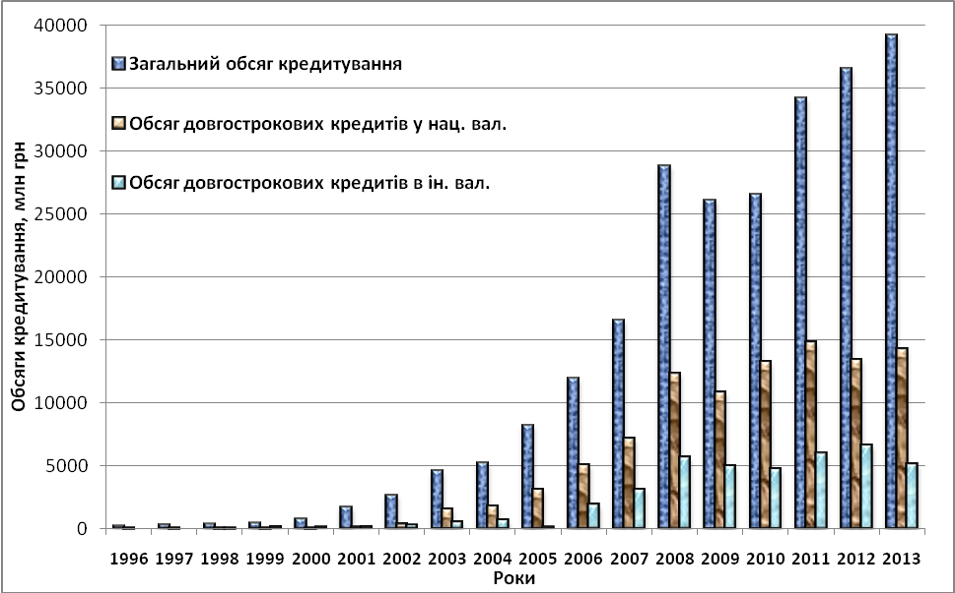
∗ Source: Calculated based on data [1]
Figure 1. Volumes of lending farms
The development of agricultural enterprises require long-term bank loans. Investments are needed in the expansion and modernization of fixed assets (physical infrastructure). Banks provide long-term loans if the borrower liquid assets that can be used as collateral. The main pledge of agricultural enterprises may be agricultural land. In Ukraine agricultural land private enterprises have a low cost, in addition there maratoriy for sale.
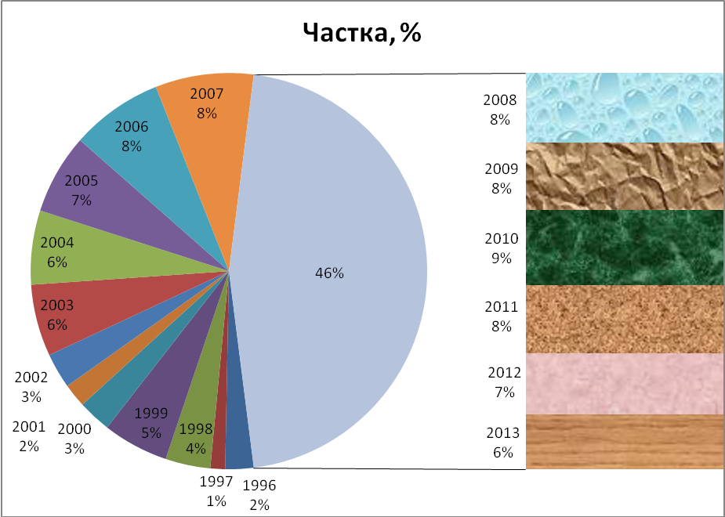
Source: Calculated based on data [1]
Figure. 2. The share of long-term loans granted to agricultural enterprises
To address the issue of financial development farms needed to solve the problem of liquid material and valuable collateral, which might enable banks freely , reducing credit risks , invest the money in the long term the main objects of agricultural enterprises. But still no government support , which provides preferential subsidies from the state budget allocations , grants , current government programs in support of the village , tax breaks , development of agrarian sector of economy of Ukraine is impossible. One way to implement this is higher than investments , which are based on sources : the state budget, state funds , investments, and long-term commercial bank loans. Effective lender will perform a special state agricultural bank. Based on the analysis , we can identify the factors influencing long-term lending to agricultural enterprises. The external factors include: agricultural policy (development and agricultural reform ) laws and legislation ( drafting and adoption by the supreme Council of Ukraine governing laws regarding: mortgage , mortgages, land fund guarantees, the development of the agricultural market , adequate support domestic producers , etc.) , state budget ( government revenues and expenditures relative to agriculture ), government financial support for agriculture (budgeted : spending , subsidies , compensation , subsidies , benefits ) stock market ( stock market development with the participation of Ukraine agriculture: an opportunity profitable sales agricultural products, mortgage bonds as an alternative to long-term loans ) designation pricing for agricultural products ( regulation and corridor level of prices of agricultural products ), land markets ( market development of agricultural land ) , guarantees and sureties (state, property surety , etc.) ( reliability guarantee, other ways of calculating credit obligations in the event of unforeseen circumstances) .The internal factors include: the creditworthiness of the borrower(to the full , and at the appropriate time to pay with their obligations, the borrower's rating , which is determined depending on the financial situation of the company , reputation, risk of loan default by the borrower , project - plan , provision (mortgage , etc.) , the liquidity provided by the property as collateral and its estimated value in the period ), which is defined by: 1. Reputation. 2. Credit history. 3. Financial condition. 4. Project Quality Plan. 5. The presence of collateral. We consider lending to investment projects farms as focusing resources on investment measures aimed at expanded reproduction of capital, according to the principles of bank lending and government support.
Conclusions and recommendations for further research. Solving the problem of long-term loans will: stabilization of the financial and economic situation in the country, the establishment of mortgage banks including state, which primarily will bring social benefits, long-term source of credit banks, an adequate analysis of the creditworthiness of agrarian enterprises (taking into account the financial condition, seasonality); create high-quality regulatory framework, the network credit bureau system of registration of property (land registry adoption and creation of state registration of rights to immovable property, etc.), government guarantees (such as reallocation of risks), government financial support, an increase in non-repayable assistance to enterprises of the agricultural sector of the economy , compensatory and preferential loans from the state, the effective regulation of money market National bank of Ukraine development of insurance.
LIST OF REFERENCES
1. Бюлетень Національного банку України. – К., 1993 – 2013. – №№ 1-12.
Проаналізовано стан довгострокового банківського кредитування
агарних підприємств та запропоновано шляхи його розвитку
Довгострокове банківське кредитування,
аграрні підприємства, фактори впливу
Проанализировано состояние долгосрочного банковского кредитования аграрных предприятий и предложено пути его развития
Долгосрочное кредитование, аграрные предприятия, факторы влияния

