Farm-Level Evaluation of Land Tenure Changes in case of Zhytomyr Oblast of Ukraine

Alena Shpak, Ph.D. student Department of International Bio-Business Studies
Akimi Fujimoto, Department of International Bio-Business Studies,
Graduate School of Agriculture, Tokyo University of Agriculture

At the time of USSR collapse in 1991, all of the member countries of the Soviet Union, including Ukraine, had severe difficulties in implementing reforms and innovations.
This paper aimed to clarify the process of Agricultural land reform implementation by classifying the evolution of land tenure changes, and discussing the peculiar features of such changes on the farm level.
Extensive review of Laws, Decrees, Land Codes, and past studies on land reform in Ukraine were conducted. Data based on questionnaire survey of 50 private farmers of Zhytomyr oblast in 2010 is presented as well, with the aim to study peculiar features of land tenure changes during the reform that are not apparent by examining only policies and legislation.

Agricultural land reform, land tenure changes, private farms, farm-level

Significant changes in land use and land ownership has happened as a result of implementation of Agricultural land reform in Ukraine after the USSR collapsed and Ukraine became an independent country in 1991. In fact, this reform was a complex process, characterized by changes of the whole system of doing agriculture, based on private ownership over collectivization, and private farms and agricultural enterprises over kolkhozes and sovkhozes. Historically, for the first time private farms were created as independent legal entities outside the collectivist framework.
This study aims to highlight the process of land tenure changes after state monopoly on land was eliminated and agricultural land was privatized, as well as to evaluate land transactions at different levels.
The objective of this paper is: to examine the main issues about establishment of private farms and to discuss the farm-level changes in land tenure status of such farms in case of Zhytomyr oblast of Ukraine.
The question of the land tenure changes during the implementation process of the land reform in Ukraine was studied by many scientists, including a significant contribution to the scientific achievements made by D.S. Dobryak, D.I. Babmindra, M.S. Bohira, P.G. Kazmir, A.G. Martin, A.M. Tretiak, M.N. Fedorov, L.Y. Nowakowski, S. Dorohuntsov et al.
The originality of this paper lies in the analysis of land tenure changes from the general outlook of Ukrainian agricultural system right after the implementation of the land reform to the detailed farm management data analysis based on collected data through a questionnaire survey of 50 private farmers of Zhytomyr Oblast of Ukraine in 2010 in order to research peculiar features of land transactions during the process of the reform.

The term “land reform” has a variety of meanings. It may involve the restoration of land rights to previous owners, a process known as land restitution. This occurs in many countries in transition when former private rights in land are being restored. At the same time land reform can also involve redistribution of land rights from one sector to another – for example, like in Ukraine, by taking land from the State and giving it to people.
The first land reform legislation was passed in December 1990 in the form of the Ukrainian Land Code. The objectives of the reform were defined in the resolutions adopted by the Ukrainian Supreme Soviet on December 18, 1990: “The task of this reform is redistribution of land and its transfer to lifetime inheritable possession of individuals, permanent possession of kolkhozes, sovkhozes, and other enterprises, and also usership, with the purpose of creating equal conditions for the development of different forms of farming ”.
All land in Ukraine is subdivided into different categories, depends on the purpose of use, Table 1 shows the structure of the Land Fund by main categories.
Table 1. Structure of Ukrainian Land Fund, various years
Purpose of use | 1991 |  | 2005 |  | 2011
 | Mn ha | % | Mn ha | % | Mn ha | %
Agricultural | 42.0 | 69.6 | 41.76 | 69.2 | 42.9 | 71.2
Forest | 10.2 | 16.9 | 10.47 | 17.4 | 10.5 | 17.4
Urbanized | 3.5 | 5.8 | 2.45 | 4.1 | 2.5 | 4.1
Degraded scrub land | 0.9 | 1.5 | 0.95 | 1.6 | 0.9 | 1.6
Land Reserve | 1.3 | 2.2 | 1.05 | 1.7 | 1.1 | 1.7
Water | 2.4 | 4.0 | 2.42 | 4.0 | 2.4 | 4.0
Unclassified | ------ | ------ | 1.22 | 2.0 | ----- | ----
Total | 60.32 | 100 | 60.32 | 100 | 60.32 | 100
Source: State Land Committee of Ukraine, various years

In that case land reform should be understood as redistribution only of agricultural lands and its further transfer into different kinds of ownership after the State monopoly for lands was eliminated with the purpose of creating favorable conditions for development of agricultural sector.
As a result of redistribution of agricultural lands during the reform there are 6.9 million individual owners of arable land, with an average size of land plot of 4.1 ha. Individuals own 28.6 million ha of arable land (67% of total arable land in Ukraine). The remaining arable land belongs to state and municipal arable land reserve fund, according to the State Land Committee of Ukraine.
The December 1990 legislation, with all its restrictive shortcomings, was the first step on the road to new land relations. It took more than a year for additional milestone legislation to be adopted: the Law on Private Farmers passed in December 1991, the Law on Forms of Land Ownership passed in January 1992, and the new Land Code adopted in March 1992. These laws addressed the issue of “denationalization” of agricultural land by recognizing different forms of land tenure: state ownership, collective ownership, private ownership, possession, and usership.
According to legislation, entitlement to land ownership was not restricted to current land users: all citizens were entitled to own land for farming and other designated uses. The list of approved farming uses included establishment of independent private farms, subsidiary household plots, gardens and vegetable patches. Legitimate non-farming uses of private land included construction of dachas (summer cottages) and garage or storage space.
The list of farming uses covers two categories of eligible persons: individuals who are members and employees of farm enterprises and individuals outside the existing farm enterprises.
To enable land to be allocated to new users, some land cultivated by collective, state, and other farm enterprises was extracted into a state land reserve. This reserve, or redistribution fund, was intended as a pool of land for distribution to individuals who are not members or employees of existing farm enterprises:
- “Outsiders” receive land for private farms, gardens and vegetable patches, and dacha plots.
- “Insiders” (members and employees of farm enterprises) receive land for subsidiary household plots.
Creation of private farms is growing in Ukraine, but remains a distant third player in contribution to aggregate production, after the new collective sector and traditional household subsidiary farming. It is therefore necessary to study the peculiar realities of private farms.
In 2010, a questionnaire survey of 50 private farmers was conducted in Zhytomyr Oblast in order to obtain detailed farm management data. An average family among farmers under study consisted of 4 persons. Average age of the farm head varied from 41 to 44 years. These farmers have sufficient experience in agriculture or necessary agricultural skills, which is compulsory for farm establishment and legal registration.
Majority of studied farmers had high education and an average of 8 years of farming experience (Table 2).

Table 2. Profiles of studied private farms in the Oblast
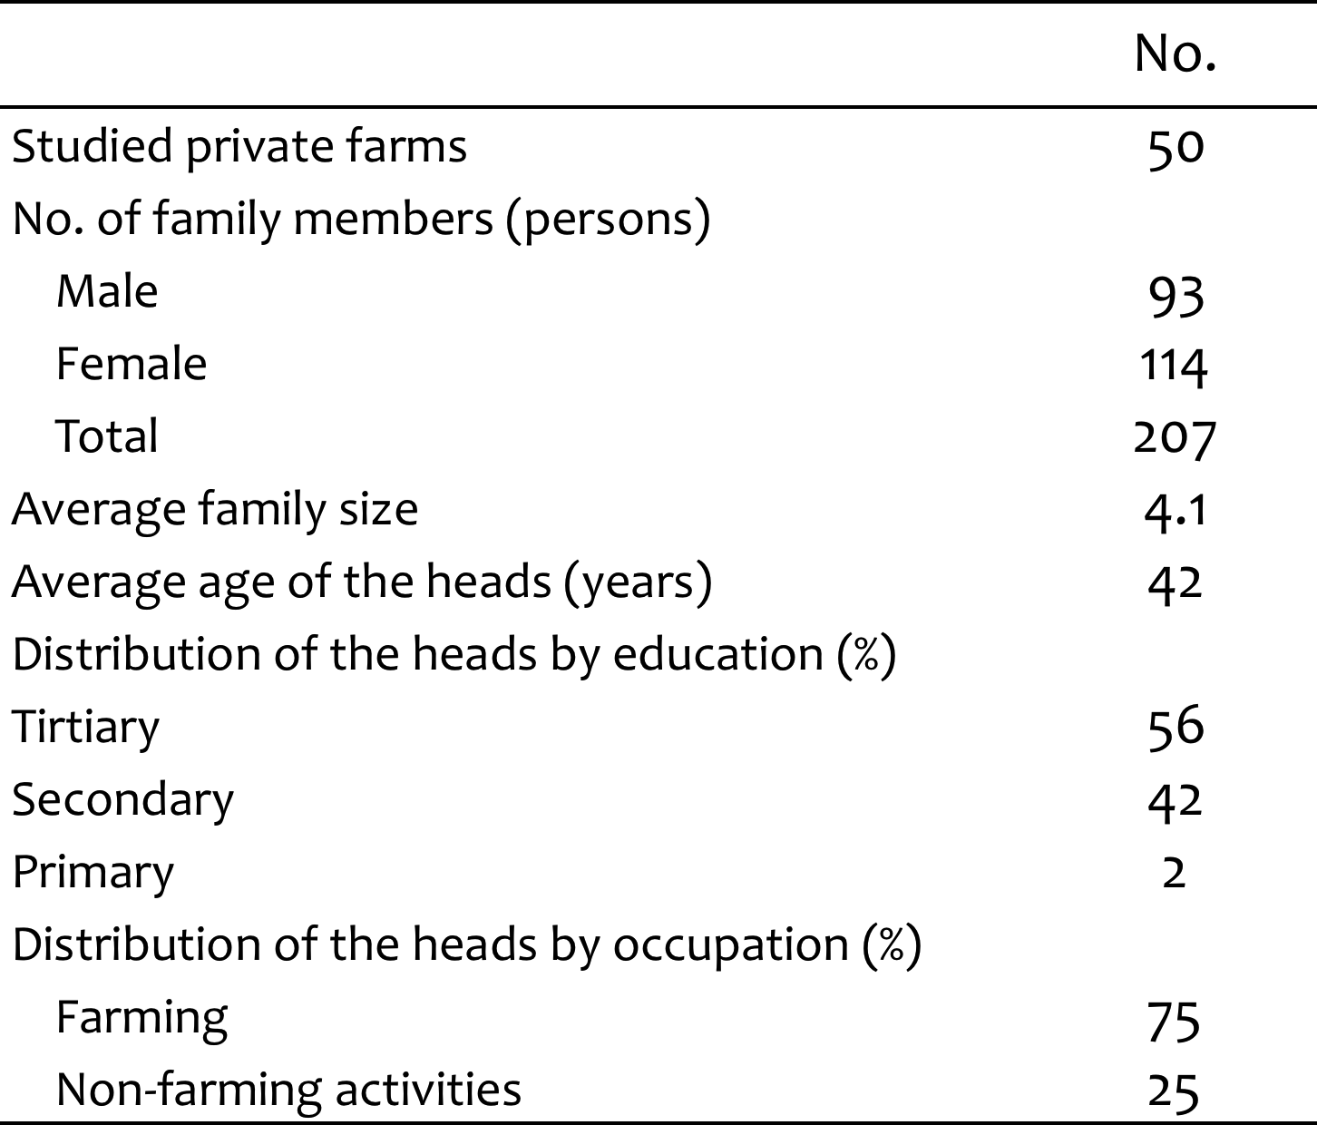
Source: Farm survey in Zhytomyr Oblast in 2010.

Moreover, all studied farmers are members of Farmers Association, which is an independent public organization that brings together private farmers on a voluntary basis and lobbies for their interests at all levels. The Association represents the interests of more than 43 thousand farmers in Ukraine.
Ukrainian private farmers provided evidence that when the legal framework during the reform created opportunities for producers to function outside collectives, individuals welcomed the opportunity, and acted upon it.
Table 3 shows the creation mode of private farms in studied region (Zhytomyr Oblast of Ukraine) for various years during the reform, which are consistent with the years of creation of studied private farms.

Table 3. Creation mode and land resources of private farms of Zhytomyr Oblast, 1995-2008.
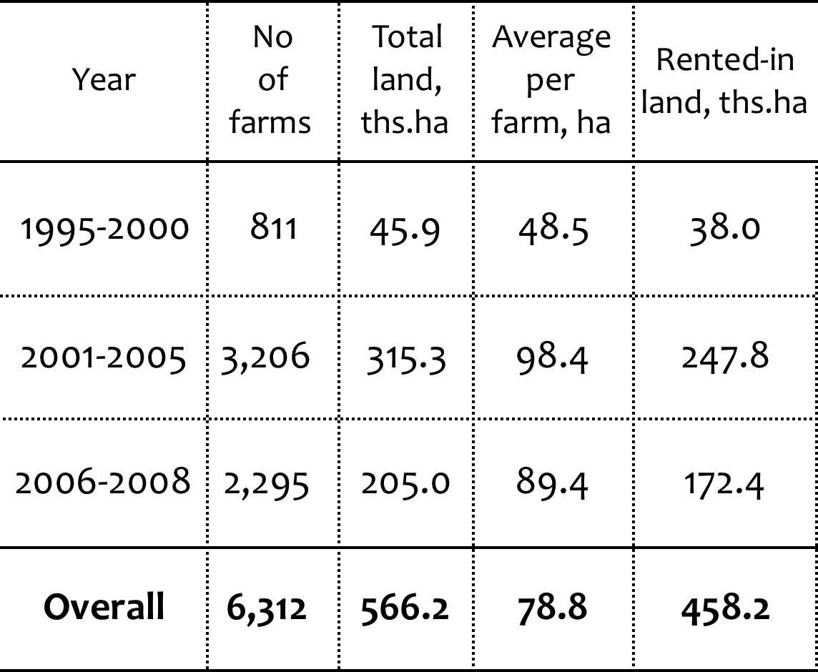
Source: State Land Committee of Ukraine (various years).

It is considered that private farmers in Ukraine are functioning between systems, and are using any possibilities that arise to keep their operations functioning. That they exist at present and that their numbers are increasing is testament to the firmly held belief that land will in the future have value, and that private production is profitable.
According to conducted survey it was observed that there were two distinct peaks in the creation of studied private farms. As it is shown in Table 4, the first wave was in 1995 up to 1999 and the second wave after 2000, immediately after the December 1999 Presidential Decree, which specified details and simplified some procedures for registration of private farms with the aim to accelerate the creation of independent private farms in Ukraine. From the comparison of Table 3 and Table 4 it could be mentioned that the dual picks of creation of studied private farms and private farms of Zhytomyr oblast are consistent.

Table 4. Creation mode and source of obtained land of studied private farmers of Zhytomyr Oblast
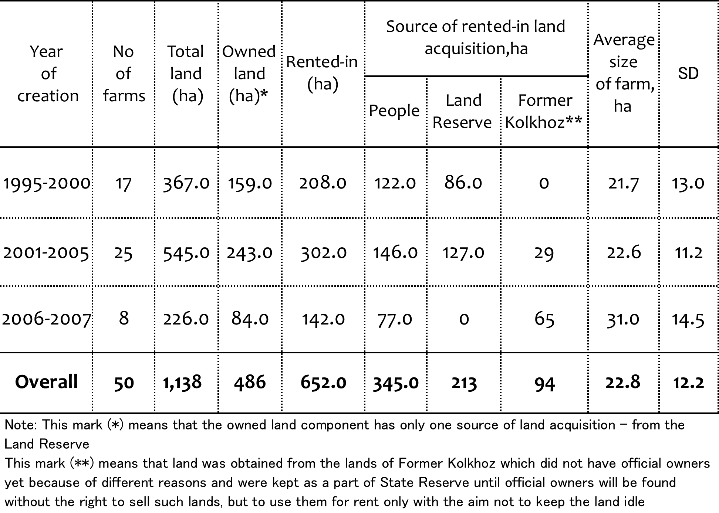
Source: Farm survey in Zhytomyr Oblast in 2010.

Two-thirds of the respondents reported that they became private farmers to be independent. Prior to taking up private farming, some heads of households were typically employees of the local collective or state farms. In the remaining cases, the farmers used to work in rural services in the village or had managerial positions in the district centre. Majority of farmers who previously worked in the local collective or state farm reported that they were entitled to receive a land plot and some assets when they decided to exit from the collective.
It is interesting to note that all private farmers who were former employees of collectives did not actually use land, but asset shares from the collective to start up their private farms. It could be explained by not willing to pay some taxes in case of registration of this land plots in assets of created private farms as well as lack of wish to submit statistical information about agricultural activities held on these land plots plus governmental check-ups of registered lands were not welcomed too.
Farmers reported that the initial investment in their farms was about $4000 - $5000. Although many farmers confirmed using credit, own savings was the most important source of start up capital. Studied farmers admitted that they experienced problems with finance in different stages of operating their farms, but on balance their outlook was more optimistic than pessimistic.
Moreover, if we would like to talk about land resources of private farms and further changes in land tenure it is useful to mention three sources from which land for private farms could be obtained: 1) from the State Reserve of the district government (the village council); 2) from the former collectives (land plots that did not have official owners yet are kept in reserve and could be rented-out for some period of time for agricultural land not to be idle); 3) from the other private landowners. Majority of studied farmers created their farms with allocations of land from the State Reserve managed by village and district councils.
According to Ukrainian law, any citizen of Ukraine 18 years old or more, who wants to start up a private farm and does not have a land could rent some land from the State Reserve and later has a chance to privatize an average land share free of charge from these rented lands, if conditions are met. Thus, the data collected through the survey confirmed that people used mostly the right given by the State to receive a land plot free of charge with the aim to do agriculture. The privately owned component (owned land plot) was about 3 ha per person, which was equal to the size of the average land share in Zhytomyr Oblast.
The source of rented-in land acquisition, which is presented in Table 4, points out the situation in Ukraine with available lands for doing agriculture. As it could be seen from the table, majority of studied private farms, which were created right after the independence of Ukraine and up to 2005 increased their land holdings with the help of Land Reserve or/and other landowners. However, Land Reserve is not unlimited and to obtain a land plots nowadays became more difficult and time consuming comparing to the beginning of the implementation of the land reform. At the same time studied private farmers mentioned one more source of rented-in lands for farm enlargement – from the lands of former collective, which did not have official owners yet and were kept in the reserve. The main source of rented-in lands at present is considered to rent land from other landowners.

In terms of farmland area, studied farms ranged from 6 ha to 50 ha and were divided into three groups with the respect to the size of land resources. Table 5 shows tenure status of studied private farms.
Table 5. Classification of studied private farms by size and by land tenure status
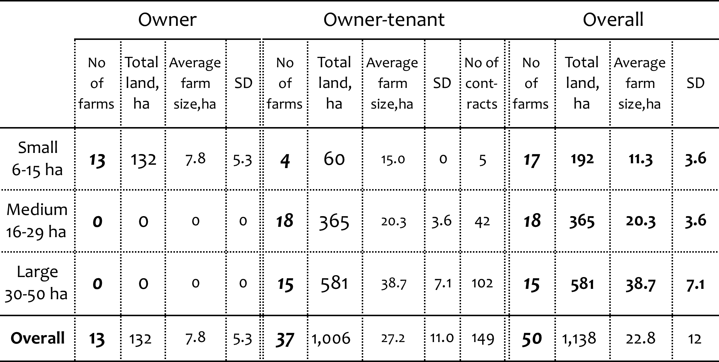
Source: Farm survey in Zhytomyr Oblast in 2010.

Among 50 studied farms there are 13 farmers who have only owned land component in their assets, but the rest (37 farmers) are owner-tenants (combination of owned land and rented-in lands). None of the farmers in the sample is renting land out. Table 5 shows that all farmer-owners (13) belong to the smallest group according to the size of land resources, and their average farm size is almost two times smaller comparing to the average farm size for farmers who belong to the smallest group of owner-tenants, and five times smaller comparing to the owner-tenants from the largest size group appropriately. It certainly points out the fact that typical farmer-owner was a single private farmer or cooperation (union) of family members, who contributed their labour and land plots for doing farming together.
The biggest number of owner-tenants farmers is presented in the medium size group, but from the point of view of accumulation of land resources the large size group is taking the first place. Based on the survey, it should be mentioned that majority of owner-tenants farms were single-family farms, and the rest were formed by two families or/and cooperation of partners.

Table 6 presents rented-in land information of studied private farms.

Table 6. Rented-in land information of studied private farms

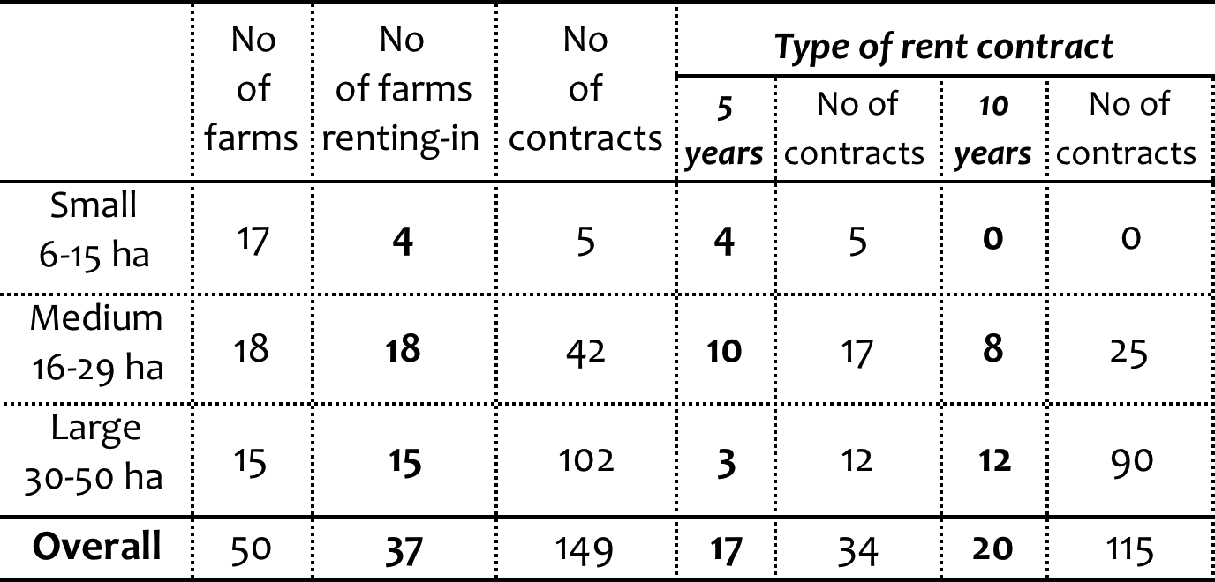
Source: Farm survey in Zhytomyr Oblast in 2010.

It could be observed that among all three groups, small size group has the smallest number of farmers (4 private farmers) who are renting-in some extra land. The special feature of that fact is that farmers of this group have only short-term contracts (only contracts for 5 years). According to the interview with these farmers it could be said that small farmers are not ready to expand their farm size because of different reasons.
On the other hand, according to the survey almost half of studied farmers wished to increase their land holdings, typically up to 50-100 ha. The mean enlargement desired was 85 ha. Those who did not wish to increase their farm size complained about the lack of machinery, equipment, and capital needed to support larger holdings. Three-quarters of those who wished to expand their farms were already taking active steps to acquire more land, mainly through the village council, from the State Reserve, or by renting land shares from other people.
However, considering the type of rent contract from the Table 6, it could be assumed that the large size group of farmers has stronger market orientation and aims to control the cost of the farm with the help of long-term contract relationship.
From the point of view of quantity of contracts it could be said that majority of private farmers do not rent extra land plots only from one landowner, but from many different ones. That fact has several reasons:
1) Some rented plots are kind of small and sometimes equal 3 ha, which is the average size of land plot in Zhytomyr oblast and always-concentrated in one hand;
2) Farmers are trying to rent-in land plots that are close to their farm area, so land around it is not always concentrated in one hand;
3) Because of former collectives one area could be divided up to 100 separate land plots with different owners (equals past quantity of workers of the collective).
Table 7 presents changes in numbers of studied private farmers along with changes of their land resources for every five-year period from the moment of farm`s establishment.

Table 7 . Studied farms and their land resources for every five-year period from the moment of farm`s establishment.
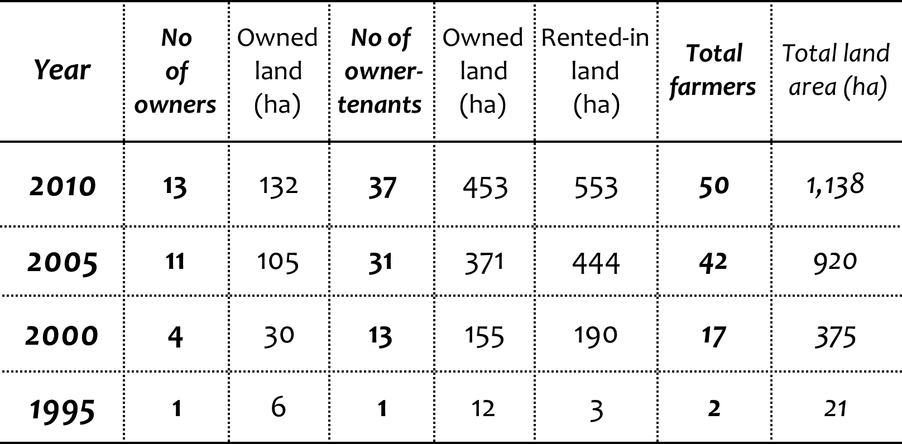

Source: Farm survey in Zhytomyr Oblast in 2010.

The first two private farms in the sample were created in 1995 and the latest year of farm creation was 2007. Comparing the time right after the implementation of the reform (1995) and present period (2010), the total operated land area (Table 7) increased from 21ha to 1,138 ha, as well as number of created private farmers changed from 2 to 50 farmers appropriately. Rented-in land component was also increasing steadily. From these facts it could be assumed that farm-level changes during the reform in general outlook created favorable conditions for private farms` establishment and operation, as far as their number and size were increasing year by year. Another positive effect shows that majority of studied farmers considered farming as their profession and full-time occupation (Table 1)

These changes were promoted also by the issuance of State Act (Deed) on the land plot, which is recognized as the final document confirming the title of ownership to the land plot.

Based on the contents of the State Act it could be concluded that it is not equivalent in legal status to a typical European title document as defined by civil law, because:

- The State Act declares that the person owns some unit of property, based on the fulfillment of all administrative conditions, substantiating his/her entitlement.
- A Title is a document that declares the status of ownership of a land/property unit based on the civil law status of the person (usually without categorical distinctions) and unbroken chain of transactions.
According to Governmental Statistics, in 2012 in Ukraine 62 thousand State Acts on property rights to land plots were filled and issued in Ukraine.
As a result of reformation 6.92 million citizens have acquired a right to land plot; out of this number 6.41 million State Acts were issued and 70 thousand rental agreements were registered. Such rental agreements for agricultural lands enable as much freedom for performing farming operations as ownership while also providing a primary right of purchase in case of the agricultural land sale moratorium lift and given that land plot holders would be willing to sell off their property.
From the point of view of land tenure changes there were three types of farms in the survey: expanding, maintaining and shrinking farms (Table 8).

Table 12. Types of farms according to changes in land tenure
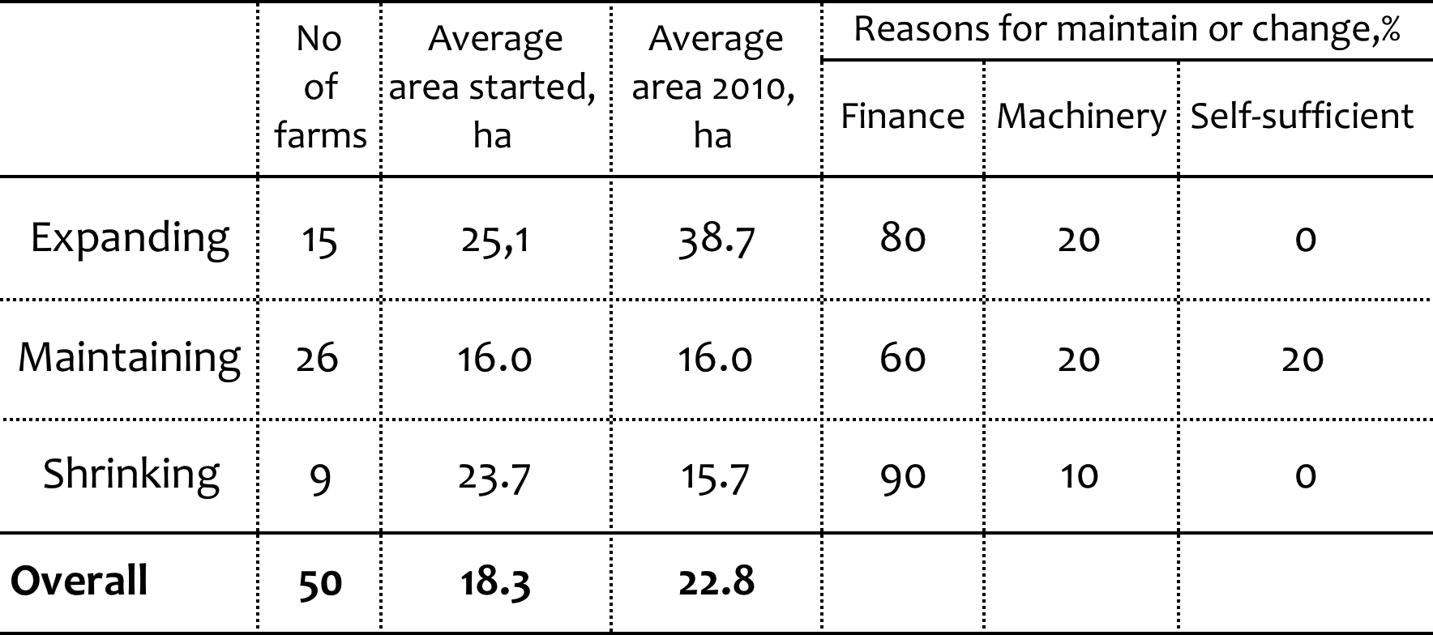

Source: Farm survey in Zhytomyr Oblast in 2010.

According to the Table 8, majority of studied private farms are maintaining farms, which means that from the moment of their establishment and up to the present time the size of land resources owned or rented-in did not change. Minority of studied farms is shrinking farms and their size of land resources decreased with the time of farm operation. And only 15 farms from the sample belong to farms with increased land area.
Reasons for maintaining or change of land tenure were different, but studied private farmers stressed the main ones:
1) Financial problems – lack of own capital or savings, difficulties with obtaining loans from the banks, as well as the perception that interest rates were too high, and that credit was in short supply;
2) Machinery – lack of machinery or availability of obsolete machines, lack of spare parts or/and technical services;
3) Difficulties with bureaucracy and resistance of local authorities to distribution of land for private farming or with inadequate legislation and lack of real governmental support.
In conclusion it should be mentioned that land reform in Ukraine not only changed the organizational forms of "farm enterprises" but also caused a profound impact on the individual sector, accelerating creation of independent private farms as well as causing structural changes. The change in tenure system during the reform process was promoted by the issuance of State Acts for the land plots, supported by the collapse of kolkhoz/sovkhoz system and motivated by cancellation of State monopoly ownership.

References

- Csaki, C & Z. Lerman (eds.) (2000): Structural Change in the Farming Sectors in Central and Eastern Europe, World Bank Paper No. 465.
- De Melo, M & A. Gelb (1996): A comparative analysis of twenty-eight transition economies in Europe and Asia. In: Post-Soviet Geography and Economics, 37 (5), p. 265-285.
- EBRD (1999): Ten Years of Transition, Transition Report 1999, London.
- Koesterko, J.F. (2000) Agriculture in East Europe. Uskinski Press, Moldova, pp.21-29.
- Land Code of Ukraine, revised (adopted in October 25, 2001 was signed and published in November 15, 2001, effective from January 1, 2002).
- Lerman Z. (1999): Land reform and farm restructuring: What has been accomplished to date? In: American Economic Review 89: (2) p. 271-275
- Nosik, V.V., Valetta, M.P. (2002) Current trends of Agrarian reform in Ukraine. Yurinkim Inter Press, Kiev, pp.11-29.

Рассмотрены изменения в использовании земли в следствии проведения аграрной реформы в Украине на основе информации, полученной в результате исследования 50 частных фермеров Житомирской области. Таким образом, двадцатилетний период реформы бул проанализирован с точки зрения причинно-следственного механизма, который характеризирует изменения в использовании земли на протяжении всего процесса реформы в Украине на фермерсом уровне.
Сельское хозяйство, аграрная реформа, изменения в землеиспользовании, Житомирская область, фермерский уровень

Розглянуті зміни у землекористуванні протягом проведення аграрної реформи в Україні на основі інформації, отриманої внаслідок дослідження 50 приватних фермерів Житомирської області. Таким чином, двадцятирічний період реформи було проаналізовано для дослідження причинно-наслідкового механізму, притаманного змінам у землекористуванні у результаті проведення реформи в Україні.
Сільське господарство, аграрна реформа, зміни у землекористуванні, Житомирська область, фермерьский рівень

