UDC 631.147:504
Victor I. Artysh, PhD, Associate Professor
National University of Life and Environmental Sciences of Ukraine
ORGANIC MARKET EXPANSION STRATEGY UKRAINE
Statement of the problem. Since the end of the last century, rapidly increased interest community to the development of the organic production. The absence in our country an appropriate legal framework and national certification of organic production is a barrier to the development of the domestic market for organic products. The development of state consumer policy in Ukraine can be a significant mechanism for increasing public confidence in the government. Only far-sighted government policies in the agricultural sector and in the development of consumer market that can provide lift organic production.
Analysis of recent research. The issue of organic farming is now paid a lot of attention in domestic and foreign literature. Among Ukrainian scholars explore this issue in his writings Antonets A. [1] S. Antonets [2] T. Zaychuk [3] L. Sokol [6] A. Shubravska [7] M. Shykula [8] , W. Chlapak [9] and others.
The study aims to study strategic actions to expand organic production in the concept of sustainable development.
The main material. Each year, an increase in demand for organic products has attracted market expansion and increase in the number of farms. So in 2001, Ukraine had certified 31 companies when in 2011 their number was 155. For ten years the number of farms increased by 21% (Figure 1).
Most Ukrainian organic farms located in Odessa, Kherson, Poltava, Vinnitsa, Transcarpathian, Lviv, Ternopil, Khmelnitsky. Ukrainian certified organic farming is a different size from a few acres, as in most European countries to tens of hectares of arable land and more.
However, in Ukraine there are many farmers who are willing to sell organic produce but are unable to position them in the market as organic. Some certify and sell their products abroad, some - in the domestic market, but as usual.

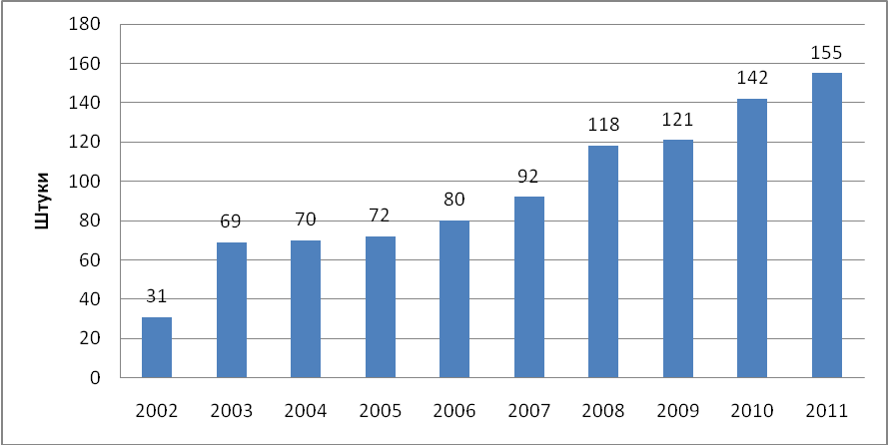
Figure. 1. Number of certified organic farms in Ukraine

We consider it appropriate to develop on the basis of international experience and taking into account the functioning of domestic agriculture series of regulations that define the details and rules of organic production: crops and livestock. In crop production, for example, is to legislate in the rotation alternating legumes, bacteria that accumulate nitrogen, and other crops that consume it for mineral nutrition, exercise breeding plants that are well adapted to the conditions of a particular region and maintain a balance of pests; systematic soil application of manure required and, if necessary, some rocks to improve soil fertility [4].
An important aspect in the development and formation of organic agriculture in Ukraine should be part of farmers in developing training programs and changes to regulations that regulate organic production. This practice is widely used in the European Union, which is natural, since in farming practice is a combination of academic achievement. Therefore they are able to make constructive proposals for adjusting measures of state support and regulate this area.
Necessary to ensure sustainable development of the agricultural sector of Ukraine through the development and support of organic production as one of the priorities of the state agricultural policy (Fig. 2).

Strategy
sustainable development of organic farming

Перекладач Google для компаній:Translator Toolkit
Інструмент перекладу веб-сайтів
Пошук на світовому ринку
Вимкнути миттєвий переклад
Про Перекладач GoogleМобільні пристроїКонфіденційністьДовідкаНадіслати відгук

Ensuring the competitiveness of Ukrainian agricultural products

Перекладач Google для компаній:Translator Toolkit
Інструмент перекладу веб-сайтів
Пошук на світовому ринку
Вимкнути миттєвий переклад
Про Перекладач GoogleМобільні пристроїКонфіденційністьДовідкаНадіслати відгук
Creation of appropriate conditions for the development of rural areas

Перекладач Google для компаній:Translator Toolkit
Інструмент перекладу веб-сайтів
Пошук на світовому ринку
Вимкнути миттєвий переклад
Про Перекладач GoogleМобільні пристроїКонфіденційністьДовідкаНадіслати відгук

Providing the population with quality certified organic and safe food
Preservation and improvement of soil fertility

Перекладач Google для компаній:Translator Toolkit
Інструмент перекладу веб-сайтів
Пошук на світовому ринку
Вимкнути миттєвий переклад
Про Перекладач GoogleМобільні пристроїКонфіденційністьДовідкаНадіслати відгук

Fig.2. Proposals for sustainable development of the agricultural sector of Ukraine

Important for Ukraine to become international experience of the institutions extension whose main purpose is to facilitate the rapid and painless transition manufacturers on the principles of organic agricultural production through the provision of information to farmers, organization and conduct of education, training and so on. Indicative of this is the experience of consulting and advisory organizations of Sweden, who develop and conduct free training programs. Thus farmers who are trained, receive monetary compensation.
It should stay on the experience of the functioning of control over the production of environmentally friendly products in Norway, which also provides consulting services. Thus, the Norwegian farmer who is engaged in breeding once a year, submit to the service plan fertilizer and every five years the ground sample for analysis. If necessary control services specialists develop animal feed rations from forages that are available to the farmer.
In the Czech organizations that support ecological farming, in addition to advice and assistance to farmers, many focused on familiarizing children with environment, thus forming an environmental consciousness in the new generations. [5]
An important step in the spread of organic farming should be the government financial and advisory support. Financial support from the state we see in helping peasants and farmers during their transition to organic production. First, it is concessional medium-term (5 years) loans for the purchase of seed and young cattle that meet the requirements established for organic products, free of state examination of soil on these farms are organic content in the minerals and their chemical and radiological cleanliness, partial state reimbursement of lease payments for the lease of agricultural machinery in the first 3 years of operation of these farms and so on.
To ensure that public funds were used for the intended purpose and really contributed to the development and distribution of organic products, farms must be registered as entrepreneurs, a business plan for economic development, and to engage in the manufacture of these products in compliance with all requirements of growing least 10 years (in case of violation of the legislated requirement to provide penalties).
One of the key roles in the production of organic products play an advisory and consulting organizations. The purpose their interaction with agricultural producers is to provide highly professional assistance in choosing the specialization of the economy, providing advice on marketing channels and promotion of markets for products, advice and information about organizations that carry out inspection of soil and manufactured products for the presence in them harmful to human health matters, providing advice on protecting and improving the quality of soil and so on. At the core of advisory and consultancy organizations must be based on the principle of individual approach to each sector, which is engaged in organic production, given its climatic conditions, geographic location, proximity of markets, qualified workers these farms and so on.
Development of the manufacture of organic products is impossible without the introduction of the achievements of Soviet science and consideration of international experience in this field. It is first on the protection of plants against pests, the use of biological agents that do not contain nitrates and pesticides differentiated approach to the full range of resources (natural, technological and human), the most suitable for a given region; theoretical basis for the formation of local agricultural systems based on species and genetic diversification plants within a region that operate high-performance and environmental sustainability have an external adverse factors like.
An important step towards promoting production of organic products may be state financial aid for examination and certification of peasant plots and farms in transition to organic farming principles, as well as for the certification of the first grown on the basis of output as the current financial situation of most households will not unable to pay their own expertise and certification institutions. [9]
Conclusions. Thus, for effective development of organic agriculture in Ukraine need to lay its institutional dimension, namely to develop and adopt regulations that contain provisions no less stringent than those provided by EU Directives, provide state support for agricultural producers in transition to organic production ( at least for a transition period); promote institutions that advise and monitor the activities of organic production at all stages of the production process, to create a system of state certification to teach agricultural producers the basics of organic agriculture through the introduction of advanced international experience and scientific achievements.
Prospects for further research. Therefore further development in this area need to question that facilitate the expansion of the organic market in Ukraine, release it with a new, strategic level.
References
1. Antonets AS,. Pisarenko, VV,. T.V Lukyanenko et al. Formation market eco-friendly products for organic farming / AS Antonets, V.V.Pysarenko, T.V.Lukyanenko, Yu.H.Pysarenko / / Economy APC. - 2010. - № 12. - P.79-81.
2. Antonets SS, V. Pisarenko When Ukraine realize its planetary mission / SS Antonets, VM Pisarenko / / Bulletin of Poltava State Agrarian Academy. - 2011. - № 2 - P.5-8.
3. Zaychuk T. Production of organic foods as the strategic direction of Ukraine / T. O.Zaichuk / / Economy and region. - 2009. - № 1. - S. 100-105.
4. K. Malkov "green economy": global economic change beginning with the global sector / K. Malkov / / International Charitable Organization "information center" Green Dossier "." [Electronic Resource] - Mode of access: http:// organicstandart.com.ua.
5. Organic products in the global market. [Electron. resource]. Available from: http://www.harchovyk.com.
6. Sokol LM, Stefanovskyi tr Eco (organic) agriculture - part of sustainable agriculture / L. M. Sokol, tr Stefanovskyi / / Environmental Safety. - 2008. - № 3. - P.102-109.
7. Oh Shubravska market for organic produce and perspectives of its development in Ukraine / O. Shubravska / / Economy of Ukraine. - 2008. - № 1. - S. 53-61.
8. Shykula MK Restoration of soil fertility in soil agriculture / mK Shykula - K. .2000 year - s.453.
9. Chlapak VA On the cultivation of environmentally friendly products in Ukraine. [Electronic resource]. - Available from: http://www.lol.org.ua
10. European Organic Farming Statistics [електронний ресурс]. Режим
доступу:http:// organic- Europe.net.

11. Global Organic Farming Statistics and News [електронний ресурс]. – режим
доступу:http:// organic- world.net.
В.І. Артиш Стратегія розширення органічного ринку України
Виявлено переваги системи органічного виробництва та запропоновано пріоритетні напрями розвитку. Розглянуто передумови його формування та ефективного функціонування в Україні в умовах ринкової економіки.
Ключові слова: органічна продукція, ринок органічної продукції, органічні господарства, законодавча база, стратегія.
В.И. Артыш Стратегия расширения органичного ринку Украины
Выявлено преимущество системы органического производства и предлагаются приоритетные направления развития. Рассмотрены предпосылки его формирования та эффективного функционирования в Украине в условиях рыночной экономики.
Ключевые слова: органическая продукция, рынок органической продукции, органические предприятия, законодательная база, стратегия.
V. Artych Strategy expansion of the market of organic products in Ukraine
Discovered the benefits of organic production and suggests priority areas of development. Consider of its formation and effective functioning in Ukraine a market economy.
Keywords: organic products, the market for organic produce, organic farming, legislation, strategy.

