UDK 338.516.22:637.12
PRICE SITUATION ON THE RAW MILK MARKET IN UKRAINE

Radko V.I., candidate of economic sciences, associate professor,
Androsovych I.I., candidate of economic sciences,
department of organization of agribusiness
National University of Life and Environmental Sciences of Ukraine

The paper describes the main trends and factors of pricing in the market of raw milk in Ukraine and the ways of its improvement in the future
Keywords: purchase price, raw milk, demand, supply, seasonality

Statement of the problem. Economic efficiency of agricultural production depends on many factors. Some agricultural producers provide their own capabilities (organization of production, technology, resources), while others are in the plane of the macro. Under market conditions one of the most important conditions for the formation of mutually beneficial relationships between producers, processors and buyers is the price. This parameter accumulates the influence purchasing ability of customers, their preferences and needs with the capabilities of producers, quality and safety of products. The process of price formation depends on the nature of the formation supply and demand at the market, and the price level characterizes the consent of consumers to buy products and vendors to sell it.
According Pokropyvnyy S.F. and some other scientists choose of pricing and installation in accordance with it a certain level of price is the initial stage of development strategies and tactics of the companies [3, s.444].
In a globalized world economy, these issues are of particular relevance. The number of customers is increasing, stimulating the development of nutritional needs. But the demand is limited by opportunities to meet as much of the world's population lives below the poverty. The price for main components of production increasing, creating the potential for higher prices of products, which seriously affects its availability for consumption.
All these tendencies inherent in all agriculture and livestock in particular. Proof of this is the consumption of milk and meat at a level that does not meet the scientific recommendations. Addressing these issues devoted to the work of famous local scientists, including Ilchuk M.M., Kvasha S.M., Svynous I.V., Slobodyan N.Y., Shpychak O.M. and many others. But at the same time, the urgency of the problem is not decreasing, but rather increasing, especially with Ukraine's accession to the WTO.
The main purpose of this paper was to study the price situation on the market of raw milk, the establishment of specific features of the formation and working of its prospects.
The main material. For quite a long period in dairy cattle breeding in Ukraine marked some negative trends. They are particularly evident in a catastrophic decrease in the number of cows in all categories of farms. This leads to a decrease in production of raw milk, despite the increase livestock productivity. Consequently, the formation of a stable supply of raw milk becomes hard that affects the market conditions as a whole.
Andriychuk V.G. claims that pricing and price is one of the most difficult problems which overlap most economic, social and political problems of the state [2, s.426].
Price behavior is influenced by the volume of demand and supply of balance. Partly defining principle of pricing is the cost of production, but in a market economy is a transformation component pricing and changes in the level of their influence on the final result. Consumers are buying products that meet their needs and their purchasing ability. They are not interested in the cost. If the cost is high and it increases the price the buyers reduce the consumption, stop it in general or replaced with alternative products. According producers suffer from it. Otherwise, when the market existing deficit - demand exceeds supply, the consumers are willing to pay a higher price for such products to satisfy their needs. They are not interested in the level of cost. In this case, meet their own needs is at the first place. Due to the excess of price over production costs, the manufacturer receives additional income, which increases its economic efficiency. The cost of production affects the outcome of management, not the price level.
One of the major components that form the supply on the market is the volume of production, import and available stocks. In 2011, the volume of milk production by all categories of farms was 11,086 tons, or 80,8% in comparison to 2005. This was an important reason for the rapid decline of milk resources from 13799 tons in 2005 to 11352 tons in 2011, or by 17,7%. A significant limitation of supply in the market led growth in imports to meet domestic consumers. The level of this indicator increased from 112 thousand tons in 2005 to 257 tons in 2011, or 2,3 times. There is increasing competition from domestic producerswith foreign ones for a domestic market, and the growth of imported goods from abroad indicates very little capacity to resist Ukrainian enterprises in the fight for the consumer.
Limit the amount of resources to reduce the impact of milk consumption fund in 2011 to 9363 thousand tonnes, or 11,9% compared to 2005, which led to a decline in milk consumption to 204,9 kg per year per person or 53,9% to scientific recommendations.
Reducing the milk production level and its demand in the market has exacerbated the problem of shortage of raw milk. Consequently, among the processors considerably sharpened competition, which has become an important cause of increased purchase prices. As a result, the price of raw milk increased from 1126,9 UAH/t in 2005 to 3041,6 UAH/t in 2011, or almost 2,7 times (Fig. 1).
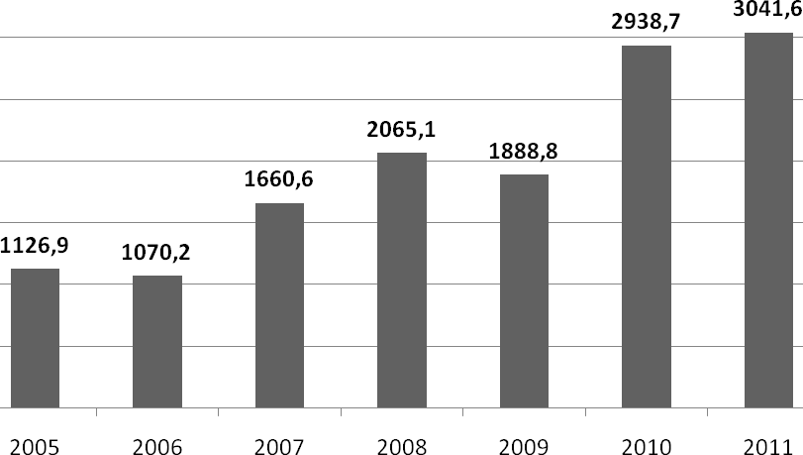
Figure 1. Prices of milk raw in Ukraine, UAH/t

As a result, milk prices nearly reached the level of world leaders in the market of milk. Thus, if during 2005-2007 the price of milk in Ukraine was lower than in the European Union and the United States, in 2008-2010 they were almost up with the level of the United States, and in 2010 even exceeded it (Fig. 2). In our opinion, raise prices for milk in the future there will not be an effective measure to ensure the profitability of agricultural producers. Since this will be an important prerequisite for the rising cost of ready products and adversely affect the competitiveness of the global market.
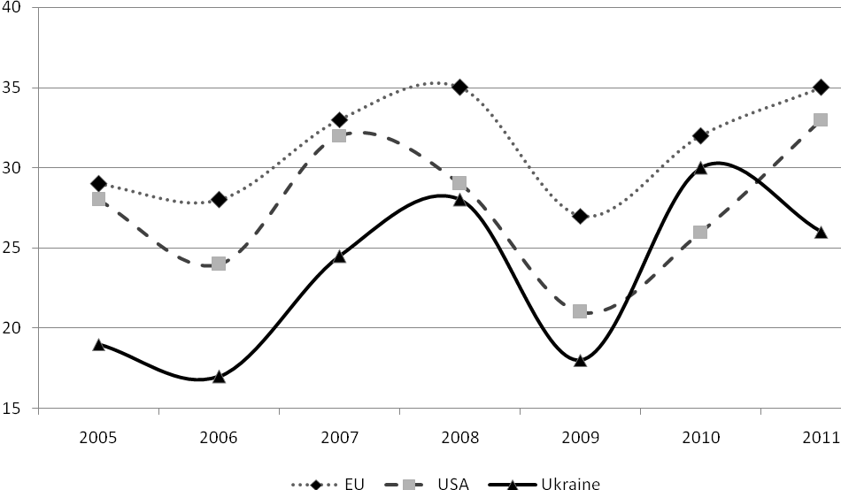
Figure 2. The purchase price for raw milk, Euro / kg*
According to [1]

An important factors that have major impact on pricing, are significant differences in the supply of milk at different times of the year. So, in the winter there is a significant reduction in output, and in the summer - on the contrary it serious growth (Fig. 3). The increase of supply affects the price level and decrease – on the contrary. Consequently, the prises in winter period are higher than in summer by 30-40%.
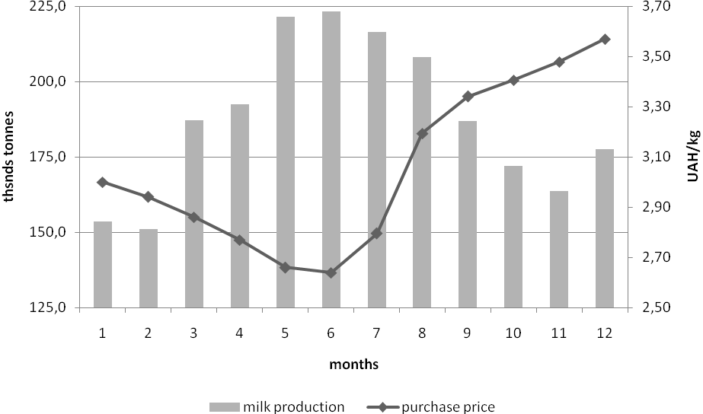
Fig.3. Monthly dynamics of milk production and purchase milk prices

An important reason for these changes may be flaws in the organization of production. Thus, due to lack of funds and facilities for the effective development a large number of farms are planning a massive calving cows in the spring and summer, when the value of livestock and their feed is reduced through the use of summer playgrounds and green mass. This allows producers to partially resolve the situation with the need for resources, but affects the level of prices for raw milk. Consequently, the profitability of dairy farming reduces. That is, solving the problems in this way producers further exacerbate the problems in the industry.
The problem of production seasonality experts provide special value and reduce its rate positive impact on the efficiency of both producers and processors [6].
Conclusions and suggestions. Farms in many cases are unable to influence the level of prices in the market. They are trying to organize their production so that production costs were lower than the prices paid for it in order to ensure profitability. It does not happen with all producers, because according to the State Statistics Service of Ukraine about 40% of agricultural units in 2011 were tortious.
Therefore, in order to provide income level particular attention should be paid to improvment the system of production, increase productivity and livestock. In addition, Kondratiuk O.I indicates that the competitiveness of domestic products in foreign markets very important issue is the quality [4, p.59]. All this together will help to improve the economic efficiency of milk production and don’t shift the problem to the end user as a result of the price increase. As dairies now pay almost the same price for raw materials as in the U.S. and the European Union, and its growth will lead to adverse consequences.

REFERENCES

- LTO International comparison of producer prices for milk – 2011 / LTO Nederland, 2012. – 25 p.
- Андрійчук В. Г. Економіка аграрних підприємств: Підручник. — 2-ге вид., доп. і перероблене. / В. Г. Андрійчук. — К.: КНЕУ, 2002. — 624 с.
- Економіка підприємства: Підручник/ За ред. С. Ф. Покропивного. — К.: КНЕУ, — 1999. — 541 с. с.444] .
- Кондратюк О.І. Конкурентоспроможність сільського господарства та шляхи її підвищення / О.І. Кондратюк // Актуальні проблеми економіки. – 2011. – №1(115). – ст.56-63
- Сільське господарство України. Статистичний збірник 2011 р. - К.: Державна служба статистики України, 2011. – 388 с.
- Шеремет О.О., Слободян Н.Я. Актуальні проблеми розвитку молочної промисловості в Україні / Сталість розвитку агропродовольчого комплексу України. – К.: Об’єднаний інститут економіки, 2004. – 141 с.

