УДК 619:611.37:611.018:636.7

HISTOLOGICAL CHANGES OF UTERINE TISSUE OF FEMALES OF SMALL CARNIVOROUS WITH PATHOLOGY OF REPRODUCTIVE SYSTEM OF MYCOPLASMA ETHIOLOGY

O.P.PROVALOVA, aspirant*

The paper presents the histological changes in the uterine tissues of healthy females and small animals with abnormal reproductive system mycoplasma etiology.

Bitch, queen, uterus, mycoplasma infection.

Widespread of urogenital mycoplasmas and their frequent detection of clinically healthy animals complicates the question of the meaning of these microorganisms in the pathogenesis of diseases of the reproductive system. In terms of some researchers, they belong to the absolute pathogens, other researchers believe mycoplasmas are opportunistic pathogens [2, 4].

Distinctive features of mycoplasma is lack of cell wall and the ability to parasitize (persist) in the cell membrane of the host. Mycoplasmas multiply intracellularly and intensively by dividing mother cells and by budding daughter cells from the surface of membrane of the mother cell. The cycle of development last about 6 days [3, 6].

It is proved that all mycoplasmas cause very large changes in the metabolism of the cells of the host organism: break an exchange of amino acids, synthesis of proteins, nucleic acids, introduce new genetic information. They increase the amount of free arachidonic acid, causing activation of prostaglandin synthesis, which can cause abortion, abnormal births, stillbirths, inflammatory diseases of the reproductive organs [1, 5].
During the study of uterine animals of the first group, there were observed no visible changed in the uterus during sterilization (ovariohysterectomy). (Pic. 1)
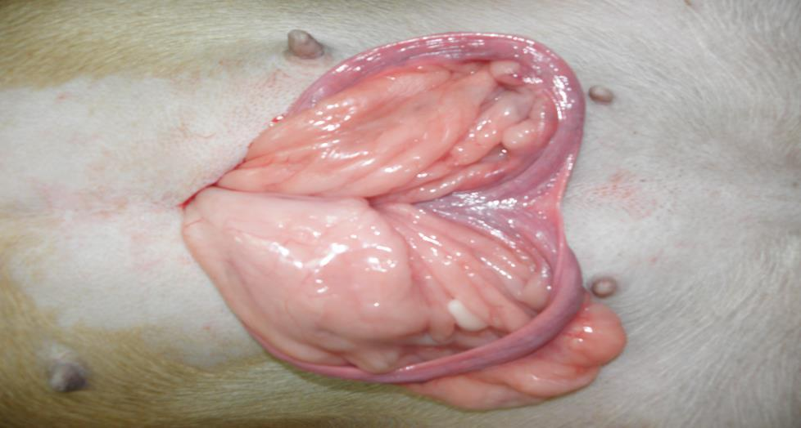

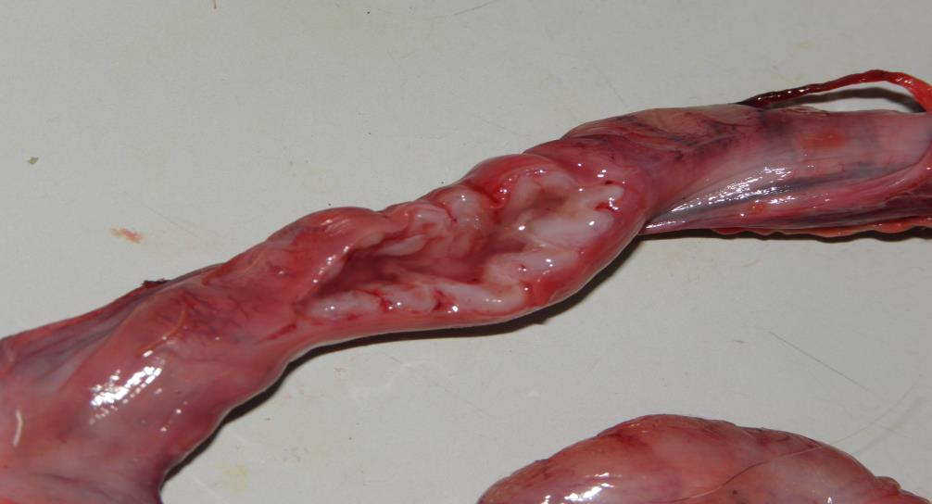
During sterilization (ovariohysterectomy) of animals of the second group we mentioned that uterus is visually altered and deformed. Uterine wall is thickened, sealed, rough, there is a few fluid in the cavity, endometrium is swollen, hyperemic (Pic. 2).

During ovariohysterectomy we removed the uterus filled with pus or with dead or unfolded fetuses from the animals of third group.(Pic. 3).
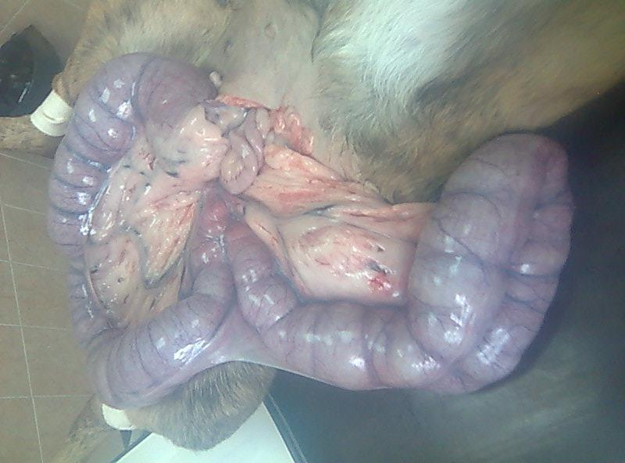

Two females, with signs of endometritis, histological examination revealed glandular-cystic endometrial hyperplasia with areas of adenocarcinoma (Pic. 4).
