UDC: 619: 616 - 091.8 : 578.822:636.7

PATHOMORPHOLOGICAL CHANGES IN CATS WITH CHLAMIDIOSIS
N. B. KOLYCH,Candidate of Veterinary Sciences, Associate Professor
Academician V. G. Kasyanenko Department of Anatomy, Histology and Pathomorphology
https://orcid.org/ 0000-0001-8024-0810
N. HUDZ, Candidate of Veterinary Sciences, Senior Researcher
Institute of Veterinary Medicine NAAS
https://orcid.org/ 0000-0001-8024-0810
National University of Life and Environmental Sciences of Ukraine, Kyiv, Ukraine
E-mail: Natasha-vet@ukr.net
Abstract. In recent years, there is a tendency to increase the incidence of the disease in dogs with signs of diarrhea, not only in Ukraine, but also in Europe. In general, diseases with the manifestation of such specific clinical sign as diarrhea can be caused by viruses, bacteria and helminths. In general pathology of dogs, enterovirus infections of puppies occupy a leading place. The practice of specific prophylaxis suggests that in the etiological aspect diseases emerging with this symptom can be caused not only by parvo-, but also corona- and rotavirus enteritis. These diseases are extremely dangerous for puppies and miniature dogs, due to rapid dehydration, and as a result, death.
The article presents the results of a study on histological changes in organs and tissues of dogs with coronavirus infection. A histological study of pathological material sampled from 6 dogs of various breeds and sex, aged from 2 to 6 months, died from diarrheal syndrome was carried out. The presence of the coronavirus was confirmed in fecal samples by polymerase chain reaction.
The most expressed injuries and typical changes in all dead dogs we recorded in the small intestine, namely in the jejunum and ileum, regional lymph nodes, and also in the spleen.
Morphological manifestations of coronavirus infection in dogs at macroscopic level are the following signs: the presence of exudative inflammation in the small intestine in form of serous-fibrinous jejunoileitis, hyperplasia and serohemorrhagic lymphadenitis of the mesenteric lymph nodes, multiple foci of hemorrhage in the parenchyma of the spleen and serous membrane of the small intestine, passive venous hyperemia of the liver and kidneys, dilatation of the right ventricle of the heart, pulmonary edema, cachexia and dehydration of the body.
At the microscopic level we registered the following: serofibrinous jejunoileitis, hyperplasia of the lymphoid nodules of the spleen and lymph nodes, hemorrhagic infarctions in the spleen, hyperplasia of individual and aggregated lymphoid nodules of the mucous membrane in the small intestine, degenerative processes in the parenchyma of the liver and kidneys.
Key words: coronavirus infection, dogs, histological changes, hemorrhages, serofibrinous jejunoileitis, serohemorrhagic lymphadenitis, hyperplasia, lymphoid nodules.

Introduction
The main threat to global health, economic stability and national security is zoonotic viral diseases, both known and re-emerging (R. L. Graham, D. J. Deming, M. E., 2018). The emergence of zoonoses can be considered a logical consequence of the ecology and evolution of pathogens that use new niches and adapt to new hosts.
Due to the constant human interference with the animal habitat and our close contact with domestic animals, the number of zoonoses will continue to increase, given the spread and density of population and livestock production over the next century.
In developed countries, the problem of infectious pathology of small domestic animals, as well as in ours, has its own stages of exacerbation, since pathogens evolve, adapt, occupy new niches and, thus, do not allow to weaken our attention to them. At the same time, there is a lack of domestic literature devoted to the problems of infectious pathology of small animals, presented with consideration of modern data obtained by scientists on a global scale.
More than 60% of infectious diseases in humans are caused by pathogens inherent in wild or domestic animals. Microorganisms that cause zoonoses include those that are endemic in human populations or enzootic in animal populations with frequent interspecies transmission to humans (W. B. Karesh, A. Dobson, 2012). The role of viruses in the emergence and development of human infectious diseases is growing steadily. Only at the beginning of the 21st century, many new viruses appeared, which were not previously known, and most of which are able to cause severe infectious diseases, often fatal.
Among them are new human coronaviruses, which are called SARS-CoV (Severe acute respiratory syndrome, SARS) and MERS-CoV (Middle East respiratory syndrome, MERS). Both of them cause acute respiratory distress syndrome (ARDS) and are associated with high mortality rates (S. Su, G. Wong at all, 2016).
In N. Decaro and C. Buonavoglia (2008) review on the genetic evolution of CCoV and the emergence of new CoVs in canines, it is also noted that the emergence of severe acute respiratory syndrome in humans has provoked new interest, to animal coronaviruses as well, as potential agents of direct and indirect zoonoses .

Analysis of recent research and publications
Canine coronavirus (CCoV), has been known since the 1970s. In dogs, CoV is associated with mild enteritis. But CoV strains with different biological and genetic properties in relation to the classic CCoV strains have been found in dogs in recent years, leading to a complete reconsideration of the CoV-induced canine diseases.
The practice of specific prophylaxis allows us to state that in the etiological aspect, diseases emerging with this symptom can be caused not only by parvo-, but also corona- and rotavirus enteritis. S.A. Godsall et al. (2010) also noted that canine parvovirus (CPV) and canine enteric coronavirus (CECoV) are usually cause diarrhea in dogs. Although the canine enteric coronavirus is less common, it still remains a potentially important pathogen, the authors noted (Godsall S.A,2010). These diseases are extremely dangerous for puppies and miniature dogs, due to rapid dehydration and, as a consequence, death.
The name “coronavirus” dates back to 1968 and derives from the Greek κορώνα, which means corona (corona-like structure observed in these viruses in an electron microscope). Coronaviruses (CoVs) are enveloped viruses with spherical, and sometimes pleomorphic virions with a diameter of 80 to 120 nm. Coronaviruses have the largest genomes of all RNA-viruses known today with an average length of 27 to 31 thousand bp and replicate using a unique mechanism, which leads to a high frequency of recombinations (X. Wang, C. Li, D. Guo et al.2016).
Previously, coronaviruses were divided into three genera (I-III), which were usually called groups and based on serological cross-reactivity (Pratelli A. , 2011).
Phylogroup I CoV including human coronaviruses HCoV-229E and HCoVNL63 that cause respiratory infections, feline coronaviruses (FCoVs) type 1 and 2, transmissible gastroenteritis virus (TGEV) of pigs, porcine respiratory coronavirus (PRCoV), porcine epidemic diarrhea virus (PEDV), and canine coronaviruses (CCoVs). Ferret coronavirus has recently been identified as a member of phylogroup I.
Phylogroup II of the mammalian CoV is divided into two subgroups, bovine-like subgroup 2a and SARS-like subgroup 2b. Subgroup 2a includes bovine coronavirus (BCoV), murine hepatitis virus (MHV), sialodacryoadenitis virus of rats (SDAV), porcine hemaglutinous encephalomyelitis virus (PHEV), human coronaviruses (HCoV-OC43 and HCoV-HKU1), which cause respiratory infections, human enteric coronavirus (HECV-4408), the recently recognized equine coronavirus (ECoV) and canine respiratory coronavirus (CRCoV).
Group III includes only avian coronaviruses, such as infectious bronchitis virus (IBV), turkey coronavirus (TCoV) and pheasant coronavirus.
Canine coronavirus (CCoV) causes sporadic cases of enteritis in dogs. In general, CCoV is recognized as the etiological agent of self-limiting small intestine infections, which can lead to mild gastroenteritis. Mild illness or asymptomatic carrier state are likely to be the usual consequences of infection in most cases. Canine coronavirus enteritis (CCoV) is a common infection, usually in young dogs, especially those in large groups such as dog pounds, shelters and kennels (Stavisky, G. Pinchbeck, RM. Gaskell et al., 2012). However, several years ago, a highly virulent strain (pantropic CCoV) was isolated that caused an outbreak of fatal, systemic diseases in puppies. This strain showed some genetic changes relative to the existing strains circulating in the dog population. By definition, 53 feline and canine coronaviruses are common pathogens in cats and dogs that can cause fatal infections such as feline infectious peritonitis (FIP) and canine pantropic coronavirus infection. Alphacoronavirus coronavirus and Betacoronavirus respiratory coronavirus have been found in dogs (T. Takano, S. Yamashita, M. Murata-Ohkubo at all. 2016).
The extent of the natural disease caused by canine coronavirus is not well understood, as the pathogenesis of CCoV is not yet well defined. It was previously reported that the infection was associated with moderate to severe gastroenteritis, but it now appears that CCoVs are predominantly mild or subclinical, with low mortality rates.
CCoV is acid resistant, so it passes through the stomach unchanged. Viremia and generalized infection are not observed. The superficial epithelium of the small intestine is the main target of CCoV, but the large intestine is resistant to infection. In 2 days after oral infection, CCoV can be detected in the cytoplasm of mature epithelial cells of the villi in the upper two-thirds of the duodenum, compared to canine parvovirus type 2 (CPV-2), which destroys the epithelium of intestinal crypts.
Loss of villi of mature enterocytes causes atrophy of intestinal villi and, as a consequence, weakening of the integrity of the intestinal barrier [54]. After the fourth day of infection, the small intestine usually has a heterogeneous distribution of infected villi [68]. Together these changes in the morphology of the small intestine result in a loss of normal digestive and absorption functions, as well as clinical signs of diarrhea and dehydration in sick dogs.
The factors regulating the course of natural diseases caused by intestinal CCoVs are not well understood. CCoVs are responsible for enteritis in dogs, and signs of infection can range from mild to moderate, but more severe in young puppies or in combination with other pathogens. All data raise a number of questions and request deeper studies of the pathobiology of CCoVs types 1 and 2.

Material and methods of research.
The study was performed in the pathohistological laboratory of the the Academician V.G. Kasyanenko Department of Anatomy, Histology and Pathomorphology of Animals of the Faculty of Veterinary Medicine of NULES of Ukraine.
The material of the study was the pathological material collected during the postmortem autopsy of dogs of various breeds and genders who died with diarrheal syndrome at the age from 2 to 7 months (n = 6). The presence of coronavirus, with no other pathogens, was confirmed in fecal samples of dogs before death by PCR. According to the anamnestic data, animals had pronounced clinical signs such as the disruption of the digestive system of an infectious origin (fever, lack of appetite, vomiting, diarrhea). The pathological and anatomical autopsy of the dogs’ carcasses was performed in the supine position by the method of partial evisceration in the generally accepted sequence.
The main method used in the study was histological examination, during which microstructural changes in organs and tissues were recorded and described. The pathological material was processed according to generally accepted histological methods.
Pieces of organs were fixed with a 10% Neutral Buffered Formalin according to Lilly’s prescription, graded alcohols were used for dehydration and embedded in paraffin after chloroform. Using a sled microtome, sections with a thickness of 6-7 μm were obtained. The histological structure of organs and tissues was studied by sections’ staining with Karazzi’s hematoxylin and eosin. The histopreparation was examined and photographed using an Olympus microscope BX-41 (L.P. Goralskij, M L. Radzihovskij, S. S. Zayika 2018).

Research results and discussion.
On external examination of the dead animals’ carcasses in all cases we noted dull coat, the skin was dry, not elastic, the visible mucous membranes were dry, pale with a grayish color, not shiny. All animals showed signs of malnutrition as a result of dehydration and diarrhea.
The liver was enlarged, elastic, dark cherry color with insignificant areas of putrefactive color, which indicated the presence of dystrophic processes in its parenchyma. A red, bloody fluid flowed from the incision. Histological examination revealed the destruction of the beam structure of the liver. Hepatocytes are placed randomly with signs of granular dystrophy, which was morphologically manifested by cells’ swelling, disappearance of cytoplasm transparency, and appearance of protein origin grains. Hepatocytes showed signs of karyolysis. Sinusoidal capillaries were engorged with blood in the center of the lobules. In the lumen of the central veins there were formed elements of blood, mainly erythrocytes. In some cases, small areas of fatty degeneration were found with the formation of characteristic vacuoles of various sizes in the cells’ cytoplasm.
The gallbladder in all cases was filled with thick dark green bile.
The pancreas was of gray-pink color, slightly enlarged, edematous. The lobulated structure was well-defined.
The spleen was moderately enlarged, had soft texture with pointed edges. Hemorrhagic infarcts were registered on the surface of the spleen.
Microscopically, the red pulp showed hemorrhages and clear contours and a specific triangular structure of hemorrhagic infarcts. On the section, a pronounced granular structure of the organ was shown by hyperplastic lymphoid nodules due to active proliferation of lymphoid cells.
The kidneys in all cases were dark cherry in color. On the section, the border between the cortical and medullary substances was smoothed, the section surface had increased moisture. It should be noted that venous hyperemia of the liver and kidneys was the result of hemodynamic disturbances in the systemic circulation due to heart failure. The main microscopic changes of a dystrophic nature were found in the epithelium of the convoluted tubules. The affected epithelium is massively desquamated into the lumen of the tubules.
The heart is enlarged in size, round in shape due to the right ventricle enlargement, less often the entire right side, and due to the displacement of the heart apex to the left. The heart muscle was soft, unevenly colored, a gray-pink color. The cut surface had increased moisture, the blood vessels of the heart were full of blood. Such pathological processes may indicate the development of compensated heart failure during the life of the animal, which developed as a result of the disease.
Lungs had even red color, pastry, elastic consistency, the pieces floated difficult in water. A foamy reddish liquid flows down from the cut surface. The same fluid was in the trachea and in the lumen of large bronchi that was a morphological sign of pulmonary edema due to venous hyperemia.
Examination of the abdominal organs in all cases showed enlarged mesenteric lymph nodes, vascular hyperemia and hemorrhages in the serous membrane of the intestine. On the cut, the parenchyma of the lymph nodes was pink-red, juicy, and shiny. Signs of serohemorrhagic inflammation were noted in the form of serous impregnation of the lymph node parenchyma and the release of formed blood cells with exudate.
Microscopically the lymphoid nodules hyperplasia of lymph nodes was shown as a result of active proliferation of reticulocytes and lymphoid cells. In some nodules necrosis and devastation were observed.
Along the entire length of the small intestine, striped, less often spotted hemorrhages appeared on the serous membrane. The content of the small intestine, in particular the jejunum and ileum, looked like a cloudy gray-pink fluid. The surface of the mucous membrane of the jejunum and ileum was covered with a large amount of liquid cloudy mucus, under which small spotty hemorrhages were manifested. In the cut, the wall of the small intestine was edematous and gelatinous. In some cases, pityriasis with gray-yellow films were noted on the mucous membrane of the jejunum and ileum that were difficult to remove (Fig.1).
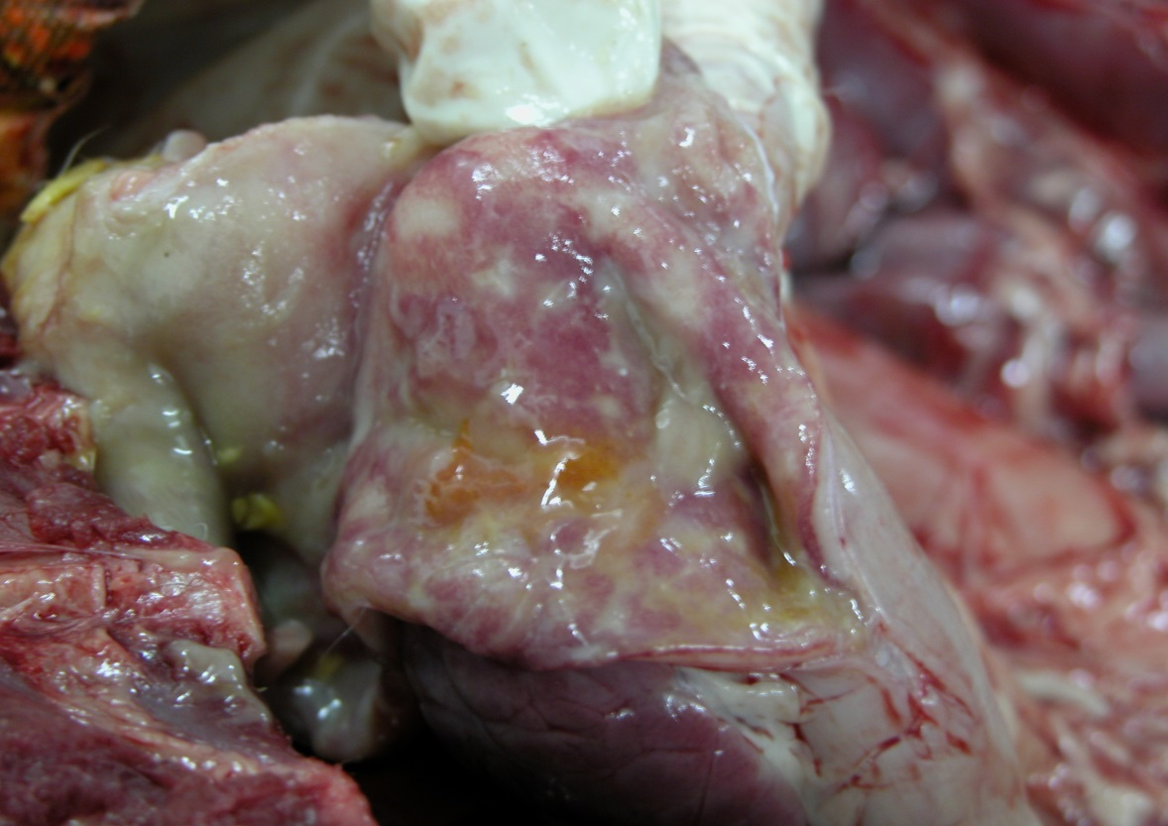
Figure 1. Сatarrhal-hemorrhagic inflammation of the small intestine

In the jejunum, an increase in the lymphoid formations of the intestinal wall was observed: rare and aggregated lymphoid nodules due to the proliferation of reticulocytes and the accumulation of a large number of lymphocytes. They acquired a clear rounded shape and were intensively stained with hematoxylin. The main changes were localized mainly in the villi area. Effusion of fibrinous exudate was observed on the surface of the mucous membrane, which, together with the desquamated epithelial cells, covered the villi in the form of lumps. In epithelial cells there were karyopyknosis, karyorrhexis and signs of cytolysis. Necrosis and loss of the epithelium of the villi of the small intestine were accompanied with their atrophy, deformation, shortening and desquamation of the virus-infected enterocytes into the lumen (Fig. 2).
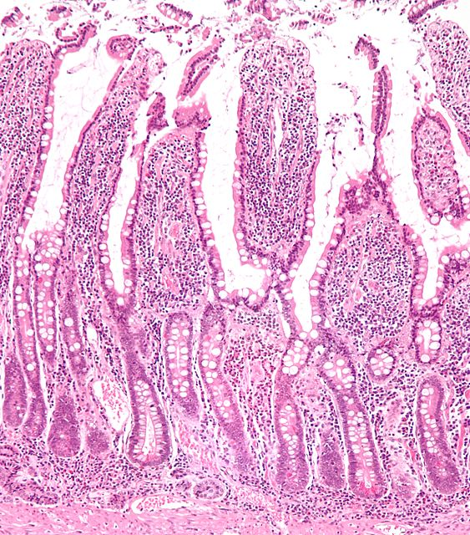
Figure 2. Desquamation of the epithelium, deformation and destruction of villi. Hematoxylin and eosin. 400x.

Along with expressive alterative changes in the epithelium, regeneration processes were often clearly expressed, mainly in crypt areas. There were no significant histological changes. The structure of the crypts and the epithelium was preserved. Necrosis and loss of epithelium of the villi of the small intestine and the probable disruption of goblet cell secretion leads to the destruction of its protective barrier. Diarrheal syndrome is one of the main clinical manifestations and a key link in the pathogenesis of coronavirus infection is due to the development of serofibrinous enteritis, since in the areas of inflammation there is a loss of mature epithelium, parietal digestion and cellular absorption are disturbed.

Conclusions
- Morphological manifestations of coronavirus infection in dogs at the macroscopic level are: serofibrinous jejunoileitis, hyperplasia and serohemorrhagic lymphadenitis of mesenteric lymph nodes, dilatation of the right ventricle of the heart, multiple hemorrhages in the spleen parenchyma and in the serous membrane of the small intestine, cachexia and dehydration of the body.
- At the microscopic level, the following was noted: serofibrinous jejunoileitis, hyperplasia of the lymphoid nodules of the spleen and lymph nodes, hemorrhagic infarcts in the spleen, hyperplasia of individual and aggregated lymphoid nodules of the mucous membrane of the small intestine, passive venous hyperemia of the liver and kidneys, dystrophic processes in the parenchyma of the liver and kidneys.
Prospects for further research. For a complete study of the pathomorphological picture of coronavirus enteritis in dogs, as the next stage, it is advisable to investigate the characteristics of this disease using histochemical methods.
References
Ann S.Y., Kim H.T., Kim, D. (2014). M gene analysis of canine coronavirus strains detected in Korea. J Vet Sci. 15, 495–502.
Decaro, N., Mari, V., von Reitzenstein, M. (2012). A pantropic canine coronavirus genetically related to the prototype isolate CB/05. Vet Microbiol. 159 (1–2), 239–244.
Gizzi, A.B.R., Oliveira, S.T., Leutenegger, C.M. et al. (2014). Presence of infectious agents and co-infections in diarrheic dogs determined with a real-time polymerase chain reaction-based panel. BMC Veterinary research, 6, 81‒90.
Goralskij, L.P., Homych, V.T., Kononskij, O.I. (2011). Osnovy histologichnoyi tehniky i morfofunkcionalni metody doslidjen u normi ta pry patologiyi [Foundations of histological engineering and morphofunctional methods of research in norm and pathology]. Jytomir, Ukrainian: Polissya (in Ukrainian).
Godsall S.A. Epidemiology of canine parvovirus and coronavirus in dogs presented with severe diarrhoea to PDSA / Godsall SA, Clegg SR, Stavisky JH // Pet Aid hospitals. Vet Rec. – 2010. – 167. – P. 196–201, doi: 10.1136/vr.c3095.
Graham R. L. Evaluation of a recombination-resistant coronavirus as a broadly applicable, rapidly implementable vaccine platform / R. L. Graham, D. J. Deming, M. E. Deming, B. L. Yount, R. S. Baric // Communications Biology. – 2018. – V. 1. – Article number: 179. Режим доступу: https://www.nature.com/articles/s42003-018-0175-7
Karesh W. B. Ecology of zoonoses: natural and unnatural histories / W. B. Karesh, A. Dobson, J. O. Lloyd-Smith et al. // Lancet, 2012. – V. 380. – P. 1936–1945.
Pratelli A. The Evolutionary Processes of Canine Coronaviruses / A. Pratelli // Advances in Virology. – Vol. 2011. – Article ID 562831, 10pages.doi.org/10.1155/2011/562831. Режим доступу: https://www.hindawi.com/journals/av/2011/562831/
Stavisky J. Cross sectional and longitudinal surveys of canine enteric coronavirus infection in kennelled dogs: a molecular marker for biosecurity / J. 125 Stavisky, G. Pinchbeck, RM. Gaskell et al. // Infect Genet Evol. – 2012. – 12. – P. 1419–1426.
Su S. Epidemiology, Genetic Recombination, and Pathogenesis of Coronaviruses / S. Su, G. Wong, W. Shi, J. Liu, A. C.K. Lai et all. // Trends in microbiology. – 2016. – 24 (6). – P. 490-502.
Takano T. Prevalence of canine coronavirus (CCoV) in dog in Japan: detection of CCoV RNA and retrospective serological analysis / T. Takano, S. Yamashita, M. Murata-Ohkubo, K. Satoh, T. Doki and T. Hohdatsu //J Vet Med Sci. – 2016. – 78(2). – P. 341–345.
Wang, X., Li, C., Guo, D. (2016). Co-Circulation of Canine Coronavirus I and IIa/b with High Prevalence and Genetic Diversity in Heilongjiang Province, Northeast China. Available at: http://journals.plos.org/plosone/ articleid=10.1371/journal.pone.0146975 Jeoung,

