UGC: 519.23

DETERMINATION OF THE DYNAMIC PROPERTIES OF THE CEREAL LAYER IN HD CONVECTIVE EFFECTS

©D. А. BUDNIKOV, Candidate of Technical Sciences

FGBNU VIECH (c. Moscow)

Implementation of energy saving process postharvest processing of grain due to the construction of automatic control systems for the effective operation of which requires knowledge of the behavior of the material being processed under the influence factors used. The absence of these data leads to a waste of energy, as well as the decline in the quality of the final product. In this case, drying is often one of the most processes in the production of cereals. This study aimed at obtaining the dynamic properties of the grain mass during drying by electromagnetic waves.
Microwave-convective drying, postharvest handling, dynamic properties, identification.

For the construction of optimal designs of energy-saving facilities for drying agricultural products need to have an understanding of the dynamic properties of the treated object. The absence of these data leads to a waste of energy, and reduce the quality of the final product. Thus, the information that the drying is one of the most energy intensive processes in the production of grain that determines the relevance of the study.
Studies on the dynamic properties of granular materials during the drying process are conducted to a particular plant type. So now there are data obtained for the mine dryers, active ventilation systems and other [1-5]. The researchers obtained dynamic characteristics, and regression models for the large number of crops. Scientists of the University of California and the Western Regional Research Center (USA) shows the dependence to describe the process of drying rice varieties different in a thin layer [4]. Ongoing studies [2-5], can judge that for the development of control systems of drying equipment necessary to conduct a detailed study of different cultures under the influence of the whole variety of existing factors affecting grain material in the drying process. Of great interest is the use of microwave-convection effects, although data on the behavior of the grain layer in such a treatment is not yet complete. This is due to the fact that the installation of this type has not yet been widely used due to low productivity, increased requirements for the qualification of staff, etc.
The purpose of research - to provide the dynamic properties of the grain layer in a microwave-convective impact and purpose of the article - to show the results obtained in the microwave convection drying. In this grain layer acts as the control object, and expressed in some form information about the most important characteristics of a model object.
The cereal layer as the control object is a dynamic object, i.e. object, whose output depends not only on the current values ​​of the input signal, but also from their values ​​at the previous times.
Materials and methods of research. Analysis of dynamic characteristics was performed for a fixed grain dense layer subjected to the effects of convection microwave. Scheme of laboratory setup is shown in Fig. 1. Position the following parameters: the size of the zone of microwave and convective effects, filled with grain 200 × 200 × 300 mm, power = 900W magnetron Pc, a filtration rate of air through the grain layer V = 0.6 m / s. Experimental conditions: outdoor temperature (drying agent) T = 18S, the crops - wheat, grain moisture content of the material W = 12 ÷ 20% in increments of 2%; Ventilation is carried out continuously, the impact of microwave field was carried out in pulsed mode (5 SHF on, 10 off). The specific power of the electromagnetic field dissipated at a particular point, is determined depending on initial moisture content of the processed material. The response as a function of the selected temperature of the grain material.
To determine the power density at a particular point has been developed "Apparatus for determining the specific power of the electromagnetic field of the microwave emitted into the grain bed" (Fig. 2).
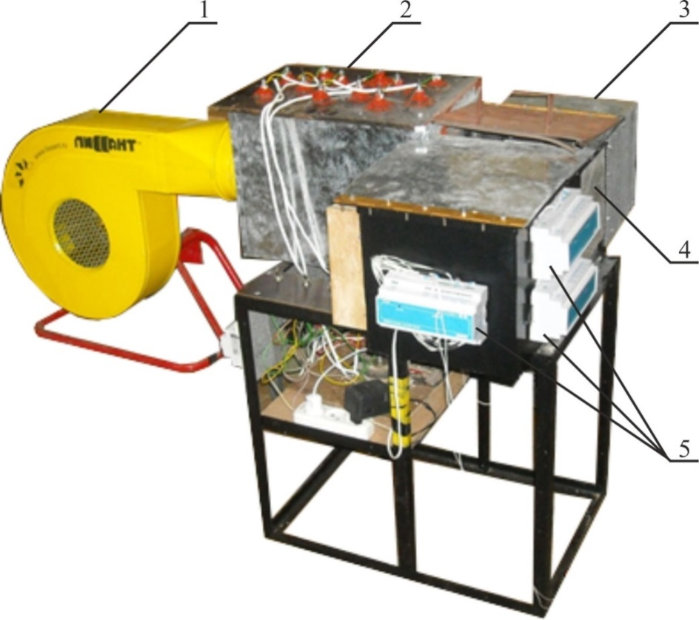
Fig. 1. Laboratory installation: 1 - blowing fan; 2 - unit heaters; 3 - magnetron; 4 - zone convection microwave exposure; 5 - signal acquisition modules
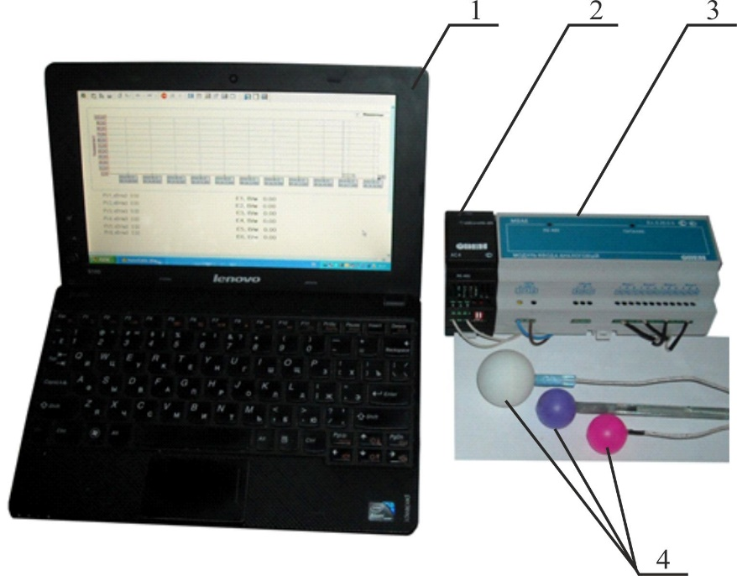

Fig. 2. Apparatus for determining the specific power of the electromagnetic field of the microwave emitted into the grain layer:
1 - PC, which implements the algorithm of measurement; 2 - interface converter; 3 - input module signals (up to 8 sensors); 4 – Sensors

Fig. 3 shows the arrangement of the temperature sensors during the experiment. The distances between adjacent sensors equal to L = 50 mm, the horizontal distance to the input screen of the microwave field was made of 70 mm, A = 70 mm B = 45 mm. Theoretical background of the scheme described in [6-7].
Processing the results of experiments conducted in Matlab package using System Identification Toolbox. The experimental data were recorded in csv - file format, which is supported by Matlab for data import. Then carried out a preliminary processing of the signals of the object, the removal of any DC component and ask the data range. For the analysis of parametric models were constructed (parametric model) of ARX-model (AutoRegressive with eXternal input) of different levels according to the procedures described in [8-11].
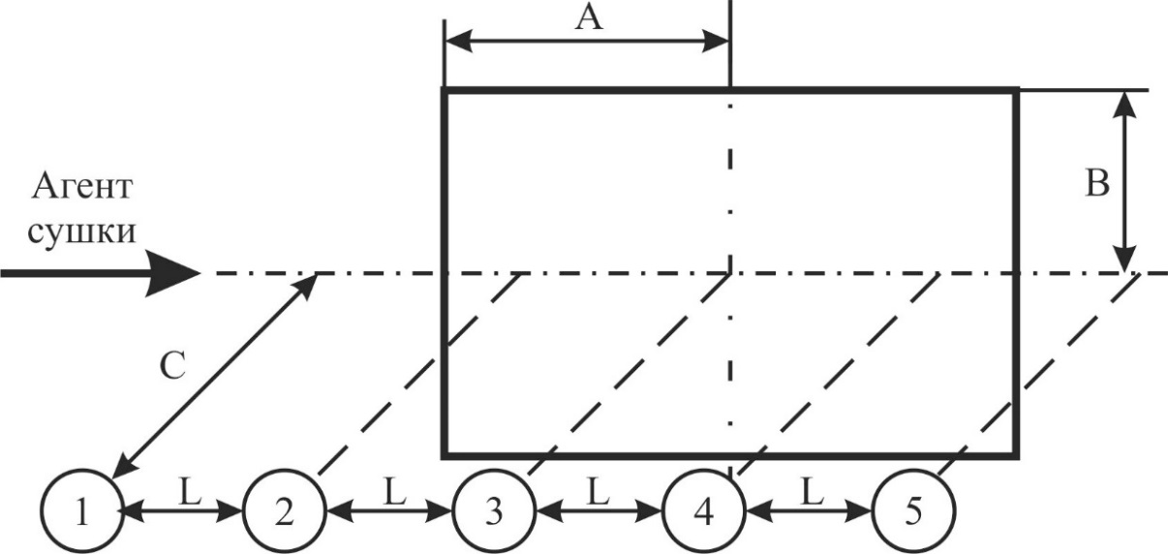

Fig. 3. Scheme of the sensors

The results of research. An example of the measurement results is shown in Fig. 4.

Fig. 4. Results of the experiment at W = 18%

ARX- the model can be represented as:
A(z)y(t)=B(z)u(t)+e(t), (1)
or in expanded form:
y(t)+a₁y(t-1)+…a_{na}y(t-n)=b₁u(t)+b₂u(t-1)+…+b_{nb}u(t-m)+e(t), (2)
Further analyzes were polynomial transfer functions. General view of the transfer function of a Process Models is:
$G\left(s\right)=\frac{Kp}{1+Tp1∙s}∙e^{−Td∙s}.$ (3)
Example coefficients for it is shown in Table 1.
At the final stage of the order we assessed the parametric model, comparison of models and assess their adequacy. Models describing the dynamic properties of the layer during microwave wheat convective effects resulting from analysis of the experimental data partially shown in Table 2.

1. Coefficients Process Models for grain layer
W,% | № of sensor | Kp | Tp1 | Td
16 | 1 | 0,54795 | 935,59 | 23,935
16 | 2 | 0,68909 | 527,15 | 11,765
16 | 3 | 0,048423 | 189,0945 | 12,523
16 | 4 | 0,12185 | 121,3217 | 0
16 | 5 | 0,945976 | 217,8842 | 27,169

EXAMPLE transfer functions obtained for cereal layer is shown in Table 3.
2. Results polynomial analysis in System Identification Toolbox | Type of model | arx223 | A(z)=1-1,336z⁻¹+0,3525z⁻²  B(z)=-0,0001427z⁻³-0,0006153z⁻⁴ | A(z)=1-1,322z⁻¹+0,3444z⁻²  B(z)=-0,0003183z⁻³-0,00007325z⁻⁴ | A(z)=1-1,447z⁻¹+0,4596z⁻²  B(z)=-0,00000177z⁻³-0,00003852z⁻⁴ | A(z)=1-1,507z⁻¹+0,5321z⁻²  B(z)=-0,0001467z⁻³-0,0003056z⁻⁴ | A(z)=1-1,35z⁻¹+0,3521z⁻²  B(z)=-0,0002023z⁻³-0,00008896z⁻⁴ | A(z)=1-1,404z⁻¹+0,4886z⁻²  B(z)=-0,001329z⁻³+0,0003492z⁻⁴ | A(z)=1-1,476z⁻¹+0,5656z⁻²  B(z)=-0,0001585z⁻³+0,00008151z⁻⁴ | A(z)=1-1,451z⁻¹+0,5081z⁻²  B(z)=-0,0000952z⁻³+0,00000253z⁻⁴ | A(z)=1-1,441z⁻¹+0,4636z⁻²  B(z)=-0,000003455z⁻³-0,00005538z⁻⁴ | A(z)=1-1,499z⁻¹+0,5046z⁻²  B(z)=-0,001124z⁻³+0,00003138z⁻⁴
 | Type of model | arx332 | A(z)=1-1,342z⁻¹+0,430z⁻²-0,07237z⁻³  B(z)=0,0001748z⁻²-0,0002074z⁻³-0,0006489z⁻⁴ | A(z)=1-1,373z⁻¹+0,498z⁻²-0,1049z⁻³  B(z)=-0,000005863z⁻²-0,001846z⁻³-0,00008234z⁻⁴ | A(z)=1-1,436z⁻¹+0,5824z⁻²-0,1334z⁻³  B(z)=0,00002683z⁻²-0,00001128z⁻³-0,00003976z⁻⁴ | A(z)=1-1,279z⁻¹+0,7614z⁻²-0,4598z⁻³  B(z)=0,0005334z⁻²-0,0002439z⁻³-0,0003656z⁻⁴ | A(z)=1-1,39z⁻¹+0,5242z⁻²-0,1315z⁻³  B(z)=-0,0002345z⁻²-0,0000083z⁻³-0,0001699z⁻⁴ | A(z)=1-1,507z⁻¹+0,7711z⁻²-0,1947z⁻³  B(z)=0,0003982z⁻²-0,001739z⁻³ +0,0003682z⁻⁴ | A(z)=1-1,543z⁻¹+0,7708z⁻²-0,1599z⁻³  B(z)=-0,00007289z⁻²-0,0001106z⁻³ +0,00005382z⁻⁴ | A(z)=1-1,45z⁻¹+0,4891z⁻²+0,01823z⁻³  B(z)=-0,000005608z⁻²-0,00009498z⁻³ +0,000005342z⁻⁴ | A(z)=1-1,571z⁻¹+0,8917z⁻²-0,3065z⁻³  B(z)=-0,00006331z⁻²+0,00005635z⁻³-0,00007751z⁻⁴ | A(z)=1-1,64z⁻¹+0,9801z⁻²-0,3386z⁻³  B(z)=-0,0008764z⁻²-0,0003862z⁻³ -0,0004756z⁻⁴
 | Type of model | arx441 | A(z)=1-1,287z⁻¹+0,429z⁻²-0,2159z⁻³+0,09211z⁻⁴  B(z)=0,0006701z⁻¹-0,0003012z⁻²-0,0002491z⁻³-0,0005811z⁻⁴ | A(z)=1-1,346z⁻¹+0,5244z⁻²-0,2514z⁻³+0,09399z⁻⁴  B(z)=0,00003436z⁻¹-0,00003296z⁻²-0,00002616z⁻³-0,00007604z⁻⁴ | A(z)=1-1,344z⁻¹+0,555z⁻²-0,2907z⁻³+0,09358z⁻⁴  B(z)=0,00004234z⁻¹+0,000007242z⁻²-0,00001376z⁻³-0,00003747z⁻⁴ | A(z)=1-0,92z⁻¹+0,08925z⁻²-0,02725z⁻³+0,1844z⁻⁴  B(z)=0,00004234z⁻¹+0,000007242z⁻²-0,00001376z⁻³-0,00003747z⁻⁴ | A(z)=1-1,4z⁻¹+0,5588z⁻²-0,2327z⁻³+0,07647z⁻⁴  B(z)=-0,0001911z⁻¹-0,00009827z⁻²-0,00001106z⁻³-0,0001852z⁻⁴ | A(z)=1-1,546z⁻¹+0,9718z⁻²-0,6814z⁻³+0,3435z⁻⁴  B(z)=-0,0004318z⁻¹-0,0001135z⁻²-0,001354z⁻³-0,0001852z⁻⁴ | A(z)=1-1,578z⁻¹+0,9435z⁻²-0,5145z⁻³+0,2326z⁻⁴  B(z)=-0,000005526z⁻¹-0,0001168z⁻²-0,00004932z⁻³+0,00005697z⁻⁴ | A(z)=1-1,58z⁻¹+0,907z⁻²-0,4388z⁻³+0,1849z⁻⁴  B(z)=0,0002176z⁻¹-0,0002239z⁻²-0,00000742z⁻³-0,000001471z⁻⁴ | A(z)=1-1,625z⁻¹+1,051z⁻²-0,5935z⁻³+0,1857z⁻⁴  B(z)=0,000008551z⁻¹-0,00008586z⁻²+0,00008378z⁻³-0,00008606z⁻⁴ | A(z)=1-1,69z⁻¹+1,148z⁻²-0,661z⁻³+0,2059z⁻⁴  B(z)=-0,0005479z⁻¹-0,0006393z⁻²-0,0002432z⁻³-0,0004197z⁻⁴
 | № of  sensor |  | 1 | 2 | 3 | 4 | 5 | 1 | 2 | 3 | 4 | 5
 | W, % |  | 12 | 12 | 12 | 12 | 12 | 14 | 14 | 14 | 14 | 14

3. The transfer functions for the cereal layer
W,% | № sensor | Transmission function
18 | 1 | $$\frac{0,0007082s+0,00002612}{s^{3}+0,1965s^{2}+0,01082s+0,00003605}$$
18 | 2 | $$\frac{0,0003572s+0,00000001305}{s^{3}+0,09751s^{2}+0,003184s+1,281∙{10}^{−16}}$$
18 | 3 | $$\frac{0,0002381s+0,000004202}{s^{3}+0,1103s^{2}+0,003803s+0,00004475}$$
18 | 4 | $$\frac{0,00195s+0,0000001137}{s^{2}+0,01233s+6,368∙{10}^{−8}}$$
18 | 5 | $$\frac{0,003081s+0,0001449}{s^{3}+1,155s^{2}+0,05545s+0,0001584}$$
20 | 1 | $$\frac{0,001013s+0,00001706}{s^{3}+0,5045s^{2}+0,0134s+0,00002328}$$
20 | 2 | $$\frac{0,1657s+0,0003007}{s^{3}+363,9s^{2}+1,901s+0,00225}$$
20 | 3 | $$\frac{0,000119s+0,00000001928}{s^{3}+0,03695s^{2}+0,0014s+6,386∙{10}^{−10}}$$
20 | 4 | $$\frac{0,0002665s+0,000007215}{s^{3}+2,489s^{2}+0,03218s+0,00004237}$$
20 | 5 | $$\frac{0,0008347s+0,00003231}{s^{3}+0,3773s^{2}+0,01553s+0,00003815}$$

Conclusions
1. Dynamic properties of grain material vary in thickness from moving in the direction of ventilation at equal values ​​of specific power of the electromagnetic field.
2. Conduct identification of the grain layer, as an object of management, provides a wide range of characteristics: transition, polynomial, frequency, etc.
3. In carrying out the identification of the object you want to monitor the qualitative assessment to determine the most simple relationship with sufficient accuracy describes the process under study.
4. In most cases, the qualitative description (better than 5%) of the cereal layer behavior in the description of the transfer function using ARX-model requires third degree equation.

Список литературы
- Андрианов Н. М. Идентификация динамических характеристик зерновых сушилок / Н. М. Андрианов // Успехи современного естествознания. – 2003. – № 8 – С. 14-17.
- Olmos A. Dynamic optimal control of batch rice drying process / A. Olmos, I. Trelea // Drying Technology. – 2002. – 20(7). – Р. 1319-1345.
- Moravej M. K. Investigation of Some Effective Parameters on the Fluidized Bed Grain Dryers / M. K. Moravej // Iranica Journal of Energy & Environment. – 2013 – 4. (4): Р. – 391-397.
- Prakash В. Modeling Moisture Movement in Rice, Advanced Topics in Mass Transfer, / В.Prakash, Z. Pan // Prof. Mohamed El-Amin (Ed.).
- Bhadra R. Characteristics of Distillers Wet Grains Under Varying Condensed Distillers Solubles and Drying Temperature / R. Bhadra, K. Rosentrater, K. Muthukumarappan, S. Kannadhason // American Society of Agricultural and Biological Engineers. – 2011. Vol. 27(5). – Р. 777‐786.
- Будников Д. А. Поглощение электромагнитного поля СВЧ сельскохозяйственными материалами // Д. А. Будников // Вестник ВИЭСХ. -2013. – №2 (11). – С. 38-40.
- Будников Д. А. Исследование динамических свойств зернового слоя при СВЧ-конвективном воздействии / Д. А. Будников // Теоретический и научно-практический журнал ФГБНУ ВИЭСХ” Инновации в сельском хозяйстве” – М.: ФГБНУ ВИЭСХ, 2014. – №4(9). – С. 94-98.
- Льюинг Л. Идентификация систем [Теория для пользователя] / Л. Льюинг – М.: Наука, 1991.
- Дейч А. М. Методы идентификации динамических объектов / А. М Дейч // – М.: Энергия, 1979. – 240 с.
- Кашьяп Р. Л. Построение динамических стохастических моделей по экспериментальным данным / Р. Л. Кашьяп, А. Р. Рао – М.: Наука, 1983. – 384 с.
- Дьяконов В. MATLAB. Анализ, идентификация и моделирование систем. [Специальный справочник] // В. Дьяконов – Питер. – 2001. – 448 с.

Здійснення енергозберігаючого процесу післязбиральної обробки зерна пов'язане з побудовою систем автоматичного керування, для ефективної дії яких необхідна наявність знань про поведінку оброблюваного матеріалу під дією використовуваних факторів. Відсутність цих даних веде до перевитрати енергоресурсів, а також зниження якості кінцевої продукції. Однак сушіння часто є одним з найбільш найенергоємніших процесів за виробництва зернових. Це дослідження спрямоване на отримання динамічних властивостей зернової маси за сушіння під дією електромагнітних хвиль.
НВЧ-конвективная сушка, післязбиральна обробка, динамічні властивості, ідентифікація.

©© D. А. BUDNIKOV, 2015

