UCG 502.7

NATIONAL NATURAL PARK "CHEREMOSKYY" AND
BIOSPHERE RESERVE "MARAMOROSKYI MOUNTAINS"

©V. І. GETMAN, Candidate of Geographical Sciences

Taras Shevchenko National University of Kyiv
Carpathian Mountains - a great mountain range - which awaits the researchers, the beauty of nature lovers, waiting for geologists, medical scientists who raise a wave of research and transform the Carpathians in the country of the future.
Academician Fersman O.E

In this article accent is made on fact that in the tideway of Pan-European Biological and Landscape Diversity Strategy implementation, The National Natural Park’s “Cheremosky” will be part of created transboundary Ukrainian-Romanian environment-oriented reserve of bilateral type “Maramorosky Mountains”.
This article characterizes floral diversity of National Natural Park’s area “Cheremosky” in cause-and-effect relationship with natural (abiotic) conditions of the south-west part of the Ukrainian Carpathians region. Detailed list of rare flora species consisting of park’s vegetative grouping related to the Red Data Book of Ukraine, European Red List is presented and rare cenosises of the Green Data Book of Ukraine is also mentioned.
National Natural Park’s “Cheremosky” area is rich in landscape-recreational resources (scenery, humanistic, historical-cultural, landscape-aesthetic, balneological), which are not researched and evaluated enough, it is also indicated in this article.
National natural park, reserve, diversity, flora, vegetation.

Ukrainian Carpathians anciently famous scenic mountain and valley landscapes, valuable mineral waters, numerous monuments of wooden sacred art, cheerful Ukrainian songs and dances, in which so much poetry and beauty. Azure dome majestic peaks, green Carpathian meadows, mountain sun, fresh air filled with the scent of dense forest - dense spruce stands Buchin and dark, narrow valley of the turbulent river of crystal memorable one who traveled the Ukrainian Carpathians, unique for life.
Pristine corners of the nature of these mountains is stored in the natural reserve fund (NRF) - reserves, national parks, preserves and more. Their expansion and improvement is one of the important optimization of protection of human life, the preservation of landscape and biotic diversity of eco \ her network.
In the Ukrainian Carpathians as most important for Ukraine and Central Europe ekolohoznachymomu region has long carried out a consistent policy to establish an adequate system of protected areas, primarily due to territorial and landscape and monolithic representative areas. Currently established fairly clear structure protected areas and facilities, covering almost all the high altitude zone landscape complexes Ukrainian Carpathians - from lowland deciduous-mishanolisovyh to medium-high coniferous forests and subalpine.
Until recently, a kind of "white spot" in the Nature Reserve industry remained south-eastern part of the Ukrainian Carpathians in the upper reaches of the Black and White Cheremosh, which focuses much of the biodiversity of the region and remained the least anthropogenically modified landscapes that define regional environmental situation. It is the most remote places in southwestern Ukrainian (Forested) Carpathian Mountains on the border between Ukraine and Romania, where the area is the north-eastern foothills Maramaroskoho crystalline array - geological core PrakarpatyThat. The main (central) part of it is located within Romania.
Millions of years ago, in the second half of the Paleozoic era, the Hercynian orogenesis (about 350 - 250 million. P. So) here began forming at the site of the Carpathian Mountains geosyncline - seabed giant ancient Tethys Ocean that separated the northern and southern continents of the globe. It rises from the oldest birth Carpathians. Then began and ended in the formation of the Alpine orogenesis (from 25 to 2-1,5 million. G. Ago), the Alps, and Kavkakyh Crimean mountains, the highest of the Himalayas like.
Today's wealth of natural conditions, too biotic diversity, Intergovernmentalism natural complex Maramorosh crystalline array was a prerequisite for the creation of this powerful territorial cast transboundary Ukrainian-Romanian bilateral environmental reserve of "Maramoroskyi mountains" as provided in the framework of the European Strategy for the conservation of biological and landscape diversity. To this end, Romania established Biosphere Reserve (Park) "Maramaroschyny Mountain" area of ​​168,754 hectares, of which area (river basin Visheu) directly adjacent to the border with Ukraine should be part of the Romanian transboundary reserve. To reserve "Maramoroskyi mountain" will also include Romanian national park "Mount Rodney." The package of documents on the matter submitted to UNESCO, as reported on the Romanian side of the Romanian-Ukrainian seminar held last April in the city. Visheu de Sus funded by the EU under the cross-border project "Biorehio Carpathians".
Geographical proximity predetermined locations within the Romanian Maramaroschyny 14 Ukrainian settlements. They form within Maramures Ukrainian ethnic territory in a border zone. In the national structure of the population is over 88% are Ukrainian. It is is important to the functioning of transboundary conservation reserve.
On the Ukrainian side to enter the territory of the reserve CBR (area - 58,035.8 ha) in the Transcarpathian region and National Park (NNP) "Cheremoskyy" (area - 7117.5 ha), established by the Decree of the President of Ukraine on December 11, 2009 g. to preserve valuable natural, historical and cultural complexes and objects within Putyla district of Chernivtsi region.
However, to enable cross-border reserve proposed CHYVCHYNY Hrynyavskyy and ridges in the Ivano-Frankivsk region, and ranges Putylli Yarovytsya and land west of the village. Sarata within the Chernivtsi region [1, 4]. The first step in the organization of the Bukovina Reserve was the creation in 1997 Cheremoskoho regional landscape park (RLP) in the area of ​​6555.8 hectares. It consists of ground Perkalabskoho Forestry Putyla State Forest and several then-farms on the slopes of the ridge Yarovytsya. In 2004 the regional council has decided to expand the territory Cheremoskoho RLP through areas of forest and forestry Putyla Carpathian derzhspetslishospu APC. The total area of ​​22,103.3 hectares RLP began.
In the natural respect NPP "Cheremoskyy" located on the territory serednohirya Bukovina Carpathians (Fig. 1). He cluster type and consists of three main sets: Yarovytsko-Chornodilskyy - in the extreme southwest of the Bukovina Carpathians; Maksymetskyy array is located to the north and occupies the top of the chain ranges Maksymets - Losova - Ropachel; Rakov array - Shurdyn located in the southern part Pokuts'ka-Bukovina Carpathians (photo 1). Much of the park is concentrated in the origins of the White Cheremosh and includes the territory referred Cheremoshskiy RLP and the adjacent forests.

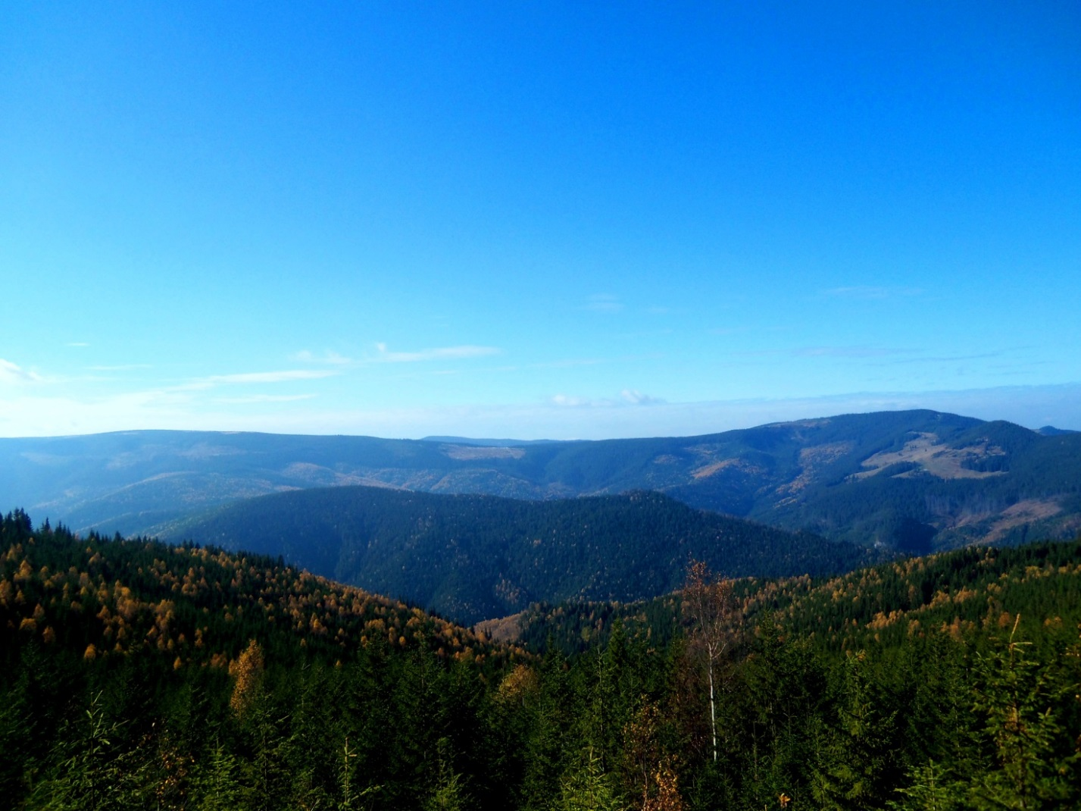
Photo. Panorama Bukovina Carpathians (photo Oksana Tomnyuk)

In general, the formation of national park "Cheremoskyy" began in 1972, when they were taken under the protection of the cliff to the city and created a large stone geological nature monument of local importance "black deeds" an area of ​​2.0 hectares. Later, in 1979, the decision of the executive committee of the Chernivtsi area increased to 263.0 hectares, and in 1980 the Council of Ministers of the Ukrainian SSR declared a landscape reserve of national importance.
Results and discussion. The territory of the NPP "Cheremoskyy" features a complex geological structure as it is within, as noted, Maramaroskoho crystalline massif - ancient Hercynian core Carpathians. Metamorphic rock solid rapidly deployed. They are observed within small skladchatist, and various violations of the amplitude of such discharges and pidkydiv.
Park Geomorphological structure closely related to the flow-geology and mining history of the region. The main orographic structures are Rakov submeridional strands - Shurdyn, Maksymets (1345 m) - Losova (1428 m), Yarovytsya - Tomnatyk an altitude of 1,567.4 meters (Yarovytsya g) and Black works - zhupan (an altitude 1480 m).
In the apical part strands Yarovytsya - Tomnatyk preserved ancient surface alignment (peneplain). The relief here has leveled-convex shape and it is available for many types of transport.
Somewhat similar is the relief of Black Ridge works - zhupan divided saddle headwaters. Sarata. There is also a well preserved ancient plateau-like area with minimal deviations. However, the overall look of undulating hilly broken strimchakovymy peaked peaks, most clearly at the tops of small and large stones (1453.6 m) Molochnobratskoho karst massif (1475 m), Saratov (1298 m). Amid slopes include some powerful blocks, vidtorzhentsi [7, 8].
The territory of the NPP "Cheremoskyy" part of the river basin White Cheremosh, Suceava. The main river is Perkalaba Drenthe, Saratov, Yalovychora, Lopushnia, turtle and others. The river valley is relatively narrow, well-defined lower terraces. Thus, in the valley. Sarata well include high floodplain (up to 2 meters), fragments of the first terrace height of 3-4 m, the second - 6-8 m, the third - 10-12 m.
The soil of the park developed on weathering products of various breeds, so in varying degrees, it turns skeletnist and acidity. In general, the differences between the various common brown mountain-forest soils capacity of 0.3-0.5 m.
In Geobotanical against the National Park "Cheremoskyy" refers to Chyvchyny-Hrynyavskyh mountains. Dominant position is occupied by pure spruce forests formation of European spruce (Piceeta albae). Most of them are almost radical in nature, and there is absolutely fundamental. Basically this option klimatohennyy smerechyn. Under conditions of cold humid temperate climate, long snowy winters and short growing season replacing spruce beech (Fagus sylvatica L.) and ordinary fir (Abies alba Mill.), Forming monodominant group, only sometimes mixed with European pine (Pinus cembra L.).
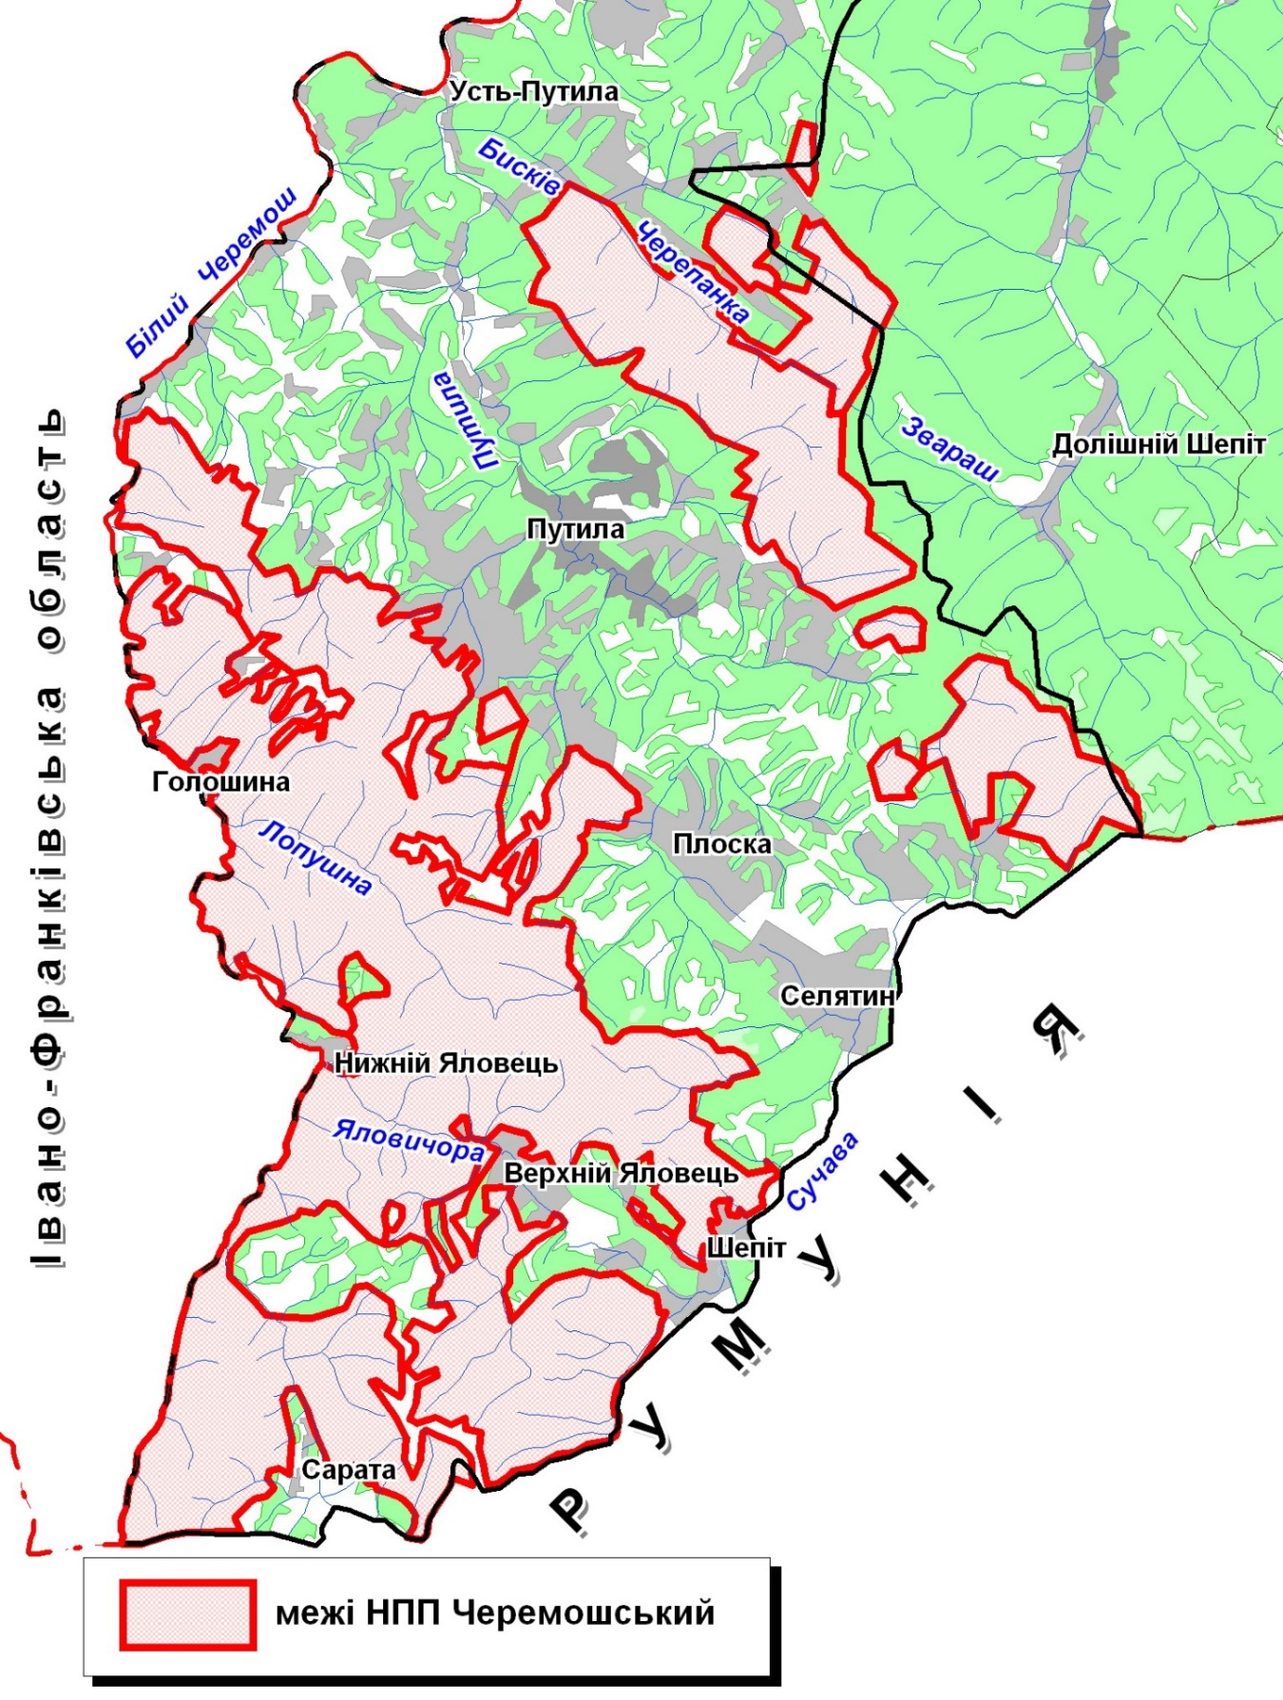

Fig. 1. Location of NNP "Cheremoskyy"

The most valuable in sozological regard are fragments completely indigenous communities cedar-fir forests (Pineto (cembrae) - Piceetum (abietis) vaccinioso (myrtilli) - hylocomiosum), which found a large stone on the mountain ridge Black Dil. This rare group of relict character, which spivdominantom acts listed in the Red Book of Ukraine pine. This is its only habitat in Bukovina Carpathians [6].
It is interesting to note that g Big Stone - one of the most unique phytodiversity cells in the Ukrainian Carpathians and Ukraine in general. There m² 1 accounts for more than 40 species of plants. Big Stone Mountain - habitat of rare plants such as crepis Zhakena (Crepis jacquinii Tausch) and sosyureya (bitter root) colored (Saussurea discolor (Willd.) DC.), Which are found in Ukraine only in the NPP "Cheremoskyy." Growing here leontopodium alpinum or edelweiss, silk kositsya (Leontopodium alpinum Cass.), Which is a symbol for the Hutsul selfless love. [10]
In the formation spruce forests most common group kvasenytsevyh smerechyn Association (Piceetum (abietis) oxalidoso (acetosellae)), which are confined to the rich soil of brown more or less gentle slopes. This is the most productive plant communities that form stands classes I-II growth class. Especially valuable are monodominant spruce grouping of associations formed to rendzina-soil on limestone and dolomite. [9]
Also presented at the park and grouping shrub type vegetation. The largest area is occupied chornychnyky (Vaccinieta myrtilli). They are mainly secondary in nature and formed in the forest belt of spruce forests in place a short-term derivatives group. In the bilberry plant communities there are such rarities as mountain arnica (Arnica montana L.), Heyfeliv saffron (Crocus heuffelianus Herb.), Rejected violet (Viola declinata Waldst.et Kit.) And others.
The second highest area - grouping meadow type vegetation. Basically it pislyalisovi bows that formed in place following summary of forests and the use of these areas for grazing or hay and confined to vypolozhenyh or slightly declivous slopes.
The most common group formation Kostrytsya red (Festuceta rubrae). They are found everywhere and are formed in place of fresh and moist spruce forest types. Most of these groups stands spivdominantom bent or polovytsya thin (Agrostis tenuis Sibth.), Which in its environmental requirements Kostrytsya close to the red (Festuca rubra L. s. Str.).
On rare species of flora consisting of groups of meadow type of vegetation growing mountain arnica, chyna smooth (Lathyrus laevigatus (Waldst et Kit.) Gren.), Cyanosis blue (Polemonium caeruleum L.), and listed in the Red Book of Ukraine Orlik blackish (Aquilegia nigricans Baumg.), Astrantia major (Astrantia major L.), Botrychium lunaria (Botrychium lunaria (L.), zatinkova sedge (Carex umbrosa Host), Carpathian cornflower (Centaurea carpatica (Porc.) Porc.), green tongue (Coeloglossum viride ( L.) C. Hartm.), autumn crocus (Colchicum autumnale L.), Heyfeliv saffron (Crocus heuffelianus Herb.), palchatokorinnyk sertsenosnyy (Dactylorhiza cordigera (Fries) Soo), Gentiana acaulis (Gentiana acaulis L.), bylynets dovhorohyy ( Gymnadenia conopsea (L.) R. Br.), lily or curly (b. name - royal curls) (Lilium martagon L.), Kukushkin tears ovate (Listera ovata
(L.) R. Br.), Decorated with orchids (Orchis signifera Vest) and burned (O. ustulata L.).
The European Red List includes tonkonih Reman (Poa rehmanni (Aschers. Et Graebn.) Woloszcz.) And poloninsky primrose (Primula poloninensis (Domin) An. Fed.). Zahalnokarpatski endemic - serrated bells (Campanula serrata (Kit.) Hendrych) and korolytsya rotundifolia (Leucanthemum rotundifolium (Waldst. Et Kit.) DC.) [8].
In the meadows growing south-east-endemic - rejected violet (Viola declinata Waldst. Et Kit.), Jaundice Alpine (Chrysosplenium alpinum Schur), alpine geraniums (Geranium alpestre Schur). East-endemic Marmaroska is cornflower (Centaurea marmarosiensis). Rare species are montannymy platanolystyy buttercup (Ranunculus platanifolius L.), cloves clusters (Dianthus compactus Kit.); decorative endangered - tyrlychnyk ciliary (Gentianopsis ciliata (L) Ma). Thus, in the meadow plant communities growing the largest number of rare species, compared with other types of groups [8, 9].
Much of the rarity fitohenofondu contained in the composition of public calcicolous rock groups. Within Bukovyna are known only in the national park. Their presence in the region due to the geological structure, shale outcrops of metamorphic, igneous rocks and fragments of Triassic-Jurassic limestone marble. Last come to the surface in the form of carbonate klipeniv (Big Stone peak hours), or some powerful vidtorzhentsiv-blocks that often occur on the ridge Black Dil.
Quite unique in coenotic and floral respect to national park "Cheremoskyy" grouping marsh vegetation type. The most common are hanging swamps, which are communities of herb-moss formations. Predominant characteristic southeast of Ukrainian Carpathians group formation sedge paniculate (Cariceta paniculatae) [9].
Paniculate Sedge (C. paniculata L.) belongs to a rare species of flora wetlands in Ukraine Ukrainian Carpathians this species has spread locally and often occurs in the mountains CHYVCHYNY (ridge Black Dil). Formation of communities as rare for Ukraine, to be protected and listed in the Green Book of Ukraine [5].
In Chyvchyny at the foot of the ridge Black Dil valley in Sarata located natural monument of local importance "White Stream". It is a pryshylove swamp, formed in place of bottling eponymous karst origin. Bog of its kind in the Ukrainian Carpathians inherent eutrophic sphagnum cover, as feed poor in minerals waters. In general, this calcareous bog with characteristic plant species and factions that other regions of Ukrainian Carpathians unknown.
Another monument of nature (geological) "Kizya Waterfall" is located between the villages of Ust-Putila and Byskiv Putyla area. The slopes around the waterfall covered with beech and spruce-fir forests mixed with sycamore or maple nespravnoplatanovoho (Acer pseudoplatanus L.).
The territory of the NPP "Cheremoskyy" rich in its landscape and recreational resources (landscape, humanistic, historical, cultural, landscape and aesthetic, spa, travel) that are poorly investigated and improperly assessed.
In the rocky cliffs of the ridge Black Dil strands (just south of Big Stone g) composed the Triassic-Jurassic limestones marmurovanymy known several karst caves and tectonic Molochnobratskoho dairy panel, announced by Presidential Decree Ukraine from 10.12.1994 number 750 karst and speleological reserve of national importance . Placed it at a distance of about 3.5 km from the confluence Perkalaba and Satara within Perkalabskoho forest on an area of ​​20.3 hectares. We know about 10 underground cavities - fractured vertical wells and horizontal caves. Most of cavities is investigated cave "Milk brothers", a depth of 40 m with a total length of 60 m. It is the second depth in the Ukrainian Carpathians and the deepest in the Chernivtsi region. This is promising for cavers and tourists object [2, 10].
Within the park are three mineral springs. In Ukraine and abroad chloride water of the type used in the treatment of cardiovascular diseases, damage to the gastrointestinal tract, urological diseases and skin. Analogues of water known in neighboring Romania (God knows resort), Lithuania (Druskininkai), Russia (Staraya Russa, Usolie) [2].
Given the lack of near major sources of air pollution should be considered a promising development of spa treatments generall profile. The aesthetic framing of the environment creates a positive and emotsiyyy background that will contribute to the efficiency of treatment and procedural measures.
Is a large historical and cultural value of the national park. It limits and in the neighborhood many interesting tourist ethno-cultural objects.
The capital of Bukovina Carpathians assumed Putila village, located on the same river. Each year, every spring (usually in May) are made the traditional mass celebration "Out of the mountain", which accompanied yutsya folk festivals and attract visitors.
Putila mention of 1501 was long settlement was called Putila, Storonets-Putyla, Putyla-Storonets. It was born Ukrainian writer Yuri Fedkovich Democrat (1834-1888). Muzsy-estate Fedkovych reproduced on the site where was his family hut.
Putila is home to the famous peasant band, head of the anti-serfdom uprising of 1848-1849. Lukyan filly (1812-1851), also was elected a deputy of the Austrian peasants Reichstag (parliament).
Museum-house and monument Lukyan filly can visit the village of Sergius, which is located near Putila, at pp. Putila. This village is also known mineral waters. For water with healing and refreshing at any time of the year Vantsen source on the slopes of the mountain of the same name coming from almost all of Bukovina. In Putyla tributaries Porkulyn Foshky and visitors can admire noisy waterfalls.
Very picturesque village Roztoky. It is easily spread in a wide area in the valley of Cheremosh. Other village - emblazoned Seliatyn fault in the mountain valley along the river Suceava. Finding here in the 80s of XIX century. treasure of Roman coins give reason to assume that here, in the old way of military significance, there was a more ancient settlement.
Conclusions. National Park "Cheremoskyy" - created by cross-border component of Ukrainian-Romanian bilateral environmental reserve of "Maramoroskyi mountains."
For representation of protected species of vascular plants in the Ukrainian Carpathians existing national parks, in terms of their significance sozological NPP "Cheremoskyy" is second only Carpathian NNP.
Phytocenoses national park "Cheremoskyy" especially rocks limestone ridge Black Dil. sozological are of exceptional importance as due to the fact that part of their growing abundance of rare, endangered and endemic species, and given the fact that many of them are in other regions of Ukrainian Carpathians and Ukraine as a whole are not available, or known from isolated habitats.
Overall, the top White (and Black) CHEREMOSH in the Ukrainian Carpathians - the most mysterious and clandestine manner of very interesting (heuristic) region.

Список літератури
- Андрієнко Т. Л. Флора та рослинність проектованого міждержавного українсько-румунського біосферного резервату “Мармароські та Чивчино-Гринявські гори” / Т. Л. Андрієнко, І. І. Чорней, В. А. Онищенко, В. В. Буджак // Укр. ботан. журн. – 2005, № 4. – С. 589-596.
- Гетьман В. I. Українські Карпати: ландшафтно-рекреаційні ресурси [Навчальна книга] // В. I. Гетьман. – Тернопіль: Богдан, 2010. – 136 с.
- Гетьман В. I. Печери природно-заповідного фонду України та їх використання / В. I. Гетьман // Заповідна справа в Україні, Т. 17, Випуск 1- 2. – Канів, 2011. – С. 1-6.
- Заповідна справа в Україні [Навчальний посібник] / За загальною редакцією М. Д. Гродзинського, М. П. Стеценка. – К.: Географіка, 2003. – 306 с.
- Зеленая книга УССР. Редкие, исчезающие и типичные, нуждающиеся в охране, растительные сообщества. – К.: Наук. думка, 1987. - 286 с.
- Каталог раритетного біорізноманіття заповідників і національних природних парків України. Фітогенетичний фонд, мікогенетичний фонд, фітоценотичний фонд / Під ред. С. Ю. Поповича. – К.: Фітосоціоцентр, 2002. – 276 с.
- Коржик В. П. Територіальні проблеми раціонального природокористування / В. П. Коржик // Географія Чернівецької області. – Чернівці, 1993. – С. 89-91.
- Матеріали проекту створення національного природного парку “Черемоський”, 2009.
- Шеляг-Сосонко Ю.Р . География растительного покрова Украины / Ю. Р. Шеляг-Сосонко, В. В. Осычнюк, Т. Л. Андриенко – К.: Наук. Думка, 1980. – 288 с.
- Юзик А. Таємниці Чорного Долу. Національний природний парк “Черемоський” / А. Юзик // Зелені Карпати. – №1-4, 2014. – С. 44-46.

В статье подчеркивается, что в русле выполнения Паневропейской стратегии сохранения биологического и ландшафтного разнообразия национальный природный парк “Черемошский” войдет в состав создаваемого транскордонного украинско-румынского природоохранного резервата билатерального типа “Мараморошские горы”.
Характеризуется флористическое разнообразие территории национального природного парка “Черемошский” в причинно-следственной связи с природными (абиотическими) условиями региона юго-западной части Украинских Карпат. Представлен детальный перечень раритетных видов флоры в составе растительных сообществ парка, внесенных в Красную книгу Украины, Европейский Красный список, а также названы редкостные ценозы Зеленой книги Украины.
Территория НПП “Черемошский” богата ландшафтно-рекреационными ресурсами (пейзажными, гумманистическими, историко-культурными, ландшафтно-эстетическими, бальнеологическими), которые еще недостаточно исследованы и оценены, на что и указано в статье.
Национальный природный парк, резерват, разнообразие, флора, растительность

©© V. І. GETMAN, 2015

