UGC 576.8:58

WATER RESEARCH ANTIMICROBIAL PROPERTIES OF PLANT EXTRACTS Galega orientalis (Lam.)

©V. V. VLIZLO, Doctor of Veterinary Science, Professor, Academician of NAANU

Institute of animal biology NAAN of Ukraine

L. М. DARMOGRAI, doctor of agricultural sciences, professor

National University of Lviv

Veterinary Medicine and Biotechnology them. SZ Gzhytsky

М. V. GONCHAR, Doctor of Biological Sciences professor

Institute of Cell Biology NAN of Ukraine

It was first conducted testing on antimicrobial activity of Galega orientalis (Lam.) on the growth pure cultural of bacteria gram positive (Micrococcus luteus), gram negative (Escherichia coli XL1, DH5) and yeasts (Saccharomyces cerevisiae W303). The material for the study was dried vegetative mass Galega orientalis (Lam) in the phase of budding and early flowering. As a result of the experiment was revealed that 20 % concentration of aqueous extract of this plant had inhibitory effects on the growth of pure cultures of bacteria and yeast. It has proved possible relationship between the antimicrobial activity of the extract of this plant and bloating of the rumen in ruminants.
Galega orientalis (Lam), water extract, Escherichia coli, Micrococcus luteus, Saccharomyces cerevisiae

In the scientific world, the search for new and more consistently-strong antimicrobial action of components of natural origin in contrast to existing synthetic antibiotics and enhance microbiological purity of food, feed additives. According to the publication of domestic and foreign authors is considerable interest in the study of antimicrobial activity unconventional but promising agriculture, one of which is Galega orientalis (Lam.), Which belongs to the perennial legumes [1, 3, 4, 5, 6].
The use of natural substances with antimicrobial action, is very important due to several issues: the microorganisms no resistance to them and the possible long-term use; not cause harmful (negative) effect on humans and animals; due to its braking action on unwelcome flora can be used in food, because food production is not allowed to use synthetic antibiotics (except peptide antibiotic nizynu).
The aim of research was to test the possible antimicrobial activity of water extracts of Galega orientalis (Lam) on the model of pure cultures of bacteria, Gram-positive (Micrococcus luteus), Gram-negative (Escherichia coli XL1, DH5) and yeast (Saccharomyces cerevisiae W303).
Materials and methods of research. The material for the study served dried vegetative mass of plants in the phases of budding and early flowering. In experiments using Endo environment for the growth of gram-negative bacteria and medium LB, which grow both gram-positive and gram-negative bacteria and wort-agar for yeast. Research conducted at the Institute of Cell Biology NAS of Ukraine, Department of Analytical Biotechnology.
Prepared 10% and 20% extract preparation (dried grass) for boiling and infusion within 10-15 hours. Extracts cold sterilized by filtration. Then the surface of the agar medium cup applied to 0.1 ml of the studied extract and planted lawn of the culture. All experiments were performed on 10 control and 10 experimental cups. Analyzed the appearance of colonies on 2-3-rd day after sowing at + 30 ° C (yeast) and in the first day - at + 35-37 ° C (bacteria), research comparing options of control (without entering extract).
Obtained in experiments biometric digital data processed using the computer program "Statistica" among MS Office 2003. The results of the average values ​​considered statistically significant * - P <0.05, ** - P <0.01, *** - R <0.001.
Results. During the period of the experiment it was observed that the drug culture in the studied concentration of 10% (in terms of initial weight of the dried plant) virtually no effect on the growth of gram-positive and gram-negative bacteria and yeast. Due to increasing concentrations of aqueous extract 20% found that in Petri dishes in the control group grew 540 ± 15 colonies of bacteria E. coli strain XL1, and in addition to the research 20% of the drug Galega orientalis (Lam.) There were less than 110 colonies. Thus, growth inhibition observed data bacteria by 20.0% (P <0.001) compared with control cups. Inter-group differences for this indicator is statistically significant. The results of testing the antimicrobial activity of the study drug are shown in Figures 1-7.
The growth of colonies of Escherichia coli cultures of pure strain XL1 control and experimental groups are depicted in Fig. 1.
Fig. 2 observed effect of aqueous extract halehy eastern growth of bacteria strain of E. coli (XL1). In research cups colonies growing less strain compared with the control that clearly confirm the inhibitory effect of water extract of culture studied.

Fig. 1. Effect of 20% extract of Galega orientalis (Lam.) On the growth of pure culture of gram-negative bacteria E. coli XL1

Control
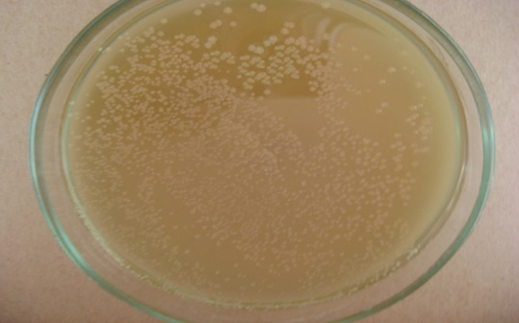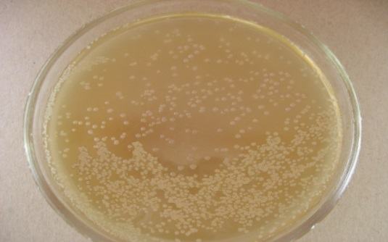
Experiment
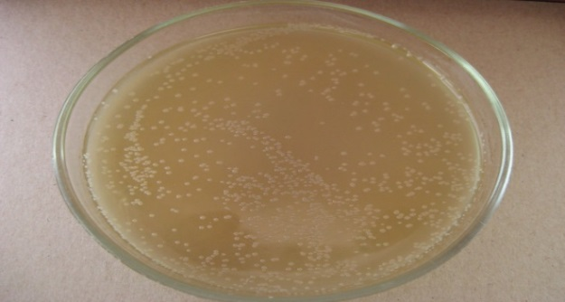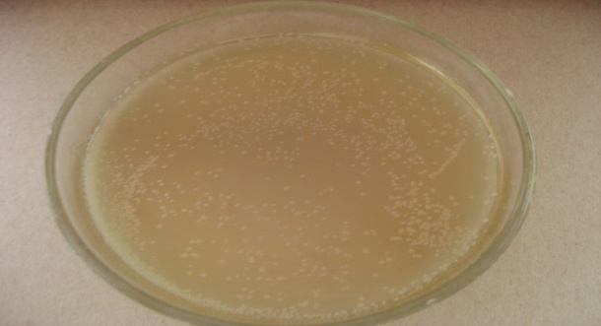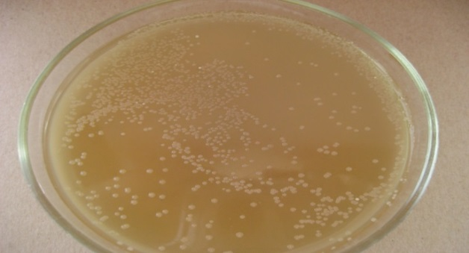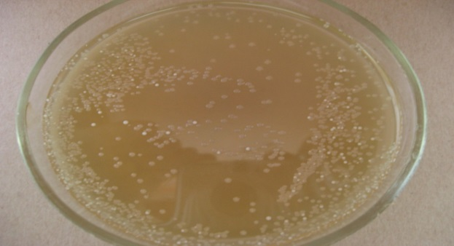
Figure 2. Petri dishes of the control and experimental groups E. coli (XL1)

In studying the antimicrobial activity of 20% aqueous extract of Galega orientalis (Lam.) On the growth of Gram-negative bacteria E. coli strain DH 5 turned out that the research cups were 117 colonies less than in controls. In percentage, this means 30% (P <0.001) inhibition of bacterial growth.
Fig. 3. Impact of 20% extract of Galega orientalis (Lam.) On the growth of pure culture of gram-negative bacteria E. coli DH 5

Conducted microbiological studies indicate that the antibacterial effect of the study drug for gram-positive bacteria M. Luteus was slightly lower. Found that 20% -vyy aqueous extract of Galega orientalis (Lam) inhibits the growth of these microorganisms by 12.0% (P <0.05) compared with control.

Fig. 4. Impact of 20% extract of Galega orientalis (Lam) on the growth of pure culture of gram-positive bacteria M. Luteus

Fig. 5 shows the growth of Gram-positive bacteria Micrococcus luteus on the background of the aqueous extract halehy east.
Fig. 5 clearly see fewer bacteria colonies in petri dishes research and, consequently, greater bacterial effect of aqueous extract halehy eastern growth of pure cultures of Gram-positive microorganisms. The quantitative difference in the colonies between control and experimental cups was 227.
Found a negative effect of water extract of Galega orientalis (Lam.) On the growth of eukaryotic organisms - yeast Saccharomyces cerevisiae strain W303. It was found that the number of cups of experimental colonies was 30.5% (P <0.01) lower compared with the control.

Control
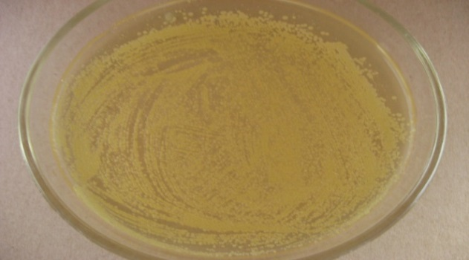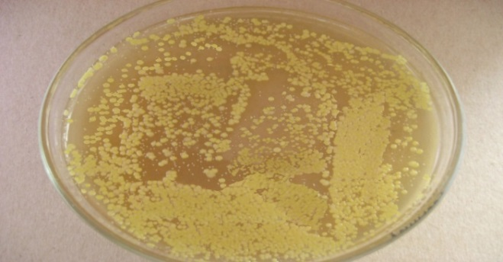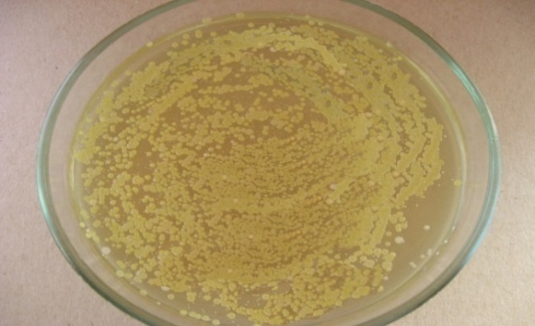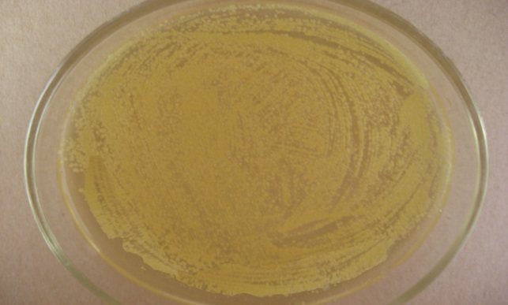

Experiment
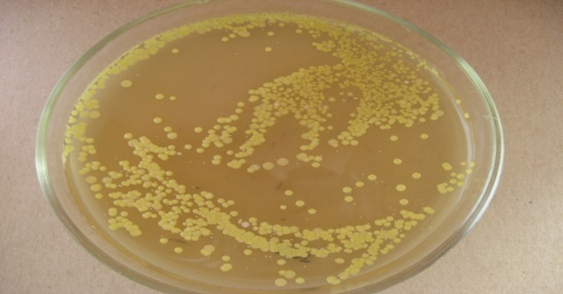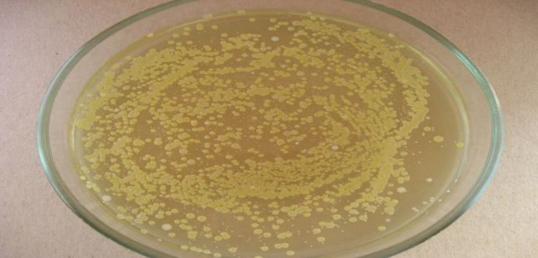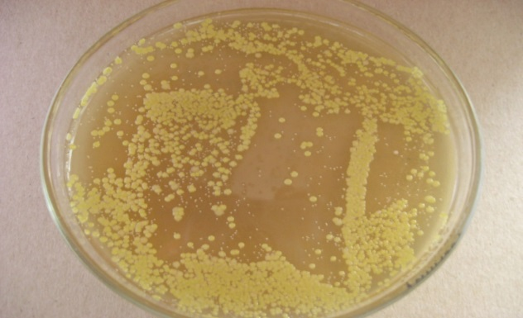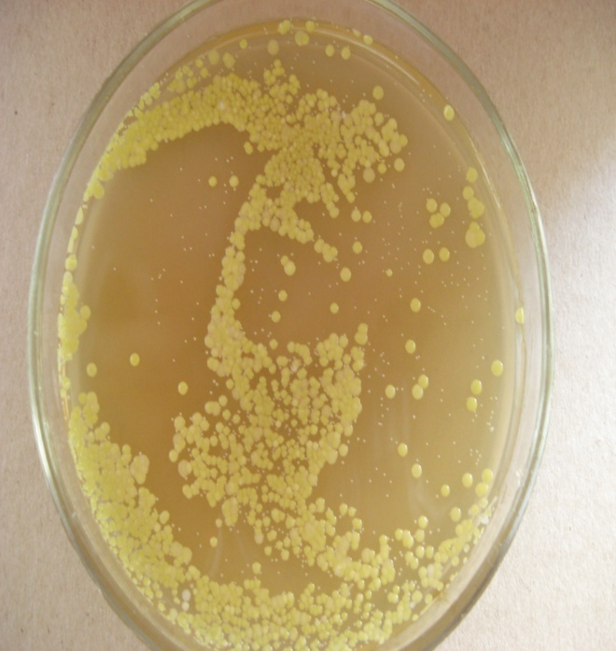
Fig. 5. Petri dishes of control and experimental groups Micrococcus luteus

Fig. 5 shows antimicrobial activity influence 20% of th drawing east halehy growth of pure cultures of yeast Saccharomyces cerevisiae strain W 303. In experimental petri dishes colonies of yeast number was less than the control, confirming inhibitory effect on the growth of oriental halehy these microorganisms.
Fig. 6. The braking effect of 20% extract of Galega orientalis (Lam) on the growth of pure culture yeast S. cerevisiae W 303

Control

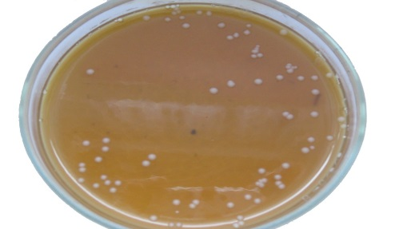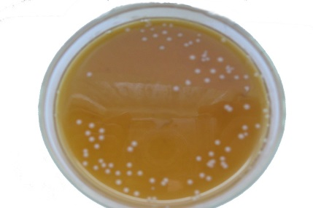
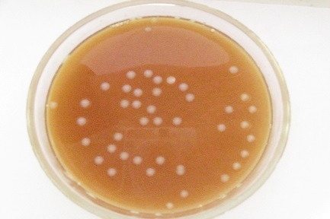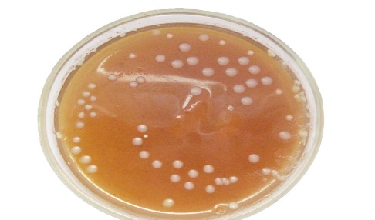

Experiment
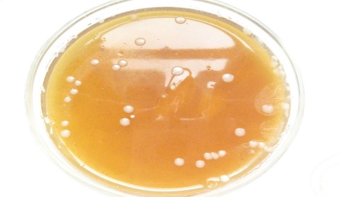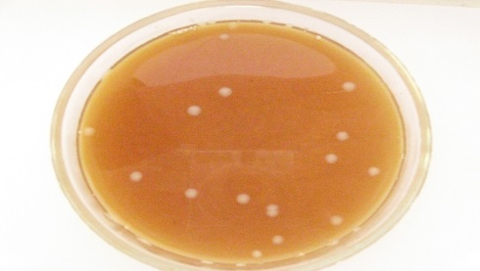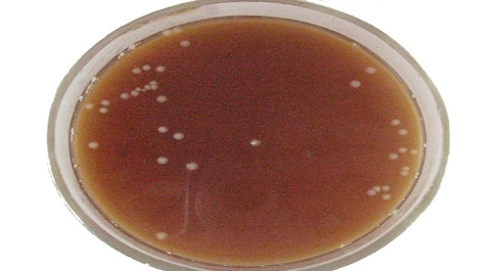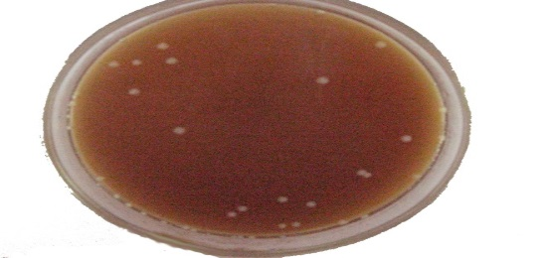

Fig. 7. Petri dishes of control and experimental groups
Saccharomyces cerevisiae (W 303)

It should be noted that in all cases the addition of experimental studies of the drug Galega orientalis (Lam) did not alter the morphology of the colonies tested strains.
Conclusions. Consequently, the results of researches allow to note a slight antimicrobial effect of 20% aqueous extract of Galega orientalis (Lam) on the growth of pure cultures of gram-negative and gram-positive bacteria and yeasts. This fact can be used in food industry as an antimicrobial agent of natural origin, to ensure the preservation and microbiological purity products, and suggests that the lack tympaniyi in animals fed this plant may be related to the inhibition of microbial growth.
Список літератури
- Дармограй Л. М. Фітохімічне вивчення вмісту біологічно активних речовин та тестування антимікробної активності галеги східної (Galega orientalis (Lam) / Л. М. Дармограй / Наук. Вісник Львівського національного університету ветеринарної медицини та біотехнологій ім. С. З. Ґжицького. − Львів, 2009. − Т. 11, № 3 (42). – Ч.2. – С. 239-242.
- Estrada A. Isolasion and evaluation of Immunologigal adjuvant activities of saponins from Polygaja senega L. / A. Estrada // Comparative Immunology. Microbiol. Infect. Dis. 23. – 2000. – P. 27 - 43.
- Irobi O. N. Antimicrobial actuvity of the barc of Bridelia ferruginea /
O.N. Irobi // Int. J. Pharmacog. 34. – 1994. – P. 87-90.
- Olorundare E. E. Antibacterial properties of leaf extract of Cassia alata /
E. E. Olorundare // Biol. Res. Com. 4. – 1992. – P. 113-117.
- Sibanda T. In vitro antibacterial regimes of crude aqueous and acetone extracts of Garcinia kola seeds. / T.Sibanda // J. Biol. Sci. 8(1). – 2008. – P. 149-154.

Впервые проведено тестирование возможной антимикробного действия Galega orientalis (Lam) на рост чистых культур бактерий грам-положительных (Micrococcus luteus), грамотрицательных (Escherichia coli XL1, DH5) и дрожжей (Saccharomyces cerevisiae W303). Материалом для исследования служила высушенная вегетативная масса Galega orientalis (Lam) в фаз бутонизации и начала цветения. В результате эксперимента установлено, что 20 %-я концентрация водного экстракта данного растения имеет ингибирующее влияние на рост чистых культур бактерий и дрожжей. Обоснованно возможную взаимосвязь между антимикробной активностью экстракта этого растения и невозникновением тимпании у коров.
Galega orientalis (Lam), водный экстракт, антимикробное действие, Escherichia coli, Micrococcus luteus, Saccharomyces cerevisiae

©© В. В. ВЛІЗЛО, Л. М. ДАРМОГРАЙ, М. В. ГОНЧАР, 2015

