UGC 581 : (477)

PHYTODIVERSITY OF TERRITORY OF

NATIONAL PARK "CHEREMOSKYY"

©V. І. GETMAN, Candidate of Geographical Sciences

Taras Shevchenko National University of Kyiv

This article characterizes floral diversity of National Natural Park’s area “Cheremosky” in cause-and-effect relationship with natural (abiotic) conditions of the south-west part of the Ukrainian Carpathians region. Detailed list of rare flora species consisting of park’s vegetative grouping related to the Red Data Book of Ukraine, European Red List is presented and rare cenosises of the Green Data Book of Ukraine is also mentioned.
Accent is made on fact that in the tideway of Pan-European Biological and Landscape Diversity Strategy implementation, The National Natural Park’s “Cheremosky” will be part of created transboundary Ukrainian-Romanian environment-oriented reserve of bilateral type “Maramorosky Mountains”.
Flora, vegetation, national natural park, reserve, diversity

Ukrainian Carpathians anciently famous scenic mountain and valley landscapes, valuable mineral waters, numerous monuments of wooden sacred art, cheerful Ukrainian songs and dances, in which so much poetry and beauty. Azure dome majestic peaks, green Carpathian meadows, mountain sun, fresh air filled with the scent of dense forest - dense spruce stands Buchin and dark, narrow valley of the turbulent river of crystal memorable one who traveled the Ukrainian Carpathians, unique for life.
Pristine corners of the nature of these mountains is stored in the natural reserve fund (NRF) - reserves, national parks, preserves and more. Their expansion and improvement is one of the important optimization of protection of human life, the preservation of landscape and biotic diversity of ecological network.
In the Ukrainian Carpathians as most important for Ukraine and Central Europe ekolohoznachymomu region has long carried out a consistent policy to establish an adequate system of protected areas, primarily due to territorial and landscape and monolithic representative areas. Currently established fairly clear structure protected areas and facilities, covering almost all the high altitude zone landscape complexes Ukrainian Carpathians - from lowland deciduous-mishanolisovyh to medium-high coniferous forests and subalpine.
Until recently, a kind of "white spot" in the Nature Reserve industry remained south-eastern part of the Ukrainian Carpathians in the upper reaches of the Black and White Cheremosh, which focuses much of the biodiversity of the region and remained the least anthropogenically modified landscapes that define regional environmental situation. It is the most remote places in southwestern Ukrainian (Forested) Carpathian Mountains on the border between Ukraine and Romania, where the area is the north-eastern foothills Maramaroskoho crystalline array - geological core PrakarpatyThat. The main (central) part of it is located within Romania.
Millions of years ago, in the second half of the Paleozoic era, the Hercynian orogenesis (about 350 - 250 million. P. So) here began forming at the site of the Carpathian Mountains geosyncline - seabed giant ancient Tethys Ocean that separated the northern and southern continents of the globe. It rises from the oldest birth Carpathians. Then began and ended in the formation of the Alpine orogenesis (from 25 to 2-1,5 million. G. Ago), the Alps, and Kavkakyh Crimean mountains, the highest of the Himalayas like.
The richness of the natural environment, especially biotic diversity, Intergovernmentalism single natural complex Maramorosh crystalline array was a prerequisite for the creation of this powerful territorial cast transboundary Ukrainian-Romanian bilateral environmental reserve of "Maramoroskyi mountains" as provided in the framework of the European Strategy for the conservation of biological and landscape diversity. To this end, Romania established Biosphere Reserve (Park) "Maramaroschyny Mountain" area of ​​168,754 hectares, of which area (river basin Visheu) directly adjacent to the border with Ukraine should be part of the Romanian transboundary reserve. To reserve "Maramoroskyi mountain" will also include Romanian national park "Mount Rodney." The package of documents on the matter submitted to UNESCO, as reported on the Romanian side of the Romanian-Ukrainian seminar held last April in the city. Visheu de Sus funded by the EU under the cross-border project "Biorehio Carpathians".
Geographical proximity predetermined locations within the Romanian Maramaroschyny 14 Ukrainian settlements. They form within Maramures Ukrainian ethnic territory in a border zone. In the national structure of the population is over 88% are Ukrainian. It is is important to the functioning of transboundary conservation reserve.
On the Ukrainian side to enter the territory of the reserve CBR (area - 58,035.8 ha) and in the Transcarpathian region and National Park (NNP) "Cheremoskyy" (area - 7117.5 ha), established by the Decree of the President of Ukraine of 11 December 2009 on the conservation of natural, historical and cultural complexes and objects within Putyla district of Chernivtsi region .
In general, the proposed cross-border reserve include CHYVCHYNY Hrynyavskyy and ridges in the Ivano-Frankivsk region, and ranges Putylli Yarovytsya and land west of the village. Sarata within the Chernivtsi region [1, 2]. The first step to this organization here was to create a reserve in 1997 Cheremoskoho regional landscape park (RLP) in the area of ​​6555.8 hectares.
In the natural respect NPP "Cheremoskyy" located on the territory serednohirya Bukovina Carpathians (Fig. 1). He cluster type and consists of three main sets: Yarovytsko-Chornodilskyy - in the extreme southwest of the Bukovina Carpathians; Maksymetskyy array is located to the north and occupies the top of the chain ranges Maksymets - Losova- Ropachel; array carcinoembryonic Shurdyn located in the southern part Pokutsko-Bukovina Carpathians. Much of the park is concentrated in the origins of the White Cheremosh and includes the territory referred Cheremoshskiy RLP and the adjacent forests.
The aim - to show the relevance of effective search of new species of flora protection Bukovina Carpathians to ensure their preservation and restoration in a constantly growing anthropogenic influence, outline the main ways and forms of modern solution to the problem of absolute conservation in the National Park.
Results and discussion. In respect Geobotanical national park "Cheremoskyy" refers to Chyvchyny-Hrynyavskyh mountains. Dominant position is occupied by pure spruce forests formation of European spruce (Piceeta albae). Most of them are almost radical in nature, and there is absolutely fundamental. Basically this option klimatohennyy smerechyn. In conditions of cold humid temperate climate, long snowy winters and short growing season replacing spruce beech (Fagus sylvatica L.) and ordinary fir (Abies alba Mill.), Forming monodominant group, only sometimes mixed with pine (Pinus cembra L .).
The most valuable in sozological regard are fragments completely indigenous communities cedar-fir forests (Pineto (cembrae) - Piceetum (abietis) vaccinioso (myrtilli) - hylocomiosum), which found a large stone on the mountain ridge Black Dil. This rare group of relict character, which spivdominantom acts listed in the Red Book of Ukraine pine. This is its only habitat in Bukovina Carpathians [4].
It is interesting to note that g Big Stone - one of the most unique phytodiversity cells in the Ukrainian Carpathians and Ukraine in general. There m² 1 accounts for more than 40 species of plants. Big Stone Mountain - habitat of rare plants such as crepis Zhakena (Crepis jacquinii Tausch) and sosyureya (bitter root) colored (Saussurea discolor (Willd.) DC.), Which are found in Ukraine only in the NPP "Cheremoskyy." Growing here leontopodium alpinum or edelweiss, silk kositsya (Leontopodium alpinum Cass.), Which is a symbol for the Hutsul selfless love. [7]
In the formation spruce forests most common group kvasenytsevyh smerechyn Association (Piceetum (abietis) oxalidoso (acetosellae)), which are confined to the rich soil of brown more or less gentle slopes. This is the most productive plant communities that form stands classes I-II growth class. Especially valuable are monodominant spruce grouping of associations formed to rendzina-soils on limestone and dolomite [6].
Fragmented are in the park and grouping shrub type vegetation. The largest area is occupied chornychnyky (Vaccinieta myrtilli). They are mainly secondary in nature and formed in the forest belt of spruce forests in place a short-term derivatives group. In the bilberry plant communities there are curiosities: mountain arnica (Arnica montana L.), Heyfeliv saffron (Crocus heuffelianus Herb.), Rejected violet (Viola declinata Waldst.et Kit.) And others.
The second highest area - grouping meadow type vegetation. Basically it pislyalisovi bows that formed in place following summary of forests and the use of these areas for grazing or hay and confined to vypolozhenyh or slightly declivous slopes.
The most common group formation Kostrytsya red (Festuceta rubrae L. s. Str.). They are found everywhere and are formed in place of fresh and moist spruce forest types. Most of these groups stands spivdominantom bent or polovytsya thin (Agrostis tenuis Sibth.), Which in its environmental requirements Kostrytsya close to the red (Festuca rubra L. s. Str.).
On rare species of flora consisting of groups of meadow type of vegetation growing mountain arnica, chyna smooth (Lathyrus laevigatus (Waldst et Kit.) Gren.), Cyanosis blue (Polemonium caeruleum L.), and listed in the Red Book of Ukraine Orlik blackish (Aquilegia nigricans Baumg.), Astrantia major (Astrantia major L.), Botrychium lunaria (Botrychium lunaria (L.), zatinkova sedge (Carex umbrosa Host), Carpathian cornflower (Centaurea carpatica (Porc.) Porc.), green tongue (Coeloglossum viride ( L.) C. Hartm.), autumn crocus (Colchicum autumnale L.), Heyfeliv saffron (Crocus heuffelianus Herb.), palchatokorinnyk sertsenosnyy (Dactylorhiza cordigera (Fries) Soo), chaff Portsiusa (Festuca porcii Hack.), Gentiana acaulis ( Gentiana acaulis L.), bylynets dovhorohyy (Gymnadenia conopsea (L.) R. Br.), levkorhis whitish (Leucorchis albida (L.) E. Mey.), lily or curly (b. name - royal curls) ( Lilium martagon L.), Kukushkin tears ovate (Listera ovata (L.) R. Br.), decorated with orchids (Orchis signifera Vest) and burned (O. ustulata L.), traunshteynera spherical (Traunsteinera globosa (L.) Reichenb.) [5].
The European Red List includes tonkonih Reman (Poa rehmanni (Aschers. Et Graebn.) Woloszcz.) And poloninsky primrose (Primula poloninensis (Domin) An. Fed.). Zahalnokarpatski endemic - serrated bells (Campanula serrata (Kit.) Hendrych) and korolytsya rotundifolia (Leucanthemum rotundifolium (Waldst. Et Kit.) DC.).
In the meadows growing south-east-endemic - rejected violet (Viola declinata Waldst. Et Kit.), Jaundice Alpine (Chrysosplenium alpinum Schur), alpine geraniums (Geranium alpestre Schur). East-endemic Marmaroska is cornflower (Centaurea marmarosiensis). endangered relict species - common ophioglossum (Ophioglossum L.).
Rare species are montannymy platanolystyy buttercup (Ranunculus platanifolius L.) and Hornshuha (R. hornschuchii Hoppe), cloves clusters (Dianthus compactus Kit.), Soldanela Hungarian (Soldanella hungarica Simonk.); decorative disappearing - tyrlychnyk ciliary (Gentianopsis ciliata (L) Ma) and sholudyvnyk Hackett (Pedicularis hacquetii Graf) .Otzhe, in the meadow plant communities growing the largest number of rare species, compared with other types of groups [5, 6].
Much of the rarity fitohenofondu contained in the composition of public calcicolous rock groups. Compared with other types of plant communities of a small area, but within Bukovyna are known only in the national park.
Their presence in the region due to the geological structure, shale outcrops of metamorphic, igneous rocks and fragments of Triassic-Jurassic limestone marble. Last come to the surface in the form of carbonate klipeniv (Big Stone peak hours), or some powerful vidtorzhentsiv-blocks that often occur on the ridge Black Dil.
Quite unique in coenotic and floral respect to national park "Cheremoskyy" grouping marsh vegetation type. The most common are hanging swamps, which are communities of herb-moss formations (classification EM Bradis). Predominant characteristic southeast of Ukrainian Carpathians group formation sedge paniculate (Cariceta paniculatae) [6].
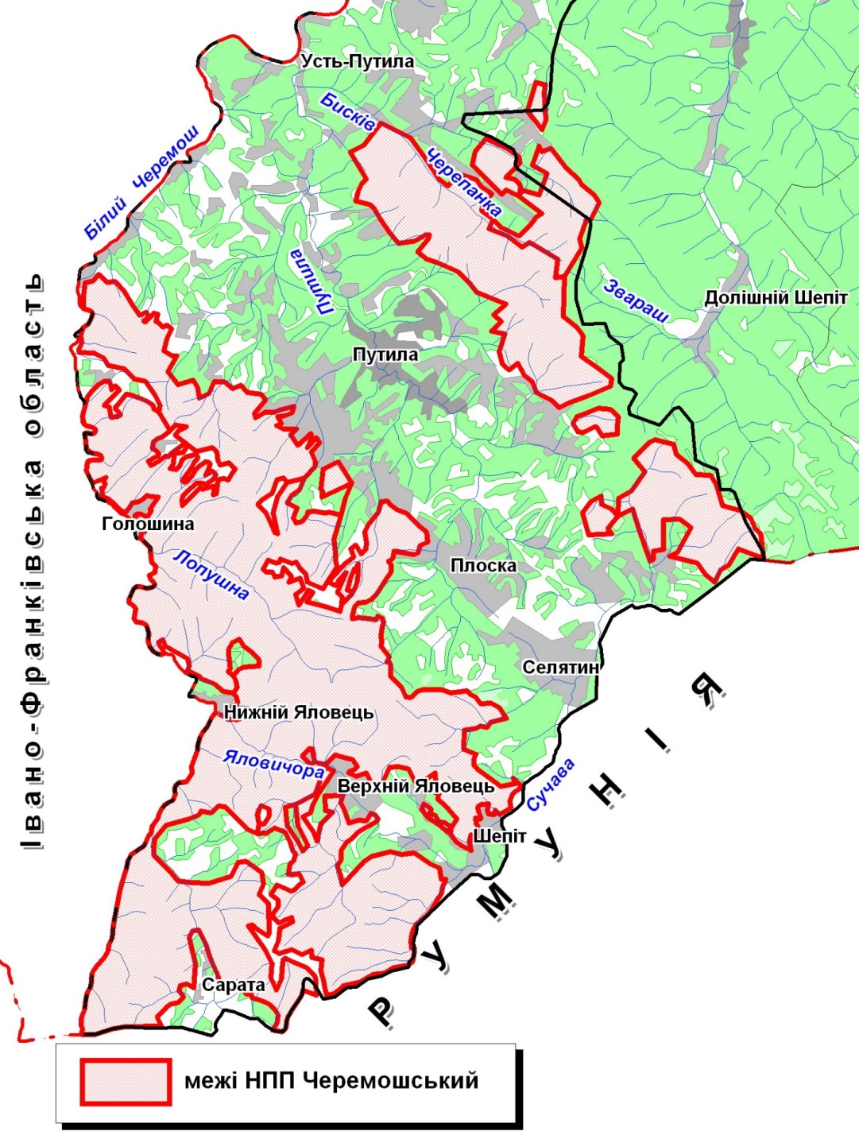
Fig. 1. Location of NNP "Cheremoskyy"
Paniculate Sedge (C. paniculata L.) belongs to a rare species of flora wetlands in Ukraine Ukrainian Carpathians this species has spread locally and often occurs in the mountains CHYVCHYNY (ridge Black Dil). Formation of communities as rare for Ukraine, to be protected and listed in the Green Book of Ukraine [3].
In Chyvchyny at the foot of the ridge Black Dil valley in Sarata located natural monument of local importance "White Stream". It is a pryshylove swamp, formed in place of bottling eponymous karst origin. Bog of its kind in the Ukrainian Carpathians inherent eutrophic sphagnum cover, as feed poor in minerals waters. In general, this calcareous bog with characteristic plant species and factions that other regions of Ukrainian Carpathians unknown.
Conclusions. National Park "Cheremoskyy" - created by cross-border component of Ukrainian-Romanian bilateral environmental reserve of "Maramoroskyi mountains."
For representation of protected species of vascular plants in the Ukrainian Carpathians existing national parks, in terms of their significance sozological NPP "Cheremoskyy" is second only Carpathian NNP.
Phytocenoses national park "Cheremoskyy" especially rocks limestone ridge Black Dil have exceptional value as sozological due to the fact that part of their growing abundance of rare, endangered and endemic species, and given the fact that much of including in other regions of the Ukrainian Carpathians and Ukraine as a whole are not available, or are known in isolated habitats.

Список літератури
- Андрієнко Т. Л. Флора та рослинність проектованого міждержавного українсько-румунського біосферного резервату “Мармароські та Чивчино-Гринявські гори” / Т. Л. Андрієнко, І. І. Чорней, В. А. Онищенко, В. В. Буджак // Укр. ботан. журн. – 2005, № 4. – С. 589-596.
- Заповідна справа в Україні [Навчальний посібник] / За загальною редакцією М. Д. Гродзинського, М. П. Стеценка. – К.: Географіка, 2003. – 306 с.
- Зеленая книга УССР. Редкие, исчезающие и типичные, нуждающиеся в охране, растительные сообщества. – К.: Наук. думка, 1987. – 286 с.
- Каталог раритетного біорізноманіття заповідників і національних природних парків України. Фітогенетичний фонд, мікогенетичний фонд, фітоценотичний фонд / Під ред. С. Ю. Поповича. – К. : Фітосоціоцентр, 2002. – 276 с.
- Матеріали проекту створення національного природного парку “Черемоський”, 2009.
- Шеляг-Сосонко Ю. Р. География растительного покрова Украины / Ю. Р. Шеляг-Сосонко, В. В. Осычнюк, Т. Л. Андриенко – К.: Наук. думка, 1980. – 288 с.
- Юзик А. Таємниці Чорного Долу. Національний природний парк “Черемоський” / А. Юзик // Зелені Карпати, №1-4, 2014. – С. 44-46.

В статье характеризуется флористическое разнообразие территории национального природного парка “Черемошский” у причинно-следственной связи с природными (абиотическими) условиями региона юго-западной части Украинских Карпат. Подан детальный перечень раритетных видов флоры в составе растительных сообществ парка, затнесенных в Красную книгу Украины, Европейский Красній список, а также названо редкостные ценозы Зеленой книги Украины.
Подчеркнуто, что в плане выполнения Общеевропейской стратегии сохранения биологического и ландшафтного разнообразия национальный природный парк “Черемошский” войдет в состав создавающегося трансграничного украинско-румунского природо-охранного резервата билатерального типа “Мараморошские горы”.
Флора, растительность, национальный природный парк, резерват, разнообразие

This article characterizes floral diversity of National Natural Park’s area “Cheremosky” in cause-and-effect relationship with natural (abiotic) conditions of the south-west part of the Ukrainian Carpathians region. Detailed list of rare flora species consisting of park’s vegetative grouping related to the Red Data Book of Ukraine, European Red List is presented and rare cenosises of the Green Data Book of Ukraine is also mentioned.
Accent is made on fact that in the tideway of Pan-European Biological and Landscape Diversity Strategy implementation, The National Natural Park’s “Cheremosky” will be part of created transboundary Ukrainian-Romanian environment-oriented reserve of bilateral type “Maramorosky Mountains”.
Flora, vegetation, national natural park, reserve, diversity

©© В. І. ГЕТЬМАН, 2015

