UGC 628.38: 662.76

PYROLYSIS sludge wastewater into water vapor HIGH PRESSURE

©U. А. KOZHEVNIKOV, А. G. CHIZHIKOV,

candidates of technical sciences

S. V. PASHKIN, Doctor of Physical and Mathematical Sciences

Federal State Scientific Institution All-Russian Research Institute for Electrification of Agriculture

The results of the experimental studies have been described aimed at the pyrolytic utilization of sewage sludge derived from municipal wastewater treatment plants using the high-pressure steam technology. The steam temperature varied in the range of 400º C to 550º C while the pressure was
©25-40 MPa. The initial moisture content in probes of sewage sludge was not less than 75%. Pyrolysis led to a not less than two times decrease in mass of the dry sludge which corresponds to about 10 times reduction of the original weight of the wet sludge. Experiments have shown that combustible gases are present in the resulting gas composition, and no carbon dioxide or nitrogen oxides have been detected. The relative composition of combustible gases is strongly dependent on the experimental conditions, and their amount corresponds to the dry weight loss of initial sludge obtained by a long-term drying procedure at 110º C. The solid dry fraction of the pyrolysis products is a dark fine powder without any specific odor that can be easily mixed with water, without consequent powder subsidence during 10 days after its preparation and without making considerable marks on a conventional paper filter of normal density.
Silt sediments, pyrolysis, installation, experiments, water vapor, pressure, temperature, flammable gases

Sewage sludge produced in large quantities at the municipal wastewater treatment plants. Sediment from the sludge can occupy an area of ​​several hundred square meters, being the source of noxious fumes with a very bad smell and the worsening ecological situation in the surrounding areas.
High (more than 70%) moisture even dewatered sludge does not allow to burn it using standard techniques, so you have to take away to landfills or substrate comprising 2/3 of the water for a natural drying, or to evaporate the residual water, which requires special equipment and large energy costs. As a rule, precipitation are taken for burial in landfills or dried for subsequent combustion in boilers. In both cases, the products are produced rotting in landfills precipitation or rainfall products of combustion in the form of polluting gases and dust, which is unacceptable from an environmental point of view.
One of the most effective solutions to the above problems is the use of a known method of organic waste pyrolysis precluding contact of the feedstock with the environment [1]. The significant disadvantages of the most common pyrolysis technologies using heat generated by partial combustion of organic matter inside the reactor being supplied with oxygen or air, can carry a large amount of tar and low calorific value gaseous process products.
An experimental study of the pyrolysis products of the sludge of wastewater in the environment of high-pressure water vapor without contact with the environment. Thus, the vapor source is water, part of the feedstock, which allows the thermochemical decomposition reaction of its organic components to form a low molecular weight gaseous compounds, coal and water which after condensation and cooling in the heat exchanger can be recycled into the environment or fed to final purification for use, for example, for technical purposes.
The purpose of research - to determine the effectiveness of the studied method and its parameters.
Materials and methods of research. The experimental setup for the processing of sludge by pyrolysis in an environment of high pressure steam is shown in Figure [2, 3].
1 pressure vessel (reactor, autoclave) has two removable end cap for placing it in the sample cup of the feedstock. This device was placed in a muffle furnace 2, which is allowed to heat the feed to a vessel with a glass temperature of 600 ° C.
Processing of the sample was subjected to many years of sludge from wastewater treatment facilities Lyubertsy Moscow Region. Initial samples had a sharp odor and semi-liquid consistency of dark green (almost black) color.
Samples were placed in a thin-walled stainless steel cup 3, which is in turn inserted with a slight clearance in a cylindrical pressure vessel 1. In one of the flanges of the steel tube was incised at the other end of which 4 were manometer and a pressure reducing valve 5. The valve was preset to reset the pressure in the range of 20,0-40,0 MPa, which corresponds to the operating regimes in the developed technology of industrial applications thermochemical reactor. To the outer side wall of the cylinder by a thin dielectric spacer 6 attached thermocouple insulated from external heat source junction so that its temperature corresponds to the temperature of the reactor wall 1. reducing valve 5 communicates pipe 7 for collecting the gases exiting from the reactor in a pre-filled with water bottle 8 placed in the water tank 10.
Experiments were conducted for samples with different initial moisture content of the mass, which organic feed was mixed with the appropriate amount of added water and mixed thoroughly until a uniform pulp 9 being placed in a glass 3 before the pyrolysis process.
To achieve the conditions necessary for each particular experiment the autoclave was heated in a muffle furnace 2. In this case, the required pressure value is maintained in the reactor 1 via a reducing valve preset by pressure relief. The maximum temperature in these experiments varied in the range of 350-550 ° C.
The experiment was performed as follows. Once placed in a muffle furnace autoclave containing a glass sample prepared by the raw materials, and include insulation gap, heating muffle furnace. When heated to a temperature of 380-400 ° C in the reactor pressure reached the threshold pressure reducing valve 5 through which gas began to flow out with water vapor. At a given temperature, heating was stopped and the reactor was removed from the muffle furnace and cooled. Full heating-cooling cycle took time from one to three hours. The reactor was then depressurized and removed a glass with solid components of raw materials processed products. The residue represented the ultrafine mass of dark brown color and a neutral odor. The properties of this mass looks like a normal ash. Upon contact with water, it is wetted and partially sink, forming a slurry, which almost completely passes through the single-ply paper filter. The composition of the product gas after processing in the autoclave at different temperatures and pressures were measured instrument Testo t350 S (Germany).
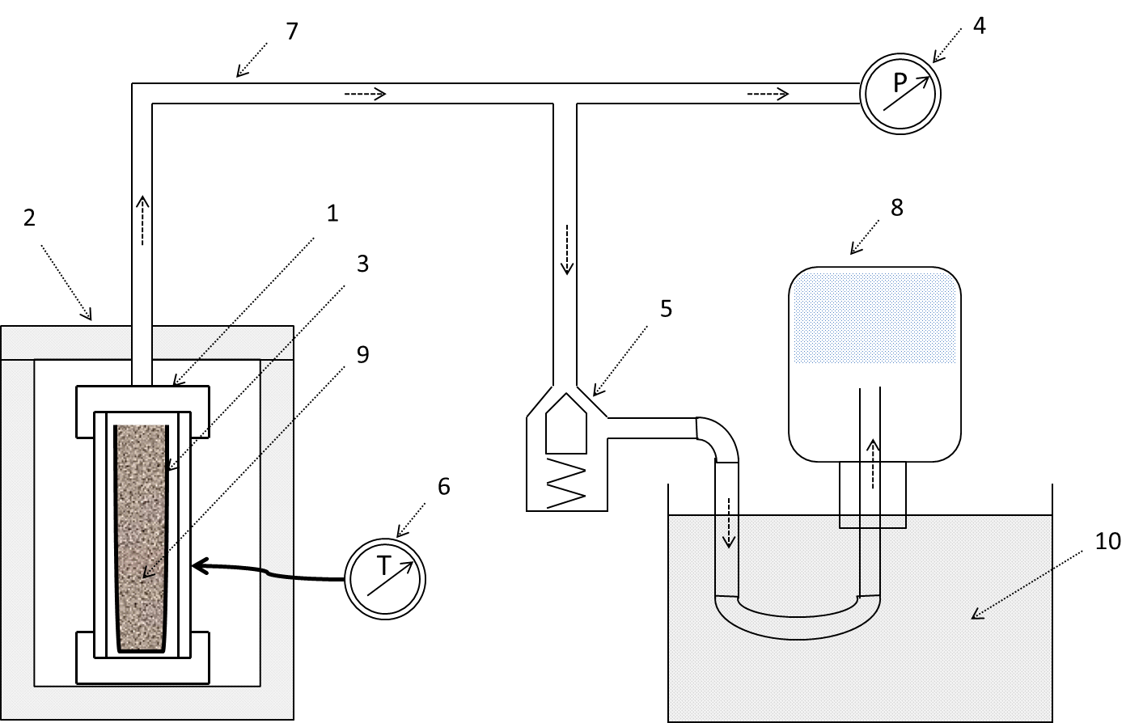
Fig. 1. Experimental setup: 1 - reactor (autoclave); 2 - muffle furnace; 3 - glass; 4 - pressure gauge;
5 - the pressure control valve; 6- thermometer with thermocouple;
7 - connecting tube; 8 - a tank for gas collection;
9 - raw water; 10 - tank containing water.

The results of research. Table 1 shows the results of determination of the dry weight of the solid pyrolysis products, which were compared with the results of the weighing of samples of the original organic material. The moisture content of the initial sample was determined by evaporating the water in a fume hood for 6-10 hours at a temperature of 110-120 º C. The sample weight loss in such measurements is 75-84%, which corresponds to an average moisture content of about 80% of samples. solid mass of thermochemical processing of samples is approximately 10 times smaller than the mass of the original organic matter. Table. 1 efficiency of utilization of the sludge is presented "a weight loss factor" - a parameter representing the ratio of the weight of the final dried product to the weight of raw material [4].

1. Loss of dry weight of solids in the long drying
and thermochemical processing of sludge.
Sample number | Sample Weight |  | Max. temperature ° C | Dry weight of the solid, g | weight loss ratio
Sample number | source  Raw g | added water, g | Max. temperature ° C | Dry weight of the solid, g | weight loss ratio
When thermochemical treatment
16 | 60,0 | 60,0 | 460 | 6,8 | 0,11
31 | 20,0 | 100,0 | 465 | 1,6 | 0,08
32 | 20,0 | 100,0 | 430 | 2,3 | 0,15
34 | 40,0 | 80,0 | 510 | 3,9 | 0,1
39 | 10,0 | 110,0 | 450 | 1,0 | 0,1
During prolonged drying (10 hours at T-D 110 ° C)
– | 133,4 | – | 120 | 27,9 | 0,21

The analysis of the composition and quantity of gases emerging from the autoclave as a result of the thermochemical treatment. Table 2 shows the values ​​of gas concentration obtained for samples processed under different experimental conditions. It should be noted a very wide range of variation of the ratio of the gaseous components in the reaction products. This indicates that the maximum temperature variation can lead to significant changes in the relative composition of the gases. However, it found that the water vapor pressure gases and does not affect the composition of the gaseous products of thermochemical processing. For this reason, the data on the dependence of the composition of gas pressure in the reactor is given.
The amount of gas collected in the various experiments are also varied within wide limits. To accurately determine the amount of product gas necessary to consider its volume in the supply tubes, remaining at a high pressure.
Used for the rapid analysis of a digital device can simultaneously detect the presence of other gases. Definitely it can be argued that the concentration of carbon dioxide and nitrogen oxides in the pyrolysis products does not exceed 0.1%. A small number of tests (about 10%) showed the presence of a small amount (less than 0,2%) SO2.
The volume of data resulting from the experiments is insufficient to explain the large variation in the relative concentrations of components of the fuel gas. Specifically, this issue has not been studied, since it goes beyond the basic task of the present work, which is rather an applied nature and is to investigate the possibility of recycling of sludge residues environmentally efficient manner, while ensuring maximum reduction of weight of the solid product.

2. The composition of the gaseous products of processing sludge.
Sample number | The composition of the sample |  | Max. temperature ° C | The composition of the gas,%
Sample number | Raw g | water, g | Max. temperature ° C | СО | Н₂ | C_{x}H_{y}
32 | 20 | 100 | 440 | 6 | 38 | 56
39 | 10 | 110 | 450 | 2 | 4 | 94
31 | 20 | 100 | 465 | 15 | 15 | 70
16 | 60 | 60 | 480 | 26 | 11 | 63
34 | 40 | 80 | 510 | 7 | 13 | 80
21 | 40 | 80 | 520 | 13 | 45 | 42

It can be assumed that the reasons for the observed substantial variation of the relative share of gas produced in the processed products in specific experiments are differences in the actual values ​​of the partial pressures of gas mixture components, which determine the kinetics of homogeneous chemical reactions. At the same time the control of these parameters was not provided for the construction of the laboratory setup. The real situation is even more complicated, given the heterogeneity of the partial pressures of the temperature distribution in the direction of flow from the reactor to the gas discharge point to the receiver via a pressure reducing valve [5].
The composition of the solids after processing in the autoclave was not determined. It can be described as a fine powder of neutral odor containing no resins or fluids.
Conclusions. The experiments on the pyrolysis of sewage sludge in an environment of high pressure steam showed the following:
- Thermochemical processing reduces the dry mass of about twice the feedstock with transition substantial portion of the substance in the gas;
- Consisting of collected gas at atmospheric pressure contains only combustible components, substantially no carbon dioxide, and nitrogen oxides, and sulfur;
- Combustible gases include carbon monoxide and hydrogen, with the ratio of the actual concentrations can vary over a wide range depending on the processing mode process.
The experimental results confirm the presence of sludge in sewage sludge significant amount of decomposed organic matter, even after long-term storage in open areas. It is shown that the composition of the resulting combustible gas can vary within wide limits depending on the temperature and other conditions of the pyrolysis process, which indicates the possibility of controlling the composition of the gaseous products useful technological methods.
Further studies will aim to clarify the technological parameters of the pyrolysis of various organic materials under supercritical conditions, the creation and testing of the experimental setup with a continuous production cycle.

Список литературы
1. Кожевников Ю. А. Использование технологии WRHTP для переработки отходов биомассы. // Ю. А. Кожевников, С. В. Пашкин, В. В. Сербин, Ю. М. Щекочихин // Тезисы докладов Международной научно-практической конференции "Будущее энергетики: возможности российско-германского сотрудничества" (в рамках года Германии в России), 26-27 февраля 2013 г.− Москва. − С. 28-31.
2. Пашкин С. В. Патент 2408649, МПК В01F 7/10 «Способ переработки органических отходов и устройство для его осуществления». Заявл. 29.12. 2008; Бюл. № 29, 2011.
3. Кондратюк В. А., Воскобойников И. В., Щелоков В.А., Пашкин С. В., Иванова М. А. Патент 2464295, МПК В01F 7/10 «Способ термохимической переработки биомассы для получения синтез-газа». Заявл. 16.11.2010. Бюл. № 29, 2011.
4. Чижиков А.Г. Приготовление экологичных котельных биотоплив / А. Г. Чижиков, Ю. А. Кожевников, О. Е. Аладинская // Альтернативная энергетика и экология. − ISJAEE 3.− 2012. − Ч. 1,− с. 96-101.
5. Систер В.Г. Приготовление композитных котельных и моторных биотоплив из альгамассы / В. Г. Систер, Е. М. Иванникова, В. Г. Чирков, Ю. А. Кожевников // Альтернативная энергетика и экология.− ISJAEE, 2013 −Том 2,4,1.

Наведено результати експериментальних досліджень піролізу мулових осадів стічних вод міських очисних споруд у водяному парі високого тиску (у діапазоні 400-550° С за тиску 25-40 МП та вологості 75%). Встановлено, що у складі утворених газів присутні тільки горючі компоненти за відсутності двоокису вуглецю та окислів азоту. Відносний склад горючих газів у значній мірі залежить від умов проведення експериментів, а їх загальна кількість відповідає втраті сухої маси, одержаної у результаті тривалого сушіння за температури 110º С вихідного мулового осаду. Отримана після піролізу суха маса являє собою ультрадисперсний гігроскопічний порошок темного кольору без запаху, який утворює стійку суспензію у воді. Після пропускання через фільтрувальний папір стандартної щільності суспензія практично не залишає слідів на фільтрі і не зазнає помітного розшарування (осідання твердої фракції) протягом, принаймні, 10 діб.
Мулові опади, піроліз, установка, експерименти, водяна пара, тиск, температура, горючі гази

©© U. А. KOZHEVNIKOV , А. G. CHIZHIKOV, S. V. PASHKIN, 2015
©

