UGC 635.928:631.526.3(062.21)(438+477)

ANALYSIS VARIETAL DIVERSITY OF PLANTS LOLIUM PERENNE L.
IN THE STATE REGISTER OF VARIETIES UKRAINE AND POLAND

О. U. LESHENKO, postgraduate*

О. V. KOLESNICHENKO, Doctor of Biological Sciences

National Agriculture University of Ukraine

The positions of the State Register of plant varieties suitable for dissemination in Ukraine and Poland National Register of representativeness plant varieties of Lolium perenne L. were analyzed.
Ecological plasticity, perennial ryegrass, register

Pasture coverage - not only an integral part of landscape management, but also the deterrent element of modern urboecosystem buffer. Decorative Lawn coverage depends on a number of environmental and biological characteristics of plants that are part of the lawn grass mixtures. The results of the analysis of kulturfitotsenoziv lawn in the city. Kyiv show (AV Choha, 2005), ornamental lawns covering virtually no purpose and is short-lived (1-2 years), due to its use of placement of plant varieties, typically not zoned for this region and Ukraine as a whole [6]. Therefore, for the placement of high-quality grass kulturfitotsenoziv should primarily take into account ecological and biological characteristics of plants and their ecological plasticity to the conditions of a region. Long-breeding practice with different kinds of grasses suggests that simulate the climate of a region is very difficult, and often impossible. [4] State Register of plant varieties suitable for dissemination in Ukraine contains a list of varieties of plants that have passed testing and have high performance adaptive to their growth in our state.
L. perenne L. (perennial pazhytnytsya) - a perennial plant that is a major cultural plant in hazonoznavstvi and fodder production in the temperate region of the world. Studies indicate [2-4, 6] that plant varieties L. perenne L. domestic breeding differ broader ecological plasticity compared with varieties of foreign selection. According to LG Revunova and DB Rakhmetova 2014, using plants L. perenne L. lawn grass mixture as a component of appropriate growing conditions for the varieties domestic breeding and regular watering. As a result of years of research established [3, 4] that the Ukrainian selection of lawn grasses, including and L. perenne L. autekolohichni have higher rates compared to foreign plant varieties selection - varieties more drought, winter and frost. Published data indicate that in these conditions, which is winter 2002-2003, the varieties of L. perenne L. Western vymerzly full selection, which was caused by the use of plants not adapted to our climatic conditions [4].
The purpose of the study - analyzing the position of the State Register of plant varieties suitable for dissemination in Ukraine and Poland plan on the National Register of varieties of L. perenne L. and their distribution by area of ​​use.
Materials and methods of research. Statistical analysis of the list of items the State Register of plant varieties suitable for dissemination in Ukraine and Poland National Register, analysis of published data on the subject of the research.
Research results. National Register plant in Poland - the official catalog of plants that have passed testing and could be implemented in Poland and other EU countries. Unlike the State Register of plant varieties suitable for dissemination in Ukraine, where all plants have a clear division in the direction of purpose, the National Registry includes five plants in Poland register of plant varieties that are entered into the National Register of Poland (Krajowy rejestr), but the effect at 30.06 . 2014 is a three - agricultural, vegetable and fruit plants (Fig. 1). Varieties of plants that are decorative, not regulated by the National Registry of Poland. There is a significant difference registers Recording plants as the National Registry of Poland is a long-term (10-20 years), unlike the Register of Ukraine, where each year must pass sortoispytanija plants.
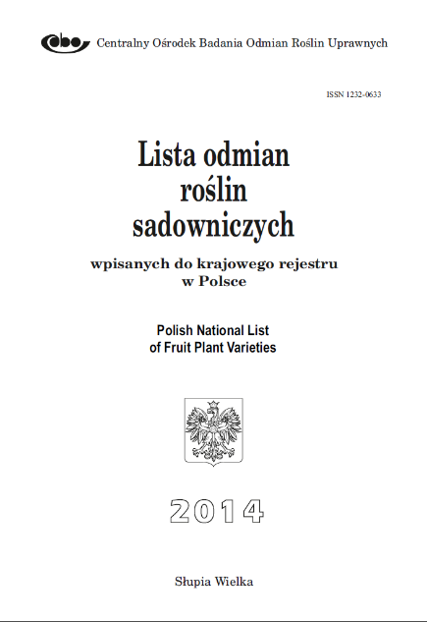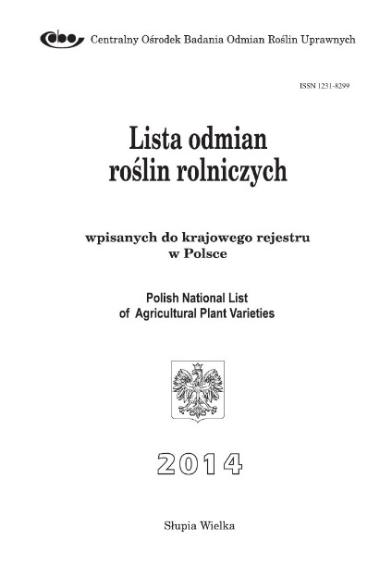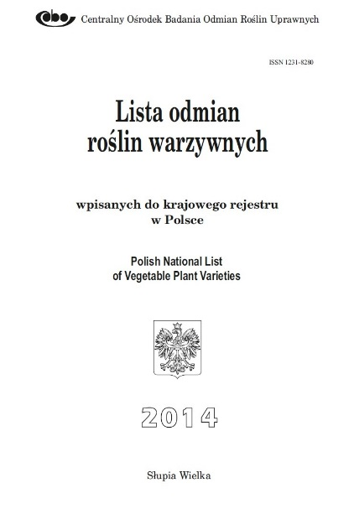
Fig. 1. General view of the Registers of plants included in the National Register of Plant Poland [7]

In 1974 Ukraine was registered in first grade plants L. perenne L. lukopasovyschnoho directly Drohobych-2. The first plant variety L. perenne L. Kyiv-101 for landscaping appearing in 1978 in 2001 marked a sharp increase in the number of registered varieties - 2.5 times and the emergence of a wide range of lawn grass breeding in Germany and the Netherlands on the market gardening Ukraine (Fig. 2), which is due, in our opinion, the development of green building in our country
Today in the State Register of plant varieties suitable for dissemination in Ukraine presented 29 varieties of plants L. perenne L., of which only 13 - the national selection, which is only 44% of the present range available (Fig. 3). Among registered foreign companies - Euro Grass Breeding GmbH & Co. KG (Germany) - Grades 6, Feldsaaten Freudenberger GmbH & Co. KG (Germany) - 4, Małopolska Hodowla Roślin Sp z o.o. (Poland) - 2, Innoseeds B.V. (Holland) - 2, DLF Trifolium (Denmark) - 1 and Pickseed (Canada) - 1 grade.

Fig. 2. Registered Plant Varieties of Lolium perenne L.
in the State Register of plant varieties suitable for dissemination in Ukraine (1974-2014 years.)

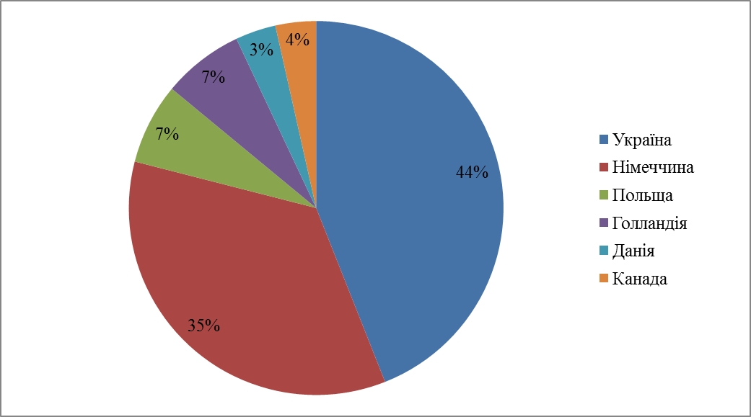
Fig. 3. Distribution of Plant Varieties of Lolium perenne L. in the State Register of plant varieties suitable for dissemination in Ukraine 2011-2014. For the countries claimants

In the Register of varieties of agricultural plant Poland registered 97 varieties of plants L. perenne L., which is part of the National Registry of Poland, of which only 39.2% own selection - 38 pcs. On the Polish market are lawn grasses such producer countries: Germany (29 pcs.), Denmark (21 pcs.) USA (4 pcs.), Netherlands (3 pcs.) And France (2 pcs.). However, unlike the State Register of plant varieties suitable for dissemination in Ukraine, where registered 2 varieties of Polish breeding, from 2001 - Inca, 2007 - Niha, selection Małopolska Hodowla Roślin Sp z oo, in the National Register of Polish plant varieties L . perenne L. Ukrainian breeding absent (Fig. 4).
In Poland, local plant varieties L. perenne L. occupy the largest share of the stated (39%), indicating a strong Polish breeders breeding work is comparable to Ukraine, where varieties own selection much less. One of the reasons, in our opinion, is the destruction of breeding and seed base in Ukraine in recent years. Also, decreased production of perennial grasses due to the decrease in acreage and yield under specialized enterprises [5].

Fig. 4. Distribution of Lolium perenne L. plants in the National Registry of Poland in 2014 by country applicants

In 2014 Ukrainian applicants organizations omnibus L. perenne L. in the State Register of plant varieties suitable for dissemination in Ukraine registered four. This research station Kyiv National Scientific Center "Institute of Agriculture UAAS") 4 varieties) and the National Botanical Garden. MM Grisha NAAS of Ukraine, Carpathian Research Station of the Institute of Agriculture and Livestock western region of Agrarian Sciences - 3 and National Science Centre "Institute of Agriculture UAAS" - 2 varieties. Major Polish institutions zamayyutsya plant breeding and testing of L. perenne L., varieties of which are registered in the National Registry of Poland - Poznańska Hodowla Roślin sp. z o.o. (8 pcs.), DANKO Hodowla Roślin sp. z o.o. (6 pcs.), Małopolska Hodowla Roślin-HBP sp. z o.o. (7 pcs.), Hodowla Roślin Bartążek sp. z o.o. Grupa IHAR (9 pcs.), Alicja Ramenda (6 pcs.,) INVEST Grzegorz Dąbrowski (3 pcs.) And Rolimpex Nasiona S.A. (2 pcs.).
Today, 60% of registered plant varieties L. perenne L. Ukrainian State Register appointment for landscaping populated areas (Figure 4), which shows the relevance and prospects lawn case in our country. In Poland, by contrast, L. perenne L. - hay and lukopasovyschnoho purpose, occupy most of the positions in the National Register of Poland - 62%.

Fig. 5. Distribution plants Lolium perenne L. in the direction of use in the State Register of plant varieties suitable for dissemination in Ukraine (1974-2014 years.)

Conclusions. The analysis suggests that the relevance lawn business in Ukraine is growing every year. Experimental data show that domestic plant varieties L. perenne L. is competitive in the global market of seeds of perennial grasses ..

Список літератури
- Державний реєстр сортів рослин, придатних для поширення в Україні у 2014 році – К. : Державна ветеринарна та фітосанітарна служба України, 2014.
- Клименко А. В. Газонні та декоративні трави / А.В. Клименко, Г. Д. Дяченко // Бібліотека «Дім, сад, город». – К., 2008. – № 4. – 40 с.
- Рахметов Д. Б. Біолого-морфологічні особливості інтродукованих газонних трав в умовах Національного ботанічного саду ім. М. М. Гришка НАН України / Д. Б. Рахметов, Л. Г. Ревунова // Вісник Харківського національного університету імені В. Н. Каразіна. Серія: Біологія. ‒ 2014. ‒ Вип. 20. – С. 61–68.
- Сердюк М. А. Нові сорти низових злакових трав для озеленення / М. А Сердюк, О. М. Сердюк, О. В. Шкура // Збірник наукових праць Національного наукового центру «Інститут землеробства УААН». – 2008. – Вип. 2. – С. 110–120.
- Стрілець Р. А. Організаційно-економічний механізм виробництва і реалізації насіння багаторічних трав. Х.: ХДАУ ім. В. В. Докучаєва, 2002
- Чоха О. В. Газонні покриття м. Києва / О. В. Чоха. – К.: Фітосоціоцентр, 2005. – 288 с.
- Lista odmian roślin rolniczych 2014. [Electronic Resource]. – Mode of access: http://www.coboru.pl/polska/Rejestr/odm_w_rej.aspx?kodgatunku=ZTThttp://www.coboru.pl/polska/Rejestr/ListyOdmian/lista_rolnicze_2014.pdf.

Проанализировано позиции Государственного реестра сортов растений пригодных для распространения в Украине и Национального реестра Польши по степени репрезентативности сортов растений Lolium perenne L.
Экологическая пластичность, райграс многолетний, реестр

* Supervisor - Doctor of Biology, Professor KOLESNICHENKO О. V. ©О. Ю. ЛЕЩЕНКО

