UGC 633.2

EXIT FROM BIOGAS herb DEPENDING

METHOD OF GRINDING

©V. M. PAVLISKYY, Doctor of Engineering,

І. V. FLONTS, Candidate of Technical Sciences

N. V. BARYLKO, specialist

VP NUBiP Ukraine "Berezhany Agrotechnical Institute"

The article presents the results of scientific research to determine the biogas yield of herbaceous plants, analyzes laboratory data and substinates dependence of methane fermentation from grinding method and particle size gives the prospects of using plants as substrate for biogas.
Вiogas, power plants, methane fermentation, extrusion, grinding, raw materials

Lack of fossil energy in the world is to find alternative sources of energy, so there is a problem using their own renewable sources, including herbaceous plants of Ukraine. However, increasing the area of ​​agricultural land for their cultivation can reduce the space for growing food crops that will boost food prices. The way out of this situation may be the attraction of the area removed from agricultural use [1].
Over the study technological, organizational and environmental aspects of biogas from different raw materials is a number of researchers, namely H. Geletukha [1] T. Zhelyezna M. Zhovnir, G. Kaletnik, V. Dubrovin, V. Kryvoruchko [2] R. Schultz [3]. But the problem today is many unresolved issues that require global systems research.
The aim - to experimentally determine the dependence of the output from biogas way of grinding and size of the studied material. Further theoretical and practical development potential herbaceous plants for energy.
Material and methods of research. In recent years, more attention is paid to biofuels produced from high-efficiency power plants. The source material may be the by-products of different origins, and specifically designed for this power plant, the main absorbent carbon dioxide, reducing its amount in the atmosphere. These plants form high yields of biomass that could be used for energy purposes for biofuel production [2].
Herbaceous plants are characterized by high ash content and mineral content, because in case of incineration, they do not emit smoke, carbon monoxide and harmful substances unlike wood.
Biogas - gas, obtained by methane fermentation of biomass, which is influenced by three types of bacteria. The first type - hydrolysis, the second - acid-third - metanoutvoryuyuchi, while bacteria eat the following products earlier life [1].
For the experimental determination of biogas out of herbaceous plants used miskant big, wild carrots and quinoa with white bows outskirts of the city Bershad (see. Table.). As a source of methane bacteria (seed) used perebrodzhenu hnoyivku cattle from the fermenter biogas plant Berezhany Agrotechnical Institute, w = CR 2.32%; pH = 7.7. Laboratory fermenter - a gas-tight package with a polymeric material that is suspended in an incubator at a temperature of 37.5 ° C + and kept there 42 days. The volume of biogas sample was determined by changing the volume of the fermenter, which was investigated biomass. Biogas is formed by the natural process of microbial decomposition of organic matter in a wet environment under anaerobic conditions (without oxygen). In fermenter bacteria that are found in nature, causing fermentation of organic matter, similar to what happens in the rumen of ruminant animals [3]. To process the study materials used laboratory knife shredder and extruder. This chaff pre-soaked for 15 minutes. in water at a temperature of + 14 ° C. Feed substrate extruder conducted manually. Extrusion - the process of punching holes forming material through the matrix.
Research results. Our results showed that preconditioning energy plants such as wild carrot, lamb's quarters, miskant large increases availability of hydrolytic enzymes to polymeric carbohydrates, which leads to splitting lihninotselyulozy and increase the yield of biogas (see. Table).

Вихід біогазу за 42 дні метанового бродіння, м³/т
№ п/п | herb | The method of grinding | Medium size, mm | Exit biogas
 |  |  |  | era
 |  |  |  | 7 | 14 | 21 | 28 | 35 | 42
1 | дика морква | laboratory  knife chopper | 23,5×3,5 | 65 | 158 | 187 | 187 | 185 | 185
1 | дика морква | extrusion | 10,0×2,0 | 159 | 260 | 361 | 360 | 359 | 358
2 | lamb's quarters | laboratory | 34,0×3,8 | 61 | 96 | 119 | 130 | 130 | 130
2 | lamb's quarters | knife chopper | 6,8×1,9 | 99 | 176 | 281 | 280 | 279 | 278
3 | miskant great | laboratory  knife chopper | 20,0×3,4 | 65 | 110 | 138 | 150 | 150 | 150
3 | miskant great | extrusion | 8,2×2,3 | 162 | 291 | 359 | 358 | 356 | 356

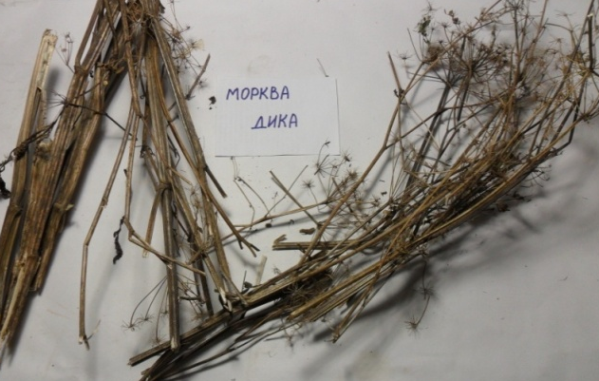
Wild carrot (Daucus carota) - a biennial plant that reaches 1 cm (Fig. 1). For comparison, depending on how the biogas output chopping knife used laboratory extruder and the chopper. After the first method of processing the average amount of broken rice 23,5 × 3,5 mm, and after the second - 10 × 2 mm. By comparing the data found that after extrusion length of the stem fell more than 2 times, width - 1.5 times (Fig. 2). Exit biogas broken rice with wild carrot was 185 m3 / ton. EXTRUSIONS chaff allocated 358 m3 / t biogas for 42 days methane fermentation (see. Table.). After analyzing the results of laboratory studies of biogas from wild carrot, one could argue that its output depends not only on the length of the stem, but the method of grinding and the difference between the largest and smallest particles of broken rice as smaller stems parameters were obtained after extrusion, resulting in obtained a higher yield of biogas.

Рис. 1. Wild carrot (dried to air-dry state)

Fig. 2. Withdrawal of biogas wild carrot, depending on the method of grinding

Lamb's quarters (Chenopodium album) - a weed, up to 1 m (Fig. 3). To determine the output of biogas plants that use the same methods of processing raw materials, as for the wild carrot. In the experiment, with white quinoa broken rice after processing chopper knife to the average particle size 34,0 × 3,8 mm and obtained 130 m3 / t biogas. After extrusion average particle size was 6,8 × 1,9 mm. This biogas yield was 278 m3 / t (see. Table.). As a result, found that the length of the stem after passing through the extruder decreased by 5 times, and width - 2 times (Figure 4). This is because after the knife Cutter declined only the length of the stem, and the extrusion - both width and length. So the surface area of ​​broken rice, which received the first method, is less than the area of ​​extruded broken rice, which as a result gave twice as much biogas yield. [3]
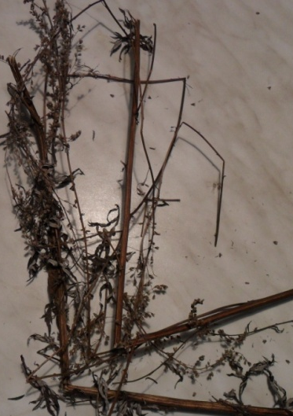
Fig. 3. lamb's quarters (dried to air-dry state)

Fig. 4. Exit biogas with white quinoa depending on how the shredding

Miskant large (Miscanthus giganteus) - a perennial herb, up to 2.5 m (Fig. 5). To determine the intensity of methane fermentation miskant dried to air-dry state and podribnyly laboratory extruder and the chopper knife. In the first embodiment, the average particle size was 8,2 × 2,3 mm, and the second -20,0 × 3,4 mm. The study received 150 m3 / t biogas from broken rice, processed knife chopper, and after extrusion - 356 m3 / t (see. Table). In this case, the length of the stem, crushed extruder decreased 2.5 times, width - 1.5 times (Fig. 6). Thus established that EXTRUSIONS chaff has the best performance. By comparing the data from cultivation miskanta big one could argue that this growing rosyny is very promising as an energy source.
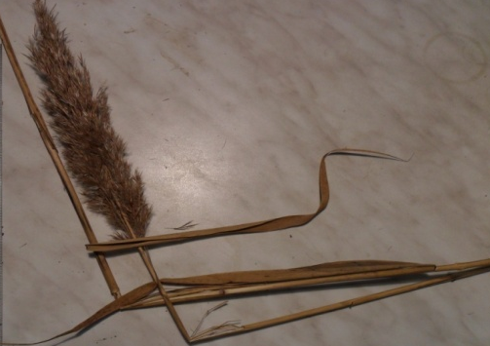

Fig. 5. Miskant large (dried to air-dry state)

Conclusions. Based on the research and treatment of the results found that wild carrots, quinoa white and miskant large can be used as a substrate for biogas production, with the required previous preparation for methane fermentation, in this case extrusion, because this method of crushing obtained best final performance in this experiment. Comparing raw materials processing laboratory extruder and chopper knife, biogas output in the second embodiment, increased by 51.7% from wild carrot, 46.8% of white quinoa, 42.1% of miskantu great.

Fig. 6. Exit biogas from miscanthus large depending on how the shredding

The advantage of this method is to increase the output of grinding biogas relatively low cost material, the use of sludge as pohazovoho biomineralizovanoho fertilizers, relatively low qualification requirements for staff. Extrusion improves biozasvoyennya waste and increases the level of availability of materials for the action of bacteria. The result of this process is enrichment materials that are difficult to transform and increase the efficiency of biogas production. Thus confirmed the potential use of some herbaceous plants for energy purposes.

Список літератури
1. Гелетуха Г. Г. Біомаса зігріє Україну [Електронний ресурс] / Г. Г. Гелетуха // Економічна правда. – 2013. – Режим доступу: http://www.epravda/com.ua/columns/2012/06/14
2. Дубровін В. Біопалива (технології, машини і обладнання) / М. Корчемний, І. Масло, О. Шептицький, А. Рожковський, З. Пасторек, А. Гжибек, П. Євич, Т. Амон , В. Криворучко ] – К.: ЦТІ “Енергетика і електрифікація”, 2004. – 256 с.
3. Шульц Р. Виробництво і використання біогазу в України [Електронний ресурс] / Р. Шульц – Київ, 2012. – Режим доступу: http://ua-energy.org/upload/files/Biogas_urg.pdf.

В работе приведены результаты научных исследований по определению выхода биогаза из травянистых растений, проанализированы лабораторные данные и обоснованна зависимость метанового брожения от способа измельчения и размера частиц, доказана перспективность использования растений в качестве субстрата для биогаза.
Биогаз, энергетические растения, метановое брожение, экструзия, измельчения, сырье

©© V. M. PAVLISKYY, І. V. FLONTS, N. V. BARYLKO, 2015

