Stepasyuk LM , PhD in Economics,
Tіtenko ZM, aspіrant

YAKІST L MILK CONTEXT OF EUROPEAN STANDARDS

Background research. In a market economy the main task facing producers is to ensure the competitiveness of products produced. Under conditions of increased competition in leading positions are only those companies that are capable of continuous updating production technology, innovation, continuous improvement of the quality and characteristics of products.
Milk and dairy products are an essential part of the human diet, according to scientifically based nutrition standards , it should consume an average of 380 kg (in terms of milk) milk and milk products, including 120 kg of milk fresh. In addition to quantitative market saturation, it is also important to provide adequate, appropriate quality dairy products that can not be done without improving the quality of primary raw material - milk.
Analysis of recent research. Research on quality improvement issues devoted to the works of famous domestic and foreign economists as J. Adler , G. Azhaldova, G. Azoyeva, L. Badalova, P. Kalita, S. Grigoriev, E. Okrepilova, P. Orlov, and Feigenbaum. Coverage of the quality and efficiency of milk production is in farms also given an important place, which was confirmed by the presence of scientific papers such domestic scholars as V. Boyko, V. Zymovtsya, M. Il'chuk, M. Kalinchyka, S. Kamilov, P. Sabluk, A. thorn and others. However, given the existence of the problem and now, further research is necessary and urgent.
The purpose of the article - is the analysis and study to improve the quality of milk and dairy farms in the Poltava region.
The main material. The modern market economy poses fundamentally different requirements for quality of products . Ukrainian milk quality standards are much lower than the world. Analysis current level of harmonization of standards in the field of agribusiness shows that in rural identified to ISO 53% of existing standards in the food and processing industries, only 28%. Thus, the 54 existing standards only 23 identified the requirements of ISO. Of this group of products meeting international quality requirements: milk cow drinking with his purchase, cheese products, yogurt, sour cream, canned milk and so on. Lack of harmonized standards for shelf life, specifications harvesting of milk, including baby food, methods of determining body fat, water purity, microbiological analysis and others [1 , 249 ].
One of the main indicators for assessing the quality of raw milk is the density, which allows to evaluate the naturalness of milk. Thus, in the case of falsification of milk water density decreases (each 10 % added water cause a decrease in the average density of 3 kg/m3), by skimming or dilute milk skim milk density increases [2, 37].
Table 1
Comparison of parameters of milk quality indicators Ukrainian and European standards
Document names | Brand | Acidity, º T | The degree of purity of a benchmark group | Total bacterial contamination (tys.sm3) | Temperature, º C | Mass fraction of dry substances,% | Somatic cell count, thous. / Cm ³
ISO 3662 - 97 "Milk korov'yachenezbyraneVymohy in Procurement" | Extra | 16,0-17,0 | І | <100 | <6 | >12,2 | <400
 | Higher | 16,0-17,0 | І | ≤300 | ≤8 | ≥11,8 | ≤400
 | First | ≤19 | І | ≤500 | ≤10 | ≥11,5 | ≤600
 | Second | ≤20 | ІІ | ≤3000 | ≤10 | ≥10,6 | ≤800
Regulation (EC) № 853/2004 of the European Parliament and of the Council of 29 April 2004 "With regard to specific hygiene rules for food hygiene" |  |  |  | <100¹ | ≤6 |  | ≤400²
¹ Is geometric Zmіnna Farmgate value mіsyatsі 2, s 2 vіdborom schonaymenshe zrazkіv on mіsyats;
² Zmіnna geometry is symmetric Farmgate value for the 3-Moonlight perіod іz vіdborom schonaymenshe one once for mіsyats for viklyu chennyam vipadkіv, if the competent authority viznachaє іnshu technique s metoyu vrahuvannya season for Change in rіv virobnitstva nyah.

Milk that by Ukrainian standards corresponding to the first grade, is considered in the second, and in compliance with the European Union generally not accepted for processing. According to GOST 3662-97 "Milk and milk products. Requirements for procurement of "general bacterial contamination of milk the premium is less than 300 tys./sm3 , first - less than 500 and a second - less than 3000 tys./sm3 [3,4 ]. In accordance with Regulation (EC ) № 853 /2004 , this figure should not exceed 100 tys./sm3. Somatic cell count per GOST 3662-97 should be no more than 400, 600 and 800 tys./sm3 to high, first and second grade , respectively, and by Regulation (EC ) № 853 /2004 , it should not exceed 400 tys./sm3 (Table 1 ).
In 2012, in Ukraine the share of farms sold milk in most meets extras senior and first class processing enterprises accounted for 94.0 %. The quality of raw milk that comes from processing farms radically different - 83% is milk brand and second nesortove (Figure 1.2 ). It should be noted that the quality of milk sold by companies tends to increase. This is due to the desire to obtain a higher revenue because the price difference between I and II grade - between 10-20 %, and between premium and nesortovym milk - more than 30 %.
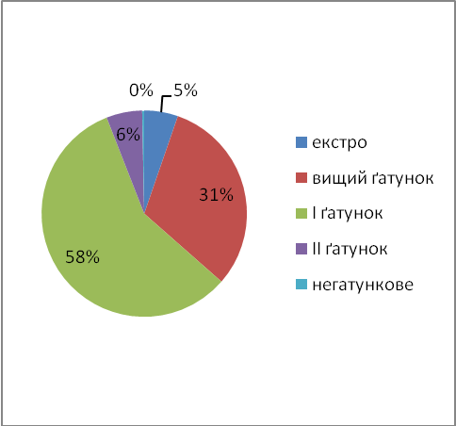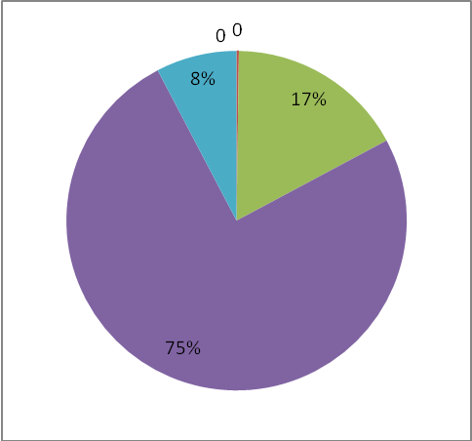
Rice. 1 Structure of milk sold Rice. 2 Struktura milk sold
agricultural companies in 2012 households in 2012

Note that a significant impact on the quality of milk has protein in the diets of cows. Thus, according to the Institute of Animal at 100% and the rate of protein in the diets of milk fat content will be 4.26 %, and at 80 minutes rate - 4.06 %, protein - respectively 3.87 % and 3.18 %. In recent years there has been a tendency to increase the fat content of milk, which is an important factor in product quality. Thus, in 2011 r.v whole Ukraine farms to processing plants realized milk fat - 3.58 %, in the Poltava region , the figure was - 3.72 %.
First of all , this situation indicates a crisis in dairy farming and impedes the development of the dairy industry because there is the issue of quality raw material processing plants . To ensure the required quality of milk produced today can only farms in which the milking machines, milk cooling and cleaning. Households have no conditions or opportunities to provide the necessary production process milk. Same because they produced milk meets only the second grade or are nehatunkove, while large farms it is implemented extra, higher and first grade. For example, in the Poltava region in 2012, 100 % of the milk, which came to processing plants on farms meet the requirements of the second class or nehatunkove (Table 2). In 94.5% of farms raw milk to qualify extras highest and first grade (0.0% , 28.6 % and 65.9 % , respectively).
Table 2
The qualitative composition of milk sold to processing companies, Poltava region, 2012
 | Extra |  | Superior grade |  | First grade |  | Second grade |  | Nehatunkove
 | thousand tons | % | thousand tons | % | thousand tons | % | thousand tons | % | thousand tons | %
Farms | 19 | 0 | 105,1 | 28,6 | 242,7 | 65,9 | 19,7 | 5,3 | 0,6 | 0,2
Households | 0 | 0 | 0 | 0 | 0 | 0 | 157,7 | 99,8 | 0,3 | 0,2

Poor quality milk zprychynena poor bio- sanitation in primary production. The presence of fat and protein depends on the quality of food: juicy , coarse and concentrated , and dietary supplements , the best ratio in their diet - the key to obtaining high-quality milk .
Inherent to Ukraine verification system safety and food quality is focused on the end result. In particular, the analysis of individual samples are subject to the product being selected controller. If the results confirming the purity of product realization shall be subject to the entire party. However, this approach does not guarantee complete safety and absolute quality of this product. Fundamentally different provisions on food safety, which notman datory EU countries set out in Council Directive European cooperation HACCP (Hazard Analysis and Critical Control Points - Hazard Analysis and Critical Control Point Control ), which are mandatory for the EU.
The system is HACCP risk assessment, which may affect the food product during its manufacture, storage, sale and use. Among these dangers can be both microorganisms and chemicals that are important for our country. HACCP offers to share the whole production process into blocks and implement a monitoring system for potential " risk " in each of these areas. Detailed analysis of the " risks " qualified and responsible operations each specialist food business documentation and all measures will minimize the likelihood of producing defective product to a minimum, almost zero [ 5, p. 68].
In Ukraine there are 499 companies engaged in the harvesting of raw milk , production of finished products and export. But now the system NASS system implemented by only 51 (only 10.2 % of companies), of which 11 located in the Poltava region. It should be noted that almost half of the enterprises regions ( 11) are without international quality requirements, and it is a testament to the lack of competitive advantage in foreign markets.
Conclusions and suggestions. So, in order to meet production requirements of the market and at a given time was competitive , manufacturers must implement and protect the quality system that provides control of all the factors affecting the quality of products and services.
With the current economic conditions the production of high quality milk provided by a combination of advanced technology content , that milking should be done only by mechanical means with a closed feed to milk in Milk cooling or purification and quality work of staff and effective management system that is built on the principles of efficiency, control and informative work.

References
1Hrabchuk The quality of milk and meat farms Zhytomyr region in the context of European integration requirements / IF Grabczuk / / Scientific Bulletin of Volyn National University of Lesya Ukrainian . - 2008 . - № 7. - S248 - 251.
2. Yakubchak AM Physical and biochemical properties of milk / O. Yakubchak / / Molochnoe case. - 2005 . - № 12. - P. 36-38 .
3. Regulation (EC ) № 853/ 2004 of the European Parliament and of the Council . - [ Valid from 2004. - 04. - 29 ].
4. Raw milk cow . Specifications : ISO 3662 - 200X . - National Standard of Ukraine : draft ; Developed by: Institute of Technology of milk and meat Ukrainian Academy of Agrarian Sciences ( Timmy UAAN ).
5. Yakubchuk A. HACCP - эffektyvnaya preventyvnaya System Security Guarantee produktov nutrition / [ O. Yakubchuk , S. Miller , A. ringing , E. Deyneko ] / / Myasnoy business. - 2004 . - № 7. - P. 68-69

