UDC 339.16.012:633.85
PROSPECTS OF PRODUCTION AND EXPORT OF RAPESEEDS IN UKRAINE
L.S. Denysenko, PhD student
National University of life and environmental sciences of Ukraine
Considered are the main indicators of production of rapeseed in Ukraine, analyzed the dynamics and geography of production and export of domestic rapeseed.
Production, export, rape seeds, geography of production of rapeseed.
Statement of the problem. In the world is growing every year the production of biodiesel based on rapeseed oil, particularly in European countries is well developed the industry. Today and in the future the views of Europe will be focused on Ukraine as a supplier of raw materials, therefore the study of the state and prospects of production and export of rape seeds is relevant.
Analysis of the last researches and publications. In the economic literature comprehensively presents the state of the market of rapeseed in various aspects: the size of the market, the dynamics of production and export, the prospects for further development. A significant contribution to diagnose the market of rape seeds introduced Russian and foreign scientists, in particular Galushko V.P. [1], Greeks L.D. [2], Kuzmin A.V. [2], Lupenko Y.A [4], Supihanov G.B. [9], Shpychak O.M. [4], and others. In most publications on state and prospects of production and export of rape seeds focus on the main trends that have developed in the whole state. Therefore it is at the level of Ukraine, it is expedient to analyze the state and prospects of production and export of rape seeds.
The aim of the research. To substantiate the expediency and prospects for the production and export of rape seeds in Ukraine.
Summary of the basic material. Rape culture in Ukraine has grown in the past century. In the 70-ies in the country was sown about 10 thousand hectares, in the 80's - about 20 thousand hectares, and in the beginning of 90-s the production of rapeseed began to pay more attention and was planned to increase sown areas up to 500 ha.
Table 1
Dynamics of production of rapeseed in Ukraine
Indicator | Years
Indicator | 2003 | 2004 | 2005 | 2006 | 2007 | 2008 | 2009 | 2010 | 2011 | 2012 | 2013
Sown area, thousand ha | 69 | 117 | 207 | 414 | 891 | 1412 | 1059 | 907 | 870 | 566 | 1080
Yield, t/ha | 0,9 | 1,39 | 1,46 | 1,57 | 1,3 | 2,07 | 1,85 | 1,7 | 1,73 | 1,7 | 2,36
Gross harvest, thousand tons | 50 | 145 | 278 | 591 | 1021 | 2801 | 1826 | 1433 | 1402 | 1180 | 2305
Source: Developed by the author based on the data of the information Agency "APK-inform" [5]

Considering the dynamics of rapeseed production, it should be noted its intensive growth over a five-year periods, when gross yields increased from 417 thousand tons, average for the period from 2003 to 2007, up to 1,7 million tons for the period from 2008 to 2012, or 4 times. It should also be noted that in 2008 Ukraine produced a record number of rape seeds, more than 90% of which was exported. In the dynamics of gross yield of rapeseed in 2008 increased against 2007 by 2.8 times. By results of the 2013 production of rape seeds increased to 2.3 million
Comparing the two previous five-year plan, sown areas under rape has increased in 2,8 times - from industry annual average of 340 hectares in 2003 - 2007 to 963 thousand hectares in 2008 - 2012. After the recession of volumes of cultivated areas from 2009 to 2012, 2013 in Ukraine under the rape was sown already 1080 thousand hectares, which is 90,8 % increase in this indicator 2012.
Examining the dynamics of the yields of rapeseed, it should be noted that it has grown on 43%, comparing five-year periods: from 1.33 t/ha in 2003 - 2007 to 1,91 t/ha in 2008 - 2012. The average yield in 2013 compared with 2012 rose by 38.8 % (from 1.7 to 2.36 t/ha, respectively) [5].
Rape has many agro-technical and economic advantages compared with other crops. However, refers to risky crops. The main threat for winter canola causes overwintering, and in Ukraine is dominated by the production of winter rape. In the structure of areas for the harvesting of 2013 the share of winter canola crops accounted for 95.8%, i.e. 1035 ha [4]. This distribution in the structure of crops can be explained by several reasons: first, the productivity of winter rape in order higher spring-sown grades, secondly, an increasing amount of time for the spring sowing campaign.
Slow formation of the market of rapeseed oil in Ukraine, the decline of the livestock industry, which led to a drop in demand for animal feed, lowest prices for rapeseed in Ukraine - the main factors, which have become a prerequisite for increasing the export of rapeseed Ukrainian enterprises. If in 2000 it was exported 52% of the rapeseed in 2001 already 70%, while in 2008 this figure was more than 90% [9].
In 2000 the enterprises of Ukraine was exported commodity seeds of the rape for the total amount of 10,700 million. The USA, in 2007 - 378,055 million. USA, and in 2013 - 1929,5 million. USA [5].

Fig.1 Ukraine: production and export of rapeseeds
Source: [7]
As we can see from Fig. 1, the volume of export of rape in 2013 exceeded the volume of its production, it is explained by the fall in domestic consumption, in particular of the processing volume of this oil crops, as well as a sufficiently large shipments crop residues 2011 at the beginning of 2012/2013 MG.
In 2000, the rape was exported mainly to Israel, Germany and the Baltic States, which accounted for 65% of total exports of rapeseed from Ukraine. As at the year 2013 in Europe exported to 84.6% of the total volume of export of rape seeds (Netherlands - 20%, Belgium - 19%, Poland - 19%, France - 17%) [8].
According to preliminary data of state statistics Committee of Ukraine, the gross yield of rapeseed in 2013/2014 MG year amounted to 2.4 million tons, while during the first three months (July-September) exported 1,29 million tons (54% of the total harvest).
In 2013, the leaders in terms of area under rapeseed among administrative-territorial units of Ukraine became Odessa (96,8 thousand ha), Vinnytsia (92,2 thousand ha) and Dnipropetrovsk region (79,1 thousand ha) (Fig. 2).
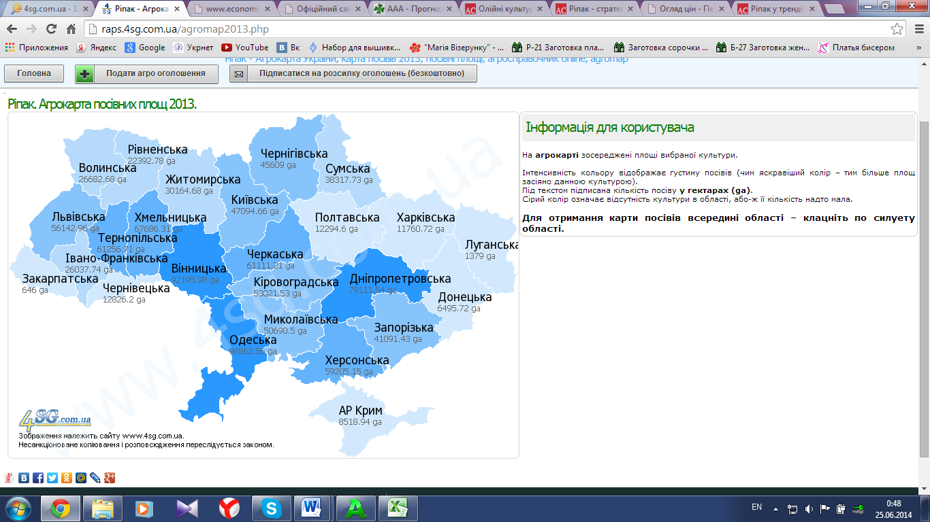
Fig. 2 Agromart acreage of rape, 2013
Source: [6]
According to the results of 2012/2013 MG, the largest exporter of canola from Ukraine is the company "Alfred S. Topfer the international / Ukraine", which accounted for 17.2% (2011/12 was 10,3%). Second place was taken by the company Serna, with a share of 11.1% (9.7% in 2011/12). On the third position-Company - Agroinvest" - 8,1% (versus 8.0% in 2011/12) [8].
Farmers have shown that rape has become one of the most profitable agricultural crops in 2008 and 2009.
Conclusions and perspectives of further research. The most important obstacle to increased production and development rape is retarded technical base of agricultural enterprises. As a result of violations of precision seeding, fertilizing, the failure rapeseed economy lose 30-50% of potential crop, which automatically increases the cost of production of rapeseed. Such factors as the lack of financial resources in the farms Poggi in breeding work also significantly hinder further development of the market of rapeseed in Ukraine.
Despite a significant decline in cultivation area in 2012, 2013, Ukraine increased their volume almost doubled, while the gross harvest of crops increased by 95%. Consequently, we should expect a positive development trends rape cultivation on both global and domestic markets.

The list of used sources
1. Galushko V.P. Basics of agricultural Economics : textbook / VP Galushko, the GV Holebrook, Ohaton etc. - K.: Higher education, 2003. - 399 p.
2. Greeks L.D., Yurchenko O.D. Korol, A.V. Kuzmin Regarding the situation on the domestic and foreign markets rape and its impact on food security in Ukraine //
National security: Ukrainian dimension. - 2009. - №3 (22). - p. 76-79.
4. Purchasing, wholesale and retail selling prices of agricultural products and products of its processing (January 2013 January 2014) / [Y.A Lupenko, A.N. Ski, P. Voskoboynik, etc.] K. : NSC IAE, 2014. - 122 p.
5. Official website of the information Agency "APK-inform" / [Electronic resource]. - Mode of access: http://www.apk-inform.com
6. Official site of "Agroprodmir online / [Electronic resource]. - Mode of access: http://raps.4sg.com.ua/agromap2013.php
7. Official website of the Ministry of agriculture of the USA / [Electronic resource]. - Mode of access: http://www.fas.usda.gov
8. Strategy of development of agrarian sector of economy (for the period to year) / [Electronic resource]. - Mode of access: http:// http://minagro.gov.ua/node/10516
9. Supihanov G.B. "Formation of the market of rape", - K. CJSC "NICHLAVA", 2003. - 140 p.

