UDC: 65.012.7:65.018:338.439.5 /.6 (477)

Ukraine on the way reorganization safety and quality control of food products.
Myronenko O.I, PhD. agricultural sciences.
Poltava State Agrarian Academy

Annotation
The article examines issues concerning the state control safety and food quality, assess the effectiveness of the current system and its shortcomings, and identified the benefits and prospects of implementing the system of state control.

Keywords: quality control, food products, food safety, food security, agriculture, veterinary and sanitary service, Codex Alimentarius

Statement of the problem. Ensuring the safety and quality of food is one of the main goals of modern society, which depends on solving the health and preservation of the gene pool. According to forecasts of the World Bank, food production worldwide by 2050 to increase by 70-100%, while the population - to reach 9 billion people. [5]
Execution of the tasks may be subject to implementation of new technologies in the global agriculture and processing industries for providing of safe and high quality food products. Ukraine on the quality of food security now ranks 47 th among 107 countries.
The country has potential for further development of agriculture, which is able to increase the volume of production. At the same time he needs financial support from the state to update the material basis of production, especially by small farms. [1]
Analysis of recent research and publications. Reorganization of the State Committee of Veterinary Medicine of the State Veterinary and Phytosanitary Service, initiating the formation of a new government, veterinary and sanitary control and supervision as in food has caused great interest among scientists, members and employees that provide direct control of safety and quality of food. Thoughts on the said reforms are sometimes diametrically opposed. But they brought a sense of caring and responsibility for the safety and quality of food. Persuasive opinion of Academician I. Trachtenberg, G. Onishchenko, G. Kuznetsov, V. Horzheyev, T. Bakhteyeva. Given the significant contribution of these scientists in solving this problem in the economic literature are not processed approaches concerning the conditions of agricultural production with numerous small businesses and private households. Currently, the production conditions do not meet the European requirements and therefore outputs can not be competitive.
The purpose of the study. The aim of the study is to analyze the existing systems of monitoring the safety and quality of food, the assessment of production conditions for internal and external customers, with continuous monitoring of safety and quality of food.
The main material. Ukrainian agricultural sector, despite the state of logistics, difficult financial and economic situation in the country continues to provide food in accordance with the domestic market. At the same time providing foreign exchange earnings to the country. Food security at all stages of social development has been and remains one of the major problems of civilized society. Without proper and sustainable development of the food sector and ensure complete consumption of all products no society can not exist.
Significant contribution to food security, farmers are making Ukraine Poltava. This is illustrated by the chart the growth of production in all categories of farms (Figure 1). The volume of production in 2012 amounted to 13,399.8 million. This is 190,4% against the indicator of 2000.

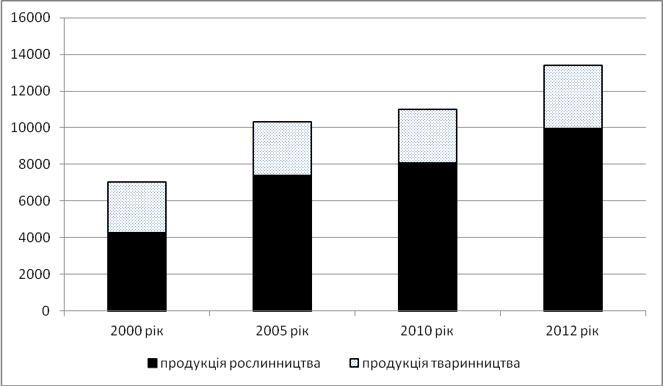
Rice. 1. Agricultural output in the Poltava region in years 2000-2012 [8] (in comparable prices of 2010, mln.).

Food security depends on the level of economic and social development of all agricultural units. In agriculture, Ukraine operate nearly 4.5 million small farms and they produce a significant amount of agricultural products.
The table shows that the proportion of households Poltava region in production is growing steadily. Increases in milk production and meat. But the economy is based on the personal work of farmers in terms of application technology, production conditions with a significant lag, and of course can not guarantee the safety and quality of food. Such products may not be competitive, because it does not comply with European standards.
Table 1.
Share of households in agricultural production in the Poltava region [8],%.
 | Years
 | 1990 | 1995 | 2000 | 2005 | 2010 | 2012
Agricultural Products  Plant products  livestock products  including - milk  meat (carcass weight) | 22,7  15,3  29,6  19,1  24 | 36,7  31,8  43,3  34,4  45,2 | 47,4  39,1  60,4  53,6  64,1 | 45,6  40,3  62,5  67,3  61,6 | 40,3  37,1  49,3  56,9  50,2 | 38,3  35,9  45,3  54,6  50,8

In accordance with the Law of Ukraine "On safety and quality of food" [3] state authorities to ensure the development, adoption and implementation of sanitary measures for food safety are: Cabinet of Ministers of Ukraine, central executive authority on health care, the State Sanitary and Epidemiological Service (hereinafter - the sanitary service), the State Veterinary Service of Ukraine (hereinafter - Veterinary Service), the central executive authority on agricultural policy, the central executive body for technical regulation and consumer policy (Article 4). The main functions to implement controls rely on veterinary and sanitary services (Article 6, Article 7).
Veterinary Service carries out state control and supervision of the raw food of animal origin on the capacities of their production, all plant products, agricultural products and raw food of animal origin sold at agricultural markets for production and final products in meat processing, rybodobuvnyh, fish processing, milk processing plants.
Sanitary Service provides state sanitary and epidemiological supervision over all the objects of sanitary measures. Controls for all food products for special dietary and all functional foods [6].
The current food control system in Ukraine, scientists and manufacturers assessed differently. In particular, G. Kuznetsov [4] describes as being: was not clearly defined organizational structure at the state level, so that there has been duplication. Establish additional obstacles for businesses inefficiently used budget and not consistent action between these bodies.

Experience Europe for organization and control of safety and quality of food is shown in Figure 2.
System of state control of food
System involving multiple agencies (exp. Ukraine, Poland, Slovenia, Croatia and other countries)
The integrated system - another government agency (the experience of Denmark, Sweden, UK, Netherlands, Canada, Mongolia)
System based on a single agency (Project Ukraine)
Has the problem:
- duplication of functions;
- lack of regulation in the first area;
- different rules apply with similar issues;
- controversy and confusion in the practical application of existing legislation
Benefits:
- a separate government agency formulates strategic objectives, plans and coordinates all activities of control;
- monitor and audit of food control;
- carry out risk management and communication of the risks;
- directly holds control and perform other functions
Outlook:
- global trends indicate that this system is based on a single agency acquired the largest distribution in the world;
- EU experience shows that it is expedient to create effective and efficient system of state control through institutional and organizational reforms that give authority to one government agency to carry out the control of products from "farm to fork consumer"

Rice. 2. Organizational form of food control in Europe

Three years ago the president of Ukraine decree reorganized the State Committee of Veterinary Medicine of the State Veterinary and Phytosanitary Service (Derzhvetfitosluzhby) initiating the formation of a new government, veterinary and sanitary control and supervision as in food. The decree was signed, but not as active reorganization took place as was thought. In furtherance of the President's decree has not been developed a number of legal documents - changes to existing laws, regulations. In the autumn of 2012 to the Parliament was submitted draft law "On amendments to some legislative acts on food safety." It is this law supposed to resolve all problems in the implementation of food control.
Functions ending live animal veterinarian. Regarding categorical statements
I. Bisyuk now the state has created the only competent authority, which controls the entire chain of food production for the population according to V. Chopenko are premature, because he took over the powers of sanitary-epidemiology service is not in stock, entrusted to him departments [9,10]. They should fix the law "On quality and safety of food products" which have not been adopted by the Verkhovna Rada of Ukraine. Addicted to the proposed reform is ambiguous. But international practice focuses on a single competent state agency that oversees food from field and farm - to the table of the consumer. As government control will be present from production to the consumer, then the manufacturer is obliged to behave responsibly produced. In particular: the crop for process - the use of chemical fertilizers, pesticides, herbicides, certified seed; in breeding for process - diagnosis, vaccination, laboratory tests, quality of feed, slaughtering, milking cows, product storage and shipping on the counter.
Ready agricultural sector of the country to cooperate with the WTO and the EU? Derzhvetfitosluzhby Chairman reported that the processed food products segment is not yet ready. First of all you need to fulfill the requirements of the EU's single body of state control over the safety and quality of food. Also required by law to resolve the question of reducing the number of permits, a feed of animal by-products not intended for human consumption. Subject to revision and law on animal identification and registration.
Practical implementation of animal identification program in agricultural enterprises and private farms of rural population began in the summer of 2002, when it was created, "Agency for Animal Identification and Registration." Identification and registration of animals is important for breeding, meat balance sheet, calculating vaccine production needs. In addition, identification of animals - epizootic welfare, quality and food safety, which is essential for the government, producers and consumers [4]. Since the organization Derzhvetfitosluzhby authority for identifying, registering handed it to her. Work is something.
Modern technologies of agricultural crops include the use of chemical fertilizers, herbicides, pesticides and other chemical products. They help increase productivity, increase shelf life, improve appearance of fruits, vegetables and grains. At the same time they provoke danger. We know that pesticides are hazardous to health and are carcinogenic. A healthy nation - above all! Science says that life is 80% dependent on the quality and safety of food products. Nourishment continue or shorten our age [9].
Grown or produced agricultural products shall not contain genetically modified organisms, as well as residues of pesticides, herbicides and other chemical products. Scientific studies show that persistent pesticides in the environment enter the human body in 95% of cases of food, 4.7% - of water. Radionuclides enter the body chain "soil - plant - a man" or "soil - plant - animal - human" in 94% of cases of food, about 5% - of water.
In connection with the accession to the WTO and the EU closer to a stipulation of the Directorate General of the European Commission and Consumer Protection (SANCO): no food product does not fall into the Eurozone, if Ukraine does not operate a single supervisory body that will ensure the quality and safety of food. Inspectors from the European Union warned Ukraine, on mandatory identification of cattle in peasant farmsteads. Failure to do so will be an obstacle exports of beef.
Ukraine has manufacturing facilities for the production of cheese and send to export 80 tons of which 80% in Russia. Recently, there are problems with exports because of non compliance with manufacturers specifications. Cheese one brand can be of two types. For specifications that each company develops "by itself" decoupling producers hands. It is about the use of overseas oil. Actually the use of overseas oil is no big sin. The main thing - honestly labeled product: natural or substitute it, both for domestic consumption and for export. [10]
Ukraine can be a successful exporter of products, namely - corn, sunflower, meat and dairy products. To do this, the conditions of livestock production to bring in line with European requirements. You also need to establish a strict system of food safety control.
Conclusions and recommendations for further research. Vector of Ukraine's economy is oriented towards the EU. To achieve this goal the government actively conducts standard-setting work in all sectors, especially in the field of life and health of citizens, trying to harmonize our legislation with EU legislation. A particular concern for the safety and quality of food.
Reorganization of state control safety and quality of food lays the foundation for the future. To do this:
- accelerate the adoption of legislation that would resolve all departments working together, clearly define the functions and powers of state control;
- strengthen the responsibility of manufacturers who must implement a system of quality management, evaluation of hazard such as ISO and HACCP standards and good manufacturing practices;
- to provide financing, technical and organizational upgrading of agricultural production;
- european choice of Ukraine requires the use of state control elements of modern quality management systems, the use of modern laboratory equipment, regular reporting of monitoring results to the public.

References.
1. Hotsuyenko E. Food security ... with deferred / http://gazeta.dt.ua/business/prodovolcha-bezpeka-z-vidstrochkoyu-_.html
2. Dyman T.N. Safety of food raw materials and food / T. Dyman, T. Mazur. - Kyiv: PH "Academy", 2011.
3. Krupin V. Aspects of Food Safety formation Ukraine / V. Krupin, Y.Y. Pushan / / Economic Innovation. - 2012. - № 47. - P.70-80.
4. Kuznetsov V.G. From farm to fork: in terms of products / http://gazeta.dt.ua/HEALTH/z_lanu_do_stolu_z_poglyadu_virobnika.html
5. Kurinna A. The food crisis is still delayed / http://gazeta.dt.ua/macrolevel/prodovolcha-kriza-poki-scho-vidkladayetsya-_.html
6. On the safety and quality of food. Law of Ukraine on December 23, 1997 // Bulletin of parliament. - 1998. - № 19. - P.98.
7. Rogov I.A. Safety prodovolstvennoho raw materials and pyschevыh produktov: Textbook / I.A. Rogov, N.I. Dunchenko, V.M. Poznyakovskyy etc. - Novosibirsk: Sib. unyv. Publishing House. , 2007. - 227 p.
8. Statistical Yearbook of the Poltava Oblast 2012 / edited by L. Kalashnyk. - Poltava.: Ch. Eng .. Statistics, 2013. - 408 p.
9. Chopenko B. kept a cow / http://gazeta.dt.ua/ariculture/berezhena-korova-_.html
10. Chopenko My Thy W. ponimaye / http://gazeta.dt.ua/ECONOMICS/moya_tvoya_ne_ponimae.html
11. Khorunzhiy M.I. Agroindustrial complex: problems of formation and functioning of the market conditions / M.I .Khorunzhiy // Economy APC. - 2012. - № 3. - P.113-120.

