УДК 519.863:636
ANIMAL AS OBJECT OF MODELLING
L.Galaieva, M.Grechko
National university of life and environmental sciences of Uraine

The article considers the state of the branch of animal husbandry in Ukraine in 1990 to 2011.,prospects of development; reasonable necessity and advantages of usage of Economics and mathematical modeling of industrial processes in the branch.
Key words: animal husbandry, indexes of production, development, modeling, feed ration, optimization, innovation ways, economics and mathematical model.

Relevance of research. Animal husbandry is the leading branch of agriculture sector in Ukraine, the main purpose of which is to ensure the production of foodstuffs of animal origin in amounts that correspond to the standards of food safety. Given branch needs to influence not only from the state but also from science.
Analysis of key publications. Проблемi розвитку та функцiонування тваринницької галузi в Українi присвяченi науковi дослiдження вiтчизняних вчених С.П. Азiзова, В.I. Аранчiй, В.I. Бойка, В.Я. Месель-Веселяка, О.В. Мазуренка, I.С. Трончука, П.Т. Саблука, Н.В. Оляднiчук.
Questions of Economics and mathematical modeling in economy and agriculture were engaged V.Vitlinskyy, A.Hataulin, V.Kadiyevskyy and other investigators.
The purpose of the article is analysis of problems of the branch of animal husbandry, reasoning directions of its further development on the basis of effective use of economics and mathematical modeling of industrial processes of branch.
The main material. Economic stability of the state and the material well-being to a great extent depend on the agricultural sector of Ukraine. Level of social life of the population directly depends on the providing of its food. Production of foodstuffs in the country is not at the proper level, there exists a number of problems that need solving. In the solution of its problems the leading role belongs to animal husbandry. [1]
Over the last several years, according to the State Statistics Committee, observed deterioration of economic indicators of the branch, and the output gap. Anymal husbandry is not in decline but needs support, both from the state to improve the indicators, so and from science that finds innovative ways of development. [2] According to official statistics, for 11 months of 2012, Ukraine imported import meat for 673 million dollars. The main suppliers of pork were Brazil, Germany and Poland. Chicken were imported to us from the USA, Germany and Hungary. Among the key reasons for the growing import market analyst call prices for meat inside the country. Thus, in the first half-year Ukrainian producers of beef and pork maintain a high level of prices. At the same time, the prices in some EU countries were favorable for imports of meat in Ukraine. Domestic meat production in Ukraine in 2012 didn’t change a lot compared to 2011. During the first 11 months of 2012, Ukraine had exported meat to 285 million dollars.
For the present time, decreased production of wool, which was the cause of the decline of the given branch in Ukraine Although manufacturers i apply new technologies, but the number of heads of sheep every year decreases. The difference between the production of wool in 1990 i 2011. is -25,927 tons in percents to -87%. Sheep husbandry requires more in-depth study and intervention.
In the 90s meat yield was high and was on its peak. The difference between the volume of production in 1990 and 2011. is - 2214 thousand tons that in percentage was 50,87%. So, it decrease more than twice. In order to understand, in what state is the branch, consider the following diagrams. Figure 1 shows the dynamics of meat production during the last 20 years.[3]

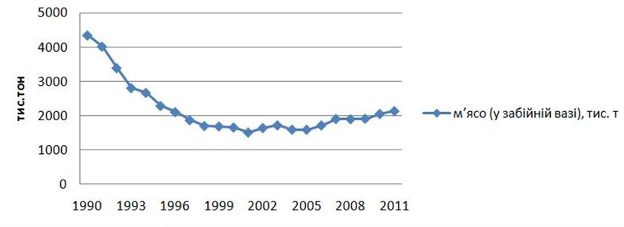
Fig.1. Dynamic of meat production (slaughter weight, thousand tons)
Almost the same situation with milk production (Fig. 2). Production of the main kinds of animal husbandry products (milk, thousand tons) [3]

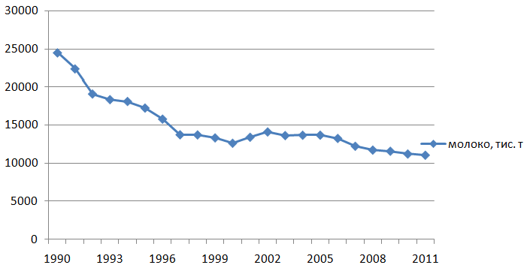
Fig.2. Dynamic of milk production, thousand tons
Ministrers of Agriculture trying to develop and implement a number of measures which in the future will provide an opportunity to support the stability of animal husbandry.[4]

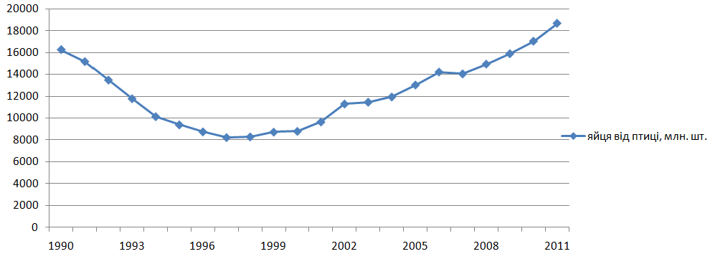
Fig.3. Dynamic of eggs production, million pieces
Egg consumption per 1 person in 2012 calculated at the level of 313 units, which is also more than last year - Fig.3. Dynamic of eggs production, million pieces. [3]
At present time, wool production decreased, which was the cause of the decline of this branch in Ukraine. Although manufacturers apply new technologies, but the number of heads of sheep every year decreases. The difference between the production of wool in 1990 i 2011. is -25,927 tons per cent to -87%. Sheep production requires more in-depth study and intervention.
One of the indicators of improving of economic activity of households is creating models oriented to minimize costs or maximize income from realization of products. After preliminary examination of the field of animal we see that the priority directions of development of animal husbandry in the future one should consider support for restructuring in animal husbandry provided through investments, activization factors of intensive reproduction through improvement of quality fodder, selection and tribal case, modern innovative technologies, training of highly qualified personnel, providing of veterinary sanitary measures. [5]
One of the main factors of providing of intensive development of animal husbandry branches is achievement of optimal ratio of industries, production specialization and concentration stock animals .[5]
Also very important is the use of modern computer technology, which allows to calculate the optimal flexible plan that differs from the plan designed by the existing traditional method of planning.
Conclusions. The development of animal husbandry requires not only the intervention of the state, but also the application of scientific advances - Economics and mathematical modeling. Its use makes it possible to get the best way from the point of view of an acceptable indicator of economic efficiency and gives the opportunity to follow zoo technical requirements, which also very important.Because, modeling a process in agriculture, we are dealing with live organisms. Providing food and other products of animal husbandry is of great importance, because for a balanced nutrition and increasing efficiency of population food goods should be in a wide assortment and high quality.

Literature
1. Азiзов С.П. Деякi питання органiзацiї та пiдвищення ефективностi тваринництва / С.П. Азiзов // Економiка АПК, 2011. – №4 – 12-15 с.
2. Бойко В.I. Ринок м’яса: свiтовi тенденцiї регiонального розвитку виробництва / В.I. Бойко, Л.В. Мамчур // Економiка АПК, 2011.– №1- 145-148 с.
3. Данi Держкомстату [Електронний ресурс]:
http://ukrstat.org/uk/operativ/operativ2006/sg/sg_rik/sg_u/tvar_u.html
4. Мазуренко О.В. Тенденцiї розвитку тваринництва в Українi / О.В. Мазуренко // Економiка АПК. – 2011. – №8 – С. 16-21.
5. Оляднiчук Н.В. Iнтенсифiкацiя галузей тваринництва в сiльськогосподарських пiдприємствах [Текст]: монографiя / Н.В.Оляднiчук, В.С.Уланчук. – Умань: Вiзавi , 2010. – 218 с.

ANIMAL AS OBJECT OF MODELLING
L.Galaieva, M.Grechko
The article reviews the state of the livestock industry in Ukraine 1990-2011. Prospects, necessity and advantages of using economic and mathematical modeling of production processes .
Keywords: animal, rates of production, development, modeling, feed ration, optimization, innovative ways, economic-mathematical model.

