УДК 338.1:633.1 ; 338.43.008
ECONOMIC EFFICIENCY OF GRAIN PRODUCTION AND INCREASING COMPETITIVENESS OF THE ENTERPRISE WITH EXTENSION SERVICE HELP
Gerasymchuk N.A., PhD in Economics, Assoiate Professor
Stefantsova I.V. , Master of Economic Science
Investigated the economic efficiency and competitiveness of grain production in agricultural enterprises of Kyiv region and performed the analysis of influence on that indicators of activity of agricultural extension services.
Key words: grain production, economic effectiveness, competitiveness, extension service.
In the stabilization of the national economy priority belongs grain subcomplex has a multiplier effect on the level of development of other sectors of the economy and social sphere and most defines food security. However, despite the favorable soil and climatic and economic conditions for the development of grain production over the past twenty-three years of apparent negative trends in its development, due, above all, lack of material and resource support production and decrease the level of mechanization of production processes, which poses a real threat to development of grain production and food security.
In order to promote sustainable development of agriculture and economic development of modern technology both in Ukraine and in Kyiv region in particular, should pay attention to the development of agricultural extension. Because advisory services in agriculture can help meet the needs of agricultural producers and rural residents in raising awareness and finding sustainable, resource-efficient methods of agricultural production. Inadequate handling these issues and their methodological and practical significance determined the choice of topics for writing.
Analysis of recent research and publications. A significant contribution to science in the field of grain production, increase its cost-effectiveness and profitability have S.S.Bakay, V.I.Boyko, M.Y.Malik, P.T.Sabluk, L.M.Hudoliy, and many others. The issue of competitiveness of production estimates grain industry is important and thoroughly studied by researchers such as V. Goncharov, NV Radchenko, Solovyev I. However, a number of issues concerning the functioning of the grain industry and agricultural extension services remain relevant.
The purpose of the study. The purpose of the article is to study ways of improving economic efficiency and competitiveness by bringing grain farm advisory services.
The main material. Economic efficiency of grain production is characterized by the ability of companies to produce the maximum amount of product required quality with minimal costs and implement it with minimal losses for the largest prices [1]. Economic efficiency depends on whether products meet market requirements and consumer.
The competition acts as a force that aligns market prices for goods. It can be in the form of intra-and inter-industry competition. Intra competition is competition between producers in more favorable conditions for the production and sale of goods within the same industry. Intersectoral competition is competition between manufacturers of products for various industries better scope of capital.
Analysis of grain production Kyiv region shows that in 2012. overall agricultural production compared to 2011. increased by 9.0%, including agricultural enterprises - 9.9% of households - by 7.2%. Index of crop production in 2012. compared to 2011. was 108.8%, including in agricultural production - 110,7% in households - 105.8%. In comparison with 2011. gross harvest of grain and leguminous crops (3187.8 tons) increased by 14.4%, due to both the expansion of harvest area (7.6 ha or 1.2%) and an increase in grain yield 1 hectare (5.9 kg or 13.1%) [6].
Agricultural enterprises produced 2812.5 thousand tons of grain, which is 12.2% more than in 2011. Individual farms - 375.3 thousand tons (34.1% more). Yields of crops compared to 2011. farms increased by 5.0 kg, or 10.5% (by 52.4 quintals per 1 ha), in households - 11.0 kg or 34.2% (by 43.2 quintals 1 ha). [6]
In 2012. collected significantly better than in 2011. harvest almost all cultures grains: rye - 46.7 thousand tons (by 74.5% more), oats - 25,7 thousand tons (by 53.1%), wheat - 869,9 thousand tons (by 44.9%), barley - 339.5 thousand tons (20.0% more), corn - 1860.9 thousand tons (2.8% more) that is due primarily to a significant increase in their productivity (except corn). Gross harvest of some crops against 2011. reduced: SC - by 51.0%, buckwheat - by 7.6% [6].
Grain production in the Kiev region, according to the study, despite the organizational and economic complexity of the current stage of management is core of most farms, as grain production is the main source of farm income.
Systemic effects of competitive advantage grains of Kyiv region can be estimated on the basis of the competitiveness index, defined as the ratio between the amount of grain that is exported outside the region, and the volume of imported grains [6]:
I = 25016,9 / 60,6 = 412,8
Since we received the results greater than unity, we can state that the grains of Kyiv region is competitive. The main factors affecting the competitiveness of the grain produced in the region is level of quality, infrastructure and price.
Doing accounting and measuring, control, distribution and catalytic function, the price was the most decisive factor in the production of grain. Preference price factor can be achieved by reducing the number of commercial structures on the way from producers to consumers of grain. This is the realization of grain commodity exchanges, which is an effective mechanism for the formation of a relatively high price levels. Although the Kyiv region there is only one commodity exchange, which may lead trading grain, more manufacturers wishing to obtain a fair price for their goods, are its members.
To quantify competitiveness using different methods [5]. We consider a method of calculating the integral indicator of the competitiveness of wheat three teaching and research farms NUBiP Ukraine, located within the same climatic region (Table 1).
Table 1.
The integral indicator of the potential competitiveness of wheat in 2011 *

Index name | НДГ «Великоснітинське ім..Музиченка» |  |  | НДГ «Ворзель» |  |  | НДГ «Агростанція»
Index name | вага показника | Бал показника | Оцінка | вага показника | Бал показника | Оцінка | вага показника | Бал показника | Оцінка
The effectiveness of agricultural technologies | 0,15 | 3 | 0,45 | 0,15 | 2 | 0,3 | 0,15 | 2 | 0,3
Quality planting material | 0,25 | 2 | 0,5 | 0,25 | 1 | 0,25 | 0,25 | 3 | 0,75
Quality of plant protection products | 0,25 | 3 | 0,75 | 0,25 | 2 | 0,5 | 0,25 | 1 | 0,25
soil fertility | 0,15 | 3 | 0,45 | 0,15 | 2 | 0,3 | 0,15 | 2 | 0,3
Level Logistics | 0,2 | 3 | 0,6 | 0,2 | 2 | 0,4 | 0,2 | 1 | 0,2
Performance hardware | 0,15 | 3 | 0,45 | 0,15 | 3 | 0,45 | 0,15 | 3 | 0,45
The integral indicator | 1 | - | 3,2 | 1 |  | 2,2 | 1 |  | 2,25

* the author's calculations
When calculating consider those indicators that are basic to the stages of cultivation and harvesting. Since the effective activity of producers on these stages depends on whether they are of high quality wheat that meets the applicable standards.
The maximum integral indicator of competitiveness of wheat NDH 3.2 "Velykosnitynske " (Table 1) shows the best level of baseline characteristics on the stages of cultivation and gathering wheat. So NDH "" for these stages are the most potentially competitive enterprise. In situations where the management of each company seeks to identify the competitive advantages of the wheat and the main directions of improving its competitiveness potential must use a method for constructing "Polygon of competitiveness" (Fig. 1).
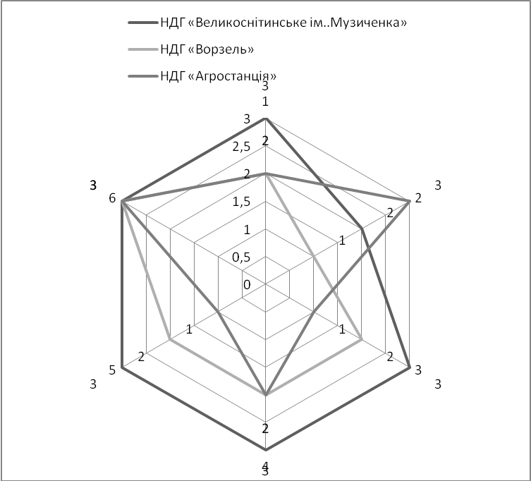
Figure. 1. Polygons potential competitiveness of wheat
The level of potential competitiveness of wheat each enterprise is, respectively:
$S_{\text{Великоснітинка}}=\frac{1}{2}×\frac{\sqrt{3}}{2}×\left(3∗3+2∗1+3∗3+3∗2+3∗2+3∗3\right)=\text{18}\text{.}\text{45}$
$$S_{\text{Ворзель}}=\frac{1}{2}×\frac{\sqrt{3}}{2}×\left(2∗3+1∗1+2∗3+2∗2+2∗2+3∗3\right)=\text{13},5$$
$$S_{\text{Агростанція}}=\frac{1}{2}×\frac{\sqrt{3}}{2}×\left(2∗3+3∗1+1∗3+2∗2+1∗2+3∗3\right)=\text{12},\text{15}$$
The largest area of ​​the polygon 18,45 and consequently the highest level of competitiveness has the potential wheat NDH "Velykosnitynske." The level of potential competitiveness NDH "Vorzel" and NDH "Ahrostantsiya" is 13.5 and 12.5. Thanks to the built polygons (Fig. 1). Noticeable that each business has its competitive advantages and disadvantages that prevent obtaining high yields of wheat quality.
Competitive advantages NDH "Velykosnitynske" can mark quality crop protection, agro-technology efficiency, productivity tools, and soil fertility, which is owned by the company. The main drawback is the lack of quality planting material, using the company in the process of growing wheat.
We believe that the key to improving economic efficiency and competitiveness of agricultural enterprises Kyiv region will be advisory organization. In the world of the information age is information, not physical, and even financial resources is a key success factor. National consultancy market, which amounts to only 2.5 billion., Is now at the stage of active formation according to the above global rates. Today the Ukrainian market operates about 400 companies engaged in management consulting. [4] Based on the experience of development and consulting services necessary aspect of their genesis is to highlight the development and dissemination of agricultural extension. After the development of extension services in Ukraine is an important element for the further development of agriculture.
Conclusions and recommendations for further research. Enterprises of grain subcomplex operate in an unstable internal and external environment. For the sake of preserving their economic efficiency and competitiveness in the market companies must constantly adapt to changes taking place, and make adjustments in their operations. At present, the agricultural extension system in the Kiev region is on track maturity. Among the causes that prevent the implementation of world-class advisory services are misunderstanding the nature of extension services, ambiguous interpretation of the Law of Ukraine "On Agricultural Advisory Services" in the area of ​​proper public funding.
List of references

- Андрійчук В.Г. Економіка підприємств агропромислового комплексу: [підручник] / В.Г. Андрійчук. –К.: КНЕУ, 2013. – 624 с.
- Ганганов В.М. Формування зернового комплексу регіону: [монографія] / В.М. Ганганов. – Одеса: Інститут проблем ринку і економіко-екологічних досліджень НАН України, 2008. – 311 с.
- Гончаров В.М. Оцінка конкурентоспроможності аграрного підприємства / В.М. Гончаров // Фінанси України 2005. - №8. - С. 66
- Кальна-Дубінюк Т.П. Управлінський консалтинг у сільському господарстві : [Монографія] – Ніжин : Видавець ПП Лисенко М.М., 2011. – 360 с.
- Методи исследования зкономических процессов : монография / [под ред. Ф.В. Зиновьева]. - Симферополь : ЧП “Предприятие Феникс”, 2009. -244 с.
- Моніторинги економічного і соціального розвитку підприємств і
організацій АПК Київської області за 2013 рр. – [Електронний ресурс] – Режим доступу : http://oblstat.kiev.ukrstat.gov.ua/content/p.php3?c=898&lang=1
- Про соціально-економічне становище Київської області за 2011 рік / Головне управління статистики у Київській області. – К. : [б.в.], 2012. – 61 с.

