УДК: 368.330.322
Bogdana V. Vyshnivska, PhD, NULES of Ukraine
THE THEORETICAL METHODS TO MINIMIZE INVESTMENT RISK OF AGRARIAN ENTERPRISES.

Abstract. The article defines risk in investing; these key components of the nature of investment risk as an economic category, the marginal value of risk analysis factors reduce the investment risk farms, generalized methods of reducing the investment risks
Keywords: investment risk, reducing the risk factors, the risk of rejection, acceptance, risk prevention, risk reduction methods.
Statement of the problem. Collision with a variety of risk – is a common threat to any investor in today's market economy. For the most part, putting their money in the production of agro commodities, investors can have complete confidence in the public recognition of this production. In practice, this recognition depends on a successful combination of different factors, so investors are risk profit, less than expected, or even incur losses.
Thus, the study of investment risk, especially agricultural enterprises sector, identifying the factors that cause them and calculating potential losses - currently the most urgent issues. Therefore, the ability to assess investment risks is essential for the modern manager.
Analysis of recent research. The problems and methods of investment risks and ways to minimize the dedicated work of many domestic and foreign scholars, such as R. Breuil, J. Bailey, W. Broilo, R. Darmits, A. Zalotov, A. Ivanitskaya, N. Mashyna A. Peresada, C Hyus, B. Shapiro et al.
The aim of the research topic is to systematize the factors and justification of theoretical methods to minimize investment risk enterprises of agricultural sector.
The main material. In the context of modern Ukrainian economy problem of investment risk is particularly acute because of the instability of the tax regime, the devaluation of the national currency, the low purchasing power of the majority of the population. Therefore investments dealing with domestic agricultural markets, particularly important to carefully calculate the possible impact of investment risk
The risk in investing - is quantitatively evaluated from the standpoint of a particular entity investment uncertainty associated with the possibility of occurrence in the implementation of the project of adverse events and their effects in the form of certain financial loss (loss of income, increased costs, loss of profits, etc.) [ 5.7].
Thus, the key elements of the nature of investment risk as an economic category are:
- the uncertainty of market factors in the present and in the future;
- the existence of several alternative scenarios;
- the possibility of adverse events, the probability of loss of assets, failure to obtain the expected profit or other deviations from the planned, predictable performance;
- an objective need for management measures to reduce the potential negative or adverse effects;
- the subjective perception of events.
Investment risk is the possibility of failure of the planned investment purposes (such as income or social impact) and cash losses. This risk must be assessed, calculate, describe and plan, developing an investment project [2].
There are general economic risks deriving from adverse conditions in all economic sectors, and individual risk associated with a specific project conditions.
Depending on factors distinguish the following types of investment risk: political risk, general risk, legal risk, technical risk, project participants, financial risk, marketing risk, environmental risk.
Factors reduce the investment risk are presented in Figure 1.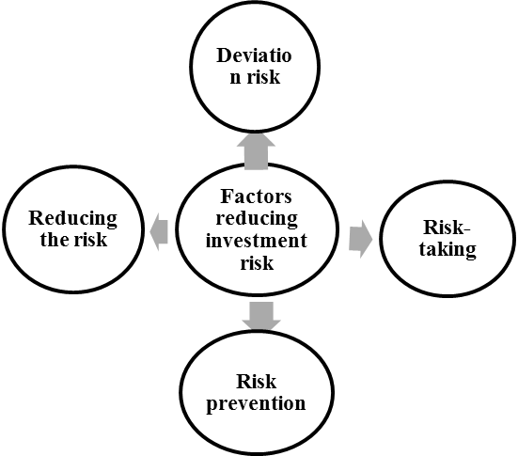
Rice. 1. Factors reducing investment risk of farms. *
* Systematized by author
Rejecting means no risk of activities (projects) that are associated with risk. This decision was taken in the case of non-compliance with the principles of risk management, such as: [6]
• rejection of business transactions, the risk is too great and onerous for the company;
• refusal of bank loans if financial market is unfavorable for the enterprise;
• rejection of any investment policy in order to maintain a high level of solvency;
• refusal of supply of imported raw materials, if there is a high degree of variability of customs legislation;
• refusal of advance payments to suppliers and sales on deferred payment terms and so on.
Risk-taking means the abandonment of all or part of the risk of liability for the entrepreneur. In this case, the decision is made to cover possible losses of their own means.
Preventing risk means simply a deviation from the west, that is connected with risk. However, prevention of risk to the person who makes decisions, often means giving up profits.
Risk reduction – is a reduction in the probability and extent of damage. To reduce the risk of different methods [8,3].
The system measures to ensure the implementation of investment projects important place belongs to neutralize the project risks. Different types of risks have varying degrees of control. Identify the level of control risk is difficult, but it is necessary to determine possible ways of neutralizing their negative consequences.
In the implementation of the investment policy of moderate boundary values of individual risk operations according to experts, are: [4]
- for operations with acceptable size of losses - 0.1 (the planned operation of uninsured risk on it must be rejected if in one case out of ten can be lost all the estimated amount of profit);
- for operations of critical size of losses - 0.01 (in one case out of a hundred - lost amount estimated gross income);
- transactions with disastrous losses in size - 0.001 (in one case out of thousands - lost all the capital invested in the project due to bankruptcy).
The following methods of reducing the investment risks:
- 1) prevent the risk;
- 2) the valuation of risk;
- 3) the allocation of risk between the parties to the project;
- 4) reduction of risk;
- 5) risk insurance.
The method of risk prevention measures is to develop inner character which completely excludes a particular type of project risks, namely avoiding the use of high amounts of debt and rejection of excessive use of investment assets in the form of low.
Rationing risk - used for those risks that go beyond their acceptable level, the investment operations in the area of critical and catastrophic risk. Normalization is realized by establishing the enterprise system of internal regulations, which may include the following indicators: limit of borrowed funds used for the implementation of real investment projects;
− minimum amount of investment assets in highly liquid form.
The distribution of risk between the parties to the project involves partial transfer of risk to partners on specific investment operations.
Main types of risk sharing:
- allocation of risk between the parties of the project;
- allocation of risk between the company and suppliers of raw materials;
- allocation of risk between the parties to the lease transaction.
Reducing the risk – is a reduction of the probability and amount of loss by reserving funds for unforeseen expenses [2,3,8].
The main directions of this method:
- formation of the reserve (insurance) fund company;
- formation of target reserve funds;
- formation of reserve amounts of financial resources in investment budgets.
Risk insurance – is an operation to transfer the investment risk of foreign insurance company.
Insurance Investment risk - is the protection of property interests of the Company upon the occurrence of insured event specific insurance companies at the expense of funds generated by them by taking premiums from policyholders. [8] The volume of redress negative effects of project risks insurers are not limited to - it is determined by the actual value of the insurance (the insurance for its evaluation), the sum insured and premiums (insurance premium).
Conclusions. Today the problem of risk for farms is most urgent. Enterprises agrarian sector in the activity of various factors addicted to investment risk. From the perspective of an investor, the important point is the need to analyze the strategy of the project in terms of accounting risk situations and develop methods to reduce investment risks. Therefore, it is important to continue to focus more on research, development and application of methods for analyzing and evaluating investment risks.

References
- Закон України про інвестиційну діяльність // Відом. Верховної Ради України. - 1991. - № 47. -Ст. 646.
- Броило В. Система оцінки ризиків інвестиційно-інноваційної діяльності організацій // Проблеми теорії й практики керування.– 2008.– № 4.– С. 61 – 71.
- Дарміць Р.З. Вплив ризиків у системі реалізації інвестиційних проектів // Науковий вісник НЛТУ України. – 2009. – Вип. 19.2. – с. 172-177.
- Зальотов О., Вареня В. Знайти й убезпечити. - http://www.meta-ukraine.com
- Іваницька О. Ринок страхових послуг як складова фінансового ринку // Вісн. УАДУ. - 2003. - № 1. -С. 135-140.
- Машина Н.І. Економічний ризик і методи його вимірювання: Навч. Посіб. - К.: Центр навч. Літ-ри, 2003. - 188 с.
- Пересада А. Управління інвестиційним процесом. - К.: Лібра, 2002. - 472 с.
- www.nbuv.gov.ua/Articles/Nadupu/2005-1

