УДК 330.131.7:631.15
SOME APPROACHES TO REDUCE THE RISK OF AGRARIAN ENTERPRISE

L.Galaieva, Associate Professor, PhD in Economics, D.Sichkar EQL Master, NULES of Ukraine

Розглянуті підходи до зменшення ризику аграрних підприємств шляхом диверсифікації.
Ключові слова: диверсифікація, ризик, модель Марковиця, аграрне підприємство.

The agricultural sector of any country in the world has a degree of risk higher than in other economic sectors. Main cause of it is weather and climate risks presence that significantly affect the profitability indicators of agrarian enterprises [7,8].
As to agrarian sector of Ukrainian economy, the situation is deteriorating due to incompleteness of institutional changes both in economy as a whole and directly in agrarian sector [1,4,5].
So macroeconomic instability (significant inflation) affect the growth of lending rates, a significant budget deficit affects the instability of the funds allocated to support the agricultural sector.
Incomplete institutional reforms in the countryside (no land market, large enterprises monopolization of foreign economic activities) increase the risk of small and medium-sized agricultural enterprises. Consequently, except inherent agrarian production of natural risks, institutional risk and little effective state regulation worsening situation in Ukraine. [3,4].
That’s why agrarian enterprises should use approaches which could reduce the risks that are able to be controlled by employer in a measure. One of the reducing risk level methods is well-known in financial mathematics - the method of Markowitz. The main idea of this method is the approach to the calculation of the diversified portfolio income of fixed (expected) risk degree [2,6,8,9].
Analysis of main research and publications. A.Peresada, O.Shevchenko, Yu.Kovalenko, T.Ostashko, N.Mashyna and others devoted their research to the problem of enterprises risk reducing. Among foreign scientists: Watshem T. J., Parramow K.K.
The problem of climate change impact on the agrarian sector development is extremely current question in additional to traditional questions. These aspects are highlighted in the research of Adams R.M., Fleming R.A., Chang C. D., Dudek, В J., Glyer J.D. and others.
Purpose of research – justification of the effectiveness of economic-mathematical methods using, including using of Markowitz model to reduce the risk of functioning of agrarian enterprises.
The main material. . Diversification of crops production of farm "Filchenkov" (region Cherkasy) based on the Markowitz portfolio model (in order to achieve the required level of income with limited degrees of risk) has made it possible to compare the structure of production which is traditional for given farm with calculated on modal basis. The structure of cereal crops production on this model should correspond to specialization of agriculture and evidence-based rotation.
Analysis of profitability of the farm "Filchenkov" during 2006-2011 showed sell trends for growing such crops as peas and soybeans. At the same time oats and buckwheat from 2008 to 2011 have unreasonably high profit margins, caused by minor acreage of crops in the structure of sown areas, and also by the ability of the farm to keep the harvest, until the selling price on the market would be maximized.
Therefore, the task of profitability maximizing with limitation permitting to the risk is extremely important and can be resolved by Markowitz model. Markowitz portfolio with maximum efficiency:
$$R_{p}→\text{max}$$
$$σ_{p}≤\text{const};$$
$$\sum_{i=1}^{n}{x_{i}}=1;$$
$$x_{i}≥0\text{.}$$
Where $x_{i}$ is the share of expenses for cultivation i-type of crop, UAH;
$σ_{p}$ – crop risk (standard deviation),%;
$R_{p}$ – expected crop yield, %;
In such notation target function will appear as:
$R_{p}=\sum_{i=1}^{n}{x_{i}m_{i}}$,
Where $m_{i}$ is profitability of individual crops, %.
Maximum of profitability of the plant growing field on the farm in the certain permitting degree according to the objective function and task limitations for 9 versions of finding the optimal plan for permitting degree are presented in Table 1.
1. Distribution of profitability and standard deviation for field of plant growing of farm "Filchenkov", %

№ п/п | Profitability | Risk
1 | 55,61 | 10,68
2 | 62,35 | 11,00
3 | 69,70 | 12,00
4 | 74,81 | 13,00
5 | 79,15 | 14,00
6 | 82,92 | 15,00
7 | 86,27 | 16,00
8 | 99,23 | 21,00
9 | 107,14 | 25,00

Basing on the data in Table 1 build Markowitz curve, which set of points is the set of plans for the structure of farm production at different permitting degrees and profitability (Fig. 1).
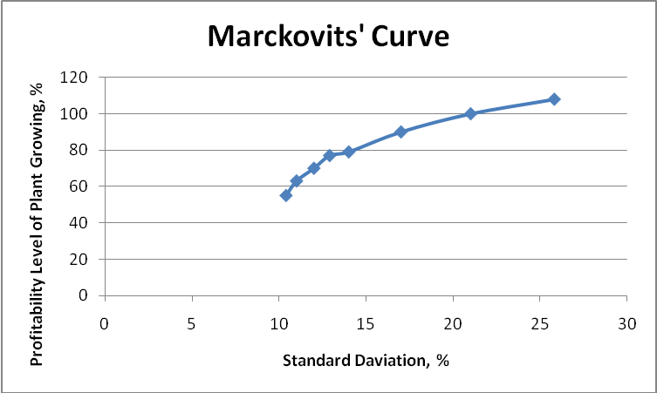
Fig. 1. Markowitz curve for the farm «Filchenkov»

When you select any point on the line with a certain degree of profitability and permitting, particle distribution of expenses for cultivation, corresponding to these data, would be defined. Selection of the optimal value is based on the experience of the manager, domestic and international economic conditions and others.
Diversification of cultivation of grain crops risks involves the calculation of the distribution of areas for crops on the basis of the allocation of shares of expenses for cultivation.
Provided that the enterprise has chosen portfolio №3 with the profitability 69.7% and 12% permission, the distribution of areas under crops would be as Fig.2.
The conducted further calculations made it possible to compare the actual structure of areas for crops on the farm with an estimated (Table 2).
The level of profitability of actual structure is higher (80.1%) than in the model variant more than 10%. However, there is a significantly higher permitting – 32 percent.
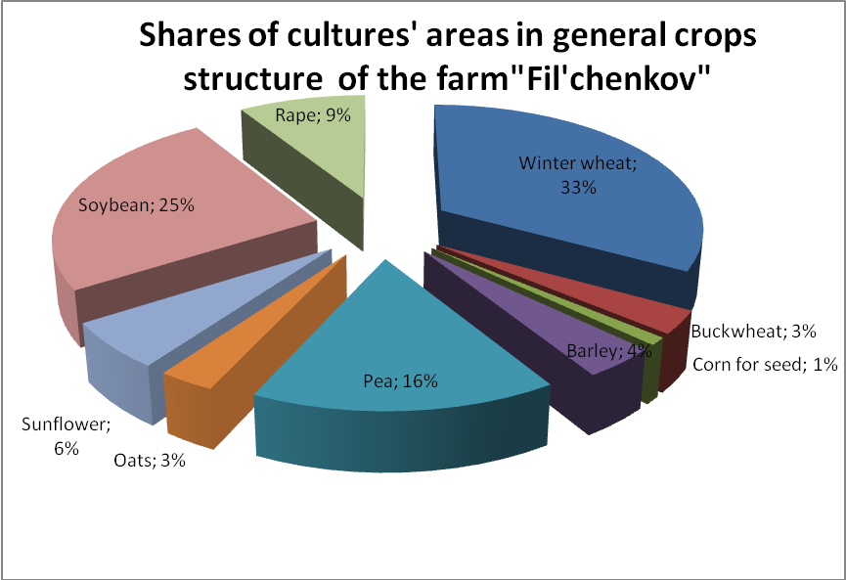
Fig. 2. Distribution of area for crops at a given degree of profitability 69.7%, 12% permitting.

2. The structure of the model and the actual distribution of acreage for farm "Filchenkov", %

Cultures | In fact | According to the model
Winter wheat | 34 | 33,2
Buckwheat | 2,8 | 2,8
Corn for seed | 10,5 | 0,8
Barley | 22,2 | 3,7
Pea | 10 | 16,2
Oats | 1,2 | 2,8
Sunflower | 15 | 6,1
Soybean | 4,1 | 25,1
Rape | 0,2 | 9,3

In addition, the level of crops specialization crops in optimized model is 40%, which is the optimum level for the given farm, and for the actual data the figure is 70%, which is not acceptable, because it does not meet the standards of crop rotation and increases the vulnerability of farm to agricultural risks.
Conclusion. Diversification strategy based on the Markowitz model, is an offensive, long-term nature strategy, while respecting economy of this model can increase the effectiveness of economic performance and competitiveness indicators.
Literature
1.Кириєнко І.Г. Актуальні питання ринку земель сільськогосподарського призначення / І.Г. Кириєнко // Економіка АПК. − 2009. − №3. − C. 44−47.
2.Машина Н.І. Економічний ризик та методи його вимірювання. К.: Центр навчальної літератури, 2003. – 188 с.
3.Осташко Т. Ризики для сільського господарства від встановлення зони вільної торгівлі з ЕС / Т. Осташко // Економіка України. − 2011. − №3. − С.57−70.
4.Присяжнюк М. Про необхідність і напрями поглиблення аграрної реформи / М. Присяжнюк, П. Саблук, М. Кропивко // Економіка України. −2011. − №6. − С.4-47.
5.Федоров М. М. Трансформація земельних відносин до ринкових умов / М. М. Федоров // Економіка АПК. – 2009. – № 3. – С. 4-18.
6. Уотшем Т.ДЖ., Паррамоу К. Количественные методы в финансах. К.: Юнити, 1999. – С.441-449.
7.Adams, R.M., Fleming R.A., Chang C., McCarl B., Rosenzweig C.. A Reassessment of the Economic Effects of Global Climate Change on U.S. Agriculture. // Climatic Change. – № 30, 1995. – P.147-167.
8.Badcock B.A., Fraser R.W. Risk management and the Environment: agriculture in Perspective// Kluwer academic Publisher, 2012. – 195 p.
9.Dana L. Hoag Applied Risk Management in Agriculture // CRC Press, 2012. – 403p.

Рассмотрены подходы к уменьшению риска аграрних предприятий путем диверсификации.
Ключевые слова: диверсификация, риск, модель Марковица, аграрное предприятие.
The article reviews approaches to reduce risk through diversification in farm enterprises.
Keywords: diversification, risk, Markowitz model, an agricultural enterprise

