UDC 338.5:631

PECULIARITIES OF PRICING OF AN AGRICULTURAL PRODUCE

Barylovych O.M.
PHD, assistant professor of marketing and international trade department
National University of Life and Environmental Sciences of Ukraine

Annotation
Factors, which influence the processes of pricing in agrarian sphere, are discussed in the article. Problems and peculiarities of price forming, that agricultural producers face to are described.
Key words: Price, pricing, agricultural produce.

Raising of problem. On the modern stage of development of agrarian enterprises of Ukraine one of basic tasks is a decision of problem of pricing in agriculture. It is known that a price has a substantial influence on efficiency of enterprise activity. However, for today, a price mechanism that exists in agriculture is unable to provide proceeding in productive potential of industry in sufficient for the extended recreation volumes, and this impedes the increase of efficiency. Thus, there is a necessity for the analysis of peculiarities of pricing process of industry and their influence on efficiency of agricultural production.
Analysis of the last researches and publications. The problems of forming of price mechanism in an agrarian sphere are investigated by many domestic scientists, in particular: Voskobiynyk Y. [1], Mesel-Veselyak V. [2], Moldavan L. [3], Paskhaver B. [4], Shpychak О. [5] and other. However, to our opinion, the issues of features of price forming in agriculture and its influence on the participants of distribution process require a further study.
Raising of task. The aim of the article is a determination of problems and peculiarities of pricing in agriculture.
Exposition of basic material of research. As known, a price is a category of conjuncture, so its forming depends on correlation of demand and supply at the market. Therefore in the conditions of market economy the price should be dictated by a market. However, it is necessary to notice that, except demand and supply, in agriculture there are a number of factors that have an impact on the process of pricing and the level of prices.
First of all, we should note the nature of price, and thus of forming of income by an agricultural producer. It is connected with existence of the so-called differential land rent. It means that a price on an agricultural produce is formed by the expenditures on worst fertile soil, and, accordingly, there is a superprofit - rent on the best areas. However, in connection with complication of evaluation of prices on an agricultural produce on worst earth, they did not get spread on practice in a pure form, but formed mostly by average costs [5, p. 5]. It, in turn, sharpens the problem of disparity of prices of an agricultural produce and material and technical resources that is used in the process of its production.
The problem of disparity of prices arose up as a result of reformation of property and transition to the market economic relations and deregulation of this process. As a result, the disparity of prices of agricultural production and prices of the consumable resources of industrial origin grew considerably. By this time we can talk about a sevenfold difference in a price index [5, p. 7].
Annual lag of increase of prices of an agricultural produce resulted in a considerable decline in its production. Especially it applies to stock-raising products. Thus, during the last twenty years the cattle stock has decreased more than by 80% (including cows almost by 70%), pigs - by 60%, sheep and goats - by 80% (rice.1)[6, p. 18].
This situation occurred because in modern conditions it is unprofitable for the agricultural commodity producers to be engaged in such finance- and resource-demanding industry. Changes of economic relations between the producers of agrarian sphere and processing enterprises, imperfect system of pricing and distribution of stock-raising products, incongruous mechanisms of supply of forage and providing by them and by other necessary resources, absence of purposeful state support resulted in a considerable exceeding of cost of produce in this sphere over its realization price. As a result collective agricultural enterprises were forced to reduce the livestock population [7, p. 93].
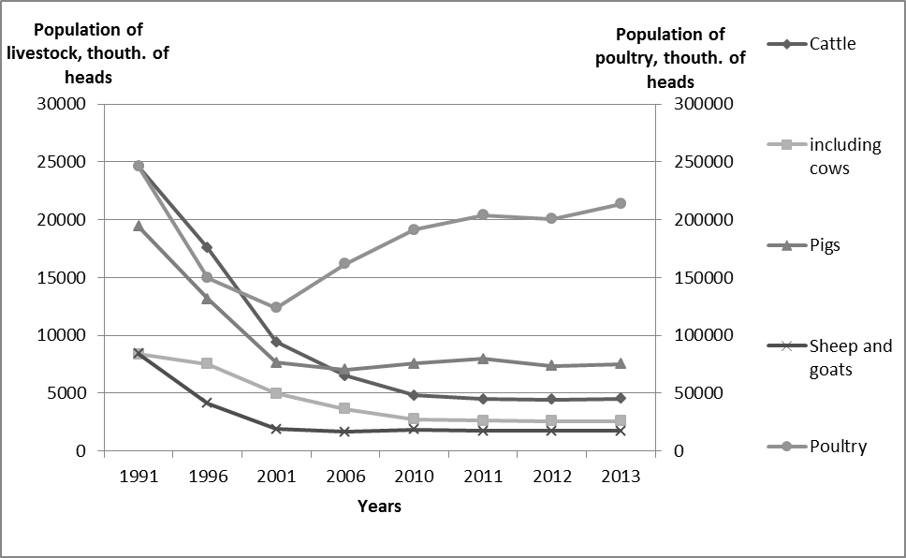
Rice.1. A dynamics of population of livestock and poultry is for 1991-2013.
As a result, on this time approximately 60% of gross products of stock-raising are produced by the households. Thus they produce 43% of meat of all kinds and 80% of milk. From the position of pricing this situation looks a little illogical, in fact purchase prices of the products of these households are considerably lower, than for agricultural enterprises, except that, they, unlike the last, do not get a special purpose grants from a budget for stimulation of increase of population. However, a feature of production of commodity output in the households should be taking into account - as a rule, it is surpluses of manufactured products. In fact the primary purpose of production is providing the members of own family with foodstuffs. Except that, a cost of manufactured products is not calculated here and there is also a psychological factor, which allows the households to be nowadays the basic producers of stock-raising products (except eggs), and also potatoes, vegetables, garden-stuffs and berries [8, p. 306].
Worsening of the state of agricultural commodity producers became a consequence not only of the disparity of prices, but the change of structure of distribution of agricultural produce, and decline of the share of commodity producer in the retail price also influenced it. On this time more than 70% of profit yields from manufactured products in agriculture are passing into ownership of numerous trade mediators and in processing industry. For an example we can consider the pattern of prices of realization of 2,5 % fat contents milk: 46,9 % from it gets a processing enterprise, 21,9 % is a share of trade, and only 31,2 % is a share of agricultural commodity producer [1, p. 186]. A situation with the households looks far more unfavorable, in fact they sell off the products mainly to the mediators at price sometimes half the height of the price of agricultural enterprises.
Such advantageous position of enterprises of processing sphere can be explained by a feature of their market structure. On the essence it is oligopoly. It means that enterprises have certain possibilities in relation to influence on prices. The agricultural commodity producers do not have such influence on pricing, in fact markets of agricultural produce are maximally close to the markets of perfect (clean) competition, except that, a price on the products of agriculture largely depends on various mediators, traders and processing enterprises.
Forming of price on an agricultural produce requires also the consideration of factor of price elasticity. As known, demand on the products of agriculture is relatively inelastic at price, it means that the increase of price by 1% results in considerably a less adequate decline (by 0,1-0,5%). It means that in the period of price advance the population relatively stable consumes foodstuffs, sacrificing durables, such as clothes and others like that. However it follows to take into account that different foodstuffs have different elasticity of demand. So, more elastic is demand on meat and manufactured meats, fish, milk products, fruit, less elastic - on the commodities of daily consumption (bread, milk, pastas, cereals, potatoes). We should also consider the fact that in the budget of average Ukrainian family expenses on foodstuffs amount about 53 % (for comparison, in the USA - 11, in Germany - 10, in Poland - 20%). That is why the demand is relatively more elastic at a profit, than at a price - the 0,5-0,9% increase of profit per capita causes the 1% increase of consumption of meat and manufactured meats, milk and milk products, vegetables and fruit [5, p. 5].
Other feature that largely influences on pricing on an agricultural produce is a seasonal price-wave. In particular, in the case of grain-growing, sunflower, vegetables, the water-melon cultures prices considerably go down in a period at a time and at once after harvesting, and their most substantial increase is observed before the next collective season. In the case of the separate types of stock-raising products a seasonal price-wave is related to the change of production and suggestion of products volumes during a year. In the case of milk and eggs prices grow in autumn, when the milk yield diminishes and the laying of chickens goes down. The highest prices on pork is observed in a period of Easter and Christmas holidays, at the same time in summer and in a period of the chief fasts prices go down.
It should be noticed that prices on food stuffs largely depend on weather conditions. That is, if a year was productive - prices go down (it is related to the increase of suggestion), and vice versa - in the years of poor harvest prices, as a rule, rise (it is related to diminishing to suggestion of this commodity). Therefore realization of manufactured products exactly in the years of poor harvest (in conditions of satisfactory harvest for a producer) often more advantageous for a commodity producer.
The choice of channel and place of realization of manufactured products also influences the level of price. Prices at to the sale of products «from the field» (directly in place of production) are the lowest. In this case a commodity producer does not carry charges on storage and transporting of products to the place of sale. Having regard to it, sometimes it is more expedient to sell off the grown products to the processing enterprise in full, even without regard to a considerable difference in prices (see table). It concerns vegetables foremost, 44,4% of that goes on processing, and also grapes (43,8%), garden-stuffs and berries (27,9%).
Table
Average costs of realization of plant-growing products on separate directions in 2011, hrn./t
Names of products | Average costs of realization |  | Including on directions of realization
Names of products |  |  | To the processing enterprises | To people on account of labor payment | to the shareholders on account of rent for earth and property shares | at the market, through own shops, stands, tents | after other the directions
Names of products | 2011 | 2011 in % to 2010
Grain-crops | 1374,2 | 122,6 | 1453,4 | 989,9 | 951,6 | 1272,3 | 1421,6
Oil-bearing cultures | 3312,0 | 112,6 | 3127,8 | 1678,3 | 1947,8 | 3151,8 | 3339,6
Sugar beets | 516,0 | 107,8 | 521,8 | 291,5 | 350,0 | 437,6 | 474,5
Potato | 2032,8 | 95,4 | 1423,5 | 1802,0 | 1881,9 | 2153,8 | 2082,9
Vegetables | 2139,1 | 83,8 | 650,3 | 1313,3 | 1345,4 | 3349,7 | 3343,6
Garden-stuffs and berries | 3175,9 | 131,2 | 1647,1 | 2108,0 | 3025,2 | 3655,4 | 3825,2
Grapes | 3571,1 | 98,2 | 3407,3 | 2040,0 | 2710,0 | 4315,0 | 3607,1
Water-melon cultures | 555,4 | 178,4 | - | 400,3 | 336,1 | 416,5 | 601,4
Source: [9].
The analysis of price and volumes of realization of grain-growing on separate channels gives an opportunity to draw a conclusion, that, in spite of the fact that an average cost of their selling to the processing enterprises (including elevators) is the greatest, share of this channel in the structure of realization folds only 3,6%, the bulk of grain is realized on other directions - 82,7% (the greatest is a volume of realization of corn - 89,6%). A similar situation is observed for to the oil-bearing cultures - only 5,2% from all volume of realization of oil-bearing cultures is realized to processing enterprises.
Analyzing the volumes of realization of other types of products of plant-growing we can mark, that bulk (87,9%) of sugar beets goes on processing. Comparatively high price (521,8 hrn./t) is also in favor of it. In the same time 87,5 % of potatoes and 75,9% of water-melon cultures is realized on other directions.
Conclusions. Thus, the basic factors that influence the process of pricing on an agricultural produce are following: presence of differential land rent, disparity of prices of an agricultural produce and material and technical resources, costly production of agricultural goods, production of the considerable part of stock-raising (60%) by households, decline of the share of commodity producer in the retail price, low elasticity of demand on an agricultural produce, seasonal price-wave, dependence on weather conditions, considerable differentiation of prices depending on a channel and place of realization, poor purchasing power of population, impossibility of exact prognostication of unit cost and prices on it to the moment of its actual production. The presence of these and other factors requires both their consideration in the price policy of enterprises and obligatory adjusting of the process of pricing of an agricultural produce by the state.
References
- Voskobiynyk Y. Functioning of price mechanism in the modern conditions of agrarian market / of Y.P. Voskobiynyk // Economy of AIC. - 2012. - № 1. - P. 185-187.
- Mesel-Veselyak V. Price factor and development of agrarian production in Ukraine / of V. Mesel-Veselyak // Economy of AIC. - 2012. - № 1. - P. 179-180.
- Moldavan L. Forms and levers of state influence on forming of inter-branch prices and their stabilizing in agricultural sector (foreign experience) / L. Moldavan // Economy of AIC. - 2012. - № 1. - P. 180-182.
- Paskhaver B. / The modern state of price disparity in AIC / B. Paskhaver // Economy of AIC. - 2012. - № 1. - P. 174-175.
- Shpychak О. Theoretical and methodological aspects of pricing of the agricultural produce / of О. Shpychak // Economy of АПК. - 2012. - № 1. - С. 3-10.
- Barylovych О. Stock-raising: the state of industry and prospects of revival / О. Barylovych // Scientific works of the Poltava state agrarian academy. - 2013. - № 1(6). - Т. 1. - P. 18-22.
- Ksyongyk I. Stock-raising: development and prospects of attraction of financial resources / I. Ksyongyk // Account and finances of AIC : international scientific-industrial journal. - Кyiv. - 2012. - P. 93-95.
- Homyn І., Kryvy Z/ Price mechanism of adjusting of development ofagrarian market of Ukraine (theory and practice) / І. Homyn, Z. Kryvy // Scientific works of the Poltava state agrarian academy. - 2013. - № 1(6). - Т. 1. - P. 302-308.
- Plant-grower of Ukraine: statistical collection / after editor N. Vlasenko; Government service of statistics of Ukraine. - K., 2012. – 108 pp.
Annotation
The analysis of factors that influence on the processes of pricing in an agrarian sphere is carried out in the article. Problems and features into that agricultural commodity producers run during forming of price are certain.
Keywords: price, pricing, agriculture.
Аннотация
In статье проанализированы факторы, которые влияют on процессы ценообразования in аграрной сфере. Определены of проблемы и особенности, с которыми сталкиваются сельскохозяйственные товаропроизводители во время формирования цены.
Ключевые of word : цена, ценообразование, сельское хозяйство.
Annotation
Factors, which influence the processes of pricing in agrarian sphere, are described in the article. Problems and features into that agricultural commodity producers run during forming of price are certain.
Key of words : price, pricing, agriculture.

