УДК 338.439.4:637.5’62
K.V.BEREGOVIY, postgraduate *

Problems of provision of Beef to Ukraine's population
Production of Beef was analyzed and provision of it to Ukraine's population. The problem of increasing of number of cattle in all forms of farms was revised. Also outlined ways to increase the efficiency of beef production to ensure the rational norms of consumption of meat the country's population.
Keywords: meat, beef, cattle, consumption, price, cost, profitability.
Formulation of the problem. Food production in all historical times was and remains an important and vital human needs. Most acute for Humanity is a food problem. Scientists attribute it to the most complex and long-term, not only in Ukraine but also in the global economy. From its solution depends realization of the genetic potential of the population, the harmonious development of physical strength and spiritual abilities. Any society cannot function properly if problem was not solved and food security is not highly developed. This is confirmed by the current state of Ukraine's economy, which is largely a result of lack of government attention to agricultural production and other sectors of agriculture, including complex of beef cattle.
Analysis of recent research and publications. Problems of development and operation of businesses, farms which produce beef in Ukraine studied mostly by Ukrainian scientists - breeders and technologists.
Insufficient implementation in practice of research of conceptual approaches to beef cattle industry development and improvement of organizational and economic relations and relations between the structures and elements of the food sector has led to disruption of the reproductive process, termination of connections and relationships between producers, processors and trade in livestock products.
This situation makes it impossible to bring the industry out of the crisis, improve competitiveness, and on this basis to provide the population with the necessary quantity of livestock products.
----------------------------------------
* Scientific adviser – V.P.Gorovii, Doctor of Economics, Professor.

Research in certain aspects of the problem devoted to the development of domestic breeds of beef cattle productivity of resource potential in the industry, improve the quality of beef, technology improvement and maintenance of animal reproduction, management selection process sufficiently and deeply highlighted in the works of V.P. Burkat, D.T. Vinnychuka, V.I. Vlasov, G.A. Gumeniuk, N.V. Gladiy, E.M. Dorotyuka, F.F. Eisner, M.V Zybsja, M.A. Kravchenko, P.L. Pogrebnyak, V.Ya. Mesel-Veselyak, V.V. Radchenko, P.T.Sablaka, V.S .Yarmak and other scientists who greatly expanded the boundaries of breeding, biotechnology, research in this specific field of animal husbandry than contributed to the establishment and development of cattle productivity.
However solving of the problem of further development of competitive beef cattle requires complex systems research in field of features of the intensification of market conditions and research of using of limited productive resources. We should point to an insufficient study of organizational - economic basis of the formation and effective functioning of businesses, farms beef cattle producers, which is important in the organization of balanced nutrition Ukraine.
The purpose of the article – to analyze the state and opportunities of beef cattle industry in forming a competitive production of high quality products at a level that would provide not only the recommended rate of consumption per capita, but also strong export resources that will strengthen the economy.
The presentation of the main results of the study.
The value of beef cattle – leader in livestock industry in all natural zones of Ukraine - is not limited to the production of beef. It is a major supplier of raw hides for light industry and organic fertilizers for field crops. Livestock developed everywhere. Livestock of Ukraine, depending on the nature of economic conditions, characterized by certain regional differences in industrial specialization. In “Polissi” and “Lisostep” developed dairy and meat and beef and dairy cattle livestock. In “Polissi” dominates meat and meat and milk livestock. In suburban areas, particularly the largest and most major cities - cattle livestock is most developed. The main problem of beef cattle is a decrease in number of animals and their productivity that occurs in farms of all types of ownership.
In the early 90-ies in the agricultural sector of Ukraine began sweeping economic reforms - the state the centralized management system was eliminated and there was a liberalized of prices, which led to a sharp disparity in the prices of agricultural and industrial products, effectively and state support of village was ended. Livestock has become a loss-making industry, which became unprofitable to deal. Destabilizing processes took sweeping character, in consequence of what, business in all types of livestock farms worsened.
Over the 22 years 1991 - 2013 (data from 1.03) in Ukraine has decreased the number of cattle to 19,705.7 thousand heads or by 5 times, on 100 hectares of agricultural land remained 11.8 heads, it is less in relation to the 1991 by 31.3 heads. In 2013 in Ukraine there are 4917.7 thousand of heads of cattle.
There was an increase of cattle per year in 2012 there were 4425.8 thousand heads, and in 2013 they numbered 4917.7 thousand heads increased by 491.9 thousand heads. Particularly sharply decreased cattle in farms for 22 years - 92.7%. For 2012 and January - February 2013 agricultural enterprises increased cattle by 19.4 thousand units, or 1.3%. Share cattle farms to their total number is 31.1%.
In farms with cattle per 100 hectares of agricultural land, the ground was in 1991, 54.5 in 2012, heads this number decreased to 7.4 heads or decreased by 86.4%
As of 01.03.2013, in households were kept cattle 3387.7 thousand heads increase over 2012 and two months of 2013 was at 472.5 thousand heads. Worked law on the promotion of farmers to preserve young cattle. Share of households to the total number of cattle is 68.9%. Significantly decreased in cattle farms of 100 hectares of agricultural land in 1991 they numbered 132.6 heads and already in 2013 they were only 21.3 heads. It is necessary to take into account the time that the reform period with increased area. g land in farms.
The total number of cattle on January 1, 2013 increased in 20 regions. The most significant increase in the number of cattle farms observed in Ivano-Frankivsk (6%), Kiev (5%), Rivne and Zaporizhia, Cherkasy (4%) regions.
The largest reduction in the number of cattle registered in Donetsk region (6%) and the Autonomous Republic of Crimea (4%);

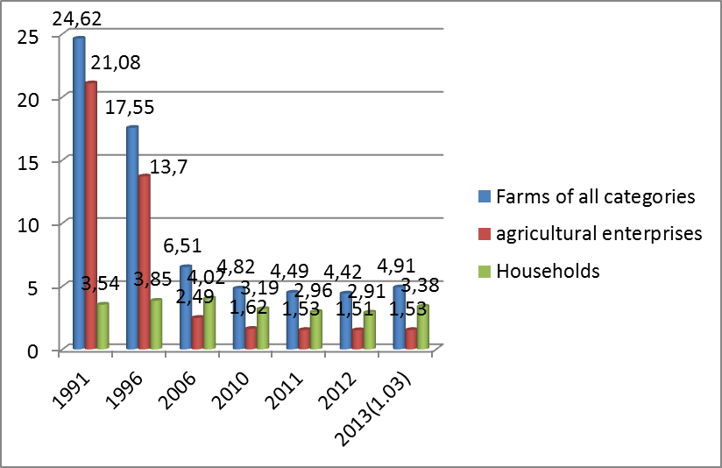
Figure. 1. Changes in the number of cattle (millions. Heads)
In Figure 1, we see that all indicators of the number of cattle a year by year continually reduced. In 1991, the main cattle herd contained in agricultural production as early as 2006, more cattle was kept in households and this trend continued until 2013. In 2012 and on 01.03.2013 the year increased the number of cattle in farms of all categories (blue column). Also, the number of cattle went up column in farms and households.
In Ukraine, 403 industrial structures of different legal forms of business as of January 1, 2012 there were 86.5 thousand head of cattle beef productivity, 14 breeds and types of cattle beef productivity in including 36.3 thousand beef cows. (Fig. 2). The share of area Polessye the total number of specialized beef cattle accounted for 55.3%, forest - steppe and 30.1% - 14.6%. In Ukraine in 1000 dairy cows and cattle breeds accounted for 15 cows specialized meat breeds, and in the area Polessye - 29, particularly in Volyn oblast - 57 cows, whereas in the U.S., Canada and France - the 200-300. If the share of world beef obtained from beef cattle 54%, in Ukraine - 3.5%. Despite the relatively small number of beef cattle, its population over the last 6 years has decreased by 39.9 thousand, head (31.6%), including cows - 20.2 thousand units (35.8% .) (1). Beef cattle industry in Ukraine in the process of forming.

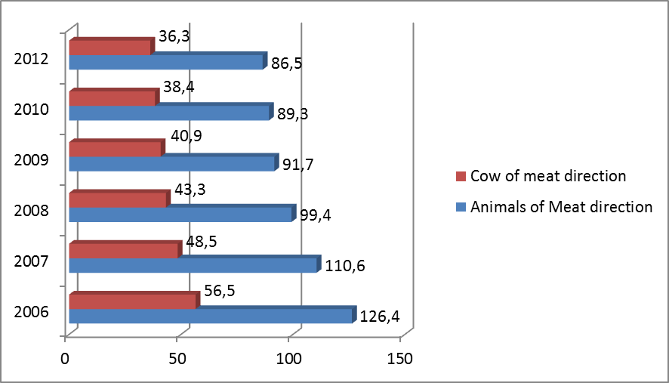
Fig.2. Dynamics of livestock and number of beef cows. (Thousand units)
In Fig. 2 shows that since 2006 the number of meat cattle productivity to 2008 and then decreased sharply decrease occurred, but at a slower pace. Stopped traffic index number of meat cattle performance in 2012 at around 86.5 thousand heads. Index number of beef cows performance, as seen in Figure 2 constantly decreasing.
Solve the problem of increasing meat production in cattle is possible by rapid development of large specialized beef cattle, which the rational organization of production requires considerable energy and labor costs, and capital investment.
Mainly by increasing the number of cattle beef cows to intensify their reproduction. First and foremost, an increase in the release of calves per 100 cows and heifers and 90 chapters, the introduction of the firstborn of the flock of 25-27 months., Extend the productive use to 5-6 calvings, the level of culling cows over the next 10 years to 15-17% in future - 20%. (2).
The sharp decline in cattle caused by several factors. One of the most significant of these is economic disinterest in growing cattle producers, because of the low purchase prices and reduced demand for these products.
As a result of objective and subjective reasons were adverse change in the development of beef cattle, reducing the number of cattle, caused a general decrease in production potential, led to a reduction in the volume of meat production in cattle.
In particular there was a decrease in beef production agricultural enterprises. So beef agricultural enterprises in 1995 produced 68.8% and households in the same year to produce the basic amount only 15%. In 2011rotsi role changed, agricultural enterprises beef produced only 11.9% and households have additions to the basic tonnage of 302 tons, and they are a major commodity producer of beef, their share in the production of beef is 75.7% total beef produced by all categories of farms. Households increased beef production for 16 years by 69.7%. It should be noted that agricultural enterprises are gaining momentum of meat production in 2011, their share in total meat production was 56.7%, and the proportion of households was 43.3%.
It is understood that broke agricultural enterprises forward not by beef.
Figure 3 shows that the column of beef in all categories of sharply goes to the bottom followed by an indicator of meat beef farms. It should be noted that the column in the production of beef farms in 2005 took some direction to the top, but my main motion it continues to decrease.
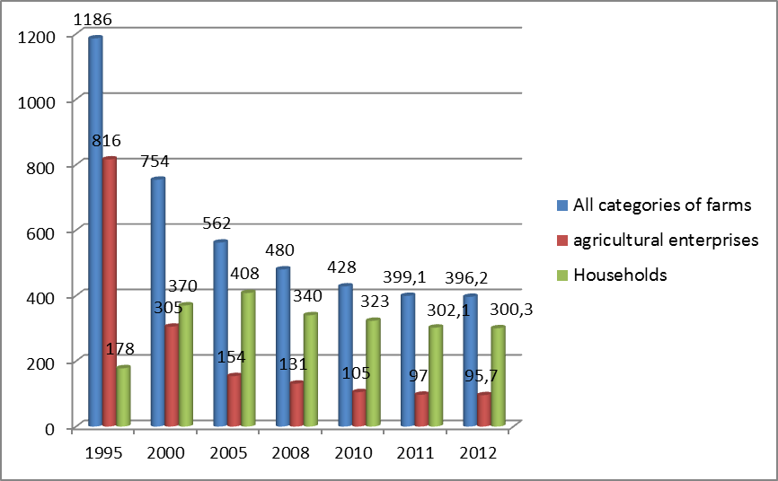
Fig.3. Dynamics of production of beef in different categories of farms (thousand tons)
Index beef production in households rose to the top by 2005 then slowly until 2008 he went to the bottom, and this year continues to move slowly in the same directed.
Households reduced in 2011, the production of beef in relation to 2010 to almost 21 tons in 2012 decreased beef production relative to 2011 by 1.8 thousand tons. The trend towards a decrease in the production of beef in households observed in 2006. That said however, that a necessary measure to maintain their own profitability by producing meat in households no longer such activities become unprofitable. Although meat production population is not the best alternative world technologies of its production, and loss of this manufacturer in the circumstances, threatens virtually transition to imported products. [1].
Negative changes in the development of beef cattle were accompanied by an increase in cost per unit of production in the industry. The pace of increase in the cost of beef production significantly exceeded growth in prices for its implementation. Thus, during the 1990-2011 biennium realizable price of 1 kg of beef (with subsidies) increased by 3.8 times, and its cost increased 5.9 times. As a result, beef production in agricultural enterprises over the years (except 1990 with grants) was unprofitable.
Cost of 1 kg of beef each year increases, which in turn leads to an increase in the price of beef.
During the period that we analyze the implementation of reduced beef in agricultural companies at 93.5%.
In 2011 also decreased sale of beef relative to 2010 to 164.3 thousand t, or 8.7%. The cost of this year increased by 2%, the price of 19.6% is allowed to reduce unprofitable production of beef by 11.1%.
Profitability of beef is considerable variation in individual years. Figure 4. shows that the profitability of meat production from 2000 to 2012rik was subzero. Meat has been unprofitable every year just with different levels of loss. The highest loss ratio of beef was in 2000 (-42.3%) and in 2007 (-41%). The lowest level of loss seen in 2008 (-24.1%) accounted for the remaining years of losses from -24.8% to -38.4%.
The optimal level of profitability of agricultural production, which is 25-45%, provides advanced production and growth funds financial incentives, cost-effectiveness and describes the basis for the justification of the most efficient industry structure of the economy and getting the required number of profit as the main regulator of production under market conditions [2].

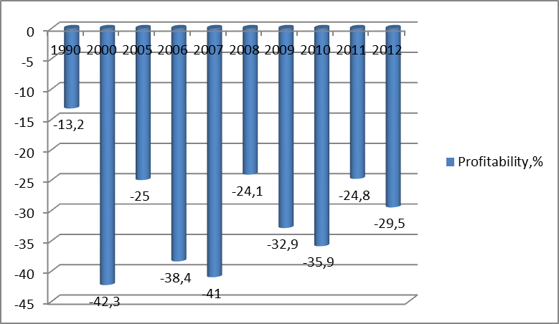
Figure. 4. Trends in profitability of beef
Analyzing the balance of beef and veal for the years 2008-2012 (Table 1) might argue that total supply over the years it decreased by 16.2%. In 2011, the total supply of beef decreased by 5.3% compared to 2010 due to a decrease in its production and imports. Production of beef and veal in 2011 amounted to 399 thousand tons is less compared to 2008 by 81 thousand tons in 2012 also reduced the production of beef and veal to 10 tons compared to 2011. Imports of beef and veal in 4 years have decreased by almost 58%. The total demand in 2012 fell by 1 thousand tons compared to 2011 due to reduced personal consumption of beef and veal population.
Domestic demand for beef and veal in 2011 - 2012 years ranges from 414-415 tons, depending on the effective demand of the population. It should be noted that the characteristic Ukraine decreasing trend in population means fewer available on the market in beef and veal end buyers, and thus leads to reduced capacity of the market. Changes in inventories of beef at the end of the year we go into the red to the required standards. But supplies of meat are a guarantee of the state in ensuring food security.

Table 1
The balance of beef and veal, tons
 | 2008 | 2009 | 2010 | 2011 | 2012 | 2012/2008
The total supply | 539 | 500 | 488 | 462 | 440 | 83,8
Beginning stocks | 21 | 33 | 35 | 40 | 35 | 166,6
production | 480 | 453 | 428 | 399 | 389 | 81,0
imports | 38 | 14 | 25 | 23 | 16 | 42,1
The total demand | 506 | 465 | 461 | 427 | 426 | 84,2
Domestic demand | 488 | 445 | 448 | 414 | 415 | 85
Private household consumption | 487 | 444 | 447 | 413 | 396 | 81,3
Expenses for non-food purposes (for food, expenses, etc.). | 1 | 1 | 1 | 1 | 1 | 100
export | 18 | 20 | 13 | 13 | 17 | 94,4
Ending stocks | 33 | 35 | 40 | 35 | 26 | 78,8
Consumption of 1 person per year, kg | 10,5 | 9,6 | 9,8 | 9,04 | 8,5 | 80,9
Source: State Statistical and own calculations [6].
Over the years we analyze the decreased production of beef per capita kg per year of all types of farms. So in 1990, agricultural enterprises produced 38.3 kg of beef per person per year, and in 2012 only 2.09 kg. Farms producing beef in 1990 per capita per year 3.4 kg in 2012 produced 6.58 kg per person.
Due to reduction of beef per capita kg per year deficits are the norm of consumption by the norms (Table 2).

Table 2
Actual and necessary production and consumption of beef (2012)
Indicators | production  total tons | Requirements  of  Ministry of Health | lack | Consumption of 1 person per year, kg
 |  |  |  | rules  Ministry of Health | fact | to normal
 |  |  |  |  |  | +/- | %
beef | 389 | 1440 | -1044 | 31,3 | 8,5 | -22,8 | 27,2
Source: State Statistics Committee [6] and own calculations
Beef produced in 2012 389 tons, and the need for normal Ministry of Health 1440 tons, the deficit - 1044 tons. Accordingly, the consumption of beef per person per year are 8.5 kg, which is less than - 22.8 kg to normal MOH. To normal consumption is only 27.2%.
Every person in the world according to the Food and Agriculture Organization (FAO) to obtain 20 g of animal protein per day, or 7.3 kg per year in order to prevent malnutrition or malnutrition. This amount of protein contained 33 kg of lean meat, fish or 45 kg or 60 kg of eggs, or 230 kg of milk, respectively. These sources are usually combined in the daily food intake. But in regions where not all of them are readily available, is necessary to increase consumption of other products. [5].

Conclusions: To speed up the development of beef cattle we need:
* Rational use of available resources potential area (grasslands, fixed assets, including the herd of cattle, working material assets, human resources);
* Introduction into the herd of beef cattle breeds with high genetic potential;
*conduct balanced feeding of livestock feeds, feeding the introduction of resource-saving technologies, maintenance and reproduction;
* increase the yield of total solids, protein from the use-of the meat;
* Use advanced forms, methods and techniques of work and production to produce more products:
* increase the level of social workers farms;
* increase the purchasing power of the population of Ukraine.
References:
1. The development of meat sector in Ukraine: monographs and 64 [MV Glady, PT Sabluk, NG Hooves et al.] Ed. CF. Gladiy. - K.: IAE NNC, 2012. - 354 p.
2. Agricultural sector of Ukraine (State and Prospects for Development) / (Prysiazhnyuk MV ZubetsM.V., Sablak PT, ETC.), Ed. M.V.Prysyazhnyuka, M.V.Zubtsya, P.T.Sabluka, VJ Mesel-Veselyaka, MMFedorov. - K.: IAE NNC, 2011. - 1008s.
3. Cerednomisyachna wages by economic activity since the beginning of the year in 2011 / State Statistics Service. - Mode of access: http://www.ukrstat.gov.ua/
4. Ministry of Economic Development and Trade of Ukraine. -Access
http://www.me.gov.ua/control/uk/publish/category/main?cat_id=195158
5. Analysis and forecast of world commodities markets livestock / [thorn (HM., Lupenko YU.O 3 Prysiazhnyuk M. et al.], Ed. A. spiers. - K. IAE NNC, 2012 . - 250 p.
6. State Statistics Committee of Ukraine. - Mode of access: http://www.ukrstat.gov.ua/

Проанализировано состояние производства мяса говядины и обеспечения им населения Украины. Рассмотрена проблема увеличения поголовья крупного рогатого скота во всех формах хозяйствования. Также намечены пути к повышению эффективности производства мяса говядины с целью обеспечения рациональной нормы потребления мяса населением страны.
Ключевые слова: мясо, говядина, крупный рогатый скот, потребление, цена, себестоимость, рентабельность.

