УДК 611- 018.51: 577.115.3 : 618.1: 618.173

THE INVESTIGATION OF ERITHROCYTES SPHERULATION IN REPRODUCTIVE AND MENOPAUSAL WOMEN

        - R. RATIANI, MD

- A. DGEBUADZE, MD, PHD, ScD, professor N. A. INTSKIRVELI, MD, PHD

G. L. ORMOTSADZE, MD, PHD

T. V. SANIKIDZE, MD, PHD, ScD, professor Tbilisi State Medical University

Many authors in several studies have examined alterations of red blood cell shape in norm and pathology [1, 2]; Noteworthy, that the degree of de-formability (elasticity) of erythrocytes membrane is determined by many fac-tors, including intensity of oxidative metabolism and membrane lipid content (saturated and unsaturated phospholipids, cholesterol), which can be changed as a result of lipid metabolism disorders. According to the literature data Lipid metabolism related disorders are common for many diseases – dislipidemia is considered as an important risk factor of metabolic syndrom and atherosclero-sis; numerous studies devoted to identifying the reliability of atherogenic index to assess the severity of dislipidemia and risk of atherosclerosis [3]. Identifica- tion of different types and quality of dislipidemia is very actual for determina-tion early diagnostical biochemical markers of atherosclerosis, as well as the key spots of its pathogenesis, and planning preventive measures of its devel-opment. In this respect it is necessary to identification statistically reliable links between parametrs of dislipidemia and metabolic disorders induced by it, sep-aration of this desorders from violation caused by other physiological (for ex-ample, age related alterations of estrogens content in woman’s body) factors. However above mentioned factors is less frequently used for studying of elas-ticity of erythrocytes membrane in the age-aspect [4].

The aim of the study was the identification of statistically reliable correla-tions and the cause-effect relationships between viability of red blood cells (de-formability of their membrane) and dislipidema parameters and/or metabolic disorders induced by age related alterations of estrogen content In women of different ages (reproductive and menopause ages).

Materials and methods. Clinical research were conducted in Central Clinic of Tbilisi State Medical University. The research complies with the norms of the bioarticle’s foundations. The local ethics committee approved the proto-col, and informed consent was obtained from all participants (The patients have signed the papers of agreements). Reproductive and menopausal aged women were undergone preliminary screening for body mass index, arterial blood pressure, history of arterial hypertension, diabetes mellitus, myocardial infarction, or stroke, angina pectoris, family history of coronary artery disease, intimae-media thickness. Extensive data were collected regarding smoking, diet, physical activity, lifestyle factors, exposure to toxic materials, etc. Two groups of women (with dislipidemia, arterial hypertension, obesity, metabolic syndrome and other symptoms) at the age of less than 45 years (reproductive age, group I, 58 women) and more than 45 years (menopause age, group II, 32 women) were selected and compared with each other. In each group we investigated the lipid profile, estrogen content and erythrocytes spherulation index. Vein Blood was collected from each of these patients and analyzed [es-trogens content, lipid spectrum (LDL, HDL, TC, VLDL, Tg), red blood cells’ spherulation index]. Exclusion criteria – cystic disease, ovarioectomy, hormon-otherapy. Lipid spectrum was measured by enzyme colorimetric method. Es-trogens content in peripheral blood was measured by ELISA method. The functional state of the red blood system was studied with the original method of analyze the distribution of peripherial erytrocytes population viability. For the evaluation of viability of erytrocytes two parameters were used: DV – the dif-ference of mean volume of “aged” and “young” erythrocytes (PBE). Statistic processing of obtained results was conducted according to SPSS 15.0 pro-gram. Student’s t-test was used for analysis of differences between means and a change with a p value <0,05 was considered statistically significant. In order to detection specific associations between the parameters in the stufing patients’ groups of correlation between the individual parameters were de-fined.

Results and their discussion. It was revealed that the elimination of red blood cells from the circulation is selective process – first of all are eliminated the old cells, but there are also stochastic component. Today there is no consensus on the red blood cells selection mechanisms, this process is de-termined by the specific markers or by the complex of age-related signs (red blood cells aging) leading to their death. Basically, two mechanisms are con-sidered:

- Impairment of dephormability of red blood cells, which reduces prob-ability of their crossing the spleen reticule – endothelial barrier and increases probability of their irreversible capture by macrophages.

- Changes in erythrocyte surface on which they will recognize macro-phages – the concentration of sialic acid residues (its concentration decreases with age, red blood cells, but the concentration of associated electrical charge density varies very little [1, 2] or changes in the immune (antigen) properties; it was shown that young and old red blood cells differ ability to join IgG.

Therefore, the fragmentation rate of young and old red blood cell frac-tions reasonably be regarded as a marker to indicate their age. Biological age of red blood cells is stochastic and, at the same time, dependent on the rate of there aging [5, 6, 7], which varie with alterations of charcteristics of physiologi-cal state. Among them, we should note the characteristics of red blood cells membrane (membrane phospolipids spectrum, content of cholesterol, perepherial polypeptide chains), viscosity of cytoplasme (degree of cell hydra-tion) and others. The combination of these characteristics is essential for the functioning of red blood cells, ratio of cell volume and its surface area (spheru-losis quality, which shows how close the cell shape is a sphere). From this po-sitions cell spherulation degree justifiably can be considered as a parameter associated with the chronological (biological) age of the cells. Indicators of spherulation (Q) and size (volume) of cells (V), both together determine the probability of overcoming red cells the capillaries of the spleen reticule-endothelial system, and therefore probability of there elimination. So, the com-plex parameters Q and V can be considered as a minimally sufficient set of pa-rameters that characterize the functional quality (age) of erythrocytes. The physical properties of cell membranes (dephormability, elasticity, sperulation quality) and functions significantly are determined by the chemical composition of their lipids. A number of data indicate that the alterations of membrane fatty acids content is reflected in metabolic and functional status of the cell, and therefore functioning of the whole organism.

The results of investigation of lipid metabolism in reproductive and men-opausal women with atherosclerosis-induced cardiovascular diseases show age-related changes in lipid spectrum. In blood of menopausal-aged women (II group) against the statistically reliable reduction of estradiol (22 %, p<0,01) re-vealed alterations in lipid metabolism parametres. In particular, in menopausal women’ blood HDL content decreased by 8 %, VLDL content statistically relia-bly not changed, triglycerides content by 16 % (p<0,05 ), the cholesterol con-tent by 58 % (p<001), LDL – by 28 % (p<001) increased in comparision to cor-responding indices in women of reproductive age (group I) [8].

As a result of our research it was shown that women in menopausal women index Tg/HDL value increased statistically significant by 31% in com-

parison of reproductive-aged women (I group Tg/HDL=1,69±0,13; II group Tg/HDL=2.22±0,12; p<0,001). In patients of both aging group negative correla-tion between blood Tg-s and HDL contents was revealed (Diagram 1).
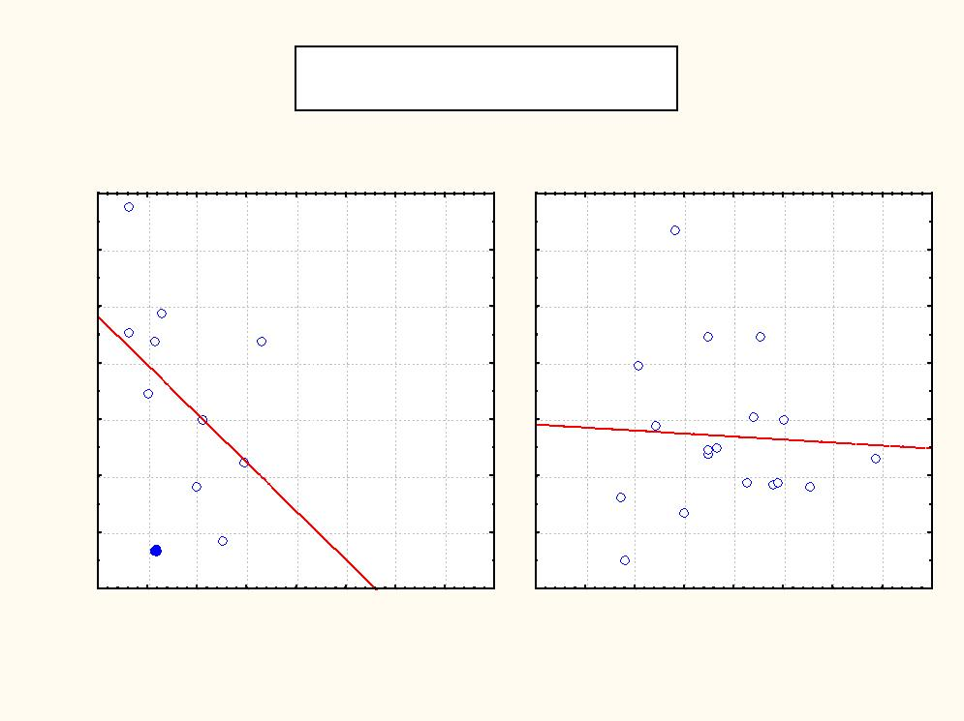

HDL

Scatterplot of HDL against TG; categorized by age

age: 1 TG:HDL: r = -0.4269, p = 0.1903 age: 2 TG:HDL: r = -0.0533, p = 0.8338

age: 1 HDL = 1.5363-0.3443*x age: 2 HDL = 0.9919-0.0213*x

1.8

1.6

1.4

1.2

1.0

0.8

0.6

0.4
0.5 | 1.0 | 1.5 | 2.0 | 2.5 | 3.0 | 3.5 | 4.0 | 4.5 | 0.5 | 1.0 | 1.5 | 2.0 | 2.5 | 3.0 | 3.5 | 4.0 | 4.5

age: 1 age: 2

TG

Diagram 1. Correlation between Tg and HDL content in women of different age groups (I – reproductive age; II – menopausal age)

As it is known, the atherogenic link between triglycerides and HDL con-tent is due to the higher plasma concentration of Tg-rich, very low-density lipo-protein that generates small, dense LDL during lipid exchange and lipolysis. These LDL particles accumulate in the circulation and form small, high dense HDL particles, which undergo accelerated catabolism, thus closing the athero-genic circle. Lipoprotein lipase (LPL), a key regulating enzyme for energy me-tabolism, catabolises plasma Tg-s into free fatty acids and glycerol. The high levels of TG are associated with impaired LPL activities.

Estrogens increase the hepatic expression of apoprotein genes and the LDL receptors and decrease the transcription of the LPL gene through ERα-s [9]. Thus, when estrogen levels decreases after the menopause, an increase of the LPL activity probably contributes to the decrease sensitivity HDL content toward fluctuation of Tg-s level in the blood. This means that in women of re-productive age the index Tg/HDL is sensitive marker of dislipidemia, but in women of postmenopause it does not reflect the violations of lipid metabolism.

In order to find feedback between parameters of lipid metabolism (and, consequently, quality of dislipidemia) and physical properties of the cellular membrane we carried out a correlation analysis between index (Tg/HDL) and erythrocytes spherulation quality (DV). Our research revealed the existence of a reliable positive correlation between the spherulation quality of erythrocytes and HDL content (Diagram 2) and a negative correlation of the spherulation quality of erythrocytes and index Tg/HDL (Diagram 3).

From the data shown on diagram 2 reveales that spherulation degree (or volume) of red blood cells is rapidly decreased at low HDL (and, therefore, a
high index Tg/HDL) in women of reproductive age; in women of menopause spherulation of red blood cells is not sensitive to HDL content. Data of diagram 3 indicates that between spherulation quality of red blood cells and index Tg/HDL reliable correlation was found, however correlation coefficient is 2 times higher in menopausal women, than in the women of reproductive age. These indicates on the existence of estrogen-related dependense between this two parameters.
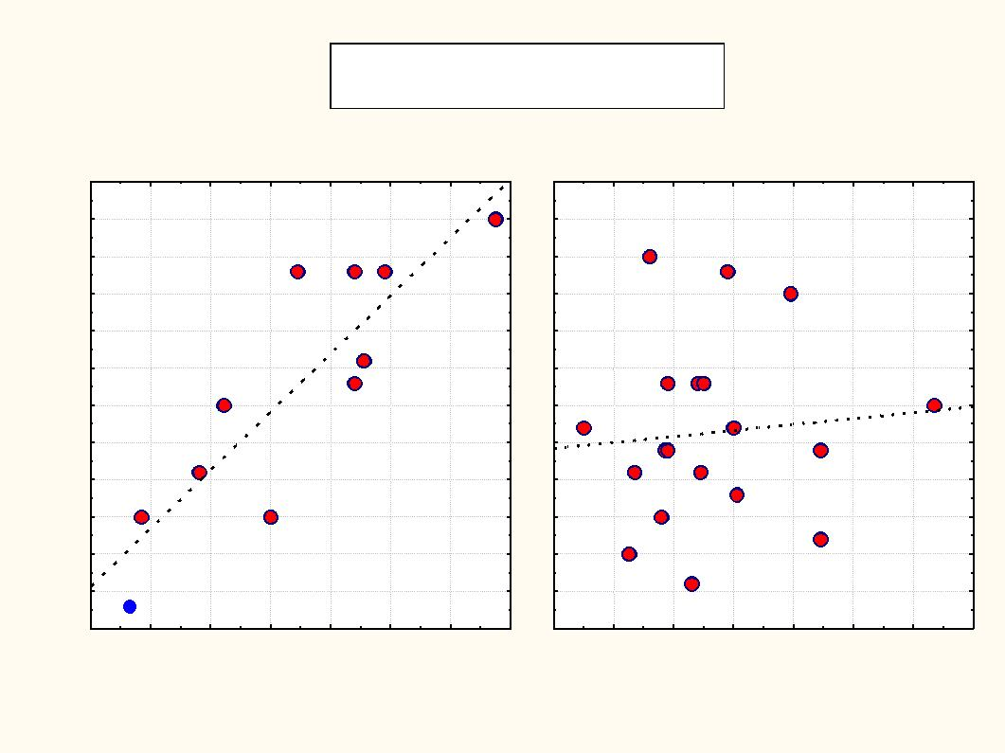

DV

Scatterplot of DV against HDL; categorized by age

age: 1 HDL:DV: r = 0.8646, p = 0.0006 age: 2 HDL:DV: r = 0.0907, p = 0.7121

age: 1 DV = -15.9596+15.6313*x age: 2 DV = -2.9366+1.603*x

12
10
8
6
4
2
0
-2
-4
-6
-8
-10
-12
0.4 | 0.6 | 0.8 | 1.0 | 1.2 | 1.4 | 1.6 | 1.8 | 0.4 | 0.6 | 0.8 | 1.0 | 1.2 | 1.4 | 1.6 | 1.8
 |  |  | age: 1 |  |  |  |  |  |  |  | age: 2

HDL

Diagram 2. Correlation feedback between blood HDL content and spherulation quality (DV) of erythrocytes in women of different age groups (I – reproductive age; II – menopausal age)
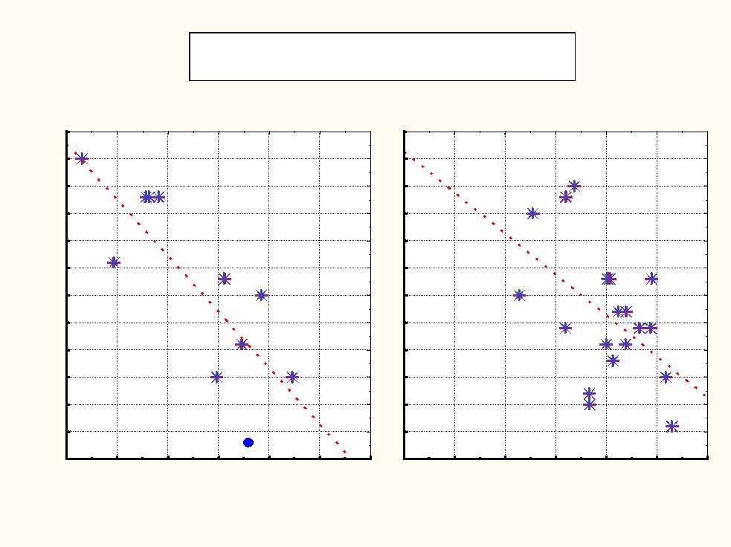
 |  |  | Scatterplot of DV against LOG10(TG/HDL); categorized by age
 |  |  |  | age: 1 LOG10(TG/HDL):DV: |  |  |  | r = -0.8086, p = 0.0026
 |  |  |  | age: 2 LOG10(TG/HDL):DV: |  |  |  | r = -0.5097, p = 0.0258
 |  |  |  |  | age: 1 DV = 2.9136-20.5413*x
 |  |  |  |  | age: 2 DV = 4.5441-15.0008*x
 | 12
 | 10
 | 8
 | 6
 | 4
 | 2
 | 0
DV | -2
 | -4
 | -6
 | -8
 | -10
 | -12
 | -0.4 | -0.2 | 0.0 | 0.2 | 0.4 | 0.6 | 0.8 -0.4 |  | -0.2 | 0.0 | 0.2 | 0.4 | 0.6 | 0.8
 |  |  |  | age: 1 |  |  |  |  |  |  | age: 2
 |  |  |  |  |  | LOG10(TG/HDL)
Diagram 3. Correlation feedback among index (Tg/HDL) and spherulation quality (DV) of erythrocytes in women of different age groups (I – reproductive age; II – menopausal age)

Spherulation of erythrocytes significantly depends on their deplorability – when deformability decreases erythrocyte becomes spheric, its volume in-creases. Deplorability of erythrocytes significantly depends on its membrane fluidity, which in turn is determined by the membrane lipid spectrum (saturated phospholipids, cholesterol content). Ability of erythrocytes to maintain high de-plorability is especially important for maintenance of normal blood flow in the microcirculation [5].

In literature there is evidence on different incorporation of fatty acids in red blood cells membranes in reproductive and menopausal aged women. In women of reproductive age the fatty acyds incorporation significantly in-creased into phosphatidylethanolamine (PE) and not into phosphatidylcholine (PC), the major acyl acceptor in red blood cells. This estrogen-dependent phospholipids acylation increases – as a function of cell age – occurs predom-inantly in PE of oldest cells [4]. As PE, being more unsaturated than PC, it is more sensitive to oxidation. On the basis of literature data we can conclude, that estrogen through the constant renewal of PE contributes to increases the red blood cell resistance to lipid peroxidation. Lack of estrogens in menopau-sal women decreases renewal of PE (incorporation of fatty acids), and there-fore decreases protection of red blood cells against oxidative damage. This in-directly contributes reduction of erythrocytes deformability, which revealed by increasing degree of spherulation in menopausal women.

Conclusions

On the basis of the analysis of research results we can conclude that in the different age groups of women with atherosclerosis-induced cardiovascular diseases revealed estrogen-related dependence between Tg-s and HDL con-tent, functional status of peripheral blood erythrocytes and severity of dislipidemia. The index Tg/HD proved to be sensitive marker of dislipidemia in reproductive aging women, but doesn’t reflect disorders of lipid metabolism in menopausal women.

It was proved the existence of reliable correlation between red blood cells dysfunction indicator, spherulation quality (low membrane deformability), and index Tg/HDL highlights; however, the correlation coefficient is 2 times higher in the reproductive age as in menopause. Spherulation quality of red blood cells at low HDL content showed fast growth rate in reproductive-aged women, and was unsensitive to HDL content in menopausal women. Age-related lack of estrogens in menopausal women indirectly contributes to de-crease protection of red blood cells against oxidative damage, reduce their de-formability and disturbance the rheological properties.

REFERENCES

1. Nordt F.J. Alterations in surface charge density versus changes in surface charge topography in aging red blood cells. Ann Hematol. 1980; 40(4):233-238.

- Piagnerelli M., Boudjeltia K.Z., Brohee D., Piro P., Carlier E., Vincent J.L., Lejeune P., Vanhaeverbeek M. Alterations of red blood cell shape and sialic acid membrane content in septic patients. Crit. Care Med. 2003; 31(8): 1052-1061.

- Ballantyne C.M., Hoogeveen R.C. Role of lipid and lipotrotein profiles in risk assessment and therapy. Am Heart J. 2003; 146(2):227-233.

- Le Petit-Thevenin B., Lerique O.N, Boyer J. Estrogen modulates phospho-lipid acylation in red blood cells: relationship to cell aging. Am J Physiol Cell Physiol. 1991; 261 (3): 423-427.

- Deuticke B. Membrane lipids and proteins as a basis of red cell shape and its alterations. In: I.Bernhardt, J.Clive Ellory (ed). Red cell membrane transport in health and disease, Ird edn. Springer-Verlag Berlin Heidelberg. New York: 2003; 27-60.

- Lux S.E. Dissecting the red cell membrane skeleton. Nature 1979; 281:
426-429.

- Mohandas N., Chasis J.A. Red blood cell deformability, membrane material properties and shape: regulation by transmembrane, skeletal and cytosolic proteins and lipids. Semin Hematol. 1993; 30(3): 171-192.

- Ratiani L, Parkosadze G, Koptonashvili L, Ormotsadze G, Sulaqvelidze M, Sanikidze T. Correlation of atherogenetic biomarkers and estradiol changes in posmenopause. Georgian Med News. 2011; 195(6):100-105.

- Saltiki K., Alevizaki M. Coronary heart disease in postmenopausal women; the role of endogenous estrogens and their receptors. Hormones. 2007; 6(1): 9-24.

In two groups of 90 women (with dislipidemia, arterial hypertension, obesity, metabolic syndrome and other symptoms) at the age of less than 45 years (repro-ductive age group - 43) and more than 45 years ( menopause age group - 50 ) were investigated the lipid profile (lipid spectrum - LDL, HDL, TC, VLDL, Tg), estrogen content and erythrocytes spherulation index and compared with each other. It was proved the existence of reliable correlation between red blood cells dysfunction indi-
cator, spherulation quality, and atherogenic index Tg/HDL highlights; however, the correlation coefficient is 2 times higher in the reproductive age as in menopause. Spherulation quality of red blood cells at low HDL content showed fast growth rate in reproductive-aged women, and was unsensitive to HDL content in menopasal wom-en. It was concluded that age-related lack of estrogens in menopausal women indi-rectly contributes to decrease protection of red blood cells against oxidative damage, reduces their deformability and disturbances the rheological properties. Spherulation quality of red blood cells may be used as a diagnostic marker of severity of athero-sclerosis.

Erythrocytes, aging changes, reproductive age, menopause, spherula-tion of erythrocytes, lipid metabolism, atherogenic index, estrogens.
Therefore, the fragmentation rate of young and old red blood cell frac-tions reasonably be regarded as a marker to indicate their age. Biological age of red blood cells is stochastic and, at the same time, dependent on the rate of there aging [5, 6, 7], which varie with alterations of charcteristics of physiologi-cal state. Among them, we should note the characteristics of red blood cells membrane (membrane phospolipids spectrum, content of cholesterol, perepherial polypeptide chains), viscosity of cytoplasme (degree of cell hydra-tion) and others. The combination of these characteristics is essential for the functioning of red blood cells, ratio of cell volume and its surface area (spheru-losis quality, which shows how close the cell shape is a sphere). From this po-sitions cell spherulation degree justifiably can be considered as a parameter associated with the chronological (biological) age of the cells. Indicators of spherulation (Q) and size (volume) of cells (V), both together determine the probability of overcoming red cells the capillaries of the spleen reticule-endothelial system, and therefore probability of there elimination. So, the com-plex parameters Q and V can be considered as a minimally sufficient set of pa-rameters that characterize the functional quality (age) of erythrocytes. The physical properties of cell membranes (dephormability, elasticity, sperulation quality) and functions significantly are determined by the chemical composition of their lipids. A number of data indicate that the alterations of membrane fatty acids content is reflected in metabolic and functional status of the cell, and therefore functioning of the whole organism.

-

