УДК 57.082:611.8

USING OF P40 TECHNIQUE FOR BRAIN SHEET PLASTINATION

D.P. SIVREV, S.R. HAMZA ,

N.D. DIMITROV, A.I. GEORGIEVA
Faculty of Medicine, University of Thrace, St. Zagora, Bulgaria

P40 plastination technology is a specific technique for the tissue preser-vation and production of brain slices. The original version of the processing has several phases: fixation, dehydration, slicing, impregnation, hardening and grinding. For achieve of high quality anatomical specimens with classic technique requires two months. This needs too much time.

Von Hagens (1994) the first describes P40 technique, but soon his fol-lowers develop this method, they discover and apply new materials that have the same application. Three years later Barnet (1997) publicizes his results of P40 plastination of coronal and horizontal brain slices. The best specialists of brain sheet P35 plastination try to produce brain slices by P40 technique and have good results (Henry and Weiglein, 1999). Weiglein and Feigl (1998) compare sheet plastination of brain slices with P35 and P40 procedures. They enhance preferences of P40 plastination method. Sora et al (1999) does a comparison between two different techniques – immersion and impregnation.

Latore et al (2004) try to do a sheet plastination with polyester as an al-ternative for all tissues. The same author and Henry (2007) describe own re-sults P40 body slices production. They use acetone, methylene chloride and polyester resin in plastination process. The flat chamber, containing the spec-imen, is filled with mixture P40-A4 (100:2). A 40 watt UVA-light minimum for one hour is hardener.

© D.P.Sivrev, S.R.Hamza, N.D.Dimitrov, A.I.Georgieva

A new P45 polyester technique was presented by Gao et al. (2006). The phases of this new method are similar to the E12 plastination technique but slices must put in 40ºC hot water for three days in hardening step. According these authors the main advantage of P45 is the decreased volume of used re-zin. The process is not complicated and less equipment and time is need.

There is an interest of P35 plastination technique last years (Weber, 2007). According authors Biodur P35 is still remains the gold standart for pro-duction of high quality brain slices.

Some authors (Reed et al, 2008) experimentalize to change light sourse. They fill glass casting chambers with P40 resin and placed under different light sources to record curing rates and temperatures reached during the process. Results were used to assess the effects of different light sources and the method of application of that light on the curing of P40 resin. It was found that curing of P40 resin was achieved by exposure of the resin to sunlight, artificial UV-A light and mercury lighting.

Independently of new different materials plastination process utilizes forced impregnation and casting is between two glass plates. It remains slow and time-consuming to plastinators.

The aim of this research is to reduce the time of production process. Material and Methods. Plastination process includes 5 basic steps: fix-

ation, slicing, dehydration, impregnation, hardening.

Fixation: We use 14 brains that are fixed in 10 % water mixture of for-maldehyde for 1 month after perfusion of whole cadaver. The perfusion is a best method for cadaver fixation.

Slicing: We do not set whole brains in acetone in dehydration step, but put them at minus 25 ºC freezer for 24 hours. Аll brains hardened by low tem-perature and it is easily to cut with a machine cutter and get a slice thickness 4–5 mm.

Dehydration: Slices 4–5 mm thick does not require one month to dehy-dration. 2–4 days, depending on the thickness thereof is sufficient. Acetone is an ideal dehydrator in all plastination techniques. We put brain slices on a metal grid and set them in cold (-25 ºC) first acetone (100 % purity) bath. The next day must to measure the purity of the acetone, and if necessary replacing it with a new acetone (100 % purity). The process is completed in 2–4 days.

Impregnation: The impregnation bath includes polyester P40 and activa-tor A4 in ratio 100:2. The brain slices are placed in vacuum chamber with mix-ture and vacuum must be applied immediately. The chamber must be covered from light. The vacuum is gradually increased in each of the bubbles disappear. When the bubbles decreases permanently, impregnation is com-pleted and chamber is returned to atmospheric pressure.

Curing process: The polymerization is activated by UV light. We building a glass chamber for later insertion of a brain slice from two 2 mm glasses, 4 mm silicone gasket and large fold-back clamps (fig. 1).
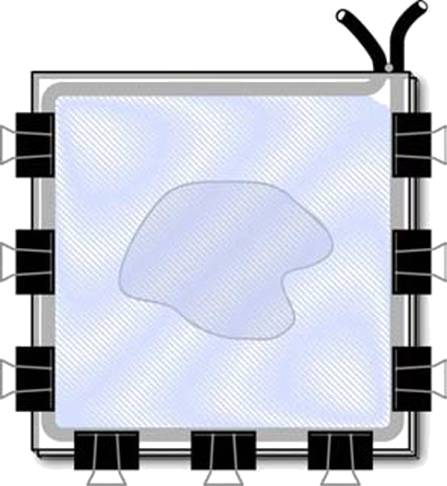

Fig. 1. A flat chamber for P40 plastination technique (by ISP)

The brain slice is inserted into the chamber and clamps are positioned nearly. The flat chamber is filled with polyester mixture and air bubbles must be rise to the surface and remove from the mixture.

The chamber is exposed to UVA-light. 40 watts UVA light tubes are used. We have a special UV device for hardening of brain slices (fig. 2). It has some position and some power of the light. During UVA light exposure must to cool the flat chamber because the reaction is exothermic and the temperature can damage the preparation.
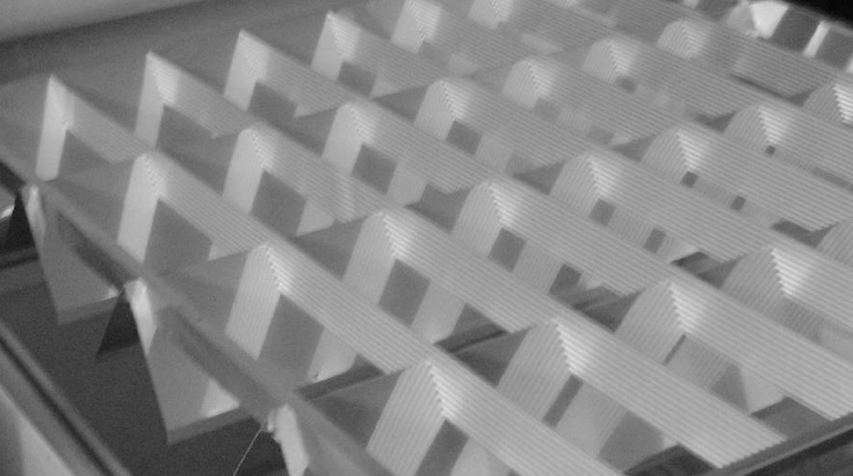

Fig. 2. The UV light-chamber for P40 plastination technique

Results. The P40 brain slices are semitransparent, durable and safely for students and lectures. They represent an excellent sectional anatomy of the brain. Gray and white matter, sub-cortical nuclei, ventricles and other de-tails are well differ.

Discusion and Conclusions. A comparison between slices, made at a different position of the flat camera, is found that when operating with a horizontal chamber, results are better – there is no displacement of the compositions, the polymer being illuminated better and no cracks. We have also discovered that the bubbles are removed more easily in the vertical position of the camera.

Therefore, we recommend air bubbles to remove in a vertical position of the flat camera but the illumination to do in a horizontal position, if possible – on both sides of the preparation.

References

  - Barnett R.J. Plastination of coronal and horizontal brain slices using the P40 technique / R.J.Barnett // J. Int. Soc. Plastination. – 1997. – Vol. 12(1). – P. 33–36.

  - Henry R.W. Polyester plastination of biological tissue: P40 technique for brain slices / R.W.Henry, R.Latorre // J. Int. Soc. Plastination. – 2007. – Vol. 22. – P. 59–68.

  - Henry R.W. Sheet plastination of brain slices – P40 procedure / R.W.Henry, A.Weiglein // J. Int. Soc. Plastination. – 1999. – Vol. 14(2). – P. 32.

  - Sheet Plastination with Polyester: An Alternative for All Tissues / R.Latorre, A.Arencibia, F.Gil [et al.] // J. Int. Soc. Plastination. – 2004. – Vol. 19. – P. 33–39.

  - Latorre R. Polyester plastination of biological tissue: P40 technique for body slices / R.Latorre, R.W.Henry // J. Int. Soc. Plastination. – 2007. – Vol. 22. – P.69–77.

  - Reed R. Curing Times of P40 Exposed to Different Light Sources / R.Reed, L.Helms, J.Rowe // J. Int. Soc. Plastination. – 2008. – Vol. 28. – P. 25–29.

  - Sui H. Polyester Plastination of Biological Tissue: Hoffen P45 technique / H.Sui, R. Henry // J. Int. Soc. Plastination. – 2007. – Vol. 22. – P. 78–81.

  - Sora M.C. P40 plastination of human brain slices: Comparison between different immersion and impregnation techniques / M.C.Sora, P.Brugger, H.Traxler // J. Int. Soc. Plastination. – 1999. – Vol. 14(1). – P. 22–24.

  - von Hagens G. Plastination of brain slices according to the P40 procedure. A step-by-step description / von Hagens G. – 1994. – 23 p.

  - Polyester Plasination of Biological Tissue: P35 Technique / W.Weber, A.Weiglein, R.Latorre, R.Henry // J. Int. Soc. Plastination. – 2007. – Vol. 22. – P. 50–58.

  - Weiglein A.H. Sheet plastination of brain slices according to the P35 and P40 procedures / A.H.Weiglein, G.Feigl // J. Int. Soc. Plastination. – 1998. – Vol. 13(2). – P. 30.

P40 plastination technology is a specific technique for the tissue preservation and production of brain slices. The original version of the processing has several phases: fixation, dehydration, slicing, impregnation, hardening and grinding. For achieve of high quality anatomical specimens with classic technique requires two months. The aim of this research is to reduce the time of production process. Fixation: We use 14 brains that are fixed in 10 % water mixture of for-maldehyde for 1 month after perfusion of whole cadaver. The perfusion is a best method for cadaver fixation. Slicing: We do not set whole brains in acetone in dehydration step, but put them at minus 25 oC freezer for 24 hours. Аll brains hardened by low tem-perature and it is easily to cut with a machine cutter and get a slice thickness 4–5 mm.
Dehydration: Slices 4–5 mm thick does not require one month to dehy-dration. 2–4 days, depending on the thickness thereof is sufficient. Acetone is an ideal dehydrator in all plastination techniques. We put brain slices on a metal grid and set them in cold (-25 oC) first acetone (100 % purity) bath. The next day must to measure the purity of the acetone, and if necessary replacing it with a new acetone (100 % purity). The process is completed in 2–4 days.
The P40 brain slices are semitransparent, durable and safely for students and lectures. They represent an excellent sectional anatomy of the brain. A comparison between slices, made at a different position of the flat camera, is found that when operating with a horizontal chamber, results are better – there is no displacement of the compositions, the polymer being illuminated better and no cracks. We have also discovered that the bubbles are removed more easily in the vertical position of the camera. Therefore, we recommend air bubbles to remove in a vertical position of the flat camera but the illumination to do in a horizontal position, if possible – on both sides of the preparation.

Аnatomy, plastination, P40, brain, slices, fixation, dehydration, impreg-nation.

