UDC 349.42
SCIENTIFIC AND LEGAL CONCLUSION AS AN INSTRUMENT FOR SOLVING ISSUES IN THE LEGAL SPHERE OF THE LAND MANAGEMENT INDUSTRY.
Dorosh Y., Doctor of Economics Sciences
e-mail: landukrainenaas@gmail.com
Ibatullin S., Doctor of Economics Sciences, Corresponding Member of NAAS
E-mail:shamilibatullin@gmail.com
Avramchuk B., Candidate of Economic Sciences (Ph.D.)
e- mail: avramchuk.bogdan@gmail.com
Kharytonenko R. Candidate of Economic Sciences (Ph.D.)
E-mail: kharytonenkor@gmail.com
Land Management Institute of the National Academy of Sciences of Ukraine
Patiyuk O., postgraduate student
e- mail: o.patiyuk@gmail.com
National University of Life and Environmental Sciences of Ukraine,
The necessity of attracting scientific and practical conclusions to resolve controversial issues in the land management industry is substantiated. The practical experience of applying the scientific and practical conclusion and conducting scientific research in solving the problem associated with the correction of technical errors in the state land cadastre is considered.
The analysis and justifiably technical error in the data of the State Land Cadastre on the change in the purpose of the land for the construction and maintenance of an apartment building from erroneous purpose for conducting agricultural production was carried out.
The list of documents that must be submitted together with the application to the cadastral registrar on making amendments based on a technical error of information about the land registered in the State Land Cadastre is given.
It is noted that it is necessary to start the practice of creating scientific and legal conclusions to resolve controversial and complex issues in land management with the involvement of leading scientists in the industry and specialized research institutions.
Key words: scientific and legal opinion, state land cadastre, purpose, public cadastral map, correction of errors in the conduct of the SLC.

Formulation of the problem. Attracting scientific and practical conclusions to resolve controversial issues in the legislation of Ukraine is becoming a constant practice in various procedural forms. In particular, this form of “examination” was widely used during court cases as an additional evidence document. Such practice is no exception when resolving contentious issues in land legislation, where special knowledge is needed to explain complex and debatable issues when interpreting, from a scientific point of view, with the involvement of leading industry experts and specialized research institutions.
The new one is the attraction of scientific and practical conclusions in resolving conflict situations between citizens (legal entities) and the executive bodies of land resources by the example of the correction of errors made in the conduct of the state land cadastre. A scientific and practical conclusion is understood as scientific activity (research), which interprets legal norms, practices of applying existing legal norms, analysis of documents that were developed earlier that characterize the object of use and describe ways to solve disputed problems within a certain area of ​​knowledge.
Purpose of the study. The use of scientific and practical conclusions as a tool for solving complex issues in land legislation on examples of correcting errors made in the conduct of the state land cadastre.
Research results and discussion. In accordance with the Law of Ukraine "On Scientific and Scientific-Technical Activities" and the possibilities of conducting research in the field of land management, a private enterprise applied to the Land Management Institute of the National Academy of Agrarian Sciences of Ukraine with a request for scientific justification for determining the purpose of a land area of ​​5.2000 hectares, located in the territory of. Sofievskaya Borshchagovka, Kiev-Svyatoshinsky district, Kiev region [2]. This land plot was leased to this private enterprise in 2003 for a period of 49 years. Landlord of the Kiev Regional State Administration.
The need for scientific research is due to the fact that the main purpose for which the land is used is in accordance with the concluded lease agreement for the construction and maintenance of an apartment building (code KVTSPZ - 02.03). However, this plot in the register of the State Land Cadastre on the public cadastral map was mistakenly registered with the intended purpose for agricultural commodity production (KVPPZ code - 01.01), does not correspond to the actual use of the land plot and in the future it will make it impossible to commission an apartment building [ 6].
After analyzing the land management documentation, it was found that prior to leasing it to a private enterprise, the land plot was outside the locality in the state ownership on the territory of the Sofievsko-Borshchagovsky village council in the use of the state-owned enterprise Pushcha-Voditsa Research and Production Industrial Complex. The land plot was assigned for its intended purpose for agricultural commodity production in accordance with the Ukrainian classifier of intended use.
In 2003, a land management project was developed to allocate a land plot for rent to a private enterprise for the construction and maintenance of an apartment building. This project of land management in accordance with article 186 of the Land Code of Ukraine was agreed in the prescribed manner with the relevant authorities and received a positive conclusion from the state land management expertise [1]. Based on this, the Kiev Regional State Administration concluded a lease agreement with this private enterprise.
At the time of the development and approval of project documentation in the legislation of Ukraine, it was only based to adopt normative legal acts on the assignment of cadastral numbers and entering information about the land into the State Land Cadastre. Therefore, in the transitional period of the formation of legislation, a land plot, which was leased to a private enterprise, was not assigned a cadastral number but information was not entered into the State Land Cadastre.
In order to continue to use the land area of ​​5.2 hectares in the legal plane for the construction and operation of an apartment building, in 2015 a private enterprise applied to the State Enterprise Kyiv Research and Design Institute of Land Management with a request for the development of technical documentation for land management on establishing (restoring) the boundaries of the land plot in kind (on the ground) transferred to long-term lease, for assigning the cadastral number to the land plot and entering information Register Holding Foot land cadastre.
After the development of technical documentation at the time of registration of the land data, it turned out that it was already registered in the State Land Cadastre under cadastral number 3222486200: MM: ХХХ: ХХХХ state property with the designated purpose - 01.01 for agricultural commodity production.
It is worth noting that the types of intended use of the land for agricultural commodity production (KVPCPZ code - 01.01 section A) and for the construction and maintenance of an apartment building (KVPCPZ code - 02.03 section B) belong to different categories of land, which contradicts their legal use. Also, in accordance with the extract from the Unified State Register of Rights to the Land Plot, there was no information that it was in long-term lease [4,6] (Fig. 1).
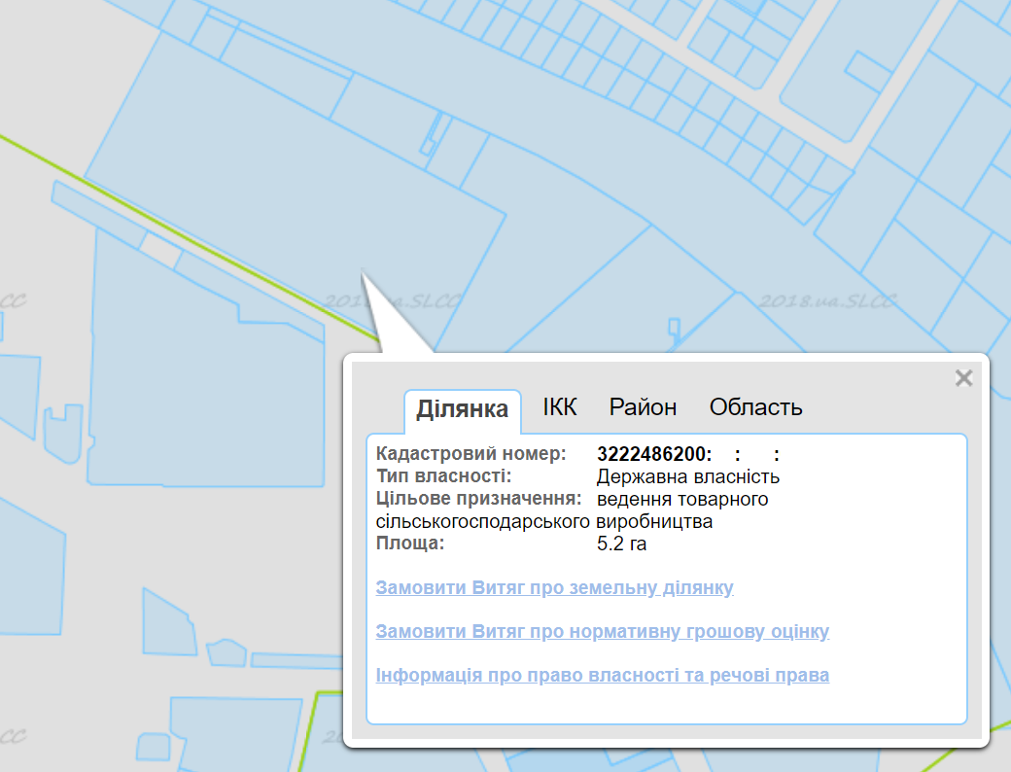
Fig. 1. A land plot with a detected error for the intended purpose in the information of the State Land Cadastre [7]

In accordance with Art. 1 of the Law of Ukraine "On Land Management" the intended purpose of the land: the use of the land for the purpose determined on the basis of documentation on land management in the manner prescribed by law [3]. The intended purpose of land plots is determined in accordance with the classification of types of designated purpose of land (KVPPZ), approved by order of the State Committee for Land Resources 23.07.2010 No. 548 [6].
In the developed land management documentation, the intended purpose of the land area of ​​5.2 hectares is set for the construction and maintenance of an apartment building (KVTSPZ code - 02.03).
The user of the land plot intends to use it for the construction and maintenance of an apartment building in accordance with code 02.03 according to the classification of land uses, since this type of land use corresponds to the urban planning documentation of the territory where the land plots are located.
According to the Decree of the Cabinet of Ministers of Ukraine “On Approval of the Procedure for Maintaining the State Land Cadastre” dated 10.17.2012 No. 1051 in paragraph 107, state registration of a land plot is carried out during its formation based on the results of submission of land management documentation, which was agreed upon in the established order and decision on its approval by the state authority or local government by opening the Land Register on such a land plot [4,5].
In accordance with Article 20 of the Land Code of Ukraine, the establishment and change of the purpose of land is carried out by the Land Management Plan for the allotment of the land [1].
To use the land, if desired, it is necessary to amend the information regarding the intended use of the land, which is registered in the State Land Cadastre [4].
In accordance with the Decree of the Cabinet of Ministers of Ukraine “On Approving the Procedure for Maintaining the State Land Cadastre” dated 10.17.2012 No. 1051, the correction of errors made in the maintenance of the state land cadastre (GZK) in the event of a technical error is carried out on the basis of No. 1561 [5].
A technical error made in the information of the SLC due to the transfer of information about the land plot was not registered in the state land registry, if there is an open Unified State Register of Rights, it is corrected on the basis of technical documentation on land management regarding the establishment (restoration) of the boundaries of land plots in kind (on the ground) or land inventory materials or court decisions.
Based on the foregoing, to make changes to the information of the SLC and to correct the technical error of the intended purpose of the land area of ​​5.2 hectares, it is necessary to carry out the following actions:
- produce an electronic document in XML format to ensure that the correct information on the purpose (type of use) of the land plot by the State Cadastral Registrar is entered;
- prepare an Application for Amendments to the State Land Cadastre, in which to indicate information on this land plot with the intended purpose of the land plot “Land for residential and public buildings” by transferring from KVPPZ code - 01.01 for conducting agricultural commodity production the KVPPZ code - 02.03 for construction and maintenance multi-family residential building;
- to the application for amendments to the SLC it is necessary to add a scientific and legal conclusion on the possibility of making changes to the SLC information on the land plot in case of technical errors, an identification document, assigned tax number, electronic document, extract from the State Land Cadastre on the provision of statements about the land plot, design and technical documentation for land management, which was developed for this land plot.
Findings. Given a common position with respect to employees of executive bodies in any industry, including land resources, they should be independent and not need outside assistance in resolving legal issues. As the practice of appeals of citizens and legal entities to the SLC with non-typical problems about making legitimate changes to information about the land plot shows, it is necessary to have a third party to resolve disputes not in court. The beginning of the practice of applying the scientific and legal conclusions of the study, conducted by specialized scientific institutions and leading scientists of the industry, will help clarify complex and controversial issues in land management.

References
- Zemelnyi kodeks Ukrainy. Rezhym dostupu : https://zakon.rada.gov.ua/laws/show/2768-142.
- Zakon Ukrainy «Pro naukovu ta naukovo-tekhnichnu diialnist» Rezhym dostupu : https://zakon.rada.gov.ua/laws/show/848-19
- Zakon Ukrainy «Pro zemleustrii». Rezhym dostupu : https://zakon.rada.gov.ua/laws/show/858-15
- Zakon Ukrainy «Pro derzhavnyi zemelnyi kadastr». Rezhym dostupu : https://zakon.rada.gov.ua/laws/show/3613-17
- Postanova Kabinetu Ministriv Ukrainy. «Pro zatverdzhennia Poriadku vedennia Derzhavnoho zemelnoho kadastru». Rezhym dostupu : https://zakon.rada.gov.ua/laws/show/1051-2012-%D0%BF
- Nakaz Derzhavnoho komitetu Ukrainy iz zemelnykh resursiv «Pro zatverdzhennia Klasyfikatsii vydiv tsilovoho pryznachennia zemel». Rezhym dostupu : https://zakon.rada.gov.ua/laws/show/z1011-10
- Publichna kadastrova karta Ukrainy. Derzhavnyi zemelnyi kadastr. Rezhym dostupu : http://map.land.gov.ua/kadastrova-karta

Дорош Й.М., Ібатуллін Ш.І., Аврамчук Б.О., Харитоненко Р.А., Патіюк О.О.
НАУКОВО-ПРАВОВИЙ ВИСНОВОК – ІНСТРУМЕНТ РОЗВ’ЯЗАННЯ проблемних питань в ПРАВОВІЙ площині землевпорядної СФЕРи
Обґрунтовано потребу залучення науково-практичних висновків для вирішення спірних питань в землевпорядній галузі. Розглянуто практичний досвід застосування науково-практичного висновку та проведення наукового дослідження при вирішенні проблем, пов’язаних із виправленням технічних помилок в державному земельному кадастрі.
Проведено аналіз та обґрунтовано технічну помилку в даних Державного земельного кадастру щодо зміни цільового призначення земельної ділянки для будівництва і обслуговування багатоквартирного житлового будинку із внесених помилково цільових призначень для ведення товарного сільськогосподарського виробництва.
Наведено перелік документів, які необхідно подати разом із заявою до кадастрового реєстратора щодо внесення змін на підставі технічної помилки інформації про земельну ділянку, зареєстрованої в Державному земельному кадастрі.
Наголошено про необхідність започаткування практики створення науково-правових висновків для розв’язання спірних та складних питань в землевпорядкуванні із залученням провідних науковців галузі та профільних науково-дослідних установ.
Ключові слова: науково-правовий висновок, державний земельний кадастр, цільове призначення, публічна кадастрова карта, виправлення помилок під час ведення ДЗК

Дорош Й.М., Ибатуллин Ш.И., Аврамчук Б.О., Харитоненко Р.А. Патиюк О.О.
НАУЧНО-ПРАВОВОЕ ЗАКЛЮЧЕНИЕ КАК ИНСТРУМЕНТ РЕШЕНИЯ ПРОБЛЕМНЫХ ВОПРОСОВ В ПРАВОВОЙ ПЛОСКОСТИ ЗЕМЛЕУСТРОИТЕЛЬНОЙ ОТРАСЛИ
Обоснована необходимость привлечения научно-практических выводов для решения спорных вопросов в землеустроительной отрасли. Рассмотрены практический опыт применения научно-практического заключения и проведения научного исследования при решении проблемы связанных с исправлением технических ошибок в государственном земельном кадастре.
Проведен анализ и обоснованно технической ошибки в данных Государственного земельного кадастра по изменению целевого назначения земельного участка для строительства и обслуживания многоквартирного жилого дома из внесенных ошибочно целевых назначений для ведения товарного сельскохозяйственного производства.
Приведен перечень документов, которые необходимо подать вместе с заявлением в кадастрового регистратора по внесению изменений на основании технической ошибки информации о земельном участке, зарегистрированной в Государственном земельном кадастре.
Отмечено о необходимости начала практики создания научно-правовых заключений для решения спорных и сложных вопросов в землеустройстве с привлечением ведущих ученых отрасли и профильных научно-исследовательских учреждений.
Ключевые слова: научно-правовое заключение, государственный земельный кадастр, целевое назначение, публичная кадастровая карта, исправления ошибок при ведении ГЗК..

