УДК 631:173:633
THEORETICAL PRINCIPLES OF CONDUCTING AGROCHEMICAL CERTIFICATION FOR ENVIRONMENTAL LAND USE
I.S. Kuzmenko
assistant of the Department of Geoinformatics and Aerospace Research of the Earth
National University of Life and Environmental Sciences of Ukraine
E-mail: givemearifle@gmail.com
Abstract: Agriculture is a promising area for agricultural production, provided that the land is environmentally friendly and sustainable. The aim of sustainable land management is to optimize the activities of agricultural workers to improve the environmental, economic and social dynamics of agricultural sector development by maintaining and improving the quality of soils and consumption products.
The development of environmentally friendly land use through the use of geoinformation technologies is possible due to the creation of a logical base that provides information not only about the state of land resources, but also about the main causes of deterioration in the quality of agrochemical indicators. Due to the nature and complexity of land issues, geoinformation systems in the form of information databases help to solve issues of land management and agroenvironmental zones. At the same time, this spatial stratification contributes to the involvement of farmers and local governments in the overall process of improving agriculture and environmental management.
Geoinformation systems in agrochemical certification are focused on preventive maintenance, not rehabilitation, and provide methodology and approach to integrate socio-economic and biophysical information needed to improve green land use strategies.
The novelty of this study is to improve the processes of information support for landowners by creating and filling the registration base of agricultural enterprises engaged in growing organic crop production.
Keywords: ecological safety, landmanagement, agroecological zones, geoinformation systems.

Topicality. The strategy of the state environmental policy of Ukraine for the period up to 2020 envisages the development of the state system of environmental monitoring. The demand for environmentally friendly food is increasing every year and organic farming is becoming increasingly popular. Provision of food for the population is an economic, environmental and social problem of society.
Nowadays, in order to prevent anthropogenic load on agricultural land, it is very important to introduce land use types of environmental orientation such as "rational", "effective", "optimal", "sustainable", "environmentally balanced", "environmentally balanced", "environmentally balanced" , etc. At the same time, the types of land use described should not only be different in name, but also be judged by a set of indicators to which agrochemicals belong.
The agrochemical passport includes more than 20 indicators of soil quality: agrophysical (granulometric composition, soil density, productive moisture), agrochemical (acidity, pH, amount of absorbed bases, content of humus, nitrogen, phosphorus, potassium, microelements, etc.) metals, pesticide residues, radionuclides, etc.).
Agrochemical certification helps to monitor the condition of soils on agricultural lands. This is done in order to detect changes in the state of the land in a timely manner, evaluate them, prevent negative processes and eliminate their consequences. Such passports record the initial and current levels of soil nutrient supply and contamination levels.
In order to arrange ecologically safe land use, many different data must be taken into account: agrochemical characteristics of soils, their state of contamination with toxic substances and radionuclides, etc. This defines the need for a tool that allows you to collect, manage, analyze, report and transmit data both descriptively and spatially. Geoinformation technology is such a tool.
Analysis of recent research and publications. Studies of environmentally friendly agricultural land use have been covered in the works of such authors as Makarenko N.A., Dobryak D.S., Razumnyi I.A., Bondar V.I., Budyak V.M., Gunko L.A., Sohnych A.Y., Bulygin S.Y., Degtyarev V.V., Tarariko O.G., Demidov O.A. and others. Questions of efficiency of application of geoinformation systems in the rational organization of agricultural land territory were studied by such scientists as Vinogradov B.V., Dovgy S.O., Kohan S.S., Moskalenko A.A., Vostokov A.B., Drozdovsky O.P. An analysis of the latest scientific publications and research in the field of environmentally friendly land use shows the importance of improving the information base used in conducting agrochemical certification.
The aim of the study. To substantiate theoretical principles of agrochemical certification of agricultural land, as a necessary informative component of environmentally friendly land use.
Materials and methods of research. The object of the study is the agrochemical certification of agricultural land.
The agrochemical certification of the land plot is the result of the survey of agricultural lands, which is conducted with the purpose of state control over changes in fertility rates, soil contamination by toxic substances and radionuclides, rational use of agricultural lands. According to the purpose and task of agrochemical certification, methods of its research are divided into three groups: laboratory, physiological-agrochemical and field experiments, which are mutually complementary. Recent advances in science and technology, especially in the field of information technology, allow us to reach a new level of soil survey.
Agrochemical testing uses Earth remote sensing data, GPS, GLONASS receivers and automatic samplers. The use of modern geoinformation technologies allows to obtain maps of the spatial distribution of agrochemical indices within each field.
Results of the study and their discussion. During the creation of the registration base of agricultural enterprises engaged in growing organic crop production, the data of LLC "SAD" and SLLC "Knyazhytske" in the territory of Kyiv region, Brovarsky district were used. It has been determined that consumers are interested in open access to an interactive map with indicators of soil quality and fertility of agricultural land.
Assessment of the ecological status of land
Accounting for the quantity and quality of land

Boning

Soil quality monitoring
STATE LAND AGENCY
BODIES OF STATE AND EXECUTIVE AUTHORITIES
MONITORING SYSTEM
LAND
SUITABLE FOR ORGANIC FARMING
STATE LAND CADASTRE
LAND OWNERS AND LAND USERS
MINISTRY OF AGRARIAN POLICY OF UKRAINE

Agrochemical certification
INTERESTED
THE PARTIES
STATE INSTITUTION «INSTITUTE OF SOIL PROTECTION OF UKRAINE»

Land suitability for environmentally friendly agriculture

Pic.1. Classification of types of tasks and users of the Eco-Land Use Database.
The most interested audience is the unit-holders who rent out their holdings. After conducting the examination and obtaining an agrochemical passport of the field, land, a document is provided in which the real indicators of the soil condition are recorded. Passing it to the tenant discusses the condition that the soils should be in worse condition after the expiration of the lease of the land. Namely, a passport is the only way to evaluate the quality of soil cover before the transfer and when returning from the lease of land (pic.1)
Optimal land use, in contrast to rational land use, involves establishing environmentally sound and economically viable relationships between different types of agricultural land [6] with the gradual removal of low-productive, heavily eroded and degraded land, that is, balancing anthropogenic and natural anthropogenic.
The main tasks of agrochemical certification, which should be facilitated by the creation of GIS, are [4; 5]:
- monitoring of agrochemical parameters;
- control of the environmental situation;
- preparation and up-to-date maintenance of planning-mapping and digital materials;
- management of turnover and use of land resources;
- control over the activities of land users and landowners;
- prompt processing of spatial data;
- assessment, zoning and planning of economic and environmental development of territories, etc.
The basis of the geospatial database for environmentally friendly land use is agrochemical certification data, which should include, in addition, agrochemical surveys, information on landowners / land users, crops and crop rotations, requirements and suitability of land for organic farming, etc.
Agricultural productionGroups
codeAgroup
nameAgroGroup
bonusScore
SuitabilityCultivationAgriculturalCultures
AgriculturalCultures

codeCultures
nameCultures
ElementaryPlot

element codeParticle
areaElementaryPlot
OwnerUser

codeOwnerUser
nameOwnerUser
Farming

codeFarming
nameFarming
areaFarming
directionManufacture
RequirementsOrganic Production

codeRequirements
nameStandard
metricNormative
Fields

codeField
nameField
AgrochemicalResearch

codeReview
indicator
indicatorValue
Rotations

nameChange
nameChange
justificationChange
1
∞
Pic.2. Conceptual model of geospatial database for ecological land use
In accordance with the methodology of agrochemical certification, the survey of agricultural land, sampling and processing [1]. The generated results are exported to a spatially referenced database. Using such software as ArcGis and digitizing the surveyed areas, entering informative data with subsequent analysis of the results of agrochemical research (pic. 2). The creation of soil cartograms can significantly improve the accuracy of the selection of boundary soil boundaries, much more correctly to allocate eroded soils and to detail information about the soil cover. Thematic maps in the land use documentation are graphic materials in electronic and paper forms [2].
Recently, large agroholdings have been using the remote sensing system and the Global Positioning System (GPS) to sample, create various maps and cartograms, including agrochemicals. In most cases, using a digital agrochemical passport with such accuracy is sufficient. This makes it possible to make agrochemical cartograms with the spatial distribution of nutrients in a particular field, and also enables the introduction of accurate farming (pic. 3, 4).
In general, agrochemical certification of a land is an important tool in the formation of sustainable agricultural land use through the lens of interaction between the legal, technological, environmental and economic environment. One of the methods of ecologically safe land use is the introduction of organic farming. Agrotechnics should ensure not only high but also stable crop yields, and at the same time soil condition should be monitored on the basis of agrochemical survey of the territories.
Soil conservation and resource conservation agriculture is a widely adapted approach to farming that will ensure more sustainable agricultural production, it is a broader concept. It is a system in which crop rotation is widely practiced and at least 30% of the soil surface is covered with plant residues and the following crop is sown.
Soil quality is evaluated on the basis of physical, chemical and biological indicators. Agrotechnical techniques, such as plowing and leaving plant residues, can change the quality of the soil.
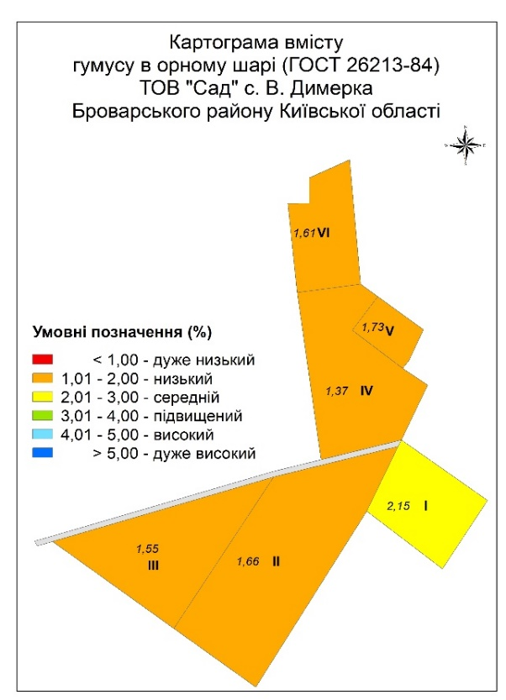
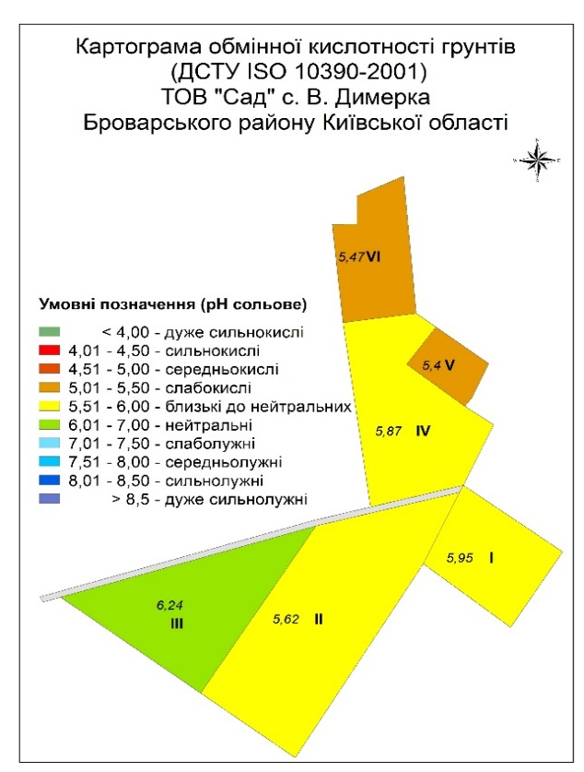
Pic.3. Agrochemical cartogram of humus and exchange acidity on the example of fields of LLC "SAD".
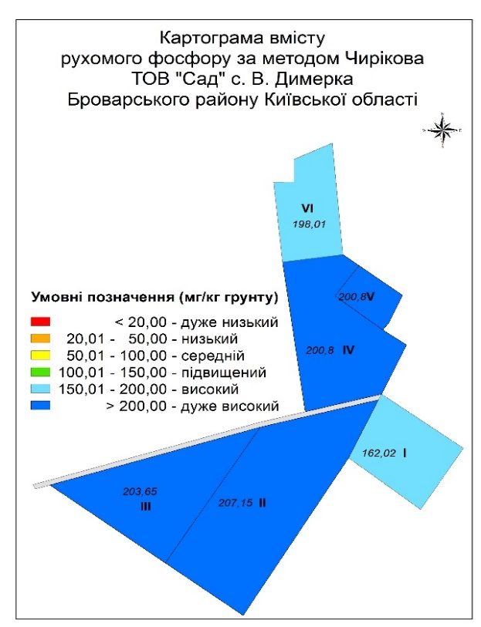
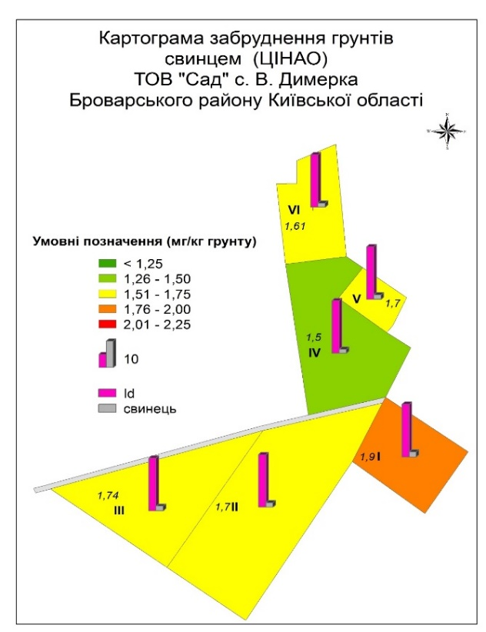
Pic.4. Agrochemical cartogram of mobile phosphorus and lead contamination on the example of fields of LLC "SAD".
However, changes in soil quality are related not only to crop production technologies but also to environmental factors such as temperature and precipitation. Comparative soil quality assessment is the process by which system productivity is determined according to alternative farming systems. Biotic and abiotic qualities of soil systems in all alternative farming systems are compared over time. This kind of comparison is useful for determining the impact of agricultural technology that has been in use for some period of time.
Agrochemical certification is the main informative source for the introduction of environmentally friendly land use. Thanks to prompt obtaining of qualitative indicators of soil condition, it becomes possible to prevent the depletion of land resources, which contributes to the expansion of enterprises engaged in growing organic crop production.
Organic farming is not considered an intensive agricultural production technology. Organic farming is a system of reducing energy input from outside to produce products that do not use synthetic chemicals. The main goal is to produce food without the use of potentially hazardous substances, and therefore relatively safe to eat.
The need to create a system of agricultural production that is both economically viable and environmentally sustainable is the reason for many studies on the impact of alternative tillage systems on its properties. A variety of agrotechnical approaches can be tested in field research and compared using conventional statistical analysis. Another possibility is to compare certain types of business over a period of time. Using this approach, we can estimate the condition of soils in organic and conventional farming systems, taking into account the impact of these systems on soil quality indicators.
Intensive organic farming technologies are carefully studied and selected to use for restoration and then to maintain ecological balance in and around the farm. The use of organic farming technologies is not yet a guarantee that products will be completely free from toxic substances. They can come from air, soil, water, other sources that the farmer cannot always control.
Today, GIS are an indispensable means of exploring tasks related to spatial-distributed information, including input and storage of source information, efficient processing of spatial data, visual and geostatistical analysis, and preparation of various source mapping and other documents [3].
The spatial approach provided by GIS enables the use of complex multidimensional and multicriteria models in the study of land-use processes and the assessment of the negative effects of anthropogenic impact.
Conclusions and Prospects. Modern agricultural technologies require constant monitoring of soil fertility and prompt monitoring of changes taking place over a wide range of parameters. Nowadays, agrochemical certification is one of the main types of differentiation of agricultural land suitable for ecologically safe land use. The interest of agricultural consumers and land users in the creation of a filled interactive soil map, which will include a complete database containing not only agrochemical soil indicators, crop rotation, but also methods of cultivation of soil cover, has been investigated.
ESRI has found a comprehensive approach to addressing the challenges of environmentally friendly land use. A database based on agrochemical certification in ArcGIS will provide full support for the technological chain of agrochemical data processing, starting with the introduction of these field observations, creating maps of various subjects and receiving the reporting documentation, as well as will serve as a basis for the organization of agricultural fertility monitoring data by region and region.
The prospect of further research is to develop a structure of geospatial database on the basis of ArcGIS, which will contain data on the location of the land, agrochemical soil indicators, field numbering, crop rotation, degree of soil contamination, suitability for growing ecologically safe products.

Referencеs
1. Methods of agrochemical certification of agricultural lands / Edited S.M. Rizhuk, M.V. Forest, D.M. Bentsarovsky – K., 2003. – P. 64.
2. Retrieved from URL : http://zakon1.rada. gov.ua/laws/show/858-15/page3
3. Retrieved from URL : http://razumkov.org.ua/ukr/files/category_journal/NSD124_ukr_1.pdf
4. Zatserkovnyi V. I. Analysis of the possibility of increasing the efficiency of agricultural production in the application of GIS in management tasks/ V. I. Zatserkovnyi, S. V. Kryvoberets // Visnyk CHDTU – Technical Sciences Series. - No. 3 (67). Chernihiv: CHDTU, 2013. – P. 174–183.
5. Modern directions of economic support of rational nature management in Ukraine/ [for science. ed. Acad. National Academy of Sciences of Ukraine, prof. M.A. Hvesika, Ph.D. of sciences, prof. S.O. Lizun; State Institution "Institute of Economics of Environmental Management and Sustainable Development of the National Academy of Sciences of Ukraine"]. - K.: State Institution of IEEMSD of NAS of Ukraine, 2013. 2013. – P. 64.
6. Socio-economic and environmental problems of land use and protection in the context of land reform: collection of scientific works. - Kharkiv: KNAU, 2003. – P. 55.

И. С. Кузьменко
ТЕОРЕТИЧЕСКИЕ ПРИНЦИПЫ ПРОВЕДЕНИЯ АГРОХИМИЧЕСКОЙ ПАСПОРТИЗАЦИИ ДЛЯ ЭКОЛОГОБЕЗОПАСНОГО ЗЕМЛЕПОЛЬЗОВАНИЯ
Аннотация: Земледелие является перспективным направлением для сельскохозяйственного производства, при условии экологобезопасного и рационального землепользования. Цель устойчивого управления земельными ресурсами - оптимизировать деятельность работников сельского хозяйства для улучшения экологической, экономической и социальной динамики развития аграрного сектора за счет сохранения и повышения качества почв и продуктов питания.
Развитие экологобезопасного землепользования за использование геоинформационных технологий возможен за счет создания логической базы, обеспечивающей информацией не только о состоянии земельных ресурсов, но и об основных причинах ухудшения качества агрохимических показателей. Из-за характера и сложности земельных вопросов, геоинформационные системы в виде информационных баз данных помогают решать вопросы управления землей и агроэкологическими зонами. В то же время, эта пространственная стратификация способствует включению фермеров и органов местного самоуправления в общий процесс совершенствования земледелия и экологического землеустройства.
Геоинформационные системы в проведении агрохимической паспортизации ориентированы на превентивное обслуживание, а не на реабилитацию, и обеспечивают внедрение методологии и подход к интеграции социально-экономической и биофизической информации, необходимой для улучшения стратегий экологобезопасного землепользования.
Новизна данного исследования заключается в совершенствовании процессов информационного обеспечения землевладельцев путем создания и наполнения базы регистрации сельскохозяйственных предприятий, занимающихся выращиванием органической продукции растениеводства.
Ключевые слова: экологическая безопасность, землеустройство, агроэкологические зоны, геоинформационные системы.

І. С. КУЗЬМЕНКО
ТЕОРЕТИЧНІ ЗАСАДИ ПРОВЕДЕННЯ АГРОХІМІЧНОЇ ПАСПОРТИЗАЦІЇ ДЛЯ ЕКОЛОГОБЕЗПЕЧНОГО ЗЕМЛЕКОРИСТУВАННЯ
Анотація: Землеробство є перспективним напрямком для сільськогосподарського виробництва, за умови екологічно безпечного та раціонального землекористування. Мета сталого управління земельними ресурсами - оптимізувати діяльність працівників сільського господарства для покращення екологічної, економічної та соціальної динаміки розвитку аграрного сектору за рахунок збереження та підвищення якості ґрунтів та продуктів споживання.
Розвиток екологічно безпечного землекористування за використання геоінформаційних технологій можливий за рахунок створення логічної бази, яка забезпечує інформацією не тільки про стан земельних ресурсів, а й про основні причини погіршення якості агрохімічних показників. Через характер та складність земельних питань, геоінформаційні системи у вигляді інформаційних баз даних допомагають вирішувати питання управління землею та агроекологічними зонами. У той же час, ця просторова стратифікація сприяє включенню фермерів та органів місцевого самоврядування у загальний процес вдосконалення землеробства та екологічного землеустрою.
Геоінформаційні системи в проведенні агрохімічної паспортизації орієнтовані на превентивне обслуговування, а не на реабілітацію, та забезпечують впровадження методології та підхід до інтеграції соціально-економічної та біофізичної інформації, необхідної для покращення стратегій екологобезпечного землекористування.
Новизна даного дослідження полягає у вдосконаленні процесів інформаційного забезпечення землевласників шляхом створення та наповнення бази реєстрації сільськогосподарських підприємств, що займаються вирощуванням органічної продукції рослинництва.
Ключові слова: екологобезпечність, землевпорядкування, агроекологічні зони, геоінформаційні системи.

