LAND RELATIONS MONITORING IN UKRAINE: STATUS AND PROSPECTS FOR DEVELOPMENT

Butenko E.,
National University of Life and Environmental Sciences of Ukraine
e-mail: evg_cat@ukr.net
Kononyuk A., student
National University of Life and Environmental Sciences of Ukraine
e-mail: kalabahasoul@gmail.com

Abstract. The article analyzes the prospects of development of land relations monitoring, principles of its functioning and tendencies on the basis of consciously selected indicators and scientifically sound methods. Reliable monitoring data is difficult to obtain in situations existing in different areas characterized by large areas and significant spatial and temporal characteristics. Proper use of these tools allows the information collected through monitoring activities to serve as a basis for assessing whether resource conditions are changing or not and whether these changes are desirable.
One of the main problems is considered - the closed access to the information on land relations, which allows against the national and local public interests, officials and related selfish intentions to use the land for their own interests. And this closure raises many problems.
Emphasized on the creation of an open, constantly updated database on land relations, which will become an integrated information network for monitoring entities, will provide a new level of transparency, local decision-making awareness. This will provide a new level of transparency in land relations and will focus on improving land use and creating the conditions for effective governance.
Keywords: Land monitoring, land relations, remote sensing, automation, database.

Formulation of the problem. The need for monitoring of land relations in Ukraine as a constantly updated information system is dictated by the fact that in our country all information about land relations is scattered, as it is collected and maintained by various agencies and local authorities as departmental information with limited access by other governmental institutions. organizations and individuals. To address major economic and social problems, such information is far from being fully utilized. However, social significance would be much more significant if all the available information on land relations were concentrated in one authority, were comparable and complementary. Therefore, the central authorities are not always able to find optimal solutions for improving the development of land relations, because of the scattered land information mentioned above.
The study identified major problems, one of which was the lack of information. First of all, these are high-quality planned mapping materials on land owned and used by enterprises and farms, late submission of information in a non-standard form, errors in the format of data submission, duplication of information. Also, data are not recorded or provided in the format of regular reports important for political decision-making. In particular, the land cadastre does not contain information on court decisions regarding specific land plots. Automating the monitoring process will overcome most of these issues in the future.
Analysis of recent research and publications. The content, procedure and features of the land monitoring are regulated by: the Law of Ukraine "On Land Protection", the Land Code of Ukraine, the Laws "On Environmental Protection", "On Land Management", "Regulations on Land Monitoring" and other regulatory legal acts [ 1,2,7,8].
Regarding the implementation of land relations monitoring, scientific researches are being conducted, which are shown in the works of L. Perovich, V. Kravtsov, A. Sohnych, P. Kulinich and others. In particular, legal aspects are revealed in the works of NR Malyshev, MI Erofeev, DV Busuyok, SV Sharapov and others. Despite the large number of scientific works on land monitoring in general, it remains under-researched.
The purpose of the study is to analyze the existing system of monitoring land relations in Ukraine and the prospects of its application in the effective management of land resources.
Results of the study and their discussion. Land relations monitoring is a system of mutual exchange of information between subjects of information interaction for the purpose of systematic collection, storage, generalization and disclosure of information on the status of land relations, that is, for the purpose of systematization and generalization of information on ownership, use and disposal of land plots. It is conducted at the level of districts and cities of regional subordination, cities of Kyiv and Sevastopol. The system covers a set of over 140 indicators and allows you to analyze the current state of land relations. The results of the monitoring can be used both when taking measures on this basis to eliminate identified deficiencies in the organization of land relations and their further improvement, as well as in the analysis and evaluation of the activities of the authorities and their officials in the field of land relations. Land relations monitoring plays a more important role than ever. The issues of land tenure and access to land are extremely politicized and contested [6].
The objectives of the monitoring are:
1) introduction of a system of exchange of information on land relations;
2) improving the quality of the provision of services in the field of land relations;
3) improving the quality of land management at all levels;
4) increasing the level of investment attractiveness of land resources and improving the business climate;
5) creation of an information base for the modernization of land relations.

Picture 1 – Main indicators of land relations monitoring

Accordingly, the program, in which systematic and generalized information on the ownership, use and disposal of land plots is - monitoring of land relations.
Principles of land relations monitoring:
- timeliness and complexity of receiving information
- objectivity of information
- prompt provision of information
- openness of results.

Picture 2 – Land Relations Monitoring Data Providers

Ukraine has become the first country in the world to approve, at the legislative level, such an innovative instrument as monitoring land relations. The following stages can be distinguished in the development of land relations monitoring in Ukraine: 1) an informal pilot phase (1916-1917) carried out on the initiative and with the support of the World Bank; 2) the official pilot stage (1917-1919), which is carried out on the basis of a by-law - resolution of the Cabinet of Ministers of Ukraine of August 23, 2017 No. 639 “On the implementation of a pilot project on monitoring land relations and amending some Cabinet decrees Ministers of Ukraine ”[3].
Implementation of a pilot project on monitoring land relations to ensure transparency of functioning in Ukraine will overcome these problems.
As a result, the system will provide the executive and local governments with relevant information and analytical materials, both at the state and territorial communities, on the prospects for the development of land relations, and will also serve as a basis for exploring the economic mechanism for regulating land relations. The monitoring will serve as the basis of governance in the field of land relations, will provide the ability to prevent negative changes, allow analysis and predict directions of reform. This will improve land relations both in the regions and in Ukraine as a whole. The experience of the pilot project has shown that there is a need for the following steps: development of automated reporting systems, responsible regulatory acts, ensuring that the results are made available in the open access and regularly updated.
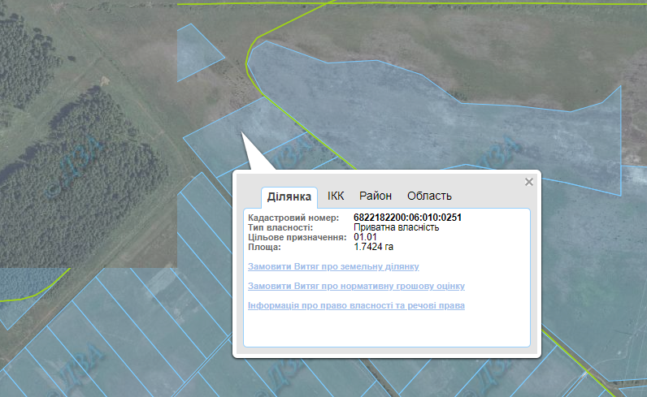
To investigate this problem, we give an example of the information provided on the Public Cadastral Map of Ukraine. In this database you can see information about a specific plot of land, cadastral number, purpose, purpose of ownership.
Picture 3 - Land plot information on the Public Cadastre Map

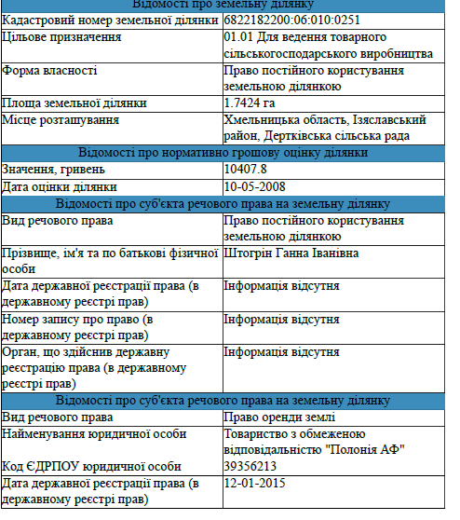
You can order an extract from the state land cadastre about a land plot or a certificate on the normative monetary valuation of a land plot through a web site, as well as view information about ownership rights and other property rights to a land plot. Including all information is provided free of charge.
Picture 4 - Information about property rights and other property rights to land

After analyzing, it was found that on the cadastral map it is possible to find information about the land plot without considering the characteristics of land relations. Therefore, the data on the movement of land relations, such as the transfer of land rights, the value of sales and lease agreements, the number of transactions, etc., are in the closed access. It should be noted that it is also important to account for information on the procedure for alienation of land through auctions, bidding, privatization, etc.
The presented research material indicates that the introduction of public access to information on land relations will allow timely provision of information, avoid duplication and mistakes, improve monitoring methods and create an effective national system. Improvement of the renewable database will improve the exchange of information between state registers, make it accessible to the public and increase the level of investment in the agricultural sector. Accordingly, unification in a single system of the whole spectrum of data on land relations will contribute to the reduction of corruption, as it will provide forecasting and modeling of the development of the situation in the land sphere and land legislation as a legal basis for the formation of land relations, as well as providing a factual basis for the analysis of the situation, identification of trends, problems. positions.
Conclusions.
Free access to data will make land relations transparent and controllable. Information on unclaimed units, known heritage, registration and use of public lands will be available. The land monitoring system will provide an opportunity to track the dynamics of changes in online mode that will occur with land use and land ownership, where taxes are processed or paid.
Undoubtedly, the monitoring alternative is to make the data not only open, but also to consolidate it into a single database with regular updates. This will, first of all, improve the quality of administrative services, fight corruption, raiding. As the fastest solution to this problem will help accelerate the market launch. In order to ensure the legal status of monitoring land relations as a permanent function of the authorities in the field of land resources management, it is advisable to adopt a special law that will give it the status of a separate function of the authorities in managing land resources.
The final step should be the creation of a single electronic data set open to external control, which allows tracking the dynamics of land relations.

References
- Zemelnyi kodeks Ukrainy [Land Code of Ukraine]. (2001, October 25). Vidomosti Verkhovnoi Rady Ukrainy – Bulletin of Verkhovna Rada of Ukraine. Kyiv: Parlam. vyd-vo [in Ukrainian].
- On approval of the Regulation on land monitoring: Resolution of the Cabinet of Ministers of Ukraine of August 20, 1993 No. 661 // Collection of government regulations of Ukraine. – 1994. - №1.
- Statystychnyi shchorichnyk «Monitorynh zemelnykh vidnosyn v Ukraini: 2016-2017» [Statistical Yearbook «Monitoring of Land Relations in Ukraine: 2016-2017»] - Retrieved from http://www.kse.org.ua/download.php?downloadid=1081.
- Perovych, L.M., Ludchak, O.Ye., Hulko, O.R. (2018) Analysis of the world experience of using space survey methods for agricultural land monitoring [paragraph] /"Modern achievements of geodetic science and production", a collection of scientific works of the Western Geodetic Society USGC.
- On approval of the Regulation on Soil Monitoring on Agricultural Lands: Resolution of the Cabinet of Ministers of Ukraine of December 26, 2003 No. 2041 // Collection of government regulations of Ukraine. – 2003.
- The order of implementation of the pilot project on monitoring of land relations: Resolution of the Cabinet of Ministers of Ukraine of August 23, 2017 No. 639 // Collection of government regulations of Ukraine. – 2017.
- Perovych, L.M., Vynarchyk, L.V., (2009). Kadastrovyi monitorynh zemel/ Land cadastral monitoring// Interdepartmental Scientific and Technical Collection "Geodesy, Cartography and Aerial Photography" - Lviv Polytechnic National University.
***
Бутенко Є.В., Кононюк А.В.
МОНІТОРИНГ ЗЕМЕЛЬНИХ ВІДНОСИН В УКРАЇНІ: СТАН І ПЕРСПЕКТИВИ РОЗВИТКУ

Анотація. У статті проаналізовано перспективи розвитку моніторингу земельних відносин, принципи його функціонування та тенденції на основі свідомо підібраних показників та науково обґрунтованих методів. Достовірні дані моніторингу важко отримати в ситуаціях, що існують у різних районах, для яких характерні великі площі та значні просторові та часові характеристики. Належне використання цих інструментів дозволяє інформації, зібраній за допомогою моніторингової діяльності, послужити основою для оцінки виявлення того, змінюються чи не змінюються умови ресурсів та чи бажані ці зміни.
Розглянуто одну з головних проблем – закритий доступ до відомостей про земельні відносини, що дозволяє всупереч національним та місцевим публічним інтересам, посадовцям та пов’язаним з ними спільними корисливими намірами особам використовувати землю у своїх інтересах. І ця закритість породжує багато проблем.
Наголошено на створенні відкритої, постійно обновлюваної бази даних, про земельні відносини, що стане інтегруючою інформаційною мережею для суб'єктів моніторингу, забезпечить новий рівень прозорості, усвідомленості прийняття рішень на місцевому рівні. Це забезпечить новий рівень прозорості в земельних відносинах і дозволить зосередити зусилля на поліпшенні використання земель і створення умов для ефективного управління.
Ключові слова: Моніторинг земель, земельні відносини, дистанційне зондування, автоматизація, база даних.
***
Бутенко Е.В., Кононюк А.В.
МОНИТОРИНГ ЗЕМЕЛЬНЫХ ОТНОШЕНИЙ В УКРАИНЕ: СОСТОЯНИЕ И ПЕРСПЕКТИВЫ РАЗВИТИЯ

Аннотация. В статье проанализированы перспективы развития мониторинга земельных отношений, принципы его функционирования и тенденции на основе сознательно подобранных показателей и научно обоснованных методов. Достоверные данные мониторинга трудно получить в ситуациях, существующих в различных районах, для которых характерны большие площади и значительные пространственные и временные характеристики. Правильное использование этих инструментов позволяет информации, собранной с помощью мониторинговой деятельности, послужить основой для оценки выявления того, изменяются или не изменяются условия ресурсов и или желаемые эти изменения.
Рассмотрены одну из главных проблем - закрыт доступ к сведениям о земельных отношениях, что позволяет вопреки национальным и местным публичным интересам, должностным лицам и связанным с ними общими корыстными намерениями лицам использовать землю в своих интересах. И эта закрытость порождает много проблем.
Отмечено создании открытой, постоянно обновляемой базы данных, о земельных отношениях, который станет интегрирующей информационной сетью для субъектов мониторинга, обеспечит новый уровень прозрачности, осознанности принятия решений на местном уровне. Это обеспечит новый уровень прозрачности в земельных отношениях и позволит сосредоточить усилия на улучшении использования земель и создание условий для эффективного управления.
Ключевые слова: Мониторинг земель, земельные отношения, дистанционное зондирование, автоматизация, база данных.

