DEVELOPMENT OF A GEOSPATIAL DATABASE FOR THE ESTABLISHMENT OF RESTRICTIONS AND ENCUMBRANCES ON LAND RIGHTS WITHIN SETTLEMENTS
A. Moskalenko, PhD
National University of Life and Environmental Sciences of Ukraine
E-mail: Moskalenko_a@nubip.edu.ua
Yu. Dikun, technician in land management
LLC "TERRATOP"
E-mail: dikun.yulia@gmail.com

The possibilities of building an information structure that can provide systematization and accumulation of spatial and attributive data to solve problems of spatial-temporal analysis and support the solution of the problem of simplifying the establishment of limits and encumbrances on land rights have been shown in the research.
A general algorithm for establishing restrictions and encumbrances on land rights through a functional model was structured in the article.
As a result of the research, a model of the geospatial database was developed as the main component of geoinformation support for the establishment of restrictions and encumbrances on land rights within settlements, which can solve spatial and temporal analysis and support the problem of simplifying the establishment of restrictions and encumbrances on land rights.
The results of the research can be used in the process of developing master plans of cities and in the process of forming spatial decisions on land use.
Keywords: geospatial database, restriction of rights, encumbrance of rights.

Introduction. The formation of the Land-Use System is significantly influenced by the characteristics of the legal regime of land plots. Such characteristics include restrictions on land use and encumbrance of land rights [1]. Their establishment requires the processing of a large amount of data on the land, both spatial and attributive, as well as their changes over time. So, to provide adequate information support for decision-making on the establishment of restrictions and encumbrances on land rights, it is necessary to develop an information structure that can provide solutions to spatial-temporal analysis and can support the solution of simplification of restrictions and encumbrances.
An important role in the development of information support for the establishment of restrictions and encumbrances on land rights is played by geographic information systems, which are a powerful tool for collecting, modelling, geospatial analysis and building spatial solutions.
Analysis of recent researches and publications. Analysis of recent researches and publications. The development of a problem of restrictions and encumbrances on land rights have been discovered in works Ukrainian scientists as D.I. Babmindra, D.V. Busuiok, D.S. Dobriak, O.S. Dorosh, A.V. Malko, A.H. Martin, E.O. Milchurin, I.V. Mirinenko, A.М. Tretiak and others. Among foreign scientists, research in this direction was done by such scientists as D.V. Antropov, V.V. Butariova, P.P. Lebediev, P.A. Lepiokhin, O.N. Lepioshnika and others. The works [2] developed a classification of territorial restrictions on land use by type, of which there are five. And the types are divided into subtypes for the full characteristic of restrictions. The article [3] showed the features of the process of forming restrictions on land use.
The problems of the application of geoinformation technologies in the field of land management have been considered in works [4-6]. In the article [4] the author considers the issue of building models of information assessment of land quality. The research [5] presents the features of geographic information support of land information system. In the study [6] the authors determined the principles of organization of geospatial data for registration in cadastral systems of land use restrictions and developed a conceptual database model to implement geoinformation technology of production and registration in the State Land Cadastre system of profile sets of geospatial data restriction areas.
However, the research of scientists concerns some problems of geographic information support in the field of land management only, while the issue of establishing restrictions and encumbrances requires a comprehensive approach. Whereas, an effective geodatabase will provide an opportunity to generate information about land plots and their legal status.
Thus, solving the problem of developing a geodatabase to establish restrictions and encumbrances on land rights within settlements is relevant.
The purpose of the study is to substantiate the main components of the geospatial database of restrictions and encumbrances on land rights within settlements.
Research methodology. To achieve the goal of the study, a model of the geospatial database of establishing restrictions and encumbrances on land rights within settlements has been developed and substantiated. The model was developed using a unified UML modelling language. Geoimages are constructed using modelling tools such as layering operations.
Presentation of the main research material. Analysis of recent research and publications has shown that when establishing restrictions and encumbrances on land rights within settlements, it is necessary to process not only objects which forming mode and zones around them, but also land plots with allocation of a part on which restrictions and encumbrances are established.
This study developed a model of a geospatial database of restrictions and encumbrances on land rights within settlements. It takes into account not only the objects which forming mode and restrictions around them, but also data on land plots subject whom these restrictions and encumbrances concern, and owners/users of these land plots (Fig. 1).
In the developed model, the Land Parcel class is the main target class of geoinformation support for which restrictions and encumbrances on land rights are established within settlements. The part of the land plot for which the special mode of use is established is given through the Elementary Plot class. The Land Parcel class is associated with the Owner/User class, which specifies the owner or user of the land plot, and the Ownership class, which describes the type of ownership.
The classes that are most fully responsible for the formation of geoinformation support for restrictions and encumbrances on land rights are the Restriction and Encumbrance classes. Classification of restrictions and encumbrances was carried out in accordance with the Procedure for maintaining the State Land Cadastre approved by the Resolution of the Cabinet of Ministers № 1051 of 17.10.2012 - Annex 6 [7].
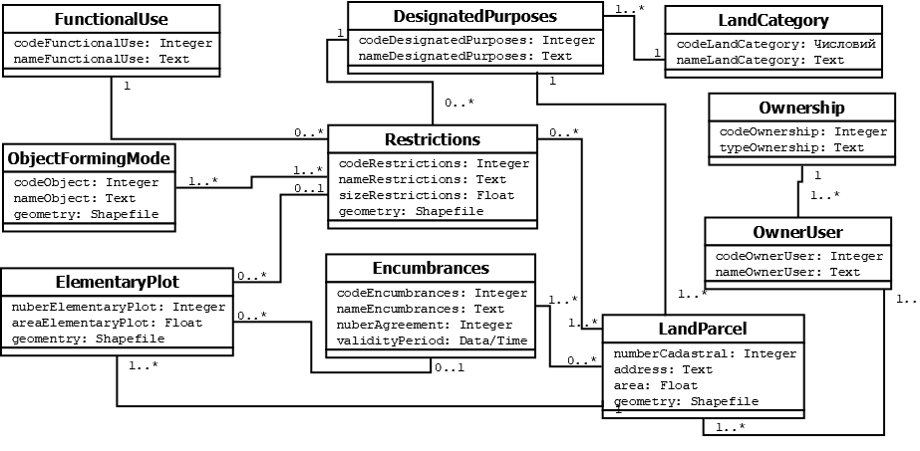
Fig.1. Logical model of geodatabase for the establishment of restrictions and encumbrances on land rights within settlements

The objects which forming mode class is defined to indicate the objects that create the conditions for the existence of restrictions around them. Class Functional Use will take into account the urban prospects of functional and planning development of the settlement. According to asset 19 of the Land Code of Ukraine, the land of Ukraine according to the main purpose is divided into categories, which are presented in the model by the class Category Land. Within the category of lands, lands of different designated purposes allocated, which are submitted through the class Designated Purposes.
The general scheme of the algorithm for setting restrictions using data in the geodatabase is given in Fig. 2.
The statement of the problem includes the definition of the settlement. The next stage is the collection of information about mode-forming objects, which fills the database of geospatial data. The geospatial database will contain various types of spatial and attributive information about land plots belonging to the settlement, as well as data on factors and factors influencing them.
The statement of the problem
Land plots that are not subject to restrictions
Creating thematic maps of the study area
Decision support
The collection of information
Conducting spatial analysis
Land plots that are subject to restrictions
the impact of targeted use
the impact of mode of use
the impact of environmental requirements
the impact of land easements and sanitary
existing restrictions?
display of existing restrictions
display of design constraints
Yes
No
Filling the geodatabase
Fig. 2. Functional model for establishing restrictions on land rights

The next stage involves identifying areas affected by restrictions, among which the following groups are identified: the impact of targeted use, mode of use, land easements and sanitary, environmental requirements, which in turn are divided into existing and design. At the next stage, spatial analysis is carried out and a thematic map is built, taking into account norms and standards (fig 3). The final stage is decision-making on land use.
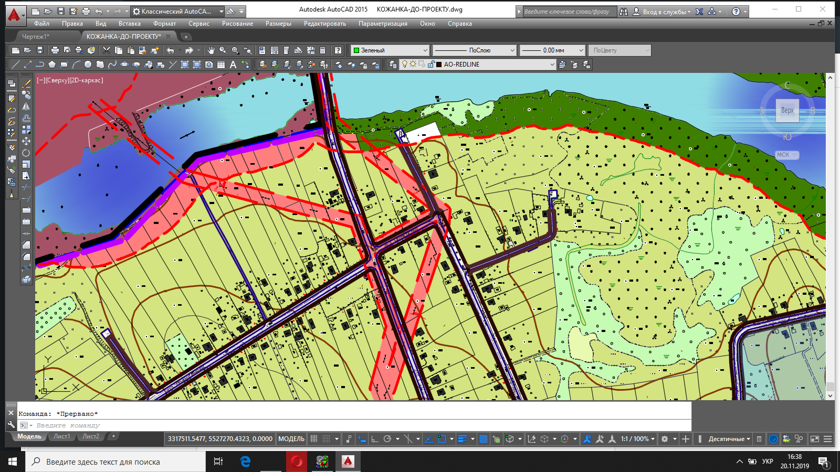
Fig. 3. A fragment of the protective zone of the transmission line

The final stage of establishing restrictions is decision-making on land use. At this stage, it is necessary to take into account not only the regulatory component (laws, regulations, state building codes and others), but also factors that increase or decrease the impact of regime-forming objects and affect the quality of life. Such factors include: steepness and exposure of slopes, soil type, the presence of vegetation, the use in the production of filters with a high degree of purification, and so on. They can be divided into two groups: anthropogenic and natural. Thus, when establishing the sanitary protection zone of railways, the available protection against noise should be taken into account [8]: anthropogenic origin - artificial noise shields and natural origin - noise protection greenery and properties of relief elements (hills, ravines). Thus, the geospatial database should contain a library of standards, a catalog of additional factors of influence, which is structured in the model of the knowledge base (Fig. 4). This component should be integrated into the geospatial database of the establishment of restrictions and encumbrances on land rights within settlements.
In order to effectively take into account additional factors when setting restrictions, it is necessary to systematize all regulatory documents in the knowledge base and develop limits on the variation of the size of restrictions in the classifier of restrictions and encumbrances on land rights.
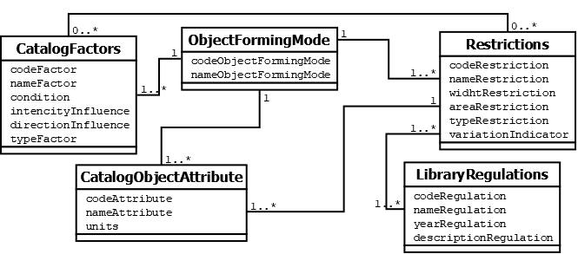
Fig 4. Knowledge base model

Conclusions. The study developed a model of a database of geospatial data for the establishment of restrictions and encumbrances on land rights within settlements. The model takes into account not only normative documents and objects which forming mode for establishing restrictions and encumbrances on land rights within settlements, but also additional factors that affect the size of restrictions and/or comfort of the population.
The results of the study can be used in the process of developing master plans of cities and in the formation of spatial decisions on land use.
The prospect of further research is to develop and automate an algorithm for calculating the impact of additional factors on the regulation of the size of the restrictions around the objects which forming mode within the settlements.
Список літератури
1. Земельний кодекс України // ВВР. – 2002. – № 3- 4, ст. 27. URL: https://zakon.rada.gov.ua/laws/show/2768-14#Text
2. Дорош Й. М. Проблемні аспекти розроблення проектів землеустрою щодо встановлення меж обмежень у використанні земель та їх режимоутворюючих об’єктів / Й. М. Дорош, І. П. Купріянчик // Землеустрій, кадастр і моніторинг земель. 2016. № 4. С. 11-18
3. Третяк А. М. Особливості методологічного процесу формування обмежень у використанні земель і земельних ділянок / А. М. Третяк, Й. М. Дорош // Землеустрій, кадастр і моніторинг земель. 2017. № 2. С. 13-19.
4. Кузнєцов М. О. Інформаційні технології в галузі землевпорядкування /М. О. Кузнєцов // Містобудування та територіальне планування. 2017. Вип. 65. С. 274-282.
5. Таратула Р. Б. Особливості геоінформаційного забезпечення земельно-інформаційної системи. Збалансоване природокористування. 2017. № 2. С. 118-123.
6. Лященко А. Концептуальні засади геоінформаційного моделювання Зон обмежень та їх реєстрації у земельному і містобудівному кадастрах /А. Лященко, Ю. Кравченко, Д. Горковчук // Cучасні досягнення геодезичної науки та виробництва, випуск ІІ (30), 2015. – С. 61-68.
7. Закон України. Про затвердження Порядку ведення Державного земельного кадастру (додатки 2-57 до Порядку). URL: http://zakon3.rada.gov.ua/laws/show/1051-2012-п/
8. ДБН В.1.1-31:2013 «Захист територій, будинків і споруд від шуму» URL: https://www.acoustic.ua/img/pdfs/pdffile_131.pdf
References
1. Land Code of Ukraine (2002) Information of the Supreme Soviet, №3-4, 27. Available at: https://zakon.rada.gov.ua/laws/show/2768-14#Text
2. Dorosh Y., Kupriyanchyk I. (2016) Problemni aspekty rozroblennya proektiv zemleustroyu shchodo vstanovlennya mezh obmezhenʹ u vykorystanni zemelʹ ta yikh rezhymoutvoryuyuchykh obʺyektiv [Problem aspects of development of land management projects to establish the limits of restrictions on land use and their regime-forming objects] // Zemleustriy, kadastr i monitorynh zemel, 4, 11-18
3. Tretyak A., Dorosh Y. (2017) Osoblyvosti metodolohichnoho protsesu formuvannya obmezhenʹ u vykorystanni zemelʹ i zemelʹnykh dilyanok [Peculiarities of the methodological process of formation of restrictions in the use of land and land plots] Zemleustriy, kadastr i monitorynh zemel, 2, 13-19.
4. Kuznyetsov M. (2017) Informatsiyni tekhnolohiyi v haluzi zemlevporyadkuvannya [Information technologies in the field of land management] Mistobuduvannya ta terytorialʹne planuvannya, 65, 274-282.
5. Taratula R. (2017) Osoblyvosti heoinformatsiynoho zabezpechennya zemelʹno-informatsiynoyi systemy [Features of geoinformation support of land information system] Zbalansovane pryrodokorystuvannya, 2, 118-123.
6. Lyashchenko A., Kravchenko YU., Horkovchuk D. (2015) Kontseptualʹni zasady heoinformatsiynoho modelyuvannya Zon obmezhenʹ ta yikh reyestratsiyi u zemelʹnomu i mistobudivnomu kadastrakh [Conceptual principles of geoinformation modeling of Restriction Zones and their registration in land and urban cadastres] Cuchasni dosyahnennya heodezychnoyi nauky ta vyrobnytstva, II (30), 61-68.
7. Zakon Ukrayiny. Pro zatverdzhennya Poryadku vedennya Derzhavnoho zemelʹnoho kadastru [Law of Ukraine. On approval of the Procedure for maintaining the State Land Cadastre]. Available at: http://zakon3.rada.gov.ua/laws/show/1051-2012-п/
8. DBN B.1.1-31: 2013 " Zakhyst terytoriy, budynkiv i sporud vid shumu " [Protection of territories, buildings and structures from noise] /Available at: https://www.acoustic.ua/img/pdfs/pdffile_131.pdf
Москаленко А. А., Дікун Ю. В.
Розроблення бази геопросторових даних встановлення обмежень та обтяжень прав на землю в межах населених пунктів
У дослідженні відображення можливості побудови інформаційної структури, яка здатна забезпечити систематизування та накопичення просторових та атрибутивних даних з метою вирішення задач просторово-часового аналізу та підтримати вирішення задачі спрощення встановлення меж обмежень та обтяжень прав на земельну ділянку.
У статті було структуровано загальний алгоритм встановлення обмежень та обтяжень прав на землю через функціональну модель.
В результаті дослідження було розроблено модель бази геопросторових даних, як основної складової геоінформаційного забезпечення встановлення обмежень та обтяжень прав на землю в межах населених пунктів, що здатна забезпечити вирішення задач просторово-часового аналізу та підтримати вирішення задачі спрощення встановлення меж обмежень та обтяжень прав на земельні ділянки.
Результати дослідження можуть бути використані у процесі розроблення генеральних планів міст та в процесі формування просторових рішень щодо використання земельних ділянок.
Ключові слова: база геопросторових даних, обмеження прав, обтяження прав.
Москаленко А. А., Дикун Ю. В.
РАЗРАБОТКА БАЗЫ ГЕОПРОСТРАНСТВЕННЫХ ДАННЫХ УСТАНОВЛЕНИЯ ОГРАНИЧЕНИЙ И ОБРЕМЕНЕНИЙ ПРАВ НА ЗЕМЛЮ В ПРЕДЕЛАХ НАСЕЛЕННЫХ ПУНКТОВ
В исследовании отображены возможности построения информационной структуры, которая способна обеспечить систематизацию и накопление пространственных и атрибутивных данных для решения задач пространственно-временного анализа и поддержать решения задачи упрощения установки границ ограничений и обременений прав на земельный участок.
В статье было структурировано общий алгоритм установления ограничений и обременений прав на землю через функциональную модель.
В результате исследования была разработана модель базы геопространственных данных, как основной составляющей геоинформационного обеспечения установления ограничений и обременений прав на землю в пределах населенных пунктов. База способна обеспечить решение задач пространственно-временного анализа и поддержать решения задачи упрощения установки границ ограничений и обременений прав на земельные участки.
Результаты исследования могут быть использованы в процессе разработки генеральных планов городов и в процессе формирования пространственных решений по использованию земельных участков.
Ключевые слова: база геопространственных данных, ограничения прав, обременения прав.

