UDK 332.14
URBANIZATION: DEFINITION, COMPONENTS, AND CLASSIFICATION IN CONTEXT OF LAND AND ECONOMICS SCIENCES
V. Nazarenko, graduate student, National University of Life and Environmental Sciences of Ukraine
nazarenko.vladymyr@gmail.com

Abstract. Any prominent research relies on terminology, methodology, and data. Urbanization research is being one of such fields that lacks in general term definition, process components, and key data metrics. This paper approaches urbanization from the broader context of land and economic sciences, with a focus on the theoretical framework and practical use of data classification. International organizations, official government bodies, and private research institutions have different views on urbanization, rely on various methods for statics research and data classification. In this paper we overviewed the term from several angles, such as land use and settlements area, population dynamics and regional economics, agriculture and resources use, followed by sustainable development in the context of urban development plans and policies. The proposed conceptual model of urbanization inland and economics science context determined urbanization as both state and ongoing process. As a result of research work, urbanization process and state key data and research metrics were presented and categorized by fields of application and research subfield category. The important section of the urbanization definition is a robust multistage research framework. We believe that it can help other researchers, as well as the author, look like urban growth, history, and development prospects with less bias and with a focus on long-term vision, multidisciplinary approach.
Keywords. urbanization, urban economics, land science, land use, legislation.
Topicality. In this article we aim to answer the following questions, what is the correct definition of the city, how are modern cities different from old ones, how can we differentiate between urban, suburban, and rural areas. Many factors make this distinction unclear, among them are social and political, economic, and governmental regulatory acts. It is vital to classify the main factors that made urbanization possible in the past and that catalyze urbanization expansion. To classify cities and the urbanization process, we should understand why settlements were built on specific locations, what are the modern determinants of new settlements' expansion and construction. One of the hypotheses on why the urbanization process is going is population shift towards large urban centers, metropolises. In past decades, this migration rate has increased and, in the future, this shift will be tremendous - in some countries, this is already happening and inevitable, while others will show a huge leap in the next ten to fifteen years. However, there is no single model that describes what is urbanisation, contributing factors, and why some cities are being built and developed more than others - what are the major determining factors. Our initial assumption is that transports, communications, and ecological ecosystems are key components of urban development. In this paper, we propose a framework model for urbanization definition in the context of land and economic sciences.
Analysis of recent research and publications. An urban area is defined by one or more of the following data: administrative criteria or political boundaries (e.g., area within the jurisdiction of a municipality or town committee), a threshold population size (where the minimum for an urban settlement is typically in the region of 2,000 people, although this varies globally between 200 and 50,000), population density, economic function (e.g., where a significant majority of the population is not primarily engaged in agriculture, or where there is surplus employment) or the presence of urban characteristics (e.g., paved streets, electric lighting, sewerage) [1, 2]. In 2010, 3.5 billion people lived in areas classified as urban [1]. Urbanization is the quality or state of being urbanized or the process of becoming urbanized [1]. It can be classified as a process where people move from the country (rural areas) to densely populated, large settlements. The most urbanized areas are the United States, European countries, India, Brazil, and East Asian countries, such as China, according to UNN 2014 report [1]. There is a common misconception that most of the urban population live in Megacity central district, while in a majority of heavily urbanized countries, a large part of the population resides in smaller suburban towns and settlements [1]. There is no standard definition that denotes that is an urban area or an urban population, how it differs from suburban or neighbouring rural settlements [2]. Most, if not all, counties have their definition of city and urban settlements. As a result, statistical data often can be misleading or misinterpreted due to this. Based on the above-mentioned facts, it is difficult to have a real view of the percentage of urbanized population and settlements, without first establishing urbanization terminology and providing its definition.
The aim of the study. There is no single definition of urbanization as a state or as a process. This research aims to determine the main components of urbanization, as well as provide the classification of economical and land use aspects of this process, state. We will be reviewing how urbanization is defined by international organizations such as FAO, UNN, and UNESCO, as well as overview what is urban definition in selected heavily urbanized countries.
Materials and methods of research. The problem is how we classify urban center, what properties should it have and what areas to include/exclude. Urbanization in a broader context can be defined by – official city limits, industrial and agricultural business placement and size, population size, and density. International organizations provide broader systems urban classifications with a focus on economic, social, and land use aspects of it. City development is based on spatial development axis, transport infrastructure and road cover, natural and food resources centers, and local community clusters. Some cities can be classified not national but international cities, for instance, a large metropolis in European Union, such as Paris or Berlin, London in the United Kingdom, or Hong Kong. Special attention should be given to how we classify future cities and newly developed urban clusters, for instance in Africa or Latin America, as they have their own rules and special context of development. In Figures 1 and 2 the author provides urbanization classification with a focus on land use (Figure 1) and economic aspects (Figure 2).
Fig.1 Urbanization, land sciences context [1-15]
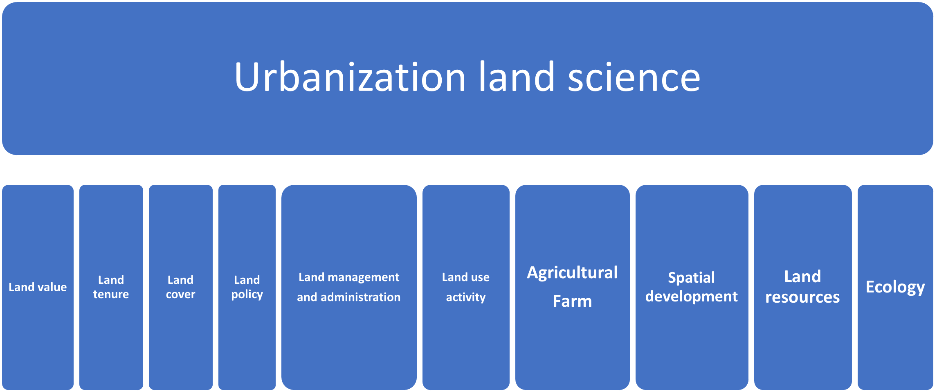
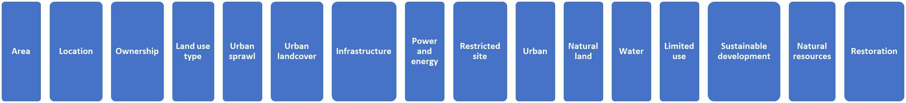
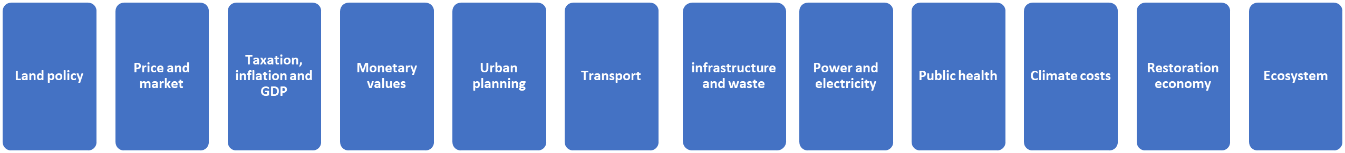
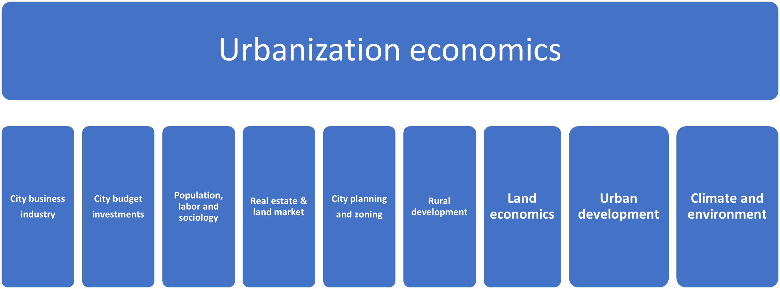
Fig.2 Urbanization, economics sciences context [1-15]
The core data that has been gathered, processed, and used in this research is provided in Table 1. Table 1 presents structured information on urbanization terminology and its components, ordered by organization and country, key components of this definition as well as research subfields that this definition is based on, revolves around.
Table 1. Urbanization terminology definition and components *
Terminology | Sciences  Subfields of research | Organization  Country | Description  Components
Urbanization | Economics and Social data | United Nations | Urban size and population dynamics  Urban growth and city boundaries  Ecological consequences
Sustainable Urbanization | Ecology  Sustainability Environment | United Nations | Economic, financial, and social aspects of cities sustainable development
Sustainable cities | Ecology  Sustainability  Architecture | UNESCO | Smart city  Architectural heritage and historical sites  Sustainable development plan
Impact of Urbanization | Agriculture  Policy and governance  Green cities | FAO | Rural economic development planning and policy  Food and social effects of urbanization  Green city planning and policy
Cities and urbanization | Governance  Legislation  Climate and natural resources management | World Economic Forum | Social and political aspects of city management  Urban governance and economic planning  Financial, investments and ecology economic planning and policy
Urban development | Economic growth  Sustainability  Spatial development | World Bank | Urban population and dynamics  Sustainable city development plan  Urban economics, growth, and city planning
Urban Agriculture | Agriculture  Land use  Policy and governance | American Planning Association,  US | Green space  Economic development of suburban and rural areas  Local policies and governance  Urban farming and food supply planning
Urbanization | Sociology  Economic development | Britannica,  US | Settlement classification  Urban economics definition  Urban land area size
Urbanization | Term definition | Merriam-Webster,  US | Urbanization history  Urbanization state definition
Urban land area | Land use and development  Geography | Our World in Data,  UK | Urban land area size and dynamics  Population density and statistics  Urban to rural population mapping
Urban definition | Population and social studies  Term definition | Population Reference Bureau,  US | Regional and international settlement classification  Population statistics and prospects
Urbanization | Economic and Social development | Policy Research Institute, Ministry of Finance,  Japan | Population growth and dynamics  Urban centralization and decentralization  GDP and employment statistics, planning
Urban living | Population and social studies  Governance | Deutschland.de, Germany | Urban to rural population statistics  Living conditions and economic equality
The Urban Informal Economy | Sociology  Economic development  Urban Planning | Urbanet,  Germany | Urban Planning  Land Allocation  Small business economic plans  Waste management  Future planning and policies
Big city | Economics and Social data  Political studies | The National Institute for Strategic Studies,  Ukraine | Political, economic, and social aspects of city, definition focused.  Infrastructure development and city long term planning
General scheme of planning of the territory of Ukraine | Spatial development  Urban Planning  Real estate economics | City 2030,  Ukraine | Housing stock dynamics and planning  Mortgage policies and regulations  Real estate financial statistics
Agglomeration processes | Term definition  Policy and governance | Decentralization governmental website,  Ukraine | Capital agglomeration definition and legal regulations  National centralization and decentralization city-related policies  Settlement administrative division
* prepared based on personal research data and data from various sources[1-15]
Research results and their discussion. There is a persistent number of cases with a certain number of large cities when their actual area, size is larger than officially noted. In this context, it is important to understand how cities' areas are defined now in terms of official classification, terminology, and labels. In this paper we analyzed factors that present the modern definition of urban center - city and based on it we constructed key metrics data to help us in the task of urban area classification. One of the major determinants of modern city definition is urban population, population density, urban area boundaries. It should be noted that there are many ways to label a specific settlement as an urban area and the general concept of city limits is quite vaguely outlined. If we look at the United States definition, then urban area and city are similar terms, while metropolitan area is a different type of settlement. Generally speaking, the settlement is classified as flowing areas - city, suburban area, town, and rural area. While each individual is type is divided based on settlement population size and proximity to large, densely populated areas. Meanwhile, there is a common denominator in the international official definition of the cities. If we analyze them, we can divide settlements into two broader categories - urban and rural areas. What differs is the definition and specifics map outline of city boundaries. The next step would be to research how cities were formed and study their history from several angles, including different cases of when two or more cities were joined together or when several industrial discitis were connected to form a production cluster that later grew into a municipality. However, such research work goes beyond the scope of present research and can potentially be studied in the future.
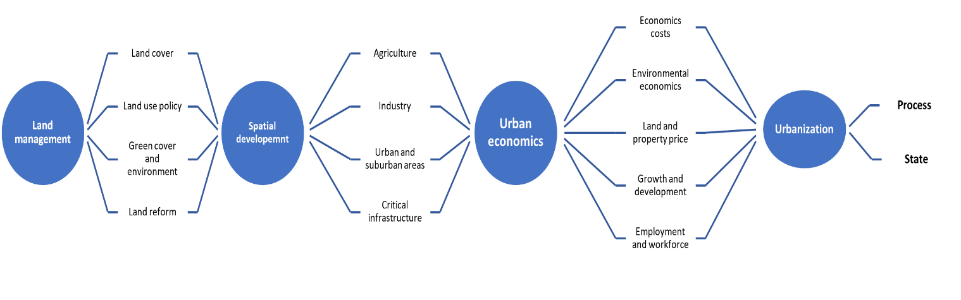
Fig.3 Urbanization classification conceptual model in the context of land and economics sciences
To help us identify and provide a clear definition of urbanization we focused on preparing a conceptual model in the research context of land and economic sciences. Figure 3 presents such a concept model, which denotes three subfields of urbanization – land management, spatial development, and urban economics. The resulting output of the presented model is urbanization generalized definition as both process and state.
Table 2. Urbanization key data and metrics*
Category | Components | Data  (type) | Application subareas
Economic development | Municipal budget and planning  Investment and taxation  Industry and agriculture  Real estate and land market | Taxation rate  Property tax  GDP  Inflation rate  Investments by sector  Interest rate  Property price  Property supply  Market and pricing | Urban and suburban development planning  Economic policy and municipal/governmental regulations  Economic policies of industry and agriculture
Population and sociology | Public health  Employment  Demographics  Living and housing | Urban, rural, and suburban statistics  Growth dynamics/change  Households’ data  Locality distribution  Property and financial statistics | Equality and living conditions improvement policy  Financial regulations
Geography | Landscape topology  Natural resources | Land cover  Topography  Areas and zoning | Settlement land area statistics, planning, and spatial development planning  Natural resources use planning and regulations policies
Land use and spatial planning | Urban  Suburban  Rural  Infrastructure and power grid  Industry and agriculture | Location  Area size  Dimensions  Use case/type  Total area/length  Resource mapping  Zoning and ownership | Settlement long term building plan  Smart city management  Settlement zoning and land use policies, planning
Ecology | Green cover  Water resources  Waste and landfills  Technology and power  Emissions and hazards  Healthy ecosystem  Effective natural resources management  Water management | Green energy costs  Saving and adaptation costs  Restoration costs  Land-use change costs  Environment taxation | Green cities plan  Power and ecology financial regulations  Sustainable settlement development program and policy
Policy and governance | Terminology  Land use and property rights  Municipal and local governance | Planning policy  State definition  Use rules and regulation  Taxation, interest rate, and market regulation | Cities centralization and decentralization regulations and policies  Urban, rural and suburban policy
* prepared based on personal research data
A list of major data types and field components of urbanization is presented in Table 2. The research results are classified based on six general research categories, that are derived from Figures 1, 2 and 3, and Table 1 data. The important section of Table 2 is the Application column. It represents subareas of urbanization research and practical application areas. The majority of the data in Table 2 is economic, financial costs, or regulations centered. This data can be used in further research of urban processes-related topics. It should be noted that some researchers and official publications exclude or do not pay enough attention to ecological and sustainable development subcomponents of urbanization. We addressed this issue and added the ecology category to the table as well as sustainability-related data in several adjacent categories’ fields.
In this scientific work, we determined a framework that defines urbanization as both state and process. This four stages framework is divided into two sections and is presented in Figure 4.
Fig.4 Urbanization definition framework
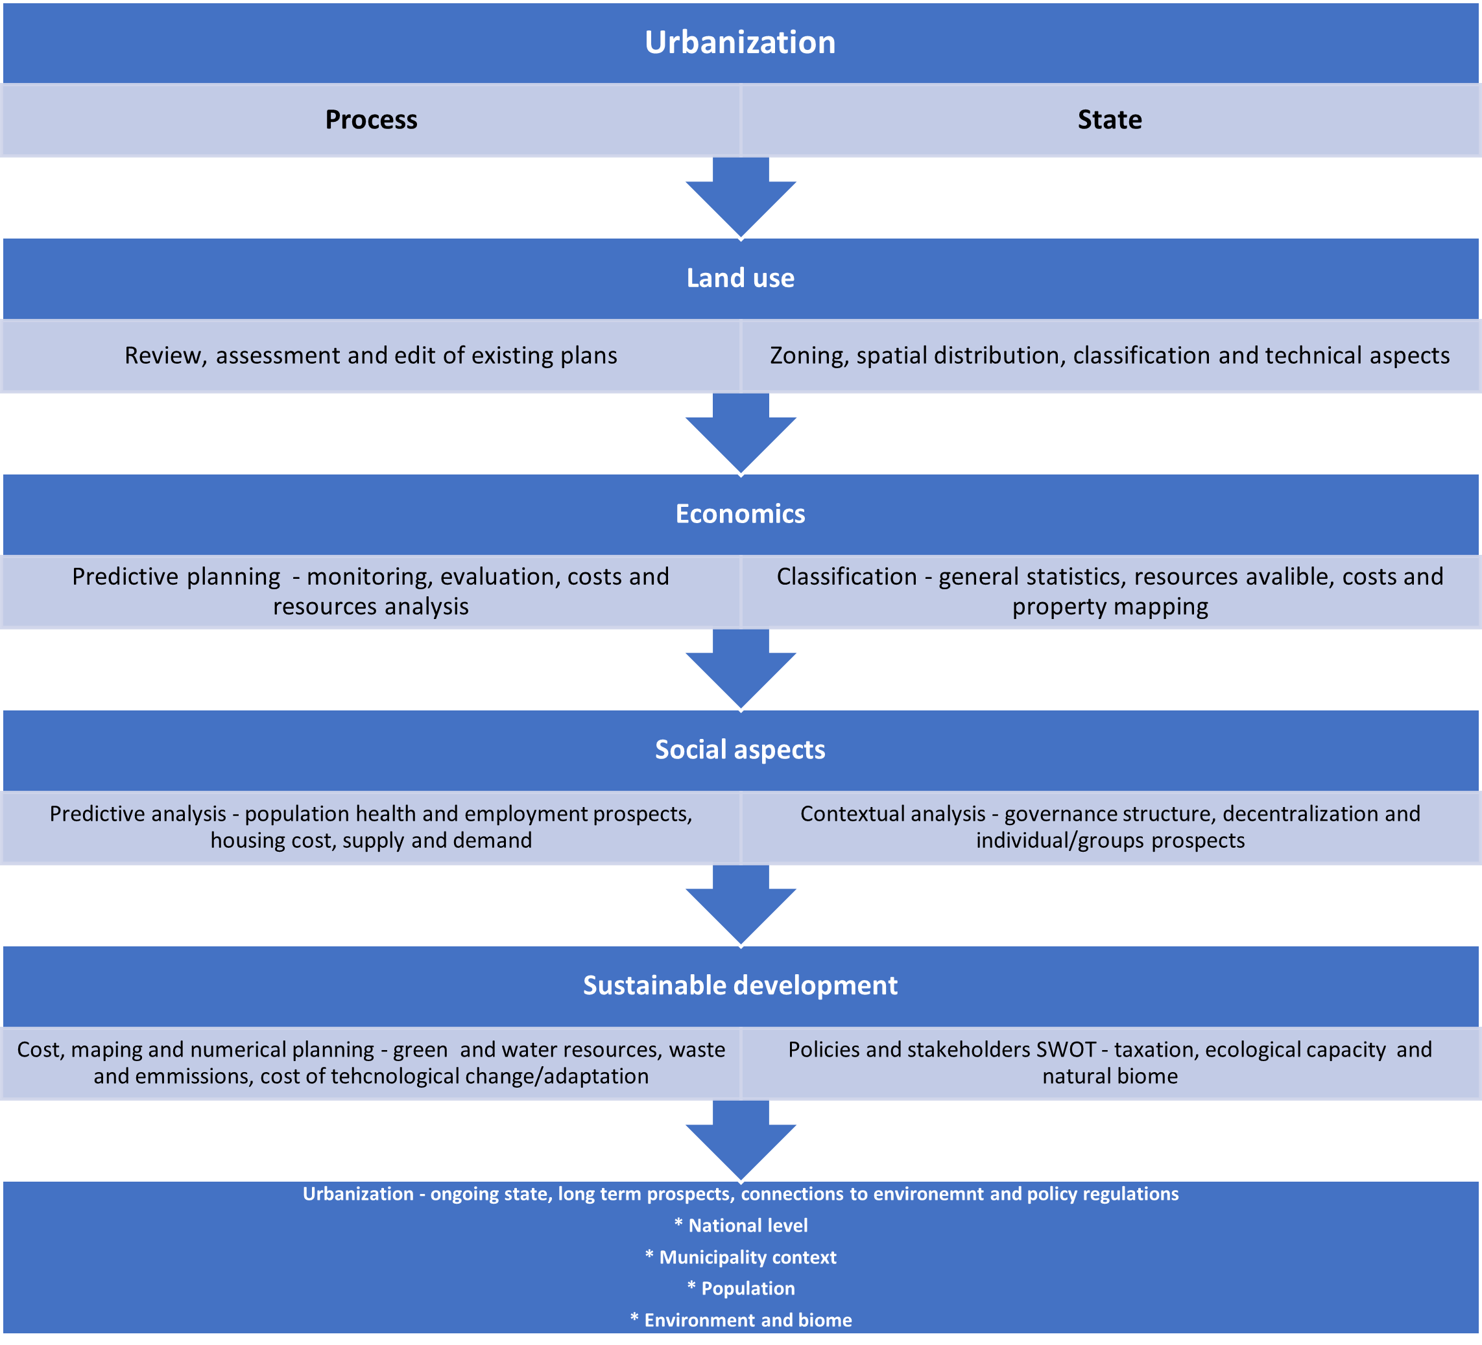
Conclusions and prospects. In this paper, we defined urbanization as both process and a state that exists in the intersection of many disciplines and fields of research, as well as international policies and acts. Urbanization in a broader context touches land use, economics, social aspects, affecting sustainable development plans and has a deep ecological impact, footprint. This process should not be looked at only on the municipal level but on national and international levels. We hope that the classification, definition, and framework that has been provided in this article will be useful for economics and land management scientist worldwide, help policymakers and intentional nonprofit organizations leaders. The author plans to continue the work on the urbanization framework from the broader context of city planning, land use mapping, and city management.
References
1. United Nations Department of Economic and Social Affairs. Population Urbanization study. Available at: https://www.un.org/en/development/desa/population/theme/urbanization/index.asp.
2. World Bank official website. Urban definition article. Available at: https://www.weforum.org/agenda/2015/06/whats-the-definition-of-urban.
3. Urbanet website. Informal Economy article. Available at: https://www.urbanet.info/urban-informal-economy.
4. Deutschland.de website. Urban and rural living article. Available at: https://www.deutschland.de/en/topic/life/urban-and-rural-living-facts-about-urbanisation-and-rural-exodus.
5. Ministry of finance of Japan website International exchange department website. Available at: https://www.mof.go.jp/pri/international_exchange.
6.Our world in data website. Available at: https://ourworldindata.org.
7. Merriam-Webster online dictionary. Urbanization definition. Available at: https://www.merriam-webster.com/dictionary/urbanization.
8. Online Encyclopedia Britannica. Urbanization topic. Available at: https://www.britannica.com/topic/urbanization.
9. UNESCO website. Sustainable cities article. Available at: https://en.unesco.org/unesco-for-sustainable-cities.
10. World economic forum website. Cities and urbanization publications. Available at: https://www.weforum.org/agenda/archive/cities-and-urbanization.
11. The National Institute for Strategic Studies website. Modern problems of urbanization in the context of national security of Ukraine article. Available at: https://niss.gov.ua/doslidzhennya/nacionalna-bezpeka/suchasni-problemi-urbanizacii-v-konteksti-nacionalnoi-bezpeki.
12. City 2030 program website. Urbanization in Ukraine review article. Available at: https://city2030.org.ua/sites/default/files/documents/Urban%20Review%20UA.pdf
13. Decentralization governmental website. Metropolitan agglomeration discussion notes. Available at: https://decentralization.gov.ua/news/13334.
14. FAO website. Available at: http://www.fao.org.
15. American Planning Association website. Urban agriculture Knowledgebase Collection. Available at: https://planning.org/knowledgebase/urbanagriculture.
В. А. Назаренко
УРБАНІЗАЦІЯ: ВИЗНАЧЕННЯ, КОМПОНЕНТИ ТА КЛАСИФІКАЦІЯ У КОНТЕКСТІ НАУК ПРО ЗЕМЛЮ ТА ЕКОНОМІКУ
Анотація. Будь-яке ґрунтовне наукове дослідження спирається на термінологію, методологію та дані. Дослідження урбанізації є однією з таких галузей, де на сьогодні не вистачає визначення основних термінів, компонентів цього процесу та ключових показників даних для дослідження та вивчення. Ця робота спрямована на вивчення засобів та методів дослідження процесу урбанізації у широкому контексті наук про землю та економічних наук, з акцентом на теоретичні засади та класифікацію даних для їх практичного використання. Міжнародні організації, офіційні державні органи та науково-дослідні установи різних форм власності мають різний погляд на процес урбанізації, покладаються на різні методи дослідження, статики та класифікації даних. У цій роботі ми провели огляд термінології, що стосується процесу урбанізації, з кількох різних ракурсів, таких як: землекористування та території населених пунктів, динаміка чисельності населення, регіональна економіка, сільське господарство та використання ресурсів з подальшим сталим розвитком у контексті планування міського розвитку та удосконалення законодавства. Запропонована нами модель урбанізації в контексті наук про землю та економічних наук визначила урбанізацію як довготривалий процес державного та місцевого рівнів. За результатами проведеної роботи представлені та класифіковані ключові дані та показники досліджень за прикладною та дослідницькою категоріями. Важливим фактором для вірного і точного формулювання визначення процесу урбанізації є надійна багатовекторна теоретична модель, отримана за результатами досліджень. Ми вважаємо, що це може допомогти іншим науковцям у їх дослідженнях, а також автору даної роботи для розгляду та вивчення процесу розвитку міст, історію їх формування, з акцентом на довгострокове економічне і соціальне планування, спираючись на мультидисциплінарний підхід.
Ключові слова. Урбанізація, економіка урбанізації, науки про землю, землекористування, законодавство.
В. А. Назаренко
УРБАНИЗАЦИЯ: ОПРЕДЕЛЕНИЕ, КОМПОНЕНТЫ И КЛАССИФИКАЦИЯ В КОНТЕКСТЕ ЗЕМЕЛЬНЫХ И ЭКОНОМИЧЕСКИХ НАУК
Аннотация. Любые современные научные исследования опираются на терминологию, методологию и данные. Одной из таких областей является исследование процесса урбанизации, в которой в настоящее время отсутствует определение основных терминов, компонентов этого процесса и ключевых показателей данных для исследований и изучения. Эта работа направлена на изучение средств и методов исследования процесса урбанизации в широком контексте земельных и экономических наук с особым акцентом на теоретических принципам и классификации данных для их практического использования. Международные организации, официальные правительственные учреждения и научно-исследовательские институции различных форм собственности по-разному рассматривают процесс урбанизации, опираясь на различные методы исследований, статистики и классификации данных. В настоящей исследований мы провели обзор терминологии, касающейся процесса урбанизации, с нескольких различных точек зрения, таких, как: землепользование и территории городов, динамика численности населения, региональная экономика, сельское хозяйство и использование ресурсов с дальнейшим устойчивым развитием в контексте планирования городского развития и совершенствования законодательства в данной области. Предлагаемая модель урбанизации в контексте земельных и экономических наук позволила определить урбанизацию как долгосрочный процесс, ка на государственном, так и на местном уровнях. По результатам работы представлены и классифицированы ключевые данные и показатели исследований по прикладным и научным категориям. Важным фактором для правильной и точной формулировки определения процесса урбанизации является надежная многовекторная теоретическая модель, полученная по результатам исследований. Мы считаем, что это может помочь другим ученым в их исследованиях, а также автору этой работы рассмотреть и изучить процесс развития городов, историю их формирования с акцентом на долгосрочное экономическое и социальное планирование, основанное на многодисциплинарный подход.
Ключевые слова. Урбанизация, экономика урбанизации, науки о земле, землепользование, законодательство.

