UDC 332.32
Methodology of geoinformation modeling of areas affected by amber mining
Andrii MARTYN, Corresponding Member of NAAS of Ukraine, Doctor of Economics, Professor, National University of Life and Environmental Sciences of Ukraine
e-mail: martyn@nubip.edu.ua
Oleh Kachanovskyi, Deputy Director for production work, SSS" Rivne Professional College of NULES of Ukraine "
e-mail: myzvk2014@gmail.com
Serhii Bulakevych, Technical department, lecturer, SSS" Rivne Professional College of NULES of Ukraine "
e-mail: s.geotehnology@gmail.com
Abstract. The article considers modern possibilities of geoinformation technologies for geospatial modeling of areas affected by amber mining in Ukraine on the example of Rivne Region. The purpose of the study is to present a methodology for decoding satellite image materials for geoinformation modeling of the areas affected by amber mining. The use of actual materials of remote sensing of modern satellite systems in combination with geospatial models during land monitoring is analyzed. It was found that the calculation of the NDVI makes it possible to identify the contours of affected areas more clearly. An approach for assessing soil cover moisture content based on the use of norm-difference water indices is presented. It is noted that the assessment of soil moisture is one of the elements of thematic processing of satellite images which makes it possible to identify the areas where amber mining by hydraulic method was carried out. It is offered to consider the method of geoinformation modeling of areas affected by amber mining as a method of practical implementation of determining affected lands using remote sensing images, due to the regularities and features of spectral analysis of a photo image. The use of the methodology is presented on a specific example, namely on state-owned lands of Dubrovytsia Forestry of Rivne Region. The methodology will provide a technical basis for the decisions on the identification of affected land plots and their further monitoring. In addition, the methodology offered in the article will help to determine the directions of land reclamation and groups of affected lands.
Keywords: affected lands, amber mining, multispectral satellite images, remote sensing.
Relevance. The level of forest cover and the quality of forests largely determine the state of the country's natural environment. However, today in Ukraine, forest vegetation is intensively exploited. It is dying of industrial emissions and fires, careless allocation of land for mining and merciless extraction of minerals, amber, in particular. These problems are particularly acute in the north-western regions of the Polissia. As of 2017 [1], according to the Main Department of the State Service of Ukraine for Geodesy, Cartography and Cadastre (Derzhheokadastr) in Rivne Region, there are about 4.16 thousand hectares of forestry land affected by illegal amber mining. It is 92% of the total amount of state-owned land affected by illegal amber mining, or 73% of the total land of the region of state and private ownership affected by illegal amber mining. Due to the rapid spread of the areas of affected land and the scale of these processes, there is a need for constant monitoring and research of the dynamics of changes on these areas.
Analysis of recent research and publications. It should be noted that the main researches on the locations of lands affected by amber mining at the regional and local levels are presented in the scientific works of V. Ye. Filipovych and R. M. Shevchuk [2]. The results of processing and analysis of multispectral satellite images of average difference to assess the dynamics and consequences of illegal amber mining in Ukraine can be found in the works of A. V. Prokopchuk, R. M. Yanchuk, S. M. Trokhymets, V. M. Maslei, D. K. Mozhovyi, K. H. Bilousov, V. S. Khoroshylov, O. S. Bushanska, M. H. Halych [3]. The work of Ye. A. Ivanov [4] includes an analysis of the ecological situation in the areas of illegal amber mining and a cartographic model of anthropogenic transformation of the natural environment in the territorial units of Rivne Region as a result of unauthorized mining. Attention should be paid to the researches of the scientists of Zhejiang University and China University of Mining and Technology, namely their methodology for determining the calendar date of land cover disturbance during mining [5]. However, scientific developments are fragmentary in nature. This is due to the coverage of only certain elements and partial consideration of the problem of studying the dynamics of changes in the area of affected territories. The method of geoinformation modeling of areas affected by the amber mining remains out of consideration.
Purpose of study. To present the methodology for decoding satellite survey materials for geoinformation modeling of lands affected by amber mining.
Materials and methods of research. This scientific study was conducted based on remote sensing data obtained from various survey systems, such as Landsat 4-5 TM (2010-2013), Landsat 8 (2014-2021), Sentinel-2 (2015-2021), cartographic materials of forest plantation estimate survey of State Enterprise "Dubrovytsia Forestry" (https://www.lisproekt.gov.ua) and digital archive of the ESRI base map WayBack.maptiles.arcgis.com with a time frame of 2010-2021, connected to the WMTS server. The materials of the list of forestry lands, namely lands affected by amber mining that need reclamation [6,7] was the information base. Among the main research methods were modeling, comparison and generalization, analysis and synthesis.
Research results and discussion. Amber mining was performed mainly manually by quarry and hydro-mechanical methods and did not provide for compliance with environmental protection measures and labor protection standards. When using the quarry method of mining, the pits with a length of 1 to 6 m, pipes with a diameter of 6 to 8 m are formed, so the integrity of geological formations is destroyed and shaft-like rock mass emissions are formed around the objects. The use of the hydro-mechanical method leads to the formation of funnel-shaped recesses of various diameters (0.4-1.0 m, > 1 m) in the soil, subsidence of soil and rocks.
Land massifs affected by amber mining are devoid of soil and vegetation cover. There are rocks on their surface that lie below the land cover, so their phototon differs from the surrounding landscapes in the image synthesized from spectral channels. Therefore, the spectral characteristics are the main parameters on the basis of which decoding is carried out, which serves as the basis for the use of remote sensing images and geospatial modeling during land monitoring [12].
Accordingly, the method of geoinformation modeling of areas affected by amber mining should be considered as a method of practical implementation of determining affected lands using remote sensing images, due to the regularities and features of spectral analysis of a photo image. This technique involves a number of stages and steps, shown in Figure 1.
According to the methodology, three zonal images are selected for the analysis of color composite remote sensing images, each of which is considered as the red, green and blue components of the RGB space. At the same time, the use of various channel combinations allows you to create color images that emphasize certain features of objects. In our case, these are Landsat 4-5 TM B05-04-03, Landsat 8 B06-B05-B04, Sentinel-2 B11-B08-B04.
Classification is one of the components of forming cartographic models of forests. Classification is a procedure for computer decryption of images, which consists in automatic division of all pixels of the image into groups (classes) corresponding to different objects [8]. Training samples of the main types of land cover were classified using the additional Spatial Analyst Module using the reference vector method in ArcGIS Pro 2.8 software.

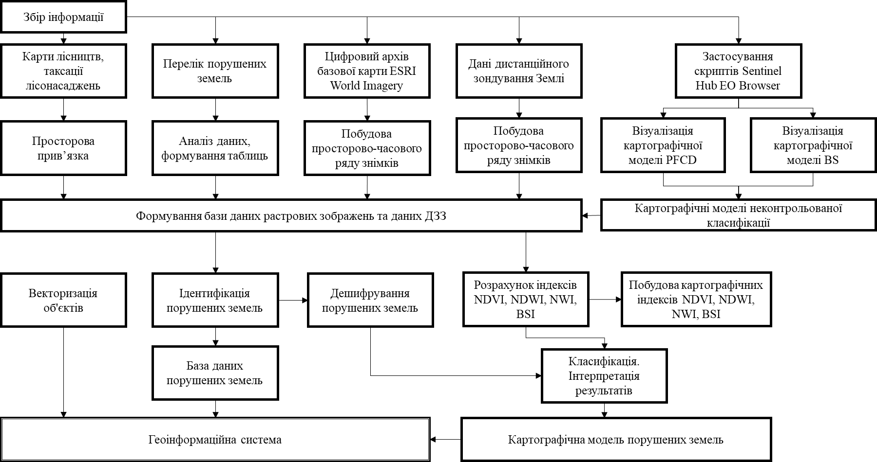
Information collection
Maps of forestry, forest plantation estimate survey
Spatial binding
List of affected lands
ESRI World Imagery base map digital archive
Earth remote sensing data
Use of Sentinel Hub EO Browser scripts
Data analysis, creation of tables
Creation of a spatial and temporal series of images
Creation of a spatial and temporal series of images

Visualization of PFCD map model
Visualization of BS map model

Creation of a database of bitmaps and remote sensing data
Cartographic models of uncontrolled classification

Object vectorization
Identification of affected lands
Decryption of affected lands
Database of affected land
Geoinformation system
Cartographic model of affected lands
Classification. Interpretation of results
Calculation of NDVI, NDWI, NWI, and BSI indexes
Creation of the NDVI, NDWI, NWI, and BSI map indexes
Figure 1. Flowchart of the methodology of geoinformation monitoring of affected lands
The surface of affected massifs is almost completely devoid of vegetation, so the use of vegetation indices under certain conditions allows us to identify the contours of disturbed lands more clearly, and therefore increase the decoding accuracy. The best decoding results are obtained by calculating the NDVI (Normalized Difference Vegetation Index) [8].
$NDVI=\frac{NIR−RED}{NIR+RED}$ (1)
where, NIR – near infrared; RED - red spectrum range. Normalized differential vegetation index is one of the most common vegetation indices for performing tasks related to the quantitative assessment of vegetation cover. It is highly sensitive to changes in vegetation cover.
That is, high photosynthetic activity, associated with dense vegetation, leads to slight reflection in the red part of the spectrum and more significant reflection in the infrared part. The ratio of these indicators to each other makes it possible to clearly separate vegetation from other natural objects and perform their analysis. However, it should be noted that the NDVI indicators of plowed fields and deforestation in the spring and autumn periods are close to the indicators of the surface of lands affected by amber mining, which makes its calculation unsuitable to identify the contours of dumps and quarries [2].
Soil moisture assessment is one of the elements of thematic processing of satellite images, which allows you to identify areas where amber mining was performed using motor pumps (hydraulic mining method).
It should be noted that soil moisture is understood as the content of water in its pores and cracks. All water in the soil under natural conditions is called natural soil moisture ($\text{W }$). Usually, soil moisture is expressed by the ratio of water weight ($q_{b}$), which is in the rock, to the weight of the dry rock ($q_{c}$) (weight moisture) as a percentage (2):
$\text{W=}\frac{{\text{q}}_{\text{b}}}{{\text{q}}_{\text{c}}}$ (2)
Based on the use of calculation methods, it is possible to determine the locations of waterlogging and excessive moisture capacity of the soil cover in an area with an open ground cover and a "pit" structure. Decoding of satellite images for humidity assessment was based on a priori analysis using some landscape components that are detected in satellite images: vegetation, terrain, and hydro network.
An approach for assessing the moisture content of the soil cover is presented, based on the use of various norm-difference water indices. In this study, existing water indices that are sensitive to soil surface moisture are considered and applied [9]. In particular, the index $NDWI$ (Normalized Difference Water Index), offered by B. Gao:
$NDWI=\frac{NIR−SWIR}{NIR+SWIR}$ (3)
To differentiate the types of soil cover, the bare soil index (BSI) was used, which was offered and used in the works of Can Trong Nguyen, Amnat Chidthaisong, Phan Kieu Diem and Lian-Zhi Huo [10]
$BSI=\frac{\left(\left(SWIR2+Red\right)−\left(NIR+Blue\right)\right)}{\left(\left(SWIR2+R\right)+\left(NIR+B\right)\right)}$ (4)
The modified bare soil index makes it possible to classify bare soil from clearings, built-up areas, and other types of land cover [13].
The object of practical verification of the methodology of geoinformation modeling of areas affected by amber mining was the state-owned land of Dubrovytsia Forestry of Rivne Region. As a result of the research, 5 main types of land cover were selected: coniferous forest, broad-leaved forest, young forest, clearings, affected land. Based on the classification, cartographic models for monitoring disturbed land as a result of amber mining were created, which are shown in Figure 2.
Based on the results of the analysis of cartographic models, it can be concluded that in certain areas of the quarter there is a renewal of forest cover, but at the same time, new affected areas of the forest appear.
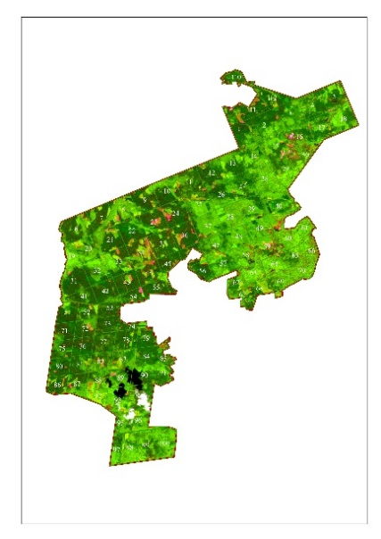  а) | 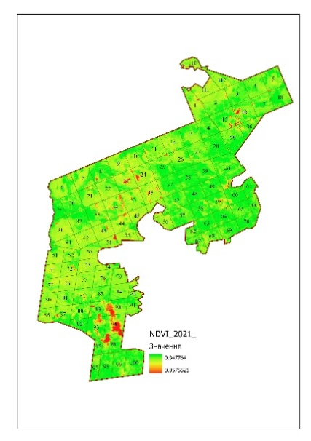  b) | 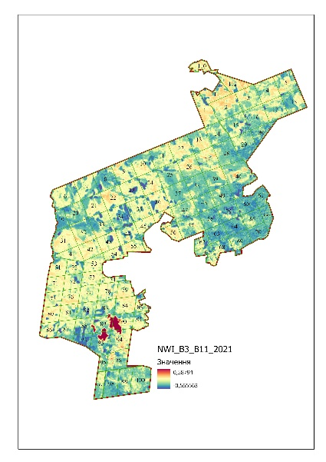  c)
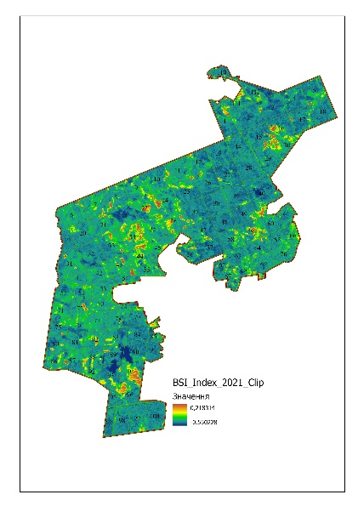  d) | 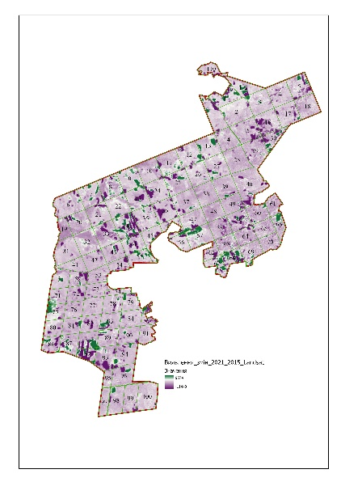  e) | 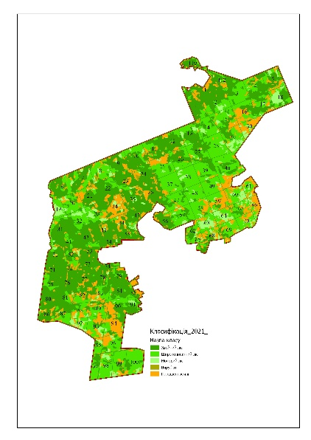  f)
Figure 2. Cartographic models for monitoring lands affected by illegal amber mining:
a) Sentinel-2B.01.08.2021 space snapshot; b) NDVI cartographic model; c) NWI cartographic model; d) BSI cartographic model; d) cartographic model for analyzing changes in soil and vegetation cover during the period of 2021-2015; e) cartographic model for classifying lands affected by illegal amber mining

According to the results of geoinformation monitoring in Dubrovytsia Forestry, the areas of disturbed lands are located in 3,5,13,16,18,30,48,50,59,61,63,65,67,69,98, 100 forest blocks and cover the area of 837.46 hectares, which is 11% of the total area of the Forestry.
area of affected lands
Figure 3. Ratio of the total area of forest blocks to the affected Dubrovytsia Forestry
It should be noted that according to the Order of the State Forestry Agency of Ukraine No. 138 [6,7] dated 21 April 2017 "List of forestry lands, within which there are parts affected by illegal amber mining and require reclamation", the Register includes 2046 land plots with a total area of affected lands of 4385.45 hectares.
State Enterprise "Dubrovytsia Forestry" includes 9 forest divisions: Chermenske Forest Division, Ozertsi Forest Division, Dubrovytsia Forest Division, Tryputnianske Forest Division, Berezhnytsia Forest Division, Litvytske Forest Division, Budymlianske Forest Division, Lisove Forest Division and Perebrodivske Forest Division. It was established that the area of affected land is 2539.56 hectares, which is 5.14% of the total area of State Enterprise "Dubrovytsia Forestry".
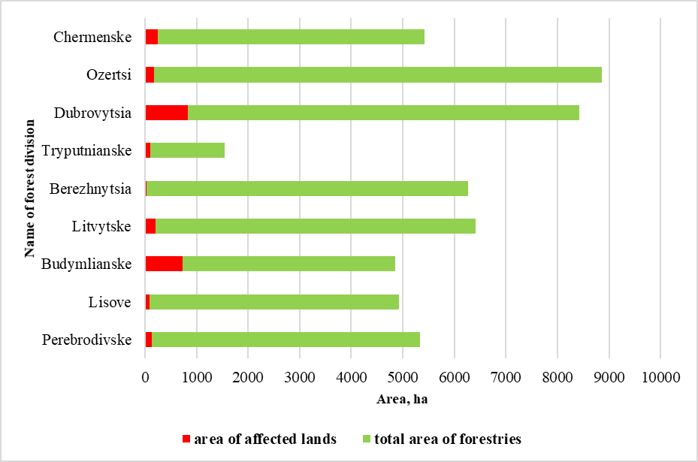
Figure 3. Ratio of the total area to the affected area of State Enterprise "Dubrovytsia Forestry"
Conclusions and prospects. The current state of natural environment of the north-western part of the Ukrainian Polissia is characterized by huge changes in agricultural landscapes. Lands affected by amber mining are permanently withdrawn from economic circulation, because the restoration of these lands is often neglected, or reclamation measures are carried out very often. Over the past 10 years, the quantitative indicator of the area of reclaimed land in the region ranges from 0 to 0.1 thousand hectares [11]. This shows that insufficient attention is paid to the reclamation of affected lands.
The article considers modern possibilities of geospatial modeling of areas affected by amber mining on the example of Rivne region. This study offers a method for deciphering satellite survey materials for geoinformation modeling of the territories with the lands affected by amber mining. The use of actual materials of remote sensing of modern satellite systems in combination with geospatial models during land monitoring is analyzed. It was found that the calculation of the NDVI makes it possible to identify the contours of affected areas more clearly. An approach for assessing soil cover moisture content based on the use of Norm-difference water indices is presented. It is noted that the assessment of soil moisture is one of the elements of thematic processing of satellite images which makes it possible to identify the areas where amber mining by hydraulic method was carried out. The use of the methodology was tested on state-owned lands of Dubrovytsia Forestry of Rivne Region. The methodology will provide a technical basis for decisions on the identification of affected land plots and their further monitoring. In addition, the methodology offered in the article will help to determine the directions of land reclamation and groups of affected lands.
References
1. Dokument Rivnenskoi oblasnoi derzhavnoi administratsii (2017) [Document of Rivne Regional State Administration] (10.05.2017).
2. Filipovych, V. Ye., & Shevchuk, R. M. (2016). Metodyka i tekhnolohiia otsinky shkody, nanesenoi Ukrainskii derzhavi vnaslidok nelehalnoho vydobutku burshtynu [The methodology and technology assessment of damage caused by Ukrainian government as a result of illegal extraction of amber] Ukrainian Journal of Remote Sensing. 11, 15-21.
3. V. M. Maslei, D. K. Mozghovyi, K. H. Bilousov, V. S. Khoroshylov, O. S. Bushanska, M. H. Halych (2016). Metodyka otsinky naslidkiv vydobutku burshtunu za bahatospektralnymy suputnykovymy znimkamy [Method of the impact evaluation of amber mining by multisprctral satellite images] Space science and technology. 6, 26-36.
4. Ivanov Ye. (2019). Analiz ekolohichnoi sytuatsii u raionakh nezakonnoho vydobuvannia burshtynu [Analysis of the ecological situation in the areas of illegal amber mining] Subsoil use in Ukraine. Investment prospects: materials of the Sixth International Scientific and Practical Conference. 2, 105-111.
5 MDPI and ACS Style. Xiao, W.; Deng, X.; He, T.; Chen, W. Mapping Annual Land Disturbance and Reclamation in a Surface Coal Mining Region Using Google Earth Engine and the LandTrendr Algorithm: A Case Study of the Shengli Coalfield in Inner Mongolia, China. Remote Sens. 2020, 12, 1612.
6. Pro zatverdzhennia Poriadku realizatsii pilotnoho proektu rekultyvatsii zemel lisohospodarskoho pryznachennia, porushenykh vnaslidok nezakonnoho vydobuvannia burshtynu: Postanova Kabinetu Ministriv Ukrainy (2016) [Resolution of the Cabinet of Ministers of Ukraine On approval of the Procedure for Implementation of the Pilot Project for Restoration of Forest Lands Disrupted as a result of Illegal Amber Mining] № 1063.
7. Perelik zemel lisohospodarskoho pryznachennia, u mezhakh yakykh ye chastyny, yaki porusheni vnaslidok nezakonnoho vydobuvannia burshtynu i potrebuiut rekultyvatsii: Nakaz Derzhlisahentstva (2017) [Order of the State Agency of Forest Resources of Ukraine List of forest lands within which there are parts that have been damaged by illegal amber production and in need of reclamation ] №138.
8. B. Bardysh, Kh. Burshtynska (2014) Vykorystannia vehetatsiinykh indeksiv dlia identyfikatsii obiektiv zemnoi poverkhni [Using vegetation indices to identify objects on the earth surface] Modern achievements of geodesic science and industry. 28, 82-88.
9. Gao B. C. NDWI - A Normalize d Differenc e Vegetatio n Index for Remote Sensing of Vegetatio n Liquid Water from Space. / B. C. Gao // Remote Sensing of Environme nt, 1996, NYC, 58, - P. 257 - 266.
10. Can Trong Nguyen, Amnat Chidthaisong, Phan Kieu Diem, Lian-Zhi Huo A Modified Bare Soil Index to Identify Bare Land Features during Agricultural Fallow-Period in Southeast Asia Using Landsat 8. Land 2021, 10, 231. Page 3. Available at:: https://www.mdpi.com/2073-445X/10/3/231/pdf.
11. Dopovid pro stan navkolyshnoho pryrodnoho seredovyshcha v Rivnenskii oblasti u 2010, 2011, 2012, 2013, 2014, 2015, 2016, 2017, 2018, 2019, 2020 [Report on the state of the environment in Rivne region in 2010, 2011, 2012, 2013, 2014, 2015, 2016, 2017, 2018, 2019, 2020]. Department of Ecology and Natural Resources of Rivne Regional State Administration. Available at: https://www.ecorivne.gov.ua/report_about_environment/

