UDC 332.3:232.7
LAND CIRCULATION: FIRST RESULTS AFTER THE DISCOVERY
M. Marynovych, PhD candidate
Lviv National Environmental University
e-mail: marynovychm@gmail.com

Abstract. Priority directions for the efficient and balanced development of the land circulation were created after taking into account the current situation of agricultural lands in Ukraine following the introduction of the land circulation. Generalization of factors influencing and developing land relations. The provisions of the Law of Ukraine “On Amendments to Certain Legislative Acts of Ukraine Regarding the Transfer of Agricultural Lands” adopted on March 31, 2020 were studied. The data of the State Service of Ukraine on geodesy, cartography and cadastre regarding the number of concluded deeds, as well as the area of land for which agreements were concluded by region were analyzed. The dynamics of changes in the average value of 1 ha of alienated land plots in the regions of Ukraine were monitored. The leading regions in terms of the number of alienated territories and the average cost of 1 hectare of land for commercial agricultural production were determined, and the main reasons for such variations were also clarified. During the land reform adoption, flaws that prevent it from moving forward successfully were exposed. For the market circulation of agricultural land to operate effectively, strategic directions have been developed, which include: improving the integrity, accessibility and interoperability of registration systems; increasing the ability of local territorial communities to rationally plan and dispose of territories; improving the content, quality of cadastral data and interaction of systems to reduce corruption and shadow transactions with land; creating and ensuring the functioning of the State Agrarian Register, to reduce information asymmetry in the agricultural sector, facilitate access to EU markets, which simplifies compliance with requirements for tracking products and environmental standards of production. The current government will determine how Ukraine's land market evolves in the future. They should lay out the key axes of its future operation and see to the creation of suitable frameworks for the advancement of land relations across the nation. The growth of the capacity of the population and territorial communities concerning planning, disposal of land, as well as creating favorable conditions for the development of agrarian business in the countryside depends on the efficiency and balance of the work of the market circulation.
Key words: land circulation, land reform, agricultural land, land resources, land resources management, strategic priorities of land circulation.
Relevance. The efficient, logical allocation and use of agricultural land is a crucial requirement for the operation of agriculture that is social and economic growth.

Considering the experience of nearby nations, improving population well-being does not always require the efficient use of agricultural land. Therefore, a fundamental aspect of contemporary land relations is the state's regulation of land circulation. Today, the land market is regulated in practically every nation where it operates. Each nation governs this issue in its unique manner according to the widely acknowledged model based on national interests and multifunctional state policy created with the aid of regulatory tools and mechanisms that are unified into a single concept [9, 11].
The practice of neighboring countries shows that the model of the circulation of agricultural land without an appropriate set of state policies intensifies such negative processes as: oligarchization, monopolization, depopulation of village territories, and a decrease in the income of the rural population. However, the model, which involves regulatory actions by the state, provides favorable conditions for attracting investment and cooperation between the public and private sectors in the economy.
The circulation of agricultural land in Ukraine started on July 1, 2021. Therefore, all former owners of the moratorium territories now have full permission to dispose of them as they like.
Analysis of recent research and publications. The issue of the circulation of agricultural land, its concept, essence and prospects for development was highlighted by many scientists, among them: A. Tretiak [9]; N. Kushnir, O. Harnaga and I. Hnatiuk [4]; V. Budziak and O. Budziak [1]; R. Stupen [8]; I. Yurchenko [11], R. Levek [5] and others. According to researchers, the functioning of the land market is a necessary step for the further socio-economic development of Ukraine, in particular rural areas on ecological grounds [2, 4]. Therefore, the authorities brought up the subject of cancellation of the moratorium on a number of occasions, but there was a considerable delay in finding a solution.
The theoretical and practical foundation for the development of the Ukrainian model of the agricultural land market started to take shape with the considerable involvement of scientists [10, 11]. The Law of Ukraine “On Amendments to Certain Legislative Acts of Ukraine Regarding the Transfer of Agricultural Lands” was consequently adopted in March 2020, serving as the foundation for the opening of land market. Since the market circulation is only starting, the problem needs to be thoroughly investigated in order to establish strategic priorities for the advancement of land reform.
The research aim is to analyze the first findings of land market functioning in Ukraine and to determine strategic priorities for the effective and balanced circulation of agricultural land on the territory of the state.
Research materials and methods. The basis of the research methodology is system analysis – a set of methodological tools for the study of complex processes, which make it possible to predict the development of the entire system in general and to use the obtained results for the preparation and argumentation of technological, organizational and other decisions. The specialists’ scientific works and the corresponding normative acts concerning land resources management were elaborated, which made it possible to identify errors in management and to form the main development paths in ensuring the further effective and rational functioning of the land reform.
Research results and their discussion. The land is the key national wealth under the exclusive protection of the state. Land ownership is guaranteed, acquired and implemented exclusively by the state, citizens and legal entities in accordance with legislation [3]. Such vigilant land protection is understandable, because in the territory of Ukraine, 67.7% of all land is agricultural, which ensures the production of plant products in the amount of 8.7% of the global amount [6].
Ukraine has been actively pursuing European integration since the beginning of 2014. Therefore, after signing of the Association Agreement between Ukraine and the European Union, our state undertook to reform all spheres of legal, political, economic and social life in order to bring the legislation of Ukraine to Acquis communautaire of the European Union [12].
The circulation of agricultural land must be regulated by the state, taking into account national interests and relevant features. Considering this fact, as well as the presence of a large base of work, after reviewing all the pros and cons, on March 31, 2020 the President of Ukraine Volodymyr Zelenskyi signed and Supreme Council of Ukraine adopted the Law “On Amendments to Certain Legislative Acts of Ukraine Regarding the Transfer of Agricultural Lands” [7]. The document became the basis for creating a legislative basis for the opening of the agricultural land market. It is designed to implement the constitutionally enshrined citizens’ rights to unhindered disposal of their allotments, as well as to create free conditions for acquiring ownership of agricultural plots for all citizens of our country.
There will be numerous phases to land reform.
The first phase: Starting on July 1, 2021, only Ukrainian citizens (individuals) will be able to purchase agricultural land. However, the legislation states that a single person is only permitted to dispose of up to 100 hectares of land at once. We are not, however, talking about land allotments that residents owned prior to the abovementioned law coming into force.
The second phase: Starting on January 1, 2024, legal entities as well as individuals (citizens) will be able to purchase agricultural land if they were formed and registered in accordance with the standards and guidelines established by Ukrainian law, the participants of which are only citizens of the country. In this instance, the total amount of agricultural land that each member may possess increases to 10,000 hectares.
The possibility of registration of the right of ownership of agricultural land by foreign citizens must be considered at the All-Ukrainian referendum. That is, before the referendum and its absolute decision, foreigners do not have the right to acquire land plots for agricultural purposes, even through constructive possession, that is, through legal entities that are registered and created in accordance with the current legislation of our country.
It is worth noting that agricultural lands can be owned by territorial communities, the state and banks. The latter, in turn, does not include the requirement “no more than 100 hectares/ from 2024 – 10 thousand hectares”. However, such banks have the right to own agricultural land only if they received it as a result of foreclosure as collateral for a certain loan. This citizens’ right on providing land as collateral and the right of banks to land becomes one of the most essential criteria for better lending to our farmers.
Additionally, if a Ukrainian citizen intends to sell his or her land allotment, he or she should consider if they have granted someone a preference to buy such a plot. The buyer must notify the owner of the property plot to whom the right has been transferred if he has given his right to someone else. After all, the preferential right to redemption is only available to those who already possess the right of perpetual use, lifelong inherited ownership, or a lease on a parcel of state or communal property.
One of the main citizens’ concerns regarding the market is that “Ukrainian lands will be bought for nothing”. As a result, guidelines for determining the cost to be paid in accordance with civil law agreements, exclusively in cashless form, with verified sources of origin of the matching money for the purchase of a particular land plot, have been established. The law does not provide a specific upper limit for the issue of how the market price for sale develops. The agreement between the seller and the buyer is the only topic covered in this case. However, it should be emphasized that no agricultural land plot developed in kind (on the site) of land shares may be sold for more than its fair market value prior to January 1, 2030.
The new law also prescribes a number of preventive measures. So, if a citizen or a legal entity accepted an inheritance, that is, bought a larger area of land than the law provides, then such allotments, acquired in violation of the limit, are confiscated.
There are instances where a citizen or a legal organization inherits or acquires land allotments pursuant to a donation agreement, already owning 100 hectares or 10,000 hectares as of 2024, respectively. In all of these cases, the law requires that the land be relinquished, such as through donation, sale, etc. The coordination of all required subtleties will take place over the course of one year. If not, the land is confiscated in accordance with a court order and then put up for sale. In these situations, acquired money is used to cover the court fees, and the remaining amount is given to the person who owned the land piece before it was taken.
According to the new law, the following do not have the right to sell or change the owner of agricultural land:
- the land of state/communal form of ownership;
- lands located in temporarily occupied territories in Donbas or the Autonomous Republic of Crimea. An exception may be a plot handed over as an inheritance. All other agreements concluded during the occupation period are considered invalid;
- lands, the distance to the state border which is less than 50 km. Citizens of other states or legal entities whose founders are foreigners do not have the right to buy such territories (even if a referendum approves the conclusion of such agreement) [8].
Today, it is already possible to analyze the first results from the day of the official opening of the circulation of agricultural land. According to the data of the State Service of Ukraine for Geodesy, Cartography and Cadastre, during the first year from July 1, 2021, 105 173 legal transactions were carried out in the state, the area of which is 252 241 hectares. At the same time, the largest number of registered agreements on the alienation of agricultural land is in Kharkiv, Poltava, Vinnytsia, Kyiv, Sumy, and Khmelnytskyi regions (Fig. 1).
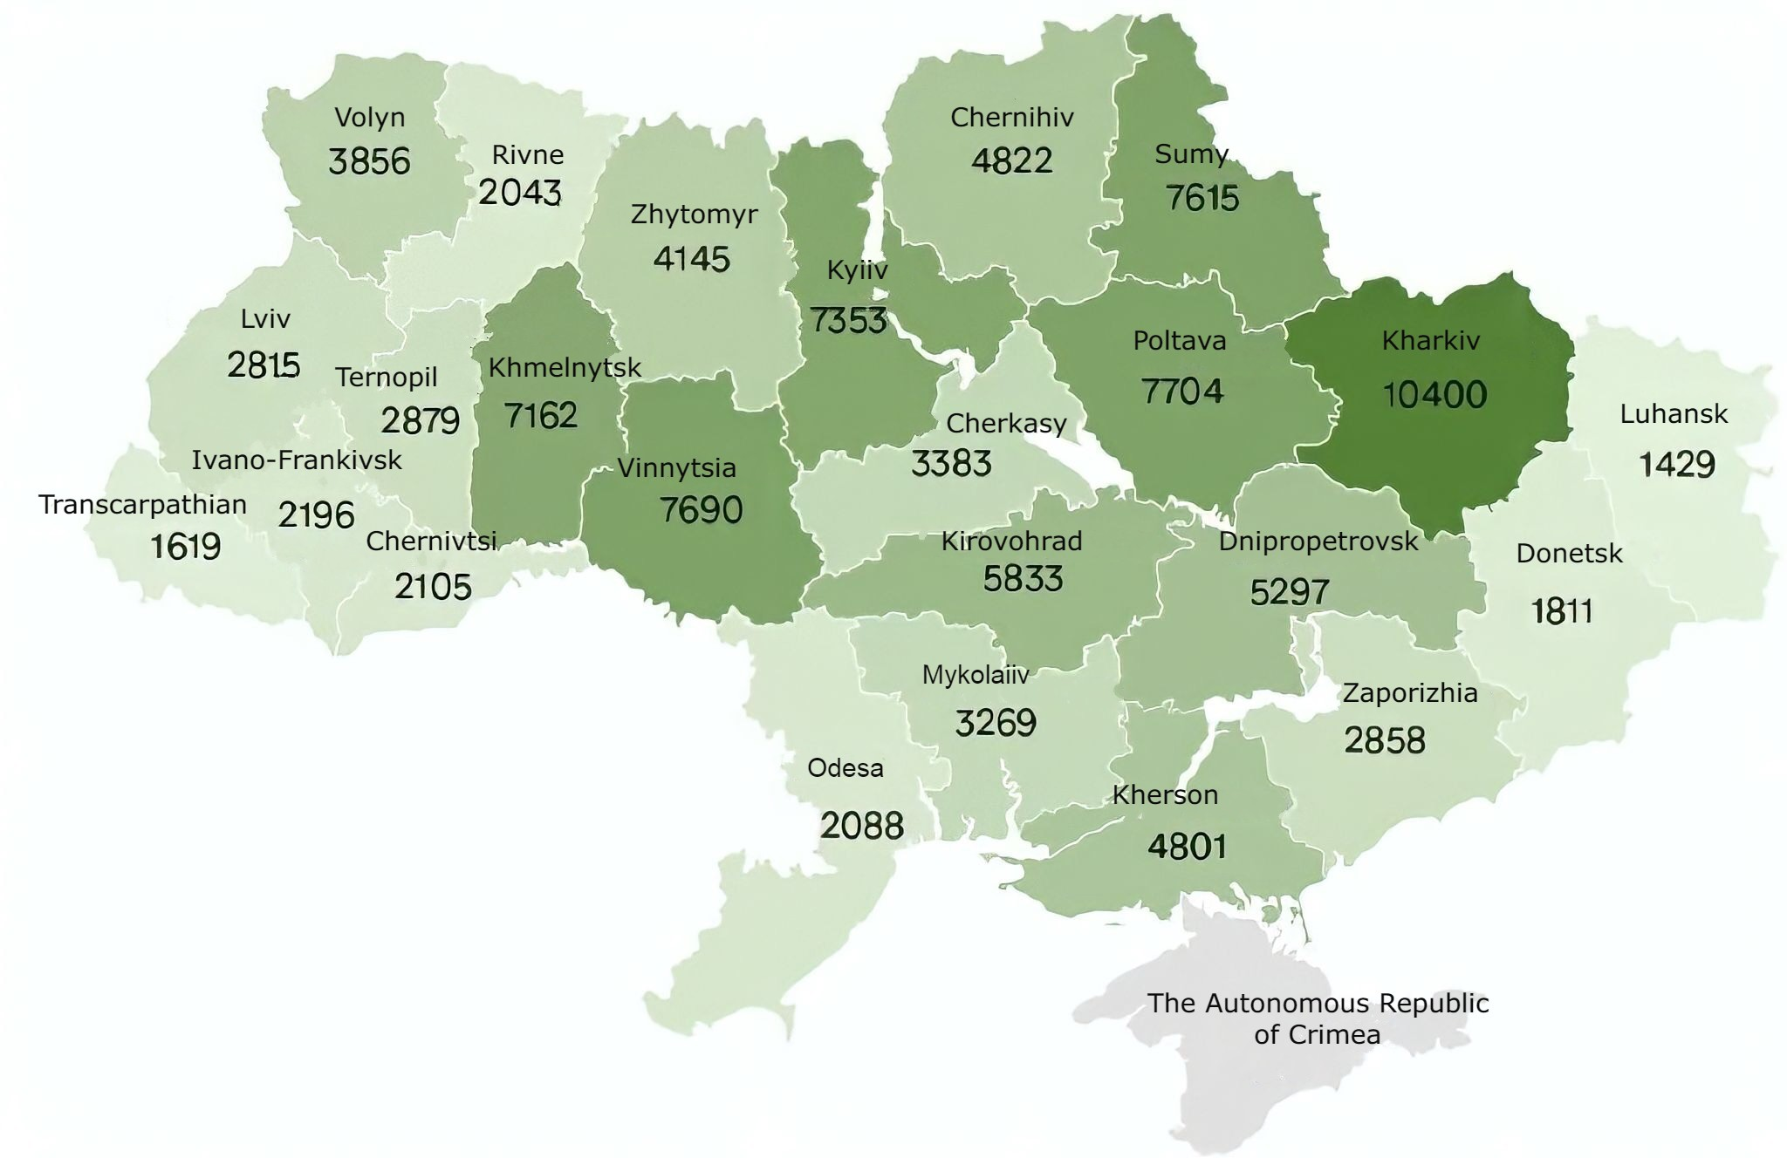
Fig. 1. Number of legal transactions by region as of July 1, 2022
Kharkiv, Dnipropetrovsk, and Kherson regions became the leaders in terms of sales volumes of land shares (Fig. 2). Thus, in Kharkiv region, agreements were concluded that related to 37116.3 hectares of land. Dnipropetrovsk region took second place with an area of 21783.3 hectares. Kherson region is in third place with an area of 21026.4 hectares. Their leadership is caused by the larger land lots put up for sale in these regions. The exception was Ivano-Frankivsk, Transcarpathian, and Chernivtsi regions, where the least number of land shares were alienated – 942.0; 1347.2 and 1702.0 hectares of land, respectively, caused by the small amount of available land for sale.
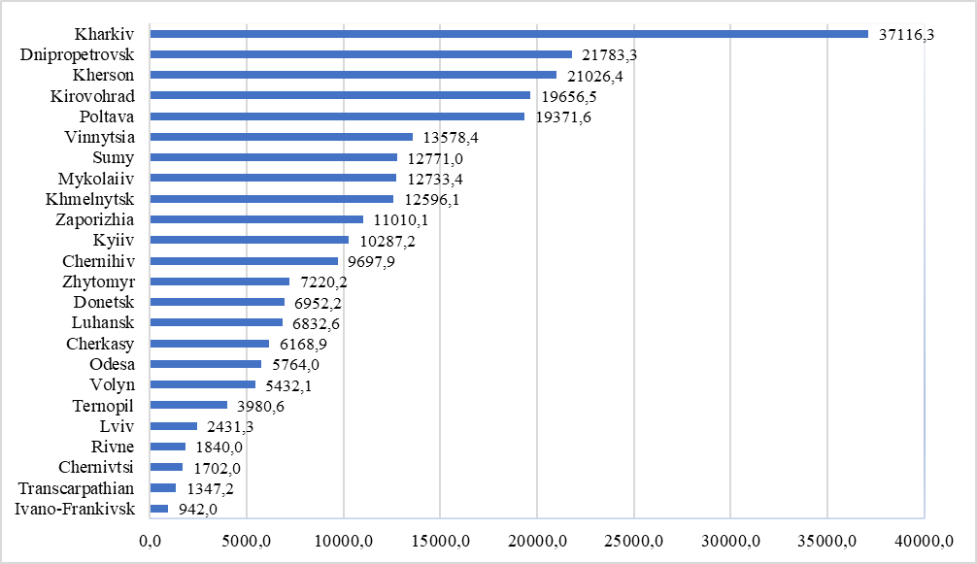
Fig. 2. The area of land, in respect of which legal transactions were concluded, ha

Considering mentioned legal transactions, there are 88 000 land purchase and sale agreements, the total value of which is more than 7 billion UAH, which is about 1% of the entire area of agricultural land in Ukraine.
The average value of one hectare of alienated land on July 1, 2022 was 37 819 UAH, which is close to the normative monetary value. However, the spread of land value is extremely large, despite the factor of land fertility, which does not play the main role in price formation. The highest indicators of the average cost of 1 ha of alienated land are in Lviv, Kyiv and Ivano-Frankivsk regions (Fig. 3).
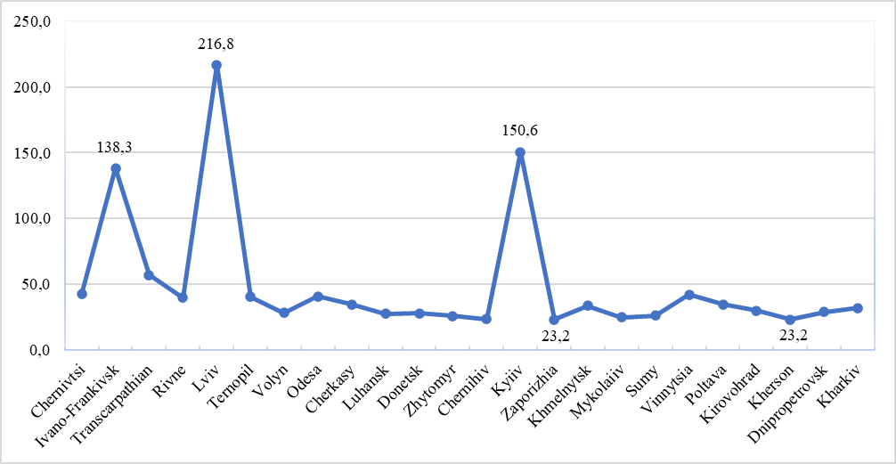
Fig. 3. Average cost of 1 hectare of alienated land plots, thousand UAH (as of July 1, 2022)

Concerning the value of agricultural land, Lviv region is the first with an indicator of 216.8 thousand UAH /hectare. Kyiv region comes in second with a price per hectare of 150.6 thousand UAH. Third-placed Ivano-Frankivsk region indicates 138.3 thousand UAH /ha. The areas of Kherson and Zaporizhzhia regions have the lowest indices, with the cost of 1 ha of alienated land which is 23.2 thousand UAH/ha. The record values of the cost are interpreted in terms of the prospect of changing the purpose of the plot for construction. After the introduction of legal entities to the market, the existence of vegetable gardens in the suburbs can be resold for a sizable profit.

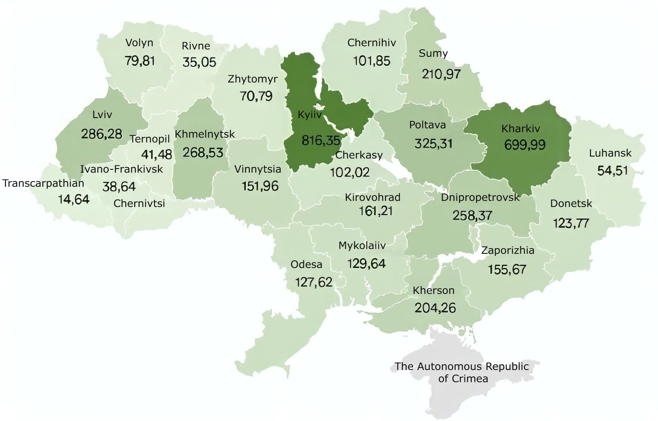
Fig. 4. The cost of alienated land plots, thousand UAH. (as of July 1, 2022)

According to the State Service of Ukraine on geodesy, cartography and cadastre data, Kyiv and Kharkiv regions are the leaders in terms of the value of alienated land plots (Fig. 4), where this amount is 816.35 thousand UAH and 699.99 thousand UAH respectively. The lowest indicators are in Transcarpathian region –14.64 thousand UAH and Rivne region 35.05 thousand UAH.
Considering analytical data, during the operation of the open circulation of land on the territory of the state, plots with a target purpose for commercial agricultural production, as well as for personal peasant production, amounting to 59.74 thousand hectares of land, were most alienated. At the same time, the highest value of 1 hectare of land intended for commercial agricultural production is observed in Lviv region and amounts to UAH 58.3 thousand (Fig. 5). The weighted average cost on the territory of the entire state for the same target use is 32 857 UAH.

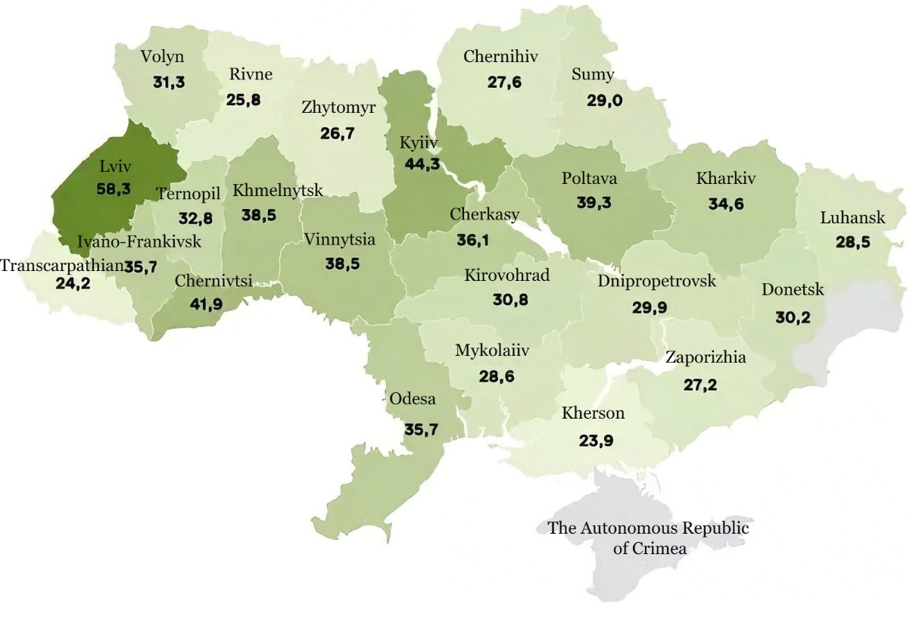
Fig. 5. An average cost of 1 hectare of land for commercial agricultural production, thousand UAH (as of October 9, 2021)

Such numbers are constantly changing due to soil fertility, prospects for land use, availability or lack of technical capabilities for agricultural soil processing. For example, due to the lack of an irrigation system, especially in the South of Ukraine, it is impossible to predict the state of the fertility of the lands, evaluate their quality treatment or predict the future yield. In addition, the cost of agricultural land determines the absence of even the smallest infrastructure in rural areas to ensure the vital needs of the rural population [5]. They, in turn, leave their homes in search of work, and the land remains uncultivated. It should be understood that setting the price for any plot is a personal matter of the buyer and seller. However, until 2030, there will be a minimum price threshold (normative-monetary assessment) in the country, below which the indicator cannot fall.
Despite the fact that there are several issues now preventing the land market from being fully developed, one of the main ones is the lengthy and rather complicated legal sales contract drafting procedure. Additionally, a lot of agricultural properties are leased for a period of 10 to 15 years, which means that even when a buyer acquires ownership rights to such plots, he cannot use them for his own purposes until the lease agreements expire. Another problem is that numerous citizens do not have their ownership rights to big tracts of land properly recorded, so it takes more time and money to get everything in order.
Inaccurate and inadequate information regarding land plots in the State Land Cadastre database is one of the major issues, which got worse with the opening of the land circulation market. In our state, it is typical that issues should be resolved by landowners rather than centrally and at the expense of necessary governmental funds [1, 4]. For example, in case of inconsistency in the coordinates of a plot that is privately owned by a citizen, the inaccuracy of its area or other errors become the owner’s problem and are corrected at her/his expense. Additionally, there are issues with the State Property Fund of Ukraine automatic evaluation of land, which in some circumstances, we observe on the outskirts of large cities, can several times exceed the real cost of land sales. In such a situation, according to the law, taxes must be paid on the percentage calculated according to such appraised value, and not on the actual sale price, because this can serve as an economically disadvantageous condition for both parties to the transaction. Therefore, the process of drawing up contracts is long-term, complex and expensive. In some places, the services of notaries for the registration of a small land plot can amount to half the cost of such an allotment, so such registration costs are too high for the parties.
Furthermore, the market for land is undersupplied. The owners are not in a rush to list their plot for sale unless there is an immediate need because they are aware that its cost may rise over time. It is better for owners to rent their plots in order to receive an annual income because cost increase of land plots results in a rise of the rent itself.
Certain strategic priorities must be defined for effective land turnover, in particular:
- to improve the integrity, accessibility and interoperability of registers. Since the modern organizational system of land registration has a number of shortcomings, it lacks a holistic approach, the interaction of the State Register of Real Property Rights and the State Land Cadastre for the exchange of data stored in the registers (electronic systems) of other state institutions. Therefore, such systems are crucial for the successful implementation of land reform;
- to improve the completeness, quality of cadastral data and interconnection of systems to reduce corruption. Nowadays, a functional and protected information system of data on land plots in the State Land Cadastre, its relationship with other registers and information systems play an extremely important role in protecting citizens’ rights to land, controlling the land market, and building public trust in the reform. Obtaining the necessary results from the opening of a full circulation of land depends on the completeness and relevance of cadastral data, as well as on the availability of a modern IT system and management solutions for proper consideration of the legal framework in the land sector. The State Land Cadastre, the completeness and quality of data is the basis for the functioning of each strategic direction, and therefore for the successful promotion of market circulation;
- to improve capacity of local communities to plan logically and administer their territories. Land did not fulfill its proper function as a rural community primary source of income or as a means of funding its budgets in order to support its sustainable growth. The situation will improve with the introduction of complete circulation of agricultural land, but it is crucial to take additional steps to strengthen capacity of local territorial communities and broaden their access to instruments and resources for sustainable development;
- create and ensure the functioning of the State Agrarian Register. The presence of permanent problems in agriculture due to information asymmetry significantly increases operational costs in the agricultural sector, which causes unsatisfactory market results, unproductive and irrational distribution of state support and worsens labor productivity in agriculture. This strategic priority aims to develop a useful and efficient State Agrarian Register as a tool for reducing information asymmetry in the agricultural sector. It will also lead to a decrease in bank costs associated with crediting farmers due to the improvement of the information available on performance indicators and characteristics of farms (along with registration records of land plots), the introduction of more targeted audience, productive, and accurate data, and the implementation of more efficient and accurate data collection methods.
- In regard to the above-mentioned issues that emerge during the market circulation of agricultural land on the soil of our state, it should be emphasized that while it is developing slowly since it is new and understudied, it is steadily getting better.
Conclusions and perspectives. The updated legislative regulation of the market circulation of agricultural land has a variety of favorable effects: ensuring that all state citizens fully exercise their right to their agricultural land plots; determining an objective market price for agricultural land as a result of its circulation and increasing in land capitalization; attracting additional credit sources to the agricultural sector; providing conditions for an efficient redistribution of agricultural plots and rationalization of their use; ensuring unrestricted access to land-related procedures; and increasing the well-being of residents.
Since land reform is still in its early stages, it is important to adhere to strategic priorities aimed at expanding the State Land Cadastre base, enhancing its connection to other registers, ensuring quality, accessibility to citizens’ register data of the State Land Cadastre, and improve the capacity of territorial communities to plan and dispose of lands.
References
- Budziak, V. M., Budziak, O. M. (2017). Instytutsionalne zabezpechennia povnotsinnoho rynku zemel silskohospodarskoho pryznachennia [Institutional support of a full-fledged agricultural land market]. Ahrosvit, 10, 3-10.
- Hadzalo, Ya.M., Hladii, M.V., Sabluk, P.T. (2016). Ahrarnyi potentsial Ukrainy: napriamy rozvytku [Agrarian potential of Ukraine: directions of development]. Kyiv: Ahrarna nauka, 332.
- Martyniuk, M.P. (2017). Rynok zemel silskohospodarskoho pryznachennia v Ukraini: stan ta perspektyvy zaprovadzhennia [Market of agricultural land in Ukraine: status and prospects of implementation]. Ekonomika APK, 3, 15–21.
- Kushnir, N. B., Harnaha, O. M., Ihnatiuk, I. Z. (2017). Perspektyvy rozvytku rynku zemel silskohospodarskoho pryznachennia v Ukraini [Prospects for the development of the agricultural land market in Ukraine]. Biznes Inform, 3, 176–181.
- Levek, R. (2020). Silskohospodarski struktury, stalist prodovolchykh system ta rehuliuvannia zemelnykh rynkiv [Agricultural structures, sustainability of food systems and regulation of land markets]. Ekonomika APK, 1, 18–33.
- Pozniak, S. P. (2016). Chornozemy Ukrainy: heohrafiia, geneza i suchasnyi stan [Black soils of Ukraine: geography, genesis and current state]. Ukrainskyi heohrafichnyi zhurnal, 1, 9-13.
- Zakon Ukrainy vid 31.03.2020 r. №552-IKh «Pro vnesennia zmin do deiakykh zakonodavchykh aktiv Ukrainy shchodo umov obihu zemel silskohospodarskoho pryznachennia» [A law of Ukraine is «On making changes to some legislative acts of Ukraine regarding the conditions of the circulation of agricultural lands»]. Available at : https://zakon.rada.gov.ua/laws/show/552-20#Text
- Stupen, R. M. (2015). Sutnist rynku zemel silskohospodarskoho pryznachennia [The essence of the agricultural land market]. Ekonomika APK, 9, 106-110.
- Tretiak, A. M. (2011). Zemelnyi kapital: teoretyko-metodolohichni osnovy formuvannia ta funktsionuvannia [Land capital: theoretical and methodological foundations of formation and functioning]. SPOLOM, 520.
- Lupenko, Yu.O., Khodakivska, O.V. (2016). Naukovi zasady zaprovadzhennia rynkovoho obihu zemel [Scientific principles of introduction of market circulation of land: scientific report]. Kyiv: NNTs «IAE», 40.
- Iurchenko, I. V. (2020). Kontseptsiia rynkovoho obihu zemel silskohospodarskoho pryznachennia [The concept of market circulation of agricultural lands]. Ekonomika APK, 2, 115–125.
- Hreshchuk, H.I. (2017). Ekoloho-ekonomichni naslidky transformatsii zemelnykh vidnosyn u silskomu hospodarstvi [Environmental and economic consequences of the transformation of land relations in agriculture]. Zbalansovane pryrodokorystuvannia, 2, 108–114.

Маринович М.
ОБІГ ЗЕМЕЛЬ: ПЕРШІ ПІДСУМКИ ПІСЛЯ ВІДКРИТТЯ
Анотація. Розглянуто сучасний стан земель сільськогосподарського призначення в Україні після відкриття обігу землі та сформувати пріоритетні напрями для ефективного та збалансованого розвитку земельного обігу. Узагальнення факторів впливу та розвитку земельних відносин. Досліджено положення прийнятого 31 березня 2020 року Закону України «Про внесення змін до деяких законодавчих актів України щодо обігу земель сільськогосподарського призначення». Проаналізовано дані Державної служби України з питань геодезії, картографії та кадастру стосовно кількості укладених правочинів, а також площ земель, відносно яких укладали угоди за регіонами. Простежено динаміку зміни середньої вартості 1 га відчужених земельних ділянок в областях України. Визначено регіони-лідери за кількістю відчужених територій та за середньозваженою вартістю 1 га землі для ведення товарного сільськогосподарського виробництва, а також з’ясовано основні причини таких варіювань. Розкрито слабкі сторони під час проходження земельної реформи, що гальмують успішність її перебігу. Сформовано стратегічні напрями для ефективного функціонування ринкового обігу земель сільськогосподарського призначення, що передбачають: покращання цілісності, доступності та інтероперабельності реєстраційних систем; зростання спроможності місцевих територіальних громад раціонально планувати та розпоряджатись територіями; покращання змістовності, якості кадастрових даних та взаємодії систем для зменшення корупційних дій і тіньових оборотів із землею; створення та забезпечення функціонування Державного аграрного реєстру, для скорочення інформаційної асиметрії в аграрному секторі, полегшення доступу до ринків ЄС, що спрощує дотримання вимог до відстеження продукції та екологічних норм виробництва. Від сьогоднішньої влади залежить, як розвиватиметься земельний ринок в Україні надалі. Вони повинні окреслити головні напрями його подальшого функціонування й забезпечити розроблення відповідних механізмів розвитку земельних відносин в країні загалом. Від ефективності та збалансованості роботи ринкового обігу залежать зростання спроможності населення і територіальних громад щодо планування, розпорядження землями, а також створення сприятливих умов для розвитку аграрного бізнесу на селі.
Ключові слова: обіг землі, земельна реформа, землі сільськогосподарського призначення, земельні ресурси, управління земельними ресурсами, стратегічні пріоритети обігу землі.

