УДК 332.33
THE CONCEPT OF LAND VALUE CAPTURE IN THE EUROPEAN LAND USE SYSTEM
O. Chumachenko, Ph. D. in Economics, Associate Professor,
National University of Life and Environmental Sciences of Ukraine anchumachenko@ukr.net
O. Kustovska, Ph. D. in Economics, Associate Professor,
National University of Life and Environmental Sciences of Ukraine
kustovska.ov@gmail.com
І. Kolhanova, Ph. D. in Economics,
National University of Life and Environmental Sciences of Ukraine
kolganova_i@ukr.net
L. Kolosa, Ph. D. in Economics,
National University of Life and Environmental Sciences of Ukraine
kolоsa_l@ukr.net
Y. Kryvoviaz, Ph. D. in Economics, Associate Professor,
National University of Life and Environmental Sciences of Ukraine
zmenichka@ukr.net

The article is devoted to the global trend of active urbanism as an approach to the study of planning and creation of cities, which pays special attention to the interaction of society with the built environment. It has been established that urban growth increases the demand for public utilities and, as a result, for land plots with the appropriate infrastructure. In this regard, there is a need to find additional sources of financing for new infrastructure projects. One of the effective means is to capture the value of land. The author substantiates the need to use the tools of land value capture as one of the main aspects of urbanism. The author provides an interpretation of each of the instruments based on the theory of land value capture: infrastructure fee, developer's obligations, payment for the opportunity to build, land reorganization and strategic land management. The author examines the peculiarities of development and implementation of the aforementioned tools in terms of administrative, legal and financial regulation on the example of European countries. It is established that the national system of land management does not sufficiently facilitate the implementation of these tools, especially in the context of the prospects for political, legal, economic, social and cultural integration of Ukraine into the European space.
Keywords: land value capture, land use, fiscal payments, authorities, land management.

Introduction. Given the global trends in the system of population settlement and environmental management that emerged in the second half of the twentieth century and the beginning of the twenty-first century, the issue of expanding urban agglomerations is becoming more relevant [6]. Urbanization is becoming a global megatrend. Thus, according to the Organization for Economic Co-operation and Development (OECD), over the past 40 years, the urban population has doubled (more than 1.5 billion), and by 2050, more than 5 billion people will live in cities [1]. Modern cities are characterized by social density, technology, and a high concentration of administrative, industrial, commercial, and cultural facilities, which inevitably increases the demand for public services and land resources with appropriate infrastructure. This trend intensifies the demand for land and infrastructure. Modern cities are facing the problems of climate neutrality and reducing anthropogenic impact on the environment, which will inevitably require additional investments in the development and restructuring of public transport, water supply, energy supply, including from renewable sources, organization of recreational areas and public space. [2] In achieving these goals, public investment projects should play a crucial role, identifying sources of funding and performing a management function.
Analysis of recent researches and publications. The study of issues related to the effectiveness of the use of tools for capturing land value is new to the land management system of Ukraine, foreign research is presented in the works of such scientists as: H. Gonzalez, S. Dougherty, M. Smolka, T. Hartmann, P. Witte, T. van Oosten. However, in the scientific space, quite a few works are devoted to research on land use planning, urban planning, land management, land valuation and taxation, which fills the content and develops the mechanisms for capturing land value. Therefore, the works of well-known national scientists - land surveyors create the basis for such mechanisms: Bambidra D., Dobriak D., Dorosh Y., Dorosh O., Martyn A., Novakovsky L., Sabluk P., Sokhnych A., Tretiak A., Khvesyk M., etc. Despite the significant creative work of domestic researchers, there are still open issues related to the study and adaptation of foreign approaches to capturing land value to the domestic land use system.
Purpose. The purpose of the study is to substantiate the characteristics and efficiency of using the tools for capturing the value of land in European countries as one of the effective mechanisms for expanding urban agglomerations.
Methods. The initial stage of the study was based on data collection, based on materials available in international bibliographic databases, namely: Index Copernicus, Google Scholar, EBSCO Publishing and others, electronic resources of national and foreign libraries. The information basis of the study is the statistical data of Eurostat, OECD iLibrary, which became the information basis of the study and allowed the use of research methods, namely: the method of analysis and synthesis (in identifying the patterns of formation of the structure of protected areas); the method of comparison (in assessing the level of nature provision of the territory); the method of analogy (in providing a comparative characterization of the author's generalization), methods of induction and deduction (in the substantive development of the terminology).
Results. Land resources are an indispensable spatial basis for the development and construction of modern cities, which at the same time can become an additional source of financial support for urban development. An effective state policy tool for solving these problems should be a system for determining the value of land, which will allow recording the growth of land value caused by state actions (infrastructure investment, improvement of urban administration, land management).
An effective financial instrument that will help increase government revenue is land seizure. Etymologically, this term is derived from the concept of value capture as a type of public financing that returns part or all of the value created by public infrastructure to private landowners [3, 4]. The peculiarity of this approach to the redistribution of financial assets is that the public sector is responsible for the infrastructure necessary for urban development, including road and other urban infrastructure; parks, recreation areas; social, medical and educational institutions; social housing; natural territorial complexes that require additional funding. Value capture ensures the return of a portion of the benefits derived from public investment to offset the costs of the investment itself. Therefore, the strategy of value capture is based on the assumption that public investment generally leads to an increase in the valuation of land and real estate, including private sector property. Public investment increases the value of adjacent land, creating additional income for private landowners. The notion of "unearned value" emerges - an increase in land value that brings "free" profit to private landowners. Thus, value capture internalizes the positive externalities of public investment by encouraging the taxation of the beneficiaries of their investments. Given the further increase in value, there is a basis for returning funds to the budgets, which will ensure that the latter are used to create additional value for real estate and infrastructure.
Today, the concept of land value capture (LVC) should be understood as a complex of legal, managerial, land evaluation, fiscal and technical measures, with the help of which state and local management bodies receive benefits (income) from the value of land or an increase in the value of land [4 ].
The state's attempt to record the increase in the value of land as a result of carrying out a certain type of work has a rather deep history. Yes, Great Britain is a world pioneer in the use of land value capture for the purpose of land management. One of the first recorded collections for "improvements" was introduced in Great Britain by Henry VI in 1497, with the aim of recording the increase in the value of private land due to flood protection works [1]. The activation of state policies regarding complex land value capture systems dates back to the beginning of the 20th century. Thus, in 1909, V. Churchill acutely raised the issue of "unearned increase in the value of land" received by landowners thanks to state investments in infrastructure, and called on state authorities to intensify such works in order to increase the public good [5]. At the beginning of the 20th century, with the support of E. Howard, Letchworth Garden City was founded within the Green Belt of London, which contributed to the increase in the value of land during the construction of residential buildings, additional funds were reinvested in local infrastructure [6]. In another part of the world, namely in Australia, in the period from 1970 to 1975, 30% of the levy for improving the value of the land was withdrawn by the State Planning Department of Sydney during the development of the capital region and directed to the construction of sewers and related infrastructure works [9].
Thus, we can see that the attempts of central and local authorities to use the mechanisms of capturing the value of land have a rather deep history. The constant search for a balance between public benefits and values and the incentives of the private sector to acquire the right to land formed the basis of modern land value capture mechanisms. Given that land is one of the most valuable forms of capital, effective state management of land resources leads to a significant increase in land value. Further redistribution and public investment of the additional value of land will ensure sustainable land use in urban agglomerations.
International practices and methodologies provide for a set of measures that form the tools for capturing land value (Figure 1).
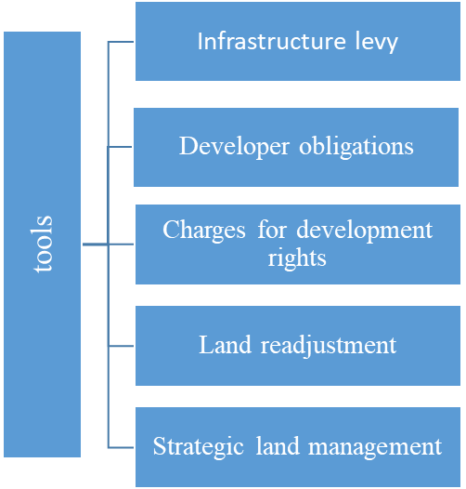
Fig. 1. Tools for capturing land value (author's generalization based on source [1])
For a deeper understanding of the above approaches to capturing land value, it is worth considering each of the methods in more detail.
Infrastructure fee is a tax (fee) paid by owners of land plots whose value has increased as a result of public (or municipal) infrastructure investments. By paying this type of fiscal payment, landowners contribute to the development (maintenance) of public roads, transportation, communications, parks, etc. The decision to implement infrastructure projects is initiated by public authorities. The main feature of this approach is the determination of the part of the private territory from which landowners receive benefits. The calculation of the fee is based on the amount of benefits received from the land value. The main forms of the fee can be a one-time payment or periodic (monthly or quarterly) payments, contributions for improvements, fees for improvements. This type of fee is most often applied to transport and utility infrastructure, public areas, and common areas, based on the amount of improvement (enhancement) of real estate. Its amount is influenced by the main characteristics of land plots: area, zoning, building density, tax, availability of amenities. In Spain, various characteristics of land plots are used, while in France and the UK, the fee is calculated based only on the land area.
Developer obligations are targeted payments in cash (in-kind) intended to reimburse the costs of forming or maintaining public infrastructure and related services that promote private sector development. In European practice, developer obligations are applied in case of the need to approve project documentation or obtain special permits. A classic example of this type of payment is when a developer builds social or affordable housing in exchange for project approval. Unlike the infrastructure tax, the obligation is initiated by landowners or developers and is coordinated with government agencies and local governments. In Poland and Norway, this type of payment is used for urban redevelopment, while in Finland this instrument is certified when local governments make changes to land management project documentation. The basis for the formation of the developer's obligations is determined by negotiations between the parties (local administrations and the developer) or by pre-established rules. However, France uses both mechanisms: taxe d'aménagement and contributions d'aménagement. The former levies a fixed fee per square meter, while the latter is based on negotiations with developers to determine the urban development zone.
Payment for the right to develop is a form of payment in cash or in kind (organization of public space, construction of social/affordable housing, infrastructure facilities, etc.) in order to acquire the right to develop beyond the established restrictions of the project documentation, which increases the density of development and actually changes the structure of land use. As a rule, the developer makes compensation payments for the opportunity to make adjustments to the project documentation to increase the building density or change the red line, if this does not contradict the law and construction standards. Such an approach requires appropriate land cadastral support: establishing the boundaries of the plot, restrictions and encumbrances on the land plot, zoning, etc.
Land reorganization (in most cases, consolidation of land plots), when capturing land value, is a set of works on combining several adjacent land plots, which helps to increase the value of the land plot and releases additional funds. The formation of new real estate properties is usually accompanied by changes in zoning or liberalization of development rules, which ultimately leads to an increase in land value. In turn, landowners provide a share of their land plots for public infrastructure facilities: roads, public utilities, recreation, public places, etc. In effect, the landowner receives a smaller plot of land, the value of which has increased significantly due to the improvements made during the redevelopment. In European practice, such work is based on a private initiative, which is actively supported by local governments, the main tool for the transition from rural to urban land use. There is also an active merger (consolidation) of agricultural land to increase the efficiency of its use. In Southern European countries (Italy, Spain), this type of work is carried out to restore land uses that have been damaged by natural disasters. Northern European countries (Finland) use this mechanism to consolidate forest lands, Estonia to lay railroad tracks, etc. It is also used to simplify integrated property ownership in areas of existing right-of-way (Israel).
Strategic land management as a system of interconnected elements of rational land use management should play a decisive role in the formation of the added value of real estate, including land. Thus, the system of effective strategic state management of land resources in most European countries (the Netherlands, Estonia, Latvia, etc.) provides for the purchase, sale and lease of land for public needs, which will help to reimburse the increase in land value obtained as a result of effective management activities with subsequent financing of public infrastructure and services. By carrying out strategic redevelopment and implementing additional infrastructure improvements, which generally contribute to the formation of additional land value, landowners can recover part of this land value by selling or leasing the land at a higher rental rate. State authorities involved in strategic land management usually promote consistent spatial development: spatial planning, urban construction, land consolidation, control of land price inflation, etc.
European experience shows (Figure 2) that for the effective implementation of land value capture mechanisms, it is necessary to create an appropriate favorable legal and administrative environment.
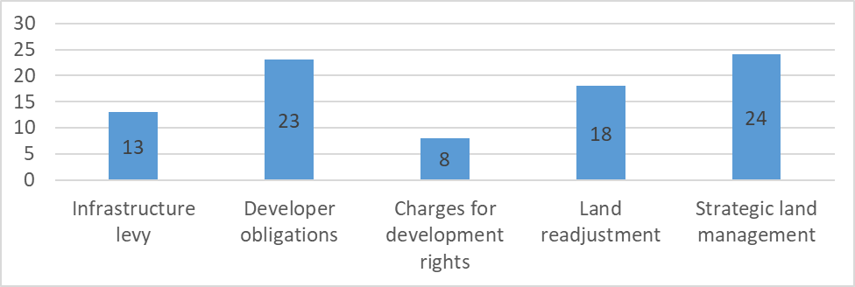
Fig. 2. Availability of tools to capture land value in European countries (number of repetitions). Author's development according to [1]. The sample was conducted among 27 countries.

The use of instruments to capture land value by European governments is heterogeneous. The most popular instruments are strategic planning (used in 24 countries) and developer obligations, while payment for the right to develop is practiced only in 8 countries. The legislative framework should facilitate the formation of a legal basis for land value seizure, define the procedure and interagency coordination of interests. The administrative component is represented by land use planning and valuation systems, land cadastre, which form the information basis for land value capture. This diversity of systems and mechanisms in many European countries contributes to a wide variety of land value capture processes. In general, the land valuation system in Europe is quite diverse and has significant differences in implementation.
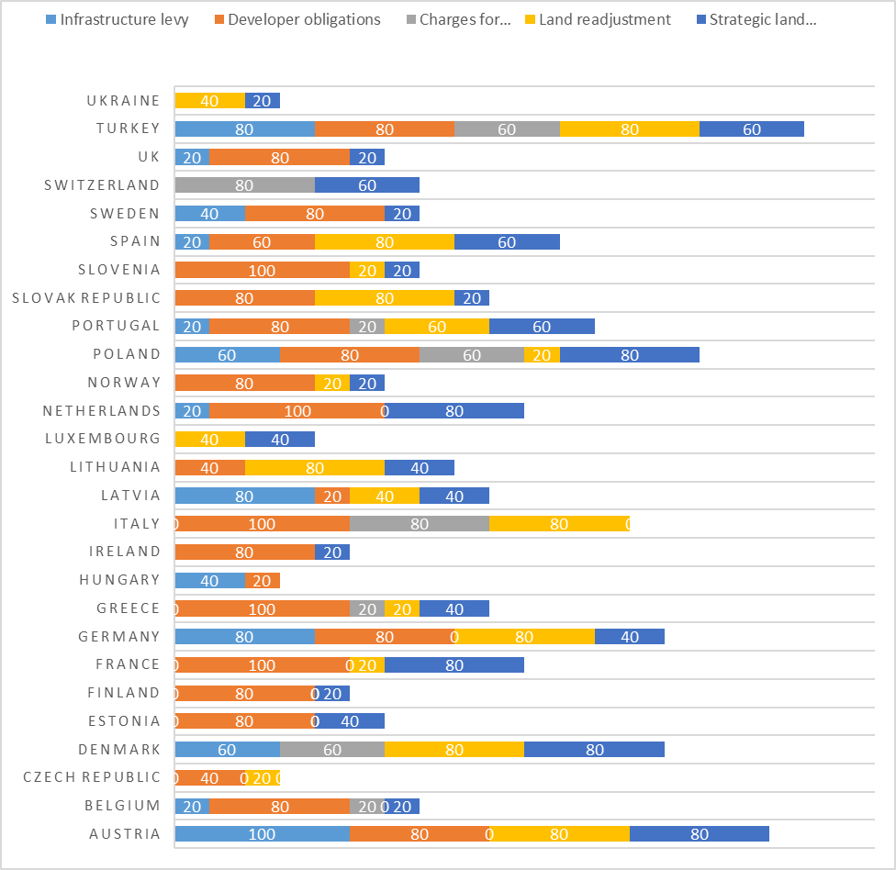
* specialized agencies and companies, private sector (landowners).
Author's conclusion based on data from [1].
Fig. 3. Levels of administrative regulation of land value capture, %.

The effective implementation of land acquisition measures is facilitated by a multi-level management system. Classically, powers are distributed among the state and regional governments, local governments, specialized agencies and companies, and the private sector (landowners). We can say that the administrative support in European countries is not homogeneous. The analysis shows that the predominant amount of work to ensure the conduct, support and management of the process of land acquisition is entrusted to local governments (LGEs). Thus, in most European countries, LGEs perform the main functions of regulating the process of land value capture (Fig. 3), namely, facilitate infrastructure fees in 85%, communications with developers in 86%, and determination and regulation of payments for the right to develop in 75%. Ensuring land amalgamation (43%) and planning of strategic land management (50%) are partially redistributed by government agencies (13% and 18% respectively) and other organizations, institutions, and the private sector (38% and 26% respectively). If we look at the administrative regulation of the process of land seizure at the state level (see Figure 4), this procedure is quite heterogeneous in the European administrative space.
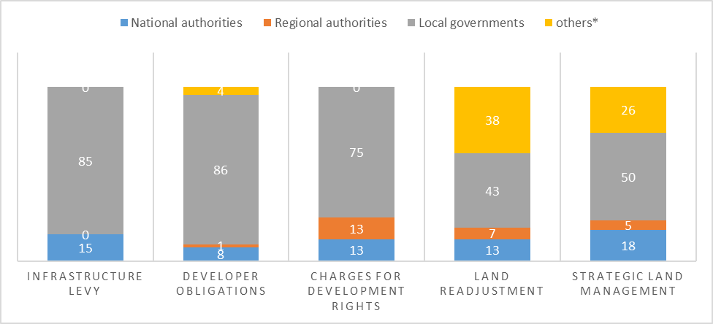Fig. 4. Administrative regulation of land seizure in European countries, in %. Author's justification of the frequency of use of the land value capture tool: always - 100, often - 80, moderately - 60, occasionally - 40, rarely - 20, never - 0.

A high degree of implementation and administrative support, and thus the use of land value capture mechanisms, is observed in Austria (only payments for the right to build), Denmark (no developer obligations), Germany (only payments for the right to build), Poland, and Turkey. Italy, the Baltic States, the Netherlands, Portugal, Spain, and the United Kingdom have somewhat lower rates of land value capture. The study found that most European countries have a rather unregulated mechanism and limited tools for seizing land value, namely the Czech Republic, Hungary, and Ukraine. Out of the entire range of tools for seizing land value, no more than two are used, and their use is not systematic, usually due to the lack of regulatory and legal regulation of the relevant mechanisms.
The effectiveness of the introduction of land value capture instruments depends on solving a number of problems that arise during their implementation. Thus, after analyzing the OECD-Lincoln study [1], it becomes clear that the lack of public support (resistance of landowners and land users) significantly hinders the implementation of the above mechanisms. Any increase in fiscal payments for land (property) is usually perceived negatively by society, which can significantly reduce the initiative of state and local governments to actively implement the full range of tools for capturing land value. A system of communication and mutual dialogue between the authorities and landowners should be the basis for successful policy implementation, especially in relation to marginalized and ethnic social groups, which often have a special understanding of land relations and a sense of land ownership. The next problem that reduces the effectiveness of the land value capture toolkit is the development of rules and regulations. After all, legal regulation promotes consensus of the parties, allows them to understand all the benefits and public goods that are expected. However, most countries have a rather low level of regulatory and legal support for land acquisition, which is partially compensated by fiscal, land valuation or civil legislation.
In most countries, local governments play a crucial role in implementing land value capture mechanisms, establishing a particular form of land ownership, determining the amount of rates and fees, ensuring the negotiation process of land relations subjects and facilitating the effective management of land assets. The realization of the potential of local self-government will offset the problem of implementing approaches to capturing land value. Successful implementation of the toolkit requires rational planning and effective land management. The absence of such capabilities is a significant obstacle to the implementation of land value capture mechanisms. The absence of cadastres and unified registers makes it impossible to identify problems of landowners and land users in a timely manner. In order to increase the effectiveness of land value capture instruments, national governments should provide local (regional) governments with administrative, political and informational support that will contribute to the effectiveness of land value capture as a fiscal instrument. Redistribution of responsibilities of different levels of government in spatial planning, preparation of reference plans and land management rules and regulations should form the administrative basis for land value capture, which is typical for the land use systems of the Netherlands and Israel [5].
In our opinion, the key areas for the effective implementation of the policy of land value capture should be:
- Active public involvement and outreach. A set of consultative measures to popularize such land value capture activities is aimed at reducing the level of resistance among landowners and land users. The main task of such activities is to communicate all the benefits (in the short, medium and long term) that landowners (land users) will receive when implementing the land value capture policy. The study shows that this aspect of policy implementation is absent or insufficient in most countries.
- Establishment of clear rules for the implementation of the land value capture policy through legal definitions, legislative acts. The practice of most European countries shows that efficiency increases when fiscal payments are based on the amount of land value increase, rather than on public expenditures, which creates some social improvement. Consideration of the socioeconomic status of landowners and land users plays an important role in the implementation of land value capture mechanisms. The differential approach to payments in land value capture should be based on the level of income of citizens.
- Increased role of local governments. In most of the countries considered in the study, local governments ensure the implementation of most aspects of the land acquisition policy: determining fees, conducting negotiations and consultations between land relations subjects, and managing land resources. In parallel with the growing role of local authorities, the level of trust in the administration system in land acquisition should increase, the corruption component should be eliminated, and the level of legal responsibility for inefficient and illegal actions should be increased. The national governments should provide adequate administrative support, timely political decisions, cadastral system (especially the land cadastre), access to databases, etc. In the context of decentralization, local authorities should realize the need to introduce and develop mechanisms for implementing procedures (tools) for seizing land value based on socio-economic, property, historical, cultural and other local characteristics. Spatial planning plays an important role in achieving the goals of land acquisition, the main function of which is to establish the role of the levels of government in developing the planning and mapping framework and land use rules that serve as the basic level of land acquisition administration.
Discussion. In most countries, there is no legal definition and justification of the concept of land acquisition, which could reduce the number of lawsuits and promote public support, which are the main obstacles to the implementation of the studied tools.
European practice shows that the most frequent cause of lawsuits is cases involving infrastructure fees, as the payment is made for public works initiated by the community. Developer obligations and development rights fees have a low level of appeal. Local governments play a crucial role in the implementation of the infrastructure tax, developer's obligation and development rights fees. Strategic management of land resources is provided by the national government, other government agencies, and landowners. Low-income countries tend to give local governments less power to implement land value capture tools than high-income countries, mainly due to corruption and low levels of trust.
The factors that significantly reduce the potential for implementing the tools under study are the resistance of property owners, including the lack of proper administrative capacity of managers, especially in low-income countries. The use of land value capture instruments is typical for European countries, with developer obligations and strategic land management being the most commonly used tools. Fees for development rights are unpopular. In Ukraine, the realization of land value capture is entrusted to strategic land management and reorganization. The main reason for this is urbanization, which requires the transformation of rural land into urban land with the use of land management documentation. The low level of local administrative capacity and corruption significantly hinder the development of developer obligations, as the latter require negotiations with private developers, which creates the basis for non-statutory relations and generally reduces the effectiveness of land acquisition instruments.

References
1 . As highlighted by the Expert Committee on Compensation and Betterment, chaired by Mr Justice Uthwatt, in 1942. Expert Committee on Compensation and Betterment (Uthwatt Committee): Minutes and Papers, 1938–1946, The National Archives
2. OECD/Lincoln Institute of Land Policy, PKU-Lincoln Institute Center (2022), Global Compendium of Land Value Capture Policies, OECD Regional Development Studies, OECD Publishing, Paris). [Електронний ресурс]. - Режим доступу: https://doi.org/10.1787/4f9559ee-en.
3 . González H. (2005), Instrumentos Para La Recuperación de Plusvalías En Bogotá, Café de Las Ciudades 4, https://www.cafedelasciudades.com.ar/economia_37.htm.
4. Kim, J. and S. Dougherty (eds.) (2020), Local Public Finance and Capacity Building in Asia: Issues and Challenges, OECD Fiscal Federalism Studies, OECD Publishing, Paris, https://doi.org/10.1787/a944b17e-en.
5. Land and Income Taxes in the Budget, Liberalism and the Social Problem, Winston Churchill, 17 July 1909. https://cooperative-individualism.org/churchill-winston_liberalism-and-the-social-problem-1909.htm
6. Letchworth Garden City — history and further information. https://londongreenbeltcouncil.org.uk/
7. Patricia Canelas, Luise Noring, Governmentalities of land value capture in urban redevelopment, Land Use Policy, Volume 122, 2022). [Електронний ресурс]. - Режим доступу: https://doi.org/10.1016/j
8. Smolka, M. (2019), “Value Capture”, The Wiley Blackwell Encyclopedia of Urban and Regional Studies.
9. Value Capture – a historical perspective. https://www.prosper.org.au/land-value-capture/value-capture-a-historical-perspective.
10. Value_capture. [Електронний ресурс]. - Режим доступу: https://en.wikipedia.org/wiki/Value_capture
11. Van Oosten T., Witte P., Hartmann T. (2018), “Active land policy in small municipalities in the Netherlands: “We don’t do it, unless...””, Land Use Policy, Vol. 77, pp. 829-836). [Електронний ресурс]. - Режим доступу: https://doi.org/10.1016/j.
12. Wolf-Powers, L. (2019). Reclaim Value Capture for Equitable Urban Development. Metropolitics.). [Електронний ресурс]. - Режим доступу: https://www.researchgate.net/publication/333845420_Reclaim_Value_Capture_for_Equitable_Urban_Development
13. "World Bank (2022), World Bank Country and Lending Groups). [Електронний ресурс]. - Режим доступу: https://datahelpdesk.worldbank.org/knowledgebase/articles/906519-world-bank-country-andlending- groups.

