UDC 332.3:631.459

To the issue of development of working land management projects to improve the condition of agricultural lands and protect land from erosion

Koshel A., Doctor of Economics, associate professor
National University of Life and Environmental Sciences of Ukraine
e-mail:koshelao@gmail.com
Kolhanova I., PhD in Economics, associate professor
National University of Life and Environmental Sciences of Ukraine
e-mail:kolganova_i@ukr.net
Kempa O., Dr inż. (PhD)
Wroclaw University of Environmental and Life Sciences
e-mail:olgierd.kempa@upwr.edu.pl
Stacherzak A., Dr inż. (PhD)
Wroclaw University of Environmental and Life Sciences
e-mail:agnieszka.stacherzak@upwr.edu.pl

Abstract. Scientific and methodical approaches to the development of working land management projects for improving the condition of agricultural land and protecting land from erosion are proposed.
The main reasons for the emergence and active development of erosion processes are the irrational destruction of natural vegetation, the deterioration of the infiltration and water-absorbing capacity of soils and their anti-erosion resistance. Modern soil erosion is mainly related to human agricultural activities. But in the absence of protective measures, it also develops in the territories of settlements and industrial enterprises, road routes, etc. Therefore, a planned and effective war against erosion is an integral part of the entire system of anti-erosion organization of the territory, and should include such basic measures as: organizational and economic, agrotechnical, forest improvement, hydrotechnical, which must interact, be designed and implemented in harmony with each other.
The obtained results can be used in the development of working land management projects and the implementation of comprehensive measures to improve the condition of the land and protect the soil from erosion.
Keywords: erosion, working project of land management, disturbed lands, soil protection, fertile soil layer, unproductive lands, land management documentation, land management, management, land use.
Actuality. Erosion – the process of soil and rock erosion by water streams. Soil erosion is the process of soil degradation by water, wind, or during agrotechnical activities. Erosion is a major factor in land and agro-landscape degradation, leading to desertification of territories due to reduced ecosystem productivity and worsened water balance. The stability of the agro-landscape and the biosphere as a whole depends on the state of the soil cover. Considering that erosion also leads to the loss of minerals that contribute to soil formation and humus accumulation, the restoration of eroded lands is very complex and often impossible in many cases. All of this emphasizes the importance of not only combating soil erosion but also preventing it.
These issues have become particularly relevant with the expansion of intensive agricultural technology use, often not aligned with soil conservation efforts. Soil protection from erosion should be carried out while considering the preservation of natural systems. Measures to protect soil from erosion should not promote the emergence of other processes that reduce soil fertility and deplete land resources. On the contrary, they should aim to prevent or significantly reduce the intensity of these processes.
In different natural regions of the country, due to various agricultural land uses, the extent and intensity of soil-destructive processes may vary. Therefore, soil protection systems in agriculture should include measures tailored to the specific soil-destructive processes prevalent in the given territory. Different soil protection measures should complement each other. For instance, anti-erosion practices enhance the soil protection efficiency of other methods, and vice versa, other methods enhance the efficiency of anti-erosion measures.
Analysis of the latest scientific research and publications. Issues related to improving the state of agricultural land and protecting lands from erosion were studied by scientists such as O.P. Kanash, V.M. Kryvov, A.G. Martyn, S.O. Osypchuk, S.P. Pohurelskyi, M.P. Stetsiuk, O.M. Chumachenko, and others. However, at the same time, questions concerning the development of land survey documentation for the improvement of agricultural land and protection of lands from erosion remain relatively underexplored.
Materials and methods of scientific research. The following generally accepted methods of scientific research were used during the research on the development of working land management projects to improve the condition of agricultural land and protect land from erosion: theoretical method, monographic method, comparative method, and generalization method.
The purpose of the article is the coverage of a methodical approach to the development of working land management projects to improve the condition of agricultural land and protect land from erosion.
The results. The purpose of developing a working land management project for improving the condition of agricultural lands and protecting land from erosion is: root and surface improvement of the condition of haymakers; introduction of no-till tillage; applying a fertile layer of soil; grounding, slitting haymakers; introduction of microbiological preparations, plant growth regulators, microfertilizers and other soil protection measures, which must be carried out during the use of land of all categories.
The object of this research was a plot of land in need of improving the condition of agricultural land and protecting it from erosion, located in the administrative boundaries of the Monastryshchensk urban territorial community of the Uman district of the Cherkasy region (Figs. 1, 2).
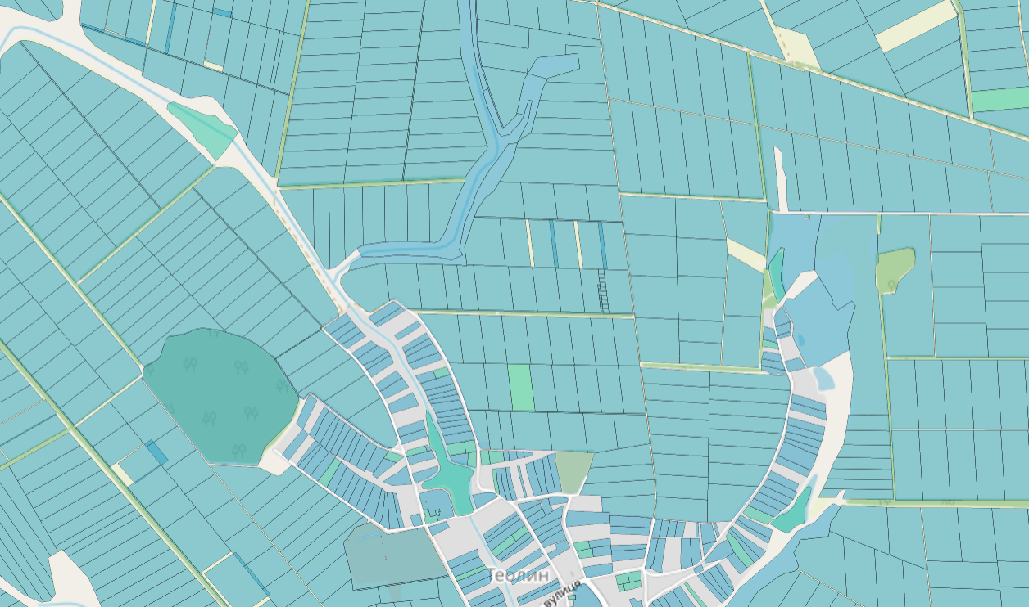
The land parcel that was the object of the study
Fig. 1. The location of the land parcel within the administrative boundaries of the Monastryshchensk urban territorial community of the Uman district of the Cherkasy region *

٭Note: according to the website https://kadastr.live (date of application 04.04.2023.).

According to the configuration in the plan, the land plot, which is the object of the study, has an irregular elongated shape (Fig. 1, 2). The soil cover is presented: dark gray weakly regraded heavily washed heavy loam on loess (51e), black soils strongly regraded medium washed heavy loam on loess (56e), meadow-swamp, and swamp carbonate soils (141).
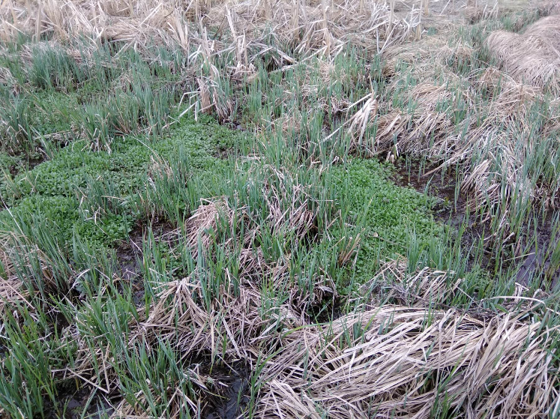 | 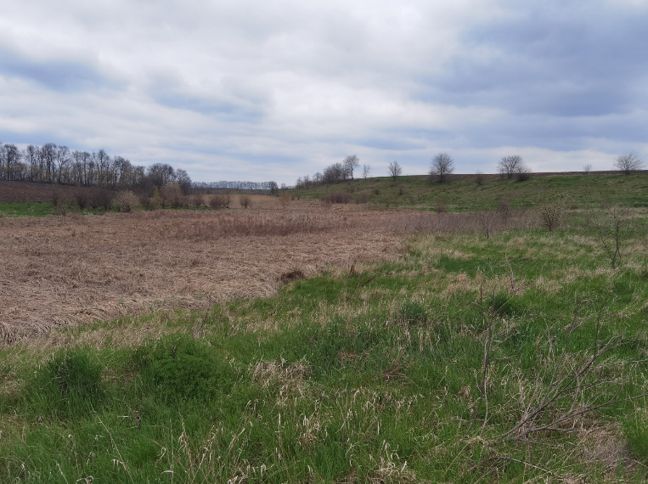
Fig. 2. Characteristics of the surface of the research area

In accordance with the Methodological Recommendations "Soils of the Cherkasy Region", UKRZEMPROEKT, 1969, regraded soils lie on flat, elevated areas of watersheds and on positive slopes. These are mainly podzolized gray, dark gray soils and podzolized chernozems. The grassy vegetation that replaced the forest and dramatically changed the soil-forming process had the greatest influence on the formation of these soils. The reaction of the soil solution of these soils is weakly acidic, close to neutral, and therefore the soils do not need liming. Absorbed calcium prevents the destruction and leaching of mineral and organic soil colloids. Regraded soils are moderately supplied with nitrogen.
Table. 1

Physico-chemical indicators of regraded soils
Soils | The depth of sample taking, cm | Humus content, % | pH of the salt extract | Hydrolytic acidity | The amount of absorbed bases | Degree of saturation with bases, %
 |  |  |  | m eq per 100 g of soil |  | Degree of saturation with bases, %
Dark gray weakly regraded | 0-20 | 2,9  1,4-3,5 | 6,4  6-6,6 | 2,1  1,6-3,6 | 27,4  23,3-32,9 | 92,3  90,5-92,3
Dark gray weakly regraded | 20-40 | 2,2  1,3-2,8 | 6,5  6,2-7,0 | 1,4  0,7-2,2 | 31,2  25,6-36,8 | 91,6  89,4-93,8
Highly regraded heavy loamy chernozems | 0-20 | 3,6  3,0-4,1 | 6,5  6-7 | 1,3  0,6-1,5 | 29,7  22,0-33 | 95,4  93,3-99,0
Highly regraded heavy loamy chernozems | 20-40 | 3,6  2,2-4,0 | 6,6  6,1-7,1 | 0,8  0,4-1,3 | 31,0  31,0-34,0 | 97,3  94,7-99,1
Highly regraded heavy loamy chernozems | 40-60 | 2,5  1,0-3,5 | 6,6  6,4-6,8 | 0,8  0,5-1,1 | - | -
Meadow-swamp and swamp soils | 20-25 | 4,4 | 6,9 | 0,56 | 37,81 | 96,0
Meadow-swamp and swamp soils | 40-45 | 4,21 | 7,05 | 0,47 | 34,07 | 98,0
Meadow-swamp and swamp soils | 75-80 | 3,18 | - | - | - | -
According to Article 35 of the Law of Ukraine "On Land Protection", owners and land users, including tenants, of land plots when carrying out economic activities are obliged to increase the fertility of the soil and preserve other useful properties of the land based on the use of environmentally safe cultivation technologies and equipment, implementation of other measures, which reduce the negative impact on the soil, prevent the irreversible loss of humus and nutrients; to ensure the protection of lands from fires, erosion, depletion, pollution, clogging, salinization, salinization, acidification, overwetting, flooding, overgrowth with weeds, shrubs and small forests.
In accordance with Article 47 of the Law of Ukraine "On Land Protection" in order to protect lands from erosion and landslides, land management, urban planning and other documentation provides for measures to ensure the anti-erosion and anti-slide stability of the territory. Owners of land plots and land users, including tenants, are obliged to carry out soil protection measures in order to prevent the deterioration of their quality and the quality of adjacent land plots and the environment as a whole.
When developing measures to improve the condition of agricultural land and protect land from erosion, it is envisaged to design anti-erosion ponds, which can later be used for the irrigation system.
The main project decisions are reduced to the following:
1. Organizational and economic measures:
- removal, transfer, preservation and use of the fertile soil layer and technological schemes for their implementation;
- reclamation of eroded lands;
2. Agrotechnical: agrotechnical measures to combat soil erosion.
3. Forest amelioration: project decisions on the location and area of protective tree and shrub plantations.
4. Hydrotechnical: determination of design measures for the placement and construction of structures to regulate surface runoff, including anti-erosion ponds.
Organizational economic measures. The territory, which is the object of the study, belongs to the floodplain lands in which the processes of water erosion are intensified (Fig. 2). According to the "Handbook of Soil Conservation Agriculture" edited by I. Bezruchko, L. Milchevskaya (Kyiv, Urozhai, 1990). These lands are classified as:
Category | Subcategory | A brief description of the terrain | Soil, hydrological and plant conditions | Reclamation and technical measures | Business measures
IV | 1 | the bottom of hollows (valleys) and gullies is wide, flat, with a stable, slightly pronounced channel | lands with strong, washed, humus soils, well-moistened, continuous turfing | strip surface or solid root improvement of grass stands with the organization of hayfields under the protection of silt filter plantings | technical operation of silt filter plantings, hay cutting, application of mineral fertilizers

This massif of land is characterized by moderate atmospheric humidity, and in some years it is excessive. Vegetation is represented by depleted cereal forbs, sometimes with admixtures of legumes. Downy oats, heifer, common broom, creeping wheatgrass, small sedge, meadow timothy, autumn dandelion, etc. grow.
The following order of use was established for the lands that became the object of the study: 1 – surface improvement with sub-sowing of perennial grasses, 2–4 – 2-time haying in the seeding stage.
Improvement of hayfields will take place in the following stages: 1 year - sowing of perennial grasses; 2-4 year – 2-time haying; 5th year - re-sowing of perennial grasses.
The grass mixtures recommended for haymaking are developed in accordance with the recommendations of the Republican Design Institute for Land Management "Ukrzemproekt" and are as close as possible to the natural state and include:
1 option. Red clover - 10 kg + meadow sedge - 8-10 kg + thornless sedge - 8-10 kg per 1 ha;
Option 2. Blue alfalfa - 6-7 kg + thornless corn - 8-10 kg + tall ryegrass - 8-10 kg per 1 ha.
Agrotechnical measures. In conditions of intensive land use, soils often lose their potential fertility, degrade or even completely destroy. In order to create ecologically sustainable agrolandscapes on the basis of soil protection principles, the prerequisite is that the factors of degradation must be reduced to a minimum.
Water erosion of soils is the most widespread process of destruction of the soil cover, which consists of removal, transfer and redeposition of the soil mass. Measures to protect soils from water erosion include:
- planting with perennial grasses;
- surface tillage;
- plowing across the slopes;
- timely cultivation of the soil in the phase of its physical "ripeness";
- combination of agrotechnical operations, reduction of the number of inter-row treatments in crops;
- prohibition of plowing thalwegs;
- systematic application of manure in doses that ensure a deficit-free balance of organic matter (approximately 20-30 t/ha once every 4 years);
- apply measures that reduce the negative consequences of soil compaction by heavy agricultural machinery. Do not use in the fields equipment with a specific pressure higher than the permissible standards (about 1 kgf/cm2 when moistened, which is equal to 0.7 physical ripeness and about 0.5 kgf/cm2 at 1 physical ripeness);
- to prevent pollution of the agricultural landscape with household waste, as well as natural ditches, forest strips, temporary quarries, water protection zones, water basins.
When carrying out these measures, it is necessary to observe agrotechnical restrictions, which are due to the need to comply with agrotechnological requirements used in agricultural production. This is, first of all, the reduction of anthropogenic impact on the surrounding natural environment, including the soil, compliance with the directions of technological operations during sowing and harvesting, more complete use of natural biopotential with a simultaneous significant reduction in the costs of performing mechanized operations and saving energy resources, etc.
Forest improvement measures. Along the banks of the ponds, on loose fertile soil, trees and bushes of woody and shrubby vegetation are planted and perennial grasses are sown. The plantations are placed in rows, at a distance of 5 m from the shore, the distance between the bushes in a row is 2.5 meters (Fig. 3). To cover the shores (slopes) of ponds with perennial grasses, creeping broom, Cromi variety, is recommended. This grass is propagated by seeds, later - vegetatively. Sowing seeds is carried out in spring and autumn when the soil temperature is not lower than 16 degrees Celsius. The seed sowing rate is 200 kg per 1 ha, the sowing depth is 0.5-1.0 cm. Alkalinity in the coastal strip will prevent erosion processes, reduce siltation and pollution of water bodies. Protective plantings are a component of the complex of anti-erosion plantings. They provide uniform snow distribution, contribute to retention and regulation of surface runoff, improve the microclimate and hydrological regime.
Projected measures to improve the condition of agricultural land and protect land from erosion (forest improvement measures) are shown in Figure 3.
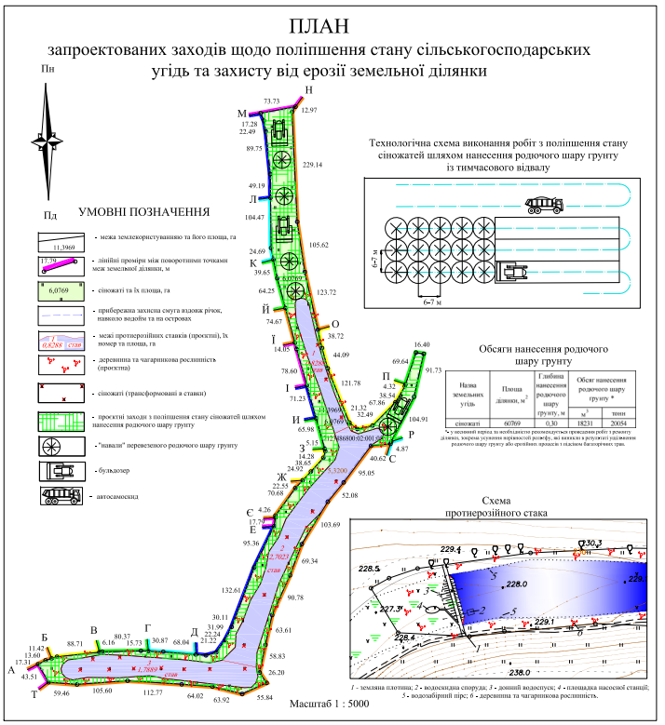
Fig. 2. A plan of planned measures to improve the condition of agricultural land and protect land from erosion
Hydrotechnical measures. Anti-erosion ponds are created in order to delay the flow of rainwater and meltwater, which cause erosion processes. Ponds can be designed on beams, hollows in the form of single ponds or their cascades. Detained water can be used to irrigate the lands bordering the ponds.
Conclusions and perspectives. The development of working land management projects to improve the condition of agricultural land and protect land from erosion is extremely important for the development of land relations. Soil erosion is the main process of soil degradation in the world. In Ukraine, due to the high level of plowing of agricultural land (80%), insignificant areas occupied by soil protection measures, against the background of the general economic crisis and military operations, soil erosion is becoming a national disaster. The area of eroded lands, according to estimates of the State Service of Ukraine for Geodesy, Cartography and Cadastre, reaches 12.2 million hectares, which is approximately 40% of all arable land. Soil erosion not only reduces the humus layer, the content of humus, the yield of agricultural crops, but also changes the appearance of the agricultural landscape, disrupts the overall ecological balance, and strengthens abiotic trends in the development of geosystems. That is why it is so important to restore the soil protection and soil restoration potential of lands by planning and developing protective measures in land management documentation.
References:
1. Land Code of Ukraine. (2001, October 25). Vidomosti Verkhovnoyi Rady Ukrayiny. Kyiv. [in Ukrainian].
2. On the approval of the Rules for the development of working projects of land management: Resolution of the Cabinet of Ministers of Ukraine № 86-2022-p (2022, February 02). Vidomosti Verkhovnoyi Rady Ukrayiny, 86. [in Ukrainian].
3. Law of Ukraine On Land Management from May 22 2003, № 858-IV. (2003, July 8). Holos Ukrainy, № 124. [in Ukrainian].
4. Law of Ukraine On Land Protection from June 19 2003, № № 962-IV. (2003, July 29). Holos Ukrainy, № 139. [in Ukrainian].
5. MARTYN A., KOLHANOVA I. (2021). Do pytannia pro pravyla robochoho proektuvannia v zemleustroi. [To the question about the rules of working design in land management]. Land management, cadastre and land monitoring, 4, 73-93. [in Ukrainian].

Кошель А.О., Колганова I.Г., Кемпа О., Стачерзак А.
До питання про розроблення робочих проектів землеустрою щодо поліпшення стану сільськогосподарських угідь та захисту земель від ерозії
Анотація. Запропоновано науково-методичні підходи до розроблення робочих проектів землеустрою щодо поліпшення стану сільськогосподарських угідь та захисту земель від ерозії.
Головними причинами виникнення і активного розвитку ерозійних процесів є нераціональне знищення природного рослинного покриву, погіршення інфільтраційної та водопоглинаючої здатності ґрунтів та їх протиерозійної стійкості. Сучасна ерозія ґрунтів пов’язана в основному із сільськогосподарською діяльністю людини. Але при відсутності захисних заходів вона розвивається також на територіях населених пунктів і промислових підприємств, трасах доріг тощо. Тому планова та ефективна війна із ерозією є невідємною частиною всієї системи протиерозійної організації території, та має включати такі основні заходи як: організаційно-господарські, агротехнічні, лісомеліоративні, гідротехнічні, які повинні взаємодіяти, проєктуватися і здійснюватися сумісно один з одним.
Отримані результати можуть бути використані при розробленні робочих проектів землеустрою та впровадженні комплексних заходів щодо поліпшення стану земель та захисту ґрунтів від ерозії.
Ключові слова: ерозія, робочий проект землеустрою, порушені землі, охорона ґрунтів, родючий шар ґрунту, малопродуктивні угіддя, документація із землеустрою, землеустрій, управління, землекористування.

