UDC 631.4:528.9
CARTOGRAPHIC MODELING OF SOIL ACIDITY LEVEL
OF THE ZDOLBUNIV DISTRICT OF THE RIVNE REGION
S. Ostapchuk, PhD, Associate Professor of Geodesy and Cartography Department,
E-mail: s.m.ostapchuk@nuwm.edu.ua
N. Kushniruk, Bachelor's degree in Geodesy and Land Management,
E-mail: kushniruk_az19@nuwm.edu.ua
National University of Water and Environmental Engineering

Abstract. The economic use of agricultural land requires systematic agrochemical surveys, a balanced analysis of the results obtained and the adoption of the right decisions to improve soil fertility, increase agricultural efficiency, and preserve the environment. One of the most important tools in this type of research is mapping modelling.
The purpose of this article is to study and analyse the level of soil acidity in one of the most agriculturally developed regions of Rivne Oblast - Zdolbuniv district. Based on the results of the last three rounds of scheduled agrochemical certification of agricultural land (rounds 9-11, 2007-2017) conducted by the Rivne branch of the State Institution "Derzhgruntoochorona", the weighted average indicators of soil pH were calculated in the context of former village councils, a corresponding database was created, and the author's own thematic maps and diagrams were created. The thematic maps were developed using ArcMap software, the coordinate system was Pulkovo 1942 GK Zone 5, the scale was 1:250,000, and the main method of depiction was cartograms. The dynamics of soil acidity in the region during the last three rounds of surveys was summarised and analysed, making it possible to identify areas with optimal, high or low values of indicators, and to identify possible problematic or potentially fertile lands. Specific recommendations for improving soil acidity were provided, primarily for medium acidic soils in the former Staromoshchanytsia and Stupnivka village councils and medium alkaline soils in the former Myrotyn and Uizdets village councils.
Thematic maps and diagrams created in this way, with other additional and detailed data, can become an important basis for making informed management decisions to optimise soil acidity both on the territory of former village councils and agricultural formations, individual fields and plots.
Keywords: soils, agrochemical properties, acidity level, cartographic modelling, thematic maps.

Relevance.
Agricultural use of land resources should be accompanied by proper control over the state of their fertility, erosion, pollution and other important characteristics, which will contribute to the formation of environmentally friendly and highly efficient production [1]. Systematic agrochemical monitoring of land is an important part of this task, as the results of such surveys allow us to make optimal decisions on restoring its fertility, using fertilisers and pesticides, and growing certain crops, which in turn helps to increase agricultural productivity and preserve the environment. The agrochemical properties of soils include various physical, chemical and biological components that are formed through the interaction of mineral, organic and microbiological components.
The main agrochemical properties of soils include the level of acidity, which is caused by the presence of hydrogen ions (H+) in the soil solution and is traditionally represented as pH. Soil pH is affected by the presence of excess calcium and toxic salts (such as chloride, carbon dioxide, etc.). Depending on the pH level, complex physicochemical and bacteriological processes take place, to which agricultural plants respond accordingly. Soils are usually divided into: very strongly acidic, strongly acidic, medium acidic, slightly acidic, close to neutral, neutral, slightly alkaline, medium alkaline, strongly alkaline, very strongly alkaline. If the pH is close to 7, such soils are considered neutral. An increase in pH indicates alkalinity of the soil, and a decrease in pH indicates acidity.
When studying the main agrochemical properties of soils, including the level of acidity, one of the most important and relevant tools is cartographic modelling. In this case, cartographic modelling involves the creation of thematic maps based on the results of agrochemical surveys that show the distribution of specified indicators in a certain area. Such an approach, with the involvement of other additional data, allows us to study the spatial variability of the specified mapping indicators, which is important for justifying appropriate decisions on the further use of agricultural land.
Analysis of the latest research and publications.
The agrochemical properties of modern soils are generally far from optimal. Most of them are characterised by low humus content, acidity deviations, and an unfavourable balance of macronutrients and trace elements. Without solving these problems, it is impossible to grow stable high crop yields [2, 3].
Plant nutritional deficiencies can be caused by both weather factors (e.g., temperature, precipitation) and soil factors (e.g., a decrease in the solubility of nutrients depends on the alkaline or acidic reaction of the soil solution) [4, 5]. The influence of weather conditions on the consumption of nutrients by agricultural plants is quite variable over time, and soil factors are characterised by territorial heterogeneity. Therefore, the issues of spatial and temporal variability of nutrition available to plants have been widely studied recently [6, 7, 8], as measures to improve it should be as specific and rational as possible. The essence of the methodology of these studies is, as a rule, a comparative analysis of geostatistical data for different periods of time.
The issues of thematic soil mapping have been widely reflected in domestic and foreign works [9, 10]. Among them are studies related to the creation of thematic maps of soil conditions in certain regions [11, 12].
Recently, there have also been studies that highlight the issues of soil mapping in certain territorial communities using GIS technologies, for example, in Zhytomyr region [13]. Such approaches are relevant, so many scientific works have been devoted to improving the methodology of soil mapping research through the introduction of modern technologies [14, 15, 16].
Domestic scientists point out that in agriculture, management decisions are still mostly made on the basis of production experience, advertising messages or banal intuition, and the level of information support, including soil mapping, is inadequate and lags behind the requirements of international practice [17, 18].
The aim of the study is to investigate, analyse and visualise the dynamics of soil acidity in the Zdolbuniv district of Rivne region using cartographic modelling.
Materials and methods of the study.
The research is based on the results of the last 9-11 rounds (2007-2017) of surveys - the planned agrochemical certification of land conducted by the Rivne branch of the State Soil Protection Service. The surveys, which are scheduled every 5 years, were not carried out in 2022 due to the Russian-Ukrainian war, a significant reduction in funding, and staff reductions. The future prospect of agrochemical soil monitoring, at least for the near future, is currently in doubt.
Since the surveys were carried out locally within individual agricultural units, we used a standard procedure to calculate the weighted average soil acidity by village councils existing at the time. The information obtained was systematised, entered into a database and used to build thematic maps using special ArcMap software. The maps show information on soil acidity using appropriate symbols and a standard colour scale. Cartograms were used as the main method of depiction. In the absence of information, cartograms are depicted in white. The thematic maps were created in the Pulkovo 1942 GK Zone 5 coordinate system and at a scale of 1:250,000. For obvious reasons, the maps are shown in a reduced form in this article.
Presentation of the main material.
Zdolbuniv district is located in the south of Rivne region and has a total area of 66.1 thousand hectares. It traditionally includes the former Zdolbuniv district, which after the administrative-territorial reform became part of the current Rivne district, and by 2020 had 20 village, settlement and city councils. Currently, Zdolbuniv district includes 3 newly formed territorial communities: Zdovbytska (united the former Zdovbytska, Myrotynska, Uizdetska, Urvenska village councils), Zdolbunivska (united the former Zdolbunivska town, Bohdashivska, Hlynska, Kopytkivska, Novosilkivska, Pyatihirska village councils), Mizotska (united the former Mizotska settlement, Bilashivska, Buderazka, Bushchanska, Dermanska Persha, Dermanska Druha, Malomoshchanytsia, Novomoshchanytsia, Pivchenska, Spasivska, Staromoshchanytsia, Stupnivska village councils). The majority of the region is located on the Volyn Upland, the smaller part on the Polissia Lowland, and the entire territory belongs to the humid and moderately warm agroclimatic zone.
In the structure of the land fund, agricultural land accounts for 42.7 thousand hectares (83.4%). Arable land comprises 34.1 thousand hectares (79.9%), pastures - 4.3 thousand hectares (10.1%), hayfields - 2.8 thousand hectares (6.6%), and perennial plantations - 1.5 thousand hectares (3.5%).
Difficult natural conditions have resulted in a wide variety of soils, with the largest share of light grey podzolised slightly stony (16.8%), dark grey podzolised (13.8%), light grey and grey podzolised medium washed (11.7%) and grey podzolised slightly washed (10.3%).
In general, different soil types have different agrochemical properties that determine their fertility. To achieve optimal results in agricultural production, it is important to take into account the specifics of each soil type and, based on this, apply appropriate agronomic measures, including crop selection, fertilisation, soil conservation, etc.
The results of the 9th round of agrochemical certification in 2007, which assessed the pH content, showed that neutral soils cover 11,437.2 ha (53.1% of the surveyed area), close to neutral soils cover 8,290.9 ha (38.5% of the surveyed area), slightly acidic soils cover 1,428.8 ha (6.6% of the surveyed area), and medium acidic soils cover 388.4 ha (1.8% of the surveyed area). The weighted average pH values by village council (Fig. 1) range from 4.6 (Staromoshchanytsia) to 6.6 (Myrotyn and Pyatihirsk). No surveys were carried out in Zdolbuniv, Stupnivka and Urvenka village councils.
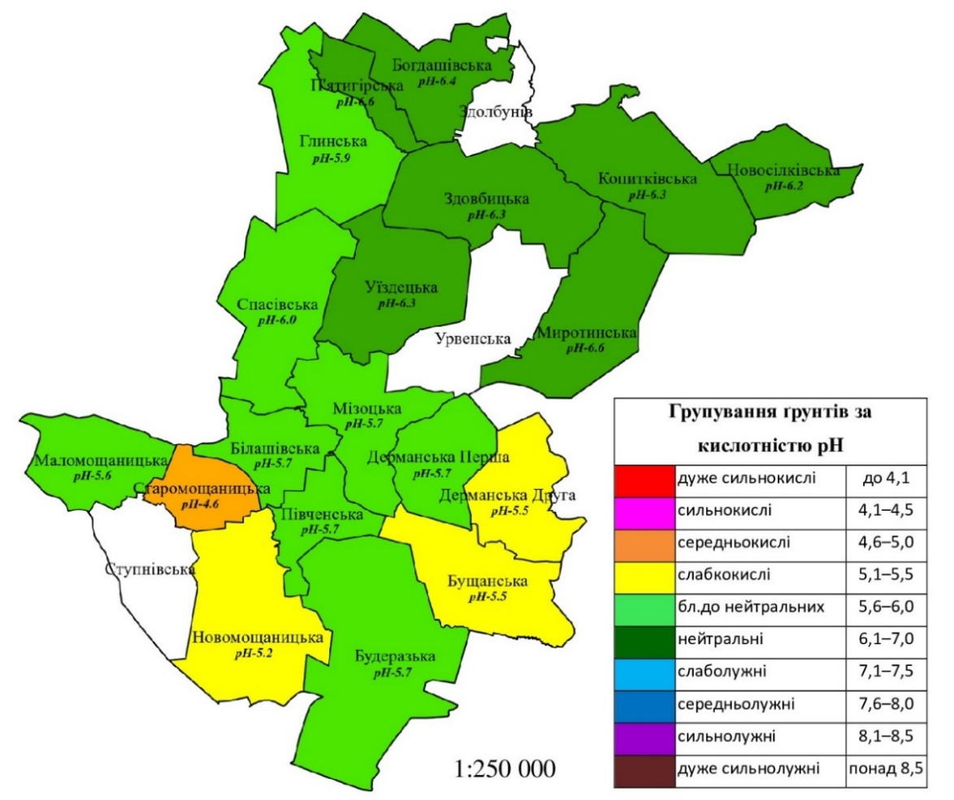
Fig. 1. Weighted average soil pH as of 2007
The 10th round of the agrochemical survey in 2012 revealed that the area of neutral soils is 14,949.1 ha (62.7% of the surveyed area), close to neutral - 6,775.2 ha (28.4% of the surveyed area), slightly acidic - 1,561.0 ha (6.6% of the surveyed area), and medium acidic - 555.5 ha (2.3% of the surveyed area). The weighted average pH values by village council (Fig. 2) vary from 5.0 (Stupnivska) to 6.9 (Myrotynska). No surveys were carried out in Zdolbuniv.
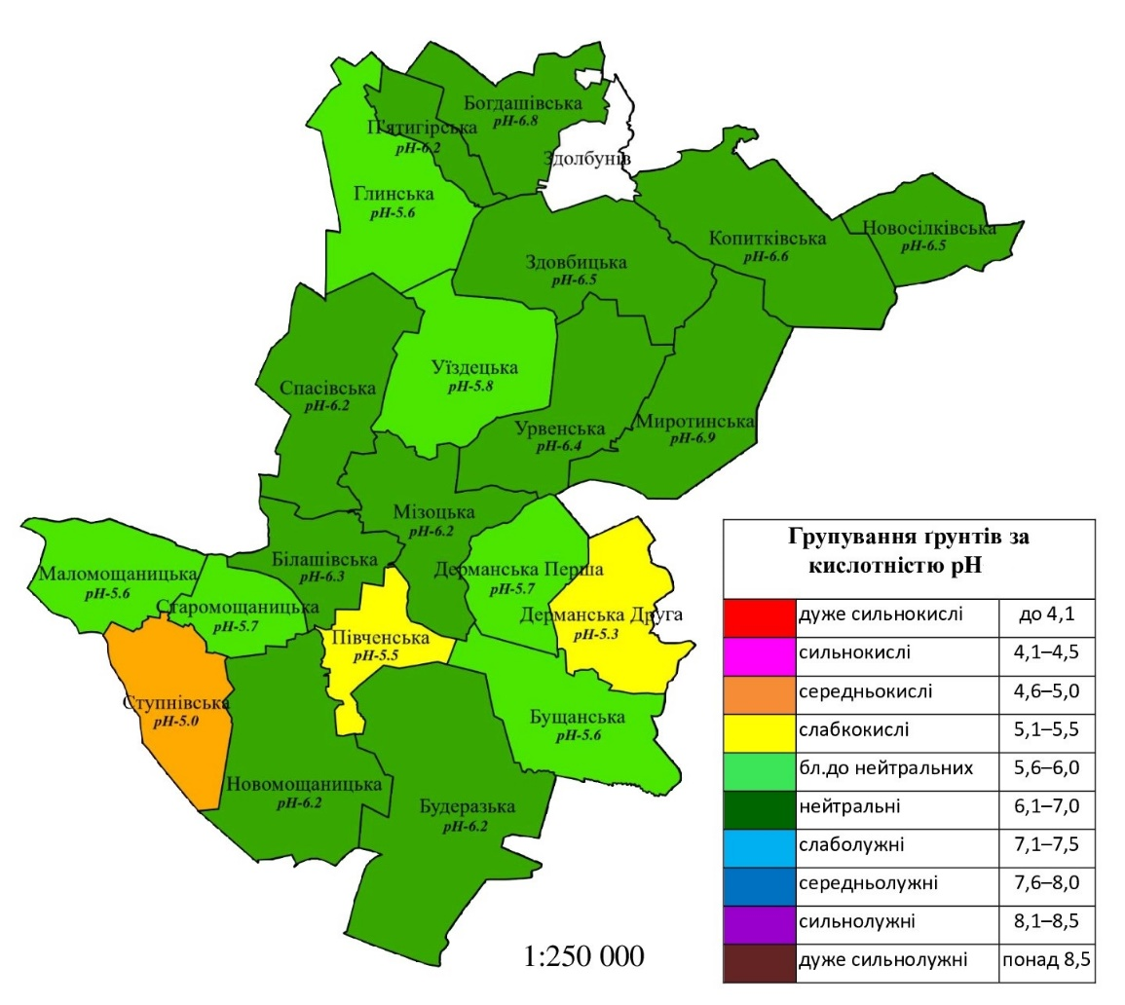
Fig. 2. Weighted average soil pH as of 2012
As a result of the 11th round of agrochemical certification in 2017, the following information was obtained: neutral soils cover 3,810.8 hectares (44.6% of the surveyed area), slightly alkaline soils cover 3,222.2 hectares (37.7% of the surveyed area), slightly acidic soils cover 901.0 hectares (10.5% of the surveyed area), and close to neutral soils cover 617.5 hectares (7.2% of the surveyed area). The weighted average pH values by village council (Fig. 3) vary from 5.3 (Staromoshchanytsia) to 7.3 (Myrotynka). No surveys were carried out in Zdolbuniv, Bushchanske, Dermanska Persha, Dermanska Druha, Malomoshchanytsia, Spasivska and Stupnivska village councils.
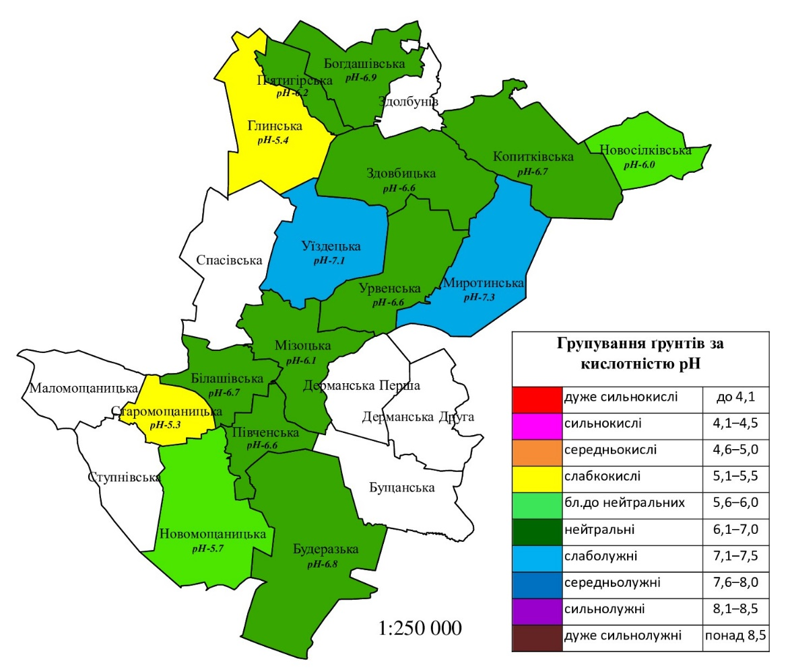
Fig. 3. Weighted average soil pH as of 2017
The thematic maps created with the help of cartograms show the spatial distribution of soil acidity by former village councils. This makes it possible to identify areas with optimal, high or low values, and to identify possible problematic or potentially fertile land. The maps also show specific quantitative weighted average pH values for village councils, which makes it possible to determine changes in the indicator over the period in question for individual territorial units.
The dynamics of changes in the weighted average acidity level of agricultural soils in the surveyed area based on the 2007-2017 agrochemical certification data is shown in the form of diagrams in Fig. 4. There was a slight change in the acidity index from 2007 to 2012 (from 6.0 to 6.1) and a rather large change from 2012 to 2017 (from 6.1 to 6.7). On all the dates shown, the weighted average pH had optimal values, with the best value being the last, 2017, survey.
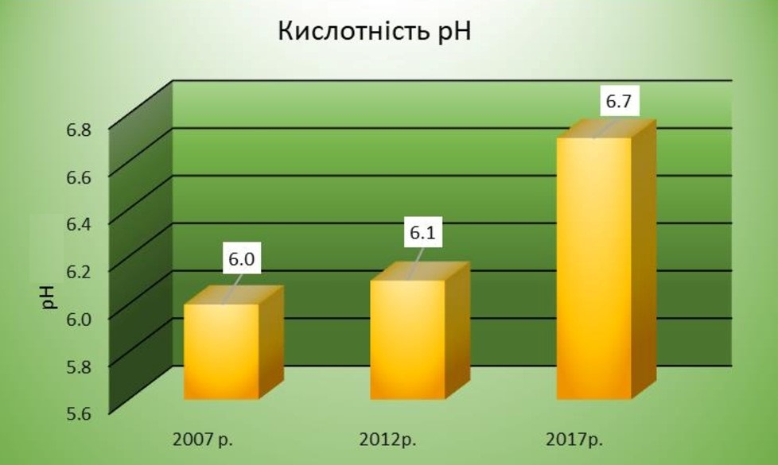
Fig. 4. Dynamics of weighted average soil acidity levels
Conclusions.
Based on the results of the 9-11 rounds (2007-2017) of the planned agrochemical certification of land carried out by the Rivne branch of the State Soil Protection Agency, a cartographic modelling of soil acidity in the Zdolbuniv district of Rivne region was carried out. The corresponding author's thematic maps were created using ArcMap software in the Pulkovo 1942 GK Zone 5 coordinate system at a scale of 1:250,000. Cartograms were chosen as the main method of depiction.
As a result of the research, it was found that the average values of soil acidity of agricultural land in the surveyed area in general for each round have optimal values (from 6.0 to 6.7). In the context of village councils, the weighted average indicators during the specified period vary from 4.6 to 7.3. In this regard, the most worrying soil conditions are in Staromoshchanytsia and Stupnytsia village councils, where they are classified as medium acidic, and in Myrotyn and Uizdets village councils, where they are classified as medium alkaline. In order to achieve a positive balance of nutrients in the soil and increase its fertility in order to grow good crops, it is recommended to use fertilisers containing alkaline elements such as calcium, magnesium and potassium in the first case. You can also use limestone and dolomite flours or sod-limestone fertilisers, which raise the pH level of the soil. On acidic soils, it is very important to use a rational crop rotation system, in which you should pay attention to lupine. In the second case, it will be useful to apply organic materials: pine needles, sawdust, horse peat, fresh manure and inorganic fertilisers: ammonium nitrate, ammonium sulphate, potassium sulphate. The cultivation of rape, white mustard, oats, vetch, and soybeans contributes to the mild acidification of the soil.
The author's thematic maps and diagrams, constructed in this way, with the use of other additional and detailed data, can become the necessary basis for making rational management decisions to optimise soil acidity levels both on the territory of former village councils and agricultural formations, individual fields and plots.
References
- Dorosh O.S., Dorosh Y.M., Zastulka I.-O.Iu. Rol upravlinskykh protsesiv, shcho hruntuiutsia na instytutsionalnomu pidkhodi u formuvanni ekolohobezpechnoho ta vysokoefektyvnoho silskohospodarskoho zemlekorystuvannia // Zemleustrii, kadastr i monitorynh zemel. – 2022. – №1. – S. 18-29.
- Baliuk S.A., Vorotyntseva L.I., Solovei V.B., Shymel V.V. Realii ukrainskoho chornozemu: suchasnyi stan, evoliutsiia, okhorona ta stale upravlinnia // Visnyk ahrarnoi nauky. – 2023. – №101(3). – S. 5-13.
- Polupan M.I., Velychko V.A., Solovei V.B. Rozvytok ukrainskoho ahronomichnoho gruntoznavstva: henetychni ta vyrobnychi osnovy. K.: Ahrarna nauka, 2015. 400 s.
- Kruhlov O.V., Panasenko Ye.V., Zalavskyi Yu.V., Lebed V.V., Afanasiev Yu.O., Nazarok P.H. Mahnitna spryiniatlyvist chornozemnykh gruntiv Kharkivskoi oblasti ta yii diahnostychne znachennia // Visnyk ahrarnoi nauky. – 2019. – №97(10). – S. 12-17.
- Labaz B., Kabala C., Waroszewski J. Ambient geochemical baselines for trace elements in Chernozems – approximation of geochemical soil transformation in an agricultural area // Environmental Monitoring and Assessment. – 2018. – V. 191(1), 19.
- Menna A. Spatial and temporal variability of soil micronutrients and their relationships with wheat (Triticum aestivum L.) yield and some major soil variables // African J. of Agricultural Research. – 2022. – V. 18(6). – P. 385–398.
- Miroshnychenko M.M., Kovalenko S.S. Prostorovo-chasova nerivnomirnist zabezpechennia gruntiv rukhomymy mikroelementamy // Visnyk ahrarnoi nauky. –2023. – №101(4). – S. 5-14.
- Tomaz A., Martins I., Catarino A. еt al. Insights into the Spatial and Temporal Variability of Soil Attributes in Irrigated Farm Fields and Correlations with Management Practices: A Multivariate Statistical Approach // Water. – 2022. – V. 14(20), 3216.
- Kovalchuk I.P., Rozhko O.V. Atlasne kartohrafuvannia gruntiv i zemelnykh resursiv u zarubizhnykh krainakh // Naukovi zapysky Ternopilskoho natsionalnoho pedahohichnoho universytetu imeni Volodymyra Hnatiuka: Heohrafiia. – 2016. – №2. – S. 202-213.
- Miller B.A., Schaetzl R.J. The historical role of base maps in soil geography // Geoderma. – 2014. – V. 230-231. – P. 329-339.
- Ostapchuk S.M., Martyniuk P.Iu. Kartohrafichne modeliuvannia osnovnykh ahrokhimichnykh vlastyvostei gruntiv Volynskoi oblasti // Visnyk Natsionalnoho universytetu vodnoho hospodarstva ta pryrodokorystuvannia: Tekhnichni nauky. – 2016. – №2(74). – S. 231-239.
- Ponomarenko O.M., Nykyforov V.V., Yakovenko V.M. Zminy khimichnykh i mikromorfolohichnykh vlastyvostei gruntiv Poltavskoi oblasti Ukrainy za ostanni 130 rokiv // Ukrainskyi heohrafichnyi zhurnal. – 2022. – №1. – S. 18-26.
- Pyvovar P.V., Nykoliuk O.M., Topolnytskyi P.P. Analiz zemnoho pokryvu terytorialnykh hromad Zhytomyrskoi oblasti z vykorystanniam HIS-tekhnolohii // Ukrainskyi zhurnal pryrodnychykh nauk. – 2022. – №2. – S. 95-117.
- Kanivets S.V., Volkov P.O., Lebed V.V., Bilivets I.I., Zalavskyi Yu.V., Korostin O.V., Shyhymaha I.L. Aktualnist i perevahy doslidzhen gruntovoho pokryvu na novykh metodychnykh zasadakh // Visnyk Kharkivskoho natsionalnoho ahrarnoho universytetu: Gruntoznavstvo, ahrokhimiia, zemlerobstvo, lisove hospodarstvo, ekolohiia gruntiv. – 2016. – №1. – S. 82-87.
- Lebed V.V., Zalavskyi Yu.V. Suchasni metody doslidzhennia gruntovoho pokryvu z vykorystanniam informatsiino-komunikatsiinykh tekhnolohii // Visnyk ahrarnoi nauky. – 2018. – №96(3). – S. 84-86.
- Mapping of salt-affected soils: Technical specifications and country guidelines. Rome: FAO, 2020. 26 p.
- Doloh T.I. Problemy i osoblyvosti upravlinnia vitchyznianymy silskohospodarskymy pidpryiemstvamy // Innovatsiina ekonomika. – 2013. – №3. – S. 101-104.
- Romashchenko M.I., Baliuk S.A., Tarariko Yu.O., Lisovyi V.M. Rozroblennia ta vprovadzhennia Systemy informatsiinoho zabezpechennia zemlerobstva // Visnyk ahrarnoi nauky. – 2022. – №100(9). – S. 5-13.
КАРТОГРАФІЧНЕ МОДЕЛЮВАННЯ РІВНЯ КИСЛОТНОСТІ ҐРУНТІВ
ЗДОЛБУНІВЩИНИ РІВНЕНСЬКОЇ ОБЛАСТІ
С.М. Остапчук, Н.В. Кушнірук
Анотація. Господарське використання сільськогосподарських угідь потребує систематичних агрохімічних обстежень, виваженого аналізу отриманих результатів та прийняття правильних рішень по покращенню родючості ґрунтів, підвищенню ефективності землеробства, збереженню довкілля. Одним із важливих інструментів при виконанні такого роду досліджень є картографічне моделювання.
Метою даної статті є вивчення та аналіз рівня кислотності ґрунтів в одному з найбільш розвинутих у сільськогосподарському відношенні регіонів Рівненської області – Здолбунівщині. За результатами трьох останніх турів планової агрохімічної паспортизації земель сільськогосподарського призначення (9-11 тури, 2007-2017 рр.), проведеної Рівненською філією ДУ «Держґрунтоохорона», обчислено середньозважені показники рівня кислотності ґрунтів рН в розрізі колишніх сільських рад, створено відповідну базу даних, виконано побудову авторських тематичних карт та діаграм. Тематичні карти розроблено з використанням спеціального програмного забезпечення ArcMap, система координат – Pulkovo 1942 GK Zone 5, масштаб – 1:250 000, основний спосіб зображення – картограми. Узагальнено та проаналізовано динаміку кислотності ґрунтів регіону впродовж трьох останніх турів обстежень, надана можливість встановити території з оптимальними, високими або низькими значеннями показників, ідентифікувати можливі проблемні чи потенційно родючі землі. Надано конкретні рекомендації щодо покращення рівня кислотності земель, які стосуються передусім середньокислих ґрунтів на території колишніх Старомощаницької і Ступнівської сільських рад та середньолужних ґрунтів на території колишніх Миротинської і Уїздецької сільських рад.
Побудовані подібним чином тематичні карти та діаграми при залученні інших додаткових і деталізованих даних можуть стати основою для прийняття виважених управлінських рішень по оптимізації кислотності ґрунтів як на території колишніх сільських рад, так і агроформувань, окремих полів та ділянок.
Ключові слова: ґрунти, агрохімічні властивості, рівень кислотності, картографічне моделювання, тематичні карти.

