UDC: 004.9:911.5/.9:528.94
TOWARDS STRATEGY OF GEOINFORMATION SYSTEMs AND TECHNOLOGIES USE FOR TERRITORY MANAGEMENT

Chabaniuk V., Ph.D. in Physics and Mathematics,
Senior Researcher,
Institute of Geography of the National Academy of Sciences of Ukraine
E-mail: chab3@i.ua
Dyshlyk O., executive director, Geomatic solutions LLC,
E-mail: dyshlyk@geomatica.kiev.ua

Abstract. GeoInformation (GI) Systems (GIS) and GI Technologies (GIT, together GIST) have been used for almost half a century, since the creation of Canada's first GIS in the 60s of the last century, to solve territory management problems. Over the past years, GISTs have reached their maturity, but still continue to develop, covering ever wider areas of use. Even the science of geoinformatics has emerged, in which GIST is used mainly as a toolkit or technology. As an example, geoinformatics in the same Canada is called geomatics and is a technology and/or technological science.
At the same time, the expansion of the field of GIST use poses to researchers the question of methods and methodology. They are followed by issues of methods and methodology of geoinformatics not only as a technology, but also as a science. Moreover, these issues become more complicated with the expansion of the field of use. In the information industry, together with the field of use, the term "domain" or "context" is used. Thus, modern GIST usage manipulate a large number of interrelated terms and concepts that are often not clearly defined. The work is devoted to the classification of the main ones, which are influenced by the strategy selected.
Spatial models of territory are used in the work. They are used in the study of both territorial systems of reality and individual spatial entities and phenomena of reality. Among spatial models, the main attention is paid to information spatial models, the most famous of which are GeoInformation Systems (GIS). GIS are inseparable from GIS tools - GeoInformation Technologies (GIT).
The main results of the article were obtained using the so-called method of Conceptual Frameworks (CoFr) of Spatial Information Systems (SpIS). The CoFr method is applied to a special class of GIS - Atlas Geo-Information Systems (AGIS) of large territories (LT). The AGIS class includes Electronic Atlases (EA), Atlas Information Systems (AtIS), Cartographic Information Systems (CIS) and, in fact, GIS, if we are talking about LT.
AGIS-LT is a hierarchical echeloned SpIS, for which the main terms and concepts of the article are applicable. These are such terms and concepts as "strategy" and "methodology" of GIS usage. GIS, in turn, use GIT, which are also classified using CoFr SpIS.
Keywords: strategy, methodology, technology, geoinformation systems (GIS), geoinformation technologies (GIT), Atlas GeoInformation System (AGIS), method of Conceptual Frameworks (CoFr)

Introduction
"Territory (lat. Territorium - area, territory; from terra - earth) - a region, a limited part of the earth's surface within natural, state, administrative or conventional boundaries: it is defined by length, as a specific type of "spatial" resource, area, geographical location, natural conditions, economic development. The territory is the object of a specific activity. Also: Administrative unit of the state, which is temporarily implemented in underdeveloped regions until the economic, demographic and political growth is noted to the extent that it is possible to manage the region in the same way as in organized developed regions of the country, such as in Canada and Australia." [accessed 2023-Aug-28, https://uk.wikipedia.org/wiki/territory].
It follows from the above and other definitions that a mandatory property of the territory is some spatial attribute or, in other words, some spatial characteristic. Territories are studied with the help of so-called spatial/territorial models/systems, which are built for a chosen research problem or, alternatively, for a chosen domain or context. It is logical to assume that tools for working with "spatial" models/systems of the territory can be GeoInformation (GI) Systems (GIS) and/or GI Technologies (GIT) - together GIST. In this work, we want to organize the concepts used in the usage of GIST. At the same time, the so-called Model-Based Approach is de facto postulated. In this approach, the "mantra" is valid: anything is a model. Therefore, models are all territorial systems. Models can also represent spatial entities, processes and phenomena, which ultimately relate to some territory and/or territorial system.
Some of these models are well-known because they are used in the consideration of well-known problems. For example, the most famous model of sustainable (balanced) development of Ukraine is the model of the so-called Agenda2030 [1]. All of its 17 goals have been adapted and approved in Ukraine by Decree of the President of Ukraine No. 722/2019 "On the Goals of Sustainable Development of Ukraine for the Period Until 2030" dated September 30, 2019 (https://www.president.gov.ua/documents/7222019-29825, accessed August 31, 2023). Some means/tool is needed to present the goals of the Agenda 2030, as well as to examine the current state of their achievement. Since Ukraine and its regions are modeled by territorial systems, it is likely that GIS can be a means of ensuring sustainable (balanced) development of Ukraine's regions.
The modelling system - such as, for example, the territorial system of sustainable development of Ukraine or its regions - is an abstraction that does not exist in reality. However, people need this abstraction to carry out activities with spatial entities, phenomena, processes and territorial systems of reality. In Agenda2030, a model of sustainable development of some hypothetical country in the world and, perhaps, the world in general, is proposed. In this work, we do not consider certain shortcomings and advantages of the Agenda2030 model. We only state that the Agenda2030 model can be implemented in a separate country with the help of: 1) modelling of processes - spatial activity system (SpAS) of sustainable development of the territory or 2) modelling of products - geo-information system (GIS) of sustainable development of the territory.
In this work, we use the concept of special modeling systems - Atlas Geo-Information Systems (AGIS). AGIS includes all Atlas Systems (AtS), which we have been engaged in for almost 20 years: Electronic Atlases (EA) and Atlas Information Systems (AtIS). AGIS is both AtS and GIS. They are considered in work [2] on the example of a specialized AGIS - AGIS of Cultural Heritage (AGIS-CH).

Problem and purpose

"Страте́гія (дав.-гр. στρατηγία, страта тегів — мистецтво полководця) — це загальний, недеталізований план, що охоплює довготривалий проміжок часу, спосіб досягнення складної мети. Завданням стратегії є ефективне використання наявних ресурсів для досягнення основної мети (стратегія як спосіб дій стає особливо необхідною в ситуації, коли для прямого досягнення основної мети недостатньо наявних ресурсів). Поняття походить від поняття військової стратегії - науки про ведення війни, однієї з областей військового мистецтва, вищий його прояв, яке охоплює питання теорії і практики підготовки до війни, її планування та ведення, досліджує закономірності війни" (https://uk.wikipedia.org/wiki/Стратегія, доступ 2023-вер-02). / "Strategy (Anc.-Gr. στρατηγία, strategy of tags — the art of the commander) is a general, non-detailed plan covering a long period of time, a way to achieve a complex goal. The task of strategy is the effective use of available resources to achieve the main goal (strategy as a method of action becomes especially necessary in a situation when there are not enough available resources for the direct achievement of the main goal). planning and conducting, explores the patterns of war" (https://uk.wikipedia.org/wiki/Strategy, accessed 2023-sep-02).
The given definition explains why the term "strategy" is so often found in the activities of organizations and individuals in conditions where something new needs to be done or something old needs to be fundamentally revised. It is especially important to have a general (but correct) plan when you need to deal with something at least intuitively "big". As a rule, the term strategy is used with some phrase that defines a part of reality or the context of using the strategy. The context of interest to us is defined as "sustainable (balanced) management of a large territory." If the territory is a country, region or other region defined by other legitimate conditions, then it is appropriate to talk about the context of the sustainable development system model of a "significant" size or "large" territory. It is in this context that we concentrate our work. Therefore, the following titles of the article "Strategy of using ..." could be correct:
- GIT for territory management.
- GIT for the creation of GIS for territory management.
- GIS territory management.
- GI methodologies (GIM) for territory management.
- GIM and GIT for managing the territory.
- GIS and GIT for creating GIS for territory management.
This list of possible article titles can be continued, but all of them can be reduced to one of two main options, which we call creation: 1) a product - for example, GIS of territory management; 2) of the process - for example, the use of GIT for territory management. The last process refers to the activity system.
In practice, none of the two options can exist separately and independently of the other. Therefore, the main interest of the work is "intermediate" options, when it is necessary to consider modeling systems of the "product-process" type. It also follows from the given names that we are limited to geo-information models, which are implemented with the help of GIM, GIT or GIS. In fact, we do not know of alternatives to these models.
The first title given above - Strategy for the use of GIT for territory management - is one of the correct titles of this article. We have come across such a phrase in our practice, and then we wanted to find out from the authors what was actually meant. However, it was very difficult to get an explanation from the authors of the terms, since the term and its meaning were understood by them very ambiguously. In addition, the given name is clearly incomplete, since strategy is a very general and too theoretical concept. On the other hand, the very first definition of technology is, for example: "TECHNOLOGY - a set (system) of rules, techniques, methods of obtaining, processing or processing raw materials, materials, intermediate products, subjects (products) used in industry." That is, technology is very closely related to practice, so it is very difficult to immediately answer the question why it is necessary to use such practical subjects as GIT for territory management.
The following clarification/continuation of the definition does not help much: "Technology, understood in a broader sense, is related not only to technology, but also to civilization conquests. When they talk, for example, about computer or information technology, they mean new opportunities opened up by them, or the scientific and technical revolution that they bring with them. … Gradually, technology began to mean a complex reality that functionally provides certain civilization conquests…”. Let's emphasize that technology "ensures" certain civilization achievements, which does not negate its "practicality".
The use of the "strategy" and "technology" concepts is not enough to develop the "overall plan to achieve the goal" that is required according to the definition of strategy. After all, in order to use technology, you need to know how to use it. That is, there must be something else "between" the concepts of strategy and technology that allows the use of technology in accordance with the strategy. This something is most generally called methodology, although in specific cases it is enough to have "method" or "methodics". For such a goal as (optimal) territory management, it is better to consider strategy, methodology, technology and the relation between them.
"METHODOLOGY is a type of rational-reflective consciousness aimed at the study, improvement and construction of methods in various spheres of spiritual and practical activity. There are methodological ideas and concepts of various degrees of development and constructiveness, of various levels and breadth of coverage (methodology at the level of philosophical reflection, general scientific methodology and the methodology of interdisciplinary science, the methodology of private sciences). Currently, methodological concepts related to certain types of activities (educational methodology, engineering methodology, design methodology, etc.) are being developed." The formation of the very idea of teaching about the method as a kind of "correct path" of cognition and meaningful life orientation is connected with the emergence of philosophy, which acts as a rational-theoretical form of worldview and thereby subjects the initial prerequisites of a person's attitude to the world to reflexive analysis and control.
"METHOD (from the Greek μετοδος (a way of research or cognition, from μετά- + ὁδός "way") — a way of research, cognition, theory, doctrine — in a broad sense, a conscious way of achieving any result, carrying out a certain activity, solving some tasks . The method involves a known sequence of actions based on a clearly understood, articulated and controlled ideal plan in various types of cognitive and practical activity in society and culture. The method, in principle, involves a conscious correlation of the methods of action of the subjects of this activity with the real situation, evaluation of their effectiveness, critical analysis and the choice of various action alternatives, etc."
"METHODICS is a fixed set of methods of practical activity that leads to a predetermined result. In scientific knowledge, the methodics plays an important role in empirical research (observation and experiment). Unlike the task method, the methodics does not include the theoretical justification of the obtained result, it concentrates on the technical side of experiment and on the regulation of the researcher's actions."
To manage the territory, it is needs to know what to manage. A large territory is perceived by people as a complex spatial system, so its direct knowledge is limited by many factors: financial, resource, time, etc. As a result, managing such real systems is very difficult. Therefore, models are created that are the necessary simplification of the spatial systems of the territory. Perhaps the most famous such model is the GeoInformation System (GIS).
At the same time, it is possible to manage the territory without creating a GIS, but only using GIT. In this case, the managing organization must have a "spatial activity system" (SpAS), which is organized in such a way that it becomes possible to use GIT for territory management. Again, we are dealing with a modeling system, which in this case is called SpAS. This system is more general than GIS of territory management, if GIS is understood according to the classical definition [3].
Thus, the more correct title of the article is: Strategy for using GIM and GIT to create a GIS or SAS of territory management. This title outlines the issues that need to be considered in any management strategy for any "large" territories: country, region, territorial reserve, community, etc.
The main goal of the work is a logical and justified classification of the concepts GeoInformation (GI) Technology (GIT), GI Methodology (GIM), GI System (GIS) in the context of territory management, as well as a multilateral (systemic) definition of the concept of "strategy" and its "location" in the resulting classification.

Research methodology
For almost twenty years, both in scientific research and in practice, we have been using information systems (IS) in a narrow (ISn) and in an broader (ISb) understanding. ISn are computer-based subsystems that are "designed to provide registration and support services for the operation and management of the organization. ISb are a set of all formal and informal data representations and actions with them in the organization, including the exchange associated with the first and second, as an internal, as well as with the outside world" [4].
A special type of such IS are spatial IS (SpIS), which are denoted respectively as SpISn and SpISb. SpIS are models of spatial systems of reality, which are hereinafter referred to as SpaSys. SpISn includes such well-known "classical" types of modeling systems as Electronic atlases (EA), Atlas information systems (AtIS), Carto- and Geo- Information Systems (CIS and GIS). For each such system in the narrow sense, there is a corresponding system in the expanded sense. Extension is carried out by adding models and systems that contain additional knowledge. An example of such extension is the addition of the Electronic version of the National Atlas of Ukraine (ElNAU) with artefacts that were created during the phases of its research and development [5]. That is, each copy of ElNAU circulation on DVD [6] is an example of ElNAUn, and its extension is ElNAUb.
In work [5], Conceptual Framework (CoFr) of ElNAU was found, to which both ElNAUb and its "operational" part - ElNAUn - correspond. Instead of the term "conceptual" it is possible to use the term "notational", since it gives an idea about the project of ElNAUn development. The following studies proved that the Conceptual Framework is valid for all EA in a certain formation of their evolution. Such evolutional formations are Web 1.0, 1.0x1.0, 2.0 and others [7]. Framework is an architectural pattern that offers (represents) an extensible template for applications in a certain subject area [8]. According to [9], "A pattern is both an subject (thing) that occurs in the world and a rule (process) that tells how to create an subject and when to create it. It is both a process and a subject; simultaneously a description of an existing subject and a description of the process that generates this subject" (Fig. 1a).
Thus, Conceptual Framework of a system represents both the subject (product, EAb) and the process of its creation, if EA is used as an example of an subject (in our case, a modeling system). Therefore, the Conceptual Framework is often called and used as the method of Conceptual Frameworks. Especially if you need to carry out research or construction of some kind of SpISn or SpISb. This method is easier to apply if there is an analog system that is used as a model - the initial value of the Conceptual Framework. Then we are talking about the parameterized Conceptual Framework (Fig. 1b). In this figure, the parameter is ElNAU, the icon of which is shown in the dotted rectangle in the upper right corner of the AGIM package.
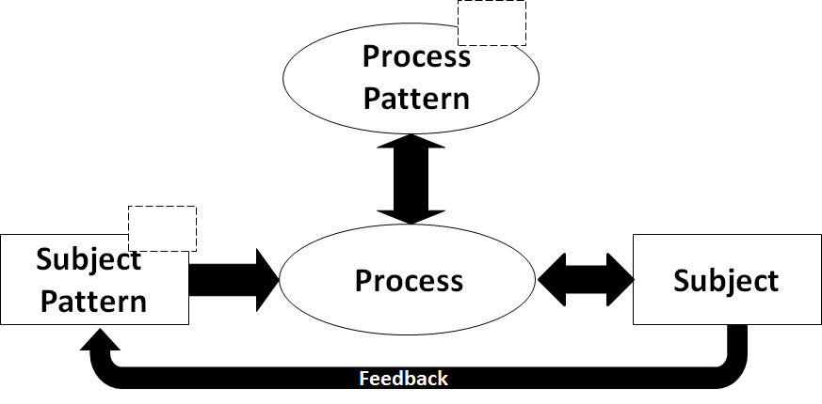 | 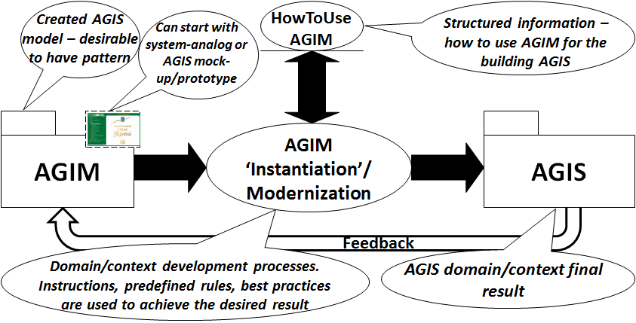
a) | b)
Fig. 1. a) Pattern scheme according to [9; p. 247]; b) The process of using AGIM to build AGIS according to [Fig. 2; 7.1]
"METHODics is a fixed set of methods of practical activity that leads to a predetermined result. In scientific cognition, the technique plays an important role in empirical research (observation and experiment). Unlike the method, the task of the methodics does not include the theoretical justification of the obtained result, it concentrates on the technical side of the experiment and on the regulation of the researcher's actions".
In this way, the Atlas GeoInformation Model (AGIM) was obtained, which in turn was used to obtain the conceptual structure of the Atlas GeoInformation System (AGIS) of the Cultural Heritage (CH) [2]. It is important to note that AGIS-CH is a model of the spatial system of sustainable development of Ukraine, which is "constructively" different from the Agenda2030 model, although it is based on it (Fig. 2).
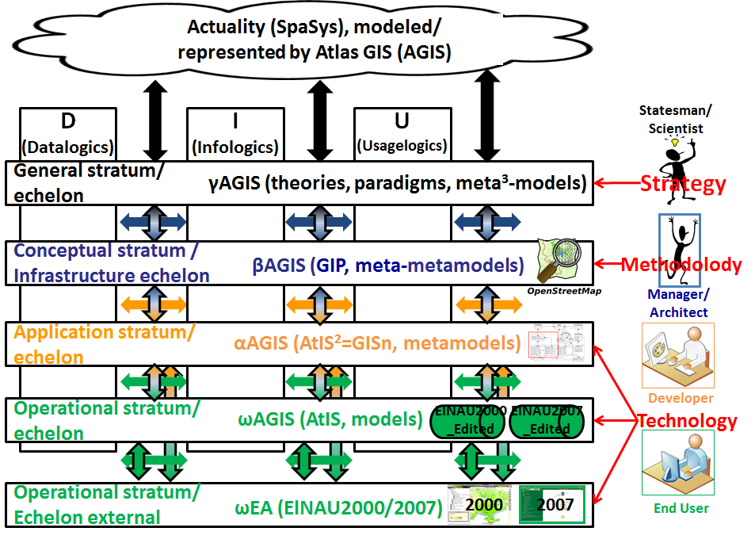Fig. 2. Conceptual structure of AGIS product part
On Fig. 2 it is marked:
- Product and process parts of AGIS. Products are identified by color, ωEA, ωAGIS αAGIS, βAGIS, γAGIS sets designations, certain clarifications in parentheses (for example, ElNAU2000/2007), and designations of some products (for example, OpenStreetMap). Processes (relations) are identified only by color and two-sided volume arrows, which also mean sets of relations. This identification of the products is enough to obtain the most complete information about them after using the additional information in the monographs [7] and [2]. Identification of processes is not enough. Therefore, in the Fig. 2 caption the term "product" is used.
- GIP – GeoInformation Platform. To better match the name, it would be more logical to use the GIS notation here. However, GIP denotes a new, "non-classic" type of GIS that has not yet received its clear definition as GIS in the scientific literature. In more detail, the issue of modern changes to the classic definition of GIS is considered in [3].
- AtIS2=GISn (AtIS2=GISn) – dynamic atlas information system. The notation of AtIS in a square is used to show that all constructive components of AtIS can change, but within a set of certain "classic" values, so the final solution still remains classic. Values obtained by using certain scientific knowledge can be called classic. The components from which AtIS is "constructed" are called constructive here. Typically, these structural components are patterns such as, for example, a decision/content tree or a thematic map.
- On the right side, approximate names of AGIS user groups, which belong to the five organizational echelons, are shown. Echelons correspond to five AGIS strata. User groups use such subjects as strategy, methodology and technology. So, the technology is mainly used by developers and two groups of end users: system and external. Managers/architects also use technology, but their main responsibility is the Conceptual stratum and the Methodology that belongs to this stratum.
AGIS includes, on the one hand, a system of spatial information systems (SSpIS). These GIS are hierarchically organized in relation to the knowledge that is implemented in them at each hierarchical stratum. The constructiveness consists in the fact that the operational strata's SpIS are EA and AtIS, which can be operated by end users. In addition, EA and AtIS are quite simple to implement, but with the preservation of power in terms of modeling spatial systems of reality. The lower strata of SSpIS are connected to the higher strata by constructive or practically realizable relations. Due to this, it is possible to improve EA and AtIS, if theoretically more powerful models of spatial systems of reality: GIS and GIP will be improved. However, GIS and GIP are difficult to implement for large territories and they will be very complex. Finally, constructiveness is also ensured by the fact that each thematic map (which may correspond to some indicator of sustainable development) from EA/AtIS can have a numerical "weight" in the model of sustainable development. In this way, it is possible to perform a numerical assessment of the level of sustainable development at each specific moment in time. So, it is possible to develop a plan to improve the value of the assessment of the state of sustainable development.
On the other hand, AGIS includes a spatial activity system (SpAS) or, more correctly, a system of activity that is carried out with spatial entities and phenomena. It so happened that during the development of information systems attention is first always paid to the structure and subjects (objects) of the system and only after that to the processes that exist between the subjects. This is exactly what is repeated in this article, but for information systems in the broader sense (ISb). Perhaps the following formulas, which are applied to sets of involved systems, will help to better understand what has been said: SpISb \ AGIS (difference) ≠ Ø (not empty), AGIS=SpIS ∪ SpAS (unification).
Please note that Fig. 2 shows two Operational echelons of end users. Echelons correspond to Operational Strata from a system perspective. These end users are not the same. End users of the "Operational Echelon External" are also called external. In principle, it can be anyone. In order to use the capabilities of AGIS-CH, external users can register and gain access to a number of system capabilities according to the rights granted by registration. End users of the "Operational Echelon" must be licensed to be authorized to work with the system.
Without going into details, we note that Fig. 2 shows the SpISb of two formations: Web 1.0 and Web 1.02: EAb and AtISb, where EAb ⊂ AtISb. AGIS-CH is a GIS of the Web 1.02 formation, and the latter includes the Web 1.0 formation. It is very important that in the Web 1.02 formation the method of extension has changed. In the Web 1.0 formation, it was a "bottom-up" method, which is also called "AtEx - Atlas Extender". This method was used in work [5] to obtain, in addition to ElNAU CoFr, also ElNAUSb. In the Web 1.02 formation, it became possible to use the "top-down" or "geoinformation extension" method (GeoInEx - GeoInformation Extender). While working on the methodology of AGIS creation, we came to the conclusion that the method of extension is closely related to the methodology of various types of GIS creation.

Strategy
Today, there is no clear understanding of what strategy is, just as there is no separate discipline dealing with its study. At the same time, the purpose of the strategy, regardless of the context of its usage, is to facilitate the transition from the current present to the desired future. The strategy answers the question of how to do it and, if possible, easier and faster. It is possible to say that strategy is a set of theoretical and practical efforts aimed at achieving and/or maintaining some desired state. The transition should be optimal, which allows to reduce the time and resources necessary for its implementation.

Introduction to the concept of strategy
There are specialized fields of strategy study and usage. Among the most well-known, it is possible to note, firstly, military strategies, secondly, business strategies, thirdly, diplomatic, political and macroeconomic strategies. Currently, there are a sufficient number of highly specialized usages of strategy, however, interdisciplinary research in this area is practically absent. Despite the large number of books in which the word "strategy" formally appears in the title, there is currently no clear and acceptable description of this discipline, applicable to the solution of specific practical problems that each of us faces.
Attempts to get acquainted with the literature on strategy end with the study of specialized literature written by recognized masters of their field. They have thoroughly studied this matter, know all the nuances and subtleties of this particular field of activity. Unfortunately, there are not many such people, and there are even fewer comprehensive books. Most often, we read something that somehow intersects with our tasks, and painfully try to transfer the acquired knowledge to the field of our activity to solve our specific and unique tasks. At the same time, there are certain regularities and principles that are repeated for many tasks and areas of knowledge.
The essence of the strategy is some key decision that should help in achieving the goal. As a rule, a strategy is a set of decisions that form the direction of efforts. All subsequent actions should be in line with this and should be subject to previously made decisions. This is the essence of the strategy - it directs efforts, sets the vector of movement.
Pay attention to the word "must": "... must help in achieving the goal." We assume it will help, but we can't know for sure. Therefore, strategy is always an opportunity. It may or may not work. However, the probability can be increased, for this there are many universal principles and laws that should be taken into account in your plans. It is not difficult to develop a strategy, it is difficult to develop a workable, effective strategy.

Strategy as an element of the Conceptual (Notational) Framework
It follows from the previous material that for optimal management of the territory, it is necessary to have a strategy for creation an AGIS or, at least, one of two systems: SSpIS and/or SpAS. Both systems correspond to the definition of ISb, but they have different specializations: product and process. Product specialization means that it is necessary to create several SpIS to manage (large) territories, combine them into a system of systems and possibly extend them to SpISb. Process specialization means that first attention should be paid to the processes of data and information transformation, and then to the realization of products that take part in these processes.
Researches have shown that there are no practical methodologies for such systems creation, so an original methodology for AGIS class systems was developed [10]. We cannot describe it in detail here. However, to begin with, it is possible to consider the "approaches" to the creation of SSpIS and/or SpAS. Four such approaches can be distinguished: 1) constructive, 2) declarative, 3) mixed constructive-declarative, 4) mixed declarative-constructive.
The first two approaches are explained here with the help of two research strategies of design science research strategies in information systems [11], which has been intensively developing recently. "In the first strategy, the researcher constructs or builds an information technology (IT) meta-artefact as a general concept of a solution to a class of problems, and then applies these solutions in a specific context. Thus, a constructive or otherwise normative approach is used. In the second strategy, the researcher tries to solve a specific client problem by building a specific IT artefact in this specific context. Thus, a descriptive approach is used. Then, constructive (prescriptive – prescriptive, normative) knowledge is extracted from the experience gained, which forms a general concept of a solution to solve a class of problems."
The third and fourth approaches are based on the first two. In our case of creation a system of territory management systems, a constructive approach can be applied to one constituent system, and a declarative approach to another.
The descriptive approach still prevails in the projects of creation of classic SpIS. It is usually consistent with some classic approach to the IS development life cycle: first the development of the specification (TOR) and then the development of the IS according to some development process. However, there are several major problems in the projects of creation of SSpIS and SAS, which make the use of a descriptive approach impossible:
- Territorial management GIS are not classic IS.
- The resulting SSpIS system of systems is so complex that the development of TOR for such a system will give almost nothing, because: 1) development of TOR will take a lot of time, 2) development of a system according to such TOR will take an order of magnitude more time, 3) over a long period of time TOR and the developed system will become obsolete to such an extent that the need for their development may disappear.
- The resulting SSpIS system of systems should include as many typical solutions as possible, so that in the end it is possible to satisfy the maximum number of users.
It is necessary to pay attention to the hierarchy of the concepts of strategy, methodology and technology in Fig. 2. According to the Conceptual Framework used for obtaining this figure, the relation between strata/echelons is very rigid. So, in particular, it is impossible to "skip" any stratum without negative consequences. Therefore, neither strategy nor technology makes any sense without a methodology. Already more than thirty years ago, we derived the rule 1+3+8=12, which is valid for the GIS being created. It means that the 1:3:8 ratio must be observed in some systematic "measure" when creating a GIS. For example, if we are talking about financial estimates of the GIS development cost, then for the success of the development project you need to have, for example: UAH 1 for hardware, UAH 3 for software (together this is technology) and UAH 8 for the "rest" of the system (which includes the methodology). The rest was to be spent on data and information transformation processes, where the main costs were to be human costs. Moreover, on qualified people who could use the methodology if it is available.
Over the years, the rule 1+3+8=12 has not changed much. Perhaps the hardware cost share has decreased. Perhaps nowadays it is possible not to spend 3 UAH for licensed software, because almost any such software has its open (open source) counterpart. However, in this case, a certain part of these 3 UAH will have to spend on specialists who do not perform, but only support the system/project. An example of such specialists are system administrators. On the other hand, the more expensive the software, the higher the qualifications of the specialists who use it for development, support and operation should be. Finally, it is not known how much the cost of specialists has increased over thirty years. Therefore, we can conclude that nowadays the difference in cost between technology and methodology has become even greater. From the viewpoint of cost, it is obvious that the differences between technology and methodology are qualitative, no less than by an order of magnitude.
We can assure readers that the issues raised are very practical. For example, if you have 4 UAH instead of 12 UAH, the expected for 12 UAH GIS will NEVER be created. Perhaps an order of magnitude simpler GIS will be created for 1-2 UAH. However, this is not a fact either, since technologies require financing even before the system is created, and therefore even for a simplified system there simply will not be enough funds. Even now, after thirty years of using GIS in Ukraine, many believe that it is enough to purchase, for example, (some part of) GIT from ESRI, Inc. (producer of ArcGIS) and the required GIS is already created, some minor work remains. They believe that ArcGIS is a GIS. In this article, we show that this is not the case. GIT cannot replace either GIS or GIM. These are different subjects. Unfortunately, the people who make decisions about funding the creation of the system are not very familiar with GIT and the practice of their usage. People who develop one or another strategy for their use in a specific organizational structure are not familiar with GIT.
Before the end of the subsection, let us remind you that SSpIS and SpAS have such a critical property as the mandatory presence of three components: educational-scientific, industrial and management (see, for example, [3]). Now the strategy of using GIM and GIT to create SSpIS or SpAS for territory management are formulated as follows: In order to create a SSpIS or SpAS for territory management using GIT, it is necessary to apply three methodologies for the development of components of the system of systems: 1) constructive - for industrial and management components, 2) descriptive-constructive - for educational-scientific components, 3) constructive-descriptive – for industrial and management components, to which it is impossible to apply a "pure" constructive methodology.

Elements of the AGIS creation methodology
We do not have the opportunity to consider in detail the methodology of AGIS creation, so we will dwell briefly only on what seems to be the most important at the moment.

Strategy and plan
At the beginning of the current century, we got acquainted with the methodology of software systems creation, which was called Microsoft Solutions Framework (MSF). We were most surprised by the goal of the methodology, which came down to the following Goal of Enterprise Architecture (ЕnA) [12]:
Provide a logically consistent plan of activities and coordinated projects that manage the development of the structure of application systems and infrastructure of the organization. The plan should define a consistent transition from the current state to the intended future state based on current and projected goals and processes.
Logically consistent - all parts of the overall plan are considered together, they must be logically connected.
Activities and coordinated projects - tasks of architecture concern both daily activities and independent projects.
Consistent transition from the current to the intended future state - architecture should not only describe the current situation, but also offer a perspective vision. Most importantly, the architecture articulates a clear path from the current state to the desired state through releasable versions.
Current and prospective business goals and processes - the project will be useless if it does not take into account both the current state of affairs and the prospects for the development of business and production processes. On the other hand, business plans are often shaped under the influence of IT advances, for example, the development of Internet access has forced many companies to urgently create e-commerce divisions.
The MSF consisted of six models, the main one of which was the Enterprise Model EnA (Fig. 3a). MSF's approach was generally called "Architecture-first". Within the framework of this article, we can call this approach the essence of the MSF strategy.
The EnA must be created iteratively, and at each iteration it was necessary to perform the stages (phases): Conceptualization (Envisioning), Planning, Developing, Stabilizing (Fig. 3b).
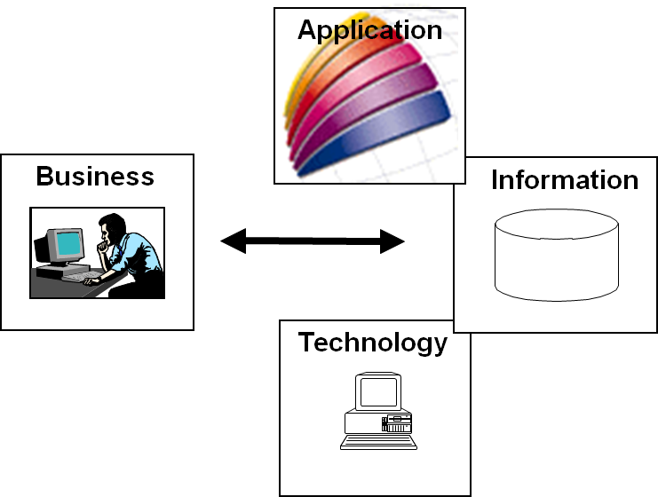 | 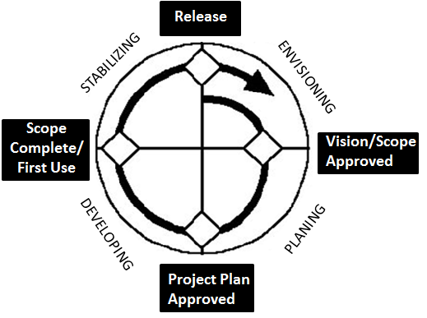
a) Four perspectives of EnA | b) Stages of EnA implementation
Fig. 3. MSF EnA model and stages of its adaptation to development projects
It should be noted that:
- The MSF methodology, as conceived by Microsoft, was aimed at enterprises that created software systems. It is clear that Microsoft's overall goal was to sell as much of their software technologies as possible. We applied MSF ideas to develop the GeoSolutions Framework (GeoSF). GeoSF has been used to develop several GIS such as REDAC3W and ChIIS-FGI. Therefore, from the viewpoint of EnA, the term and subject "software system" can be replaced by "information system".
- "Enterprise" can be a group of enterprises or a "virtual" organization that is formed from several enterprises due to joint activities in a given territory. Instead of the EnA of a specific enterprise, it is possible to consider the EnA of a group of enterprises or a virtual organization. In this case, EnA can be an information system in the extended sense, for example, AGIS=SSpIS ∪ SpAS.
The MSF methodology information provided in this section explains how the strategy can be linked to the plan. Thus, the "general plan for achieving the goal" - the strategy of optimal management of the territory - is, in fact, a plan for the iterative creation of AGIS for a defined large (significant) territory, which we denote as LT.

Some facts about the methodology of creating AGIS
According to [13]: 1) a model is a set of statements about a System Under Study (SUS, hereafter simply S); 2) theory is a way to derive new statements about SUS from statements that are already in some model of SUS; 3) metamodel - the specification model for the SUS class, where each SUS in the class is the most valid model, expressed in a certain modeling language. That is, a metamodel implements statements about what can be expressed in valid models of a particular modeling language. In many respects, the "applied" theory of Model-Based Engineering (MBE) was later developed around the essence of these concepts [14]. Facts from this "applied" theory are used below.
Before considering the facts from the methodology of AGIS creation, we will give an example of a system of this class, designed for territory management (Fig. 4). It was made by generalizing the AGIS-CH mentioned above. On Fig. 4 marked:
- LT is a large territory.
- The red ellipse shows one of the AGIS SpAS, which is called the SpAS of processes of registration of phenomena and processes studied in this system.
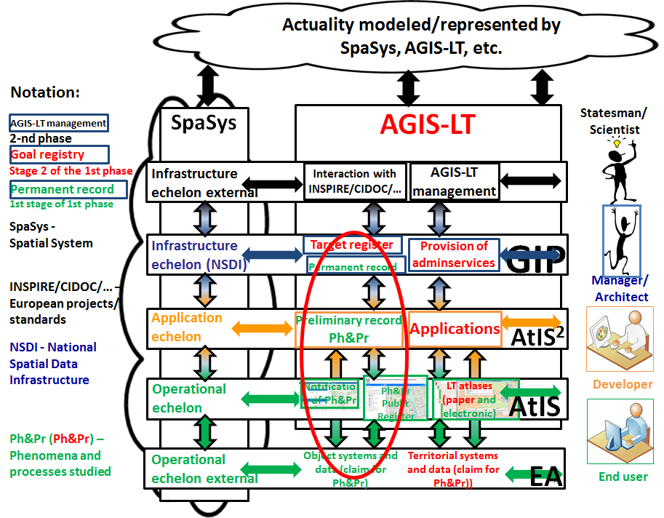
Fig. 4. Conceptual structure of AGIS-LT
Fig. 4 helps to better understand Fig. 5, where on the example of the Atlas GeoInformation System (AGIS) and its Atlas GeoInformation Model (AGIM), a general version of the scheme explaining the methodology is shown.
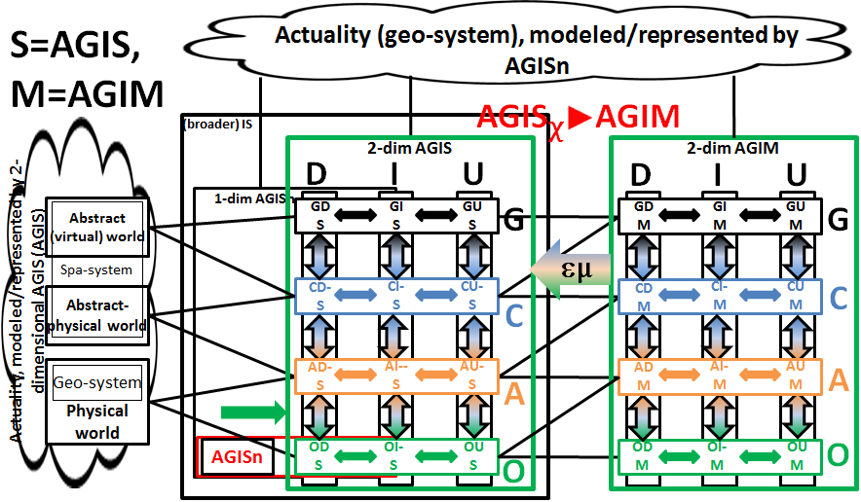
Fig. 5. Scheme explaining the methodology of AGIS creation. General variant
On Fig. 5 marked:
- XY=StratumLevel, where X=O (Operational), A (Application), C (Conceptual), G (General) strata; Y=D (Datalogic), I (Infologic), U (Organizational or Usagelogics) levels.
- ODS+OIS+OUS=OS – Operational System, ODM+OIM+ OUM=OM – Operational Model of this system. Accordingly, ADS+AIS+ AUS=AS – Application System, ADM+AIM+ AUM=AM – Application Model of this system. CDS+CIS+CUS=CS – Conceptual System, CDM+CIM+CUM=CM – Conceptual Model of this system.
- On the left, the cloud shows geo- and spatial systems of reality, which are modeled using AGIS and AGIM. On Fig. 4, this cloud corresponds to the cloud with SpaSys.
- μ - RepresentationOf, model/SUS. A model is a representation of SUS. This relation is a key to modelling. Sometimes a distinction is made between specification models that represent the system under construction (for example, a software project specification) and descriptive models that describe the existing system. These associations can be introduced as specialization μ if required [15];
- ε - ElementOf, element/set. This relation corresponds to the concept defined in set theory. At the same time, we remember that languages are sets, and they should not be confused with models of these sets [15];
- χ- ConformsTo, metamodel/conformal model. This relation defines the concept of a metamodel relative to a model. The model must correspond (be conformal) to its metamodel. In fact, χ is derived from μ and ε [15]. This fact is shown by the entry εμ on the arrow from models to systems in Fig. 5.
An example of a CM for Atlas Systems (AtS) in the first decade of the 21st century was the GeoSF GeoSolutions Framework. It was transformed into ISGeoPlatform2016 [7], which was also used as the back-end of the Atlas platform (BE AtP) for the second decade of AtS. If we limit ourselves to AtS, then we can call BE AtP by Conceptual AtlasSF1.0+ SoFr. System S in the extended sense used to be the union OS+AS+CS=Sb, and AtCoFr1.0=OM+AM+CM was its model if S=EA or S=AtIS (Atlas Information System) and the formation is Web 1.0. In 1.0+ (post-1.0) formations, Sb is defined as the union of OS+AS+CS+GS=AGIS, where GS=GDS+G(eneral)I(nfological)S+GUS. The Sb model is AGIM=OM+AM +CM+GM, GM= GDM+GIM+GUM. In principle, extended systems also include models of their constituent systems, but here systems and models are considered separately to facilitate understanding.
AtS (=EA+AtIS) of Web 1.0 formations were created mainly in the first decade of the 21st century. The concept of AGIS/AGIM was introduced and defined in the monograph [2]. It refers to the Web 1.0+ (1.0² and 2.0) formation. It is easy to see that it is also valid for the AtS of the previous formation, but at that time we did not talk about the practically implemented systems of the General stratum and in practice we limited ourselves to only the three lower strata. In addition, the AtSb of the first decade were weakly integrated. Conversions between systems of adjacent strata were carried out manually.
Let's explain Fig. 5 with the help of Fig. 6.
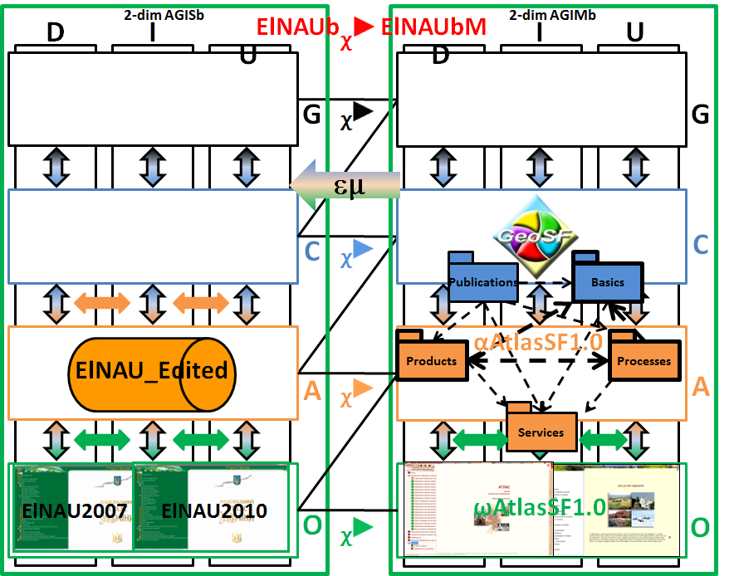
Fig. 6. Simplification of the scheme explaining the methodology of AGIS creation. Variant ElNAU
Fig. 6 shows:
- ElNAU_Edited – versions of ElNAU2007/2010 that can be edited.
- ElNAU2007, ElNAU2010 – two versions of ElNAU, editions of which were made from ElNAU_Edited in 2007 and 2010.
- ωAtlasSF1.0 denotes two atlases: 1) Atlas of Ukraine 2000, 2) RadAtlas2008. The first atlas was used as a sample (template) EA of the first half of the first decade, or else as the Operational SoFr of the first edition AtlasSF1.0 - AtlasSF1.0(1). The second atlas was used as a sample (template) EA of the second half of the first decade or otherwise as the Operational SoFr of the second edition of AtlasSF1.0 - AtlasSF1.0(2).
- αAtlasSF1.0 denotes the AtlasSF1.0 Application SoFr.
- χ , χ are the conformity relations between the elements of the Operational and Application echelons. They are the basis of the main methods of the methodology, known as meta-step patterns for the corresponding strata [15]. Next, examples of the usage of these methods in practice are described.
Initially, the ωAtlasSF1.0 and αAtlasSF1.0 SoFr were created. Having these SoFr available, it was possible to create a specific atlas in two ways. The first way was to apply the sample (template) ωAtlasSF1.0 operational atlas to the context of the atlas being created. For this, it was necessary to change the content of several operational patterns of ωAtlasSF1.0: interface, content tree, thematic maps, non-cartographic content, search and presentation. Sometimes it was necessary to change the base map. The software component needed to be changed only when moving to subsequent editions.
The second way was to use αAtlasSF1.0. Here, it was first necessary to create an editable model of the target atlas, for example, ElNAU_Edited in the case of ElNAU. In ElNAU_Edited, the application patterns of the decision tree and thematic maps were the main ones. For example, in the ElNAU project, thematic maps were created in MapInfo Professional, so they are called editable. Then the content of these two application patterns was converted into their operational counterparts. In parallel, the content of other operational patterns changed. The software component was replaced by its operational counterpart. In general, the operational software component (proprietary) and MapInfo Professional in this description are examples of GIT.
The use of pre-created pattern-models in the processes of developing a specific atlas is called a constructive approach above. However, the question arises as to what to do in the case when pattern-models for some component system have not yet been created. Here are some recommendations:
- It is necessary to start by defining the general structure of the AGIS class system. For this, you need to use the Conceptual Framework (CoFr). At the same time, we note that CoFr is applicable not only to systems of the AGIS class, but also to all SpISb of the classic and modern type.
- It is necessary to create at least an echeloned layout/mockup of the target system. This means that you need to have at least one layout/mockup for future constituent systems for each stratum/echelon. "At least a mockup" means that instead of a mockup there can be a prototype or even some version of a constituent system. Please note that this is the "architecture-first" principle in action.
- If there is no model of the component system, then we recommend searching among similar open solutions. A close solution will almost certainly be found. It is strongly recommended to beware of non-typical solutions, because in AGIS class systems you need to have as many typical solutions for component systems as possible. And finally, we strongly recommend that you do not rely on any opinion of the developers. Otherwise, you need to program at least the layout only in the most extreme case.
- After developing the layout of the constituent system, which should correspond to the constructive approach, we recommend using a declarative approach, but not just any, but the one described in [16] – DDD (Domain Driven Design). At the same time, it is necessary to solve the problem of matching the AGIS and DDD contexts.

Conclusions
Not all conclusions are obvious, however:
- Almost certainly, any strategy for using GIT for territory management will be incorrect if the methodology, or at least the method and/or methodics, is not defined and agreed "between" the strategy and the technology.
- The methodology for creation systems of this class cannot be declarative. It is necessary to do everything possible to apply constructive or normative methodology to the system as a whole and to its individual parts.
- If we consider the systemic concept of strategy, then strategy, methodology and technology must be coordinated. It is almost mandatory to consider echeloned systems with at least 3 of the 4 possible upper echelons.
- There is no alternative to using GIT (not visible now). The question of a specific GIT is secondary from the viewpoint of strategy.
- All possible GI technologies will be needed to implement SSpIS or SpAS: desktop, mobile, web, server.
- Currently, the best producer of such theoretically necessary GIT is the company ESRI, Inc., which tries to resist open technologies by restricting access to data. In particular, the GeoDatabase format is closed. Therefore, we can consider the entire GIT of ESRI, Inc. as closed.
- Open technologies are more useful for territory management tasks than ESRI, Inc. technologies. An open alternative to the closed GeoDatabase format is the open GeoPackage standard.
- AGIS for tasks of large territories management (AGIS-LT) should not be a private, but a public system, so no closed solutions should even be considered here.

References
1. Agenda2030, Transforming our world: the 2030 Agenda for Sustainable Development. Resolution adopted by the General Assembly on 25 September 2015.- United Nations General Assembly.- 35 p. (accessed 2023-Aug-30, https://sdgs.un.org/2030agenda).
2. Kulturna spadshchyna v Atlasnii heoinformatsiinii systemi staloho rozvytku Ukrainy: L.H. Rudenko, ta in. / za red. L.H. Rudenka.- Kyiv: Instytut heohrafii NAN Ukrainy, 2018.- 172 s. [Cultural heritage in the Atlas geoinformation system of sustainable development of Ukraine: L.G. Rudenko, et al. / edited by L.G. Rudenko. - Kyiv: Institute of Geography of the National Academy of Sciences of Ukraine, 2018. - 172 p.] (Ukrainian)
3. Chabaniuk V., Kolimasov I., Analysis of the Practical Use of Geoinformation Systems for Territorial Management and Determination of their Critical Properties.- Cybernetics and Computer Engineering, 2020, № 2(200), с. 5-26.
4. Falkenberg E.D., Lindgreen P., Eds. Information System Concepts: An In-depth Analysis.- Amsterdam et al., North-Holland, 1989.- 357 p.
5. Chabaniuk V., Dyshlyk O. Kontseptualʹnyy Karkas Elektronnoyi versiyi Natsionalʹnoho atlasu Ukrayiny.- Ukrayinsʹkyy heohrafichnyy zhurnal, 2014, № 2, s. 58-68. [Chabanyuk V., Dyshlyk O. Conceptual Framework of the Electronic Version of the National Atlas of Ukraine. - Ukrainian Geographical Journal, 2014, No. 2, p. 58-68.] (Ukrainian)
6. Rudenko L.H., ta in. Natsionalʹnyy atlas Ukrayiny. Naukovi osnovy stvorennya ta yikh realizatsiya.- K.: Akademperiodyka, 2007.- 408 s. Za redaktsiyeyu Rudenka L.H [Rudenko L.G., et al. National atlas of Ukraine. Scientific foundations of creation and their implementation. - K.: Akademperiodika, 2007. - 408 p. Edited by Rudenko L.G.] (Ukrainian)
7. Chabaniuk V.S. Reliatsiina kartohrafiia: Teoriia ta praktyka.- Kyiv: Instytut heohrafii NAN Ukrainy, 2018.- 525 s. [Chabaniuk V.S. Relational cartography: Theory and practice. - Kyiv: Institute of Geography of the National Academy of Sciences of Ukraine, 2018. - 525 p.] (Ukrainian)
8. Booch Grady, Rumbaugh James, Jacobson Ivar. The Unified Modeling Language User Guide.- Addison-Wesley, 2005, 2nd Ed.- 496 p.
9. Alexander Christopher. The Timeless Way Of Building.- Oxford University Press, 1979.- 552 p.
10. Rudenko L., Chabanyuk V. Metodolohiya stvorennya HIS zahroz i vyklykiv yak skladovoyi zabezpechennya staloho (zbalansovanoho) rozvytku rehioniv Ukrayiny. Teoriya.– White paper (Bila stattya), 2020-ber19-tra31, V0703ukr. 118 s. [Rudenko L., Chabanyuk V. Methodology of creating GIS threats and challenges as a component of ensuring sustainable (balanced) development of the regions of Ukraine. Theory.– White paper, 2020-mar19-may31, V0703ukr. 118 p.] (Ukrainian)
11. Iivari Juhani. Distinguishing and contrasting two strategies for design science research.- European Journal of Information Systems (2015), Vol. 24, Iss. 1, pp. 107–115.
12. Wilson Scott F., Maples Bruce, Landgrave Tim. Analyzing Requirements and Defining Solutions Architecture. MCSD Training Kit For Exam 70-100 (MCSD Training Guide).- Microsoft Press, 1999.- 700 p.
13. Seidewitz Ed. What Models Mean.- IEEE Software, Vol. 20, Iss. 5, pp. 26-32.
14. Brambilla Marco, Cabot Jordi, Wimmer Manuel. Model-driven Software Engineering in Practice.- Morgan & Claypool Publishers, 2nd Ed., 2017.- 209 p.
15. Favre Jean-Marie. Megamodelling and Etymology. A Story of Words: from MED to MDE via MODEL in Five Millenniums.- Dagstuhl Seminar Proceedings 05161, paper 427, 22 p.
16. Vernon Vaughn. Domain-Driven Design Distilled, Addison-Wesley, 2016.- 137 p.

Література
1. Agenda2030, Transforming our world: the 2030 Agenda for Sustainable Development. Resolution adopted by the General Assembly on 25 September 2015.- United Nations General Assembly.- 35 p. (accessed 2023-Aug-30, https://sdgs.un.org/2030agenda).
2. Руденко Л.Г., та ін. Культурна спадщина в Атласній геоінформаційній системі сталого розвитку України / за ред. Л.Г. Руденка.- Київ: Інститут географії НАН України, 2018.- 172 с.
3. Chabaniuk V., Kolimasov I., Analysis of the Practical Use of Geoinformation Systems for Territorial Management and Determination of their Critical Properties.- Cybernetics and Computer Engineering, 2020, № 2(200), с. 5-26.
4. Falkenberg E.D., Lindgreen P., Eds. Information System Concepts: An In-depth Analysis.- Amsterdam et al., North-Holland, 1989.- 357 p.
5. Чабанюк В.С., Дишлик О.П. Концептуальний Каркас Електронної версії Національного атласу України.- Український географічний журнал, 2014, № 2, с. 58-68.
6. Руденко Л.Г., та ін. Національний атлас України. Наукові основи створення та їх реалізація.- К.: Академперіодика, 2007.- 408 с. За редакцією Руденка Л.Г.
7. Чабанюк Віктор Савович. Реляційна картографія: Теорія та практика.- Київ: Інститут географії НАН України, 2018.- 525 с.
8. Booch Grady, Rumbaugh James, Jacobson Ivar. The Unified Modeling Language User Guide.- Addison-Wesley, 2005, 2nd Ed.- 496 p.
9. Alexander Christopher. The Timeless Way Of Building.- Oxford University Press, 1979.- 552 p.
10. Руденко Л., Чабанюк В. Методологія створення ГІС загроз і викликів як складової забезпечення сталого (збалансованого) розвитку регіонів України. Теорія.– White paper (Біла стаття), 2020-бер19-тра31, V0703ukr. 118 с.
11. Iivari Juhani. Distinguishing and contrasting two strategies for design science research.- European Journal of Information Systems (2015), Vol. 24, Iss. 1, pp. 107–115.
12. Wilson Scott F., Maples Bruce, Landgrave Tim. Analyzing Requirements and Defining Solutions Architecture. MCSD Training Kit For Exam 70-100 (MCSD Training Guide).- Microsoft Press, 1999.- 700 p.
13. Seidewitz Ed. What Models Mean.- IEEE Software, Vol. 20, Iss. 5, pp. 26-32.
14. Brambilla Marco, Cabot Jordi, Wimmer Manuel. Model-driven Software Engineering in Practice.- Morgan & Claypool Publishers, 2nd Ed., 2017.- 209 p.
15. Favre Jean-Marie. Megamodelling and Etymology. A Story of Words: from MED to MDE via MODEL in Five Millenniums.- Dagstuhl Seminar Proceedings 05161, paper 427, 22 p.
16. Vernon Vaughn. Domain-Driven Design Distilled, Addison-Wesley, 2016.- 137 p.

В. Чабанюк, О. Дишлик
ДО ПИТАННЯ СТРАТЕГІЇ ВИКОРИСТАННЯ ГЕОІНФОРМАЦІЙНИХ СИСТЕМ І ТЕХНОЛОГІЙ ДЛЯ УПРАВЛІННЯ ТЕРИТОРІЄЮ
Анотація. ГеоІнформаційні (ГІ) Системи (ГІС) і ГІ Технології (ГІТ, разом ГІСТ) вже майже півстоліття, зі створення у 60-х роках минулого століття першої ГІС Канади, використовуються для вирішення задач управління територією. За минулі роки ГІСТ досягли своєї зрілості, однак все ще продовжують розвиватися, охоплюючи все ширші сфери застосування. Виникла навіть наука геоінформатика, у якій ГІСТ використовуються переважно як інструментарій або технологія. Як приклад, геоінформатика у тій же Канаді називається геоматикою і є технологією і/або технологічною наукою.
Разом з тим, розширення сфери застосування ГІСТ ставить перед дослідниками питання методів і методології застосування ГІСТ. За ними слідують питання методів і методології геоінформатики не тільки як технології, а й науки. Причому, ці питання ускладнюються з розширенням сфери застосувань. У інформаційній індустрії разом зі сферою застосувань вживається термін «домен» або «контекст». Таким чином, сучасні застосування ГІСТ маніпулюють великою кількістю взаємопов’язаних термінів і понять, які часто не мають чіткого визначення. Робота присвячена класифікації основних з них, яка розпочинається розглядом поняття стратегії використання.
У роботі використовуються просторові моделі територій. Вони застосовуються при вивченні як територіальних систем реальності, так і окремих просторових сутностей і явищ. Серед просторових моделей основна увага приділяється просторовим інформаційним моделям, найвідомішими з яких є ГеоІнформаційні Системи (ГІС). ГІС невідривні від засобів ГІС – ГеоІнформаційних Технологій (ГІТ).
Основні результати статті отримано так званим методом Концептуальних каркасів (КоКа) Просторових інформаційних систем (ПрІС). Метод КоКа застосовано до спеціального класу ПрІС – Атласних ГеоІнформаційних Систем (АГІС) великих територій (ВТ). Клас АГІС включає в себе Електронні атласи (ЕА), Атласні інформаційні системи (АтІС), Картографічні інформаційні системи (КІС) і, власне ГІС, якщо мова йде про ВТ.
АГІС-ВТ є ієрархічною ешелонованою ПрІС, для якої застосовні основні терміни і поняття статті. Це такі терміни і поняття як «стратегія» і «методологія» застосування ГІС. ГІС, в свою чергу, використовують ГІТ, які також класифікуються за допомогою КоКа ПрІС. /
Ключові слова: стратегія, методологія, технологія, геоінформаційні системи (ГІС), геоінформаційні технології (ГІТ), метод Концептуальних каркасів (КоКа)

