UDC 332.363(477)
On the development of working land management projects for land conservation in Ukraine

Koshel A., Doctor of Economics
National University of Life and Environmental Sciences of Ukraine
e-mail:koshelao@gmail.com
Kolhanova I., PhD in Economics
National University of Life and Environmental Sciences of Ukraine
e-mail: kolganova_i@ nubip.edu.ua
Kempa O., Dr inż. (PhD)
Wroclaw University of Environmental and Life Sciences
e-mail:olgierd.kempa@upwr.edu.pl
Stacherzak A., Dr inż. (PhD)
Wroclaw University of Environmental and Life Sciences
e-mail:agnieszka.stacherzak@upwr.edu.pl

Abstract. Environmental protection and rational use of natural resources is one of the most pressing issues of our time. It is closely linked to the everyday life of people. Land, as a means of production, has special properties that differ from all other means of production. First and foremost, it is irreplaceable, limited in space, continuously functioning, and capable of continuous improvement if used properly. In the process of economic use of natural resources, we often only note those components of the environment with which our activities are related. For example, geologists and miners consider a territory in terms of its mineral wealth, timber producers are interested in areas with timber reserves, and agricultural workers are interested in land for farming. However, the natural environment is a complex of closely interconnected components that are in a state of dynamic equilibrium. Disruption of this balance can cause significant damage to natural resources. One of the main factors that destabilize the environmental situation in Ukraine is excessive agricultural development and plowing of the territory. Land conservation is the process of preserving and restoring natural resources, including soils, water, vegetation and fauna, in order to prevent the degradation of natural ecosystems and preserve biological diversity.
This article discusses the content of the concepts of "land conservation" and "degraded soils". Approaches to the development of working land management projects for the conservation of degraded and marginal arable land in Ukraine are proposed. Land conservation in this study is considered in the aspect of soil protection through conservation-transformation, when it comes to the irreversible transfer of arable land to other lands.
Key words: conservation, working draft of land management, disturbed lands, soil protection, marginal lands, land management documentation, land management, management, land use.
Actuality. Over many decades, unbalanced pressure on natural landscapes has led to significant man-made damage to Ukraine's ecosphere. The most threatening phenomena are observed in the soil cover, where huge areas of productive land have been degraded and put out of use due to erosion, pollution by agrochemicals and industrial emissions, improper agricultural practices, unreasonable and unjustified interference with the hydrological regime of the territories by drainage and irrigation reclamation. In the forest-steppe and especially steppe zones, most natural complexes and landscapes have been destroyed or anthropogenically transformed, which causes degradation and ultimately the loss of the genetic fund of representatives of natural flora and fauna. Land destroyed by exogenous processes and contaminated with toxic substances, urbanized and technologically transformed landscapes, continuous areas occupied by agrocenoses, depriving people of places of recreation and health restoration, cause negative phenomena in the social sphere. One of the main factors that destabilize the environmental situation in the country is excessive agricultural development and plowing of the territory. The share of arable land in the country is 58% of the land area, and in such regions as Dnipro, Zaporizhzhia, Kirovohrad, Mykolaiv, Kherson - more than 70%; in Vinnytsia, Cherkasy, Poltava, Khmelnytsky, Ternopil - from 63 to 67%.
It is known that the environmental sustainability of an agricultural landscape directly depends on the amount of natural phytocoenoses preserved in it. Thus, according to many experts, the improvement of the environmental situation is seen in reducing the area of arable land and, accordingly, increasing the area of ecologically stabilizing lands, whose ecosystems function according to natural analogues with minimized anthropogenic impact. Thus, we are talking about a broad environmental re-naturalization that should ensure environmental optimization of natural resources management. In the context of the idea of renaturalization is one of the main, if not the main, direction of optimization natural resources use - conservation of degraded and unproductive lands, i.e., in general, their withdrawal from intensive agricultural use.
Defining the content of the concepts of "land conservation", criteria and indicators by which degraded and marginal soils are identified in the development of working land management projects is the subject and purpose of this study.
Analysis of the latest scientific research and publications. Such scientists as O. Kanash, A. Martyn, S. Osypchuk, I. Shkvyr, D. Dobriak and others have been engaged in the development of scientific and methodological approaches to land conservation measures. At the same time, the issue of development of land management documentation for land conservation is relatively unexplored.
Materials and methods of scientific research. The following generally accepted methods of scientific research were used in the study on the development of working land management projects for land conservation: theoretical method, monographic method, comparative method and method of generalization.
The purpose of the article is to highlight the methodological approach to the development of working land management projects for land conservation in Ukraine.
The results. The purpose of developing a working draft land management project for land conservation is to determine the types and methods of land conservation: used in violation of the requirements for land protection from erosion and landslides; arable land that has one of the indicators characterizing soil properties and necessitating land conservation by natural and agricultural zones; degraded land, unproductive land without steppe, meadow, forest vegetation cover, the economic use of which is environmentally hazardous and economically inefficient.
The object of this study was a land plot that requires land conservation measures, located within the administrative boundaries of the Bashtechkivska amalgamated hromada (AH) (outside the village of Tynivka) in the Uman district of Cherkasy region.

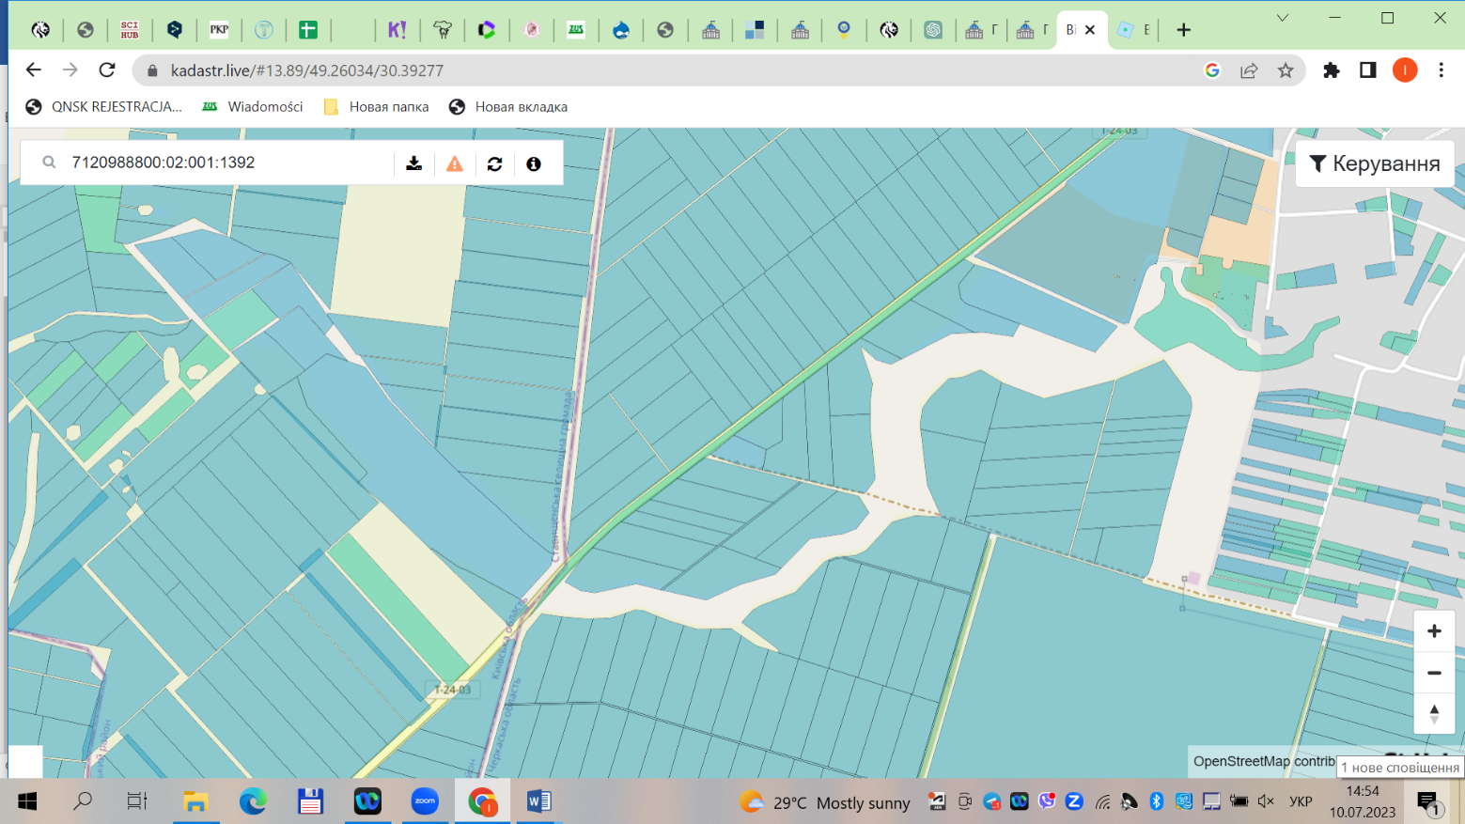
The land parcel that was the object of the study

Figure 1 - Location of the land plot, which is the object of the project, within the administrative boundaries of Bashtechkivska AH (outside the village of Tynivka), Uman district, Cherkasy region *.
٭ Note: according to https://kadastr.live (accessed June 14, 2023).

The land parcel, which is the object of design, has an area of 0,9480 hectares. In terms of configuration, the land plot has a regular rectangular elongated shape (Fig. 1). The terrain is gentle, with slopes up to 3°.
According to Article 35 of the Law of Ukraine "On Land Protection", owners and land users, including tenants, of land plots in the course of their business activities are obliged to increase soil fertility and preserve other useful properties of the land through the use of environmentally friendly cultivation technologies and equipment, and other measures that reduce the negative impact on soils, prevent the irreversible loss of humus and nutrients; ensure protection of land from fires, erosion, depletion, pollution, contamination, clogging, salinity, salinity, acidification, waterlogging, flooding, overgrowth of weeds, shrubs and small forests. It is prohibited to use land plots in ways that lead to deterioration of their quality.
On agricultural lands, the following activities may be restricted: the use of degraded, unproductive, and technologically contaminated land plots; unreasonably intensive use of land.
The use of land resources is largely determined by the nature of the soil cover, soil fertility, their suitability for growing certain crops, and the presence of restrictive features. When determining the most rational way to use land, the above factors should be taken into account in order to promote soil conservation and increase its fertility, along with maximizing economic benefits.
Profound changes in the natural properties of land, transformation of intra-soil processes, and loss of their self-healing capacity have been caused by years of extensive urbanization and industrialization of territories, uncontrolled agricultural pressure on the soil cover, etc. Hazardous industrial emissions into the air basin eventually concentrated and accumulated on the lands directly adjacent to production facilities, spreading through water and air for tens and hundreds of kilometers, polluting the environment and soil with chemical and biological components, including pesticides, radionuclides, heavy metals, and infectious disease agents. All of these negative factors affect the natural balance, disrupting the soil-air-water-plant-animal-human life cycle.
Pursuant to Article 172 of the Land Code of Ukraine, land conservation is carried out by suspending or restricting its economic use for a specified period and reclaiming, reforesting or renaturalizing it.
The Verkhovna Rada of the Autonomous Republic of Crimea, the Council of Ministers of the Autonomous Republic of Crimea, executive authorities and local self-government bodies that, in accordance with Article 122 of the Land Code of Ukraine, dispose of state or communal land, are obliged to take measures to conserve land plots.
The classification of agricultural land as degraded, low-productive and technogenically contaminated land is based on the main indicators that characterize soil properties and determine the need for land conservation (erodibility, skeletal structure, light particle size distribution, heavy particle size distribution, humus content, soil solution reaction, mobile aluminum content, absorbed sodium content, salinity, carbonation, physical degradation, chemical and radiation contamination).
In accordance with the Resolution of the Cabinet of Ministers of Ukraine "On Approval of the Rules for the Development of Working Land Management Projects" of February 2, 2022, No. 86, land conservation is designed in the areas of conservation-rehabilitation, conservation-transformation, and renaturalization.
The conservation-transformation of agricultural land is projected by converting it into hayfields and pastures or withdrawing it from agricultural land with subsequent reforestation or transferring it to other non-agricultural land.
Taking into account the indicators that characterize soil properties and determine the need for land conservation by natural and agricultural zones, conservation areas are designed: soils of heavy granulometric composition (light, medium and heavy clay soils mainly on dense clays, as well as on hard rocks) are conserved by rehabilitating them into fallow land or using them as hayfields and pastures. After a period of rehabilitation under grass vegetation (5-10 years), they can be selectively returned to their previous use, but with a lower intensity of use (in fodder or soil protection crop rotations).
The soil cover of the land parcel, which is the object of the project, is represented by typical carbonate deep low-humus medium loamy black soil on loess (53d). Below is a characterization of the soil types within the land plot that is the subject of the project:
Agrophysical parameters:
In these soils, the content of physical clay is 39,70%, silt – 22,80%, which corresponds to the heavy loamy soil texture. The maximum possible reserve of productive moisture in the range of 0-100 cm is 160 mm.
Agrochemical parameters:
The average humus content in the 0-25 cm layer is 3,28% and is classified as elevated; the reaction of the soil solution pH of the water extract is 7,53 or slightly alkaline. The content of nutrients, in particular nitrogen of easily hydrolyzable compounds according to Kornfield, is 133,00 mg/kg of soil, and its availability is assessed as low; the content of mobile phosphorus (according to Machigin) is 60,00 mg/kg of soil and is assessed as high; the content of exchangeable potassium (according to Machigin) is 400,00 mg/kg, which is at the level of high nutrient supply.
The content of the mobile form of boron is within the normal range – 0,16 mg/kg of soil.
The content of mobile forms of cobalt is 0,87 mg/kg, which does not exceed the MPC (MPC Co ≤ 5,0 mg/kg).
The content of mobile manganese is 390,00 mg/kg of soil, which does not exceed the MPC (Mn MPC ≤ 1500 mg/kg). Manganese has a pronounced synergy with such trace elements as calcium and phosphorus.
The content of mobile forms of copper in the soil is 0,84 mg/kg, which does not exceed the MPC (MPC Cu ≤ 3 mg/kg).
The content of mobile forms of zinc (Zn) on the site is 2,05 mg/kg, which is not dangerous (MPC for Zn ≤ 23 mg/kg).
Pollution:
The content of mobile form of cadmium (Cd) is within the normal range – 0,07 mg/kg (MPC Cd≤0,7 mg/kg).
The content of mobile forms of lead is 1,32 mg/kg, which does not exceed the MPC (MPC Pb ≤ 2,0 mg/kg).
Determination of pesticide residues, DDT and its metabolites, HCCH (sum of isomers) content was not carried out.
The land plot is planned to be used for land conservation by restricting its economic use in accordance with the procedure provided for by law for a period of 10 years by reforestation.
The main design solutions for land conservation (Fig. 2).
Land conservation is carried out by terminating or restricting its economic use in the manner prescribed by law for a specified period of time and reclaiming, reforesting or renaturalizing it.
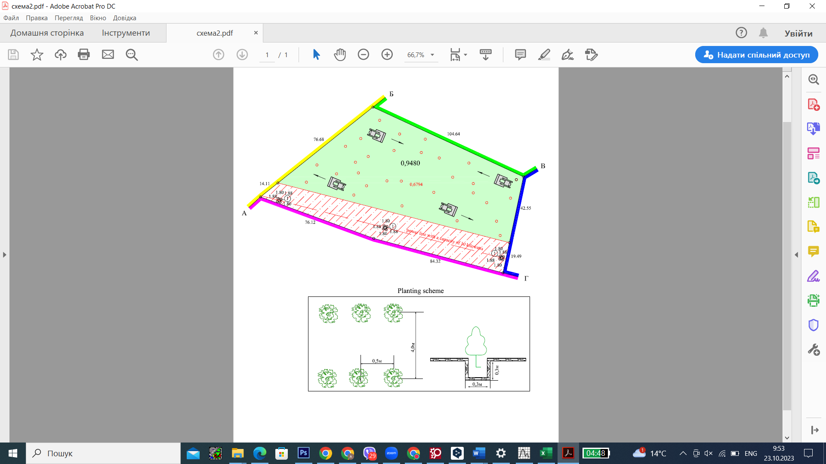
Figure 2 - Main design solutions for land conservation

Taking into account the indicators that characterize soil properties and determine the need for land conservation, the main design solutions envisaged by this working draft land management project are as follows:
1. Land conservation is projected in the direction of conservation-transformation.
The conservation-transformation of agricultural land is projected by withdrawing it from agricultural land with subsequent reforestation.
2. Implementation of afforestation measures: design decisions on the location and area of tree and shrub plantations.
On the land plot that is the object of the project, it is planned to implement land conservation measures through afforestation.
Tree species are being planted on an area of 0,6794 hectares (a 10 kV power line runs through part of the land plot, and according to Ukrainian legislation, it is prohibited to plant trees in the protection zones of these regime-forming objects).
The plantations are placed in rows, the rows are 4 meters wide, and the seedlings are spaced 0,5 meters apart. The selection of species for plantations is based on zonal conditions, physical, chemical, agrochemical and water-physical properties of soils, as well as the intended purpose of the plantations. To form environmentally sustainable plantations, mixed types of forest crops are created with the participation of main species up to 60%, related species up to 20%, and shrubs up to 20%. The following trees are recommended for this climate zone: oak, forest beech, sycamore, bear nut, common pear, black walnut, and common ash (Fig. 3). Planting of trees of various local species is allowed.
The planting rate (density) of forest crops (DSTU 2980-95 Forest Crops. Terms and Definitions) is the number of tree and shrub plants grown per unit of forestry area.
The density of forest crops is calculated by the formula:
10000
N = -----------
Rg
Where N – density of forest crops, pcs/ha
Rg – feeding area of one seedling, m².
In turn, the power supply area is determined by the formula:
Rg = a*b,
where a – distance between rows of crops, m;
b – distance between seedlings in a row, m.

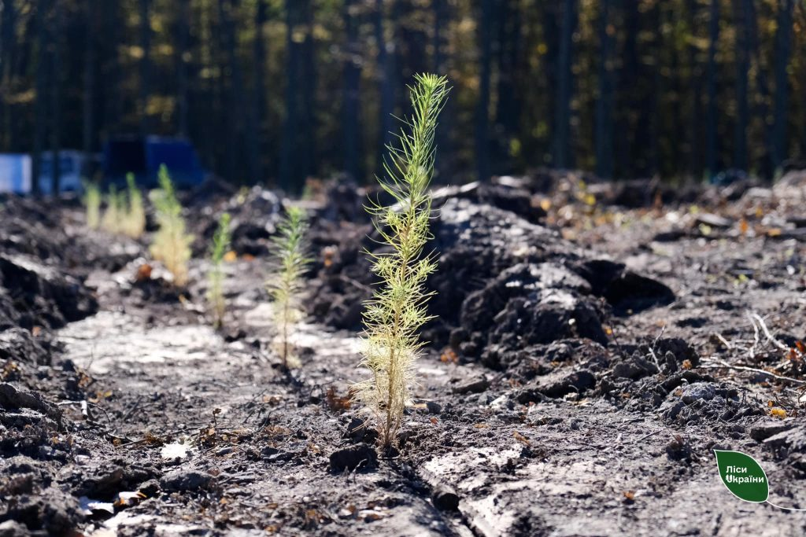 | 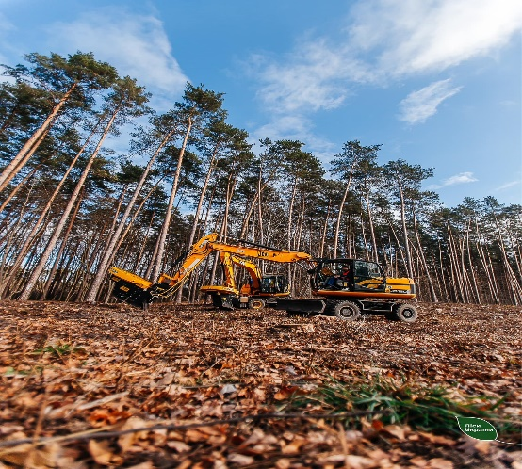
Figure 3 - Land conservation measures through afforestation

We determine the need for planting material by species depending on the scheme of planting forest crops.
Rg = 4*0,6 = 2
N = 10000/2 = 5 000 pcs/ha.
Recommended planting rates per hectare on the land plot:
- common oak 3000 seedlings
- common ash (maple) 2000 seedlings.
When creating forest plantations, the relief of the earth's surface should be flat and undulating, without closed depressions, which allows the use of machinery for planting trees and cultivating row spacing.
According to Article 51 of the Law of Ukraine "On Land Protection", the transfer of ownership and use of municipal lands in respect of which a decision has been made to conserve them for purposes unrelated to such conservation is prohibited.
Conclusions and perspectives. Based on the above material, it is possible to outline only in general terms the directions of development of working land management projects for the conservation of degraded and unproductive arable land. First and foremost, the most degraded arable lands should be subject to conservation, the exploitation of which causes significant negative environmental and economic consequences or is directly harmful to human health (heavily washed and eroded soils, chemically and radiation contaminated lands, swampy and flooded lands). The most problematic are soils of light and heavy texture. The environmental hazard of their intensive use as part of arable land is that they are permanent centers of deflation. In economic terms, the inexpediency of their use is due to the inadequacy of the costs of maintaining an acceptable level of their fertility to the profit from yields.
The conservation of such lands is mostly irreversible, i.e., transformation. In most cases, they should be removed not only from arable land, but also from agricultural land. It is most appropriate to reforest them.
Further work on this issue requires addressing a number of issues to clarify the indicators and standards for the allocation of degraded and infertile soils, and to optimize the ratio of land by natural regions.
References
- Land Code of Ukraine. (2001, October 25). Vidomosti Verkhovnoyi Rady Ukrayiny. Kyiv. [in Ukrainian].
- On the approval of the Rules for the development of working projects of land management: Resolution of the Cabinet of Ministers of Ukraine № 86-2022-p (2022, February 02). Vidomosti Verkhovnoyi Rady Ukrayiny, 86. [in Ukrainian].
- Law of Ukraine On Land Management from May 22 2003, № 858-IV. (2003, July 8). Holos Ukrainy, № 124. [in Ukrainian].
- Law of Ukraine On Land Protection from June 19 2003, № № 962-IV. (2003, July 29). Holos Ukrainy, № 139. [in Ukrainian].
- MARTYN A., KOLHANOVA I. (2021). Do pytannia pro pravyla robochoho proektuvannia v zemleustroi. [To the question about the rules of working design in land management]. Land management, cadastre and land monitoring, 4, 73-93. [in Ukrainian].

Кошель А.О., Колганова I.Г., Кемпа О., Стачерзак А.
До питання про розроблення робочих проектів землеустрою щодо консервації земель в Україні
Анотація. Охорона природи і раціональне використання природних ресурсів – одна із найбільш актуальних проблем сучасності. Вона тісно пов’язана з повсякденним життям людини. Земля, як засіб виробництва, має особливі властивості, відмінні від усіх інших засобів виробництва. Насамперед, це незамінність, обмеженість у просторі, безперервність функціонування, здатність при правильному використанні постійно поліпшуватись. У процесі господарського використання природних ресурсів ми часто відзначаємо лише ті компоненти середовища, з якими пов’язана наша діяльність. Так, геологи та гірники розглядають територію з точки зору її багатства на корисні копалини, лісопромисловці цікавлять території, де є запаси деревини, працівників сільського господарства – землі для рільництва. Та природне середовище – це комплекс тісно пов’язаних компонентів, що перебувають між собою у стані динамічної рівноваги. Порушення цієї рівноваги може завдати значної шкоди природним ресурсам. Одним з головних чинників, які дестабілізують екологічну ситуацію в Україні, є надмірна сільськогосподарська освоєність і розораність території. Консервація земель ̶ це процес збереження та відновлення природних ресурсів, включаючи ґрунти, воду, рослинність і тваринний світ, з метою запобігання деградації природних екосистем та збереження біологічного різноманіття.
В даній статті розглянуто зміст поняття «консервація земель» та «деградовані ґрунти». Запропоновано підходи щодо розроблення робочих проектів землеустрою щодо консервації деградованих та малородючих орних земель в Україні. Консервація земель в цьому дослідження розглядається в аспекті захисту ґрунтів шляхом консервації-трансформації, коли йде мова про необоротне переведення ріллі в інші угіддя.
Ключові слова: консервація, робочий проект землеустрою, порушені землі, охорона ґрунтів, малопродуктивні угіддя, документація із землеустрою, землеустрій, управління, землекористування.

