УДК: 332.6:338.439(477)
FEATURES OF CHANGES IN THE VALUE OF LAND PLOTS IN THE CONDITIONS OF ENSURING FOOD SECURITY IN UKRAINE
M.V. Bratinova, Ph.D. student
National University of Life and Environmental Sciences of Ukraine,
specialist, Land Management Institute of National Academy
of Agrarian Sciences of Ukraine, Kyiv,
e-mail: mbr4119@gmail.com
V.L. Vakulenko, Ph.D in economics,
Associate Professor of Department of Management named after
Professor of Josyp S. Zavadskyi,
Head of postgraduate education Department,
National University of Life and Environmental Sciences of Ukraine, Kyiv,
e-mail: vakulenko@nubip.edu.ua

Abstract. The paper studies the peculiarities of changes in the value of land resources in the conditions of ensuring food security of Ukraine. It has been established that the land market is recognized as one of the key components of the agricultural sector and plays an integral role in the formation of the country's food security. It was found that the highest prices for arable land and perennial crops are observed in Kyiv region, hayfields and pastures in Kharkiv region, and pastures in Cherkasy region. It was established that as a result of Russia's full-scale aggression against Ukraine, it was not possible to conclude more than 102 thousand agreements on the purchase and sale of agricultural land on a total area of 282 thousand hectares, with a total cost of UAH 11.5 billion. It was found that the highest activity of purchase and sale of agricultural land is observed primarily in the central regions of Ukraine, where the share of agricultural land in circulation exceeds 1%. It was established that the average price for 1 hectare of land in February 2022 was UAH 33,429 per hectare, and according to the results of May 2022, when deals on the land market began to be concluded again, the price was fixed at the level of UAH 37.4 until August 2022 showed positive dynamics, reaching UAH 43.9 thousand, and in September 2023, the average price was UAH 41,316 per hectare. It is established that the value of agricultural land is gradually increasing, where in 2023 the average price reached 35.4 thousand hryvnias per hectare, which is 13.5% higher than in 2022 and almost 22% higher than in 2021. It was found that the highest land prices are observed in Kyiv, Ivano-Frankivsk and Lviv regions. It was established that the market capitalization fell, that is, in December 2021, purchase and sale agreements were concluded for 936 million UAH, in August 2022 - for 74.2 million UAH, and in July 2023, we observe positive dynamics of market recovery - agreements were concluded sales by UAH 596.9 million, in August by UAH 611 million and in September by UAH 636 million.
Key words: land market, land resources, food security, cost, purchase and sale agreements

Problem statement. Given the new realities brought about by geopolitical and economic changes, there is a need for a thorough analysis and understanding of the dynamics of the land market, including its value aspects, to ensure the stability and security of Ukraine's food sector. One of the key challenges is the impact of external factors, such as political events and war, on the dynamics of agricultural land prices and the resulting changes in the terms of trade and circulation of agricultural land rights.
It is worth noting that even the conditions for ensuring Ukraine's food security cause significant changes in land values. The growing need to increase agricultural production to meet domestic demand and exports is driving the dynamics of changes in land prices. However, this situation leads to a number of problems, such as the inability of some communities and rural enterprises to access land resources due to rising land prices, which in turn creates an imbalance in access to land resources for the development of the agricultural sector, which in turn may affect the country's food security. In this regard, the relevance of the study is to analyse the peculiarities of changes in the value of land resources in the context of geopolitical and economic challenges in order to develop strategies aimed at ensuring the stability of the food market and the efficient use of land resources to achieve food security in Ukraine.
Analysis of recent research and publications. The works of domestic and foreign scholars pay little attention to various aspects of changes in the value of land resources in the context of food security. Given that the main studies on this topic are presented by the Ministry of Agrarian Policy and Food of Ukraine and the State Service of Ukraine for Geodesy, Cartography and Cadastre, it should be recognised that the lack of attention to various aspects of changes in the value of land resources in the context of food security may affect the completeness and objectivity of consideration of this issue. The need for a broader and deeper study in this area is becoming urgent to ensure a full understanding of market dynamics and its impact on food security.
The purpose of the study. To analyse the main features of changes in the value of land resources in the context of ensuring food security in Ukraine. To achieve this goal, the following tasks have been identified: to analyse changes in the value of land resources; to characterise the total number of land sale and purchase transactions; to determine the number of transactions by region.
Materials and methods of the study. To achieve this goal, a variety of general scientific and specialized research methods were used at the empirical and theoretical levels. These methods include system analysis (structural and functional), abstraction, analysis and synthesis, deduction and induction. The method of analysis was the analysis of prices per 1 hectare of agricultural land and the number of transactions for the sale and purchase of property rights.
Research results and discussion. The land market is recognised as one of the key components of the agricultural sector and plays an integral role in shaping the country's food security. The development of this market has a significant impact on the country's ability to provide its population with affordable and safe food, in accordance with their dietary needs and preferences.
The entry into force of the Law of Ukraine № 552-IX "On Amendments to Certain Legislative Acts of Ukraine on the Terms of Agricultural Land Turnover" on 1 July 2021 opened new prospects for the agricultural land market. This market has become an important tool to support the agricultural sector by providing it with additional opportunities and resources [1].
Taking into account on the normative monetary valuation of agricultural land in Ukraine as of 01.01.2021, we can make the following specific analysis:
- the highest prices for arable land and perennial plantations are observed in Kyiv region, which has the highest average price for arable land - 26,531 UAH/ha, and for perennial plantations - 42,776 UAH/ha. The high value of arable land in Kyiv region may indicate a high agricultural potential and high competitiveness of agricultural activities in this region;
- The highest average price for hayfields is in Kharkiv region - 6,281 UAH/ha, while the lowest is in Vinnytsia region, at 3,140 UAH/ha;
- Cherkasy region has the highest prices for pastures - 8,455 UAH/ha, and Lviv region has the lowest, only 4,090 UAH/ha;
- Kharkiv region is notable not only for high prices for hayfields, but also for pastures - 6,427 thousand UAH/ha, which may be a sign of the activity of the agricultural market in the region [2].
The full-scale military invasion of the territory of Ukraine by russian troops on 24 February 2022 had a significant impact on the land market, which in turn led to significant changes in the circulation of rights to agricultural land plots. During the period from 24.02.2022 to 06.05.2022, transactions on the sale and purchase of ownership rights to agricultural land plots were completely suspended.
Nevertheless, starting from May 2022, the mechanism for registering land transactions was restored in the state register, which opened up the possibility of trading land on the market even in wartime. This situation posed new challenges and aspects for the public and analysts to analyse and study the dynamics of the agricultural land market in detail [1; 3; 4].
As a result of russia's full-scale aggression against Ukraine, more than 102,000 transactions on the sale and purchase of agricultural land covering a total area of 282,000 hectares, with a total value of UAH 11.5 billion (USD 312 million), which is approximately 0.2% of the country's GDP, were not concluded. Kharkiv region, which was the leader in terms of agricultural land in circulation before the aggression, suffered the greatest losses. The cost of losses in this region was over UAH 2.7 billion (about USD 75 million). Another region with large losses was Kherson region, where the land market lost approximately UAH 1.17 billion (about USD 232 million) [5].
However, the market is now gradually recovering, and its capacity is already capable of providing at least UAH 10 billion in additional revenues to community budgets annually. The opening of the land market to legal entities from 1 January 2024 could lead to additional GDP growth of 1-2.7% annually over the next three years. At the same time, in the first 6 months of 2023, all regions except the occupied ones have seen a recovery in the volume of transactions, and some western regions, such as Zakarpattia, Ivano-Frankivsk, and Chernivtsi, exceeded the 2021 figures by +16%, +22%, and +10%, respectively [6].
The highest activity of agricultural land sales and purchases is observed primarily in the central regions of Ukraine, where the share of agricultural land in circulation exceeds 1%. The average price per 1 ha of land in February 2022 was UAH 33,429 per 1 ha. In May, when transactions on the land market started to be concluded again, it was recorded at UAH 37.4 and by August 2022 showed positive dynamics, reaching UAH 43.9 thousand, and in September 2023 the average price was UAH 41,316 per 1 ha (see Figure 1) [7].
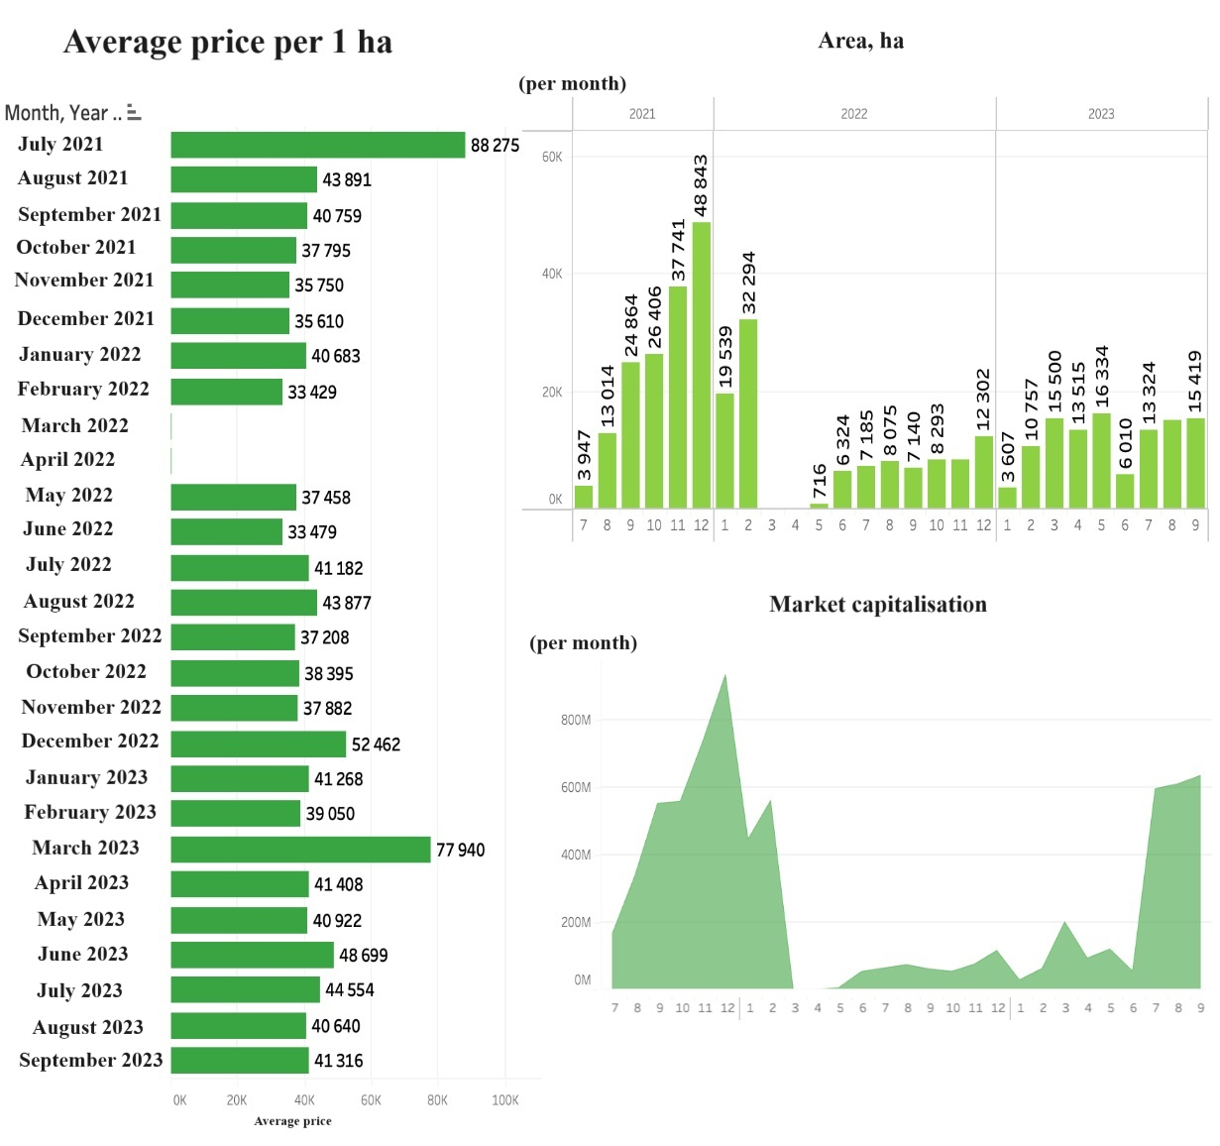
Figure 1. Analysis of average prices per 1 ha of land and land market capitalisation in July 2021 - September 2023.

The value of agricultural land is gradually increasing: in 2023, the average price reached UAH 35.4 thousand per hectare, which is 13.5% higher than in 2022 and almost 22% higher than in 2021. The highest prices are observed for land in Kyiv, Ivano-Frankivsk and Lviv regions, where this situation is typical for attractive metropolitan areas, and prices are affected by the prospect of land conversion from agricultural to non-agricultural use for further development [9] (see Figure 2).
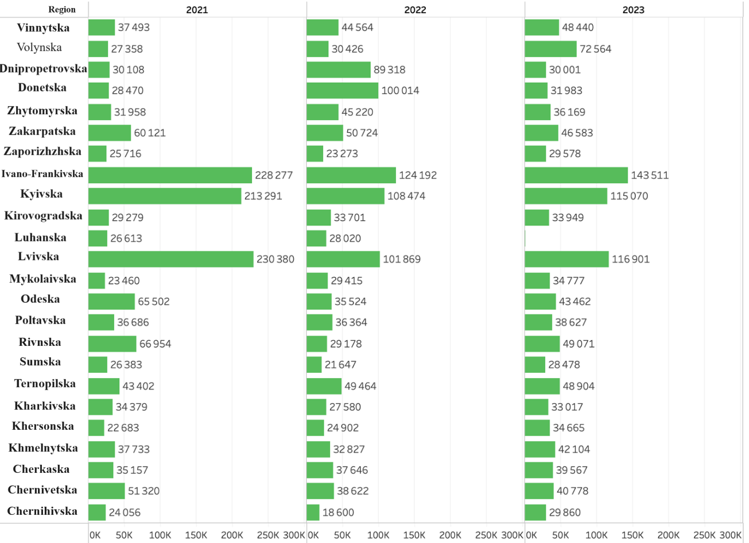
Figure 2. The state of prices per 1 ha of land in 2021-2023.

It is worth noting that the market capitalisation has also fallen. In December 2021, sales and purchase transactions amounted to UAH 936 million, the largest amount that Ukrainians have invested in land purchases. In August 2022, despite the positive dynamics of recovery (on average, transactions were UAH 10 million more than in the previous month), land market transactions amounted to UAH 74.2 million. In July 2023, we observed positive dynamics of the market recovery - purchase and sale transactions worth UAH 596.9 million were concluded, in August - UAH 611 million, and in September - UAH 636 million (see Fig. 2) [6-8].
At the same time, the volume of transactions for the month, although reflecting a certain growth trend, still lags far behind the figures recorded before 24 February. In particular, for the period from 1 July 2021 to 30 September 2023, the number of registered transactions amounted to 216863, and the area of land in respect of which transactions were registered was 471659 hectares. It should be noted that Kharkiv region was the leader in terms of the size of land areas under registered transactions (49914 hectares), and the largest number of transactions was registered in Khmelnytskyi region - 17453 (see Fig. 3).
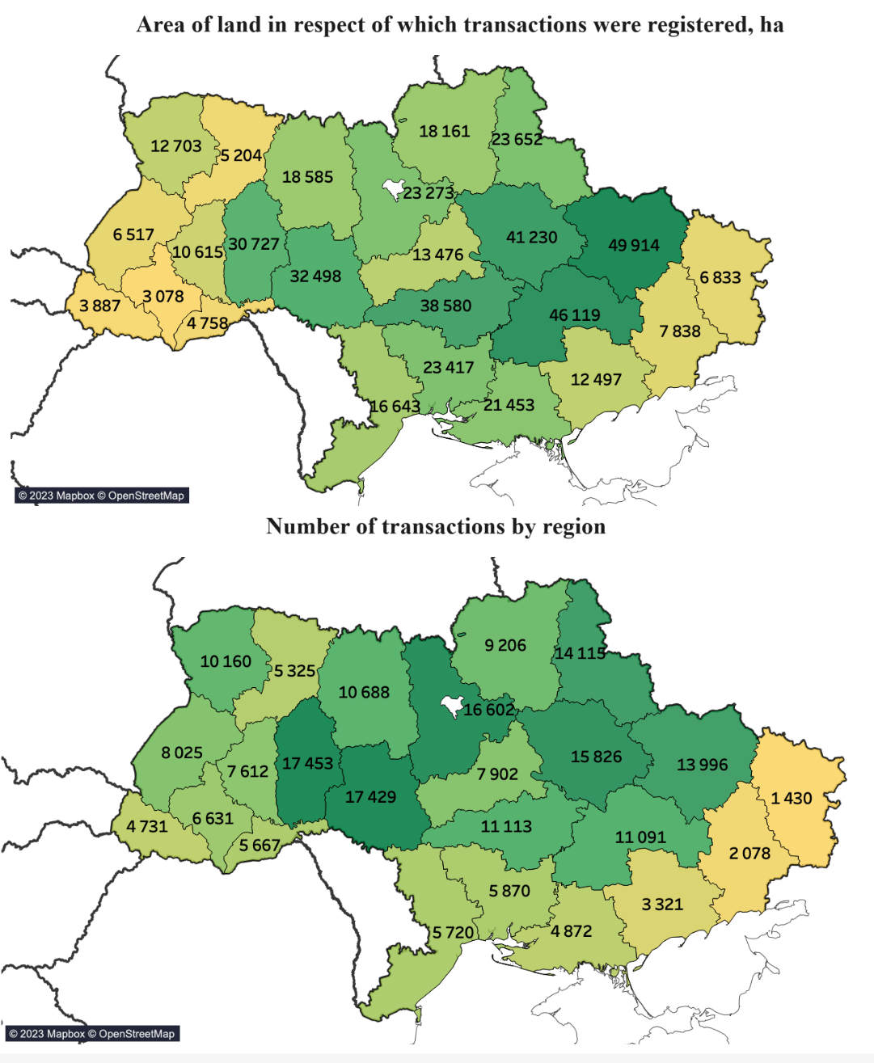
Figure 3. Number of transactions by region and area of land registered in July 2021 - September 2023.

According to statistics, between the opening of the agricultural land market on 1 July 2021 and 1 June 2023, more than 145,000 transactions for the sale and purchase of agricultural land covering a total area of almost 325,000 hectares were concluded, which is about 1% of the total area of agricultural land in Ukraine under government control. Therefore, it can be noted that the land market in Ukraine, even in the presence of martial law, remains active and attractive to investors [10]. In particular, the total change in the number of transactions since 24.02.2022 is 115897, and the average change in the number of transactions per month is 8644.
USAID's Agricultural and Rural Development Programme, known as AGRO, has announced a call for sub-grants to be held on 15 December 2022. The main goal of this competition is to conduct an analytical assessment of the development of the land market and its impact on food security, as well as to promote investment in agriculture and the recovery of communities and the country as a whole.
According to the terms of the call, the project can allocate up to UAH 5.5 million per subgrant, but the final amount will depend on the subgrant's performance and negotiations, and may be less or more than the specified estimate. The duration of the sub-grant under the agreement will not exceed 12 months. The project is scheduled to start on 15 February 2023 [11].
The project believes that the results of this sub-grant will provide an opportunity to collect important data and analyse the land market and land price dynamics, which play a key role in agriculture, where this data will be used to improve market functioning, including the participation of legal entities and the provision of "long-term" loans. The analysis will take into account regional peculiarities and the impact of the war on the agricultural sector, food security and economic recovery of the country and communities.
Conclusion. Based on the study, it can be concluded that the Ukrainian land market is currently undergoing significant changes due to the war, as the Russian military invasion has significantly affected the land market, resulting in significant financial losses, but the market is gradually recovering after the temporary suspension of sales transactions and remains attractive to investors. Despite the war, the volume of transactions in the land market is gradually increasing, although it remains lower than in previous years. Prices for agricultural land are rising, and the average price per hectare is growing, especially in the central regions, indicating a gradual market recovery. It is shown that an important advantage of land market development is its potential contribution to food security, where increased production and investment in agriculture can help the country ensure stable access to food for the population.
The practical significance of the study lies in the fact that the conclusions and recommendations developed by the author and proposed in the article can be used for: planning investments in regions with large land potential and prospects; strategic location and planning of production operations, taking into account regional differences in land values; formation of public policy and decision-making on the land market, taking into account regional characteristics; development of regional development strategies, in particular, aimed at supporting A promising area for further research on this issue is a detailed study and analysis of the impact of the war on the land market, including its long-term consequences and recovery after the conflict; a study of the impact of the land market on regional development and distribution of economic resources, including the role of different regions in the overall market dynamics.

References
- Pro vnesennia zmin do deiakykh zakonodavchykh aktiv Ukrainy shchodo umov obihu zemel sil's'kohospodars'koho pryznachennia: Zakon Ukrainy № 552-IX vid 31.03.2020 r. [On Amendments to Certain Legislative Acts of Ukraine Regarding the Terms of Turnover of Agricultural Land: Law of Ukraine № 552-IX dated 31.03.2020]. (2020). Available at: https://zakon.rada.gov.ua/laws/show/552-20#Text
- Dovidnyk pokaznykiv normatyvnoyi hroshovoyi otsinky sil's'kohospodars'kykh uhid' v Ukrayini [Handbook of indicators of normative monetary valuation of agricultural land in Ukraine] (2022). Diia. Available at: https://data.gov.ua/dataset/7c0ce9a3-d90d-40d8-815b-879c0caf5cb9
- Radtke, O.D. (2021). Rynok zemli – 2021: bahato statistyky ta malo rozuminnia [Land market - 2021: a lot of statistics and little understanding]. Yuryist i Zakon, 52-53. Available at: https://uz.ligazakon.ua/ua/magazine_article/EA015375
- Shchodo nabuttia u vlasnist zemel sil's'kohospodars'koho pryznachennia: Lyst Min’ustu № 70487/61191-33-21/8.3.2 vid 25.08.2021 r. [Regarding the acquisition of agricultural land] (2021). Available at: http://document.vobu.ua/doc/7291
- Zemelnyi rynok v Ukrayini. Analitychnyi ohliad [Land market in Ukraine. Analytical review] (2023). Center for Food and Land Use Research at the Kyiv School of Economics. Available at: https://kse.ua/wp-content/uploads/2023/07/Zemelnii---rinok-v-Ukrai--ni_analitichnii---oglyad-za-2-kv-ta-cherven-2023.pdf
- Programa USAID AGRO. Vidkryttia rynku zemel dlia yuridichnykh osib mozhе prynosyty shchorichno do 2,7% VVP - rezultaty doslidzhennia [USAID AGRO Program. Opening of the land market for legal entities can bring up to 2.7% of GDP annually - research results] (2023). Decentralization. Available at: https://decentralization.gov.ua/news/16955
- Serednia tsina 1 ha zemli v Ukrayini stanovyt' ponad 38,722 hryvni [The average price of 1 hectare of land in Ukraine is over UAH 38,722] (2022). Ministry of Agrarian Policy and Food of Ukraine. Available at: https://minagro.gov.ua/news/serednya-cina-1-ga-zemli-v-ukrayini-stanovit-ponad-38-tis-grn
- Interaktyvnyi zvit z rynku kupivli-prodazhu zemli sil's'kohospodars'koho pryznachennia [Interactive report on the market of purchase and sale of agricultural land] (2023). Ministry of Agrarian Policy and Food of Ukraine. Available at: https://minagro.gov.ua/zemelna-reforma/interaktivnij-zvit-po-rinku-zemli.
- Official website of the State Service of Ukraine for Geodesy, Cartography and Cadastre. Available at: https://land.gov.ua/
- Analitychnyi ohliad stanu zemelnoho rynku v Ukrayini. Analitychnyi zvit [Analytical review of the land market in Ukraine. Analytical report] (2023). Center for Food and Land Use Research at the Kyiv School of Economics. Available at: https://kse.ua/wp-content/uploads/2023/10/Analitichnii---oglyad-stanu-zemelnogo-rinku-v-Ukrai--ni.-Lipen-2023.pdf
- USAID vydylyla 5,5 mln hryven na otsinku rozvytku rynku zemli v Ukrayini [USAID has allocated UAH 5.5 million to assess the development of the land market in Ukraine] (2022). AgroPortal. Available at: https://agroportal.ua/news/finansy/usaid-vidilila-5-5-mln-grn-na-ocinku-rozvitku-rinku-zemli-v-ukrajini

Братінова М.В., Вакуленко В.Л.
ОСОБЛИВОСТІ ЗМІНИ ВАРТОСТІ ЗЕМЕЛЬНИХ ДІЛЯНОК В УМОВАХ ЗАБЕЗПЕЧЕННЯ ПРОДОВОЛЬЧОЇ БЕЗПЕКИ УКРАЇНИ
Анотація. У статті досліджуються особливості зміни вартості земельних ресурсів в умовах забезпечення продовольчої безпеки України. Встановлено, що земельний ринок визнається однією з ключових складових сільськогосподарського сектору та відіграє невід'ємну роль у формуванні продовольчої безпеки країни. Зʼясовано, що найвищі ціни на ріллю та багаторічні насадження спостерігаються у Київській області, на сіножаті та пасовища в Харківській області, на пасовища у Черкаській області. Встановлено, що внаслідок повномасштабної агресії росії проти України, не вдалося укласти понад 102 тисяч угод про купівлю-продаж сільськогосподарських земель на загальну площу 282 тисяч гектарів, загальною вартістю 11,5 млрд грн. Зʼясовано, що найвища активність купівлі-продаж сільськогосподарських земель спостерігається передусім в центральних регіонах України, де частка сільськогосподарських земель у обігу перевищує 1%. Встановлено, що середня ціна за 1 га землі у лютому 2022 року становила 33 429 грн за 1 га, а за результатами травня 2022 р., коли угоди на ринку землі знову почали укладатися, ціна була зафіксована на рівні 37,4 грн і до серпня 2022 р. показала позитивну динаміку, досягнувши позначки в 43,9 тис. грн, а у вересні 2023 року середня ціна становила 41 316 грн за 1 га. Встановлено, що вартість сільськогосподарських земель поступово зростає, де у 2023 році середня ціна досягла 35,4 тисяч гривень за гектар, що на 13,5% вище, ніж у 2022 році, і майже на 22% вище, ніж у 2021 році. Зʼясовано, що найвищі ціни на землі спостерігаються в Київській, Івано-Франківській та Львівській областях. Встановлено, що впала капіталізація ринку, тобто у грудні 2021 року угод купівлі-продажу було укладено на 936 млн грн, у серпні 2022 року – на 74,2 млн грн, а у липні 2023 р. спостерігаємо позитивну динаміку відновлення ринку – було укладено угод купівлі-продажу на 596,9 млн грн, у серпні – на 611 млн грн та у вересні – на 636 млн грн.
Ключові слова: земельний ринок, земельні ресурси, продовольча безпека, вартість, угоди купівлі-продажу

