UDC 332.3:332.12(477)
Scientific and applied principles of inventory of territorial communities' lands in Ukraine

E. Butenko, Candidate of Economic Sciences, Associate Professor
E-mail: evg_cat@ukr.net
M. Prykhodko, applicant
E-mail: mashka_pr@ukr.net
National University of Life and Environmental
Sciences of Ukraine
The article examines the process and stages of land inventory. The Resolution of the CMU dated June 5, 2019 No. 476 "Procedure for Land Inventory" was analyzed. The territory of a part of the settlement, which is subject to inventory, and the effectiveness of land resource management measures have been analyzed. The components and essence of land during the inventory were studied. Proposals for improving the scientific and applied principles of land inventory are offered.
The land-resource potential and the efficiency of its use within the settlement, which is the object of the study, were investigated and studied.
It is proposed to improve the scientific and applied principles of land inventory as a result of the establishment of security zones, restricted zones around regime-forming objects, and the establishment of the settlement boundary.
The process of carrying out topographical and geodetic works, the types of surveys used for the inventory process were investigated. It is proposed to improve measures to save resources and time for work during the update of the cartographic base by combining surveying methods.
The analysis of the data of the State Land Cadaster and the database of state acts of the self-governing body, which can increase the effective management of land and improve the state of land use, was carried out.
The necessity of carrying out a land inventory in order to study land resources to simplify the land management and urban planning process, effective implementation of land management by creating an electronic resource with survey materials and the results of topographical and geodetic works is substantiated.
Determined: boundaries of land plots based on the results of the inventory; boundaries of land plots with an assigned cadastral number; boundaries of lands granted ownership; boundaries of land plots used without documents certifying property rights to them; boundaries of lands not granted for ownership or use.
It is proposed to improve the scientific and applied principles of land inventory, due to the creation of an electronic resource for the publication of the results of land management works, with the aim of increasing the investment attractiveness of the community, effective management of community lands and significantly simplifying the search for plots for various needs.
Key words: land inventory, land resource potential, land resources, management efficiency, improvement, geoinformation system, settlement.

Formulation of the problem.
With the completion of the decentralization process, 69 territorial communities were formed in Kyiv region, united in seven districts. These communities need to update and update their data.
"Inventory (from the Latin word invenire - to find, to search) - in other words, it is a process of detailed study with further description of the object"[11].
According to Article 35 of the Law of Ukraine "On Land Management", land inventory "shall be carried out in order to establish the location of land management objects, their boundaries, size, legal status, identify land that is not used, used irrationally or not for its intended purpose, identify and conserve degraded agricultural land and contaminated land, and establish quantitative and qualitative characteristics of land, necessary for the maintenance of the State Land Cadaster, detection and correction of errors in the data of the State Land Cadaster, exercise of state control over the use and protection of land and adoption of relevant decisions by executive authorities and local self-government bodies on their basis" [9].
Based on the above, the community, thanks to the inventory, receives
- a database of all land plots within its boundaries;
- the ability to control and organize land within its borders;
- Identification of all land users and owners with the establishment of the area of land actually used;
- clarification of the boundaries of plots entered in the State Land Cadaster [5];
- identification of plots that are not used or are used irrationally or not for their intended purpose.
Thus, land inventory is one of the key tools for the successful functioning and development of communities.
Analysis of the latest research and publications.
The inventory of lands of territorial communities is an issue that has been attracting the attention of various scientists and researchers for several years, and the inventory is gaining more and more attention as it allows for improved management efficiency. Improvement of methods, necessity and peculiarities of land inventory have been studied in their works: Y.M. Dorosh and M.N. Kalyuzhnyi. In particular, Y.M. Dorosh in one of his works concluded that the existing methods are not equally applied to all land management objects, respectively, this requires the introduction of a new methodology that will provide a systematic approach to inventory work. E.V. Butenko's work focuses on land inventory in the context of effective territory management. A.G. Martin studied the process of inventory in modern conditions. Y.O. Karpinskyi conducted a study of the inventory of green spaces of the street and road network using geospatial data. O.S. Dorosh conducted a study on proposals for the structure, content and composition of the inventory of lands of state institutions and enterprises, in which she concluded that Resolution No. 476 does not contain provisions that take into account the specifics of land use by scientific organizations and include research fields and valuable lands for scientific research. O.F. Yarmolyuk studies this issue from the point of view of monitoring the condition and movement of land, while M.V. Trubina studies the process of inventory as a component of land payment. However, given the conditions and time, this issue needs to be studied and new methods and approaches need to be found.
The aim of the study.
To analyze the existing scientific and applied principles of territorial community land inventory and provide proposals for their improvement.
Materials and methods of scientific research.
The research was conducted using monographic and empirical methods and analysis.
In particular, the content of Resolution No. 476 "Procedure for Conducting Land Inventory" was studied using the monographic method.
Using the empirical method, the state of land resources and the efficiency of their use were determined. The types of land used were observed. A comparison of land in use and unoccupied land plots was made, and a more efficient land management system was introduced.
The analysis revealed the actual boundaries of land use. Explanations were developed and proposals were made to improve land use and protection.
Research results and discussion.
Land inventory is one of the key issues for territorial communities in implementing land reform. In 2017, the Kyiv City Council approved a land inventory program for 2017-2020, but the program has not been fully implemented. At the current stage, the inventory process is still ongoing and has a decisive impact on the economy of the Kyiv region and the country as a whole, ensuring the development of local communities. According to the heads of territorial communities, the process is delayed due to a lack of funds, but it continues, as land is inventoried in parts, first within settlements, then outside or vice versa. In this regard, at the end of 2021, the Kyiv City Council approved a target program for the use and protection of land for 2022-2025, which provides for the completion of land inventory and registration, filling the database of the State Land Cadaster and the database of the State Register of Real Property Rights [17].
It is also important to take into account the current situation in the country - the introduction of martial law, which imposes certain peculiarities on access to source information and filming of the territory. Therefore, the process can take much longer.
The amalgamation of village councils into communities has a number of important advantages, including the full transfer of powers to territorial communities and a clear division of powers between executive authorities [9]. It is also important that communities receive the full right to dispose of land resources within their territory.
After their formation, communities faced the need to determine the existing land holdings and land uses on their territory. The inventory is the tool that will help to organize the available land of the community and establish the location of land management objects, their boundaries, size, legal status, and identify unused land.
Conducting a land inventory is one of the successful steps to make a territorial community attractive to investors and to fully control the use of the community's land resources.
At the legislative level, the issue of land inventory is regulated by law. The main laws and regulations governing these issues include the following: The Land Code of Ukraine, the Law of Ukraine "On Land Management", the Resolution of the Cabinet of Ministers of Ukraine No. 476 "Procedure for Conducting Land Inventory".
The implementation of the provisions of the Resolution opens up opportunities for local governments to improve the efficiency of territory management. The implementation of inventory projects for the territorial community will be a reliable source of investment potential for the community and a prospect for community development.
As already noted, communities conduct land inventories in parts, in particular in Kyiv region, according to https://prozorro.gov.ua, approximately 90 land inventory agreements were concluded in 2023. The agreements mostly include inventory of communal land under healthcare facilities, educational institutions, under buildings of state and local authorities, under cemeteries, land plots under field roads and forest belts, and under unallocated (unclaimed) land plots [2].
The analysis revealed that the object is part of the land of the village of Vyshenky, Boryspil district, Kyiv region, which was formed in June 2020 by the merger of villages. The boundary of the research object can be found in Fig. 1.

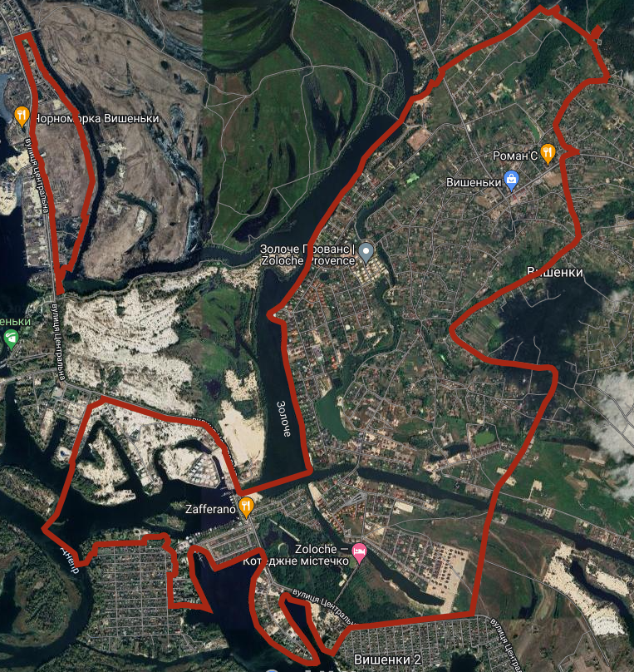
Figure 1. Inventory boundary of the village of Vyshenky, Boryspil district, Kyiv region, on a Google map.

The analysis revealed that part of the territory has an extended water system. A drainage channel of the Kaniv Reservoir's protective massif passes through the community, on the north side, and a lake washes the village border on the left. The village of Vyshenky in Boryspil district of Kyiv region has a strong recreational potential represented by natural reservoirs and diggings located on private territory. The village has a developed infrastructure, an updated master plan (2014) and an existing facility
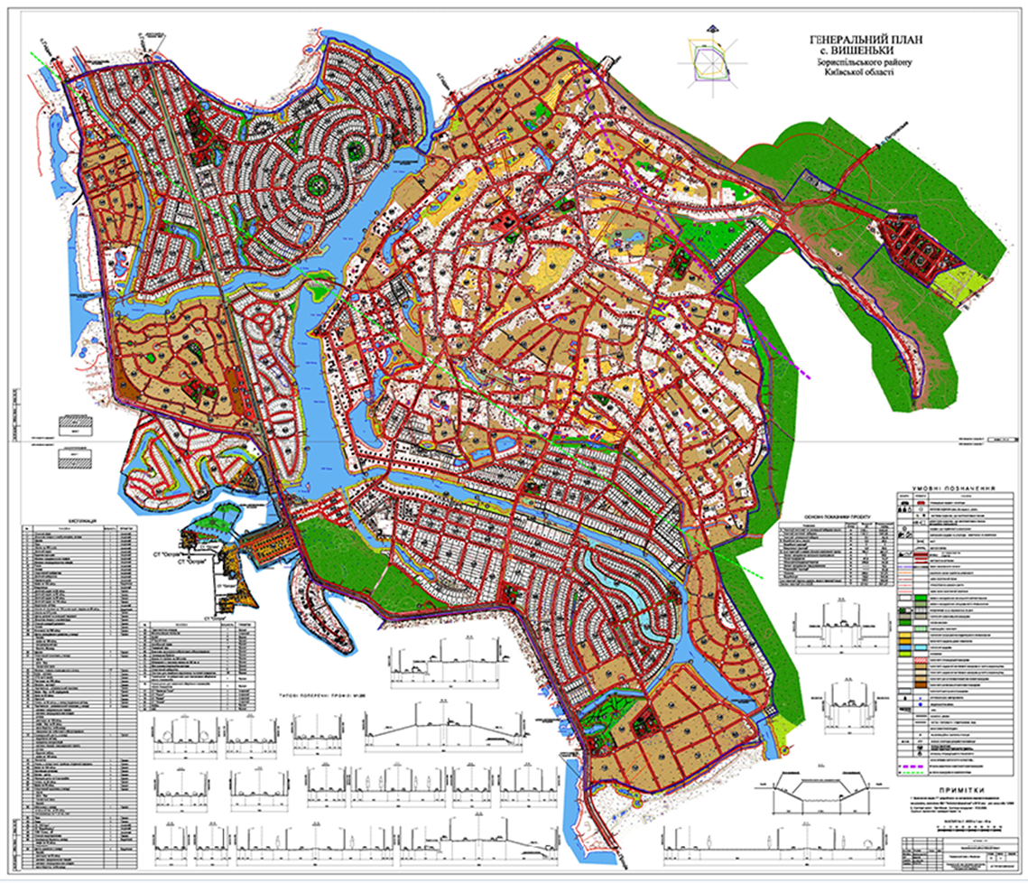
Figure 2. General plan of the settlement.

During the study of the stages of land inventory of the territorial community, we identified four main stages of inventory work, namely: preparatory, topographic and geodetic, desk-based, and documentation [7].
Land inventory work is carried out on the basis of the decision "On Approval of the Program of Land Management Measures on the Territory of Zolochiv Village Council for 2021".
Based on the results of topographic and geodetic works, an orthophoto map of the area was created (Fig. 3 with reference to the points of the State Geodetic Network, a topographic plan of the area at a scale of 1:2000 with an accuracy of 0.5 mm.

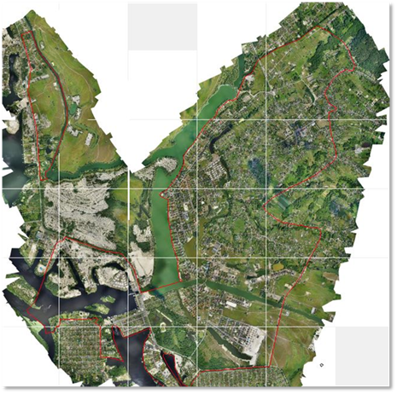
Figure 3. Orthophoto map of the area created based on aerial photography and used as a basis for land inventory.

Analyzing Art. 57 of the Law of Ukraine "On Land Management" and Resolution No. 476 "Procedure for Conducting Land Inventory", it is established that Art. 57 of the Law of Ukraine "On Land Management" establishes the content of land management documentation and has a clear gradation of content between land inventory that does not involve the formation of land and inventory with the formation of land plots [9]. In turn, the Procedure defines the requirements for conducting an inventory and performers, purpose, principles, object, basis, and list of initial data. The Procedure has the advantage of providing a clear understanding of the content of graphic materials based on the results of land inventory, so the creation of a working and consolidated inventory plan has a clear list of land plot boundaries included in the cartographic basis.
Based on the results of the analysis of the land and resource potential of the settlement territory, it was found that: water fund lands occupy 13.8%, forest fund lands - 0.7%, the territory of settlement and economic activity - 75.8% of hectares and public lands (streets, roads, passages) - 9.7% (Fig. 4). Accordingly, the land and resource potential of the site is very high and is used as a means of production (vegetable gardens, industrial facilities), and is also the spatial basis of society's activities.

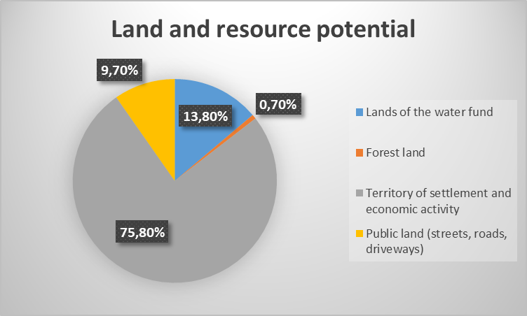
Figure 4. Land resource potential of Vyshenky village, Boryspil district, Kyiv region.

In the course of the work, it was found that the object on which the study was carried out does not have established boundaries of the settlement, documentation on the establishment of the boundaries of the water fund and coastal protection zones. It was determined that land resources are used very efficiently, including: 13.8% of the land is occupied by the water fund, 0.7% by the forest fund, the remaining 85.8% is part of the territory of settlement and economic activity, including public land (streets, roads, passages) and only 2.3% of the territory of settlement and economic activity is not used or not granted for ownership or use.
- Land and resource potential of Vyshenky village, Boryspil district, Kyiv region
No. | Land category | Area, ha
1 | Lands of the water fund | 125,37
2 | Lands of the forest fund | 6,13
3 | Lands of residential and public buildings | 657,58
4 | Lands of industry, transport, electronic communications, energy, defense and other purposes | 87,66
5 | Land plots not granted for ownership or use | 31,15
 | Total: | 907,89

When studying the object, special attention is paid to residential and public lands.
- Residential and public buildings in the village of Vyshenky, Boryspil district, Kyiv region
No. | Type of use | Area, ha
1 | Land plots granted for ownership or use (with cadastral number) | 717,6798
2 | Land plots granted for ownership or use without assignment of a cadastral number (used on the basis of a State Act) | 20,9353
3 | Land plots that are used without documents certifying property rights to them | 25,0842

It should be noted that the data of the State Land Cadaster is very distorted, as the inventory results show 3562 land plots, including land plots granted for ownership or use without assigning a cadastral number; land plots used without documents certifying property rights to them and land plots not granted for ownership or use, and 4371 in the State Land Cadaster, hence the distorted area of registered land relative to the total area of residential and public land. This is caused by a large number of overlaps.
- The main errors in the State Land Cadaster data in the context of the research object
No. | Graphic fragment | Explanation
1 | 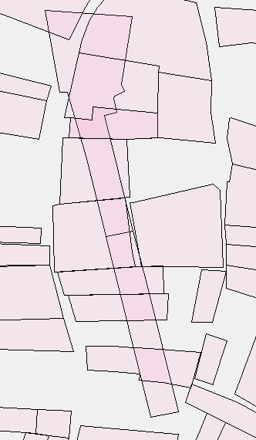 | Land plots were entered with an error in geometry, the coordinates of the plot do not correspond to the actual location.
2 | 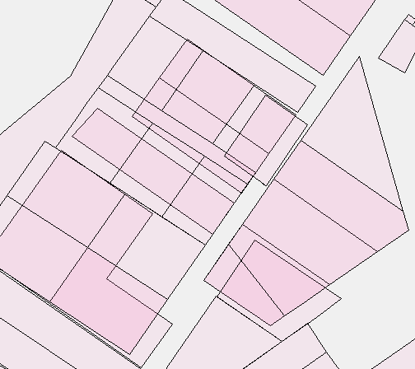 | Errors in entering the coordinates of land plots in the SLC, not canceled registration as a result of division, overlapping land plots with different owners.
3 | 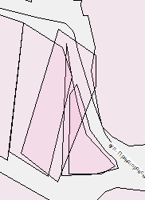 | Land plots with an error in geometry and different owners were entered.
4 | 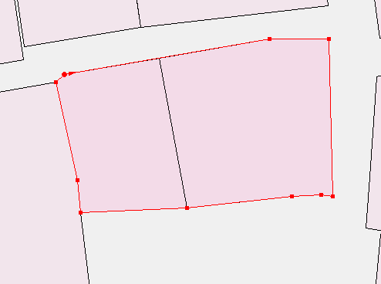 | The registration of the common land plot was not canceled and was not transferred to the archive layer as a result of the division.
5 | 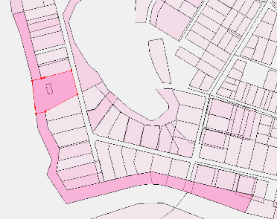 | The land plot was registered several times with different land categories and designated purposes.

As a result of the inventory, the boundaries of 3,562 land plots in actual use, including land not granted for ownership or use, were recorded, and 4,371 land plots were registered in the State Land Cadaster. It is proposed to provide an offer to owners of land plots whose lands overlap each other, plots whose registration has not been canceled as a result of division, have geometric errors, to eliminate errors and make changes to the information in the State Land Cadaster.
Based on the above, having such inaccuracies, contractors should develop a list of proposals to improve data and increase the efficiency of land management.
By analyzing the stages and the process of each stage, a list of proposals has been developed that can speed up and improve the process of work execution, and for customers to improve the efficiency of land management.
The development of a topographic base for a local self-government body in electronic form is one of the important documents for analyzing unused land and analyzing the process of illegal construction. The availability of an electronic format of the topographic base for the council makes it possible to save money on various types of work, for example, the topo plan is the basis for creating a master plan, and the need to update the base saves the community's costs.
It is also proposed to improve the inventory process by transferring not only electronic (*.pdf) and paper formats of documentation to the local government, but also transferring an electronic format of the cartographic base with land plots based on the results of the inventory and filled information about land plots in layer attributes, namely: cadastral number (if any) or information on the basis of which the land plot is used, information about the owner/user of the land, actual and registered area.
Therefore, it is proposed to develop a web platform for councils to add inventory materials: topographic plan of the area, orthophoto plan, working and consolidated plans of the area with attribute information about land plots. Fig. 5 shows an example of filling a layer with attribute information: cadastral number, area in hectares, designated purpose, name of the owner and form of ownership. This will ensure data visibility, simultaneous access to legal and spatial information, and the availability of comprehensive information about objects will allow for quick and efficient decision-making.

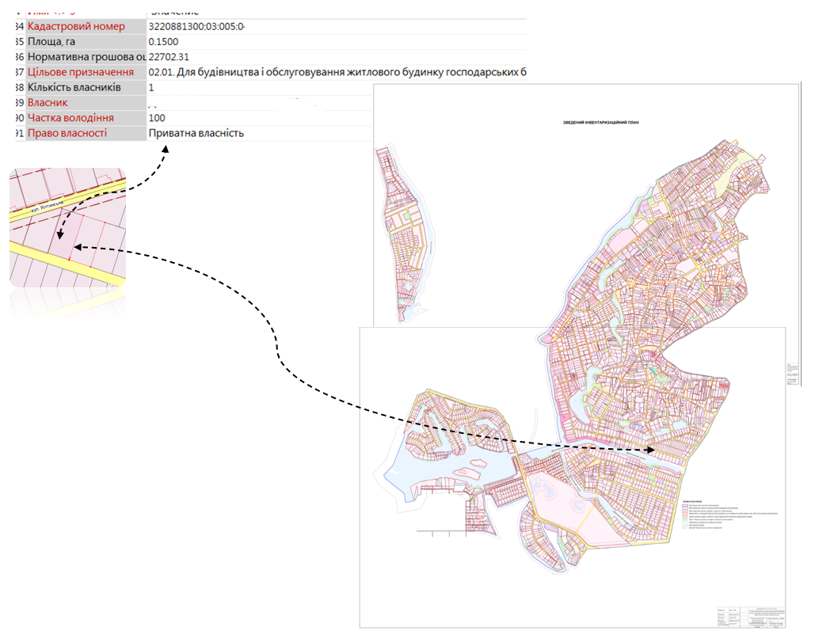
Fig. 5. Filling attributes with data on land plots.

Conclusions and suggestions.
In view of the above, the process of land inventory within a settlement is regulated at the legislative level, but there is a proposal to create a web-based platform for local governments.
Having studied the land and resource potential, 2.3% of the land has not been granted for ownership or use, therefore, it is proposed that the local government should register these land plots. Conducting an inventory and entering data into the State Land Cadaster will allow filling the community budget, for example, if a land plot not registered in the SLC is located in an array of plots and is being cultivated, it is proposed to register it in the SLC on the basis of a decision of the local government, which does not contradict the Law No. 2145-IX "On Amendments to Certain Legislative Acts of Ukraine on Creating Conditions for Ensuring Food Security under Martial Law" [7]. Accordingly, by registering such lands, the community receives a profit from the lease of these lands in the amount of UAH 1746/ha (data as of January 1, 2021, the lease amount has not changed), which is 8% of the normative monetary value on average in Ukraine [1].
In order to protect water bodies from pollution and contamination, it is proposed to develop documentation on the establishment of the boundaries of the water fund and coastal protection zones. It is also proposed to develop land management documentation for establishing (changing) the boundaries of the settlement, which will improve the efficiency of land use within its boundaries.
The analysis revealed land plots granted for ownership or use without assigning a cadastral number (used on the basis of the State Act). The community should provide a recommendation to the owners to develop technical documentation on land management to establish (restore) the boundaries of the land plot in kind (on the ground) [10].
The availability of land inventory materials on the web platform will allow them to be used to improve the organization of community land use, control and compliance with the use of land for its intended purpose, legal occupation of land plots, and to provide recommendations to territorial communities on the effectiveness of land inventory. It is also important to note that the materials on the web platform will not only visualize the data, but will also simplify the search for land plots for various needs, which will greatly increase the investment attractiveness of the community.
It is important to conduct a land inventory during martial law, as limited access to information and limited opportunities for topographic and geodetic work significantly reduce the reliability of the inventory. Customers are advised to work closely with the contractors to ensure a quality inventory and to carefully accept the work performed.

References:
1. [The cost of renting land in 2023 will not change. Available at: https://landlord.ua/news/vartist-orendy-zemli-u-2023-rotsi-ne-zminytsia-solskyi/
2. Inventaryzatsiya zemelʹ, Kyyivsʹka oblastʹ [Land inventory, Kyiv region]. Available at: https://prozorro.gov.ua/search/tender?text=
3. Butenko, E.V., Yurchenko, A.V., Danshova, I.V. (2020) Inventaryzatsiya zemelʹ yak peredumova efektyvnoho upravlinnya zemelʹnymy resursamy [Land inventory as a prerequisite for effective management of land resources]. Land management, cadastre and land monitoring. 4, 14-19
4. Land inventory. Available at: https://www.dela.kiev.ua/vyhotovlennya-tekhnichnoyi-dokumentatsiyi-shchodo-vstanovlennya-mezh-zemelnoyi-dilyanky
5. Dorosh, Y.M. (2019) Metodychni pidkhody do provedennya robit iz inventaryzatsiyi zemelʹ pry zdiysnenni zemleustroyu potrebuyutʹ zmin [Methodical approaches to carrying out work on land inventory during the implementation of land management need changes]. Land management, cadastre and land monitoring. 1, 6-15
6. Dorosh, O. (2015) Inventaryzatsiya zemelʹ: metodychni pidkhody do yiyi provedennya [Land inventory: methodical approaches to its implementation]. Agroworld. 11, 24-30
7. Law of Ukraine "On Amendments to Certain Legislative Acts of Ukraine on Creating Conditions for Ensuring Food Security in Martial Law" dated March 24, 2022 No. 2145-IX. Available at: https://zakon.rada.gov.ua/laws/show/2145-20#Text
8. Law of Ukraine "On Voluntary Unification of Territorial Communities" dated February 5, 2015 No. 157-VIII. Available at: https://zakon.rada.gov.ua/laws/show/157-19 #n20
9. Law of Ukraine "On Land Management" dated May 22, 2003 No. 858-IV Available at: https://zakon.rada.gov.ua/laws/show/858-15#Text
10. Land Code of Ukraine dated October 25, 2001 No. 2768-III. Available at: https://zakon.rada.gov.ua/laws/show/2768-14#Text
11. Land Management Company "Prykarpatsky Land Center". Land inventory of settlements. Available at: https://terram.com.ua/inventaryzatsiya-zemel/
12. Land inventory of all forms of ownership. Available at: https://kizv.gov.ua/1.php?id=7
13. Kalyuzhnyi, M.N., Dorosh, Y.M. (2011) Naukovo-metodychni zasady inventaryzatsiyi zemelʹ silʹsʹkohospodarsʹkoho pryznachennya [Scientific and methodological principles of the inventory of agricultural lands]. Land Management Bulletin. 6, 29-31
14. Karpinsky, Yu.O. (2022) Dosvid inventaryzatsiyi zelenykh nasadzhenʹ vulychno-dorozhnʹoyi merezhi mista Odesa [Experience of the inventory of green spaces of the street and road network of the city of Odesa]. Urban planning and territorial planning. 79, 26-36
15. Kyiv government. "Communities of the Kyiv Region conduct a mass inventory of land". Available at: https://kievvlast.com.ua/text/gromadi-kiivshhini-provodyat-masovu-inventarizatsiyu-zemel
16. Martin, A.H. Land inventory: how to carry it out in modern conditions. Available at: http://www.zsu.org.ua/index.php?option=com_content&view=article&id=2254:2011-05-27-14-48 -38&catid=62:2011-01-12-14-57
17. The official portal of Kyiv. The Kyiv City Council approved the city's target program of land use and protection for 2022-2025. Available at: https://kyivcity.gov.ua/news/kivrada_zatverdila_misku_tsilovu_programu_vikoristannya_ta_okhoroni_zemel_na_2022-2025_roki/
18. Resolution of the Cabinet of Ministers of Ukraine "On approval of the procedure for land inventory": dated May 23, 2012. Available at: http://zakon3.rada.gov.ua/laws/show/513-2012-% D0%BF
19. Roman Karpiuk. Inventory 2022 in conditions of war. Liga 360. Available at: https://bz.ligazakon.ua/ua/magazine_article/BZ014090
20. Trubina, M.V. (2014) Inventaryzatsiya zemelʹ yak osnovnyy komponent platy za zemlyu: ukrayinsʹkyy ta zarubizhnyy dosvid. Finansove pravo [Land inventory as the main component of the land fee: Ukrainian and foreign experience]. Finance law. 1, 30-33
21. Yarmolyuk, O.F. (2011) Inventaryzatsiya zemelʹ silʹsʹkohospodarsʹkoho pryznachennya v rynkovykh umovakh [Inventory of agricultural lands under market conditions]. Bulletin of ZhNAEU. 2(2), 18-25

Бутенко Є.В., Приходько М.Л.
Науково-прикладні засади проведення інвентаризації земель територіальних громад в Україні
У статті досліджено процес та етапи проведення інвентаризації земель. Проаналізовано Постанову КМУ від 05.06.2019 року №476 «Порядок проведення інвентаризації земель». Проаналізовано територію частини населеного пункту, який підлягає інвентаризації та ефективність заходів управління земельними ресурсами. Досліджено складові та сутність земель при проведенні інвентаризації. Запропоновано пропозиції щодо удосконалення науково-прикладних засад щодо здійснення інвентаризації земель.
Було досліджено та вивчено земельно-ресурсний потенціал і ефективність його використання в межах населеного пункту, що є об’єктом дослідження.
Запропоновано удосконалення науково-прикладних засад інвентаризації земель в результаті встановлення охоронних зон, зон обмежень навколо режимоутворюючих об’єктів, встановлення межі населеного пункту.
Було досліджено процес проведення топографо-геодезичних робіт, види зйомок, які використовувалися для процесу інвентаризації. Запропоновано удосконалення заходів з економії ресурсів і часу на виконання робіт під час оновлення картографічної основи шляхом поєднання методів знімання.
Здійснено аналіз даних Державного земельного кадастру і бази даних державних актів органу самоврядування, які можуть підвищити ефективне управління землями та поліпшити стан використання земель.
Обґрунтовано необхідність проведення інвентаризації земель з метою вивчення земельних ресурсів для спрощення землевпорядного та містобудівного процесу, ефективного здійснення землеустрою шляхом створення електронного ресурсу з матеріалами знімання та результатами топографо-геодезичних робіт.
Визначено: межі земельних ділянок за результатами проведення інвентаризації; межі земельних ділянок з присвоєним кадастровим номером; межі земель, що надані у власність; межі земельних ділянок, що використовуються без документів, які посвідчують речові права на них; межі земель не наданих у власність чи користування.
Запропоновано удосконалення науково-прикладних засад інвентаризації земель, за рахунок створення електронного ресурсу для публікації результатів землевпорядних робіт, з метою підвищення інвестиційної привабливості громади, ефективного управління землями громади та суттєвого спрощення пошуку ділянок для різних потреб.
Ключові слова: інвентаризація земель, земельно-ресурсний потенціал, земельні ресурси, ефективність управління, удосконалення, геоінформаційна система, населений пункт.

