UDC: 004.9:911.5/.9:528.94
FORMALIZATION OF THE CONCEPTUAL FRAMEWORK OF SPATIAL SYSTEMS

Chabaniuk V., Ph. D.,
Senior Researcher
Institute of Geography of the National Academy of Sciences of Ukraine
E-mail: chab3@i.ua
Dyshlyk O., executive director, Geomatic Solutions LLC
E-mail: dyshlyk@geomatica.kiev.ua

The work formalizes the phenomenon of Conceptual Frameworks of Spatial Systems. It preceded by the conceptualization of the same phenomenon, but made for a narrower class of classic Atlas Systems. Formalization needs for several reasons. The first is the use of Conceptual Frameworks in the creation of System Cartography and, in particular, Model-Based Cartography as a new system paradigm of cartography and as a specialization of Model-Based Engineering. The second is the simplification of implementation, since formalized constructions are easier to implement by informatics means. The third is the possibility of using inductive inferences by researchers with experience different from ours.
This article first describes the formalized constructions of levels and strata of the Spatial Systems Conceptual Framework. At the same time, for the formalization of the concept of strata, the concept used even more widely than Spatial Systems. This is the so-called Science of information systems, which is of great importance for understanding the essence of both research and design of system subjects X. After that, practically applicable constructions of the Atlas or Spatial Systems Conceptual Framework strata obtained by analogy.
The indicated three reasons are satisfied by considering the Conceptual Framework formalizations relevant today from the viewpoints of three disciplines: 1) cartography, 2) informatics, 3) systemology. In cartography are drawn analogies that are important for modern practice - with the formal map model of McKenney-Schneider’s Map Framework in the monograph of 2016. In computer science – with the Concepts of Software Stability in the monograph of 2015. In systemology – with Klir’s Universal System Problem Solver, which is relevant even in our time. At the end, opinions are expressed regarding the applicability of the Conceptual Framework of subjects X to the classification of Systems of spatial activity such as Cartography in general or System Cartography in particular.
Keywords: Conceptual Framework of Atlas or Spatial Systems (AtS/SpS) in the broader sense (AtSb/SpSb), Infrastructure of AtS/AtSb (SpS/SpSb), formalization of the AtSb/SpSb Conceptual Framework.

Introduction
In the article [1], the Conceptual Framework was defined by two terms: "concept" and "framework", where the framework was understood as an architectural pattern originating from computer science. There we also used a more general and understandable definition of Alexander's pattern [2], which gives the best representation of the essence of our understanding. Namely, it explains the following main problems of the series of articles on Conceptual Frameworks: 1) what should a thing (subject, product; an example of such a thing is the Atlas System) be, in order to ensure its low-problem creation, maintenance of operation and evolution in a fixed context?; 2) what should be the appropriate process (an example of such a process is the creation of a thing)? Thus, the pattern called the "Conceptual (Notional) Framework of subject X" at the same time describes both the subject (thing, product) X that needs to create, and the process of its use for the creation, maintenance of operation and evolution of X.
The notion of "Conceptual Framework" has evolved. The notion of "subject X", which is dependent on it, also evolved. In 2014, we started with the individual subject X - Electronic version of National Atlas of Ukraine (ElNAU) and its extension ElNAUb. Then we considered the class of Electronic Atlases (EA) and its extensions EAb conformed to the ElNAU/ElNAUb Conceptual Framework. Then there were Atlas Information Systems (AtIS) and their extensions AtISb, which are denoted {Atlas Systems (AtS)} = {EA} ∪ {AtIS} and {AtSb} = {EAb} ∪ {AtISb}, respectively.
Recently, we began to use intensively two more classes of Atlas Systems: 1) System Electronic Atlases and Atlas Geo-Information Systems (AGIS). These new classes sometimes called "non-classic" AtS, while the existing ones called "classic" AtS. The Conceptual Framework is applicable to all mentioned AtS. Although, to be precise, the Conceptual Framework is applicable both to classic AtS in the broader sense - AtSb, and to non-classic AtS, for which the notation has not yet been selected. In the case of the latter, each time you need to specify what and which extension is used.
Let's not forget about Atlas infrastructures. They introduced as an extensions of the so-called classic AtS in the narrow sense, denoted by AtSn. The usual EAn (for example, ElNAUn) and the usual AtISn called classic. Each such AtSn is matched by another extended AtSb’, called Atlas infrastructure, so that the conditional equation AtSb = AtSn + Atlas infrastructure AtSb’ is true. Modern Atlas infrastructures are extensions not only of AtSn, but of all AtS. That is, in principle, it is possible to extend the extension of AtSn.

Formalization of the Conceptual Framework of Atlas Systems
There are several justifications (structure) of the Conceptual Framework of subject X. Subject X can be ElNAU/ElNAUb, an element from a set of Atlas Systems ("classic" or "non-classic") and/or their extensions AtSb or even another Spatial Information System (SpIS) and their extensions of SpISb in the given context. The Conceptual Framework should be relevant to the research context. The first, abductive justification of what was said, was used in 2014 and in 2024. Justifications 2 and 3 can be called "inductive". They are used in this and subsequent articles of the series.
Justification 2 (inductive). For inferences about the levels of the Conceptual Framework, the work [3] and further research in this direction used. For inferences about the layers of the Conceptual Framework, the work [4] and further research in this direction used. The update of the formalization of levels from the viewpoint of cartography is the monograph [5], from the viewpoint of informatics (computer science) – the monograph of Fayad [6]. The update of the formalization of strata is contained in the monograph [7].
Justification 3 (inductive). In recent years, research has been developing mainly in informatics, called Model-Based Engineering (MBE). Informational (our) interpretation of the Conceptual Framework and the method of Conceptual Frameworks are constructs of MBE. It is sufficient to present the Conceptual Framework as a model, and to link the method with the modeling process. But this is the subject of another article.
This article provides Justification 2 (inductive), which is essentially a Formalization of the Conceptual Framework of System Subjects X of "Information Systems Science". This is the main result of the article. The main inductive method is the method of analogies: inferences are making for the Science of information systems or information systems in general, and inferences for spatial (cartographic) information systems are obtained by analogies.

Formalization of the levels notion of the Conceptual Framework
The levels notion of information systems is studied in [3]. J. Iivari called them levels of abstraction and meant the abstractions identified as the HoSt organization (HS), universe of discourse (UoD) and abstract technology (Abstract Technology - AT). The correspondence of the Datalogical, Infological and Organizational levels (or Technological, Language and Organizational contexts) of AtS Conceptual Framework and Datalogical/ Technical, Conceptual/Infological and Organizational levels of J. Iivari for one IS is shown in Fig. 1. The adjective "one" brings a very important meaning to the understanding of J. Iivari's result, since the author of the cited work essentially concentrated on researching the levels of abstraction of one IS. AtS Conceptual Framework deals not with one system, but with multiple systems at each of the strata, which have certain relations with each other both within one stratum and between strata.
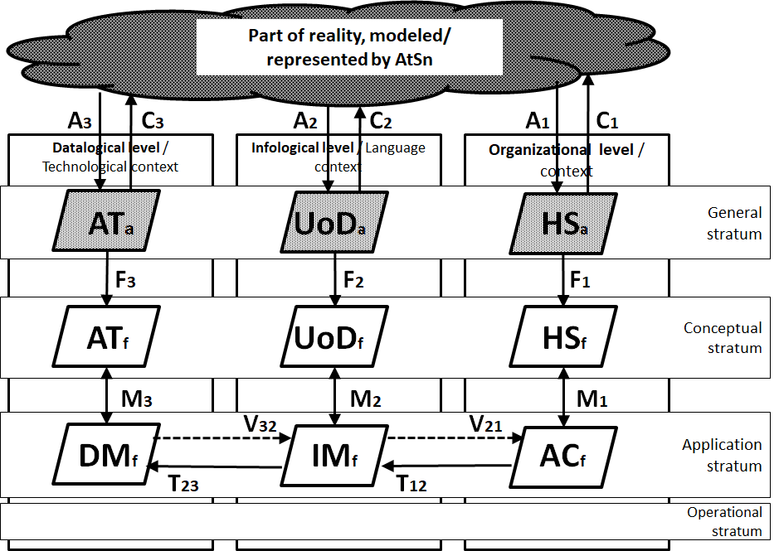
Fig. 1. Correspondence of elements of AtS CoFr levels and IS abstraction levels according to [3; Fig. 3.1]
On Fig. 1 elements from [3; Fig. 3.1] are shown by parallelograms with a border thickness of 3 pixels (for example, AT_{a} and AT_{f}), and the relation between them - with signed arrows (for example, F₃). Such elements as Datalogic, Infologic and Organizational level are described by J. Iivari, but not shown in [3; Fig. 3.1]. They are shown as rectangles with a border thickness of 2 pixels. There was no concept of "strata" in [3]. These concepts "came" from the Conceptual Framework of Subjects X. They are shown as rectangles with a border thickness of 1 pixel.
As stated in [3], “these abstractions are not necessarily passive descriptions of the existing reality, but normally constitute a new reality, reflecting the fact that information systems imply the organizational development, the change of language, and the development of technology in the host organization. Abstractions are described using appropriate formalisms (F₁-F₃). Formalisms can be semi-formal or formal. The mapping M1 between the application concept (AC_{f}) and the host system description (HS_{f}) defines the organizational context of the information system, the mapping M₂ between the infological (information) model (IM_{f}) and the description of the UoD (UoD_{f}) expresses the propositional/conceptual meaning of the information, the mapping M₃ between the datalogical model (DM_{f}) and the abstract technology (AT_{f}) describes the allocation of the functional components of the system to the abstract technical resources. The relations between levels are described as transformations T_{ij} from the upper level to the next lower level, and as inverse verification relations V_{ji}, checking whether the lower levels satisfy the upper ones”.
Shown in Fig. 1, the symbols A_{i}, and C_{i}, i = 1, 2, 3 and their corresponding arrows denote the three abstraction relations and the three concretization relations that are opposite to them.
The introduced leves notion is fundamental in computer science. Apparently, it does not need to explaine to computer science (IT) specialists. However, we suspect that it is not sufficiently clear to non-IT specialists. It is demonstrated in [8] on the example of a rather practical task of creating the National Spatial Data Infrastructure (NSDI).
In computer science and practice, there is a lot of evidence of the presence and interdependence of elements of levels/contexts [3], [9], [10]. Moreover, it is stating that these elements should be harmonized among themselves within the one stratum frame, although this was not explicitly stated. Iivari [3] considered in detail the nature and harmonized interaction of the elements of the Datalogical, Infological and Organizational levels within the one stratum frame, as well as the interaction of these elements with the elements of the metastratum. Mylopoulos et al. [9] introduced the notion of interacting worlds: Systemic (combination of Datalogical and Infological levels), Use (Organizational level), Development (Application stratum) and Subject (Conceptual stratum). Olive [10], in addition to the above description of essentially different-level elements and their interaction (Information System), considered in detail the notion of a Meta-Information System, consisting of elements of a meta-stratum, and the relations of these elements with the elements of the Information System.

Formalization of the strata notion of the Conceptual Framework
Strata are more complex phenomenon than levels. We took the names and, in part, the meaning of the strata from [4], where the Operational, Applied (Application), Notional (Conceptual) and General levels of Information Systems Science are considered. Since the term 'level' is already used, we have replaced it with the term 'stratum'. According to [4], the value of each of the four strata determined using elements of γ-, β-, α-, ω- levels (strata). Relations between "neighboring" levels (strata) defined as "meta" relations. For example, the β-level (β-stratum) defined as the meta-level (meta-stratum) of the α-level (α-stratum). Each level had its own elements. For example, the elements of the β-level: β-universe, β-construct, β-theory, β-interpretation, β-valuation, β-model, β-description, β-method.
We used the Conceptual Framework (CoFr) of Cartographic Information Systems (CIS), which is a generalization of the AtS CoFr. On Fig. 5 elements from [4] are shown by rounded rectangles with a border thickness of 3 pixels (e.g. γ-constructs, β-description), and the relations between them are shown by signed arrows (e.g. β-valuation). Elements such as Operational, Applied, Conceptual and General strata of CoFr CIS are shown by rectangles with a border thickness of 2 pixels. There are no analogues of the Datalogical, Infological and Organizational levels of the CoFr CIS in [4]. They are shown as rectangles with a border thickness of 1 pixel.
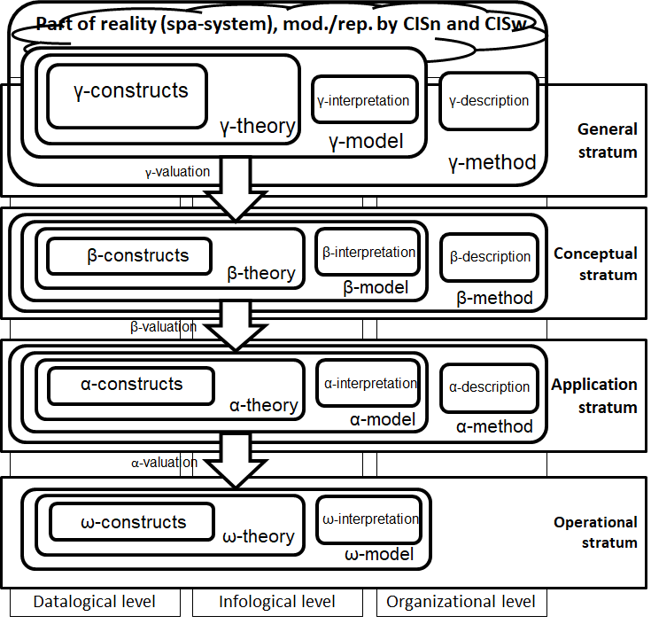
Fig. 2. Correspondence of the elements of the strategies of CoFr CIS and Science of information systems
The γ-universe in [4] was defined as “everything in the physical world (or the whole Universe) and everything in all imagined worlds thought by human beings”. In CoFr CIS, the analogue of this notion is the union of two notins: GeoSystems (SpaSystems) and the General stratum of CIS (including γCIS), moreover, GeoSystems⊂SpaSystems. This union can be called the γ-space universe. Said in this paragraph explains why the correspondence of the notions of the γ-level from [4] and the General stratum from CoFr CIS is shown as in Fig. 5. Since we consider CIS, which are a specialization of information systems, the results obtained in [4] for the Science of information systems will be valid for them. We present several examples of such (deductive) inferences (reasonings) below.
- The γ-method from [4] represented the Science of Information Systems. By analogy, the γ-method of the CIS Conceptual Framework represents the Science of Cartographic Information Systems. If CIS is generalized to all cartographic systems, then it will be possible to talk about integral System cartography, the "second direction (dimension)" of which is some Crosscuting (for example, Relational) Cartography. The first direction (dimension) of such System cartography will be one or more Subject cartographies.
- in [4] an example of the β-model is described - the Pascal programming language. β-valuation is obtaining an α-model from a β-model - writing a specific program in Pascal. The ω-model in this example is the specific state of a specific Pascal program in the computer's memory. By analogy, it is possible to describe the cartographic β-model - some implementation of the map language, for example, the MapInfo Professional cartographic language. The α-model in this case can be a specific electronic vector map constructed using MapInfo Professional. The ω-model will be an image of a vector map on a computer screen or a paper image of this map, printed, for example, on an A1 size plotter.
The multi-level (multi-strata) hierarchical system of notions described in [4] can be applied to information systems of the most diverse nature. We set ourselves the task of finding patterns in the construction of cartographic information systems using an approach based on relational patterns. That is, in the relational Conceptual Frameworks of EA and/or AtIS and/or CIS, we look for and build smaller relational patterns. Some of these patterns are architectural building blocks - Frameworks Solutions, from which and with the help of which end-user products are ultimately constructed: Electronic atlas, Atlas information system, Cartographic information system of the Operational stratum of the corresponding Formation.

Actualization of the Conceptual Framework formalizations
This section substantiates two statements:
- The formalization of the Conceptual Framework of Spatial Information Systems (SpIS), or Cartographic Information Systems (CIS), or AtIS, or EA, performed using articles [3] and [4], is a result that is still relevant today.
- An approach to cartography and cartographic systems based on relational cartographic patterns, including Conceptual Frameworks (and Frameworks Solutions), has practical value regardless of the country in which they are applied. In other words, products X may differ from country to country, but relational cartographic patterns (Conceptual Frameworks, Frameworks Solutions, etc.) do not. That is, our abductive conclusions are valid not only for EA and/or AtIS and/or CIS and/or SpIS developed by us in Ukraine since the beginning of the century. Formalization turns them into inductive inferences.
The actualization of the Conceptual Framework formalizations is considered from the viewpoint of three disciplines:
- Cartography, understood as the discipline of making and using maps. This formalization called "subject".
- Informatics, which in English called "computer science". Therefore, we call this formalization "computer".
- Systemology - a structuralist approach of J. Klir to the General Theory of Systems. Due to the use of the mathematical apparatus of J. Klir's Universal System Problem Solver, this formalization called "systemic".

"Subject" formalization of the Conceptual Framework

System map model
For the actual "subject" formalization of the Conceptual Framework, we will need the so-called System Map Model (SMM). We also recommend paying attention to the figure [1; Fig. 2], which can be understood as an example of the application of SMM to maps of one of the species - choropleths. In this article, the SMM simplifies finding analogies with the map model (MM) of the Map Framework. The SMM is also provided to demonstrate the capabilities of the models that will be used in subsequent articles in the series, in particular, to generalize the static and dynamic properties of the Conceptual Framework.
Tabl. 1. System map model (SMM)
Abstract world | DGMM | IGMM | UGMM | Users of the General echelon
Abstract-physical world | DCMM | ICMM | UCMM | Users of the Infrastructure echelon
Abstract-physical world | DAMM | ІАMM | UAMM | Users of the Application echelon
Physical world | DOMM | ІОМM | UOMM | Users of the Operational echelon
In Tabl. 1, the following abbreviations are used: D - Datalogics, Datalogical level, I - Infologics, Infological level, U - Usage, Usage world or Organizational level, O - Operational stratum, A - Application stratum, C - Conceptual stratum, G - General stratum. Strata correspond to the Echelons of users shown on the right. The introduced notions defined and studied in the monograph [8]. Note that:
1. Depending on the selected one of the four strata/echelons, we are dealing with four (sub)map models (MM) belonging to the corresponding stratum of the System Under Study (SUS) and therefore also called per-stratum: SМM=GМM+CМM+АМM+ OMM (1), where GMM - General MM, CMM - Conceptual MM, AMM - Application MM, OMM - Operational MM.
2. MM of each stratum/echelon consists of: ХМM=DХМM+IХМM+UХМM (2), where X=O, A, C, G, and D, I, U are defined above.
The left of Tabl. 1 shows the parts of the real world that are modeled by the corresponding elements of the SMM. Typically, in the real world, the SUS or part of it is first defined, then modeled by one or more SMM components. The model defined as a simplification of the system, built taking into account the intended purpose. The model should provide the ability to answer questions instead of the actual system. For example, the system of the abstract real world modeled with the help of GMM, although the correspondence of the real world system and the corresponding per-stratum model (in this case, GMM) is not always so unambiguous.
The right of Tabl. 1 shows the organizational system of users, which is divided into four echelons. There is a correspondence between the MM of each strata and a certain echelon of users. Echelons can be virtual. For example, in every real project, artifacts of practical strata O, A, C are created. The creators of these artifacts must obtain the necessary theoretical knowledge, which are artifacts of the General strata (G). These artifacts are usually created by scientists or teachers. However, teachers rarely take part in real projects, although they are always present virtually.
Formulas (1) and (2) are not simple. For example, the sign "+" is not a simple addition, but denotes operations, the result of which is the construction of a map from several components of the MM, if we want to get a complete MM. That's why we call it "superposition" here. For Operational and Application strata, the sign "+" in formula (2) denotes at least one of the four cartographic operations or their combinations: concatenation, image construction, coordinate transformations, and addition. In formula (1), the meaning of this sign is even further than addition, because between the elements of strata there are such relations as, for example, classification/ instantiation or conformity (conformsTo). The first relation usually specifies the relation between information objects of the same system, such as object/class. The second relation specifies the model/metamodel relation. In both cases, formula (1) shows some kind of "combination" of constituent elements, which we also call superposition. In general, formula (2) refers to the methodology of subject (and classic) cartography (although it must satisfy the requirements for the levels of Relational Cartography), and formula (1) to the methodology of Relational Cartography. The constituent elements of formulas (1) and (2) are also complex.

McKenney-Schneider’s Map Framework
The potential of the monograph [5] for theoretical cartography is obvious, although we began to use it actively in our public works only a few years after its publication. The first example of use was the article [11]. There we just mentioned spatial partitions as the basis of the new map model (MM) of Map Framework and expressed an opinion about its applicability to the actualization of the "datalogical part" of Berlyant's model-cognitive concept.
Over time, the need for MM of Map Framework only grows. In particular, this article examines the correspondence of the formal MM of Map Framework and models of the Datalogical level of Relational Cartography with the help of SMM. In this way, we get the formalization of the so-called model cartography - the first of the two main components of the future System Cartography.
The second example is the unconditional usefulness of the formal MM in solving practical problems that can only be solved with its help. To confirm this thought, we offer an example of practical problems. In its solution can help the formal model of the McKenney-Schneider’s Map Framework. Thanks to its accompanying algebra of operations on spatial divisions.
In general, the monograph [5] proposes a complete map hierarchy and describes correspondent data types for maps and provides type closure-guaranteed operations and predicates over map types. Maps creation begin from the creation of abstract map model. Then a discrete map model is created with the preventing the properties of the abstract model, and finally an implementation model of maps for database systems is created. The result is a complete algebra that provides a fundamental data type of maps in computing systems.
Tabl. 2 shows the correspondence between the datalogics of the SMM strata and the chapters of the monograph [5]. All the steps described below are performed in the Datalogical level of the SMM between the components of the three strata: General, Conceptual and Application.
Tabl. 2. Correspondence between SMM datalogics and chapters [5]
Abstract world | Spatial divisions: the mathematical model of maps in the section "Chapter 2. The formal model of maps as a fundamental type" | ІGMM | UGMM | Users of the General echelon
Abstract-physical world | Chapter 8. Discrete map model | ІCMM | UCMM | Users of the Infrastructure echelon
Abstract-physical world | Chapter 9. Realization of maps: Map2D | ІАMM | UАМM | Users of the Application echelon
Physical world | DOMM | ІОMM | UOMM | Users of the Operational echelon
The abstract map model defined first refers to the General Stratum. An abstract model is a mathematical formalization of map data types together with mathematical definitions of map operations. At the abstract level (in the General stratum), a precise data type is created for which we can prove type closure independently of operations; in other words, we show that operations on maps will produce maps as output, so that the operations can be composed to define complex data mining tasks. At the abstract level, implementation aspects are not considered, so concepts such as infinite sets of points are used, which cannot be directly implemented in computer systems, and the time or space complexity of operations is not taken into account. The main focus at the abstract level is on creating a mathematical basis for the MM of Map Framework.
After completing the abstract specification, we move on to the discrete map model. At the discrete level (in the Conceptual stratum), we translate the abstract data type for maps into discrete constructs that can be implemented in computer systems; however, we do not yet consider the implementation of the model in a specific system. In other words, the discrete model does not depend on the implementation details. For example, the discrete map model does not impose a specific type of numeric data to represent coordinates, rather it is left to the discretion of the implementation model.
Finally, the implementation MM (in the Application layer) provides mechanisms for implementing discrete MM in a specific system or environment. A database-oriented implementation model is proposed. In this way, the issues of storing maps and their attribute data in databases are solved and it is shown how to implement map operations defined in the abstract model in the database environment. One of the powerful aspects of the map definition sequence described is that a common abstract data type that provides precise specifications for the map type and the expected behavior of operations can be implemented in many environments and in many different ways, but all implementations will have the same type of semantics.
The basis of the Map Model (MM) of the Map Framework is the so-called spatial divisions. The definition of spatial partitions is not obvious, so an intuitive description is provided here. For this, slightly processed information from paragraph "2.3 An Informal Overview of Spatial Partitions" of the monograph [5] is used. There is also a formal definition that is too voluminous to reproduce here.
In general, a two-dimensional spatial partition is the division of a plane into pairwise disjoint regions, such that each region is associated with a label or attribute that has a simple or complex structure, and these regions are separated from each other by boundaries. The region label describes the thematic data associated with the region. All points within a spatial partition that have an identical label are part of the same region. Topological relations are implicitly modeled between regions in a spatial partition. For example, if you do not pay attention to the common borders, then the divisions of the regions never intersect; thanks to this property, maps have a fairly simple structure. The appearance of the spatial division is denoted by the symbol ⊥. Fig. 3a shows an example of a spatial partition consisting of two regions.
(a) | (b)
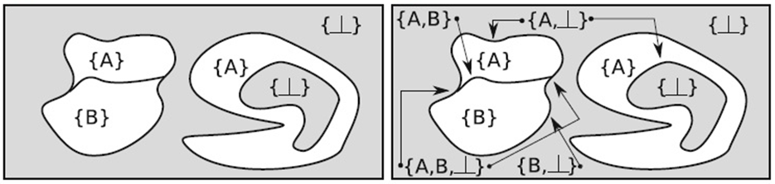
Fig. 3. An example of a spatial division with two regions. (a) Spatial division indicated by region labels. (b) Spatial division with its region and boundary labels. Note that labels are modeled as sets of attributes in spatial divisions
Each region in the spatial division is associated with one label or attribute. Spatial division is modeled by mapping Euclidean space to such labels. The labels themselves are modeled as sets of attributes. Spatial regions are then defined as consisting of all points that contain an identical label. Each contiguous region has different labels in its interior, but their common boundary is assigned a label containing the labels of both contiguous regions. On Fig. 3b shows an example of a spatial division with boundary labels. Operations on spatial divisions are defined using map operations known in the cartographic literature. All known operations on spatial divisions can be expressed in terms of three fundamental operations: intersection, relabel, and enhancement. In addition, the type of spatial partitions is closed with respect to these operations. Operations on spatial divisions are discussed in detail in the monograph.
We do not have the opportunity to consider in detail all three levels of MM Map Framework from [5]. We hope that the given summary is enough to assess the prospects of its practical use. For example, consider the possibility of a reasonable solution to the problems that arose when the administrative-territorial division of was changed in 2020.
Note that it is very difficult to rezone the territory in a logically justified way. After all, it is necessary to take into account many characteristics (attributes) of the old and new divisions of the territory: the number of inhabitants, area, borders, distance between important places, productivity of land allotments, etc. It is almost impossible to do without the appropriate tool. The solution can be the implementation of the MM Map Framework algebra.
For test examples, we selected the following problems/tasks and offered their solutions using the prototype implementation of MM Map Framework:
- Territorial communities in the 2020 administrative reform were formed from village councils. The formation was not a simple unification of their territories. Several operations from MM Map Framework should be applied for this.
- After the formation of new communities, new districts were obtained by their unitings. We had to use the MM Map Framework unification operation.
- The population in the new administrative units has changed. It can be modeled by choropleth maps. The MM Map Framework label change mechanism is used.
- The problem of planar objects belonging to the territories of state administration. For example, water bodies. It is shown how to "enter" them in MM Map Framework.
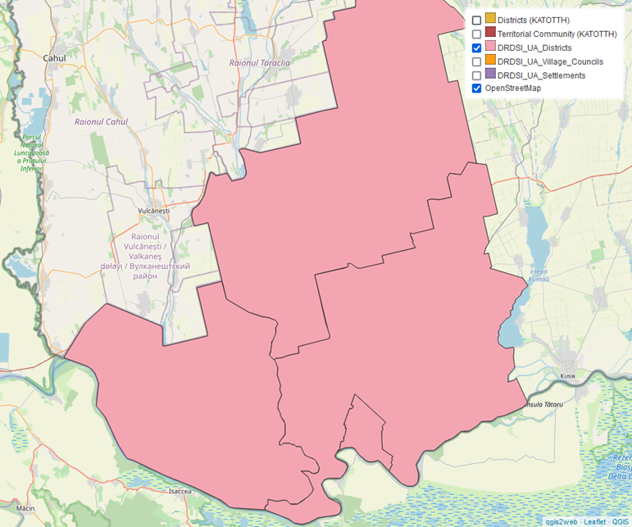
Fig. 4. Districting of the territory of DRDSI pilots (DRDSI_UA_Districts) before admin. reform
Fig. 4 - Fig. 7 are used to demonstrate some of the problems/tasks identified. Notation: DRDSI - Danube Reference Data and Services Infrastructure, DRDSI_UA_Districts: Bolgrad, Reni, Izmail districts (rayons) and the Izmail city of Odessa oblast.
We will not comment the presentrd figures. We only note that our goal was to describe the problems for which MM Map Framework is appropriate and to propose a tool for implementation. Interpretations of the results of the application of the tool are important, but we leave them for other articles. To describe the tool, you should first consider, for example, [5]. This is an author's package of spatio-temporal geometry in Python. It's not meant to be super fast, it's mostly a pure Python implementation. The current version focuses on the geometry of regions and the geometry of moving regions.
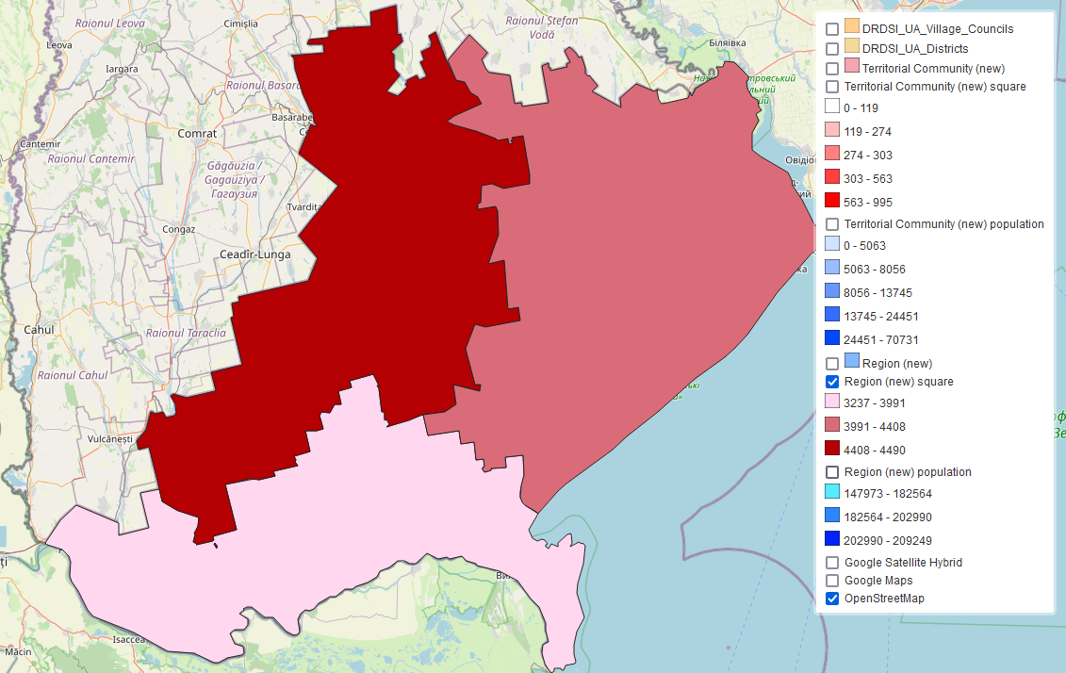
Fig. 5. 2020. Areas of new districts (Izmailskyi, Bolhradskyi, Bilhorod-Dnistrovskyi)
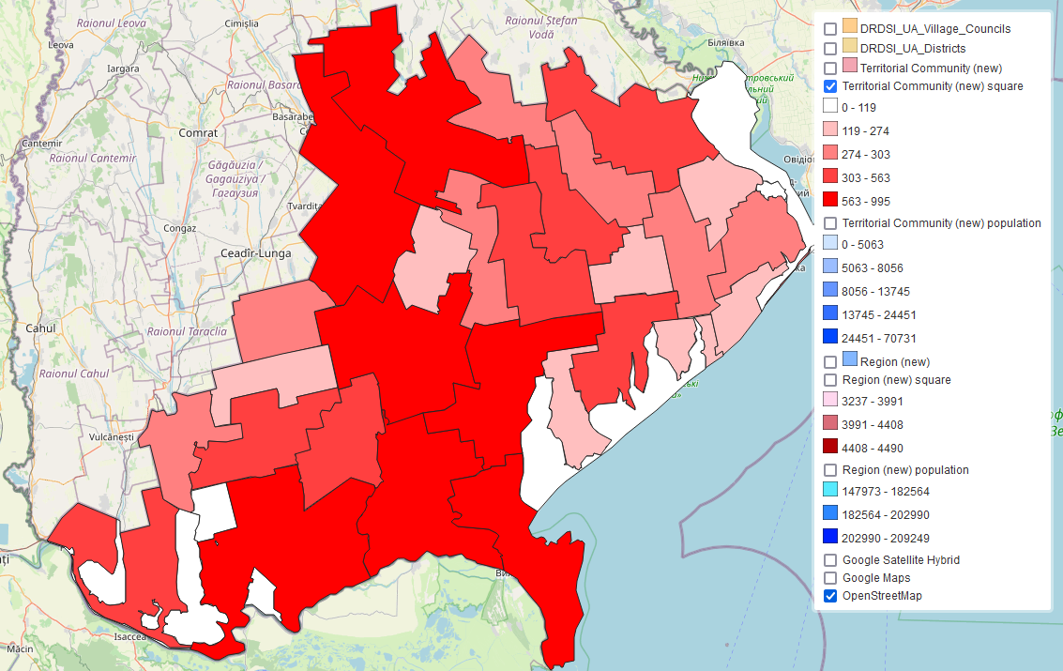
Fig. 6. 2020. Areas of newly formed territorial communities
Next, the choropleth map of the population of the newly formed territorial communities is given. The data are obtained from open sources, so it can only be used as an example.
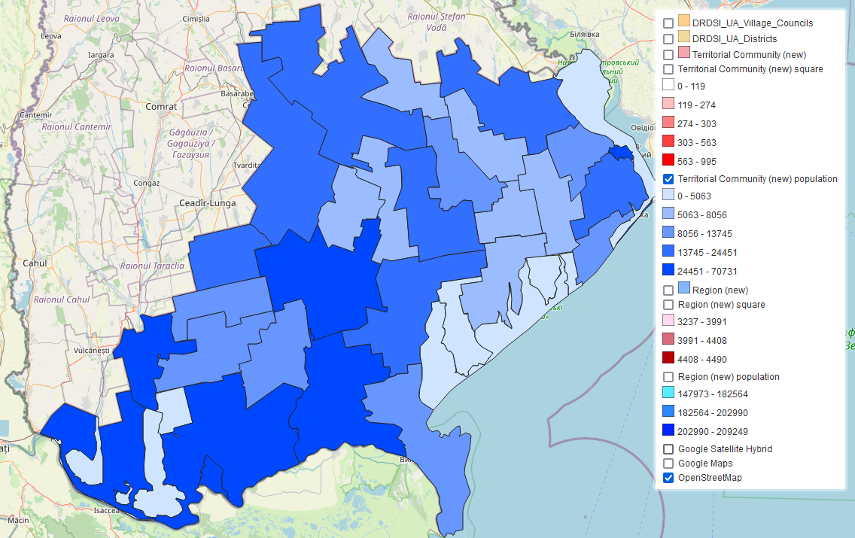
Fig. 7. Before 2020. Population of newly formed territorial communities

"Computer" formalization of the Conceptual Framework
This subsection draws analogies between (part of) the Conceptual Framework and the so-called Concepts of Software Stability. The latter are sufficiently formalized from a computer viewpoint in the monograph [6] and others. The monograph [6] was published in 2015, so in 2014, when we published our first work on Conceptual Frameworks, we did not know it yet.
At the same time, at the turn of the millennium in the projects of the Franco-German Chornobyl Initiative (FGI), we "found" the so-called Projects Solutions Framework (ProSF). It turned out that ProSF is applicable not only to FGI projects, but also to projects of virtually any nature, if the goal of the project is to create some kind of information product. Moreover, if we consider the activities of the so-called geo-enterprises, it is quite easy to single out the spatially specialized GeoSolutions Framework (GeoSF) from all the "suitable" ProSF for it. Examples of ProSF that "fit" geo-enterprise activities are the creation or use of: 1) spatial database, 2) "spatial" software, 3) electronic map, 4) electronic atlas, 5) arbitrary cartographic information system (CIS).
We even created a portal software means (tool) corresponding to the GeoSF method - the standard version sGeoSF of GeoSF, which (method and means) corresponded to the product model of Spatial Data Infrastructure (SDI) development and which (GeoSF method and means) at the beginning of the millennium we proposed as one of the ways to build a National SDI. This method can be called a "bottom-up" rise in the organizational hierarchy: from the geo-enterprise to the NSDI orgstructure. In order not to take up space, we will not quote what we wrote on this matter. An exception we are making only for the article [12], which can be accessed easily in Internet by searching for “GeoSF” in the Chrome browser. This article contains figures [12; Fig. 3, 4, 7, 8], which together with [1; Fig. 3a, 4] we will use with their descriptions further.
Before considering the needed content from the monograph [6], let us recall that there are many processes of developing programs and systems. In many of them, the development is performing gradually: from more general result models to ones that are more detailed. The most famous stages are conceptual, logical and physical. The results of the stages are a conceptual, logical and physical models or schemes of the results - the products or systems. An example of such a process is given in the figure [12; Fig. 3], which was called “Usage of the GeoSF SoFr method to create a computer system X”. We are showing it modified as in Fig. 8.
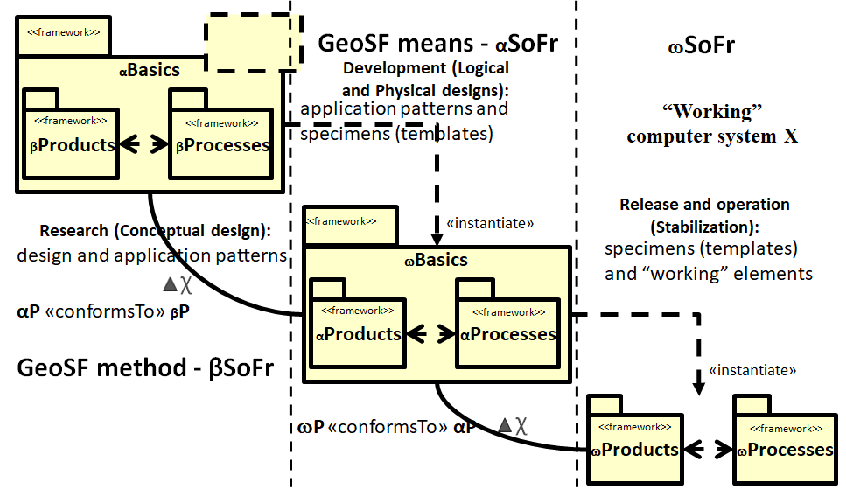
Fig. 8. Modification of GeoSF CoFr method usage to create a computer system X
Compared with [12; Fig. 3], in Fig. 8 several important for us modifications made:
1. The relations between patterns of higher and lower strata clarified. In addition to the relations "instantiate" (instantiate, instantiation), the relations are shown valid in the development processes in which patterns are used. These relations called "conformity" and denoted by χ sign. Their needed description see on pp. 145-156 of the monograph [8].
2. On p. 145 of the monograph [8] begins the subsection "Formalization of the Framework Solutions" (SoFr). There, it is made with the help of Model-Based Engineering (MBE) constructions. The "conformity" relations is one such construct.
3. Fig. 8 shows the βSoFr, αSoFr, ωSoFr patterns. It is quite easy to notice that "above" the β-stratum (Conceptual stratum) there is a γ-stratum (General stratum), on which there are βBasics, which include γProducts and γProcesses. We did not expand the figure upwards, although it is obvious that there should be γSoFr and analysis patterns aligned with the Research stage and Conceptual design. By the way, we note that Logical and Physical designs should be shown in separate stages.
The authors of the monograph [6] are known for their work on the so-called Software stability concepts approach - see Fig. 9. The first works on this approach date from the beginning of the first decade, then there were other works. Concepts of software stability divide the classes of any software system into three main conceptual layers: Enduring Business Themes (EBTs), Business Objects (BOs), and Industrial Objects (IOs).
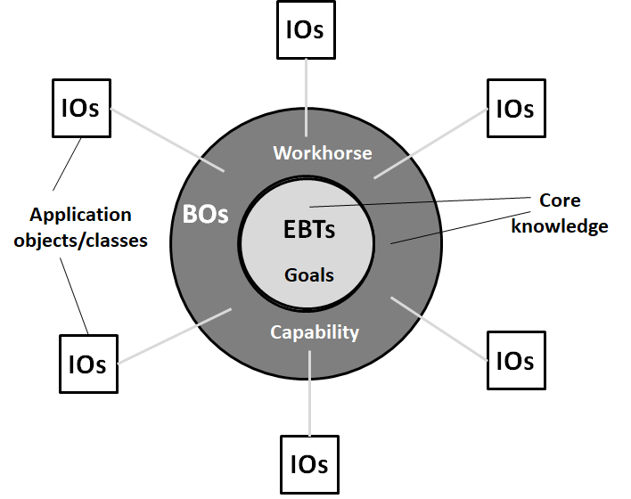
Fig. 9. Concepts of software stability approach [6; Figure 1.1]
The use of so-called "knowledge maps", which are useful when explaining not individual (separate), but "related" concepts, is useful for understanding the concepts of software stability. These are the concepts of software stability, as well as the Concept Maps used in our other works, for example, for models. Next, we use several quotes from [6; pp. 31-33]. We repeat them without additional eplanations, which are possible in other articles of the series on Conceptual Frameworks.
In the world of knowledge maps, everything is categorized by goals, opportunities, and temporal aspects. These aspects, however, are directly reflected in other areas of research, as in the case of software stability concepts and patterns. In Tab. 3 goals of knowledge maps are directly mapped to software sustainability concepts such as Enduring Business Topics (EBTs) because they represent domain-independent knowledge that contains long-term contracts or rules by which the concept applies. Due to the duration and repetitive quality of their conceptual nature, goals can also be directly mapped into the pattern field as stable patterns of analysis. The same direct mapping process occurs with capabilities that map to software sustainability concepts, such as Business Objects (BOs), because they are also durable and reusable, and their purpose is to achieve goals. Due to their built-in properties, they also form the basis for representing patterns.
Tabl. 3. Mapping of Elements in Knowledge Maps
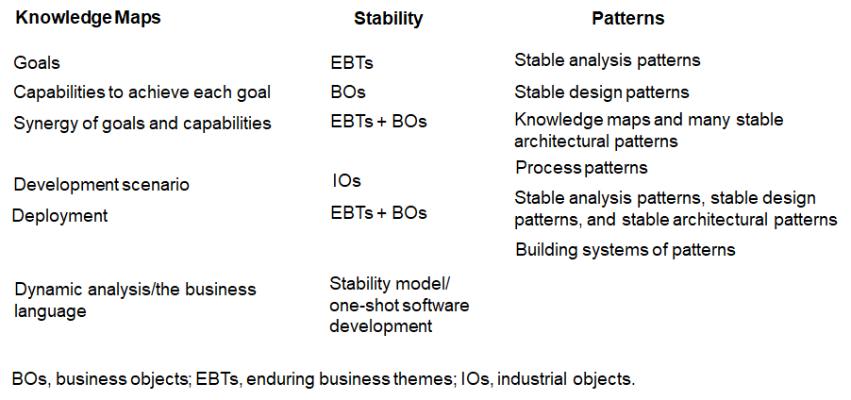
Therefore, in the world of patterns, these BOs are known as stable design patterns. Goals and opportunities are interdependent: a goal must have one or more opportunities associated with it, and an opportunity must have a well-defined goal to achieve. When we have two or more goals along with their combined capabilities, a knowledge map essentially takes shape. Knowledge maps are directly reflected in the concepts of software stability as a synergy between EBTs and BOs. Because knowledge maps are composed of goals and capabilities, and their nature is durable and reusable, the common result of their association in the pattern world is stable architectural patterns. Knowledge maps convey architectural styles that adapt or acclimate to new requirements or contexts through extension points. These extension points tell us not only how the knowledge maps will be used here, but also what the deployment context actually is (which is possible by connecting a set of transition classes to them). Because of the mutable and mutable nature of transient classes, they are mapped as industrial objects in software stability concepts. In the pattern world, they are also known as process patterns.
One important point is that regardless of the various names attributed to these concepts, their characteristics, meanings, purposes, and behavior remain almost unchanged throughout their use. Therefore, in the monograph [6], these terms are interchangeable. The rationale behind this nomenclature is to bridge the existing communication gap between technical and business people through a common language. This means that a non-technical manager, for example, can understand or control the ongoing processes associated with a particular software product in the same way as a developer, because both speak the same language.
In the world of software stability concepts, the long-lasting quality and reusability of EBTs and BOs are determined mainly by exploring the underlying knowledge that is sometimes overlooked or assumed by practitioners, mainly in business questions and rules. Thus, EBTs and BOs represent a set of norms and rules for how to understand and solve a set of recurring problems that require immediate attention from practitioners. From a knowledge map perspective, goals and capabilities share almost the same vision as EBTs and BOs. All of them are business-centric and contextual aspects that provide a hindsight to the domain rationale.
If apply software stability concepts approach, it turns out that the cartographic patterns of the EBTs layer belong to the General stratum, the cartographic patterns of BOs belong to the Conceptual stratum, and the cartographic patterns of IOs belong to the Application stratum of the CIS. An example of a cartographic interpretation of the software stability concepts is shown in Fig. 10. In addition, Fig. 10 shows the correspondence: EBT – Conceptual model (General stratum, γSoFr), BO – Logical model (Conceptual stratum, βSoFr), IO – Physical model (Application stratum, αSoFr). From the viewpoint of the strata, it is possible to "shift" one strata down: Conceptual, Application and Operational strata.
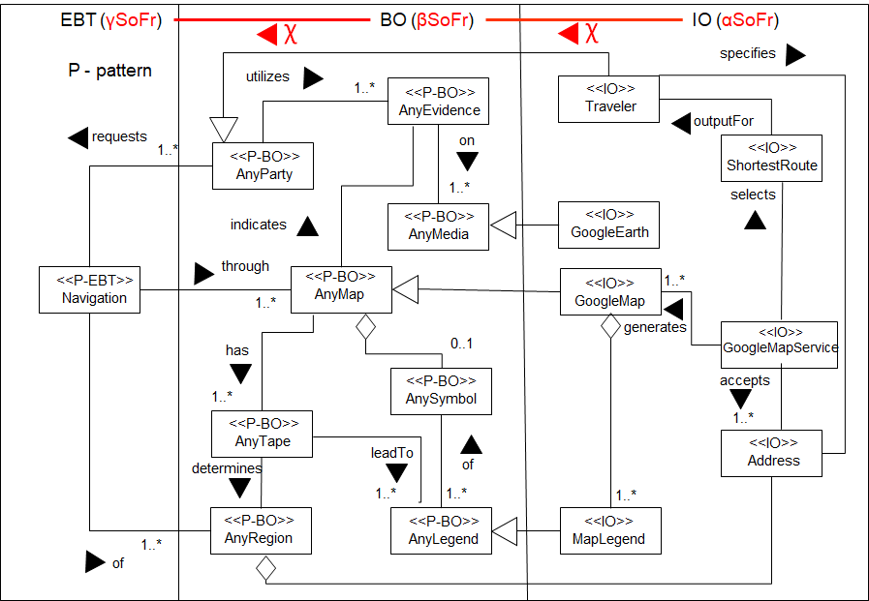
Fig. 10. Diagram of navigation classes on the Google road map [6; Figure 7.4]
The software stability concepts approach proves that the ideas of works [3] and [4] are still relevant today. This means that our research on Relational Cartography, which uses the achievements of the Science of Information Systems and relational patterns, is also relevant. Quite obvious analogies between the results of two independent approaches are an additional argument in favor of the correctness of our abductive inferences applied to obtain the main results about Conceptual Frameworks of Relational Cartography.

"Systemic" formalization of the Conceptual Framework
This subsection uses material from the monograph [8]. First, we will consider the systemic formalization of the Information System in the broader sense of Web 2.0 Atlas base maps - Web 2.0 ABM ISb. ABM is a necessary component of any Atlas System.
To research the system properties of the Web 2.0 ABM Conceptual Framework, we built a general system model (GSM) of the base map (GSM BM) using the mathematical apparatus from [7]. GSM BM allowing formally determine the ways of integrating different ABM into an integrated hierarchical system. We used two methods: a structure system and a metasystem. An abbreviated fragment of the structured system SD described below.
The GSM BM of the Web 2.0 ABM Conceptual Framework could be the following data system with semantics SD:
^{S}D =(S, d), where (1)
S=(O, ḷ, I, O, E) - source system, (2)
d: W→V – data function, where (3)
O=({ a_{i}, A_{i}) | i={1,…,11}}, {( b_{j}, B_{j}) | j={1,2,3}}) - entity system, where (4)
ai – property and A_{i} - set of its appearences, b_{j} - backdrop and B_{j} - set of its elements; W= W₁xW₂xW₃, V= V₁xV₂x…xV₁₁, W_{j}, j={1,2,3}, V_{i}, i={1,…,11}, are defined below.
Specific image system ḷ=({(ṿ_{i}, Ṿ_{i}) | i={1,…,11}}, {(ẉ_{j}, Ẉ_{j}) | j={1,2,3}}). (5)
General image system I=({(v_{i}, V_{i}) | i={1,…,11}}, {(w_{j}, W_{j}) | j={1,2,3}}). (6)
Observation channel O=({(A_{i}, Ṿ_{i}, o_{i}) | i={1,…,11}}, {(B_{j}, Ẉ_{j}, ω_{j}) | j={1,2,3}}), where o_{i}: A_{i}→Ṿ_{i}, ω_{j}: B_{j}→ Ẉ_{j}. (7)
Tabl. 4 The value of the ai properties. (TMC) means the Ukrainian Topomap Classifier of 1998.
Property | Value
a₁: Mathematical elements, elements of the plan and height basis (TMC) | Reference points (Astronomical points, Points of the state geodetic network, Points of the survey network (points of the local network), Points of the leveling network, Height marks (signed points), Boundary pillars (boundary marks), which have the value of landmarks)
a₂: Land relief (TMC) | Relief expressed by horizontal lines; Relief forms that are not expressed horizontally; Characteristics features on the map that stand out as independent objects
A₃: Hydrography and hydrotechnical structures (TMC) | Hydrography; Waterworks; Crossings and sea routes; Islands
a₄: Settlements (TMC) | Urban settlements; Rural settlements; Other settlements; Separate buildings; Elements of the internal structure of the settlement; Elements of individual buildings and structures
a₅: Industrial, agricultural and socio-cultural objects (TMC) | Industrial facilities; Agricultural objects; Socio-cultural objects; Auxiliary objects at constructions
a₆: Road network and road structures (TMC) | Road network; Road constructions; Characteristics of the road network, which are highlighted on the map as independent objects; Traffic light arches, arches on highways
a₇: Vegetation and soil (TMC) | Vegetation cover; Soils
a₈: Boundaries | Include village, city (municipal), district, regional, national boundaries. Very often the boundaries show specialized landownership (parks, airports, military facilities and wildlife  reserves)
a₉: Administrative-territorial division | Administrative-territorial division of Ukraine into settlements exclusively
a₁₀: Cadastral information | Ownership and boundaries of land plots
a₁₁: Digital orthoimages | Digital aerophotos and space images
Tabl. 5 Values of backdrops b_{j}
Backdrop | Value
b₁: Time | The period of time during which the base map of Ukraine exists. Analogous record t.
b_{2,3}: Surface | Unification of the Earth's surfaces within Ukraine in different periods of its existence. Analogous entry (x, y).
Abstraction/Exemplification channel E=({( Ṿ_{i}, V_{i}, e_{i}) | i={1,…,11}}, {( Ẉ_{j}, W_{j}, ε_{j}) | j={1,2,3}}), where e_{i}: V_{i}→Ṿ_{i}, ε_{j}: W_{j}→Ẉ_{j}. (8)
Inverse with respect to e_{i} and ε_{j} functions specify abstractions accordingly ṿ_{i} and ẉ_{j}: e_{i}⁻¹: Ṿ_{i}→V_{i}, ε_{j}⁻¹: Ẉ_{j}→W_{j}.
No organization in Ukraine can obtain all necessary values of specific variables ṿi and parameters ẉj by means of observations or measurements. That is why it is necessary to use the structure system method thanks to which the complete system can be obtained from separate systems or subsystems. In this case every constituent data system is built separately and then it is integrated into the complete system SD.
SD={(^{m}V, ^{m}D) | m={1,2,3,4}}, where (9)
¹V=V₁x…xV₈, де V_{j}, j={1,…,8} – the same as in (6), ¹D – appropriate ¹V topographic map data system of Ukraine;
²V=V₈xV₉, V₈, V₉ – the same as in (6), ²D – appropriate ²V data system of the administrative-territorial division of Ukraine;
³V=V₈xV₁₀, V₈, V₁₀ – the same as in (6), ³D – appropriate ³V cadastral index map data system of Ukraine;
⁴V=V₈xV₁₁, V₈, V₁₁ – the same as in (6), ⁴D – appropriate ⁴V aerophotomap data system of Ukraine.
The structure data system SD (9) is the GSM BM, built taking into account the Topomap Classifier of 1998. To obtain the GSM of the choropleth map, the SD backdrops extended by groups b4_k, k=1, …, >1 with the help of which into the BM integrated system of layers and subsystems the thematic properties (maps and layers) a(11+l)_m, l=1, …, >1 are added. l is the number of the thematic map; a1 - a11 are used for the layers of the base map, m=1, …, > 1 (layer number m in thematic map number l). Examples of groups in the National Atlas of Ukraine (k=6) are so-called thematic blocks: 1 - General characteristics, 2 - History, 3 - Natural conditions and natural resources, 4 - Population and human development, 5 - Economy, 6 - Ecological state of natural environment. The methods of building structure systems remain the same as for the BM.
Consider as an example map 4035 from ElNAU2007/2010. This map has two thematic layers: choropleth (01) and diagrammatic (02). The number "4" in the map code 4035 means the thematic block "Population and Human Development", "035" is the serial number of the map in the block. Then the GSM ChMap4035_01 for the 1st, choropleth, map layer 4035 will be determined by formula (10):
SD(ChMap4035_01)={(^{46_01}V, ^{46_01}D), SD}, where (10)
SD is determined by formula (9), and
^{46_01}V=V₉xV_{46_01}, де V₉, where V₉ is the same as in (6), ^{46_01}D is the corresponding ^{46_01}V data system of the choropleth map 4035_01, and V_{46_01} is the set of values of the variable v_{46_01}, which is an observation of v_{46_01} of the property a_{(11+35)_01} using observation channel (11) followed by abstraction of the observed variable ṿ_{46_01} using the abstraction/exemplification channel (12).
Observation channel O(ChMap4035_01)=({(A_{46_01}, Ṿ_{46_01}, o_{46_01}), (B_{4_4}, Ẉ_{4_4}, ω_{4_4})}), where o_{46_01}: A_{46_01}→Ṿ_{46_01}, ω_{4_4}: B_{4_4}→ Ẉ_{4_4}. (11)
Abstraction/exemplification channel E(ChMap4035_01)=({(Ṿ_{46_01}, V_{46_01}, e_{46_01}), (Ẉ_{4_4}, W_{4_4}, ε_{4_4})}), where e_{46_01}: V_{46_01}→Ṿ_{46_01}, ε_{4_4}: W_{4_4}→Ẉ_{4_4}. (12)
Inverse with respect to e_{46_01} і ε_{4_4} functions specify abstractions accordingly ṿ_{46_01} and ẉ_{4_4}: e_{46_01}⁻¹: Ṿ_{46_01}→V_{46_01}, ε_{4_4}⁻¹: Ẉ_{4_4}→W_{4_4}.
Using Web 2.0 ABM ISb, we will get Fig. 10. At(I)Sb denotes the extension of AtISb or AtSb, since we distinguish EA and AtIS, AtS=EA∪AtIS. G. Klir's "constructive" systemology was used [7] and as a practical example - the Electronic version of the National Atlas of Ukraine (ElNAU2000/2007). The latter is shown by two products: ωAt(I)S and αAt(I)S. They mean nothing more than operational and application products of ElNAU. The first is seen by the end user on DVD. The second product is intended for developers. You can read more about this in the monograph [8].
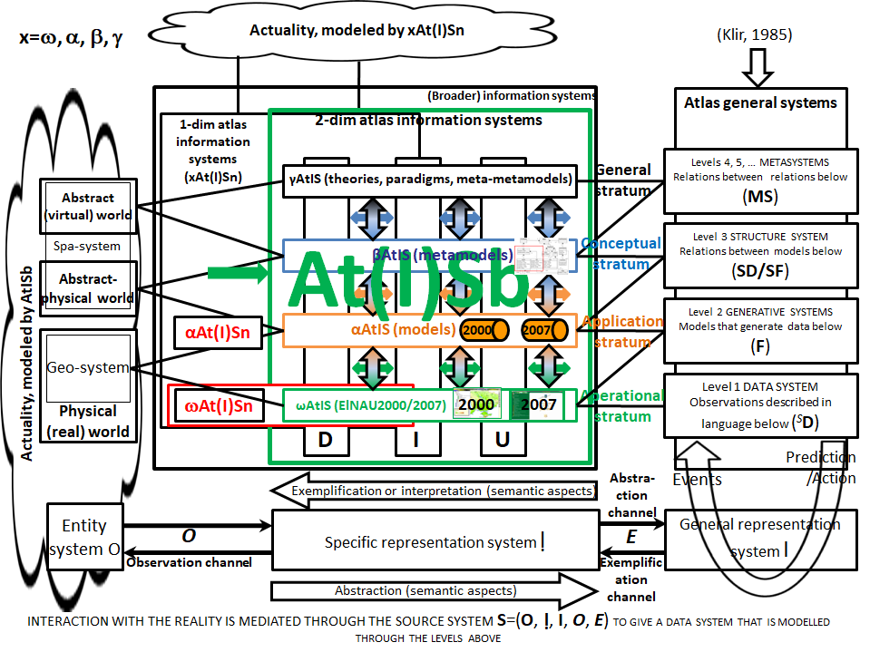
Fig. 10. SUS relations at a fixed time interval according to [7]

Conclusions
The formalization performed in this article is the next step after the conceptualization performed in the first 2024 article of the series on Conceptual Frameworks. Formalization is important for the following reasons:
1. The use of the formal model of the McKinney-Schneider Carto-Frame map together with works on analytical cartography prove the existence of Model Cartography. It can be a paradigm of cartography. Model cartography is a component of Conceptual Framework and can be the first of two components of System cartography.
2. Підхід Концепцій стабільності програмного забезпечення можливо описати з допомогою Концептуальних Каркасів.
3. Універсальний Вирішувач Системних Проблем Дж. Кліра відповідає Концептуальному Каркасу.
4. Allows other scientists without our experience to test or repeat our inferences about the creation of AtS and GIS.
5. It opens up new opportunities for research in cartography: both theoretical and practical.

References
1. Chabaniuk, V., Dyshlyk, O. (2024). Update Of The Atlas Systems Conceptual Framework. Land management, cadastre and land monitoring, 2, 158–177. 1. DOI: http://dx.doi.org/10.31548/zemleustriy2024.02.013
2. Alexander Christopher. (1979). The Timeless Way Of Building. NY: Oxford University Press., 552 p.
3. Iivari Juhari. (1989). Levels of abstraction as a conceptual framework for an information system, pp. 323-352, in Falkenberg Eckhard D., Lindgreen Paul, Eds. Information System Concepts: An In-depth Analysis. North-Holland,. 357 p.
4. Bergheim, et al. Bergheim Geir, Sandersen Erik, Solvberg Arne. (1989). A Taxonomy of Concepts for the Science of Information Systems, 269-323 // Falkenberg Eckhard D., Lindgreen Paul, Eds. Information System Concepts: An In-depth Analysis. North-Holland, 357 p.
5. McKenney Mark, Schneider Markus. (2016). Map Framework: A Formal Model of Maps as a Fundamental Data Type in Information Systems. Springer,. XI, 140 (145) p.; Пакет просторово-часової геометрії / Available at: marmcke / pyspatiotemporalgeom — Bitbucket, accessed 2024-aug-30).
6. Fayad Mohamed, Sanchez Huascar A., Hegde Srikanth G.K., Basia Anshu, Vakil Ashka. (2015). Software Patterns, Knowledge Maps, and Domain Analysis. CRC Press (Auerbach). 422 p.
7. Klir George J., Elias Doug. (2003). Architecture of Systems Problem Solving, 2nd Ed., 349 (356) p.
8. Chabaniuk Viktor. (2018). Reliatsiina kartohrafiia: Teoriia ta praktyka [Relational cartography: Theory and practice]. Institute of Geography of the National Academy of Sciences of Ukraine,. 525 p. (In Ukrainian)
9. Mylopoulos John, Borgida Alex, Jarke Matthias, Koubarakis Manolis. (1990). Telos: Representing Knowledge About Information Systems. ACM Transactions On Information Systems, Vol. 8, No. 4, 325-362.
10. Olive Antoni. (2007). Conceptual Modeling of Information Systems. Springer, 455 p.
11. Chabaniuk V. (2021). Atlas Solutions Framework as a method of the renewed Model-cognitive conception of cartography. Ukrainian Geographic Journal, No. 3(115), 31-40.
12. Chabaniuk V., et al. (2022). Main Conceptual Provisions of the Creation of an Electronic State Register of Immovable Cultural Heritage of Ukraine. Part 1. Land management, cadastre and land monitoring, No. 2, 30. (Ukrainian, English)

Формалізація Концептуального Каркаса Просторових Систем
Чабанюк В., Дишлик О.
У роботі формалізується явище Концептуальні Каркаси Просторових Систем. Їй передує концептуалізація цього ж явища, але для вужчого класу класичних Атласних Систем. Формалізація потрібна з кількох причин. Першою є використання Концептуальних Каркасів у створенні Системної картографії і, зокрема, Базованої на Моделях Картографїї як нової системної парадигми картографії і як спеціалізації Базованої на Моделях Інженерії. Другою є спрощення реалізації, оскільки формалізовані конструкції простіше реалізувати засобами інформатики. Третьою є можливість використання індуктивних умовиводів дослідниками з відмінним від нашого досвідом.
У даній статті спочатку описуються формалізовані конструкції рівнів і страт Концептуального Каркаса Просторових Систем. При цьому для формалізації поняття страт використовується ще ширше, ніж Просторові Системи, поняття. Це так звана Наука інформаційних систем, яка має велике значення для розуміння суті як дослідження, так і проектування системних предметів Х. Після цього практично примінимі конструкції страт Концептуального Каркаса Атласних або Просторових Систем отримуються аналогією.
Вказані три причини задовольняються розглядом актуальних сьогодні формалізацій Концептуального Каркаса з точок зору трьох дисциплін: 1) картографії, 2) інформатики, 3) системології. У картографії проводяться важливі для сучасної практики аналогії з формальною моделлю карти Карто-Каркаса МакКінні-Шнайдера у викладі монографії 2016 р. У інформатиці – з Концепціями стабільності програмного забезпечення у викладі монографії 2015 р. У системології – з Універсальним Вирішувачем Системних Проблем Кліра, який є актуальним і у наш час. На завершення висловлюються думки щодо примінимості Коцептуального Каркаса предметів Х до класифікації Систем просторової діяльності таких, якщо такими представити Картографію загалом або Системну картографію зокрема.
Ключові слова: Концептуальний Каркас Атласних або Просторових Систем (АтС/ПрС) у розширеному розумінні (АтСш/ПрСш), Інфраструктура АтС/АтСш (ПрС/ПрСш), формалізація Концептуального Каркаса АтСш/ПрСш.

