УДК 620.9
BIOENERGETICS: CURRENT STATE, PERSPECTIVES, FOREIGN EXPERIENCE
Holub R. post-graduate student of the Department of Economic Theory
National university of life and environmental sciences of Ukraine
E-mail: office_kiev@takagro.ua

Abstract. Ukraine has good preconditions and sufficient potential for dynamic development of the bioenergy sector. The main driving forces of this process are the constant rise in prices for traditional energy sources and the availability of large biomass potential available for energy use.
The most favorable direction for solving the problem is the search for and use of renewable energy sources, among which a new segment of the economy, which is possible on all continents, which includes the production of energy sources of biological origin or biofuels: biodiesel, bioethanol, biogas, is becoming a widespread development. Biofuels throughout the developed world slowly, but confidently squeeze traditional energy.
In the context of the aggravation of Ukraine's energy supply, there is a need to revise the structure of available energy sources in favor of renewable energy technologies. The search for and use of biofuels is the most conducive to solving the problem.
For Ukraine, bioenergy is one of the strategic directions for the development of the renewable energy sector, given the high dependence of the country on imported energy resources, first of all, on natural gas, and the great potential of biomass available for energy production. Unfortunately, the pace of bioenergy development in Ukraine still lags far behind European ones.
Keywords. Bioenergy, biofuels, renewable sources, biomass, energy, consumption.

Introduction. The most important condition for sustainable development in the modern economy is the transition to a new level of organization of business processes, the implementation of successive actions aimed at increasing the efficiency of production and reducing the energy intensity of products, the use of renewable energy sources. Their rational use in the production process would reduce the consumption of oil, natural gas and fossil fuels.
Biofuels today are the only alternative substitute for mineral fuels. The main producer of biofuels can be agriculture itself, with huge potential for the production of bioenergy in the form of the main, as well as by-products of crop and livestock production [5].
Analysis of Recent Researches and Publications. Issues concerning the essence and practical justification of bioenergy potential were considered in the scientific publications of such domestic scientists as Ya.B. Oliynyk [4], P.T. Sabluk, M.S. Samoylik [5], B.S. Fedorchenko [6], Svitlana Trybush and others.
Purpose. Research of the modern state of bioenergy in Ukraine, as well as analysis of foreign experience on these issues.
Methods. In the course of the research, the following methods were used: monographic - during the processing of professional literary sources and work with a textual presentation of the mentioned problem; systemic - to specify categorical apparatus; logical - to determine the positive social and economic effects, in order to summarize the results and form conclusions.
Results. For Ukraine, bioenergy is one of the strategic directions for the development of the renewable energy sector, given the high dependence of the country on imported energy resources, first of all, on natural gas, and the great potential of biomass available for energy production. Unfortunately, the pace of bioenergy development in Ukraine still lags far behind European ones. Today, the share of biomass in the total supply of primary energy in the country is only 1.2% [2], and in gross final energy consumption - 1.78%.
For Ukraine, bioenergy is one of the strategic directions for the development of the renewable energy sector, given the high dependence of the country on imported energy resources, first of all, on natural gas, and the great potential of biomass available for energy production. Unfortunately, the pace of bioenergy development in Ukraine still lags far behind European ones. At present, the share of biomass in gross final energy consumption is 1.78%. Every year in Ukraine for the production of energy is used about 2 million tons of fuel equivalent per year biomass of various types. Wood has the highest percentage of utilization of economically feasible potential - 80%, while for other types of biomass (with the exception of sunflower husks) this figure is an order of magnitude lower. The least active (at the level of 1%) is the energy potential of straw cereals and canola.
Renewable energy sources are currently playing a significant role in the global energy industry. Their contribution to gross final energy consumption is more than 18%, including biomass - 14% VCE or 76% of the total contribution of all RESs (Figure 1) [7].

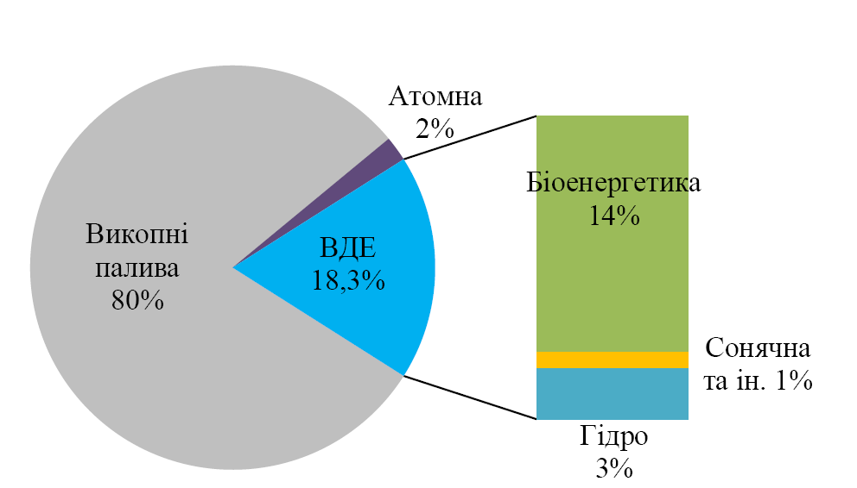

Fig. 1. Structure of gross final energy consumption in the world
(a total of 339,000 PJs) [7]

The main directions of implementation of the energy potential of biomass and biogas in Ukraine are the production of thermal and electric energy. Appropriate concepts for the development of biomass / biogas energy generation up to 2020 and 2030 were developed by the Bioenergy Association of Ukraine [6].
At existing prices for fossil fuels (primarily natural gas), thermal energy and biomass, the introduction of biofuel boilers for thermal energy production is economically feasible and can be recommended for heat and power facilities in the industrial and budgetary sectors. Implementation of such projects in the housing and utilities sector is today on the brink of profitability. The payback period of projects for the implementation of boilers on wood and straw is 2-3 years for industrial and budgetary sectors and for 8-10 years for utilities.
By 2020, biomass can replace about 3.5 billion cubic meters of natural gas per year for thermal energy production in Ukraine, and by the year 2030 it will be 7.5 billion cubic meters per year (Table 1). One of the key concepts of the concept is the gradual increase in the share of CHP capacities in biomass and solid household waste. For 2030 the following distribution of thermal power seems to be optimal: biomass CHP plants - 25%, CHP plants - 10%, boilers and household boilers - 65%.
European experience has shown that biomass and other renewable energy sources play an increasingly important role in the overall energy balance. According to experts from the Bioenergy Association of Ukraine, in the EU, the share of renewable sources today is 15% and in Ukraine 1% [1]. In this case, biomass itself accounts for 62% of the total contribution of renewable energy sources. And in European countries with the most advanced agro-industrial complex, such as Hungary, Poland, Finland, the Baltic States, due to the large volume of bioenergy raw materials, the production of energy from biomass reaches 95%. Taking into account the potential of Ukraine regarding the amount of raw materials for biomass production, our state has all chances to embrace the leading positions in the field of bioenergy.
Table 1
Key indicators of the concept of heat energy production from biomass in Ukraine [4]
Indexes | 2011 | 2020 | 2030
Consumption of primary energy resources, mln tons of fuel | 180,7 | 212,8 | 238,1
Share of biomass in total energy consumption | 1,24% | 3,0% | 7,0%
in million tons of fuel oil | 2,24% | 6,4 | 16,7
The share of biomass in gross final energy consumption | 1,78% | 4,30% | 10,0%
Installed power of bioenergy equipment for heat energy production, MW | 3586 | 7665 | 17150
power distribution:
CHP on biomass | 1,00% | 13,00% | 25,00%
CHP on the solid waste | - | 2,00% | 10,00%
boilers, domestic boilers and biomass stoves | 99,0% | 85,0% | 65,0%
Volume of BM for the production of thermal energy, million tons of fuel equivalent | 2,16 | 4,29 | 8,84
the share of biomass potential | 6,40% | 13,0% | 26,0%
Total heat energy production, million Gcal | 232 | 250 | 271
The share of biomass in the total production of heat energy | 6,0% | 14,0% | 32,0%
million Gcal | 13,9 | 35 | 86,7
Replacement of natural gas consumption for the production of thermal energy, billion m 3 / year | 1,67 | 3,5 | 7,5
share of total natural gas consumption | 2,9% | 7,0% | 15,0%

The European Union is successfully moving towards the 2020 renewable energy target of 20% of renewable energy (RES) in gross final energy consumption. Over the past 10 years, this figure has increased from 8% to 14%. Three countries (Sweden, Bulgaria and Estonia) have already fulfilled their national goals by 2020.
Today, the volume of biomass energy consumption in the European Union is over 120 million tons of energy / year, and by 2020 gross final consumption of biomass should increase to 138 million tons of oil equivalent per year. The main type of biomass used is solid biomass. Its share in the total consumption is invariably about 70%. The EU's gross final consumption of biomass has already exceeded 8%, and by 2020 it has to rise to 14%. In some leading countries, the level of bioenergy development is much higher than average in Europe. So, in Finland, the share of biomass in final energy consumption is 28%, in Latvia - more than 27%, in Sweden and Estonia - about 26% (for comparison - in Ukraine 1,78%). Ukraine has a great potential for biomass available for energy production, which is a good precondition for the dynamic development of the bioenergy sector. The economically feasible energy potential of biomass in the country is about 20-25 million tons of fuel equivalent per year. The main components of the potential are agricultural waste (straw, corn stalks, sunflower stems, etc.) - more than 11 million tons of fuel equivalent per year (according to 2015) and energy crops - about 10 million tons year / year. At the same time, agricultural waste is a real part of the potential of biomass, and data on energy crops reflect the amount of biomass that can be obtained by growing these crops on free lands in Ukraine. It should be noted that this process has been actively developing over the past few years.
Discussion. In Ukraine, there are a number of barriers to the successful development of the bioenergy sector. These include the imperfection of existing legislation under the "green" tariff, the insufficient attention of the current Energy Strategy to the opportunities of the sector, the lack of effective mechanisms for stimulating renewable energy and others. The Bioenergy Association of Ukraine has developed a set of measures aimed at overcoming these barriers and the active involvement of biomass in the energy balance of the country. We believe that the implementation of these measures will make a significant contribution to strengthening the energy independence of Ukraine.
Therefore, in the nearest future, it is necessary to solve all the problems that hinder the development of the bioenergy industry in Ukraine. Because this is a strategic issue, the solution of which directly affects the maintenance of energy independence of our state.

References
- Burikin O. B., Tomashevsky Yu.V., Malogulko Yu.V., Radziyevskaya N.V. (2016) Optimalne keruvannya vidnovlyuvalnimi dzherelami elektroenergiyi u lokalnih elektrichnih sistemah [Optimal control of renewable power sources in local electrical systems]. Power engineering and electrical engineering, № 4, 69-74.
- Energy potential of biomass in Ukraine. Available at: http://nubip.edu.ua/sites/default/files/BIOMASS_UA_PRAGM_31_05_2011.pdf
- Energy strategy of Ukraine for the period up to 2030. Approved by the order of the Cabinet of Ministers of Ukraine № 1071 dated July 24, 2013
- Oliynyk Ya. B., Shishchenko P. G, Gavrilenko O. P. (2012) Osnovi ekologiyi : pidruchnik [Fundamentals of Ecology: Textbook]. Kyiv, Ukraine: Knowledge, 558.
- Samoylik MS, Chudan MS, Shulika A.O. (2011). Ocinka bioenergetichnogo potencialu Poltavskoyi oblasti [Assessment of bioenergetic potential of Poltava region]. Newsletter of the Poltava State Agrarian Academy, № 1, 36-41.
- Fedorchenko B. S. (2013). Stan ta perspektivi rozvitku bioenergetichnogo potencialu silskogospodarskih pidpriyemstv Ukrayini [Status and prospects of development of bioenergy potential of agricultural enterprises of Ukraine]. Bulletin of the NTU "KhPI", №. 46 (1019), 97-105.
- WBA Global Bioenergy Statistics, 2014.

Голуб Р.Т.
БІОЕНЕРГЕТИКА: СУЧАСНИЙ СТАН, ПЕРСПЕКТИВИ, ЗАРУБІЖНИЙ ДОСВІД

Анотація. Україна має хороші передумови та достатній потенціал для динамічного розвитку сектору біоенергетики. Основними рушійними силами цього процесу є постійний ріст цін на традиційні енергоносії та наявність великого потенціалу біомаси, доступної для енергетичного використання.
Найбільш сприятливим напрямом вирішення проблеми стає пошук і використання відновлюваних джерел енергії, серед яких широкого розвитку набуває новий сегмент економіки, що можливий на всіх континентах, і який охоплює виробництво енергоносіїв біологічного походження або біопалива: біодизель, біоетанол, біогаз. Біопаливо у всьому розвиненому світі поволі, але впевнено витискає традиційні енергоносії.
В умовах загострення проблеми енергозабезпечення України постає необхідність переглянути структуру наявних джерел енергії на користь технологій, що використовують відновлювані енергоресурси. Найбільш сприятливим напрямом вирішення проблеми стає пошук і використання біопалива.
Для України біоенергетика є одним із стратегічних напрямків розвитку сектору відновлюваних джерел енергії, враховуючи високу залежність країни від імпортних енергоносіїв, в першу чергу, природного газу, і великий потенціал біомаси, доступної для виробництва енергії. Нажаль, темпи розвитку біоенергетики в Україні досі істотно відстають від європейських.
Ключові слова. Біоенергетика, біопаливо, відновлювальні джерела, біомаса, енергія, споживання.

Голуб Р.Т.
БИОЭНЕРГЕТИКА: СОВРЕМЕННОЕ СОСТОЯНИЕ, ПЕРСПЕКТИВЫ, ЗАРУБЕЖНЫЙ ОПЫТ

Аннотация. Украина имеет хорошие предпосылки и достаточный потенциал для динамичного развития сектора биоэнергетики. Основными движущими силами этого процесса является постоянный рост цен на традиционные энергоносители и наличие большого потенциала биомассы, доступной для энергетического использования.
Наиболее благоприятным направлением решения проблемы становится поиск и использование возобновляемых источников энергии, среди которых широкое развитие приобретает новый сегмент экономики, возможен на всех континентах, и который охватывает производство энергоносителей биологического происхождения или биотоплива: биодизель, биоэтанол, биогаз. Биотопливо во всем развитом мире медленно, но уверенно вытесняет традиционные энергоносители.
В условиях обострения проблемы энергообеспечения Украины возникает необходимость пересмотреть структуру имеющихся источников энергии в пользу технологий, использующих возобновляемые энергоресурсы. Наиболее благоприятным направлением решения проблемы становится поиск и использование биотоплива.
Для Украины биоэнергетика является одним из стратегических направлений развития сектора возобновляемых источников энергии, учитывая высокую зависимость страны от импортных энергоносителей, в первую очередь, природного газа, и большой потенциал биомассы, доступной для производства энергии. К сожалению, темпы развития биоэнергетики в Украине до сих пор существенно отстают от европейских.
Ключевые слова. Биоэнергетика, биотопливо, возобновляемые источники, биомасса, энергия, потребления.

