УДК 339.1 : 662.88
ANALYSIS OF THE OIL AND PETROLEUM MARKET IN UKRAINE
V. VASHCHENKO post-graduate student of the Department of Economic Theory
National university of life and environmental sciences of Ukraine
E-mail: vashchenko.valentyn@gmail.com

Abstract. Today, the issues of oil and petroleum products are very important both in the theoretical and practical aspects. Of particular importance is the issue of completeness and compliance with the current market conditions of the existing in Ukraine order of formation of prices for petroleum domestic production.
The article analyzes the current state of the oil market in Ukraine. The dynamics of average prices for petroleum products in Ukraine is investigated. The dynamics of prices for petroleum products in Europe is analyzed. The tendencies of oil extraction in Ukraine are investigated and their steady decline in recent years has been determined.
As a result of the analysis of the national market of crude oil, it was determined that: the tendency of crude oil trade in the Ukrainian market has been caused by the reduction of oil processing volumes, which, in turn, is caused by the exclusion from the domestic market of domestic fuel imports; the main reason for the unsatisfactory competitiveness of domestic motor fuel is its quality, which does not meet the requirements of modern standards and the price not corresponding to it; low quality motor fuel of domestic production is determined by the prevailing use for its production of low-quality (high-sulfur) import (Russian) oil; in general, the competitiveness of the domestic oil refining industry is considered low.
Keywords. Oil, petroleum products, price, import, esport, market, dynamics.

Introduction. The rapid rise in oil prices in the world market leads to the need to determine the causes and factors that have caused it. Problems of pricing on hydrocarbons are lately relevant both in the domestic market and in the foreign one. This is determined by the special role that oil plays in the world, and the scarcity of hydrocarbon resources, their exhaustiveness. Constant fluctuations in prices on world oil markets complicate the possibility of their forecasting with the purpose of reserving funds in the budget or other state funds to stabilize prices. It is these and other circumstances that determine the relevance of the submitted research.
Analysis of Recent Researches and Publications. Problems of pricing have always been of interest to foreign scientists such as Kaufman, Gatelli, Marne, Rögnner, Zavada, among Russian scientists - V. Yesipov, V. Tarasevich, who studied methods of pricing on the basis of the cost method and its adaptation to the conditions of a market economy. Among the domestic scholars, the theoretical foundations of pricing were reflected in the scientific works of I. Lukinov, Y. Plotkin, P. Belenky, A. Melnik and others who investigated the above problem primarily in the context of cost management and results and state regulation, and in particular - in the market of petroleum products .
Research of pricing mechanisms on the domestic and world oil markets today is practically absent both due to its relative closeness and due to lack of interest among researchers, since this market was almost always the most regulated.
Purpose. Analysis of the oil and petroleum market in Ukraine and prospects for its development in accordance with world experience.
Methods. In the course of the research, the following methods were used: monographic - during the processing of professional literary sources and work with a textual presentation of the mentioned problem; systemic - to specify categorical apparatus; logical - to determine the positive social and economic effects, in order to summarize the results and form conclusions.

Results. Oil and its processing products play a leading role in the development of the world economy. Starting from the 70s of the twentieth century, when oil became the dominant energy carrier and strategic commodity, the market situation for oil and petroleum products was the focus of world business and politics. It is in this market that, in its diversity and contradiction, the weak and strong sides of the development of the world economy as a whole and the results of the activities of its individual participants are revealed. The oil market is a market in which the interests of many countries of the world are interconnected [7].
Oil was, is and in the near future will remain the main source of primary energy, consumption of which is steadily expanding in connection with the further development of the world economy. At the same time, the use of oil and petroleum products as raw materials for the chemical industry is growing, which is known to be economically more justified and effective compared to direct energy use of hydrocarbons.
In Ukraine, there are three oil and gas regions: Eastern, Western and Southern.
The eastern region was formed in the Dnipro-Donetska oil and gas region and is currently the most productive of the volumes of hydrocarbon production in Ukraine. It has about 85% of natural gas reserves and about 61% of Ukraine's oil extraction reserves [3]. Geographically located within the boundaries of Chernihiv, Sumy, Poltava, Dnipropetrovsk, Kharkiv, Lugansk and partly Donetsk region.
The western region includes the Carpathian, Carpathian, Volyn-Podolsk oil and gas and the Transcarpathian gas-bearing area. Geographically located in Volyn, Lviv, Ivano-Frankivsk, Chernivtsi and Transcarpathian regions.
Southern region form Pre-Dobrug, Black Sea-Crimean, Indo-Kuban and Azov-Berezansk oil and gas regions. Geographically located in Odesa, Mykolaiv, Kherson, Zaporizhzhya and partly in Donetsk Oblast, as well as in Crimea.
In the analyzed period, Ukraine experienced a steady decline in the oil market, the main reason for which was the decline in demand for it. Indicators characterizing the dynamics of oil production in Ukraine are shown in Fig. 1

Fig. 1 Trend of oil production in Ukraine, million tons

As can be seen from Fig. 1, the volume of oil production decreases with each passing year. In 2017, compared with 2014, oil production decreased by 0.631 million tons (30.1%).
Previously, at the Ukrainian refineries, from 24 million tons of oil (2004 data) to 10 million tons (2010) was processed. In recent years, the annual volumes of oil refining in Ukraine totaled about 2.1-2.3 million tons. The share of Ukrainian diesel fuel in the domestic market in 2016-2017 is estimated at only 10-11%. As a result of the reduction in oil refining, demand for the Ukrainian market in petroleum products is met at the expense of imports mainly from Belarus, Lithuania, the Russian Federation, Poland, etc. [6].
In the last four years, only Kremenchug oil refineries operate in Ukraine, and then not at full capacity. Consequently, the actual absence of production in Ukraine of the necessary volumes of petroleum products, in terms of their impact on the formation of the balance of supply and demand, led to the fact that prices for imported petroleum products when supplied to Ukraine are formed with a premium to the quotations (on the principle of import parity). In the best times for the industry, import import prices for Ukraine were formed at a discount to quotations (export parity). Thus, the crisis situation in the Ukrainian oil refining industry leads to higher prices for petroleum products for the final consumer (an estimated difference of 20-50 USD / t). In addition, this premium is not priced in Ukraine and is not geared towards economic development.
Estimated consumption of diesel fuel in Ukraine during the last five years has increased by 17%, or 858 thousand tons (2017 compared to 2013). Diesel fuel imports to Ukraine increased by 26%, or 1.1 million tons, with 39% decrease, or 382 thousand tons (2017 relative to 2013). The analysis of the geographical structure of imports for the period 2015-2017 (2013 and 2014 is not taken into account due to the scheduled deliveries of "transit" and the situation in the Autonomous Republic of Crimea, Lugansk and Donetsk oblasts) shows a significant increase in the volume of import of diesel fuel from Belarus, Lithuania, Turkmenistan and twofold increase - from the Russian Federation. Also, a double increase in the volume of gas imports is observed from Belarus - in 2015 it was imported 621 thousand tons, in 2016 - about 1.2 million tons, in 2017 - almost 1 million tons, accounting for about 80% of the total import of gasoline in Ukraine [6].
Table 1
Geographical structure of import of diesel fuel to Ukraine in 2015-2017 (ths. Tons)
Country | 2015 | 2016 | fraction 2016 р., % | 2017 р. | fraction 2017 р., % | Change 2017/2016, thousand tons
Belarus | 2173 | 2813 | 54,88 | 2336 | 43,11 | -477
The Russian Federation | 1334 | 1058 | 20,64 | 2044 | 37,72 | 986
Lithuania | 465 | 550 | 10,73 | 540 | 9,96 | -11
Greece | 310 | 298 | 5,81 | 200 | 3,69 | -98
Turkmenistan | 18 | 40 | 0,78 | 150 | 2,77 | 110
India | - | 45 | 0,88 | 61 | 1,13 | 16
Poland | 288 | 109 | 2,13 | 24 | 0,44 | -85
Hungary | 54 | 58 | 1,13 | 22 | 0,41 | -36
Israel | 137 | 87 | 1,7 | 21 | 0,39 | -67
others | 56 | 68 | 1,33 | 21 | 0,39 | -46
Total | 4835 | 5126 | 100 | 5419 | 100 | 293

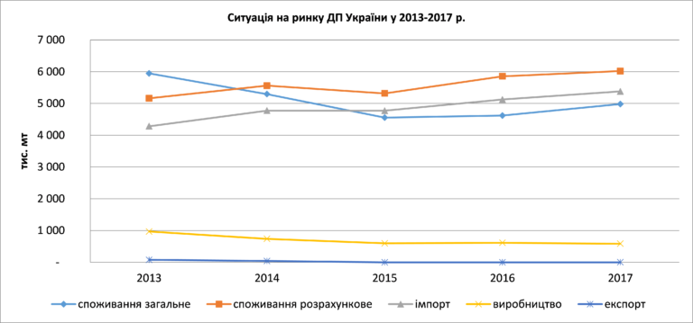
Fig. 2 The situation on the market of the Ukrainian state enterprise in 2013-2017.

Over the past decade, due to the difference in the price of diesel and gasoline in the Ukrainian market, there is a tendency for the gradual shift of gas consumers from the DP and SPBT (though, due to a significant increase in the cost of SPBT in recent times, the transition to it has become less attractive). All this, as well as the situation in the Autonomous Republic of Crimea, Luhansk and Donetsk oblasts, over the past five years (2017 compared to 2013) has led to the estimated consumption of gasoline engines in Ukraine decreased by 28%, or 711 thousand. tons At the same time, import of gasoline to Ukraine decreased by 30%, or 526 thousand tons, with 42% reduction, or 407 thousand tons.
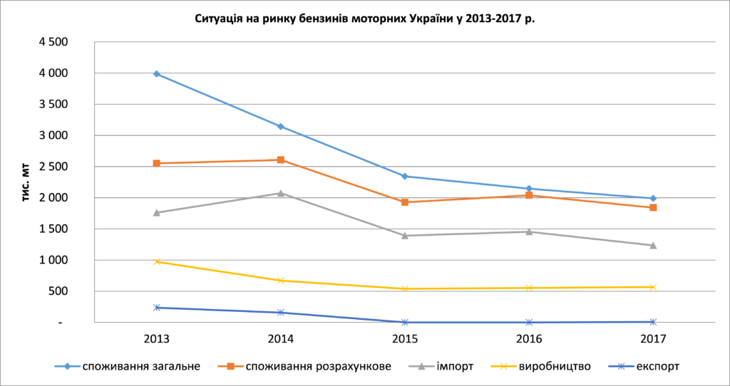
Fig. 3 Situation in the market of motor gasoline in Ukraine in 2013-2017.

In our view, in order to meet the current needs of Ukraine in gasoline and gasoline (according to various estimates, a total of about 6.8-7.5 million tons per year) and a projected slight increase in the level of consumption in the short term, it is necessary to recycle about 15-16 million tons of oil. In addition, about 3-3.5 million tons of fuel oil (it can be used to replace coal and gas at the TPP) and about 0.5-0.7 million tons of bitumen (used for road repair) will be further developed.
For decades, oil has been the main source of primary energy. The growth of the global economy will lead to increased demand for many types of raw materials and, above all, for oil. The main role in the formation of demand for petroleum products is played by the level of use of heating, electricity, transport, the level of economic development and climatic conditions of the country. The proposal is affected by the costs of exploration of oil fields and production of petroleum products, technological level, regulatory environment, as well as price fluctuations [3]. Highly-developed countries, as a rule, are more than underdeveloped, but there is a tendency for a significant increase in demand for oil from developing countries (Fig. 4).

Fig. 4 Projected oil consumption (million barrels per day) [2]

The increase in demand for oil in industrial regions will be primarily due to increased demand for petroleum products in the transport sector, where there are almost no economically viable alternatives to these fuels. In developing countries, demand for oil will increase in all sectors of consumption (the use of diesel engines for generating electricity, increasing demand for raw materials in the petrochemical industry).
Discussion. The issue of development of the oil and petroleum products market in Ukraine and in the world is relevant to date and needs further analysis. The formation of interconnections and the definition of the level of development of countries is closely linked to energy consumption. Based on the analysis of the development of the world oil and petroleum products market, we can draw the following conclusions. The main reason for the unsatisfactory competitiveness of domestic motor fuel is its quality, which does not meet the requirements of modern standards and the price not corresponding to it. In general, the competitiveness of the domestic oil refining industry is rather low.
Based on the above identified features of the formation of crude oil on the Ukrainian market in comparison with international experience, significant distortions can be noted in the mechanism of its pricing, which leads to a rise in the cost of its processing, and hence to the uncompetitiveness of domestic petroleum products.

References
- Viktorov S. (2015). Energetika - 2030: doroga do krizi? [Power engineering - 2030: the road to the crisis?]. Energy Policy of Ukraine, 10, 8- 10.
- Gіrnichiy entsiklopedichniy slovnik : u 3 t [Mining Encyclopedic Dictionary: 3 t.] (2004). Donetsk: Eastern Publishing House, 752.
- Dorozhkina M. (2006) Rinok nafti ta naftoproduktіv Ukraїni: problemi rozvitku ta regulyuvannya [Market of oil and petroleum products in Ukraine: problems of development and regulation]. Economics, № 85, 8-11.
- The Energy Strategy of Ukraine for the period up to 2030 The Ministry of Energy and Coal Industry of Ukraine. Available at: http://mpe.kmu.gov.ua/minugol/doccatalog/document?id= 260994.
- Problems and Prospects for Oil Products Market Development in the Context of Ensuring Energy Security – NISS. Available at: http://www.niss.gov.ua/content/articles/files/nafta 89ffa.pdf
- Ryabtsev G.L. (2014) A esli tak? SHest vozmojnyih stsenariev razvitiya ukrainskoy pererabotki i toplivnogo ryinka v 2014– 2015 gg [And if so? Six possible scenarios for the development of Ukrainian refining and fuel market in 2014-2015]. Terminal, №. 14, 6-11.

ВАЩЕНКО В.В.
АНАЛІЗ РИНКУ НАФТИ ТА НАФТОПРОДУКТІВ В УКРАЇНІ
Анотація. Нині питання нафти та нафтопродуктів є досить важливим як у теоретичній, так і практичній площинах. Особливо значення набуває питання повноти та відповідності сучасним ринковим умовам існуючого в Україні порядку формування цін на нафту вітчизняного видобутку.
У статті аналізується сучасний стан ринку нафти в Україні. Досліджено динаміку середніх цін на нафтопродукти в Україні. Проаналізовано динаміку цін на нафтопродукти в Європі. Досліджено тенденції видобутку нафти в Україні та визначено їх неухильне зниження в останні роки.
В результаті аналізу національного ринку сирої нафти визначено, що: стала тенденція торгівлі сирою нафтою на ринку України обумовлена скороченням об’ємів переробки нафти, яке, в свою чергу, спричинене витисненням з національного ринку вітчизняного пального імпортом; основною причиною незадовільної конкурентоспроможності вітчизняного моторного палива є його якість, що не відповідає вимогам сучасних стандартів та не відповідна до нього ціна; низька якість моторного палива вітчизняного виробництва визначається переважним використанням для його виробництва низькоякісної (високосірчастої) імпортної (російської) нафти; в цілому конкурентоспроможність вітчизняної нафтопереробної галузі визнана низькою.
Ключові слова. Нафта, нафтопродукти, ціна, імпорт, еспорт, ринок, динаміка.

ВАЩЕНКО В.В.
АНАЛИЗ РЫНКА НЕФТИ И НЕФТЕПРОДУКТОВ В УКРАИНЕ
Аннотация. Сейчас вопрос нефти и нефтепродуктов является весьма важным как в теоретическом, так и практическом плоскостях. Особенно значение приобретает вопрос полноты и соответствия современным рыночным условиям существующего в Украине порядка формирования цен на нефть отечественной добычи.
В статье анализируется современное состояние рынка нефти в Украине. Исследована динамика средних цен на нефтепродукты в Украине. Проанализирована динамика цен на нефтепродукты в Европе. Исследована тенденции добычи нефти в Украину и определены их неуклонное снижение в последние годы.
В результате анализа национального рынка сырой нефти определено, что: устойчивая тенденция торговли сырой нефтью на рынке Украины обусловлена ​​сокращением объемов переработки нефти, которое, в свою очередь, вызвано вытеснением с национального рынка отечественного горючего импортом; основной причиной неудовлетворительной конкурентоспособности отечественного моторного топлива является его качество, не соответствует требованиям современных стандартов и не соответствующих него цена; низкое качество моторного топлива отечественного производства определяется преимущественным использованием для его производства низкокачественной (високосирчастои) импортной (российской) нефти; в целом конкурентоспособность отечественной нефтеперерабатывающей отрасли признана низкой.
Ключевые слова. Нефть, нефтепродукты, цена, импорт, еспорт, рынок, динамика.

