Mapping bee forage trees
A. Moskalenko, PhD,
І. Domina, student of MS,
National University of Life and Environmental Sciences of Ukraine
E-mail: A-Moskalenko@it.nubip.edu.ua
The possibilities of using the remote sensing data for bee forage mapping in the forest have been shown in the research. Finding the areas of nectar and pollen plants could help effective development of beekeeping.
In the article was shown the analysis of different periods of remote sensing data acquisition for the most suitable mapping bee forage trees.
The NDVI was calculated during the growing season from late April to the beginning of October. That index were fluctuating during the period of the research. The peak of the development of green massperiod was defined for NDVI as the most suitable for the study and selection of different types of trees.
As a result of the research, it was established that the determining location of bee forage trees based on remote sensing data provides the best result in combination of several NDVI images.
Key words: remote sensing data, bee forage, mapping.

Introduction. Remote sensing is an approach to get operative spatial data and keeping the data up to date. Today remote sensing is commonly used in different spheres in solving problems in nature and human activities. Many researches using remote sensing for identifying plants were performed.
Finding the areas of nectar and pollen plants could help effective development of beekeeping. Beekeepers need to find enough areas of bee forage. The basis of bee forage may be honey forest plants, because, as a rule, forest plants do not change place of localization every year.
This paper uses remote sensing data for bee forage mapping in the forest.
Analysis of recent researches and publications. The development problems of scientific and organizational principles of beekeeping in Ukraine from the earliest time to the present has been covered by scientists M.M. Vitvitsky, O.H. Andriyashev, V.A. Nestervodsky, G.L. Bodnarchuk.
The research [1] covered usageng of remote sensing data for forest park landscape classification in urban and suburban forests. However, the identification of the areas of nectary and pollen forest resources according to remote sensing data was not highlighted.
The identificationof agricultural resourcesbased on vegetation indexes of the remote sensing data has covered in different researches [2-5].
The article [6] considers elements of applying some methods of multispectral images classification for bee forage determining based on field crops.
The study [7] highlights the inventory of honey plants in arid zones. Ground-based inventory works were supported by GIS-applications.
However, an optimal period for identification and bee forage trees mapping based on the remote sensing data was not defined in the Ukrainian forest-steppe zone.
Objectives of the article:the analysis of different periods of remote sensing data acquisition for the most suitable mapping bee forage trees.
Materials and methods.The study was conducted on the territory of Boryspil district of Kyiv region.
To achieve the objective of the study, the following methods were used: thematic processing of remote sensing data; statistical and cartographic methods.
The paper used modules of image processing of the Idrisi Selva software. The information base of the research is the ground-based survey of place and multispectral images Landsat 8.
Results. The remote sensing data is an operative source for obtaining geoinformation data and the main source for keeping information up-to-date.
To achieve the research objective the tasks which were structured in the model were performed. The functional model of the application of remote sensing data and data collection in the nature for selection the optimal location of apiaries was illustrated in Fig. 1.
The key components of this model are: problem statement and determination of the territory, collection of data in the nature, visual image interpretation, selection of reference areas, selection of remote sensing data, thematic processing of remote sensing data and the creation of a thematic map of perennial honey trees.
Problem statement
Visual image interpretation
Collectionof ground based data
Selection of training sites.
Remote Sensing Data Selection
Thematic processing of remote sensing data
Mapping bee forage trees
Fig. 1. The functional model of the implementation of actions to solve the problem.

Problem statement. The rational development of beekeeping depends entirely on the availability of bee forage resources, their productivity and quantitative composition.
Many honey plants grow in the forest. However, not every forestland is rich in honey vegetation. Honey-bearing forest plants include acacia, apple, pear, cherry, poplar, birch, elm, linden, heather, blackberry, blueberries, raspberries etc[9].
Honey plants can be found in all tiers in the forest. However, based on remote sensing data, only plants that grow in the upper tier could identified. In this way, large forests can be explored in search of nectar or pollen. In this work, the following forest crops were selected for research: birch, alder, acacia, aspen, willow, linden, pine, spruce, oak, ash, maple.
Collection of ground based data. The ground-based survey usedGarmin device to define the location of trees.
Visual image interpretation. Vegetation could be determined by visual image interpretation based on separate spectral channels or color compositions. However, this method did not provide the exact result of the location of nectar and pollen plants.
Selection of training sites.The selection of reference areas is carried out in the ground based was used to create training sites. In the research of terrain, objects are interpreted directly by comparing of their image to image in nature. The research of the images in laboratories was based on a variety of cartographic and reference materials. Using the combination of these two methods, more precise and standardized templates were obtained - exemplary interpreted images of forest areas with a known breed of trees [8].
Remote sensing data selection. Since the objective of the research is to define the territories for the location of nomadic and stationary apiaries, the objects of spatial differentiation are arrays of trees that are not less than 0,1 hectares, which can be covered by multispectral images of Landsat 8 with a spatial resolution of 30 meters.
Clouds were covering target territory on the more than half of Landsat 8 images during vegetation periods in 2017 and 2018. During the growing season in 2016, Landsat 8 took images on the following dates: 24.04, 10.05, 26.05, 11.06 (cloudiness), 27.06, 13.07, 29.07, 14.08 (clouds), 30.08 (few clouds), 15.09, 1.10.
Thematic processing of remote sensing data. Vegetation indices are widely usedfor the evaluation and mapping of the vegetation state. Vegetation indices were calculated based on measured spectral brightness of different plant types[2].
NDVI is a simple quantitative indicator of the amount of photosynthetic active biomass, which is calculated by two of the most stable parts of the spectral reflection curve of plants. In the red region of the spectrum (0.6-0.7 microns), the maximum absorption of solar radiation by chlorophyll plants lies and the infrared region (0.7-1.0 microns) is the region of maximum reflection of the cellular structures of the leaf [8].
The NDVI was calculated during the growing season from late April to the beginning of October. Figure 2 shows NDVI graphs for each type of studding plants.
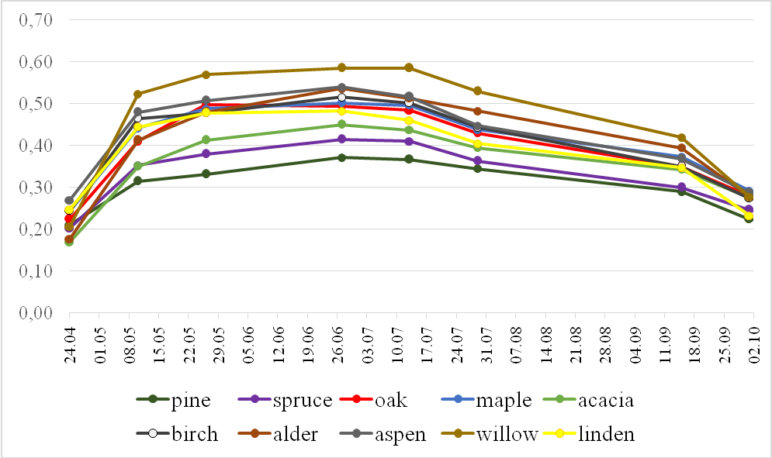
Fig. 2 – NDVI graphs.
The values of NDVI were fluctuating during the period of the research. The most of the studied plants are broad-leaved vegetations, so the peak of the development of green mass in them increases at the end of May and lasts until mid-July. The same period was defined for NDVI as the most suitable for the study and selection of different types of trees.
Thematic processing of remote sensing data included algorithms of supervised classification. Training sites were selected of reference areas carried out in the terrain. They included etalons of honey and background plants such as pine and spruce.
From the set of algorithms of the supervised classification for the identification and mapping of the beekeeping feed base, we considered the possibility of using "hard classifiers": methods of Minimum Distance to Means, Linear discriminant analysis. (Table 1).
The classification of satellite images was carried out separately on certain days and combination of days.
Table 1
Classification results
 | 10.05 | 26.05 | 13.07 | 29.07 | NDVI
Linear discriminant analysis | 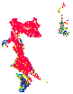 | 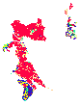 | 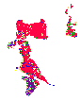 | 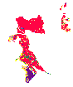 | 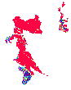
Minimum Distance to Means | 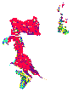 | 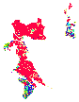 | 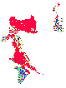 | 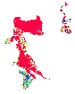 | 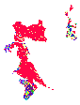
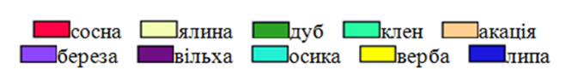
pinespruceoak mapleacaciabirchalder aspen willow linden

The Method of Minimum Distance to Means. On May 10, background plants - pine and spruce - were well-recognized. Linden trees were recognized erroneously. On May 26, the results were slightly better, because the green biomass of the studied plants had increased. Alder, oak, nut and ash have been recognized partly on correct places. On July 13, there was the peak of green biomass and the most diverse NDVI in the studied plants. Therefore, we saw no bad results, but instead of pine the classifier partially recognized spruce. On July 29, the classification result was similar to July, 13. Using the Method of Minimum Distance to Means of supervised classificationbased on combining NDVI images provided the best result.
The Method of Linear discriminant analysis. This method provided the best results, even in the middle of May, when the plants are starting to grow up green biomass. All plants were recognized. Of course, the best results of supervised classification was shown on July image, when there is the largest green mass. In the combined image the classifier of plants had bigger recognition accuracy.
Mapping bee forage trees.Identification and mapping of the bee forage trees based on remote sensing data was performed. Thematic maps of tree types were created. They had scale 1:100000 and can be used as the base to the planning of the localization of roaming apiaries.
Conclusions.This research describes which periods are the best for bee forage trees identification as well as methods which demonstrate the best results.
Determining location of bee forage trees based on remote sensing data provides the best result in combination of several NDVI images (26.05, 27.06 and 13.07). The method of linear discriminant analysis used the best result of bee forage trees localization.
References
  - Giers O., Myroniuk V.,&Kutya, M. (2012) Rozpiznavannya lisoparkovykh landshaftiv zelenoyi zony m. Kyiva za danymy DZZ(Forest park identification of Kyiv Green zone using remote sensing data)Scientific reports of NULES of Ukraine, 7 (36). Retrieved from http://nd.nubip.edu.ua/2012_7/12goa.pdf
  - Kokhan, S.S. (2011). Zastosuvannya vehetatsiynykh indeksiv na osnovi seriyi kosmichnykh znimkiv IRS-1D LISS-III dlya vyznachennya stanu posiviv silskohospodarskykh ku'tur [Application of vegetation indexes derived from satellite images IRS–1D LISS–III for determination of crop status].Space Science and Technology, 17 (5), 58-63.
  - Slobodyanyk, M.P. (2014). Prohnozuvannya vrozhaynosti sil's'kohospodars'kykh kul'tur za materialamy DZZ ta vehetatsiynymy indeksamy [Forecasting crop yields based on remote sensing data and vegetation index]. Journal of Geodesy and Cartography, 6, 16-20.
  - Conrad C., Fritsch S., Rocker G., Dech S. (2010) Per-field irrigated crop classification in arid central Asia using SPOT and ASTER data. Remote Sens, 2, 1035-1056.
  - Verhulst, N., B. Govaerts, K.D. Sayre, J. Deckers, L. Dendooven. (2009). Using NDVI and soil quality analysis to assess influence of agronomic management on within-plot spatial variability and factors limiting production. Plant and Soil, 317: 41-59.
  - Moskalenko, A., Domina, І. (2017). Identyfikatsiya osnovnykh medonosnykh kulʹtur za danymy dystantsiynoho zonduvannya Zemli(Identificationofthemainhoneycropsbasedonremotesensingdata)Land management, cadastre and land monitoring,2: 66-74.
  - Adgaba, Nuru; Alghamdi, Ahmed; Sammoud, Rachid; Shenkute, Awraris; Tadesse, Yilma; Ansaria, Mahammad J.; Sharma,Deepak; Hepburnc, Colleen. (2017) Determining spatio-temporal distribution of bee forage species of Al-Baha region based on ground inventorying supported with GIS applications and Remote Sensed Satellite Image analysis. Saudi Journal of Biological Sciences, Vol: 24 Issue: 5: 1038-1044.doi:10.1016/j.sjbs.2017.01.009
  - Kokhan, S.S., Vostokov, A.B. (2009). Dystantsiyne zonduvannya Zemli: teoretychni osnovy [Remote sensing: the theoretical basics]. Kyiv, 511.
  - Cherkasova, A.I., Blonsʹka, V.M., Huba, P.O., Davydenko, I.K., Yatsun, O.M., Voznyy, P.A., Mukvych, N.V. (1989). Bdzhilʹnytstvo [Beekeping]. Retrieved from http://bee-home.ru/bdzhil-nytstvo-uk.html

Москаленко А., Демина И.
Картографирование медоносных деревьев
В исследовании были показаны возможности использования данных дистанционного зондирования для картографирования кормовой базы пчеловодства в лесу. Поиск областей нектарных и пыльценосных растений может помочь в эффективном развитии пчеловодства.
В статье был показан анализ различных периодов сбора данных дистанционного зондирования наиболее подходящих для картографирования деревьевкормовой базы пчеловодства.
NDVI был рассчитан в течение вегетационного периода с конца апреля до начала октября. Этот индекс колебался в течение периода исследования. Период наибольшего развития зеленоймассы был определен для NDVI как наиболее подходящий для изучения и отбора различных типов деревьев.
В результате исследования было установлено, что определение местоположения деревьев кормовой базы пчеловодства на основе данных дистанционного зондирования обеспечивает лучший результат в сочетании нескольких изображений NDVI.
Ключевые слова: данные дистанционного зондирования, пчеловодство, картография.

Москаленко А., Дьоміна І.
КАРТОГРАФУВАННЯ МЕДОНОСНИХ ДЕРЕВ
У дослідженні було показано можливості використання даних дистанційного зондування для картографування кормової бази бджільництва у лісі. Пошук районів нектаро- та пилконосних рослин може допомогти ефективному розвитку бджільництва.
У статті було показано аналіз різних періодів даних дистанційного зондування з метоювизначення найбільш оптимального для картографування кормової бази бджільництва у лісі.
NDVI був розрахований протягом вегетаційного періоду з кінця квітня до початку жовтня. Цей індекс коливався протягом періоду дослідження. Період піку розвитку зеленої масибув визначений для NDVI як найбільш підходящий для вивчення та відбору різних типів дерев.
В результаті дослідження було встановлено, що картографування кормової бази бджільництвабагаторічних дерев на основі даних дистанційного зондування забезпечує найкращий результат при поєднанні кількох зображень NDVI.
Ключові слова: дані дистанційного зондування, кормова база бджільництва, картографування.

